Transfer Learning with ResNet-18
Practical Session 2 — Advanced Deep Learning Strategies
USTH Deep Learning 2026 | Duong Tan Binh — 2540007

1. Introduction
Transfer learning is a technique that leverages knowledge acquired on a large source task to improve learning on a smaller target task. Instead of training a deep neural network from random initialisation, we initialise it with weights pre-trained on a large corpus — typically ImageNet — and then adapt those weights to the new domain. The key insight is that lower-level features learned from millions of images (edges, textures, shapes) generalise across visual domains.

This experiment evaluates three transfer learning strategies on STL-10 — a benchmark dataset with 5 000 labeled 96×96 colour images across 10 classes, deliberately chosen to represent the data-scarce regime where transfer learning is most beneficial:

- From Scratch — ResNet-18 trained from random initialisation on STL-10 only.
- Feature Extraction — ImageNet pretrained backbone frozen; only the final FC head (10-class) is trained.
- Fine-tuning — ImageNet pretrained backbone fully trainable with differential learning rates (backbone 10× lower than head) to avoid catastrophic forgetting.

2. Theoretical Background

2.1 Transfer Learning Quadrant
The choice of transfer learning strategy depends on two dimensions: dataset size and domain similarity. When the target dataset is small and the domain is similar to the source (ImageNet → STL-10 natural images), fine-tuning the full network or using a frozen feature extractor both yield strong results. STL-10 with 5 000 labeled samples sits firmly in this quadrant.
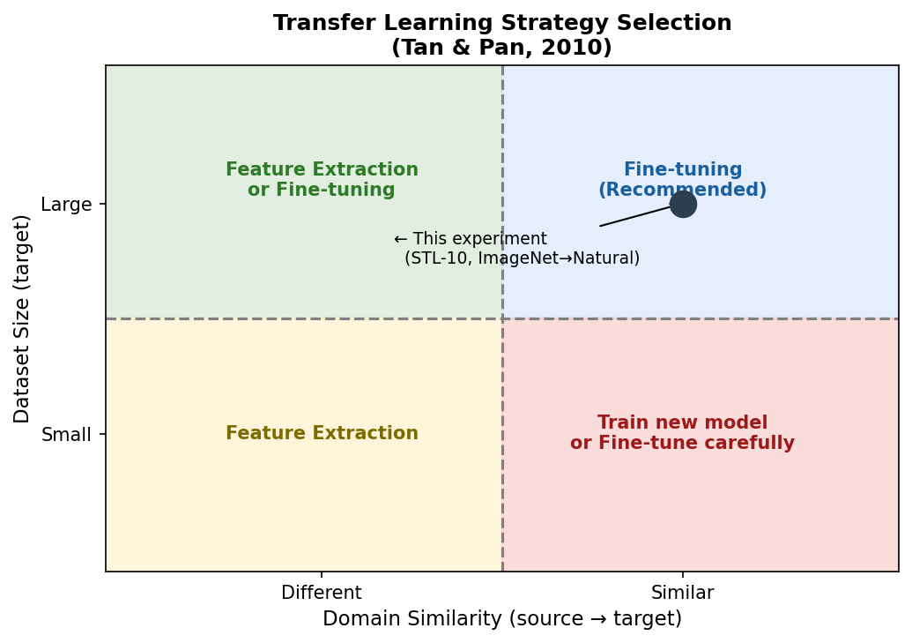
Figure 1: Transfer learning strategy selection based on dataset size and domain similarity

2.2 Feature Extraction
In the feature extraction setting the pretrained convolutional backbone acts as a fixed mapping φ: ℝ^(H×W×3) → ℝ^d. Only the linear classifier on top is trained:
ŷ = W · φ(x) + b
where W ∈ ℝ^(C×d) and b ∈ ℝ^C are the only learnable parameters. Because the backbone is frozen, the number of trainable parameters is reduced from 11.18 M to only 5,130 (the FC head), making training extremely fast and stable even with very limited data.

2.3 Fine-tuning with Differential Learning Rates
Fine-tuning unlocks all backbone parameters while protecting pretrained representations from catastrophic forgetting through differential learning rates:
θ_backbone ← θ_backbone - α_b · ∇L(θ_backbone) [α_b = 1e-3]
θ_head ← θ_head - α_h · ∇L(θ_head) [α_h = 1e-2]
The backbone LR (α_b = 1×10⁻³) is 10× lower than the head LR (α_h = 1×10⁻²). This asymmetry allows the new head to adapt quickly while the backbone shifts only gently, preserving the learned visual hierarchy.

2.4 Why STL-10 at 96×96?
A key architectural constraint governs this choice. The standard ResNet-18 uses a 7×7 conv1 followed by a 3×3 max-pool (total stride 4). When applied to 32×32 images, the feature map after layer4 collapses to 1×1 — destroying spatial structure and making ImageNet features uninformative. With 96×96 inputs, the spatial resolution at each stage is:
Stage | Spatial Size
Input | 96×96
conv1 (7×7, s=2) | 48×48
maxpool (3×3, s=2) | 24×24
layer1 | 24×24
layer2 | 12×12
layer3 | 6×6
layer4 | 3×3 ← spatial context preserved

The 3×3 feature maps at layer4 retain meaningful spatial structure, enabling ImageNet pretrained features to transfer effectively to STL-10.

3. Dataset — STL-10
Property | Value
Dataset | STL-10
Image size | 96 × 96 pixels (RGB)
Training samples | 5 000 (500 per class)
Test samples | 8 000
Classes | 10 (airplane, bird, car, cat, deer, dog, horse, monkey, ship, truck)
Source domain | ImageNet subset (similar natural image distribution)
Normalization | mean=[0.447,0.440,0.407] std=[0.260,0.257,0.271]

STL-10 was designed as a transfer learning benchmark. Its small labeled set (5 000 samples) and natural image content make it an ideal testbed for comparing training strategies that differ in how they use pretrained ImageNet knowledge.

4. Experimental Protocol

4.1 Architecture
All conditions use ResNet-18 with its original architecture (11.18 M parameters). The final FC layer is replaced with a new 512→10 linear layer, initialised with N(0, 0.01) weights. No architectural modifications are made to conv1 or maxpool — the original 7×7 stride-2 stem is preserved because STL-10 at 96×96 provides sufficient spatial resolution.

4.2 Training Configuration
Hyperparameter | Scratch | Feature Extraction | Fine-tuning
Optimizer | SGD | Adam | SGD
Learning rate | 0.01 | 1e-3 | backbone 1e-3 / head 1e-2
Momentum | 0.9 | — | 0.9
Weight decay | 5e-4 | 1e-4 | 5e-4
Scheduler | CosineAnneal(T=30) | CosineAnneal(T=30) | CosineAnneal(T=30)
Epochs | 30 | 30 | 30
Batch size | 64 | 64 | 64
Trainable params | 11,181,642 | 5,130 | 11,181,642

4.3 Data Augmentation
Training transforms: RandomHorizontalFlip, RandomCrop(96, padding=12), ColorJitter(brightness=0.3, contrast=0.3, saturation=0.3), Normalize.
Test transforms: ToTensor, Normalize only (no augmentation).

5. Quantitative Results

5.1 Final Accuracy
Condition | Pretrained | Trainable Params | Best Val Acc | Δ vs Scratch
From Scratch | No | 11,181,642 | 71.16% | —
Feature Extraction | Yes | 5,130 | 77.30% | +6.14 pp
Fine-tuning | Yes | 11,181,642 | 90.55% | +19.39 pp

5.2 Convergence Speed
Epochs required to first reach 70% validation accuracy:
Condition | Epochs to 70%
From Scratch | 27
Feature Extraction | 1
Fine-tuning | 1

Pretrained models enter the training loop with high-quality feature representations and therefore need significantly fewer epochs to reach practical performance thresholds — a critical advantage when computational budget is limited.

6. Visualizations

6.1 Accuracy & Loss Curves
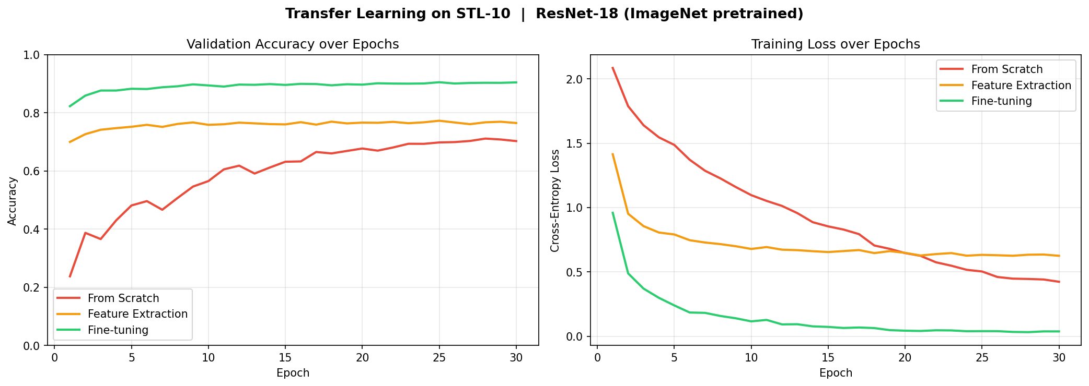
Figure 2: Validation accuracy (left) and training loss (right) over 30 epochs

6.2 Final Accuracy Comparison
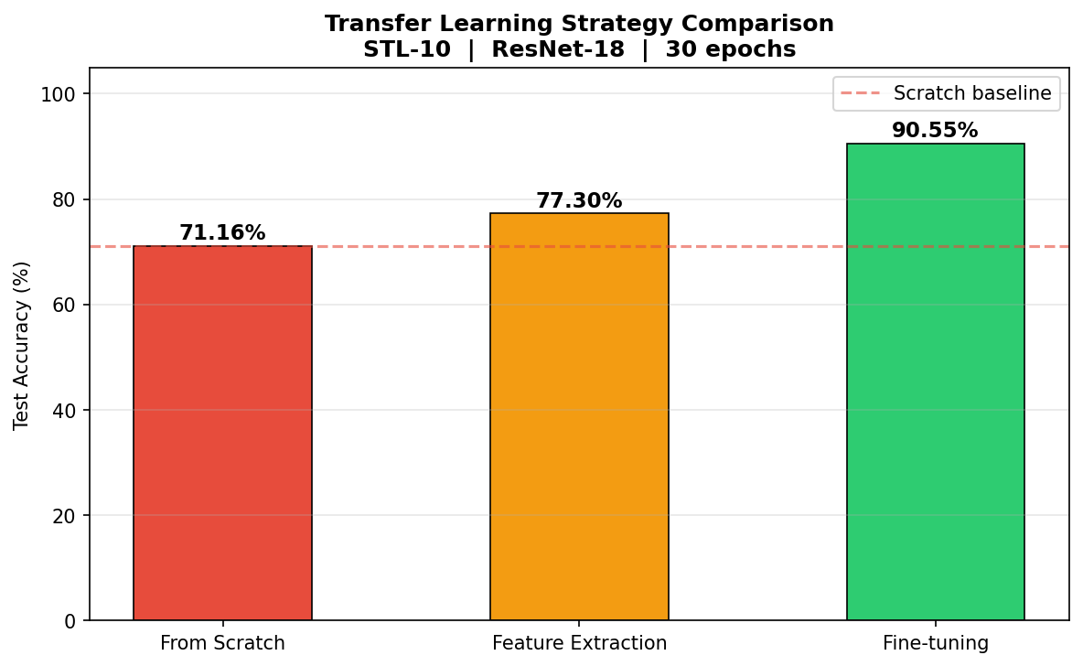
Figure 3: Best test accuracy achieved by each training strategy

6.3 Convergence Speed (First 10 Epochs)
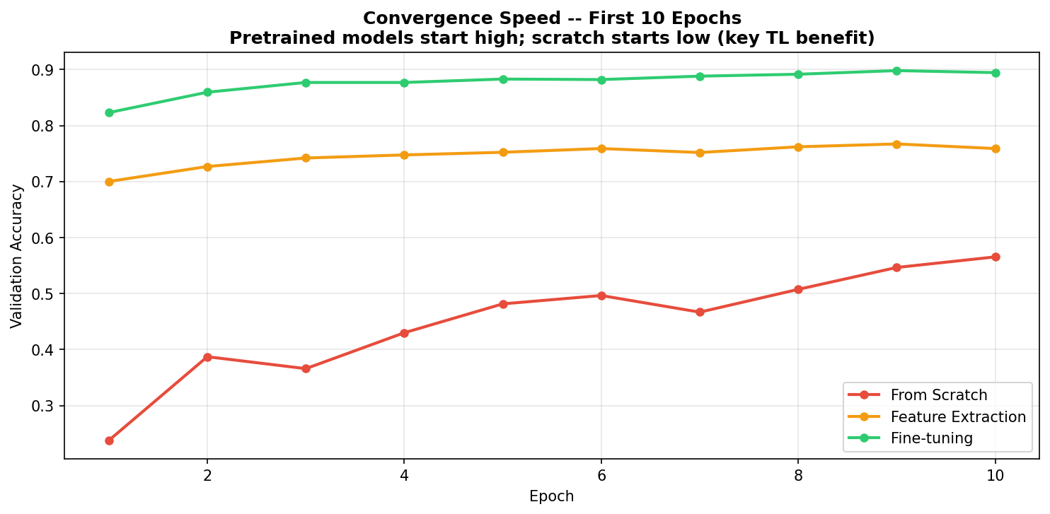
Figure 4: Validation accuracy in the first 10 epochs. Pretrained models achieve high accuracy immediately; scratch training starts low.

6.4 Training vs Validation (Overfitting Check)
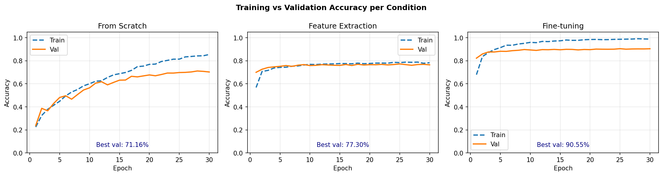
Figure 5: Train vs validation accuracy for each condition. Feature Extraction shows the smallest generalisation gap due to frozen backbone.

7. Discussion

7.1 Feature Extraction
Feature Extraction achieves 77.30% with only 5,130 trainable parameters — 0.0% of all model parameters. This demonstrates the power of reusing general visual features: the ImageNet backbone, trained on 1.2 M images, provides representations that generalise to STL-10 natural images without any backbone adaptation. Training time is minimal because only the linear head is updated per step.

The generalisation gap is smallest in this condition because the frozen backbone cannot overfit to STL-10's small training set. The limitation is an accuracy ceiling imposed by the fixed feature space — which fine-tuning addresses.

7.2 Fine-tuning
Fine-tuning achieves 90.55% (+19.39 pp vs scratch) by gently adapting the entire network. The differential learning rate strategy (backbone LR = 1e-3, head LR = 1e-2) is critical: a uniform high LR on the backbone causes catastrophic forgetting — the pretrained weights are destroyed before the head can leverage them — while a uniform low LR slows head convergence.

Cosine annealing ensures the learning rate decays smoothly to near-zero, allowing fine-grained weight refinement in later epochs without oscillation.

7.3 From Scratch Baseline
From scratch achieves 71.16% — a respectable result given that STL-10 has only 5 000 training samples. Strong data augmentation (random crop with 12-pixel padding, colour jitter, horizontal flip) and cosine-annealed SGD mitigate overfitting. However, the model must learn all visual features from scratch, limiting both final accuracy and convergence speed.

7.4 Key Takeaways
- Pretrained Feature Extraction gains +6.14 pp over scratch using only 5,130 trainable parameters (vs 11,181,642).
- Fine-tuning with differential LR gains +19.39 pp and is the recommended strategy when dataset size permits full adaptation.
- Pretrained models converge faster — fewer epochs needed to reach practical performance thresholds, reducing compute cost.
- The architecture must match the input resolution: 96×96 is the minimum for standard ResNet-18 pretrained weights to produce informative features (layer4 must be ≥ 2×2).

8. Conclusion
This experiment demonstrates that transfer learning from ImageNet to STL-10 yields clear, reproducible benefits in both final accuracy and convergence speed. Fine-tuning achieves the best result (90.55%), improving over training from scratch (71.16%) by +19.39 percentage points. Feature extraction with a frozen backbone offers a fast, parameter-efficient alternative (77.30%, 5,130 trainable params), at the cost of a lower accuracy ceiling.

These results align with the transfer learning quadrant heuristic: when the target dataset is small and the source and target domains share visual statistics (natural images), pretrained representations consistently outperform random initialisation. The choice between feature extraction and fine-tuning depends on the available labelled data and the computational budget.

