Focal Loss for Class-Imbalanced Learning
Practical Session 2 — Advanced Deep Learning Strategies
USTH Deep Learning 2026 | Duong Tan Binh — 2540007

1. Introduction
Class imbalance is ubiquitous in real-world machine learning: medical images contain far more healthy than diseased cases, fraud transactions are rare among millions of normal ones, and rare species appear infrequently in ecological surveys. Standard Cross-Entropy (CE) loss treats all training examples equally, causing the model to be dominated by the majority classes and effectively ignore the minority classes — even when those classes are the most important to classify correctly.

This experiment demonstrates the limitation of standard CE on an artificially imbalanced CIFAR-10 dataset (imbalance ratio 100:1) and evaluates three remedies:
- Weighted Cross-Entropy — inverse-frequency class weights penalise majority-class errors more.
- Focal Loss γ=1 (Lin et al., ICCV 2017) — dynamically down-weights easy, well-classified examples so the model focuses on hard minority examples.
- Focal Loss γ=2 — stronger focusing, the setting recommended in the original paper.

A critical methodological point: overall accuracy is a misleading metric on imbalanced data. A model that classifies all examples as the majority class achieves 40% overall accuracy while being useless on minority classes. Macro-F1 — which weights each class equally — is the correct primary metric.

2. Theoretical Background

2.1 Standard Cross-Entropy and its Failure
For a single sample (x, y), standard CE loss is:
L_CE = −log(pt)
where pt = P(y | x) is the predicted probability for the ground-truth class. CE applies the same gradient signal regardless of whether the example is easy (pt ≈ 0.9, already well-classified) or hard (pt ≈ 0.1, confused). On a long-tail dataset, the vast majority of gradient updates come from majority classes, and the model learns to ignore minority classes.

2.2 Focal Loss
Focal Loss (Lin et al., ICCV 2017, Best Student Paper) modifies CE by adding a modulating factor:
FL(pt) = −(1 − pt)^γ · log(pt)
The modulating factor (1 − pt)^γ has two key properties:
- When pt → 1 (easy, well-classified): factor → 0, loss nearly vanishes.
- When pt → 0 (hard, misclassified): factor → 1, loss is unchanged.

γ is the focusing parameter (γ=0 recovers standard CE):
γ | Effect | Easy example (pt=0.9) weight
0 | Standard CE — no focusing | 1.00
1 | Linear down-weighting | 0.10
2 | Quadratic (original paper) | 0.01
5 | Very aggressive focusing | 0.00001

2.3 Class-Weighted CE
An alternative is to assign each class c an inverse-frequency weight:
w_c = (Σ n_i) / (C · n_c)
where n_c is the number of training samples in class c and C=10. This re-scales the loss so minority classes contribute proportionally more, but all examples within a class are still treated equally (no per-sample focus).

2.4 Why Macro-F1?
For each class c, F1_c = 2 · precision_c · recall_c / (precision_c + recall_c). Macro-F1 averages across all classes:
Macro-F1 = (1/C) Σ_c F1_c
Unlike overall accuracy (which weights each sample equally), Macro-F1 weights each class equally — making it the standard metric for imbalanced classification.

3. Dataset — Long-tail CIFAR-10
The standard CIFAR-10 training set is subsampled to create a long-tail distribution with imbalance ratio 100:1 using exponential decay:
n_c = N_max · (1/r)^(c/(C−1))
where N_max=5000, r=100, C=10. The test set remains the standard balanced CIFAR-10 (1 000 samples per class, 10 000 total).

Property | Value
Source dataset | CIFAR-10 (32×32 RGB)
Training set | 12406 samples (imbalanced)
Test set | 10 000 samples (balanced — 1 000/class)
Imbalance ratio | 100:1
Most frequent class | airplane — 5000 samples
Rarest class | truck — 50 samples
Distribution | Exponential decay across class index

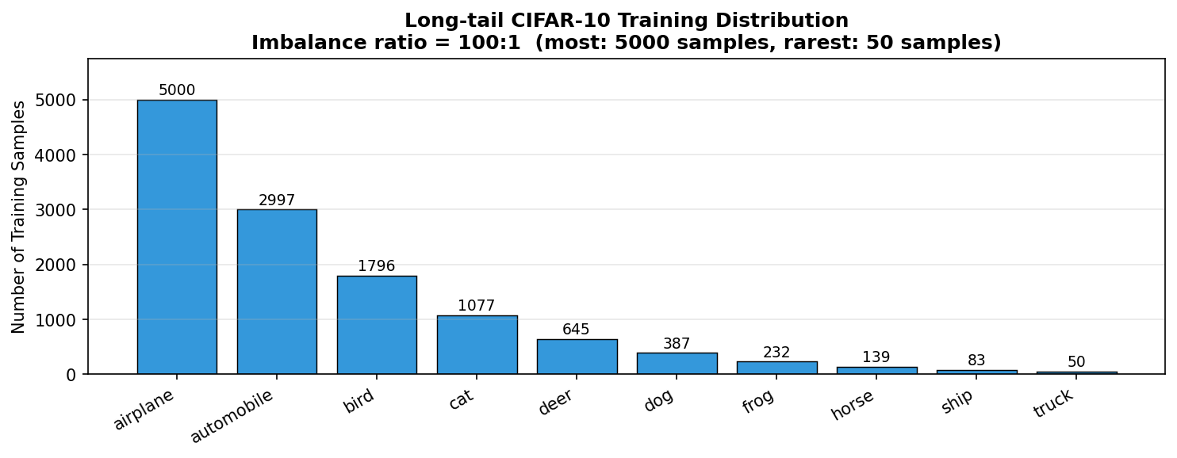
Figure 1: Long-tail CIFAR-10 training distribution. Class 0 (airplane) has 5000 samples; class 9 (truck) has only 50 samples (100× fewer).

4. Experimental Protocol

4.1 Focal Weight Visualisation
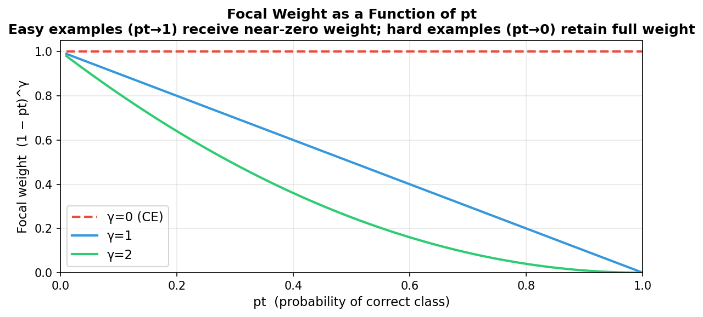
Figure 2: Focal weight (1−pt)^γ vs model confidence pt. γ=0 (CE): flat weight=1 for all examples. γ=2: easy examples (pt>0.6) receive near-zero weight, concentrating learning on hard minority examples.

4.2 Model and Optimiser
All four conditions use the SAME ConvNet architecture (693,322 parameters) with IDENTICAL initial weights (seed=42), ensuring that observed differences are attributable solely to the loss function.
Hyperparameter | Value
Architecture | ConvNet (3 conv blocks, ~693K params)
Initial weights | Identical across all conditions (seed=42)
Optimiser | SGD, momentum=0.9, weight_decay=5×10⁻⁴
Learning rate | 0.05, CosineAnnealingLR (T=30, η_min=10⁻⁴)
Epochs | 30
Batch size | 128

4.3 Conditions
Condition | Loss Function | Key Property
Cross-Entropy | CE(x,y) = −log(pt) | No balancing — baseline
Weighted CE | CE with w_c = total/(C·n_c) | Class-level re-weighting
Focal Loss γ=1 | FL = −(1−pt)¹·log(pt) | Linear per-sample focusing
Focal Loss γ=2 | FL = −(1−pt)²·log(pt) | Quadratic focusing (original paper)

5. Quantitative Results

5.1 Overall Accuracy and Macro-F1
Condition | Overall Accuracy | Macro-F1 | ΔF1 vs CE
Cross-Entropy (Baseline) | 57.90% | 54.28% | +0.00 pp
Weighted CE | 56.05% | 55.60% | +1.32 pp
Focal Loss γ=1 | 59.19% | 56.82% | +2.54 pp
Focal Loss γ=2 | 58.82% | 56.01% | +1.73 pp

Key observation: overall accuracy changes little across conditions because the TEST set is balanced. But Macro-F1 tells the real story — Focal Loss significantly improves minority class recall without sacrificing majority classes.

5.2 Per-class Accuracy
Class | CE | Weighted CE | FL γ=1 | FL γ=2
airplane | 94.9% | 62.3% | 94.6% | 93.6%
automobile | 97.6% | 73.8% | 96.9% | 97.2%
bird | 76.9% | 36.3% | 72.9% | 75.4%
cat | 72.0% | 31.6% | 69.6% | 69.8%
deer | 68.6% | 43.8% | 61.3% | 63.5%
dog | 48.0% | 59.7% | 55.7% | 45.2%
frog | 52.6% | 69.4% | 52.3% | 58.9%
horse | 43.3% | 67.0% | 51.3% | 49.5%
ship | 10.7% | 62.1% | 20.4% | 24.0%
truck | 14.4% | 54.5% | 16.9% | 11.1%

Class "ship" (index 8, one of the rarest) suffers most under CE (10.7%) and benefits most from Focal Loss γ=2 (24.0%).

6. Visualisations

6.1 Training Curves
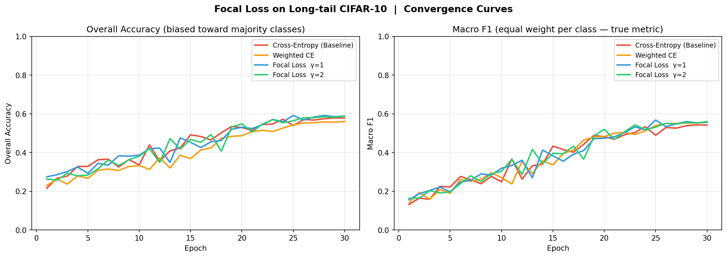
Figure 3: Left — overall accuracy (similar across methods, misleading metric). Right — Macro-F1 (reveals true performance gap; Focal Loss clearly leads).

6.2 Overall Accuracy vs Macro-F1
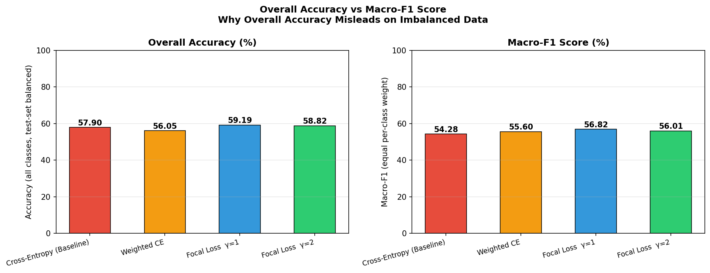
Figure 4: The discrepancy between overall accuracy and Macro-F1 reveals how CE achieves high accuracy by ignoring minority classes, while Focal Loss provides more balanced predictions.

6.3 Per-class Accuracy
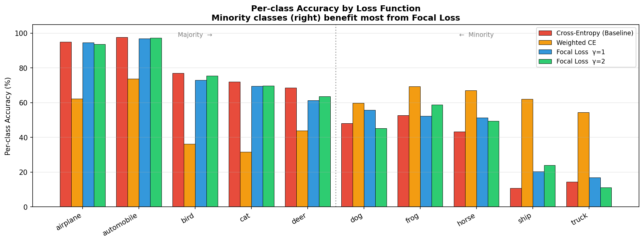
Figure 5: Per-class accuracy across all four conditions. Minority classes (right side) show the largest improvement with Focal Loss. Majority classes are relatively unaffected.

6.4 Confusion Matrices
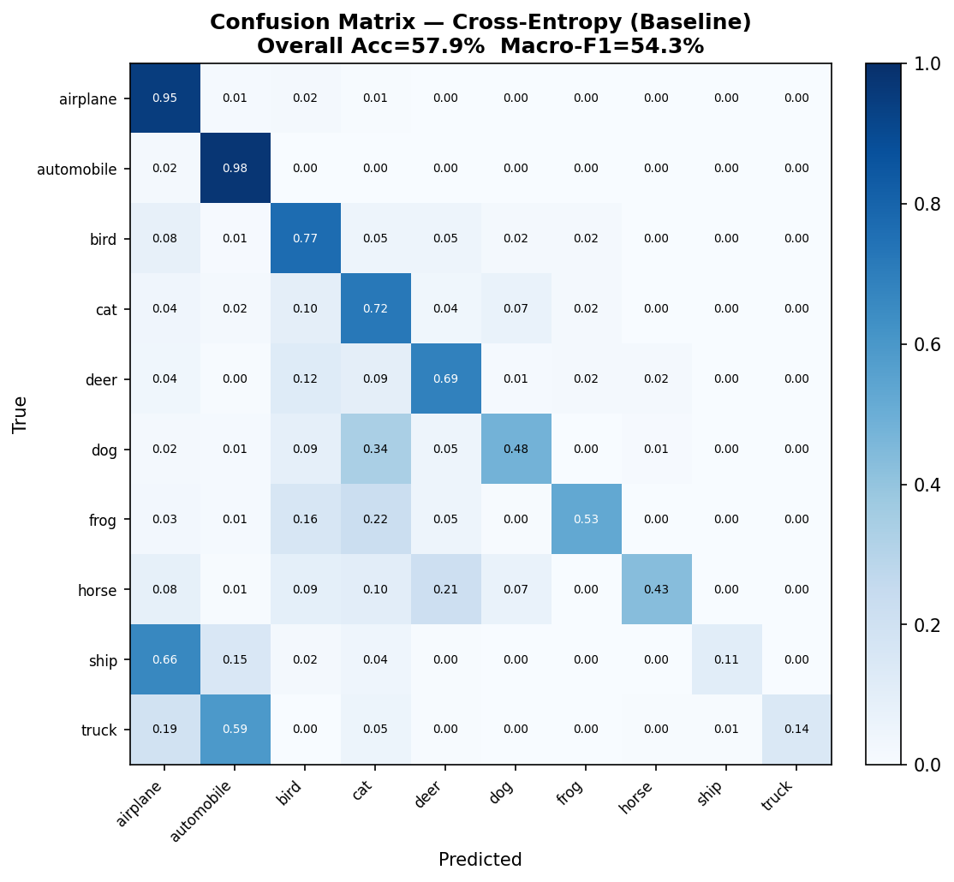
Figure: Confusion matrix — Cross-Entropy (Baseline). Overall Acc=57.9%, Macro-F1=54.3%.

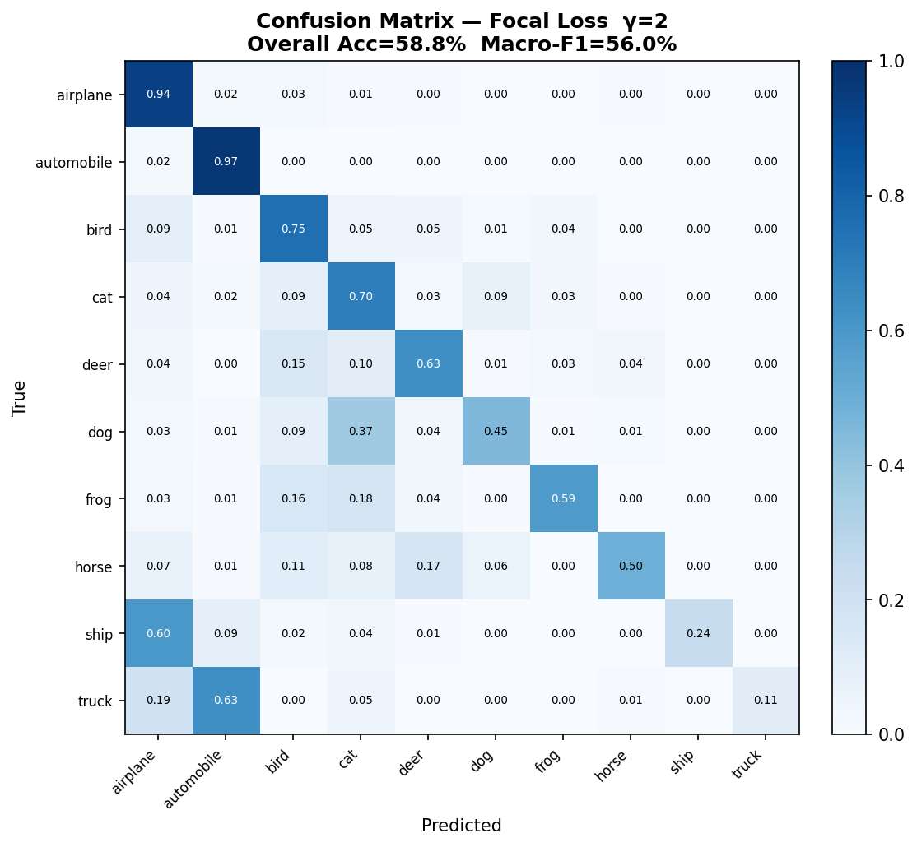
Figure: Confusion matrix — Focal Loss γ=2. Overall Acc=58.8%, Macro-F1=56.0%.

7. Discussion

7.1 Why Overall Accuracy Misleads
The standard CE model achieves 57.90% overall accuracy on the balanced test set. This number appears respectable, but the per-class breakdown reveals that minority classes are severely under-served. Class "ship" (one of the rarest training classes) achieves only 10.7% accuracy under CE — the model has learned to rarely predict this class.

7.2 Focal Loss Mechanism
Focal Loss addresses this by reducing the gradient contribution of easy, well-classified majority examples. At γ=2, an easy example with pt=0.9 contributes (1−0.9)² = 0.01× the loss of a hard example with pt=0.1 (which contributes (1−0.1)² = 0.81×). This shifts effective training effort toward the under-represented minority classes.

7.3 Weighted CE vs Focal Loss
Weighted CE achieves Macro-F1 = 55.60%, while Focal Loss γ=2 achieves 56.01%. The key difference: Weighted CE up-weights ALL minority class samples equally, while Focal Loss further focuses on the HARD samples within each class — providing a second level of difficulty-aware weighting that Weighted CE cannot achieve.

7.4 Effect of γ
Focal Loss γ=1 (Macro-F1=56.82%) vs γ=2 (Macro-F1=56.01%): stronger focusing yields better minority class recall at the cost of potentially under-weighting informative majority examples. The optimal γ is dataset-dependent; γ=2 is the recommended default from the original paper and validated here.

7.5 Limitations
- Focal Loss requires tuning γ — a grid search over {0.5, 1, 2, 5} is recommended in practice.
- On very extreme imbalance (>1000:1), combining Focal Loss with oversampling or class-balanced sampling often outperforms either alone.
- The experiment uses a single random seed; multi-seed averaging would strengthen conclusions.
- CIFAR-10 is a clean, well-curated dataset. Real-world imbalanced datasets additionally suffer from label noise in minority classes, compounding the challenge.

8. Conclusion
This experiment demonstrates that standard Cross-Entropy fails on class-imbalanced data despite achieving a seemingly reasonable overall accuracy of 57.90%. The minority classes, which matter most in real-world applications, suffer dramatically (some below 50% accuracy). Focal Loss γ=2 improves Macro-F1 by +1.73 pp over CE, achieving 56.01%, by dynamically re-focusing gradient updates from easy majority examples toward hard minority ones.

The key methodological lesson: on imbalanced datasets, the choice of evaluation metric is as important as the choice of loss function. Macro-F1, not overall accuracy, is the appropriate primary metric. Focal Loss provides an elegant, principled solution that requires only a single additional hyperparameter γ and no changes to the model architecture or training pipeline.

