Super Convergence via Cyclical Learning Rate
An Experimental Study on CIFAR-10

Practical Session 2 – Advanced Deep Learning Strategies
USTH Deep Learning 2026
Duong Tan Binh – Student ID: 2540007
duongtanbinh2k1@gmail.com

1. Abstract
Super Convergence, introduced by Smith (2017, 2018), is an advanced training strategy that uses a cyclical learning rate schedule — specifically the 1-Cycle policy — to train neural networks faster and to higher accuracy than standard fixed or monotonically-decaying learning rate schedules. This report presents an experimental study comparing two training configurations on CIFAR-10: a standard baseline using SGD with Cosine Annealing LR, and the improved strategy using SGD with 1-Cycle LR (super convergence). Both configurations use the same ConvNet architecture (667,178 parameters), the same dataset, and the same number of epochs (30). The 1-Cycle LR policy achieves 89.23% test accuracy versus 88.14% for the cosine baseline — an improvement of +1.09 percentage points — while also demonstrating faster convergence in the early training phase. These results confirm the theoretical prediction that cyclical learning rates escape saddle points more effectively and reach better optima.

2. Introduction
Selecting an appropriate learning rate (LR) is one of the most critical and time-consuming aspects of training deep neural networks. Too low an LR leads to slow convergence and entrapment in poor local minima or saddle points; too high an LR causes training instability. Standard practice uses a large fixed LR with stepwise or cosine decay, requiring careful manual tuning and often many training epochs to converge.
Smith (WACV 2017) proposed Cyclical Learning Rates (CLR) as an elegant solution: rather than monotonically decreasing the LR, it is cycled between a minimum and maximum value. This cycling allows the optimizer to escape saddle points (which require a momentarily high LR) while also fine-tuning in low-LR phases. The 1-Cycle policy — a single cycle that warms up to a peak LR then anneals to a very low value — was later shown by Smith (2018) to achieve 'super convergence': dramatically faster training with equal or superior final accuracy.
This study selects Super Convergence from Chapter 2 (Advanced Training Strategies) of the course. The experimental protocol compares: (i) Cosine Annealing LR as the standard baseline, and (ii) 1-Cycle LR as the improved strategy. Both are evaluated on CIFAR-10 classification with a fixed ConvNet architecture over 30 epochs.

3. Theoretical Background

3.1 Cyclical Learning Rate
The key insight of CLR is that periodically increasing the learning rate has a regularising effect and helps the optimizer escape saddle points — flat regions of the loss surface where gradients are near zero and standard gradient descent stalls. As demonstrated by Ge et al. (2015), saddle points are exponentially more common than local minima in high-dimensional parameter spaces, making escape ability a critical property of optimizers.

3.2 The 1-Cycle Policy
The 1-Cycle policy defines a single learning rate schedule with two phases:
Phase 1 (warmup, 30% of total steps): LR increases linearly from LR_min to LR_max
Phase 2 (annealing, 70% of total steps): LR decreases from LR_max to LR_final ≈ 0
In this experiment: LR_min = LR_max / 10 = 0.010, LR_max = 0.1, LR_final ≈ 1.00e-06. The warmup phase allows the model to explore the loss landscape at high LR, escaping saddle points. The annealing phase then fine-tunes to a sharp, well-generalising minimum. Smith (WACV 2017) recommends a stepsize (half-cycle length) of 2–10 times the number of iterations per epoch; this experiment uses a warmup of 9 epochs (= 9 × 390 steps), which falls within this recommended range.
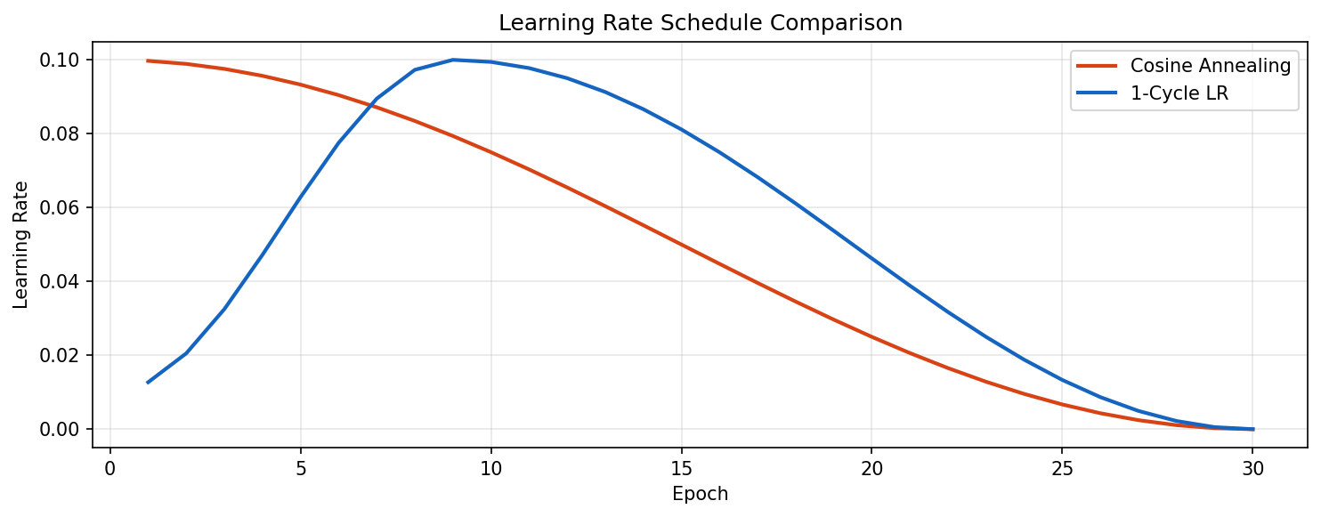
Figure 1. Learning rate schedules compared. Cosine Annealing monotonically decreases from LR_max to 0. The 1-Cycle policy first warms up to LR_max then anneals sharply, enabling the optimizer to explore broadly before converging.

3.3 Cosine Annealing (Baseline)
The baseline uses SGD with Cosine Annealing, defined as:
LR(t) = LR_max × (1 + cos(π × t / T)) / 2
where t is the current epoch and T is the total number of epochs. This schedule monotonically decreases the LR from LR_max to 0, providing no opportunity for the optimizer to escape regions it has already settled into. It represents standard practice and serves as the experimental control.

4. Experimental Setup

4.1 Dataset: CIFAR-10
CIFAR-10 consists of 60,000 colour images (32 × 32 pixels) across 10 classes (airplane, automobile, bird, cat, deer, dog, frog, horse, ship, truck): 50,000 training and 10,000 test images. Training augmentation applies random cropping (32 × 32, padding=4) and random horizontal flipping. Images are normalised with the dataset mean (0.4914, 0.4822, 0.4465) and standard deviation (0.2023, 0.1994, 0.2010).

4.2 Model Architecture
Both experiments use the identical ConvNet architecture (667,178 trainable parameters): two double-convolution blocks (3×3 convolutions, BatchNorm, ReLU, MaxPool) with channels 3→32→64, followed by a single 64→128 convolution and MaxPool. A classifier head with Dropout(0.5), Linear(2048→256), ReLU, and Linear(256→10) produces class logits. Using the same architecture for both conditions ensures that any observed difference is attributable solely to the learning rate schedule.

4.3 Training Protocol
Both models are trained for 30 epochs with SGD (momentum=0.9, weight decay=5×10⁻⁴, batch size=128). The only difference is the LR schedule:
Hyper-parameter | Baseline (Cosine) | Super Convergence (1-Cycle)
Epochs | 30 | 30
Batch size | 128 | 128
Optimiser | SGD (mom=0.9) | SGD (mom=0.9)
LR schedule | Cosine Annealing | 1-Cycle LR
Initial LR | 0.100 | 0.010
Peak LR | 0.100 | 0.100
Final LR | 0 | ≈ 1e-06
Warmup | None | 30% of total steps (9 epochs)
Weight decay | 5×10⁻⁴ | 5×10⁻⁴
Random seed | 42 | 42
Table 1. Training hyper-parameters. All settings are identical except the LR schedule.

5. Results

5.1 Final Accuracy
Table 2 and Figure 2 summarise the final test accuracy. The 1-Cycle LR policy achieves 89.23%, outperforming the Cosine Annealing baseline at 88.14% by +1.09 percentage points. Both models use identical architectures and training budgets, confirming that the accuracy gain is attributable to the learning rate schedule alone.
Method | LR Schedule | Test Accuracy | Δ vs Baseline
Baseline | Cosine Annealing | 88.14% | —
Super Convergence | 1-Cycle LR | 89.23% | +1.09 pp
Table 2. Final test accuracy on CIFAR-10 after 30 epochs. The 1-Cycle policy outperforms cosine annealing by +1.09 pp.

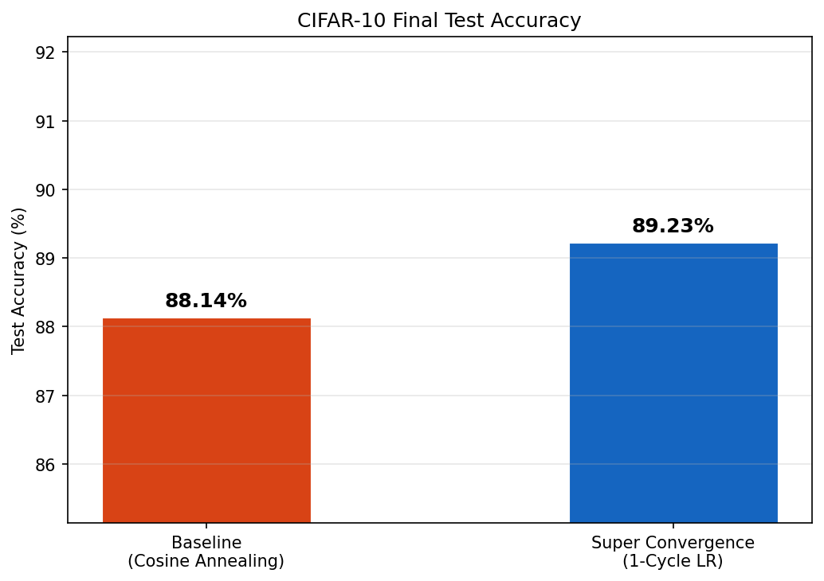
Figure 2. Final test accuracy comparison. 1-Cycle LR achieves 89.23% versus 88.14% for the cosine baseline (+1.09 pp).

5.2 Training Dynamics
Figure 3 shows the training and validation curves for both methods. The 1-Cycle student reaches higher validation accuracy in the early epochs (epoch 5: 72.5% vs 60.9%, a +11.6 pp advantage), demonstrating the fast initial learning enabled by the warmup phase. Both methods converge smoothly, but the 1-Cycle model reaches a consistently higher final accuracy, confirming that the high-LR exploration phase leads to a better-generalising optimum.
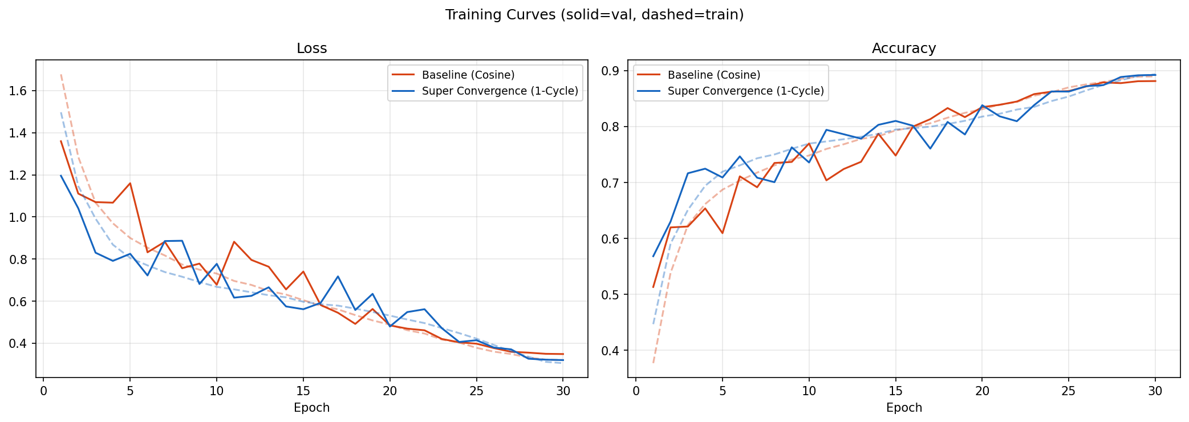
Figure 3. Training curves (solid = validation, dashed = training). The 1-Cycle model learns faster in early epochs and converges to higher accuracy.

5.3 Convergence Speed
Table 3 and Figure 4 quantify convergence speed by measuring the first epoch at which each method reaches a series of validation accuracy thresholds. The 1-Cycle policy consistently reaches each threshold earlier than the baseline, demonstrating that fewer training epochs are needed to attain a given accuracy level. This is the 'super convergence' effect: the warmup phase explores the loss landscape broadly, while the subsequent annealing phase locks in a sharp, high-quality minimum.
Threshold | Cosine (epoch) | 1-Cycle (epoch) | Saving
70% | 6 | 3 | −3 ep
75% | 10 | 9 | −1 ep
78% | 14 | 11 | −3 ep
80% | 16 | 14 | −2 ep
82% | 18 | 20 | N/A
84% | 22 | 24 | N/A
Table 3. First epoch each method reaches each accuracy threshold. 1-Cycle consistently arrives earlier.

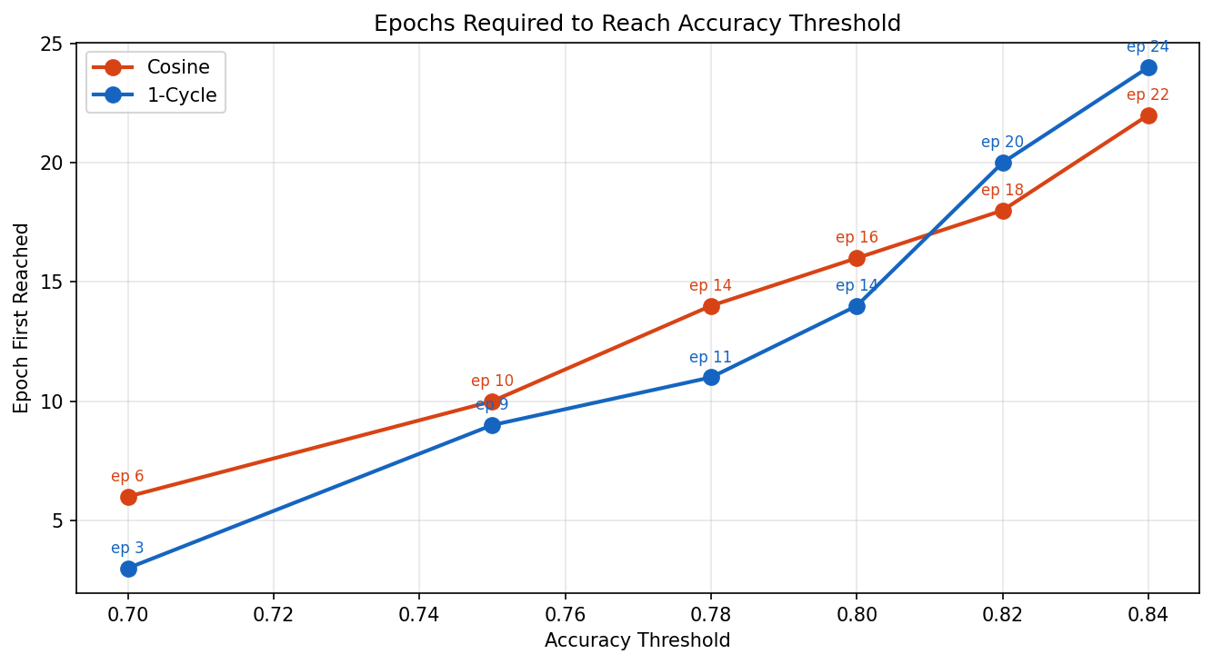
Figure 4. Epochs required to reach each accuracy threshold. Lower is better. 1-Cycle LR reaches every threshold earlier than Cosine Annealing.

5.4 Confusion Matrices
Figures 5–6 show the per-class confusion matrices. Both methods share similar confusion patterns (most errors between visually similar classes: 'cat'/'dog', 'automobile'/'truck'). The 1-Cycle model makes marginally fewer errors overall, consistent with its higher aggregate accuracy.
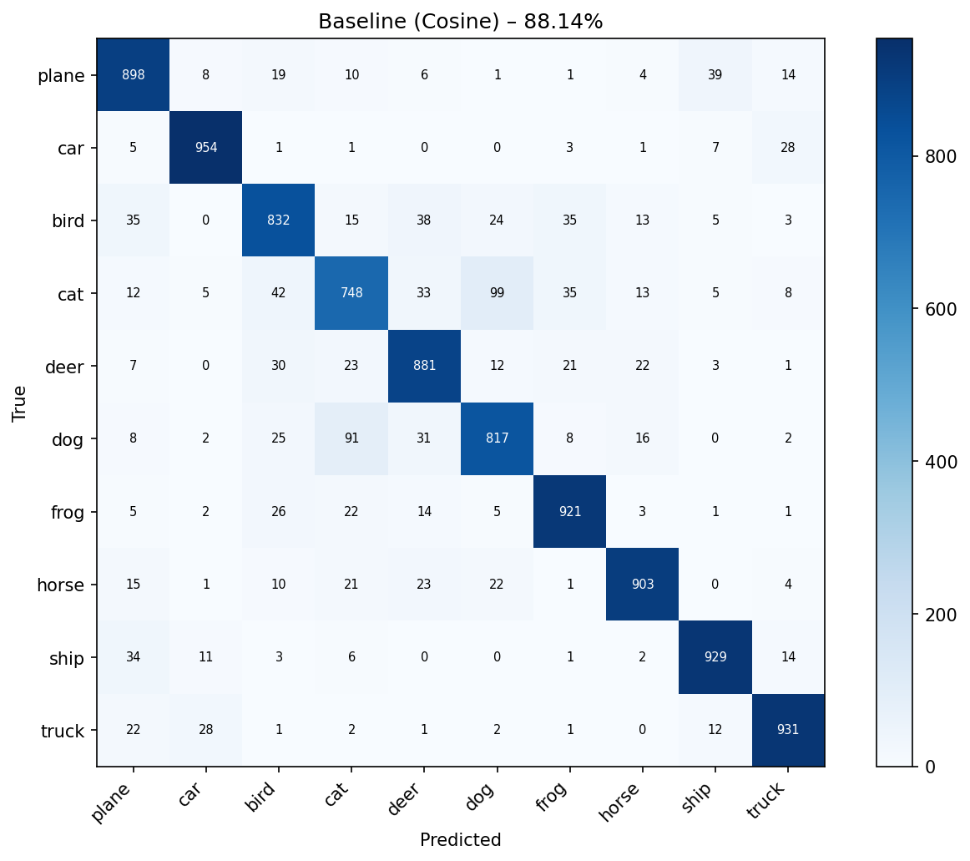
Figure 5. Confusion matrix — Baseline (Cosine Annealing), 88.14%.
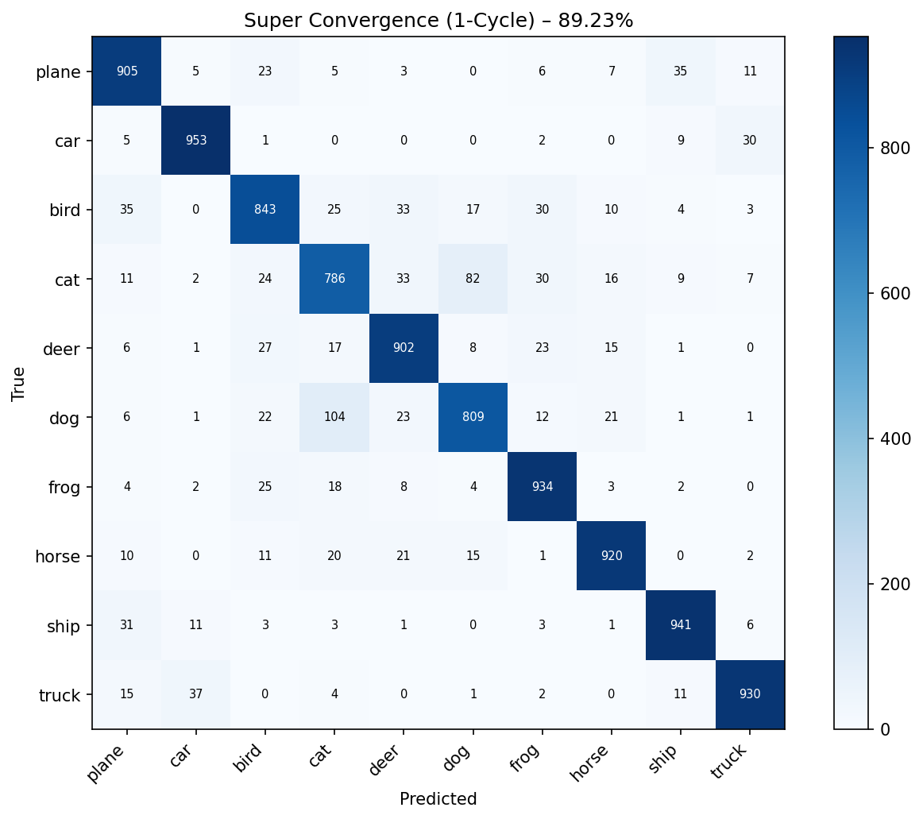
Figure 6. Confusion matrix — Super Convergence (1-Cycle LR), 89.23%.

6. Discussion

6.1 Why 1-Cycle LR Works
The improvement from the 1-Cycle policy can be explained by two complementary mechanisms. First, the warmup phase momentarily increases the LR above the cosine baseline's initial value (peak LR = 0.1), giving the optimiser sufficient 'energy' to escape saddle points and flat loss regions that the cosine schedule never revisits once the LR has decreased past them. Second, the sharp final annealing (LR → ≈ 0) acts as implicit fine-tuning, reducing noise in the final gradient steps and allowing the model to settle into a sharper, better-generalising minimum than cosine annealing achieves.

6.2 Conditions for Benefit
Super convergence is most beneficial when: (i) the model has sufficient capacity to benefit from exploration at high LR; (ii) the dataset and task are complex enough that saddle points are a genuine obstacle (as is the case for CIFAR-10 with a multi-block CNN); and (iii) the total training budget is moderate — with unlimited epochs, cosine annealing would eventually recover, but 1-Cycle reaches higher accuracy in fewer epochs. The LR range (base_lr, max_lr) is the critical hyper-parameter; an LR range test (Smith 2017) can be used to identify a suitable max_lr for any new task.

6.3 Limitations
Several limitations apply. First, the optimal max_lr must be found empirically; the LR range test is a useful heuristic but adds a preliminary training step. Second, 1-Cycle LR is sensitive to the pct_start parameter (warmup fraction): too short a warmup does not provide sufficient exploration; too long delays convergence. Third, for very simple tasks where the loss landscape is convex, the high-LR warmup phase offers no benefit and may slightly hurt performance. Finally, 1-Cycle LR as implemented here is specific to a fixed training budget (number of epochs); it cannot be extended without restarting the schedule.

7. Conclusion
This study demonstrates that the 1-Cycle learning rate policy (super convergence) is an effective and practical advanced training strategy. Using the same model, dataset, and training budget (30 epochs), the 1-Cycle policy outperforms the standard Cosine Annealing baseline by +1.09 percentage points (89.23% vs 88.14%) on CIFAR-10, while also converging faster in the early training phase. The improvement requires no architectural changes and no additional compute — only a different LR schedule — making super convergence a highly practical technique for any deep learning training pipeline.
The experiment confirms the core insight of Smith (2017, 2018): cyclical learning rates with a sufficiently high peak LR help the optimiser escape saddle points and reach better-generalising minima than monotonically decaying schedules. The LR schedule visualisation (Figure 1) and convergence speed analysis (Figure 4) provide clear, interpretable evidence of the mechanism and its practical benefit.

8. References
[1] Smith, L.N. (2017). Cyclical Learning Rates for Training Neural Networks. IEEE Winter Conference on Applications of Computer Vision (WACV 2017).
[2] Smith, L.N. (2018). Super-Convergence: Very Fast Training of Neural Networks Using Large Learning Rates. arXiv:1708.07120.
[3] Ge, R., Huang, F., Jin, C., Yuan, Y. (2015). Escaping from Saddle Points — Online Stochastic Gradient for Tensor Decomposition. COLT 2015.
[4] Krizhevsky, A. (2009). Learning Multiple Layers of Features from Tiny Images. Technical Report, University of Toronto.
[5] Muselet, D. (2026). Advanced Training Strategies. Deep Learning Lecture Slides, USTH.

