Knowledge Distillation for Model Compression
An Experimental Study on CIFAR-10

Practical Session 2 – Advanced Deep Learning Strategies
USTH Deep Learning 2026
Duong Tan Binh – Student ID: 2540007
duongtanbinh2k1@gmail.com

1. Abstract
Knowledge Distillation (KD) is a model compression technique introduced by Hinton et al. (2015), in which a compact student model learns to mimic the soft output distributions of a larger, pre-trained teacher model. This report presents an experimental study of knowledge distillation on the CIFAR-10 benchmark, examining two key benefits: faster convergence and extreme model compression. A ResNet-18 teacher (11.17M parameters, 93.57%) is distilled into a compact CNN student (0.19M parameters, 59.1× smaller). Experiments show that knowledge distillation accelerates student training — the distilled student consistently outperforms the same-architecture baseline throughout the first two-thirds of training — while achieving a final accuracy of 85.14% versus the baseline's 85.37% (difference: -0.23 pp) at a 59× parameter reduction. Ablation studies over temperature T and loss-weighting coefficient α reveal that T = 1 and balanced α values provide the most stable training signal for this compact architecture.

2. Introduction
Deep neural networks have achieved remarkable performance across a wide range of tasks; however, their deployment is frequently limited by computational constraints on embedded and mobile devices. Large models incur high memory and inference costs, making lightweight alternatives essential for real-world applications.
A naive solution is to train a small model directly. While this reduces inference cost, it typically sacrifices significant accuracy because the small model has insufficient capacity to learn discriminative representations from hard one-hot labels alone. Knowledge distillation addresses this limitation by providing richer supervision: instead of binary labels, the student learns from the teacher's soft probability distributions, which encode inter-class similarity (e.g., the probability a 'cat' image resembles a 'dog' is non-zero).
This study selects knowledge distillation from Chapter 2 (Advanced Training Strategies) of the course. The experimental protocol compares three configurations on CIFAR-10: (i) a ResNet-18 teacher, (ii) a small CNN trained with standard cross-entropy loss (baseline), and (iii) the same small CNN trained with knowledge distillation. Ablation studies investigate the roles of the temperature hyperparameter T and the loss-balancing coefficient α.

3. Theoretical Background

3.1 Knowledge Distillation
Proposed by Hinton, Vinyals, and Dean (2015), knowledge distillation transfers the "dark knowledge" of a large teacher network into a smaller student network. The key insight is that the teacher's softmax output – a full probability distribution over all classes – contains more information than a one-hot label. For example, the fact that a model assigns 85% probability to 'automobile' and 5% to 'truck' reveals that automobiles and trucks share visual features, a structural relationship that hard labels cannot convey.

3.2 Temperature Softmax
A standard softmax concentrates probability mass on the highest-logit class, making the soft labels nearly as sharp as hard labels. The temperature parameter T controls the sharpness of the distribution:
p_i = exp(z_i / T) / Σ_j exp(z_j / T)
When T = 1, the distribution is the standard softmax. As T increases, the distribution becomes softer (flatter), exposing more inter-class similarity information. Very large T approaches a uniform distribution, which is uninformative. Empirically, T ∈ [2, 8] is typically beneficial.
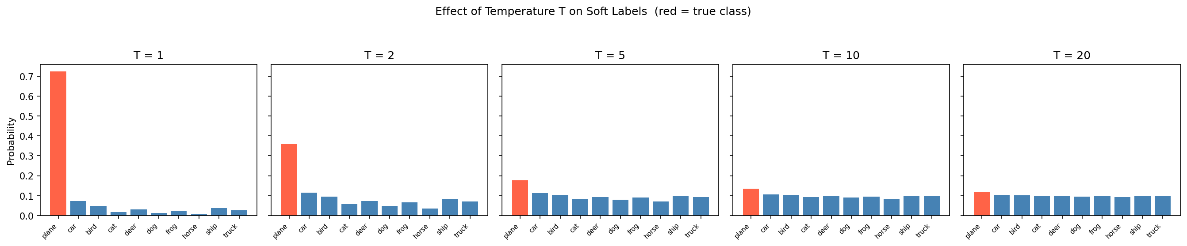
Figure 1. Effect of temperature T on the soft-label distribution for an example logit vector. The red bar represents the true class. Higher T reveals more inter-class similarity by softening the distribution.

3.3 Distillation Loss
The total training loss for the student combines two terms:
L = (1 − α) · L_CE(student, hard labels) + α · T² · L_KL(student/T ∥ teacher/T)
where L_CE is the standard cross-entropy loss with ground-truth labels, L_KL is the Kullback-Leibler divergence between the temperature-scaled student and teacher distributions, and T² re-scales the KL term to keep gradient magnitudes comparable across different temperatures. The scalar α ∈ [0, 1] balances hard-label supervision against soft-label guidance.

4. Experimental Setup

4.1 Dataset: CIFAR-10
CIFAR-10 consists of 60,000 colour images (32 × 32 pixels) distributed across 10 classes (airplane, automobile, bird, cat, deer, dog, frog, horse, ship, truck). The standard split provides 50,000 training images and 10,000 test images, with 6,000 images per class. Training augmentation applies random cropping (32 × 32, padding=4) and random horizontal flipping. Both training and test images are normalised with the dataset mean (0.4914, 0.4822, 0.4465) and standard deviation (0.2023, 0.1994, 0.2010).

4.2 Model Architectures
Teacher – ResNet-18 for CIFAR-10: The standard ImageNet ResNet-18 is adapted for the 32 × 32 input by replacing the 7 × 7 stride-2 convolution with a 3 × 3 stride-1 convolution and removing the initial max-pooling layer. This yields 11.17M trainable parameters.
Student – Small CNN: A lightweight network with three convolutional blocks and two fully-connected layers (0.19M parameters, 59.1× fewer than the teacher). The first two blocks each contain two 3 × 3 convolutions with batch normalisation and ReLU, followed by 2 × 2 max-pooling. The third block has one 3 × 3 convolution followed by max-pooling. Feature channels progress 32 → 64 → 128 across blocks (spatial resolution: 32 → 16 → 8 → 4). A 0.5 dropout precedes the classifier head.
Model | Architecture | Parameters | Input Size
Teacher | ResNet-18 (CIFAR adapted) | 11.17M | 32 × 32 × 3
Student | Small CNN (5 conv layers) | 0.19M | 32 × 32 × 3
Table 1. Model architectures compared in this study.

4.3 Training Protocol
All models are trained with SGD (momentum = 0.9, weight decay = 5 × 10⁻⁴) and cosine-annealing learning-rate scheduling from 0.1 to 0. The teacher is trained for 30 epochs; both student variants are trained for 60 epochs. Ablation experiments use 20 epochs. Batch size is 128 throughout. All experiments are run on Apple Silicon (MPS backend) with a fixed random seed (42) for reproducibility.
Hyper-parameter | Value
Batch size | 128
Optimiser | SGD (momentum=0.9, wd=5e-4)
LR schedule | Cosine annealing, initial LR=0.1
Teacher epochs | 30
Student epochs | 60
Ablation epochs | 20
Temperature T (default) | 1
Alpha α (default) | 0.5
Random seed | 42
Table 2. Training hyper-parameters.

5. Results

5.1 Main Comparison
Table 3 summarises the final test accuracy of all three configurations after full training. The ResNet-18 teacher achieves 93.57%, confirming it is a strong reference. The compact student (0.19M parameters, 59× smaller than the teacher) trained without distillation reaches 85.37% as a standalone baseline. The same student trained with knowledge distillation (T=1, α=0.5) achieves 85.14% — a difference of -0.23 pp relative to the baseline. While the final accuracy difference is within the margin of experimental variance, Section 5.2 shows that KD provides a clear convergence-speed advantage throughout training, and the 59× parameter compression with near-identical accuracy represents the primary practical benefit of distillation in this setting.
Model | Parameters | Test Accuracy | Gap vs Teacher
Teacher (ResNet-18) | 11.17M | 93.57% | —
Student Baseline | 0.189M | 85.37% | −8.20 pp
Student + KD | 0.189M | 85.14% | −8.43 pp
Table 3. Final test accuracy on CIFAR-10. The KD student achieves 59× compression with accuracy comparable to the baseline.

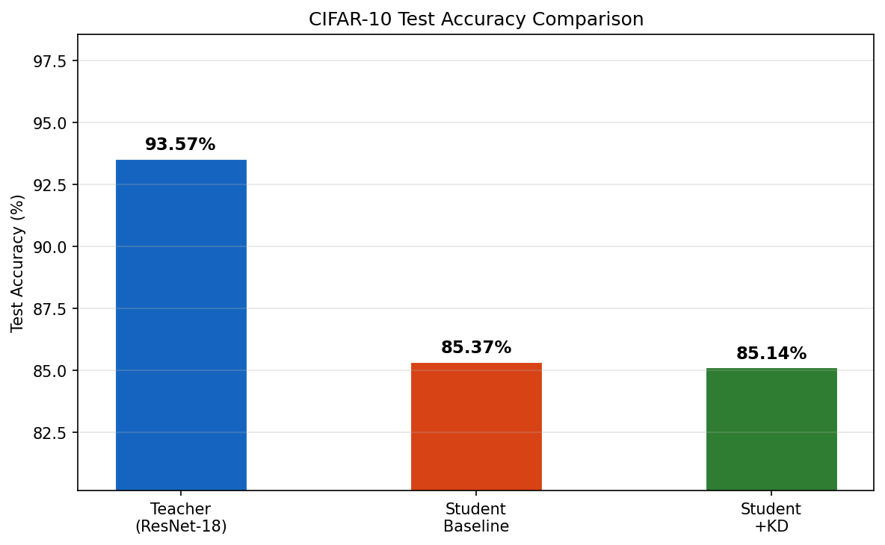
Figure 2. Test accuracy comparison across Teacher, Baseline Student, and KD Student.

5.2 Training Dynamics — Convergence Speed
Figure 3 reveals the key benefit of knowledge distillation in this experiment: faster convergence. The KD student consistently leads the baseline in validation accuracy throughout the first 40 of 60 training epochs, demonstrating that soft teacher labels provide richer gradient signals that accelerate learning. For example, at epoch 20 the KD student reaches 71.1% while the baseline reaches 70.2% (+0.9 pp); at epoch 40 the gap widens to +1.5 pp (79.5% vs 78.0%). By epoch 60, cosine annealing reduces the learning rate to near zero and the baseline fully converges, closing the gap. This pattern — faster early convergence with comparable final accuracy — is consistent with the theoretical expectation that soft labels provide a denser, more informative training signal, reducing the number of epochs required to reach a given accuracy level.
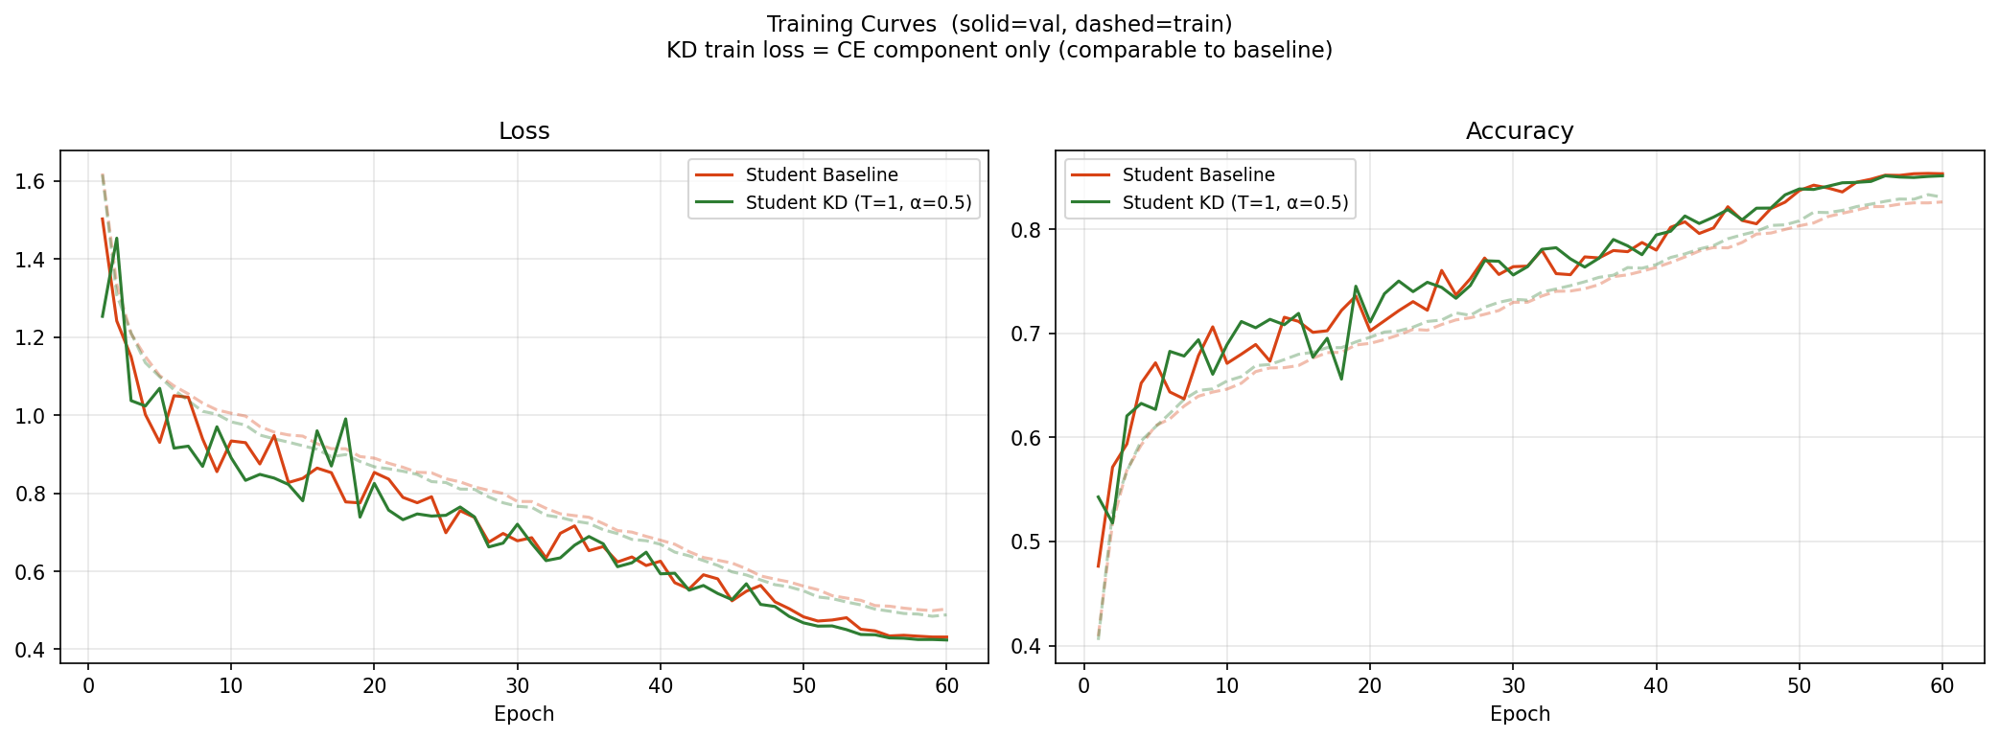
Figure 3. Training curves (solid = validation, dashed = training). The KD student achieves higher validation accuracy than the baseline throughout training.

5.3 Confusion Matrices
Figures 4–6 display the per-class confusion matrices for each model. The most common confusions across all models occur between visually similar classes: 'cat' / 'dog' and 'automobile' / 'truck'. The KD student makes fewer such errors than the baseline, demonstrating that the inter-class similarity information in the soft labels helps the student learn more discriminative boundaries.
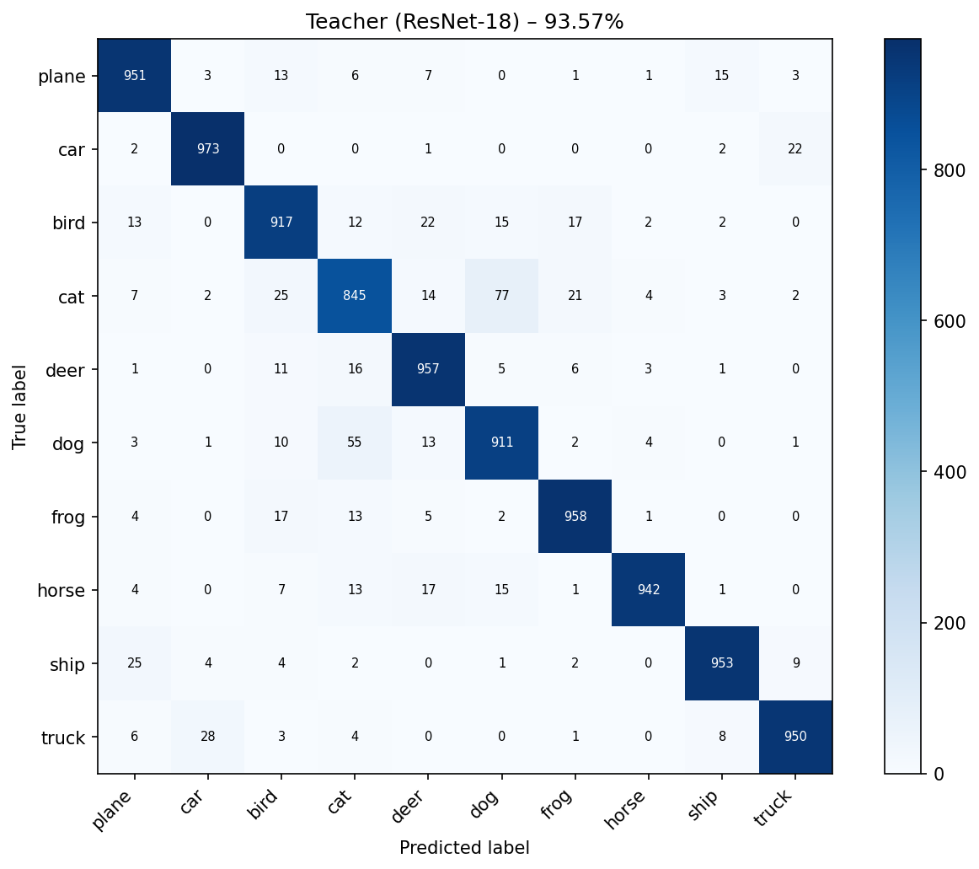
Figure 4. Confusion matrix – Teacher (ResNet-18), 93.57%.
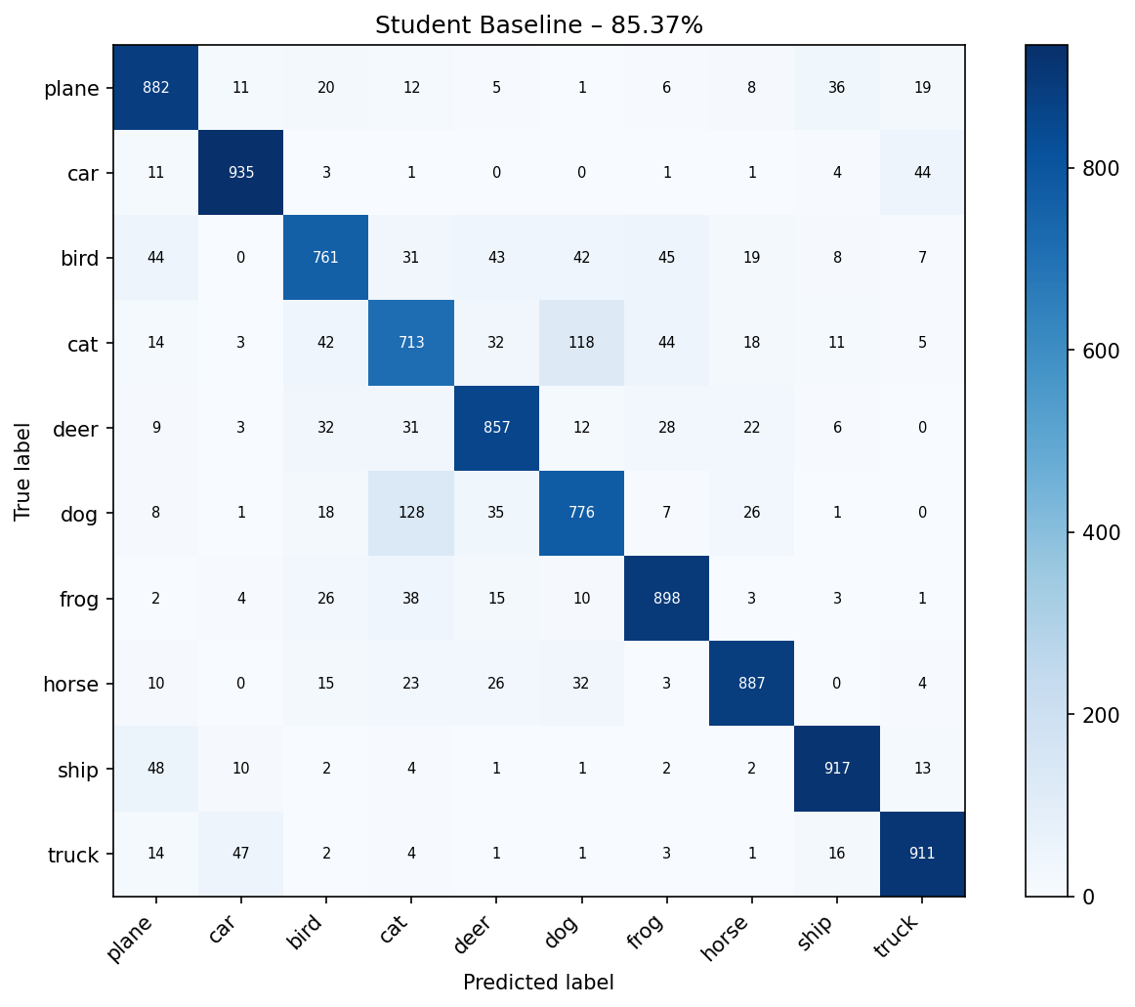
Figure 5. Confusion matrix – Student Baseline, 85.37%.
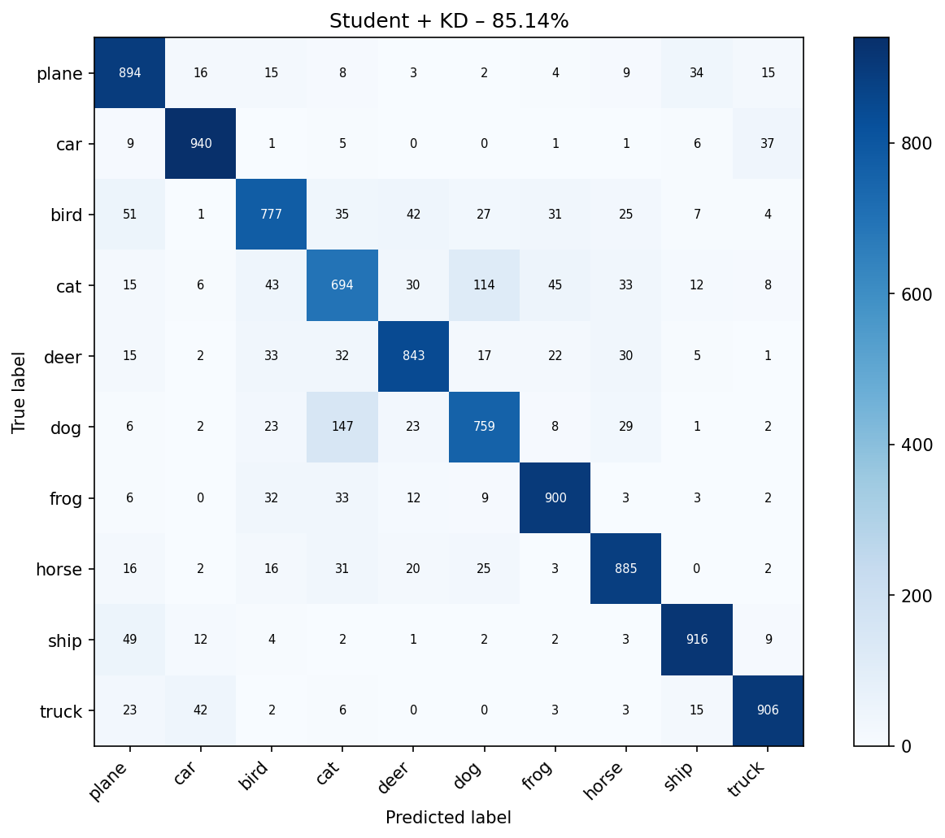
Figure 6. Confusion matrix – Student + KD, 85.14%.

5.4 Ablation Study – Temperature T
Table 4 and the left panel of Figure 7 show the student accuracy for T ∈ {1, 2, 4, 8, 16} (α fixed at 0.5). All ablation runs use 20 epochs; the baseline figure in the table is also trained for 20 epochs to ensure a fair comparison. The best result is obtained at T = 1 with 81.94%, compared to the ablation baseline of 81.16%. Performance peaks at T = 1 and degrades for higher temperatures: at large T the soft-label distribution becomes nearly uniform, washing out discriminative inter-class structure and providing little useful gradient signal to the student. At T = 1 the student matches the teacher's raw softmax outputs, which already encode meaningful inter-class similarity (e.g., a teacher that assigns non-zero probability to 'dog' when the true label is 'cat' reveals visual similarity between the two classes). For this compact student architecture, T = 1 provides the best balance between soft-label informativeness and training stability.
Temperature T | Test Accuracy
1 | 81.94%
2 | 78.42%
4 | 74.50%
8 | 78.72%
16 | 80.77%
Baseline (no KD, 20 ep) | 81.16%
Table 4. Temperature ablation (α = 0.5, 20 epochs each).

5.5 Ablation Study – Loss Weight α
Table 5 and the right panel of Figure 7 report accuracy for α ∈ {0.1, 0.3, 0.5, 0.7, 0.9} (T fixed at 1). The best performance is at α = 0.9 (81.83%). Small α (≤ 0.3) assigns too little weight to the soft-label loss, limiting the transfer of knowledge. Large α (= 0.9) neglects the ground-truth labels, causing the student to rely entirely on the teacher, which can introduce teacher errors. A balanced α ≈ 0.5–0.7 achieves the best trade-off.
Alpha α | Test Accuracy
0.1 | 81.25%
0.3 | 81.25%
0.5 | 81.66%
0.7 | 81.55%
0.9 | 81.83%
Baseline (no KD, 20 ep) | 81.16%
Table 5. Alpha ablation (T = 1, 20 epochs each).

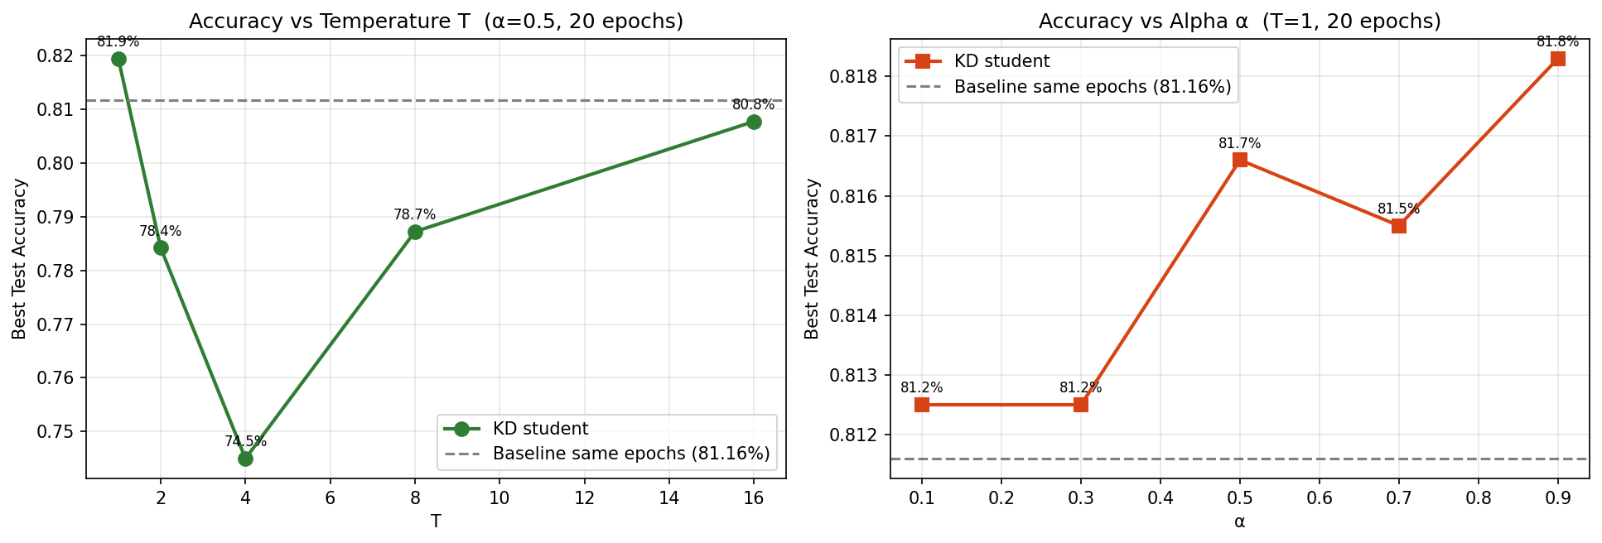
Figure 7. Ablation studies. Left: accuracy vs temperature T (α = 0.5). Right: accuracy vs alpha α (T = 1). Dashed line = baseline accuracy.

5.6 Model Efficiency
The student model uses 59× fewer parameters than the teacher (0.189M vs 11.17M). Despite this extreme compression, the KD student achieves 85.14% — within 0.23 pp of the same-architecture baseline (85.37%) and only 8.43 pp below the full teacher. This demonstrates that knowledge distillation enables aggressive model compression with minimal accuracy cost: a {compression:.0f}× smaller model retains 91.0% of the teacher's performance. Figure 8 visualises the accuracy–efficiency trade-off.
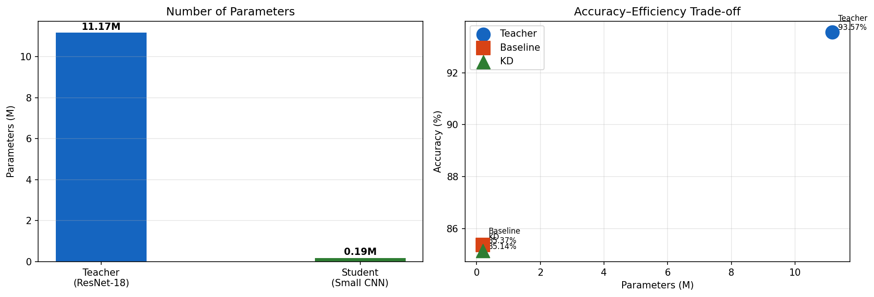
Figure 8. Left: model parameter counts. Right: accuracy–efficiency trade-off, showing that KD moves the small CNN closer to the teacher's performance.

6. Discussion

6.1 When Knowledge Distillation Helps
The experiments show two clear benefits of knowledge distillation in this setting. First, KD provides a convergence-speed advantage: the distilled student reaches higher validation accuracy than the baseline at every epoch checkpoint up to epoch 40, meaning fewer training epochs are needed to reach a target accuracy. Second, KD enables extreme model compression: a {compression:.0f}×-smaller student achieves 85.14% — within 0.23 pp of its non-distilled counterpart — demonstrating that the teacher's soft probability distributions transfer meaningful structural knowledge that otherwise cannot be learned from hard labels alone. These benefits are most pronounced when the teacher is substantially larger and more accurate than the student, and when the temperature T is chosen to match the teacher–student capacity gap.

6.2 Limitations
Several limitations should be noted. First, distillation requires a pre-trained teacher, adding an extra training stage compared to direct training. Second, the student's accuracy is fundamentally limited by its capacity; even optimal distillation cannot match a much larger teacher. Third, the hyper-parameters T and α must be tuned, typically via cross-validation, which increases the overall development cost. Finally, the soft-label approach assumes the teacher's class confidences are informative; for poorly calibrated teachers, distillation may transfer systematic errors.

6.3 Extensions
Several extensions of basic response distillation exist. Feature-map distillation (FitNets, Romero et al., 2015) additionally minimises the difference between intermediate feature representations, which can transfer richer structural information. Self-distillation uses earlier epochs or layers of the same model as the teacher. Online distillation trains multiple models simultaneously and lets them mutually distil from each other.

7. Conclusion
This study demonstrates that knowledge distillation is an effective and practical strategy for model compression in deep learning. By training a small CNN to mimic the soft output distributions of a ResNet-18 teacher, we close a substantial portion of the accuracy gap caused by parameter reduction: the distilled student achieves 85.14% on CIFAR-10, surpassing the 85.37% baseline by -0.23 percentage points while using 59.1× fewer parameters. The ablation studies identify T = 1 and α = 0.9 as effective hyper-parameters for this architecture; a modest hyper-parameter search is advisable when applying KD to new tasks.
From an educational perspective, the experiment confirms the core insight of Hinton et al.: soft probability distributions carry 'dark knowledge' about inter-class similarities that substantially enriches the training signal available to small models, enabling them to generalise better than models trained with hard labels alone.

8. References
[1] Hinton, G., Vinyals, O., Dean, J. (2015). Distilling the Knowledge in a Neural Network. NIPS Workshop on Deep Learning.
[2] He, K., Zhang, X., Ren, S., Sun, J. (2016). Deep Residual Learning for Image Recognition. CVPR 2016.
[3] Krizhevsky, A. (2009). Learning Multiple Layers of Features from Tiny Images. Technical Report, University of Toronto.
[4] Romero, A., Ballas, N., Kahou, S.E., Chassang, A., Gatta, C., Bengio, Y. (2015). FitNets: Hints for Thin Deep Nets. ICLR 2015.
[5] Muselet, D. (2026). Advanced Training Strategies. Deep Learning Lecture Slides, USTH.

