1. Singleton

Purpose: Make sure one class have only one instance and we can access this instance everywhere in project.

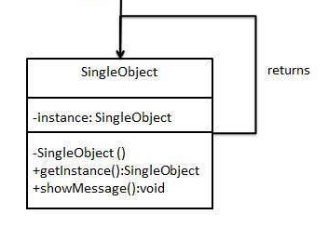

1. Observer

Purpose: Create one to many relationship between objects. If one object is modify, observers will be notify automatically.

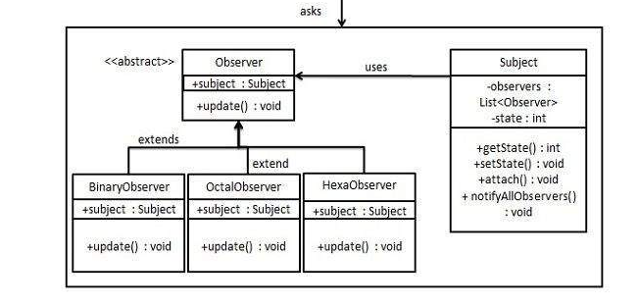

1. Factory:

Purpose: To create object without exposing the creation logic to the client and refer to newly created object using common interface

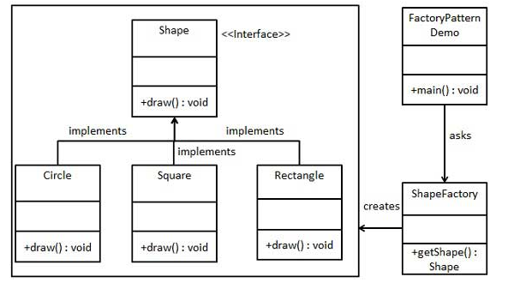

1. Decorator:

Purpose: To add new functionality to existing object without changing object.

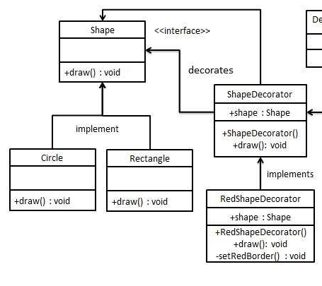

1. Adapter

Purpose: Work as bridge between two incompatible interface

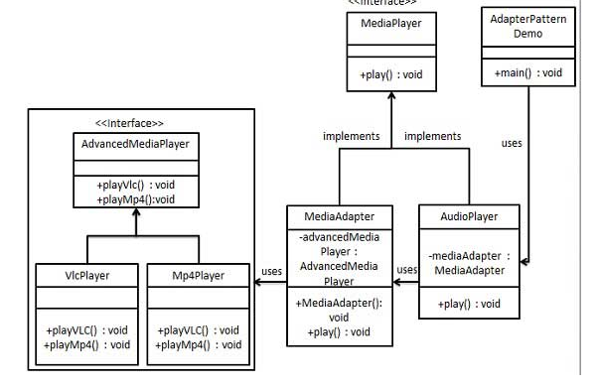

1. Proxy:

Purpose: To present functionality of another class (to protect abnormal access)

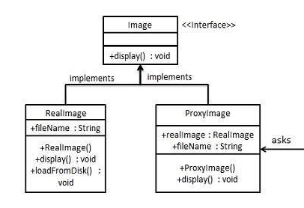

1. Pool

Purpose: In case cost of initializing and destruction of object is very high.

