Write a letter/ email
~180 words/ 20 minutes
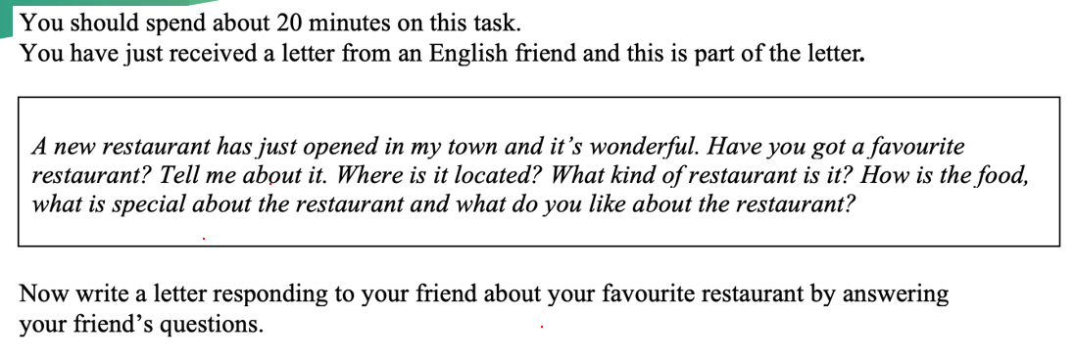
Make the most of my free time to…
It has positive impacts on the reputation of the restaurant.
Dear [Name],
It has been such a long time since we last met at [place/event]. How have you been? I’m doing well. I just received your [letter/email] asking me about [topic], so I’m writing now to answer your questions.
….
I hope I’ve answered all your questions about [topic]. How about your [ hỏi lại đề]? I’d love to hear more about it in your next [letter/email].
I should stop here for now since I have to go to [school/work].
Write to me soon!
Your friend,
[Không viết tên]

Gia Phụng
Dear Tom,
It has been such a long time since we last met at english class. How have you been? I’m doing well. I just received your email asking me about I got a favorite restaurant, so I’m writing now to answer your questions.
Yes, I have a favorite restaurant, and I would like to tell you about the restaurant that I really like, it is pizza 4’P. The first time I came here with my dad and sister, when we were walking around district 1 and after watching a movie at the cinema, we were so hungry and we watched it, the restaurant that I really like, it is on the other side of district 1 and near the cinema. So I just kidding with the word "fast food" and there are reasons why I favorite restaurant. First, the pizza, pasta, salad very delicious. Second, the food here is cheaper the other pizza restaurants. moreover, there are have good service. In the end, This is a restaurant with good foods and service here, I think you should try it once. I hope I’ve answered all your questions about a favorite restaurant. How about your favorite restaurant? I’d love to hear more about it in your next email.
I should stop here for now since I have to go to school. Write to me soon!
Your friend,

Ms Thuý Vân

Hi John,

It has been such a long time since we last met at Lan wedding. How have you been? I’m doing well. It's so cool that you have a new restaurant to try out. That's a great reason to get together with friends.

Yes, I have a favorite restaurant here in Ho Chi Minh City that I'd love to tell you about. It's a fantastic Chinese place called San Fu Lou, and it's located in District 7, right inside the Crescent Mall. It's a great spot because after a meal, you can walk around the mall or the beautiful lake nearby.

The food there is authentic and delicious, especially their dim sum. I highly recommend the shrimp dumplings and the steamed pork buns. They are absolutely amazing. What's special about this restaurant is its unique atmosphere. It has a modern, elegant design with an open kitchen, so you can watch the chefs at work. The lighting is very warm and welcoming, which makes it a perfect place for a relaxed dinner. What I like most is the friendly service and the quality of the food. It's a place where you can enjoy a great meal and a lovely evening.

I hope you get a chance to visit it someday!

All the best,

Thảo My
Dear John,
It has been such a long time since we last met at Ho Chi Minh Ctiy. How have you been? I’m doing well. I hope this letter finds you well.

I am so glad to receive your email asking about my favorite restaurant. When it comes to my restaurant that i like best, I highly recommand you ABC restaurant in my town It has just opend last month and lots of people come to it. ABC restaurant is located on a famous street in my city – Phan Xich Long street, i think you know that. It is the Korea restaurant, it has many kinds of food, such as: tokbokki, beefsteak, fire chicken, fire rice,… All of food is very delicious because i have never seen any bad rating before. Moreover, there are many dessert, for instance: cheesecake, fruit, ice-cream… and all are Free. One of the reasons i like best about this restaurant is the happiness of the waiter and waitress and i feel so comfortable when i enjoy food. That is all the reasons why i am like ABC restaurant best.

I hope I have answered all your questions about my favorite restaurant. How about the restaurant you like best?
I should stop here for now since i have to go to work.
I forward to hearing your response.
Write to me soon!
Anna

Phương Ngân
Dear John,
How have you been? Many thanks for your last letter. It is great to hear from you again. I am sorry I haven’t written for such a long time, but I have been really busy working with my job. I hope you are doing well. I just received your letter asking me about my favorite restaurant, so I am writing to answer your questions.
My favourite restaurant in Vietnam is called Pho 24. It is located in the center of Ho Chi Minh City. It is a traditional Vietnamese restaurant that mainly serves noodle soup and other local dishes. The food is always tasty and fresh. My favourite dish is “pho bo,” which is beef noodle soup. The soup is cooked for many hours, so it has a rich flavour, and the rice noodles are very soft, so it’s the special about the restaurant. I like the restaurant not only the taste but also the atmosphere. The restaurant is decorated with bamboo chairs, which create a warm. If you ever visit Vietnam, I will take you to Pho 24, and I’m sure you will enjoy it as much as I do.
I must go and get on my work.
Write to me soon!
Your friend,

Dương
Dear John,
Getting your message made my day. How is life treating you? I trust everything is going smoothly. I'm glad your area has a restaurant that make you happy! I am going to tell you about the restaurant in my area.
The restaurant is called "ABC", it is a restaurant with seafood dishes. I often go to this restaurant because it is very close to my university, I come here with my classmates after every school day. The restaurant's address is 101 Le Loi Boulevard, Ben Thanh Ward, HCMC, which is a busy area because it is the center of the city. However, the prices at the restaurant are very suitable for all needs, for example you can drink a glass of orange juice for 15000 vnd, or eat a big shrimp for 1000000 vnd.I love it so much because of its vintage and cozy style, under the yellow light I feel relaxed and peaceful. Hope to see you at this restaurant soon.
That is the update from my side. Pass on my greetings to your family, and I am looking forward to catching up through your response.
Best wishes,

Anh Thư
Dear John,
It has been such a long time since we last met at my home. How have you been? I’m doing well. I just received your letter asking me about my favorite restaurant, so I’m writing now to answer your questions.

To be honest, I’m a food lover, and I spend almost my day-off for exploring a diversity of restaurants with my loves. But to me, the best choice is Sushi Hokkaido which is come from Japanese cuisine. It is easily looked around the city and I often visit it in Takashimaya shopping mall located in district 1. Sushi Hokkaido is specialized in a roll of sushi, raw fishes like salmon, herring, crab, and salads. One thing I’m into this restaurant is their services here where the decoration is warm, the staffs are friendly, waiting time for food is quite short, the food is so fresh and pleasant-tasting that this store has always been on top of my highly recommend list. I find nothing to compare this sushi shops with others.

I hope I’ve answered all your questions about favorite food shops. How about yourself? I’d love to hear more about it in your next letter.
I should stop here for now since I have to go to work.
Write to me soon!
Your friend,

Thank you very much for using our sports centre. As you visit our sports centre so often, I am writing to ask for your opinions so that we can improve the service quality. We would be grateful if you could tell us the reasons why you chose our centre and whether you are satisfied using the sports facilities. We would also want to know if there is anything you are unhappy with and things you would like to be changed. And is there anything new you would like to see and use?
Reply the email of the sports center manager
Dear Mr./Ms. [Last Name], -> Dear sports center manager,
Thank you for your recent letter/email asking for my opinion regarding [chủ đề].
First of all, I truly appreciate your interest in my perspective. I have carefully read your message, and I am pleased to respond to your questions about [topic].
…x3
I hope my response has addressed your concerns. If you have any further questions, please do not hesitate to contact me again either by this email address or by my mobile phone number.
I look forward to seeing you soon at [place/event]
Best regards,

