2025.09.22 – VLU – ĐỀ SPEAKING

TEST 01 2
TEST 02 3
TEST 1 4
TEST 2 5
TEST 3 6
TEST 4 7
TEST 5 8
TEST 6 9
TEST 7 10
COMPLETE TEST 11

TEST 01
Part 1
Let’s talk about walking.
- Do you like walking? When and where do you walk?
- Do you think walking is important?
- Do you think walking in the countryside is better than walking in the city?

Let’s talk about your eating habits.
- Do you often eat healthy food?
- What do you usually eat at school/ at work?
- What is the unhealthiest food you can think of?

Part 2
Situation: You are choosing a birthday gift for your friend. There are three suggestions: a book, a music show ticket, and a shopping coupon. Which do you think is the best choice?

Part 3
Topic: Cheap air travel should be promoted.
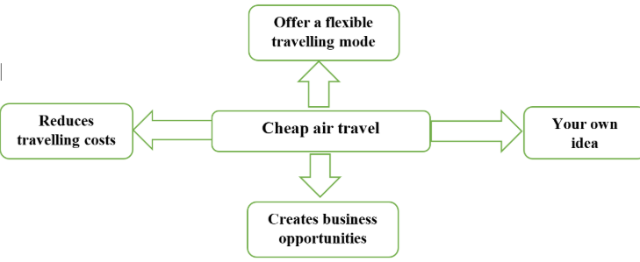
- Do you think that governments should encourage cheap flights?
- Are there any problems with low-cost air travel?
- Cheap air tickets should be offered on domestic flights of international flights?

TEST 02
Part 1
Let’s talk about your family.
- Do you have any brothers or sisters?
- Do you like to have many siblings? If yes, why? And if no, why not?
- Do you look more like your mother or your father?
Let’s talk about your relationship.
- Who do you get on well best in your family?
- Who do you think knows you better, your family or your friends? Why?
- What do you usually do when you stay with your family?

Part 2
Situation: You have to make a decision of the university you are going to apply to. There are three groups of people you can ask for advice: family, teachers and friends. Who do you think you could receive the most appropriate advice?

Part 3
Topic: Doing sports has a lot of benefits.
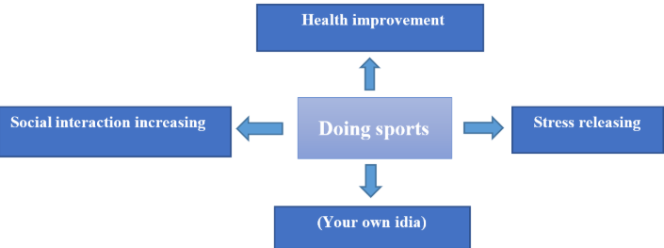
- Do you think famous sportspeople are good role models for children?
- Do you think the types of sport that are popular will change in the future?
- How can sports bring people from different countries closer together?

TEST 1
Part 1
Let’s talk about your study.
- What are you studying?
- What do you like about your studies?
- What do you like about learning English?
- How often do you use English?
Let’s talk about your hometown.
- What part of your country do you come from?
- What's the weather like in your hometown?
- Can you describe your hometown?

Part 2
Situation: You are making a plan for your holiday. Where do you prefer to go: to the beach, to the mountain or to the countryside?

Part 3
Topic: Studying abroad has a lot of benefits.
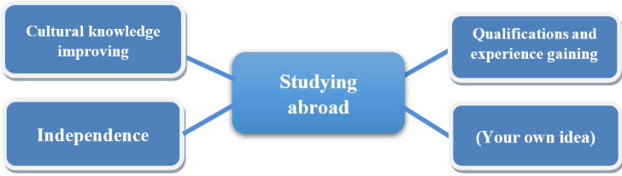
Follow-up questions:
- Which kinds of jobs have the highest salary in your country? And why?
- Are there any kinds of job you think should have high salary? And why do you think so?
- Some people say that it would be better for the society if everyone has the same salary. What do you think?

TEST 2
Part 1
Let’s talk about map:
· Have you ever used maps?
· Would you prefer paper maps or electronic maps? Why?
· Have you ever asked for directions instead of using maps? What happened?
Let’s talk about personality:
· Are you a family person?
· What are the qualities of a good wife?
· Will your personality change when you get older?

Part 2
Situation: You want to buy some clothes. You are considering where to buy. 3 options are suggested: a shop, an open-air market, an online store. Which one do you choose?

Part 3
Topic: Living on campus is beneficial to college students.
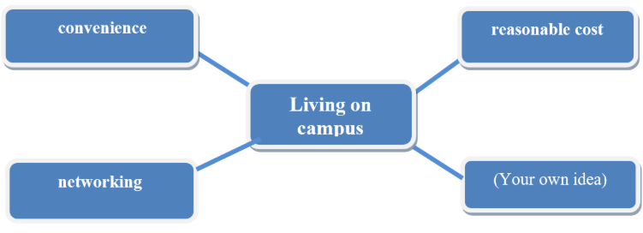
Follow-up questions:
· Should freshmen live on campus?
· Why do some students not want to live on campus?
· What are the disadvantages of living on campus?

TEST 3
Part 1
Let’s talk about Gameshow.
· What gameshow do you often watch?
· Would you prefer to watch it alone or with someone else?
· What are the benefits of watching a gameshow?
Let’s talk about buses:
· Have you ever travelled by bus?
· Is bus service good in your country?
· What are the benefits of travelling by bus?

Part 2
Situation: It is getting hotter and your family is planning a trip. Three places are suggested to stay: seaside resort, a lakeside hotel, a countryside cottage. Which one do you like most? Give your reasons.

Part 3
Topic: There are a lot of disadvantages of keeping animals in zoos.
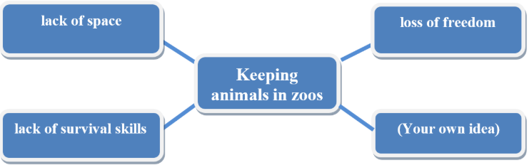
Follow-up questions:
· What kinds of animals are usually kept in zoos?
· What are the benefits of keeping animals in zoos?
· What can people do to protect wildlife species?

TEST 4
Part 1
Let’s talk about yourself.
- Can you tell me about your typical working day?
- What do you like most about your studying/job?
- How do you spend the weekends?
Let’s talk about your reading habit.
- What do you like to read the best?
- Do you often read newspapers?
- Where do you like to read?

Part 2
Situation: Your foreign friend is visiting Hanoi. You are going to take him/ her around Hanoi. Which means of transport do you choose, motorbike, bus or car? And why?

Part 3
Topic: Mobile phones are necessary for people.
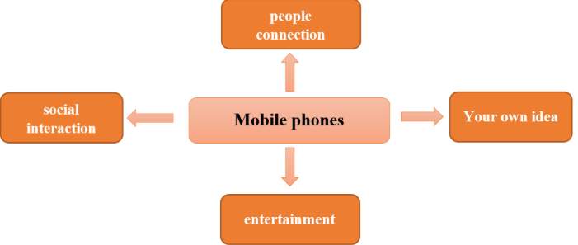
Follow-up questions:
- What differences are there between the attitudes of older and younger people to technology for communication?
- Do you think that the advance of technology has improved standards of education in schools?
- Would you agree that the rapid development of digital technology has had a positive impact on the world of work?

TEST 5
Part 1
Let’s talk about noise.
- Do you like to live in a noisy place or a quiet place?
- What kind of noise disturbs you most?
- Does noise affect your health?
Let’s talk about your favorite photograph.
- What is your favorite photograph?
- When was it taken?
- What makes the photograph special to you?

Part 2
Situation: You are thinking about how to spend your evening. There are three options: hanging out with friends, reading books, and surfing the Internet. Explain your choice.

Part 3
Topic: There are several ways for people to make friends.
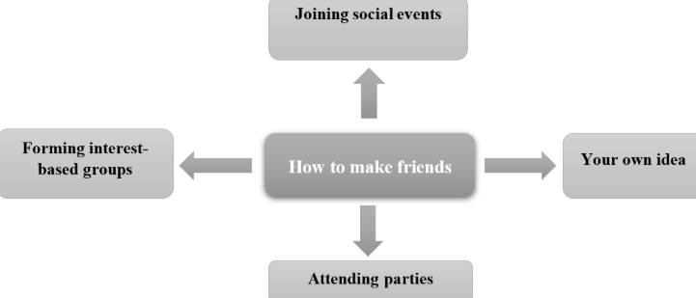
Follow-up questions:
- Should people trust online friends? Why or why not?
- What factors can contribute to a true friendship?
- Which one is more important: family or friends?

TEST 6
Part 1
Let’s talk about weather.
- What kind of weather do you like?
- Does weather affect your mood/ feeling?
- What do you usually do in hot/ cold weather?
Let’s talk about your favorite childhood game.
- What game(s) did you enjoy playing when you were a child?
- Who did you play with?
- Did you need any skills to play the game?

Part 2
Situation: You are planning your holiday. There are three suggestions: a beach holiday, a climbing holiday, and a sight-seeing holiday. Which do you think is the best choice for you?

Part 3
Topic: Music should be taught in schools.
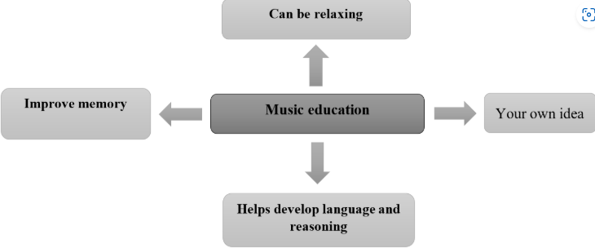
Follow-up questions:
- Should children be encouraged to learn music early?
- Do you agree that music can change people’s moods/ feelings?
- How would life be like without music?

TEST 7
Part 1
Let’s talk about traditional villages
· Have you ever been to a traditional village?
· What are some popular traditional villages in your country?
· What should we do to maintain traditional villages?
Let’s talk about flowers
· Do you like flowers?
· Which flowers are popular in your country?
· Are there any flowers with special meanings?

Part 2
Your youth club is supposed to invite a speaker to talk about his/ her life experience. 3 options are suggested: a famous singer, a company president, an excellent student. Which option is the best?

Part 3
There are some benefits of living alone for students.
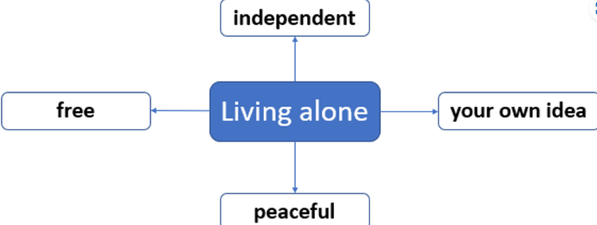
Follow-up questions:
· Is living alone popular among students? Why/ why not?
· What are the disadvantages of living alone?
· Do students now live alone more than their parents’ generation did? Why/ why not?
· Do more students live alone now than in the past?

COMPLETE TEST
Part 1
Let’s talk about ice-cream.
· Do you like ice-cream?
· Which flavor do you like?
· Is ice-cream good for your health?
Let’s talk about sleeping habits.
· How many hours do you sleep for a day?
· Why sleeping enough time is important?
· What should we do to have a good sleeping habit?

Part 2
Situation: You are going to send you child to a primary school. Which type of school would you like to choose: a school with relaxed regulation, a school focusing on academic performance and a school dedicating for personal development

Part 3
Topic: Having lunch at school canteen has a lot of benefits.
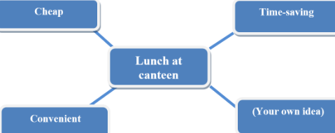
Follow-up questions:
· How does a school attract more students to have lunch at its canteen?
· What are some disadvantages when eating at the canteen?
· What should schools do to have hygienic and healthy meals for students?

