

FPT ACADEMY INTERNATIONAL
FPT – APTECH COMPUTER EDUCATION

Amazing Bridges

eProject - Group 4 – T11907M0

I. System Requirement

No | Software | Description
1 | Operating system | Windows
2 | Hardware | A minimum computer system that will help you access all the tools in the courses is a Pentium 166 or better; 64 Megabytes of RAM or better
3 | Software | Notepad/HTML editor, Dreamweaver, IE 5.0/Netscape
4 | Web browser | Internet Explorer, Chrome, Firefox, etc

II. Instructions for downloading the source code
- Visit the link https://github.com/Dung0402/Dung0402.github.io
Then click on "Clone or download":
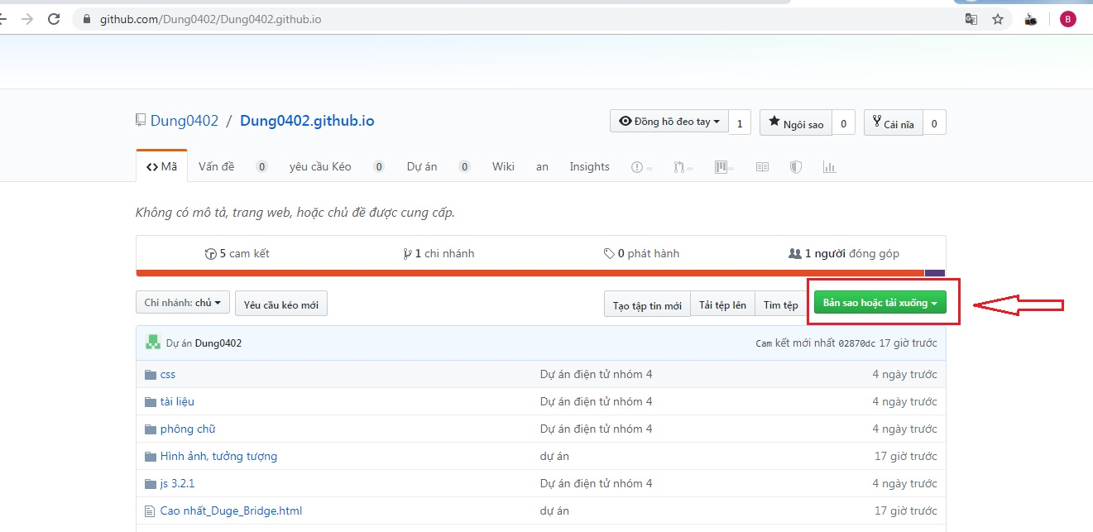
- Next choose “Download Zip”:
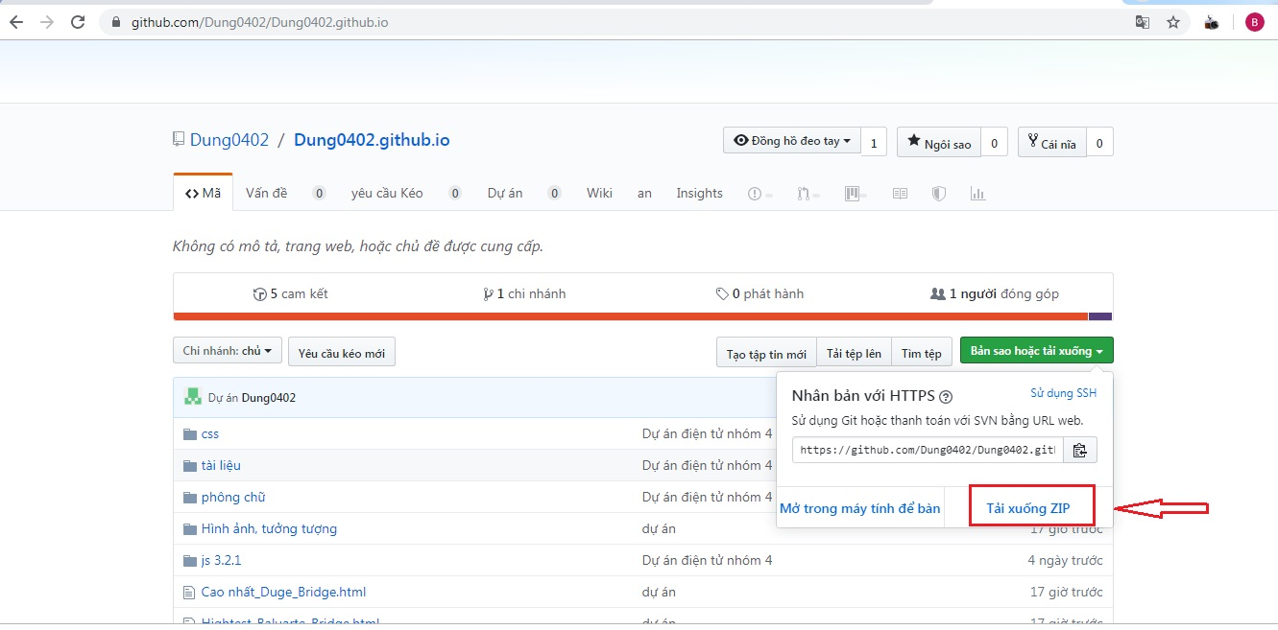
- Select the drive you want to save. Then extract the Zip file.
III. Test:
- Find index.html in eProject(final) folder then run it on web browsers or enter link: https://dung0402.github.io/ on url address of the browser.
- If the file is loaded successfully, homepage should be displayed as described in the documentation.


