METHODS REPORT
Controlled, Multi-Site, Staggered, and Hierarchical Interrupted Time Series
Simulation, assumptions, R implementation, results, diagnostics, and AI-assisted auditing
Academic methods presentation and manuscript-ready report
September 2026

Executive summary
Central conclusion Advanced ITS is most persuasive when concurrent controls, multiple sites, staggered timing, and explicit heterogeneity modeling jointly strengthen the counterfactual. Statistical flexibility cannot repair weak causal identification.

This report uses a reproducible simulated example with 30 sites followed monthly for 84 months. Eighteen sites adopted an intervention at months 37, 43, or 49; 12 sites never adopted. The simulation included seasonality, nonlinear secular change, a system-wide shock, site-level heterogeneity, intervention-effect heterogeneity, and AR(1) errors.
The segmented hierarchical ITS estimated an immediate increase of 2.80 points (95% CI, 1.78 to 3.82). The incremental monthly slope was 0.087 points (95% CI, -0.004 to 0.178; p=0.061), yielding an estimated total effect of 3.85 points at 12 months (95% CI, 2.51 to 5.18). A Sun-Abraham staggered event study showed no clear pre-intervention deviations and an overall post-treatment ATT of 4.72 points (SE, 0.74; p<0.001).
A critical diagnostic finding was that the mixed model estimated essentially zero random-intercept and random-slope variance while AR(1) increased to 0.913. Because the data-generating mechanism included real site heterogeneity and AR(1)=0.55, this indicates covariance-component confounding or an optimizer boundary solution. The intervention coefficients remain informative as an illustration, but the hierarchical covariance model should be refitted and stress-tested before publication.

1. Why this design will become more important
Healthcare, public health, and policy interventions are increasingly implemented at system level and recorded continuously in electronic health records, registries, claims, and administrative systems. When randomization is infeasible, ITS makes the counterfactual trajectory explicit. Its strongest future form will combine four complementary features:
Feature | What it contributes
Controlled | Separates intervention effects from common calendar-time shocks.
Multi-site | Adds intervention-level replication and permits assessment of heterogeneity.
Staggered | Separates calendar time from time since implementation and uses not-yet-treated sites.
Hierarchical | Partially pools site effects and represents site-to-site variation when identifiable.

Design principle The design establishes credibility; the model quantifies the contrast. A complex forecast is not a causal design by itself.

2. Simulation design and data structure
Design element | Specification
Sites | 30 total: 18 treated and 12 never treated
Observation frequency | Monthly
Series length | 84 months per site
Adoption cohorts | Six sites each at months 37, 43, and 49
Rows | 2,520 site-month observations
Outcome | Continuous; mean 61.24, range 41.52 to 82.57
True intervention form | Immediate level +2.5; monthly slope +0.12, with site heterogeneity
Other processes | Seasonality, nonlinear trend, common shock at month 55, AR(1)=0.55

One row per site per month
site | month | adoption | ever_treated | post | event_time | time_after | y
1 | 1 | 37.0 | 1 | 0 | -36.0 | 0 | 64.07
1 | 2 | 37.0 | 1 | 0 | -35.0 | 0 | 64.33
1 | 3 | 37.0 | 1 | 0 | -34.0 | 0 | 62.97
1 | 4 | 37.0 | 1 | 0 | -33.0 | 0 | 64.14
1 | 5 | 37.0 | 1 | 0 | -32.0 | 0 | 65.56
1 | 6 | 37.0 | 1 | 0 | -31.0 | 0 | 62.62

The adoption variable is constant within site. Post equals 1 beginning in the adoption month. Event time equals calendar month minus adoption month. Time after equals zero before treatment and then increases from zero after adoption.

3. Estimands and statistical models

Hierarchical segmented ITS
The primary model included calendar-month fixed effects, an indicator for ever-treated sites, an immediate post indicator, time after implementation, random site intercepts and site trends, and within-site AR(1) residual correlation. Calendar-month effects absorbed common seasonality, nonlinear secular change, and the common month-55 shock.
Quantity | Interpretation
post | Average immediate level difference at adoption, beyond concurrent calendar changes.
time_after | Additional monthly change after adoption.
post + k x time_after | Total effect k months after implementation.
Random intercept/trend | Between-site variation in starting level and underlying trajectory.
AR(1) | Correlation between adjacent within-site residuals.

Staggered event study
The Sun-Abraham specification estimated cohort-by-event-time effects using never-treated and eligible not-yet-treated observations as comparisons, with site and calendar-month fixed effects and site-clustered standard errors. Month -1 was the reference. Distant relative periods were binned at <=-13 and >=13 months.

4. Identification assumptions and practical conditions
- Intervention timing is externally justified and not selected because the outcome changed.
- In the absence of treatment, treated sites would have followed a counterfactual path represented by the comparison sites after conditioning on site and calendar time.
- There is no differential co-intervention, coding change, or data-system change coinciding with adoption.
- No meaningful anticipation occurs before implementation, unless explicitly modeled.
- Treatment status is well defined, adoption is measured correctly, and reversal or partial exposure is handled appropriately.
- Outcome definitions, denominators, ascertainment, and population composition remain comparable over time.
- Spillover between treated and control sites is absent or negligible.
- The modeled impact shape is scientifically plausible; immediate, gradual, and phase-in effects are prespecified.
- Serial correlation, seasonality, nonlinearity, overdispersion, and site heterogeneity are adequately represented.
- The number of sites and time points—not merely the number of patients—is sufficient for the intended inference.
Necessary reporting condition Show observed data, the estimated counterfactual, dynamic event-time estimates, meaningful-time contrasts, and sensitivity analyses. A regression table alone is inadequate.

5. Results from the hierarchical segmented ITS
Estimand | Estimate | 95% CI lower | 95% CI upper
Immediate level change | 2.800 | 1.785 | 3.816
Additional monthly slope | 0.087 | -0.004 | 0.178
Total effect at 12 months | 3.847 | 2.512 | 5.182

The immediate level change was clearly positive. The incremental monthly slope was positive but its 95% confidence interval narrowly included zero. Because level and slope combine over time, the estimated 12-month total effect was positive and clinically easier to interpret than the slope coefficient alone.
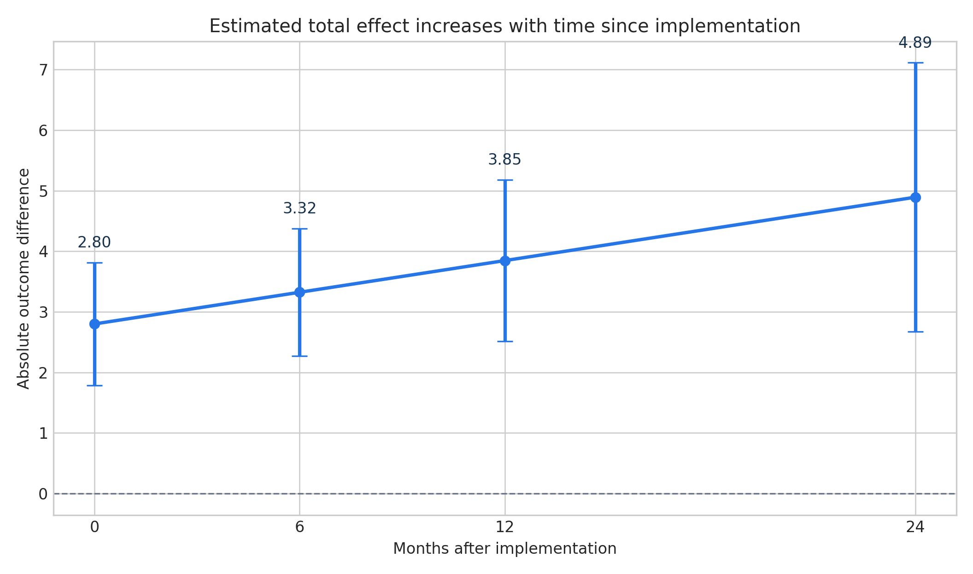
Figure 1. Estimated total intervention effects at 0, 6, 12, and 24 months. Error bars show 95% confidence intervals.
Interpretation At 12 months, the model estimated an outcome 3.85 points higher than the modeled no-intervention counterfactual, conditional on the model and identification assumptions.

6. Dynamic and cohort-specific evidence
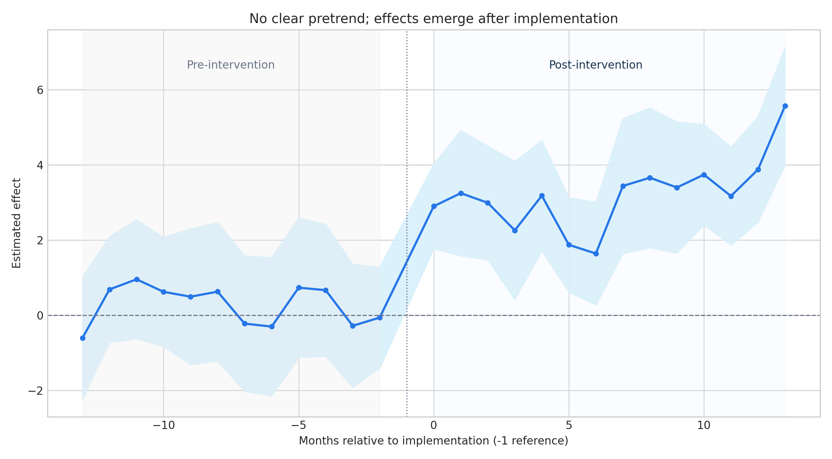
Figure 2. Binned Sun-Abraham event-study estimates relative to month -1. Shaded bands use site-clustered uncertainty.
The binned pre-intervention coefficients from months -12 through -2 were individually compatible with zero. Positive effects emerged at implementation and persisted through month 13. This pattern supports an intervention-associated change but does not rule out time-varying confounding or differential co-interventions.
Event-study estimand | Estimate | SE | p-value
Overall ATT | 4.721 | 0.736 | <0.001
Adoption month 37 | 3.964 | 1.171 | 0.002
Adoption month 43 | 4.907 | 1.310 | <0.001
Adoption month 49 | 5.513 | 1.027 | <0.001

The cohort-specific averages increased across later cohorts. These are descriptive averages over different post-treatment windows and should not automatically be interpreted as direct tests of between-cohort effect modification.

7. Diagnostics: an important covariance warning
Diagnostic | Observed result | Meaning
Random-intercept SD | 3.26 x 10^-9 | Boundary estimate; site-level baseline variance was not recovered.
Random-trend SD | 5.85 x 10^-8 | Boundary estimate; site-level trend variance was not recovered.
Residual SD | 4.79 | Substantially larger than the innovation SD used in simulation.
AR(1) phi | 0.913 | Much larger than the simulated value of 0.55.
AIC: AR(1) vs no AR(1) | 10,667.8 vs 11,233.1 | AR(1) improves fit, but covariance decomposition remains suspect.
Placebo level | 0.92; 95% CI -0.11 to 1.95 | Not conventionally significant; p=0.080.
Placebo slope | -0.052; 95% CI -0.309 to 0.204 | No evidence of a placebo slope change; p=0.689.

Because the simulation deliberately generated site intercept SD=4, site-trend SD=0.35, and AR(1)=0.55, the fitted covariance components reveal confounding between highly persistent AR(1) errors and random site effects or a local optimizer solution. This is not a cosmetic issue: the uncertainty for intervention effects depends on the covariance model.
Publication recommendation Do not label the present mixed model as a successfully validated hierarchical analysis. Refit with alternative optimizers and starting values; compare random-effects-only, site-fixed-effects plus AR(1), and Bayesian models with weakly informative priors; and examine bootstrap or small-cluster-robust inference.

8. How AI can improve ITS without encouraging model shopping
AI-assisted task | Legitimate use | Safeguard
Seasonality | Inspect monthly patterns, spectra, and residual ACF. | Prespecify the primary seasonal adjustment from scientific context.
Structural breaks | Flag coding changes, shocks, or unexplained discontinuities. | Do not move the intervention date to maximize the estimated effect.
Nonlinear trends | Compare splines, GAMs, and state-space alternatives. | Select on pre-period fit and plausibility, not the post-treatment p-value.
Model auditing | Check residuals, overdispersion, leverage, convergence, and heterogeneity. | Retain a complete audit trail and label alternatives as sensitivity analyses.
Simulation | Assess power, bias, and coverage under plausible scenarios. | Vary uncertain assumptions and report Monte Carlo error.
Specification comparison | Automate a disciplined multiverse of reasonable models. | Declare the primary model before examining intervention estimates.

AI is most useful when it tries to falsify the primary analysis. It becomes dangerous when it searches across dates, controls, lags, trends, exclusion periods, and outcome definitions and then quietly promotes the most favorable result.

9. Recommended analysis and reporting workflow
1. Define the causal question. Specify population, intervention, adoption date, outcome, estimand, follow-up, and counterfactual.
2. Lock the primary specification. Prespecify controls, impact shape, calendar adjustment, correlation structure, and primary effect time.
3. Audit the data. Confirm one row per unit-time, stable measurement, adoption coding, missingness, and denominator composition.
4. Visualize before modeling. Plot site and cohort trajectories, adoption dates, disruptions, and potential seasonality.
5. Fit complementary models. Use a controlled segmented model for interpretable level/slope effects and a modern staggered event study for dynamics.
6. Challenge identification. Examine pretrends, placebo dates, negative-control outcomes, alternative controls, and phase-in periods.
7. Stress-test covariance. Compare plausible random-effects and autocorrelation structures; inspect boundary estimates and convergence.
8. Report meaningfully. Present absolute effects at meaningful times, uncertainty, cohort heterogeneity, and all material sensitivity results.

10. Manuscript-ready language

Methods
We conducted a controlled, multi-site interrupted time-series simulation comprising 30 sites observed monthly for 84 months. Eighteen sites adopted the intervention in three cohorts at months 37, 43, and 49, and 12 sites remained untreated. The data-generating process included annual seasonality, a nonlinear secular trend, a common shock at month 55, site-specific baseline levels and trends, heterogeneous intervention level and slope effects, and first-order autoregressive errors. We estimated immediate and gradual intervention effects using a segmented mixed-effects model with calendar-month fixed effects, site-level random intercepts and trends, and AR(1) residual correlation. Total effects at 6, 12, and 24 months were calculated as linear combinations of the immediate level and post-intervention slope coefficients. As a complementary analysis, we fit a Sun-Abraham staggered event-study model with site and calendar-month fixed effects and site-clustered standard errors; month -1 was the reference period and distant event times were binned at <=-13 and >=13 months. We also evaluated a placebo intervention date 12 months before actual adoption.

Results
The segmented model estimated an immediate intervention-associated increase of 2.80 points (95% CI, 1.78 to 3.82). The estimated incremental monthly slope was 0.087 points (95% CI, -0.004 to 0.178; p=0.061). The corresponding total effect was 3.32 points at 6 months (95% CI, 2.27 to 4.38), 3.85 points at 12 months (95% CI, 2.51 to 5.18), and 4.89 points at 24 months (95% CI, 2.67 to 7.11). In the staggered event study, pre-intervention estimates were compatible with zero and post-intervention estimates were positive. The overall ATT was 4.72 points (SE, 0.74; p<0.001). Placebo analyses did not identify a slope change; however, the placebo level estimate was imprecisely positive (0.92; 95% CI, -0.11 to 1.95; p=0.080). Random-effect variances approached zero while AR(1) phi was 0.913, indicating that the covariance model did not recover the simulated site heterogeneity and required further sensitivity analysis.

Discussion
The simulation illustrates how concurrent controls, multiple sites, staggered implementation, and dynamic event-time estimation can strengthen ITS evaluation. The estimated immediate and 12-month effects were close to the simulated intervention pattern, and the event study showed no clear evidence of differential pretrends. At the same time, the boundary covariance estimates demonstrate that a model may produce plausible intervention coefficients while failing to identify the intended hierarchical variance structure. Advanced ITS analyses should therefore distinguish causal identification from covariance modeling, report effects at meaningful times, and treat convergence and variance-component diagnostics as substantive results rather than technical details.

11. Limitations of this demonstration
- This is one simulated dataset, not a Monte Carlo simulation study; it does not establish bias, coverage, type I error, or power.
- The outcome is continuous and balanced. Real studies may involve counts, proportions, unequal denominators, missing months, or changing patient composition.
- Only 30 sites were available for cluster-level inference; small-cluster corrections or wild cluster bootstrap methods should be considered.
- The controls were generated under the same common calendar process. Real control selection requires clinical and operational justification.
- The placebo test has limited power and a nonsignificant result does not prove absence of confounding.
- The hierarchical covariance structure was not successfully recovered in the reported fit.

12. Bottom line
Best future use of ITS Use controlled, multi-site, staggered designs with hierarchical or otherwise site-aware modeling; pair an interpretable prespecified primary model with dynamic event-study evidence; and use AI to expose threats to validity, not to search for significance.

For a real manuscript, the next analytical priority is not adding a more flexible trend. It is resolving the covariance-identification problem, confirming inference with a site-fixed-effects AR(1) model and small-cluster-robust methods, and demonstrating that conclusions survive prespecified sensitivity analyses.

References
- Bernal JL, Cummins S, Gasparrini A. Interrupted time series regression for the evaluation of public health interventions: a tutorial. International Journal of Epidemiology. 2017;46:348-355. doi:10.1093/ije/dyw098.
- Lopez Bernal J, Cummins S, Gasparrini A. The use of controls in interrupted time series studies of public health interventions. International Journal of Epidemiology. 2018;47:2082-2093. doi:10.1093/ije/dyy135.
- Sun L, Abraham S. Estimating dynamic treatment effects in event studies with heterogeneous treatment effects. Journal of Econometrics. 2021;225:175-199. doi:10.1016/j.jeconom.2020.09.006.
- Turner SL, Forbes AB, Karahalios A, Taljaard M, McKenzie JE. Evaluation of statistical methods used in the analysis of interrupted time series studies: a simulation study. BMC Medical Research Methodology. 2021;21:181. doi:10.1186/s12874-021-01364-0.
- Turner SL, Karahalios A, Forbes AB, Taljaard M, Grimshaw JM, McKenzie JE. Comparison of six statistical methods for interrupted time series studies: empirical evaluation of 190 published series. BMC Medical Research Methodology. 2021;21:134. doi:10.1186/s12874-021-01306-w.
- Berge L. fixest: Sun and Abraham interactions (sunab). Package documentation, version 0.14.2. https://lrberge.github.io/fixest/reference/sunab.html.

Supplementary files
The companion R script, Controlled_Multisite_Staggered_Hierarchical_ITS.R, contains the complete simulation, hierarchical ITS, dynamic contrasts, diagnostics, staggered event study, placebo analysis, export code, and recommended covariance-sensitivity models. The supplied CSV files preserve the exact R outputs used in this report.

