Question 3:

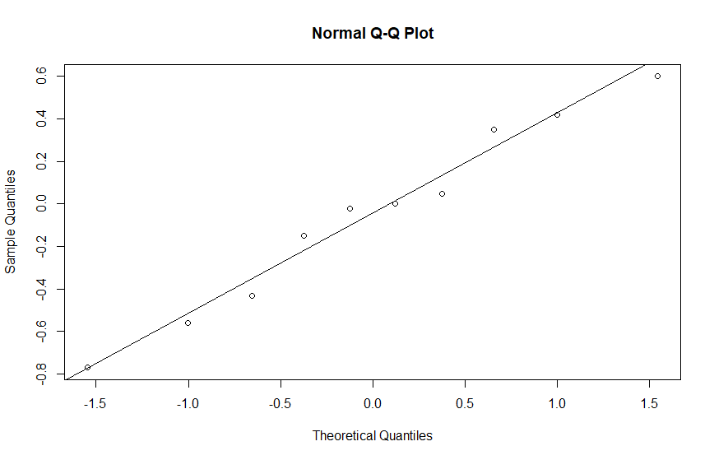

Code:

# Import input

loca="C:/Users/Duong Hung/OneDrive - University Of Houston/Msds classes materials/Fall semester/Math 6357-01 Linear models"

setwd(loca)

fil_nam="HW3.3.txt"

df = file(fil_nam, open = "r") #open file

dat=NULL

k=0

name=c('BO1','BO2')

while (length(oneLine <- readLines(df, n = 1, warn = FALSE)) > 0) {

num_lis = (strsplit(oneLine, " "))

num_lis = as.numeric(num_lis[[1]])

a=length(num_lis)

for (i in 1:a){

dat$bo[k+i]=name[i]

dat$int[k+i]=num_lis[i]

}

k=k+a

}

close(df)

dat=data.frame(dat)

dat=dat[order(dat$bo),]

a=length(num_lis)

n=length(dat$bo)

print(dat)

bo1=dat[(dat$bo=='BO1'),]$int

bo2=dat[(dat$bo=='BO2'),]$int

dif_ord=bo1-bo2

qqnorm(dif_ord)

qqline(dif_ord)

# Question 4:

data=read.table("HW3.4.txt")

names(data)=c('Sham','1h','2h','4h')

data=data.frame(data)

for (i in 1:4){

print(i)

print(sum(data[i]))

}

y_dot= colMeans(data)

y2dot=sum(data)

y2dot_bar=y2dot/80

values=data.matrix(data)

SSt=0

for (a in 1:4){

for (i in 1:20){

SSt=SSt+(values[i,a]-y2dot_bar)^2

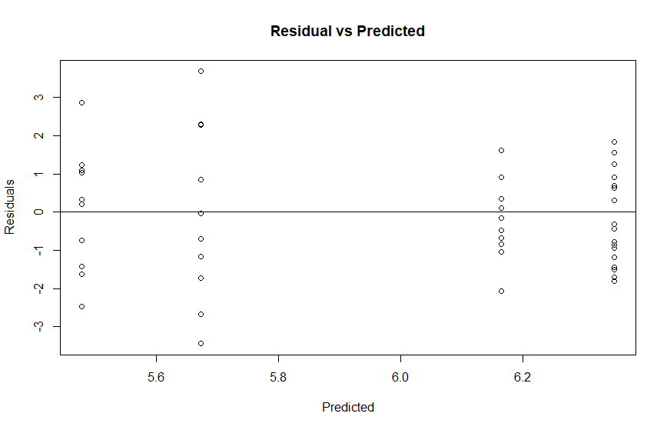 }

}

SStreat=0

for (a in 1:4){

SStreat=SStreat+(y_dot[a]-y2dot_bar)^2

}

SStreat=20*SStreat

SSe=SSt-SStreat

MStreat=SStreat/3

MSe=SSe/(80-4)

F0=MStreat/MSe

e=values

for (a in 1:4) {e[,a]=e[,a]-y_dot[a]}

qqnorm(e[,1])

qqline(e[,1])

pdata=NULL

fv=NULL

for (a in 1:4){

for (i in 1:20){

index=i+(a-1)*10

pdata[index]=e[i,a]

fv[index]=y_dot[a]

}

}

plot(fv,pdata, main = 'Residual vs Predicted',xlab = 'Predicted',ylab = 'Residuals')

abline(0,0)

# Question 5

fil_nam="HW3.5.txt"

df = file(fil_nam, open = "r") #open file

dat=NULL

k=1

while (length(oneLine <- readLines(df, n = 1, warn = FALSE)) > 0) {

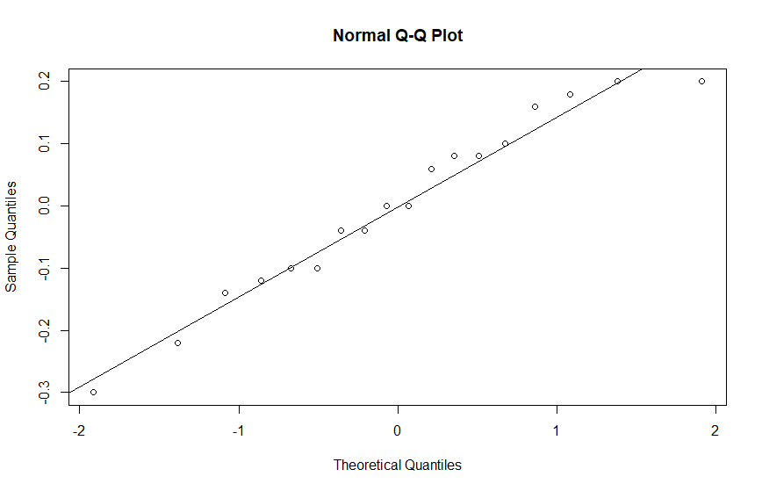 num_lis = (strsplit(oneLine, " "))

num_lis = as.numeric(num_lis[[1]])

for (i in 2:length(num_lis)){

dat$dens[k]=num_lis[i]

dat$temp[k]=num_lis[1]

k=k+1

}

}

close(df)

print(dat)

y_dot=tapply(dat$dens, dat$temp, mean)

tapply(dat$dens, dat$temp, length)

y2dot=sum(dat$dens)

N=length(dat$dens)

y2dot_bar=y2dot/N

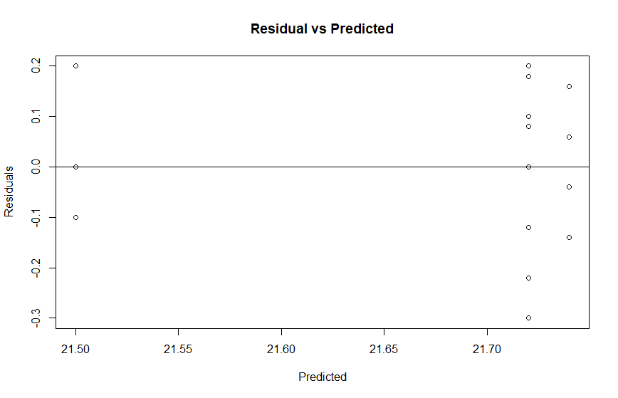values=data.matrix(dat)

SSt=0

for (i in 1:N){

SSt=SSt+(dat$dens[i]-y2dot_bar)^2

}

SStreat=0

for (a in 1:4){

SStreat=SStreat+(y_dot[a]-y2dot_bar)^2

}

SStreat=4.5*SStreat

SSe=SSt-SStreat

MStreat=SStreat/3

MSe=SSe/(N-4)

F0=MStreat/MSe

print(oneway.test(dens~temp,data = dat))

e=dat$dens

e[1:5]=e[1:5]-y_dot[1]

e[6:9]=e[6:9]-y_dot[2]

e[10:14]=e[10:14]-y_dot[3]

e[15:18]=e[15:18]-y_dot[4]

qqnorm(e)

qqline(e)

fv=c(rep(y_dot[1],5),rep(y_dot[2],4),rep(y_dot[3],5),rep(y_dot[4],4))

plot(fv,e, main = 'Residual vs Predicted',xlab = 'Predicted',ylab = 'Residuals')

abline(0,0)

# Question 6

# Import input

fil_nam="HW3.6.txt"

df = file(fil_nam, open = "r") #open file

dat=NULL

k=0

name=c('B1','B2','B3')

while (length(oneLine <- readLines(df, n = 1, warn = FALSE)) > 0) {

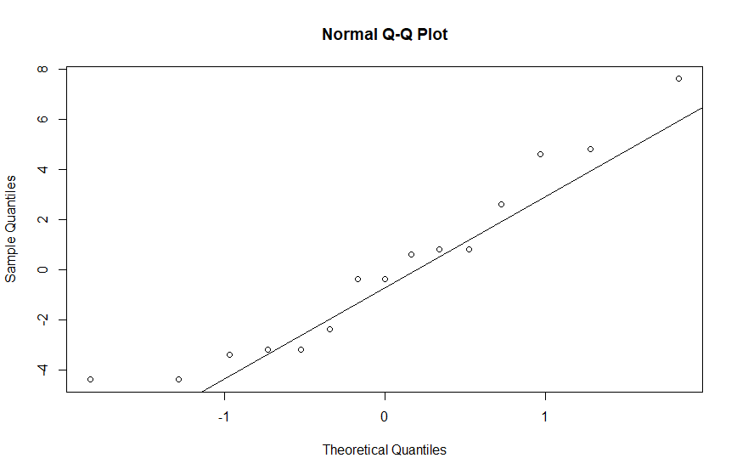 num_lis = (strsplit(oneLine, " "))

num_lis = as.numeric(num_lis[[1]])

for (i in 1:length(num_lis)){

dat$brand[k+i]=name[i]

dat$week[k+i]=num_lis[i]

}

k=k+3

}

close(df)

dat=data.frame(dat)

dat=dat[order(dat$brand),]

a=3

n=5

print(dat)

y_dot=tapply(dat$week, dat$brand, mean)

tapply(dat$week, dat$brand, length)

y2dot=sum(dat$week)

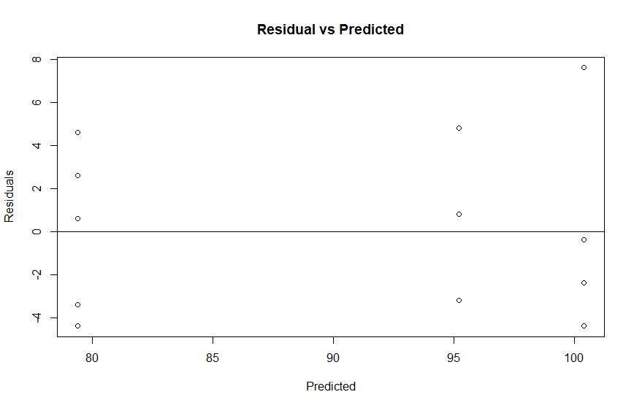N=length(dat$week)

y2dot_bar=y2dot/N

values=data.matrix(dat)

SSt=0

for (i in 1:N){

SSt=SSt+(dat$week[i]-y2dot_bar)^2

}

SStreat=0

for (a in 1:a){

SStreat=SStreat+(y_dot[a]-y2dot_bar)^2

}

SStreat=n*SStreat

SSe=SSt-SStreat

MStreat=SStreat/(a-1)

MSe=SSe/(N-a)

F0=MStreat/MSe

oneway.test(week~brand,data = dat)

print(qf(0.95,a-1,N-a))

for (i in 1:a){

print(a)

LL=y_dot[i]-qt(0.975,N-a)*sqrt(MSe/n)

UL=y_dot[i]+qt(0.975,N-a)*sqrt(MSe/n)

print(paste(LL,'<',y_dot[i],'<',UL))

}

diff23=y_dot[2]-y_dot[3]

ci23=qt(0.995,N-a)*sqrt(2*MSe/n)

LL23=diff23-ci23

UL23=diff23+ci23

print(paste(LL23,'<',diff23,'<',UL23))

e=dat$week

fv=c(rep(y_dot[1],5),rep(y_dot[2],5),rep(y_dot[3],5))

e=dat$week-fv

qqnorm(e)

qqline(e)

plot(fv,e, main = 'Residual vs Predicted',xlab = 'Predicted',ylab = 'Residuals')

abline(0,0)

# Question 7:

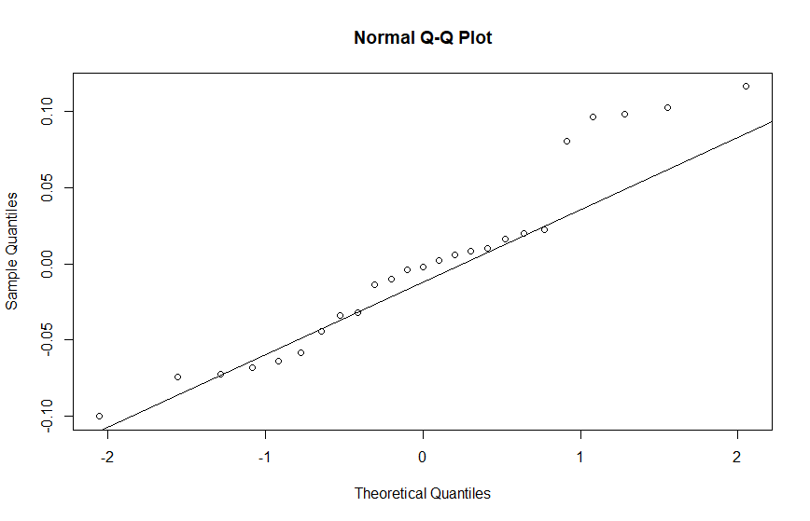

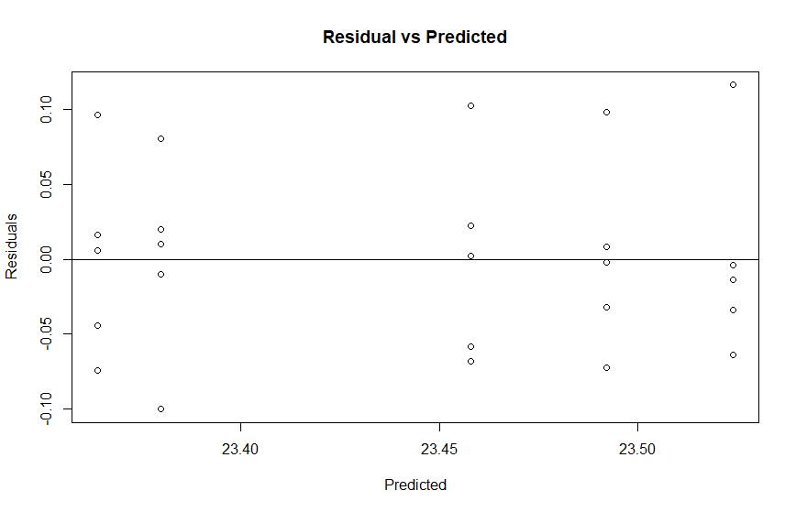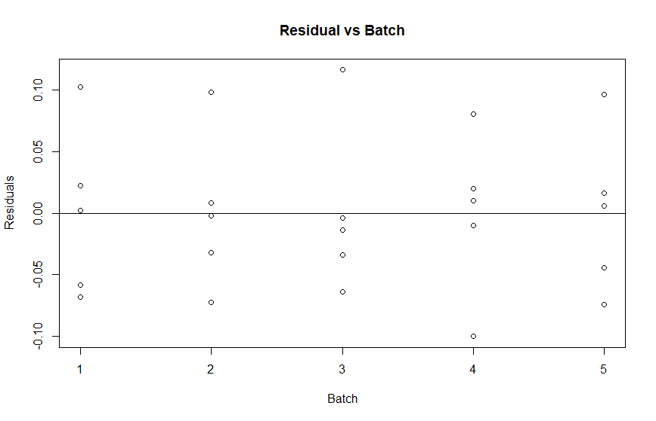

# Import input

loca="C:/Users/Duong Hung/OneDrive - University Of Houston/Msds classes materials/Fall semester/Math 6357-01 Linear models"

setwd(loca)

fil_nam="HW3.7.txt"

df = file(fil_nam, open = "r") #open file

dat=NULL

k=0

name=c('B1','B2','B3','B4','B5')

while (length(oneLine <- readLines(df, n = 1, warn = FALSE)) > 0) {

num_lis = (strsplit(oneLine, " "))

num_lis = as.numeric(num_lis[[1]])

for (i in 1:length(num_lis)){

dat$batch[k+i]=name[i]

dat$calcium[k+i]=num_lis[i]

}

k=k+5

}

close(df)

dat=data.frame(dat)

dat=dat[order(dat$batch),]

a=5

n=5

print(dat)

y_dot=tapply(dat$calcium, dat$batch, mean)

tapply(dat$calcium, dat$batch, length)

y2dot=sum(dat$calcium)

N=length(dat$calcium)

y2dot_bar=y2dot/N

values=data.matrix(dat)

SSt=0

for (i in 1:N){

SSt=SSt+(dat$calcium[i]-y2dot_bar)^2

}

SStreat=0

for (i in 1:a){

SStreat=SStreat+(y_dot[i]-y2dot_bar)^2

}

SStreat=n*SStreat

SSe=SSt-SStreat

MStreat=SStreat/(a-1)

MSe=SSe/(N-a)

F0=MStreat/MSe

oneway.test(calcium~batch,data = dat)

print(qf(0.95,a-1,N-a))

print((MStreat-MSe)/n)

e=dat$calcium

fv=c(rep(y_dot[1],5),rep(y_dot[2],5),rep(y_dot[3],5),rep(y_dot[4],5),rep(y_dot[5],5))

e=dat$calcium-fv

qqnorm(e)

qqline(e)

plot(fv,e, main = 'Residual vs Predicted',xlab = 'Predicted',ylab = 'Residuals')

abline(0,0)

plot(rep(1:5,each=5),e, main = 'Residual vs Batch',xlab = 'Batch',ylab = 'Residuals')

abline(0,0)