Homework-0

**Out Date:** 08/22/2018 (Friday)

**Due Date:** 09/01/2018 (Sunday) 11:59PM

Team#: _6__

Team Member-1:_ Thanh Hung Duong_______Member’s Contribution (in %) 50

Team Member-2:__ Johnny Nino Ladino______Member’s Contribution (in %) 50

**Submission**

1. Work on the following requirements.
2. Prepare your Python file (e.g., HW0_Team#.py).
3. Prepare your Jupyter Notebook file (e.g., HW0_Team#. ipynb).
4. Upload the files to blackboard.

**Problem Statement:** Please execute the following and submit the necessary files.

1. Download the Anaconda Distribution Platform from here: <https://www.anaconda.com/distribution/#download-section>
2. Install it on your computer. The installation may take about 10-15 minutes.

**[Spyder]**

1. Launch Spyder

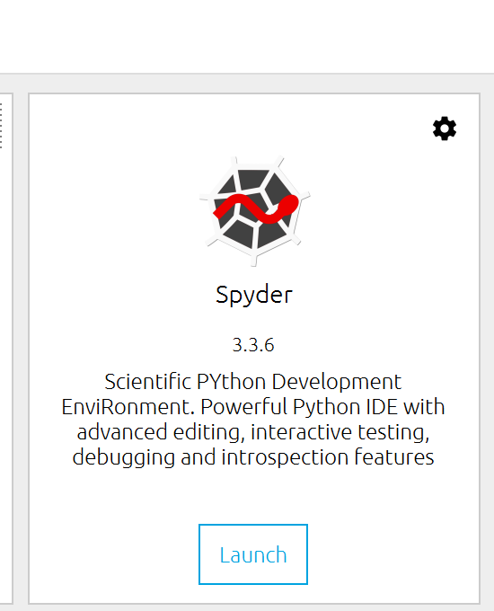

1. Create a Python script to print your team# and team members’ names. A sample output is give below.

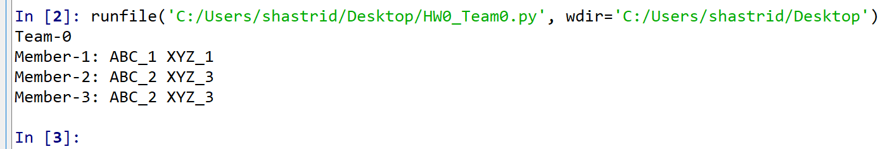

1. Save the script as HW0_Team#.py, where # represents your team number.

**[Jupyter Notebook]**

1. Now lunch Jupyter Notebook and write a Python script to print your team# and team members’ names. A sample output is give below.

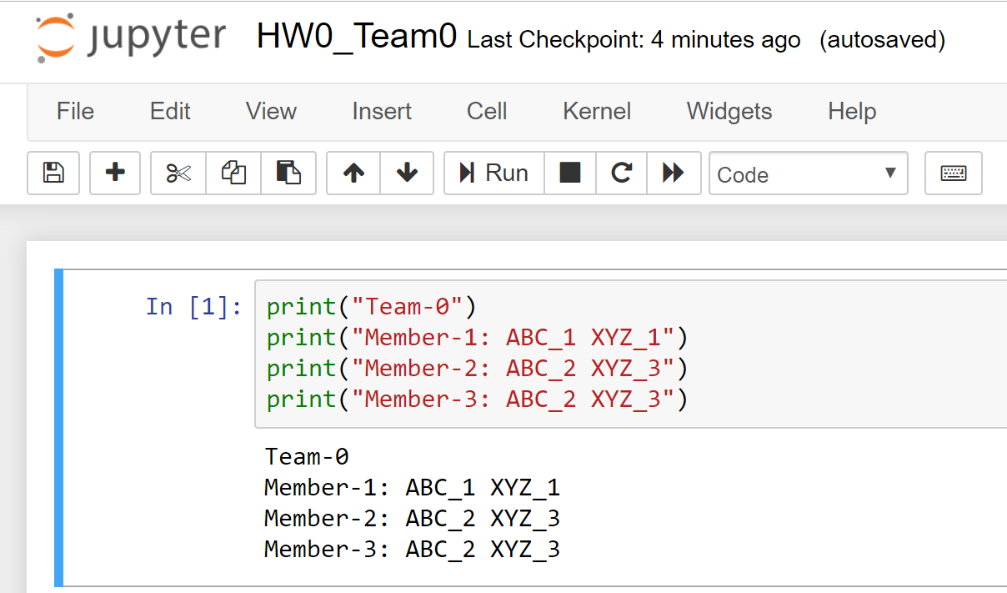

1. Save the script as HW0_Team#.ipynb, where # represents your team number.

**Scoring Distribution [100 points]**

* 25 points for programing style
* 75 points for appropriate outputs