Homework-2

**Out Date:** 09/06/2019 (Friday)

**Due Date:** 09/15/2019 (Sunday) 11:59PM

Team#: 6

Team Member-1:Johnny Nino Ladino____________Member’s Contribution (in %) 50

Team Member-2: Thanh Hung Duong____________Member’s Contribution (in %) 50

**Submission**

1. Work on the Problme-1 to Problem-3.
2. Prepare your Python file for Problem-1 (e.g., HW2_P1_Team#.py).
3. Prepare your Python file for Problem-2 (e.g., HW2_P2_Team#.py).
4. Prepare your Python file for Problem-3 (e.g., HW2_P3_Team#.py).
5. Upload the files to blackboard.

**Problem-1 [25 points]**

Write a program to prompt for a score between 0.0 and 100.0 and print a grade using the following table:

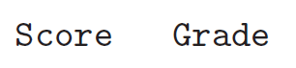

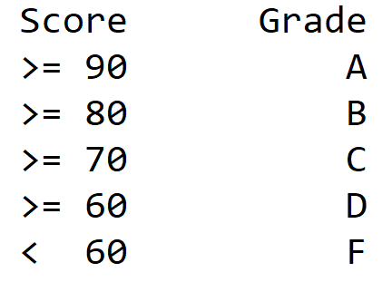

**The program should have at least 2 functions:**

1. **validate_input():** It validates the user’s inputs. Specifically, if the score is out of range, it prints an error message. If the user enters non-digits, it prints an error message (e.g., Please enter numbers only) **[10 points]**
2. **calculate_grade():** It takes the validated score, computes the grade as shown in the above *score-to-grade* mapping table, and return the course grade **[10 points]**.

The program should display the course grade **[5 points]**. Please refer to the sample test cases.

**Sample input and output - 1:**

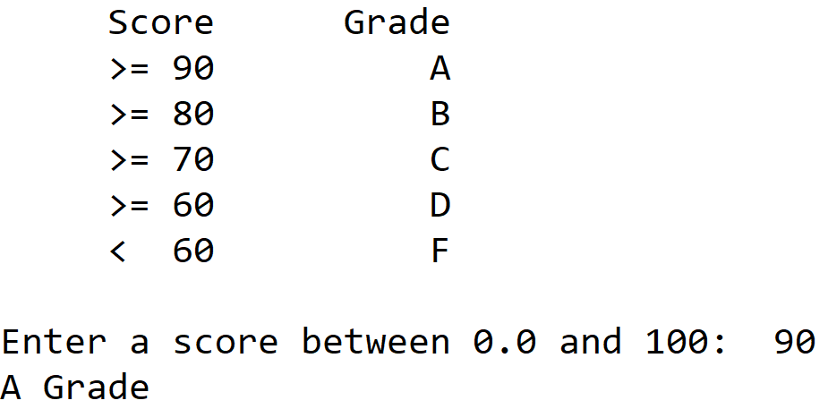

**Sample input and output - 2:**

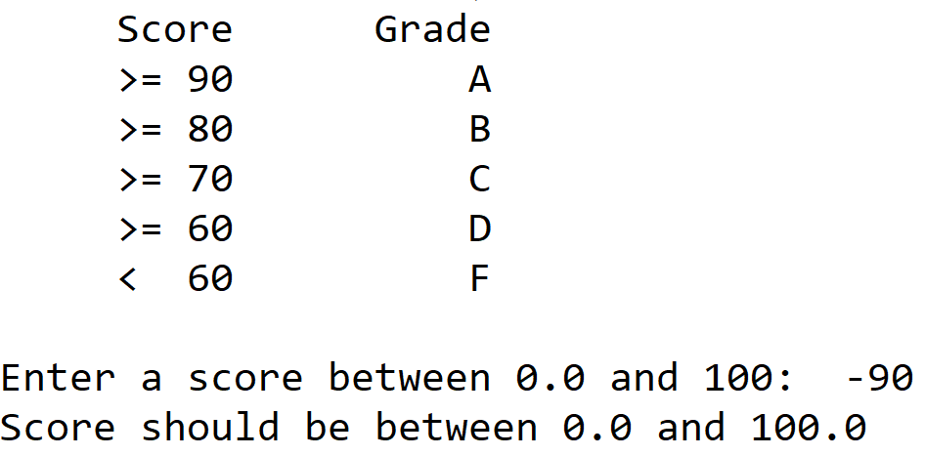

**Sample input and output - 3:**

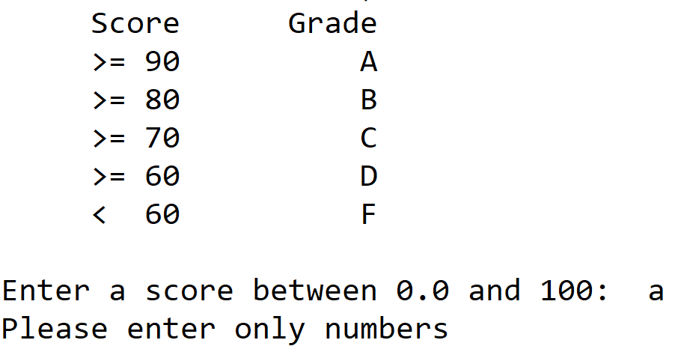

**Problem-2 [25 points]**

In physics, an object that is in motion is said to have kinetic energy. The following formula can be used to determine a moving object’s kinetic energy:

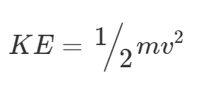

The variables in the formula are as follows: KE is the kinetic energy, m is the object’s mass in kilograms, and v is the object’s velocity in meters per second.

Write a function named kinetic_energy() that accepts an object’s mass (in kilograms) and velocity (in meters per second) as arguments. The function should return the amount of kinetic energy that the object has **[10 points]**. Write a program that asks the user to enter values for mass and velocity **[5 points]**, then calls the kinetic_energy function to get the object’s kinetic energy and print the value **[5 points]**.

**Input validation:** Don’t allow the user to enter negative numbers **[5 points]**.

**Problem-3 [30 points]**

Write a program that calculates and displays a person’s body mass index (BMI) **[5 points]**. The BMI is often used to determine whether a person with a sedentary lifestyle is overweight or underweight for his or her height. A person’s BMI is calculated with the following formula:

BMI = weight × 703 / height2

Where, weight is measured in pounds and height is measured in inches. The program should display a message indicating whether the person has optimal weight, is underweight, or is overweight **[5 points]**. A sedentary person’s weight is considered to be optimal if his or her BMI is between 18.5 and 25. If the BMI is less than 18.5, the person is considered to be underweight. If the BMI value is greater than 25, the person is considered to be overweight.

The program should have at least 3 functions as described below:

1. **get_input():** This function will take user inputs (height and weight) and validate them. If inputs are negative numbers, the program should throw an error message. If the inputs are strings, the program should throw an error message. Otherwise, it should return the number. **[5 points]**
2. **calculate_BMI():** This function should take the user’s inputs as arguments, calculate BMI, and returns BMI. **[10 points]**
3. **calculate_weight_category():** This function should take the BMI value and compute one of the three weight categories (underweight, optimal-weight or overweight). **[5 points]**

Please make sure your code follows the Python programing style guide available here: <https://www.python.org/dev/peps/pep-0008/> **[10 points]**.

Please make sure the code is well-commented **[10 points]**