Customer Relationship Management

Programming 1

Duong huu khoi - s3820797

2020

Contents

1. Introduction 2

2. CRM build 2

2.1 Menu and login 2

2.2 Leads and Interactions 3

2.3 Report 4

3. Function implementation and update 5

References 6

# Introduction

Customer relationship system or CRM is a software use among companies to manage company’s relationships, interactions with customers and potential customers. The goal of CRM is to help business improve their relationships and growth. Customer relationship system can be advantage variety of personnel in business environment from sale persons to customer service, business development, recruiting and marketing. CRM is one of the largest and fastest growing application software firm right now, it is expecting to worth $114.4 billion USD by 2027.

The following CRM is built on Java programming language using Intellij IDE and its console to prompt in input as well as read output. The program insists of simple for loop, while loop and if else nested control statement while also using 2 object class for leads and interactions. Information will be stored in two separate files which are leads.csv and interactions.csv. This CRM contain almost every primary functionality that required such as view, add, update, delete as well as report statistics.

# CRM build

We will be splitting the functionality into three main parts: main menu and login, leads and interactions, report.

## Menu and login

As the program run, it will prompt out a welcome page and let user choose whether to login or exit. Once the user entered “1”, the program will ask for username and password. The username and password were set as “admin” and “admin”. A function to validate the username and password was also include in the program. Once the correct password is prompted, it will take the user to next menu. If the user decided to enter “2”, the string “Goodbye” will be printed out to the console and exit the program. Anything except from “1” and “2” will be as error and continue to ask user to enter correct option.

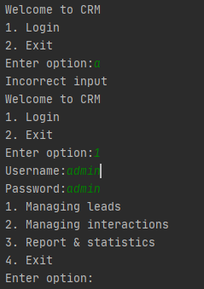

Figure 2.1.1: Main menu and login

From the input, the function will return to menu with nested if loop and while to decide which function the program must run next. The code will be like this.

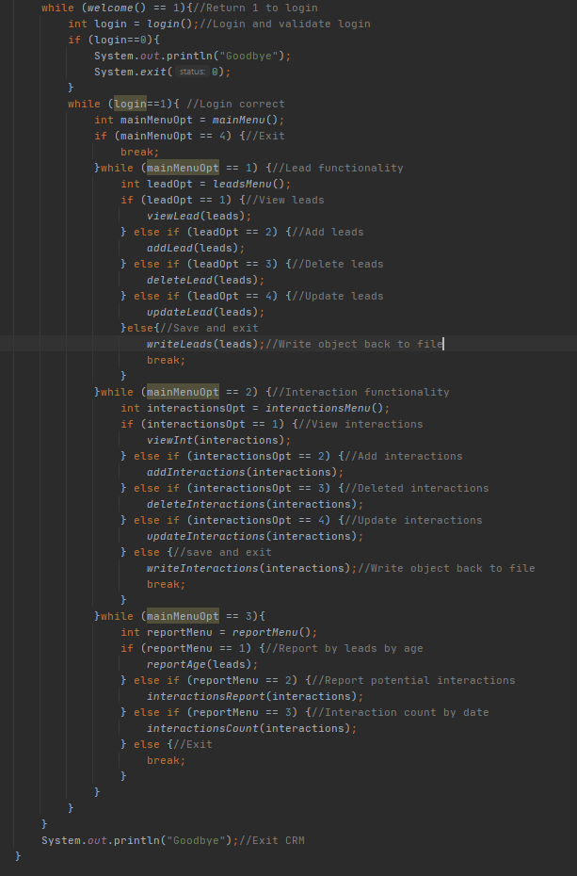

Figure 2.1.2: Looping for menu

## Leads and Interactions

Leads and interactions functionality are quite similar which allow user to view all the data, add more leads or interactions, delete data, update data, read and write to file. The 2 files are reads at the beginning of the program once it run. This will read and save it as 2 array type already declare are leads and interactions class, Leads [] leads and Interactions[] interaction.



Figure 2.2.1: Read file declaration

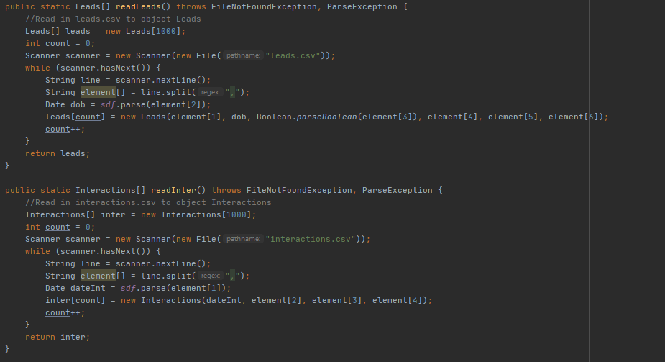

Figure 2.2.2: Read file function

If the user chooses to view either leads or interactions, the program will run a for loop through the array and prompt out by using print command with getter of the class. Delete leads will read lead ID entered by user, compare it with the leads that are save and set the name to null. Once we set the name to null, we won’t be printing it out in console as well as write it to the file. We only set the name to null because gender is declare as Boolean which can’t be set to null so setting one character to null is good enough. Add interactions or leads will allow user to enter and add more to the list. This will also be running through validation test that written as functions in the code. Update is also similar with delete, read in id, compare it with the list and update the characteristics of the ID. At the end, user will be able to exit and write the list back to the file by using for loop.

## Report

The report section has three functions: display all number of leads by age, all number of interactions by potential, all the number of interaction by month. A function getage written into the lead class in order to get age from date of birth given. From that by using for loop to go through all the leads, and if function to compare all the age, report can be given. By compare the potential key words, positive, negative and neutral we were able to count all the interactions.

# Function implementation and update

These are the functionalities of the program

Menu:

1. Login

Leads:

1. View leads
2. Add lead
3. Delete lead
4. Update lead

Interactions:

1. View interactions
2. Add interactions
3. Delete interactions
4. Update interactions

Report:

1. Age summary
2. Potential interactions
3. Interactions report by month

The project was done alone since I can’t find a partner in time. The result was better than I expected. All the functions that needed are included and work as expected. The only thing that challenge was getting input from user by using scanner.next() and scanner.nextline() since if using scanner.nextline() it will jump to the next line without prompting anything for user to input and some cases, scanner.next() won’t work such as address because of the space in between. If I have chance to improve, I will improve on the code efficiency and the layout of the code as well as the input validation as I think it’s quite weak. Another thing was the text print out is not straight as I like. Overall, I think I have succeeded and learn a lot from doing the project.

Demonstration : https://youtu.be/2OoQLj2SbgA

# References

CRM.org. 2020. *What Is CRM? Definition & Beginner’S Guide To CRM*. [online] Available at: <https://crm.org/crmland/what-is-a-crm> [Accessed 19 September 2020].

Salesforce.com. 2020. *What Is CRM*. [online] Available at: <https://www.salesforce.com/ap/crm/what-is-crm/> [Accessed 19 September 2020].