Wireframe explaination

1. Visitor screen

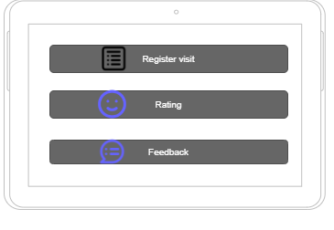

*First screen displays to visitor*

This is first srceen displayed on tablet has three button

Register visit is the button when visitors click, it will go to visiting register form below

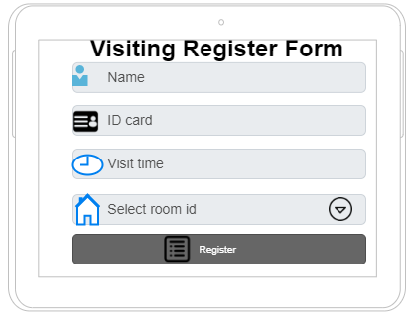

*Second screen displays to visitor*

The visitor need to fill in this form to register for visiting owner department:

Name is full-name of visitor

ID card is identity card of visitor

Visit time is the time which visitor choose to meet owner department

Room id is an id of apartment

When the visitor clicks button register, it will go back to the first screen

Rating is the button when visitor click, it will go to the rating screen below

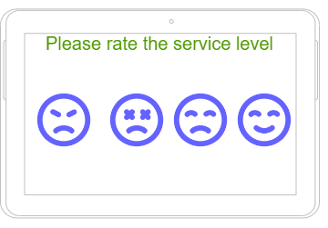

*Third screen displays to visitor*

There are four level: angry, boring, sad and happy, the visitor rates it by choosing the face, which reveal what they think about the service

After choose one of four face, it will go to the first screen

Feedback is the button when visitor click, it will go to the feedback screen

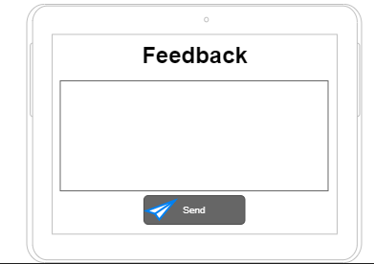

*Four screen displays to visitor*

The visitor type what they think, their idea in the text box, then they click on send button. The system will record the feedback and it change to first screen.

1. Security screen

The security need to login to use system

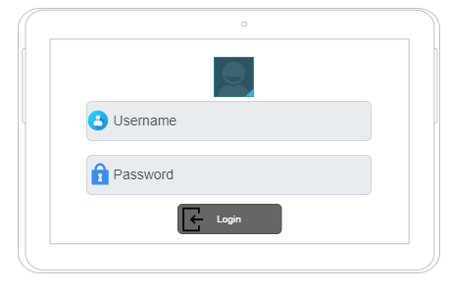

*Login screen*

After login successful, the screen will go to menu where security can choose below:

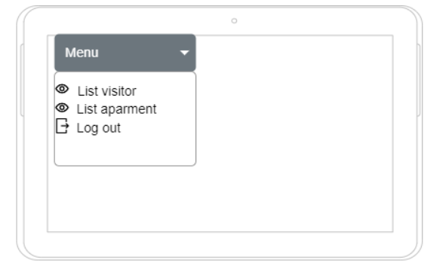

*Menu screen security*

If the security click on log out the screen will change to login screen

If security choose view list visitor, the screen will display below

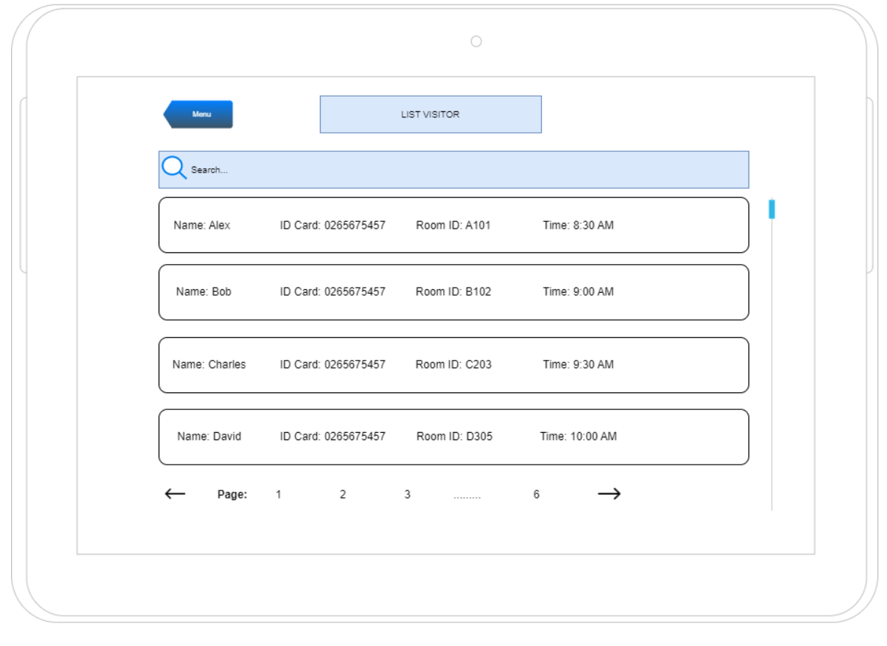

*List visitor screen*

The security can go back by click on button menu

If security choose view list apartment, the screen will display below

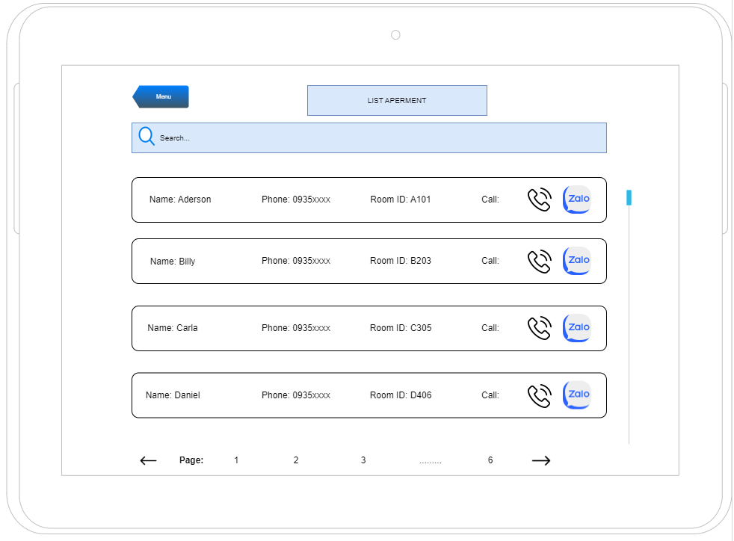

*List apartment screen*

1. Admin screen

The admin need to login to use system

If the admin clicks on log out the screen will change to login screen



*Login screen*

After login successful, the screen will go to menu where admin can choose below:

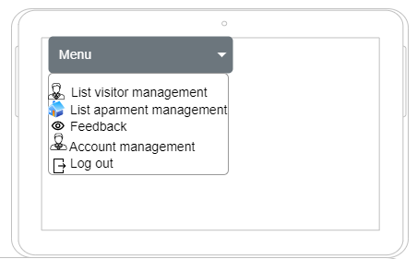

*Menu screen admin*

If admin click on list visitor management, admin can add, delete, edit visitor

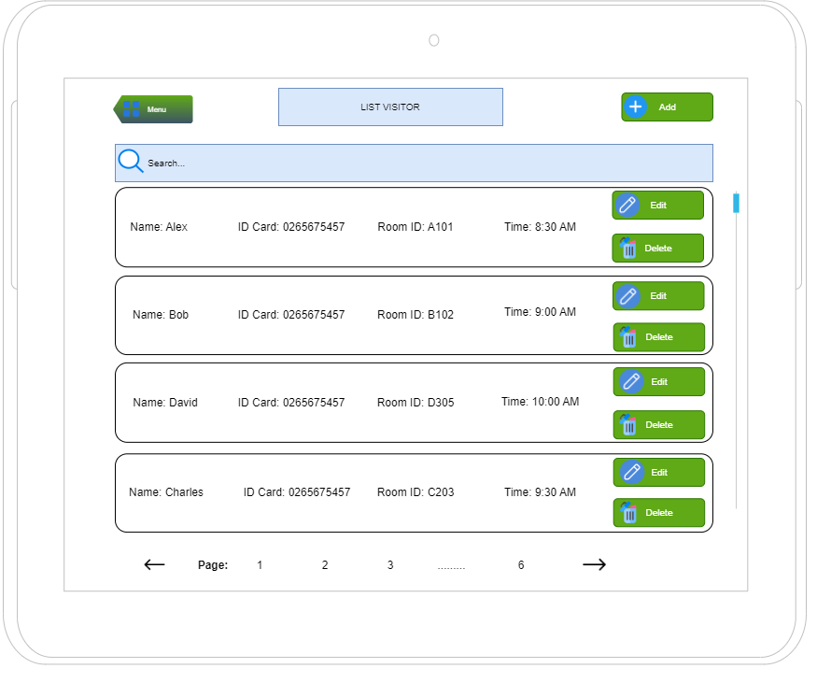

*List visitor management screen*

When admin click on add button, admin need to fill in new visitor form

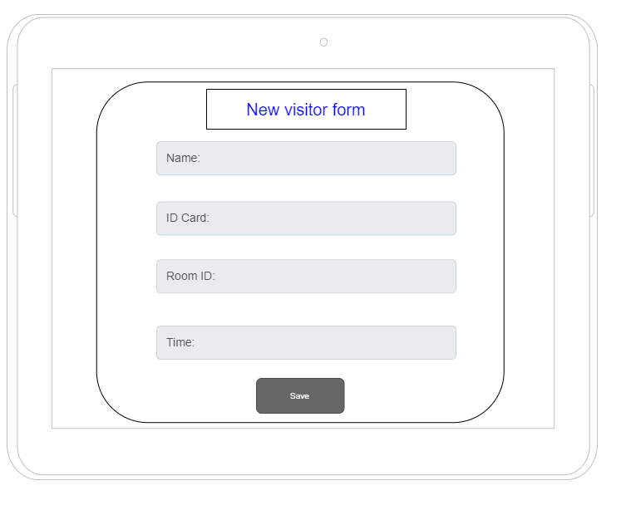

*New visitor form screen*

After filling in, admin click on button save

When admin click on delete button, admin need to confirm yes or no

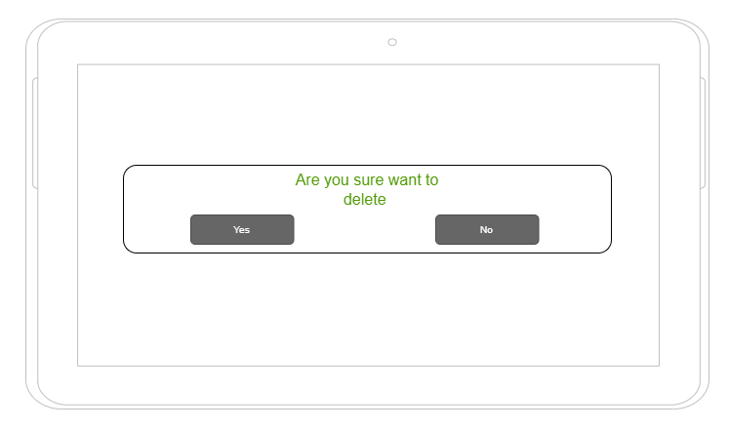

*Delete confirm screen*

If admin click on button edit, admin need to fill in edit visitor form

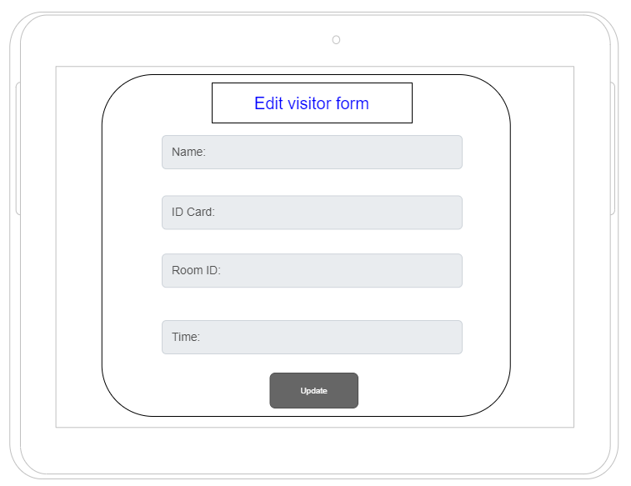

*Edit visitor form screen*

After filling in form, admin click on button update

If admin click on list apartment management, admin can add, delete, edit apartment

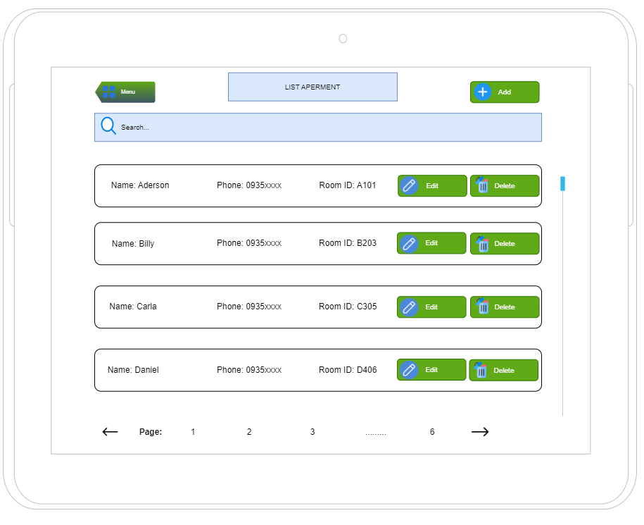

*List apartment screen*

When admin click on add button, admin need to fill in new apartment form

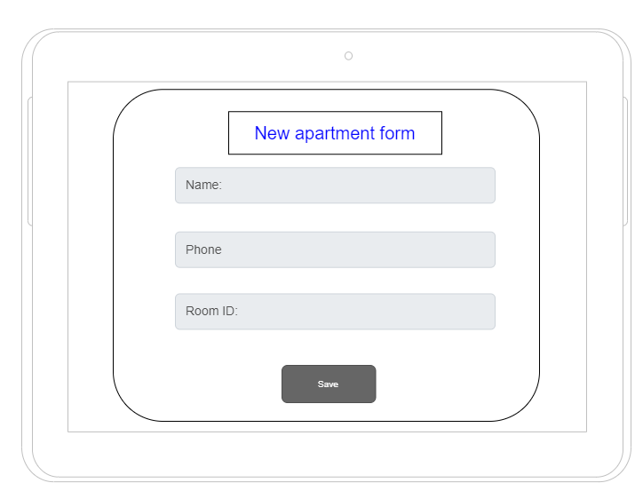

*New apartment form screen*

After filling in, admin click on button save

When admin click on delete button, admin need to confirm yes or no



*Delete confirm screen*

If admin click on button edit, admin need to fill in edit apartment form

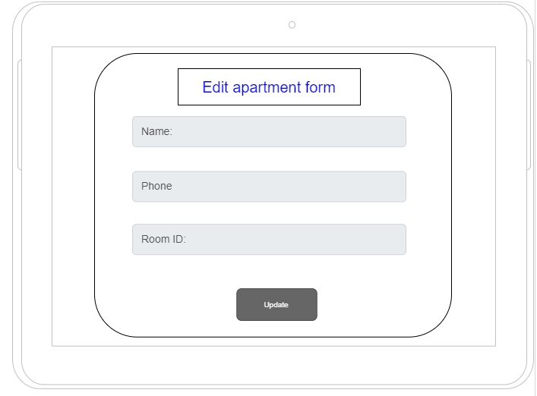

*Edit apartment form screen*

After filling in form, admin click on button update

If admin click on button feedback, admin can see feedback

If admin click on list visitor management, admin can add, delete, edit account

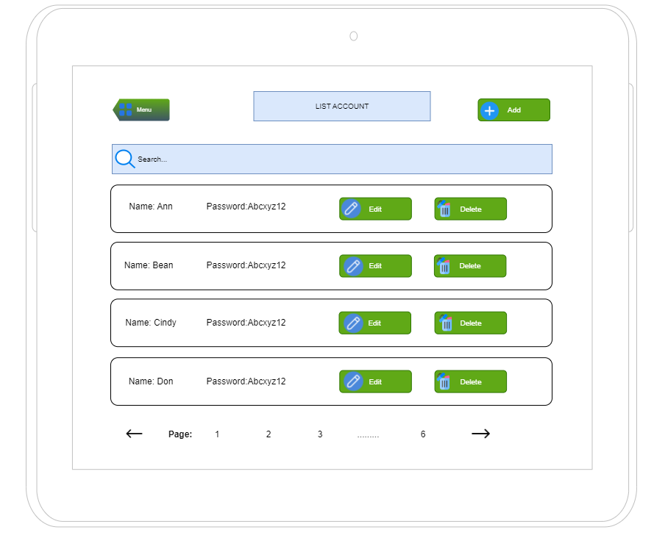

*List account screen*

When admin click on button add, admin need to fill in new account form

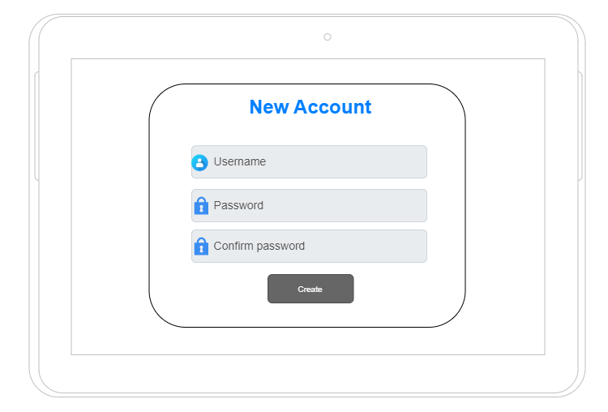

*New account form screen*

After filling in, admin click on button create

When admin click on delete button, admin need to confirm yes or no



*Delete confirm screen*

When admin click on button edit, admin need to fill in edit account form

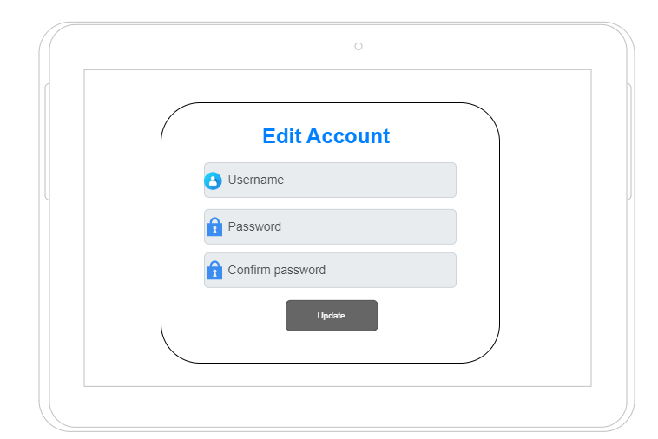

*Edit account screen form*

After filling in, admin click on button edit

Finally if admin want to go back menu screen ,they click on button menu.