

Car-Breezy

Documentation

Authors | C2203L-Group1
Authors | - Nguyễn Trọng Thăng  - Trịnh Hữu Dương  - Lê Văn Toản  - Doãn Hoàng Hải  - Lê Hải Triều
Date | 14/10/2022
Instructor | Nguyễn Đức Hoàng

Hanoi,12/10/2022
Index
1. Problem Definition 3
1.1. Problem Abstraction 3
1.2. The Current System 3
1.3. The Proposed System 3
1.3.1. Boundaries of the System 34
1.3.2. Hardware and Software Requirements 3
2. Customer Requirements Specification 3
2.1. Users of the System 3
2.2. System functions 3
3. System Designs 3
3.1. Entity Relationship Diagram 3
3.2. Database Design 3
3.3. Sitemap 3
3.4. System fucntions design 4
4. Validation Checklists 4

- Problem Statement
  - Problem Abstraction
Due to the development of today's modern world, the information technology (IT) industry has changed rapidly due to the needs of people in the world. And the website has played the most important role for people today, it helps us connect with each other, helps us to increase communication between users and admins, increases the range of users (possibly on a large scale). worldwide, unlike before, it can only be in a certain scope), increase interactivity (can help users search faster and offer products that match user needs), serve customers effectively,.…

CarBreezy is a leading automotive digital marketplace that seeks to make car buying easy, transparent and efficient.

Your car buying destiny is in your hands, but we will help you every step of the way. We built this site to make car buying as fast and easy as possible.

From discovery to delivery, consumers can use CarBreezy to explore vehicles from an expansive, cross-brand selection of inventory from our vast network.

CarBreezy has built a trusted brand and a strong reputation for providing consumers with useful tools, research, market context and pricing transparency as they embark on their car-buying journey. The Company is bringing more of the purchasing process online by allowing consumers to find a vehicle that is right for them and complete their purchase with all from the comfort of their home.
  - The Current System
Working process of the system without applying technology:
If customers wanna buy or experience car, they have to go to the showroom. When they come, the customers make a request. The staff will listen to the customer's request and then take them to the car they want. And they’ll decide to buy this one or not. Finaly they take the contract. But sometime, the car which they want is not available, or they get some finance problems. Here is where inconveniences come

So that , the agency will facing difficulties:
- Cars:
Agency cannot guarantee all models at all times, because there are many different brand, models, class and colours.
- Consultants:
Some consultants have built a reputation after many years of work and have a large loyal customer base. Clients only want to work with these people. It is inevitable that they have to contact and work with many customers at the same time. Thus, it is not possible to guarantee the quality of work and services provided to customers

  - The Proposed System
- F1: The system shall allow admins to create new categories according the brand new cars.
- F2: The system shall display for admins categories what has been created by admins.
- F3: The system shall allow admins to update information of categories.
- F4: The system shall delete categories.
- F5: The system shall allow admins to create new products.
- F6: The system shall display products that have been created.
- F7: The system shall update products by admin.
- F8: The system shall delete products useless.
- F9: The system shall allow admins to see all admins.
- F10: The system shall allow admins to update information of admins.
- F11: The system shall login by user name and password.
- F12: The system shall logout of this system.
- F13:The system shall display all information of customers for admins.
- F14: The system shall allow admins to update information of customers.
- F15: The system shall display a homepage for customers.
- F16: The system shall display a list category.
- F17: The system shall allow customers to see all products.
- F18: The system shall display list products by category.
- F19: The system shall display list products by search.
- F20: The system shall display details of the product.
- F21: The system shall allow customers to sign-up information.

1.3.1. Boundaries of the System
- Customers: For everyone in need.
- Use object: Everyone has a need to buy car
- Scope of application: anywhere in the world
    - Hardware and Software Requirements
Hardware
- Intel Core i3/i5 Processor or higher
- 8 GB RAM or above
- Color SVGA
- 500 GB Hard Disk space
- Mouse
- Keyboard

Software
Technologies to be used:
- Frontend: HTML5, CSS, Bootstrap, JavaScript, jQuery, AngularJS, XML
- Data Store: JSON files or TXT files

Other Requirements:
- Operating Portal: Windows
- Browsers: Edge, Chrome, Mozilla Firefox, Safari

- Customer Requirements Specification
  - Users of the System
- Amin:
Who can login, logout in the system. And they can change all data in the database. Especialy, they can decide what to display to the customers.
- Customer:
They can visit the website, they are allowed to see the cars for sale, and choose the most suitable cars. And can order cars and send request to the admins.
  - System functions
F1: The system allows administrators to create new car according the brand new ones.
- Input information: Information about car that the administrator needs to create according to market demand (name of car, image, price, model, colour, etc...)
- Output information: After admin create cars show whether car has been created or not.
- How to handle: Submit form, Validate, Add car that the administrator needs to add to the database
- Stored data: Save the new car created by the administrator
F2: The system allows the administrator to view all created car’s information (car name, image, ...)
- Input information: Information for each type of car
- Output information: View all information of each car
- How to handle: Select from the car table, display full information.
- Stored data: Not stored
F3: The system allows administrators to update information about car including (name of car, image, ...)
- Input information: Initial car information has not been updated, car information that the administrator wants to change
- Output information: After admin updated the car number, show whether the car has been updated or not.
- How to handle: Submit form, Validate, access data and edit car information to be corrected.
- Stored data: New car has been updated by admin
F4: The system allows the administrator to delete the cars.
- Input information: Car information to be deleted
- Output information: After admin delete car number, show if car has been deleted or not
- How to handle: Delete the information of each type of old car from the database.
- Stored data: Not stored
F5: The system allows administrators to create product categories of each new type of car including (name, image, ingredients, selling price,etc...)
- Input information: Product information of the type of car that the admin needs to create
- Output information: Notice the result after working, whether it is successful or not.
- How to handle: Put each type of car that the administrator has created into the database
- Stored data: Categorize cars and save them in the database
F6: The system allows administrators to view all product categories of each type of car including (name, image, price,etc...)
- Input information: Product information of the type of car that the administrator needs to see
- Output information: display product information of each type of car that the administrator needs to see
- How to handle: Go to the database to find and give all the information of each type of car that the administrator needs to see
- Stored data: No need to store
F7: The system allows the administrator to update all types of products of each type of car including (name, image, price,...)
- Input information: Car model information needs to be updated, old information
- Output information: Notice the result after working, whether it is successful or not.
- How to handle: Update the model of car is updated to the database
- Stored data: Save the updated car in the database.
F8: The system allows the administrator to delete all types of products of each type of car including (name, image, proce,...),
- Input information: The product information of the car that the administrator needs to delete.
- Output information: Notice the result after working, whether it is successful or not.
- How to handle: Go to the database to find out the products of the type of car that the administrator needs to delete..
- Stored data: Save the deleted car name(ID).
F9: The system allows administrators to view all information of other administrators from name, email, phone number, password in hash form to secure information.
- Input information : The information of the administrator but the password will be protected as a hash code.
- Output information : Display the administrator's information, note the password in the form of a hash.
- How to handle: Get the information of administrators and passwords in the form of hashes in the database and display.
- Stored data: The system will not need to save the data.
F10: The system allows the administrator to update the administrator's information
- Input information: Information given by the administrator (large) to update the administrator (small).
- Output Information: After updating, show the administrator whether the update was successful or not.
- How to handle: Go to the database to find and update the information that the administrator needs to update.
- Stored data: Save the changes after successfully updating the administrator's information.

F11: The system allows the administrator to log in with the user name and password to start working.
- Input information: Administrator username and password information..
- Output Information: Displays the correct or incorrect password, whether the username exists, if it is correct, both will display successful login and enter the system.
- How to handle: Go to the system's database to find out if the username and password given by the administrator is correct, if it's correct, then enter it, if it's wrong, don't enter it.
- Stored data: The system will save the number of login attempts.
F12: The system allows the administrator to log out of the system
- Input information: When the administrator presses the exit button from the system.
- Stored data : After logging out, the system will show the administrator whether or not he has successfully logged out.
- How to handle: When the administrator presses the logout button, the system will return to the home page (login to the system).
- Stored data: The system does not need to save data.
F13: The system allows the administrator to view all customer information (Name, age, gender, address, email, sdt).
- Input Information: Any customer information that the administrator needs to see.
- Output Information: Display customer information that the administrator needs to see
- How to handle: Go to the database to get customer information that the administrator needs to see and give it to the administrator.
- Stored data: If there are changes, save them, otherwise, the system does not need to save them.
F14: The system allows the administrator to change customer information.
- Input information: Any information that the customer gives to the administrator needs to be changed.
- Output Information: After the change, display to the administrator whether the change was successful or not.
- How to handle: Go to the system's database, find customers who need to change information.
- Stored data: save new customer information data.
F15: The system allows to display the home page, including the store's introduction
- Input information:HTTP Request;
- Output information: the home page includes brand information and a brief description of the car.
- How to handle: User's HTTP Request is routed to the router and the router determines which controller to handle. The controller gets data from the model to generate the homepage view for the user.
- Stored data: No data is saved.

F16 : The system allows displaying cars according to national events.
- Input information: Manipulating the guest's holiday selection.
- Output information: Car’s user inrterface on that holiday
- How to handle: Submit the holiday and search the database for the car’s colours relate to that holiday then display
- Stored data: No data is saved.
F17: The system allows to display all the car lists created by the admin, either by category.
- Input information: Car models, or all cars
- Output information: List of cars to look for
- How to handle: Receive input information, Access data in product table, find and display all product names with names as customers need..
- Stored data : none

F18: The system will allow users to view all information of all kinds of cars (eg name, image, price,...),
- Input information: guest's choice of car name or model
- Output information: All information related to cars that customers are interested in.
- How to handle: Access the data and get all the information about the car that the customer chooses
- Stored data: None.
F19: The system allows the user to search by the name of the cars.
- Input information: user input character.
- Output information : List of cars containing characters to look for
- How to handle: Get user input
- Stored data: none
F20: The system will allow users to view detailed information of all types of cars (for example, car name, image, description
- Input information: guest's choice of car name
- Output information: All information related to cars that customers are interested in.
- How to handle: Access data and get full information about the model of car the customer chooses
- Stored: None
F21: The system allows customers to sign-up.
- Input information: Customer information
- Output information: Display sign-up complete or not
- How to handle: Submit, Validation, Access database and add customer
- Stored data: Account, password, customer information

- System Designs
  - Entity Relationship Diagram

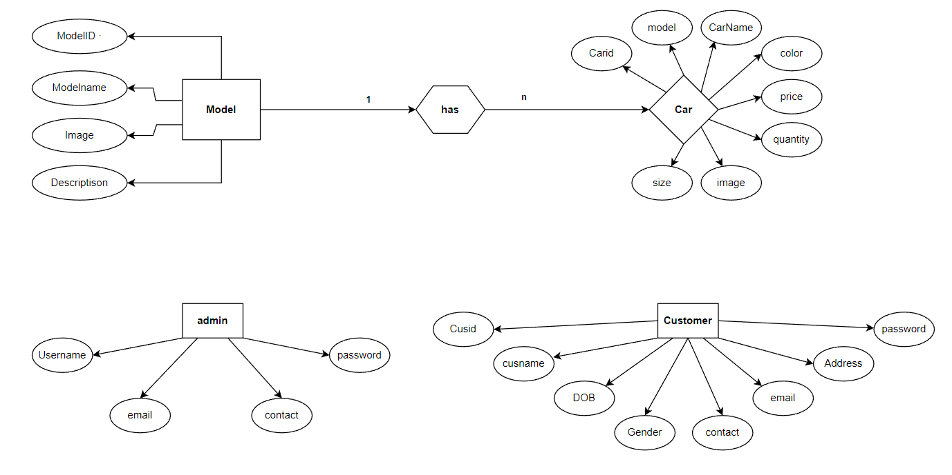
  - Database Design
- Table

Column | Type | Key | Size
Modelid | int | Primary key | 11
Modelname | Varchar |  | 255
Image | Varchar |  | 64
Description | Text

- Car Table

Column | Data Type | Key | Length
Carid | int | Primary key | 11
model | int | Foreign key | 11
Carname | Varchar |  | 255
Color | Varchar |  | 30
Price | Char |  | 10
quantify | smallint |  | 6
Image | Varchar |  | 64
Size | Varchar |  | 255

c) Customer Table

Column | Data Type | Key | Length
Cusid | int | Primary key | 11
Cusname | int |  | 255
Dob | Varchar
Gender | Date |  | 6
Contact | Varchar | Unique | 11
Email | Char |  | 255
Address | Varchar |  | 255
Password | Varchar |  | 255

- Admin Table

Column | Data Type | Key | Length
adminid | int | Primary key | 11
Username | Varchar |  | 255
Contact | bigint |  | 255
Email | Varchar |  | 15
PASSWORD | Varchar |  | 255

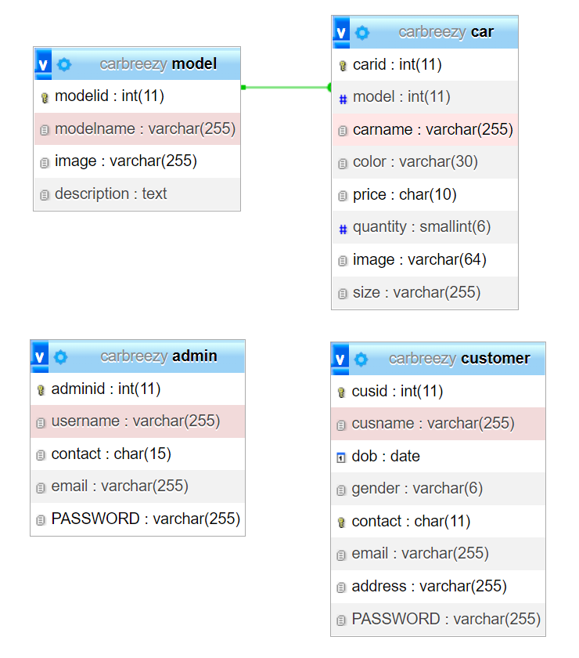

Relationship

  - Sitemap
- Admin Site map:

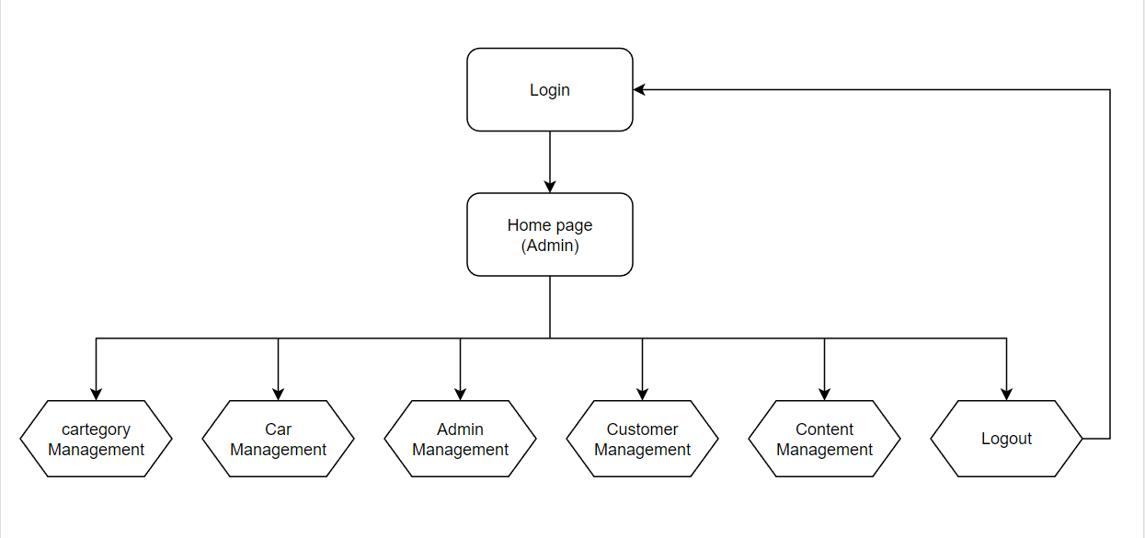
- Customer Site map:

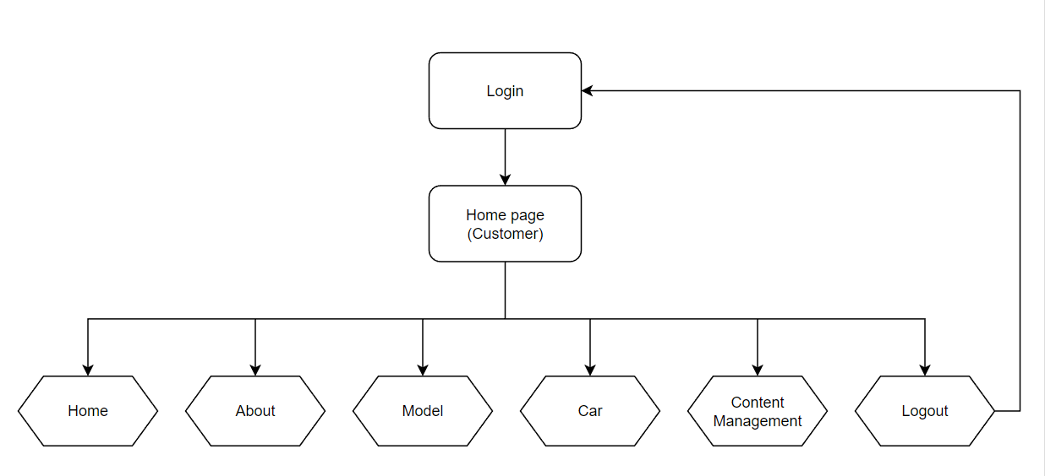

- Home page

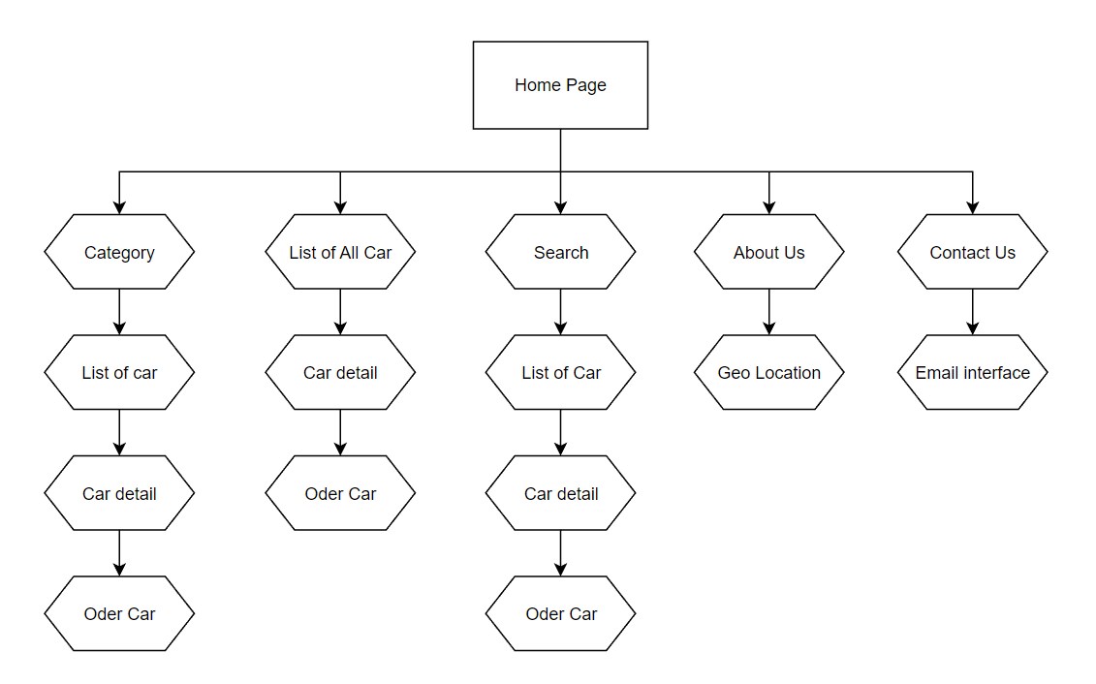

  - System fucntions design
    - Interface:
- Admin
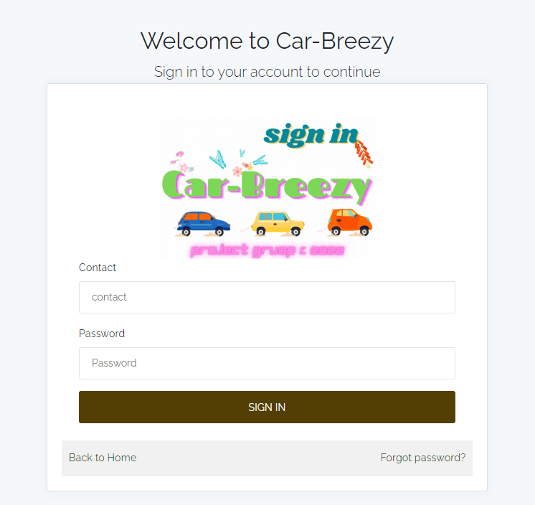
Admin login

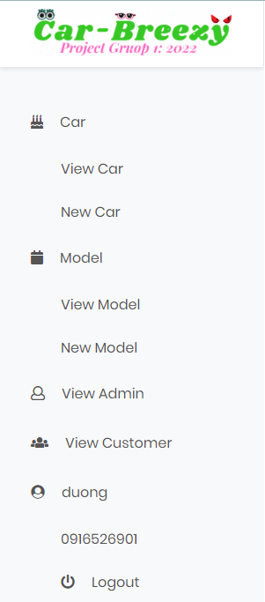

Side bar

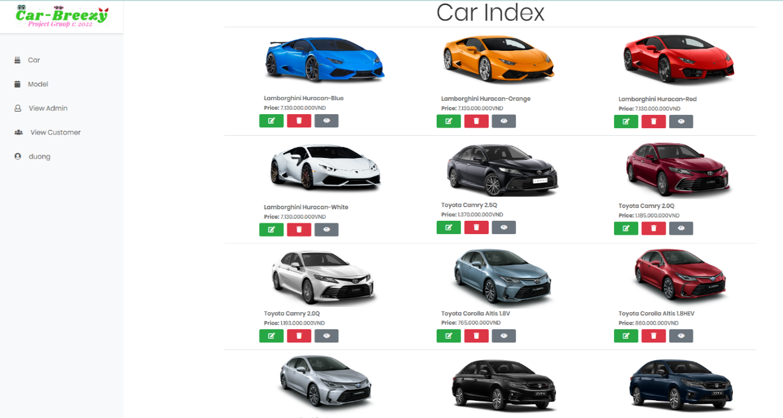

Car view Page

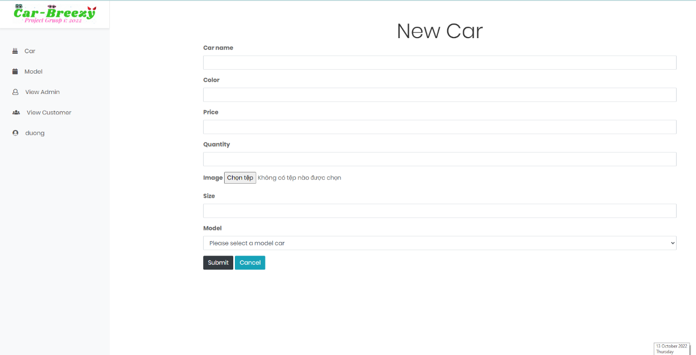

New Car Page

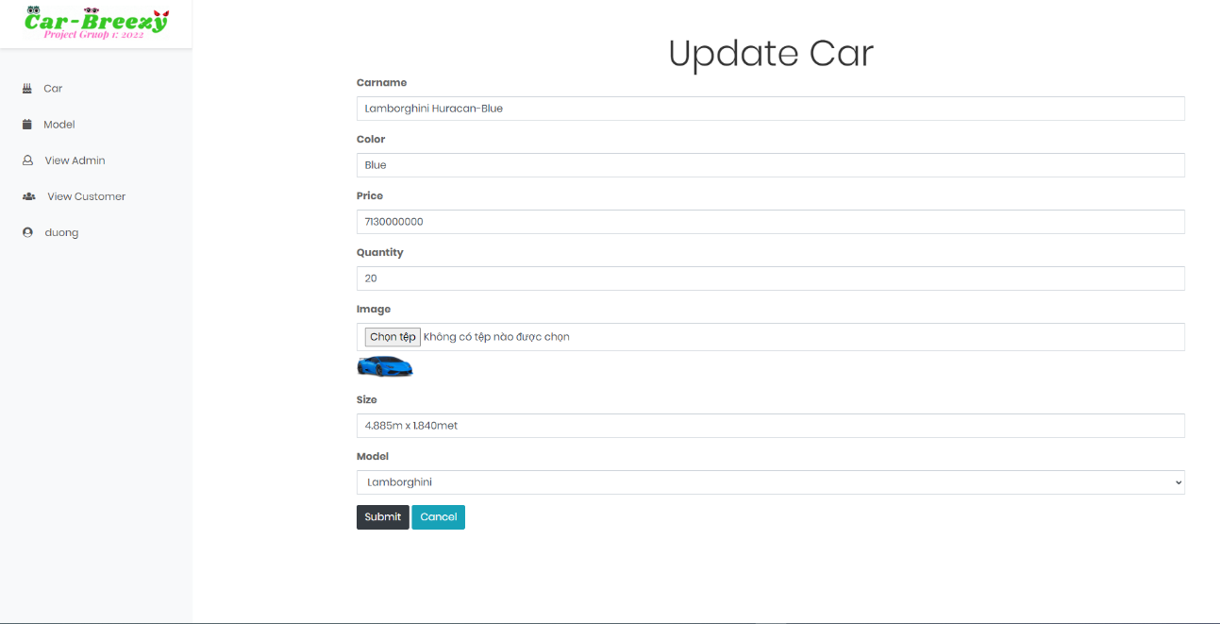

Update car form

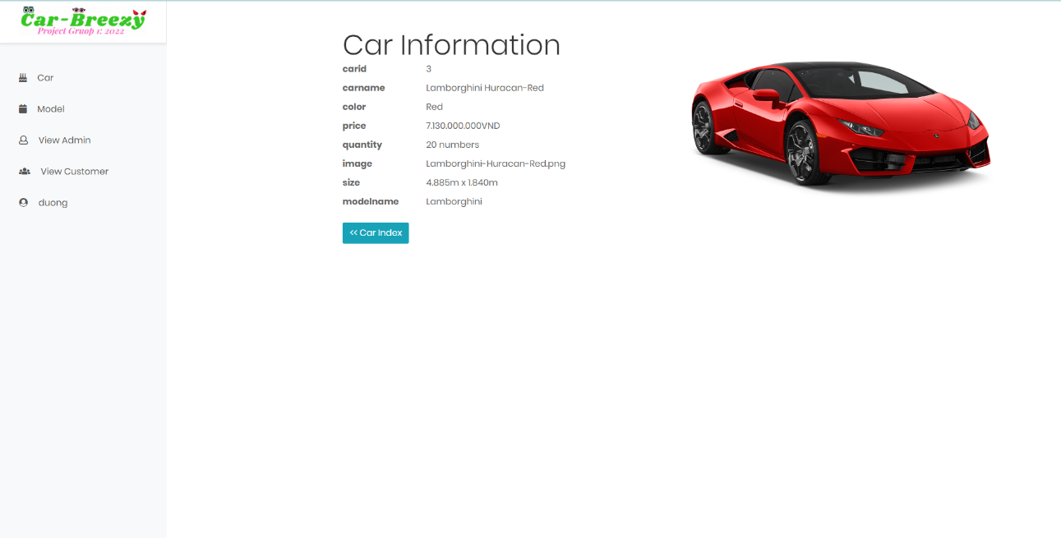Cake Detail

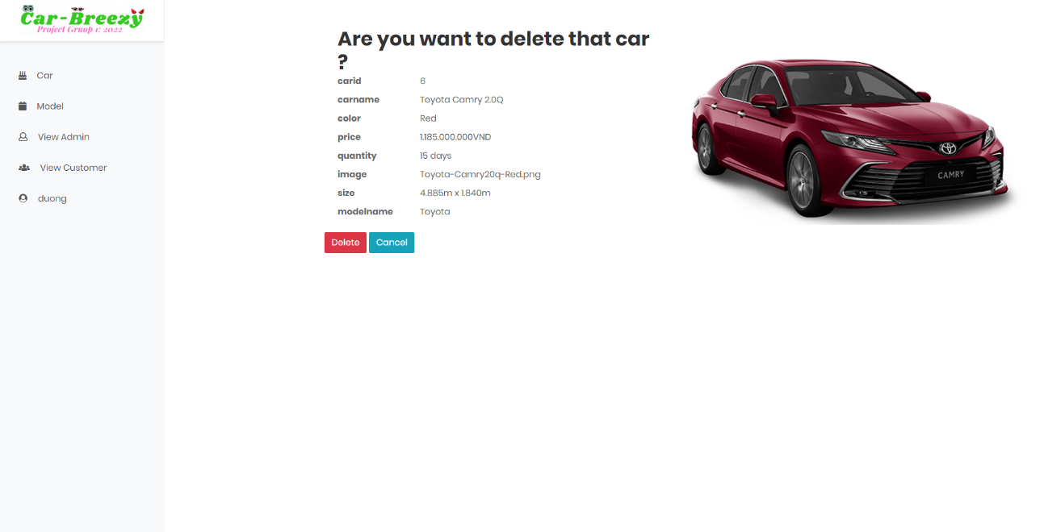
Delete Car Page

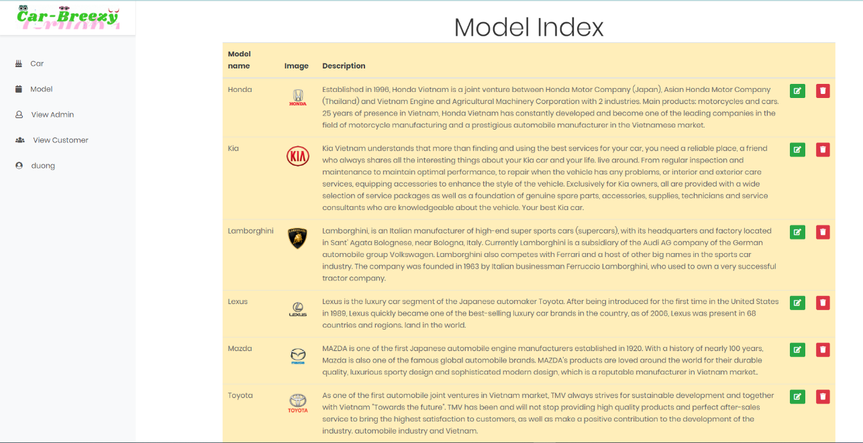

Model Page

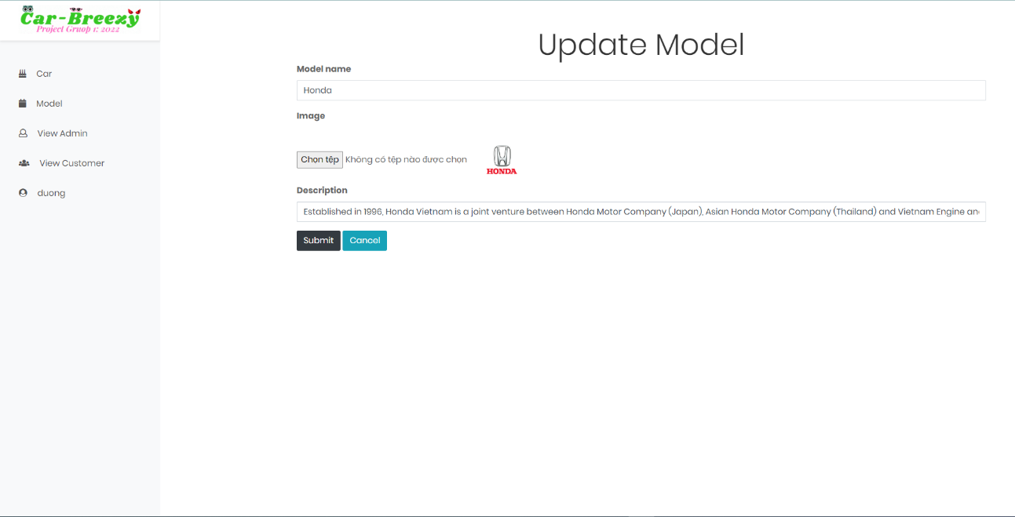
Model form

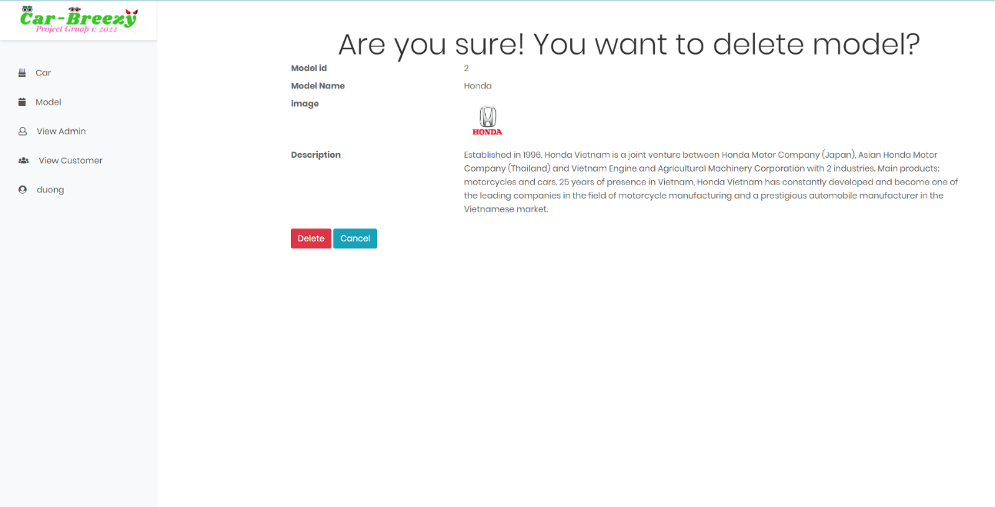

Delete Car model page

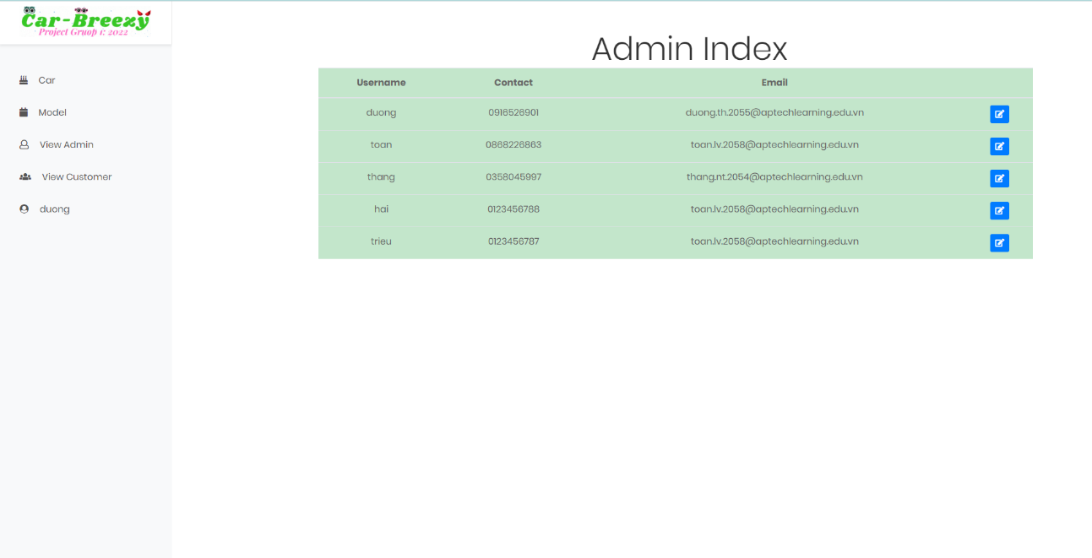

Admin View

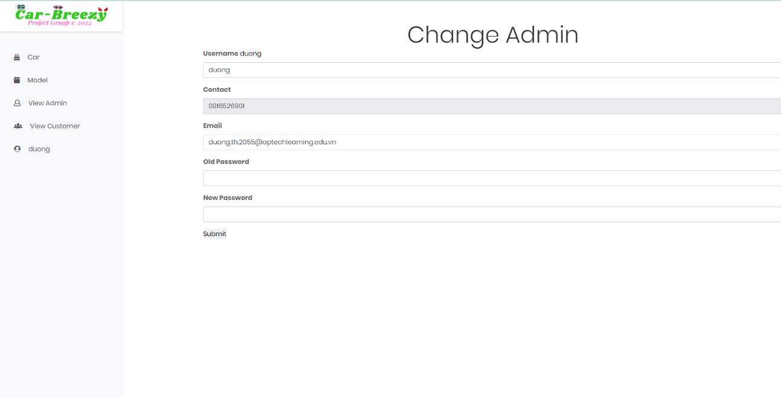

Update Admin Information Page

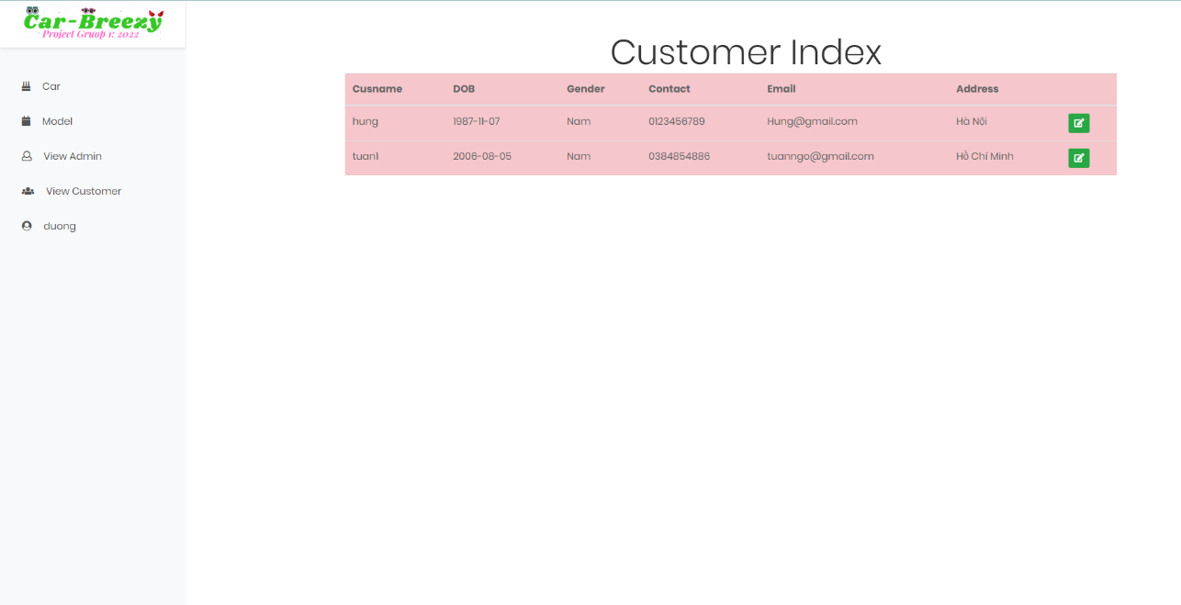
Customer View Page

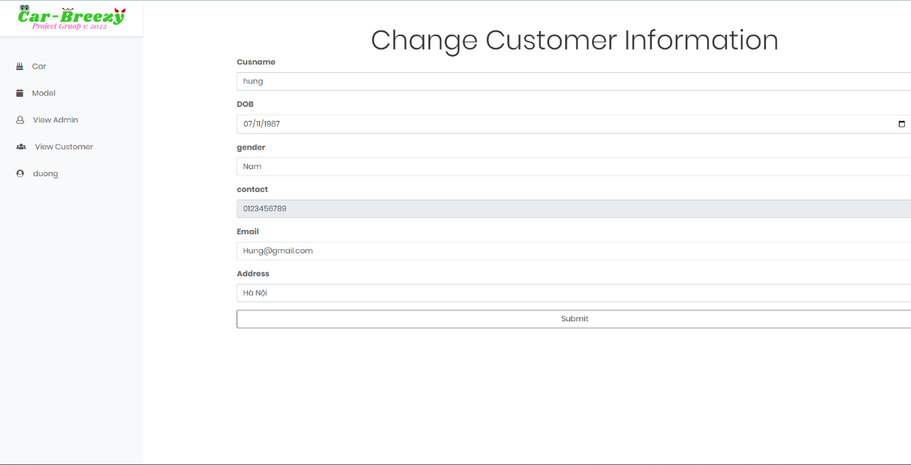
Update Customer

- User
Client Navbar


Client Footer

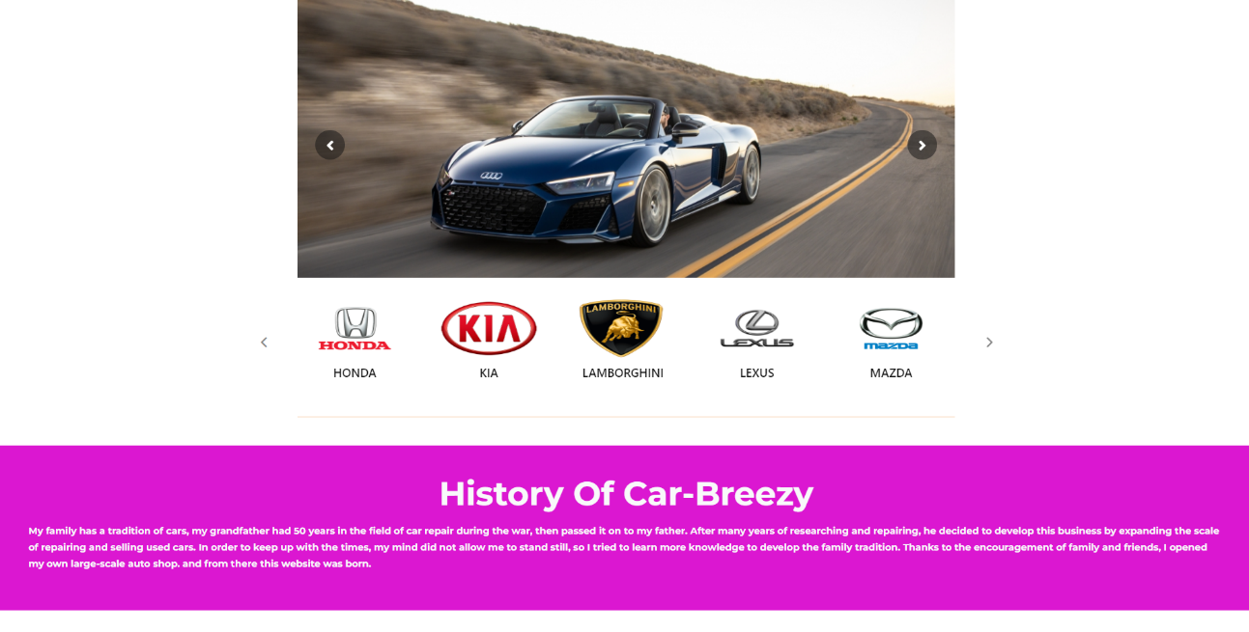

2 images of Client Home Page

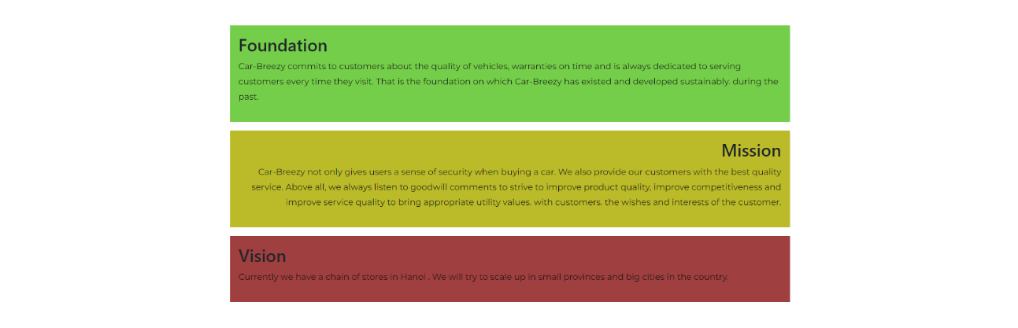
About Us Page

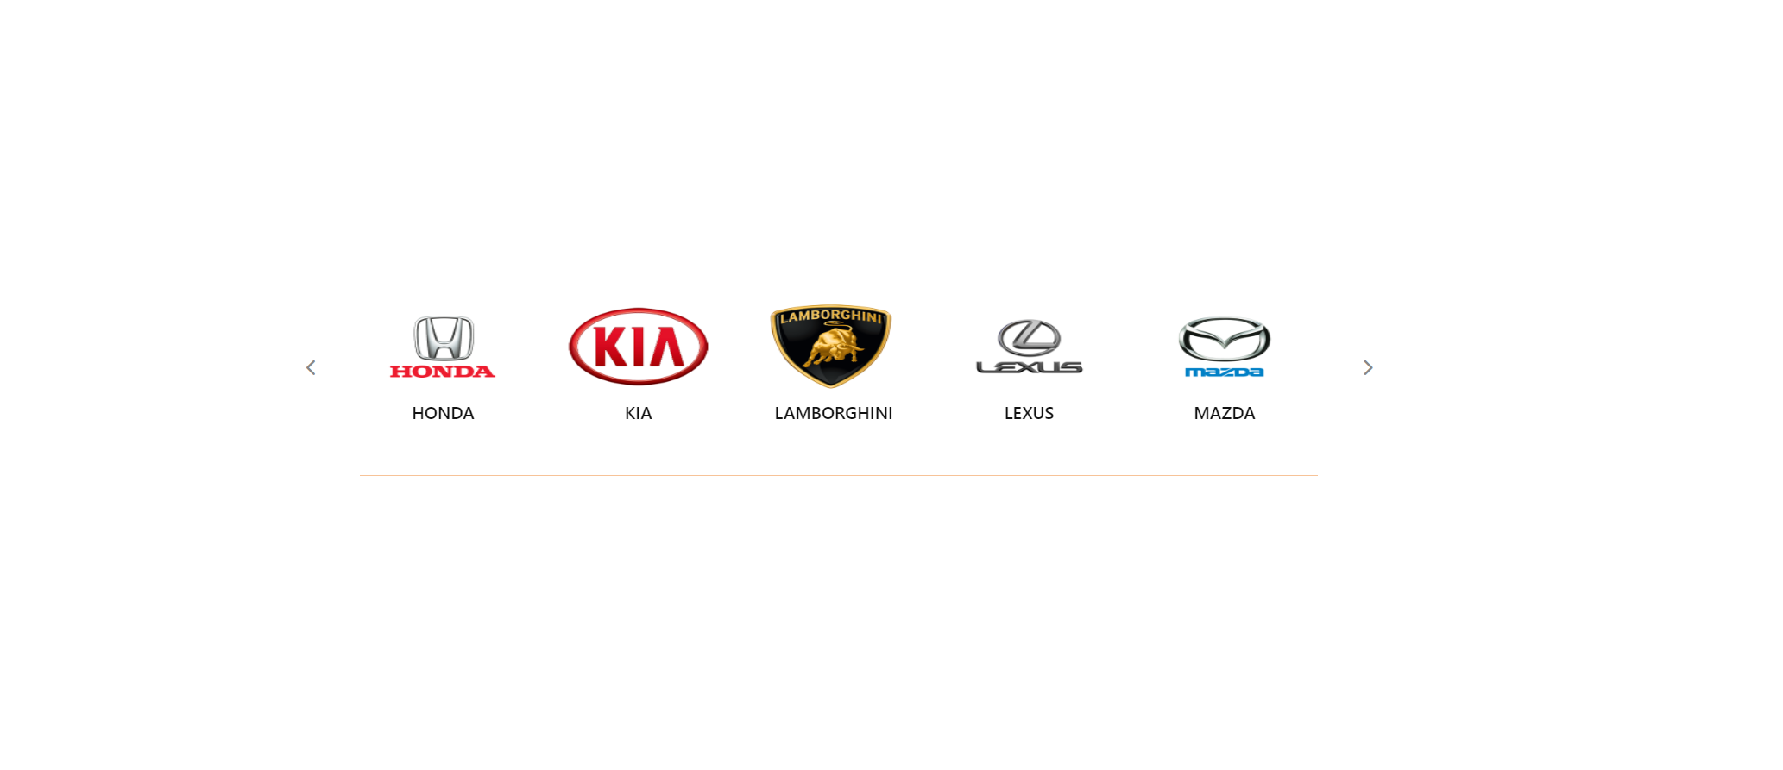
Model

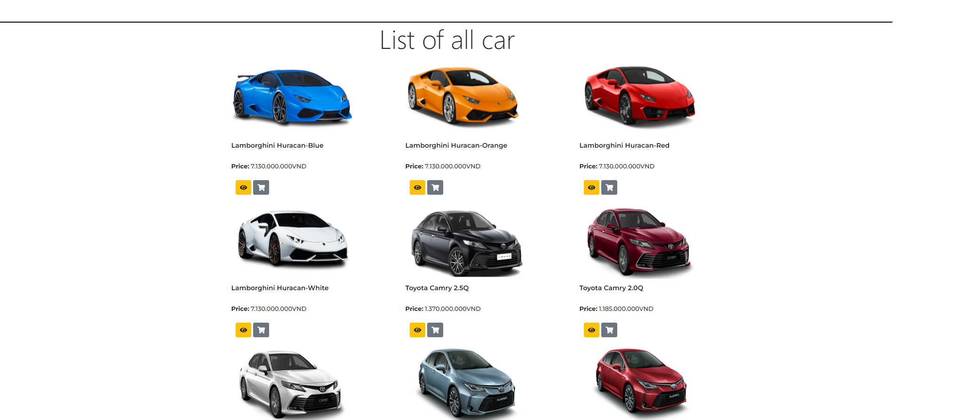
All Car Page

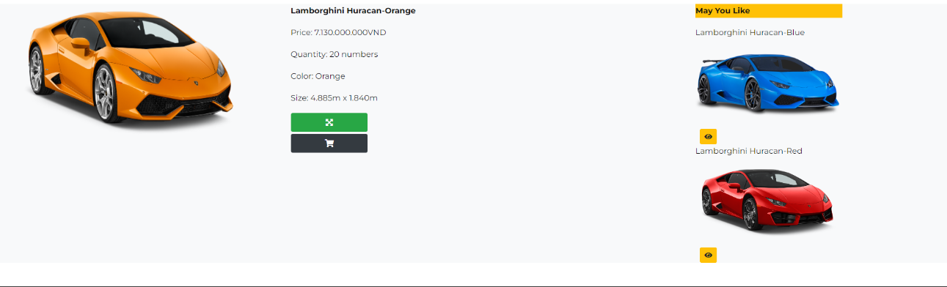
Car Detail Page

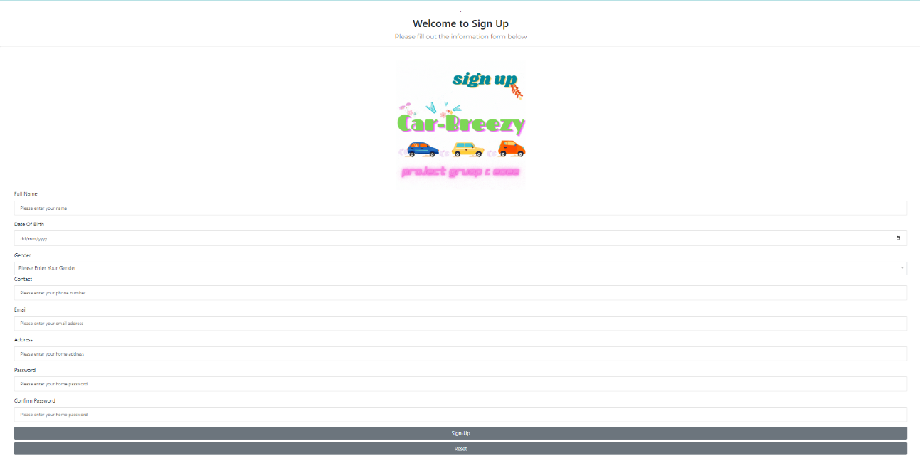

Form Order

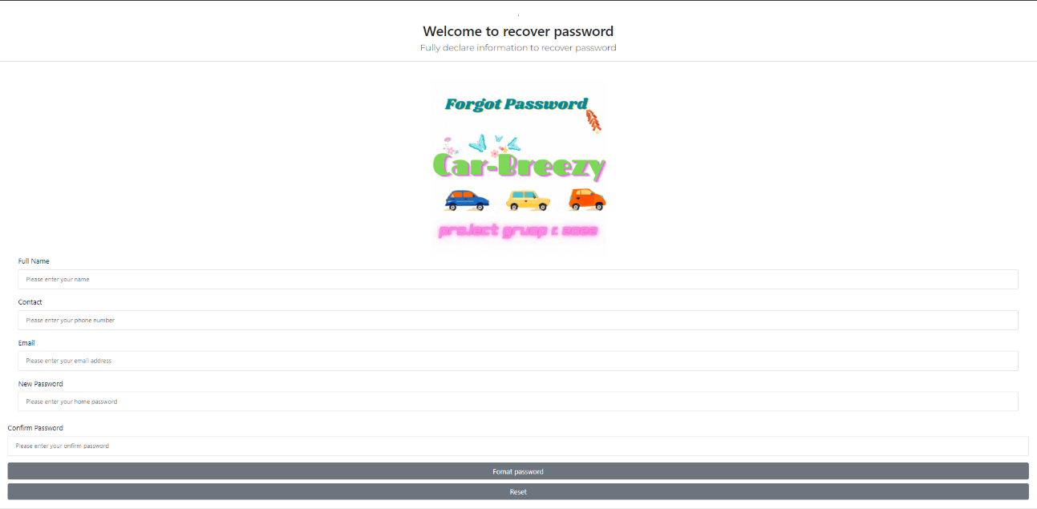

Forgot Password Customer

Login Customer

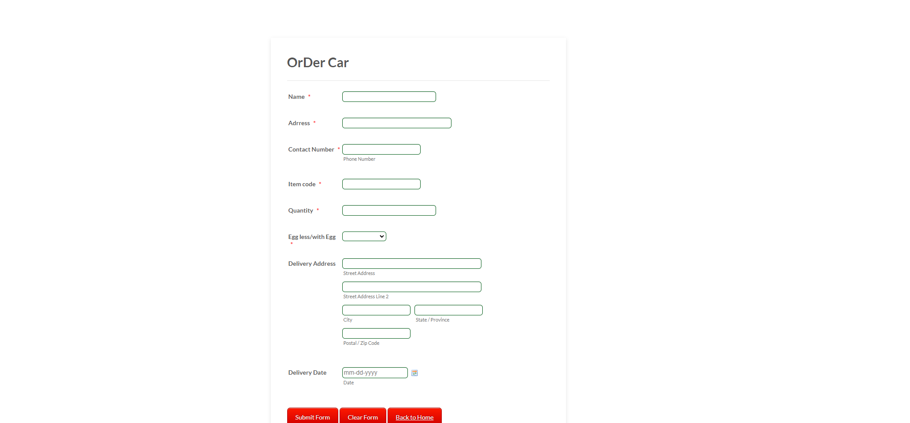
Form Order


Search Car Form

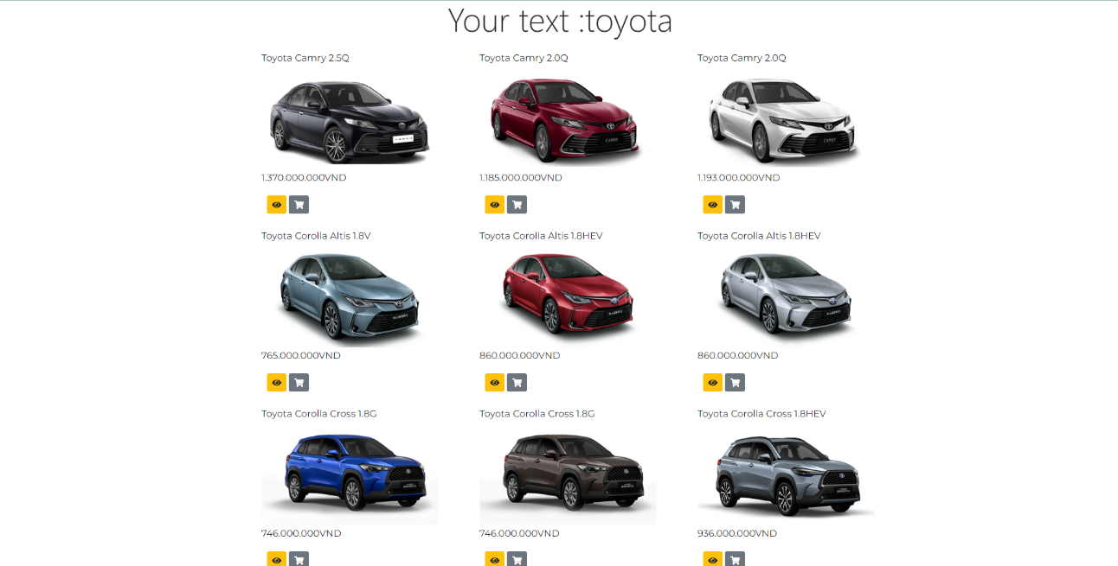
Search Car Page

    - Function:

F1: The system allows the administrator to create new car.
- When creating a new category, the admin must enter information such as (car name, image, description).
- The system will then check the authentication (required category name, no more than 255 characters; image cannot be empty link). If the admin enters incorrectly, it will display an error for the user to re-enter.
- If through authentication, the system accesses the database and compares, if the category name appears, it will print an error and return to the input step.
- If the name does not appear, show more success and redirect to the homepage.
F2: The system allows the administrator to view all created car information (car name, image, ...)
- When the admin wants to see the cars, the system will access the database and get all the information.
- After retrieving all the necessary information, the system will print to the screen.
F3: The system allows administrators to update information about cars (name of car, image, description, ...).
- When updating a car category, the administrator needs to enter information such as (category name, image, description).
- The system will check the validation (The name of the car is required, the image is also required.). If the administrator has entered it incorrectly, please re-enter it.
- After Validate is correct, the system will access the database, this time will compare the data entered by the administrator with the available data, if there is a match, notify the existing data, exit for the user to re-enter .
- If, after checking, the new information entered by the administrator does not match the old information, it will save the new information and notify the administrator of successful saving, then return to the homepage.
F4: The system allows the administrator to delete the cars.
- When the admin wants to delete a car, the system will access the database and display all the information of the car to be deleted.
- If the selected car is the model of car to be deleted, the admin will press the delete button and the system will delete the information, display a message of successful deletion and return to the homepage. Otherwise, it will return to the category management page.
F5: The system shall allow admins to create new products.

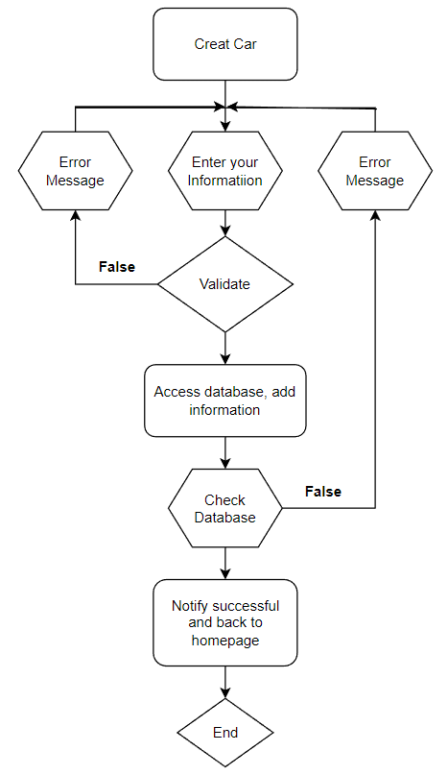
F6: The system shall display products that have been created.
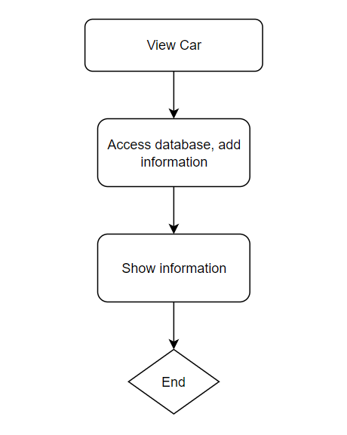

F7: The system shall update products by admin.
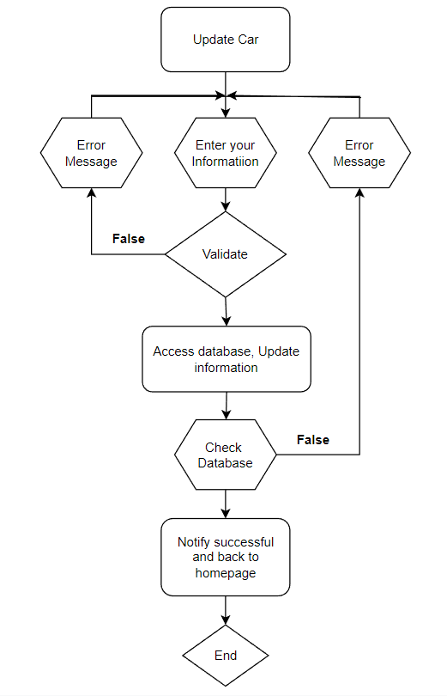

F8: The system shall delete products useless.
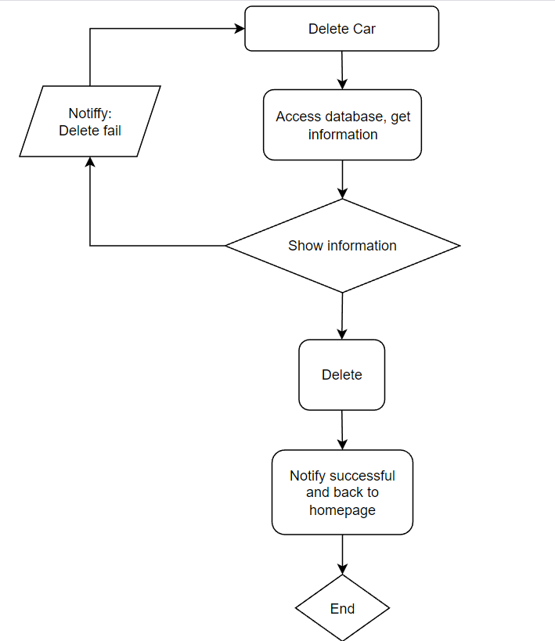

F9: The system shall allow admins to see all admins.
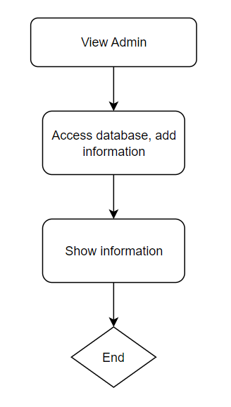

F10: The system shall allow admins to update information of admins.
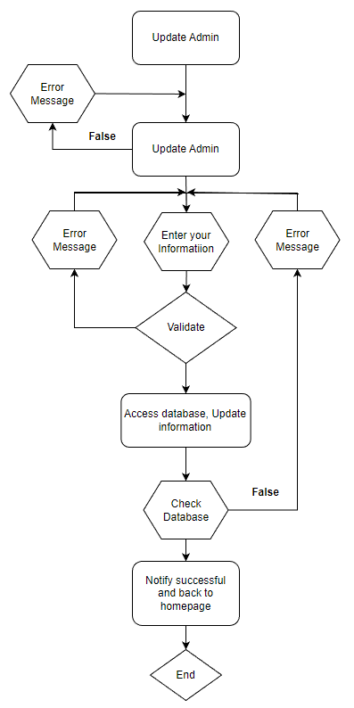

F11: The system shall login by user name and password.
- If the admin wants to log in to the system, the admin needs to enter the account name with the password.
- The system will check the validation (Account name must not be longer than 255 characters, and cannot be blank, password cannot be blank and must not exceed 255 characters).
- If the admin entered incorrectly, notify the admin and let the admin re-enter it.
- After validating, the system will access the database to see if the account name and password match, otherwise, the wrong account name and password will be reported and then return to the login page for admin to re-enter.
- If the information is correct, let the admin go to the homepage to start working.
F12: The system shall logout of this system.
- When the admin presses the logout button, the system deletes the session variable.
- The system will check if it has been deleted or not, if not, the admin will log out again
- If the deletion is successful, the admin will return to the login page
F13:The system shall display all information of customers for admins.
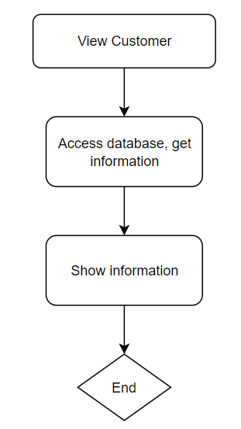

F14: The system shall allow admins to update information of customers.
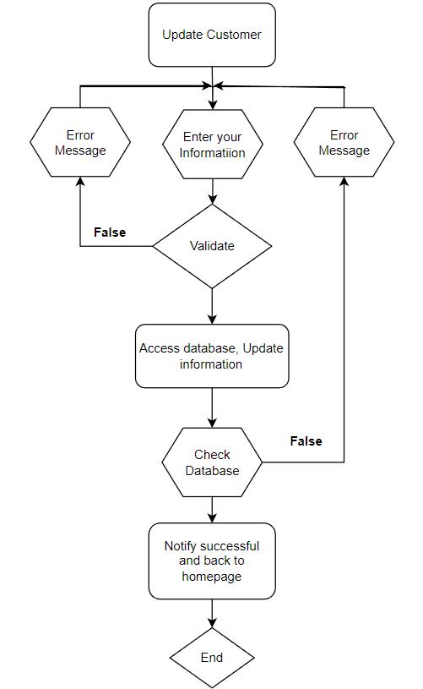

F15: The system shall display a homepage for customers.

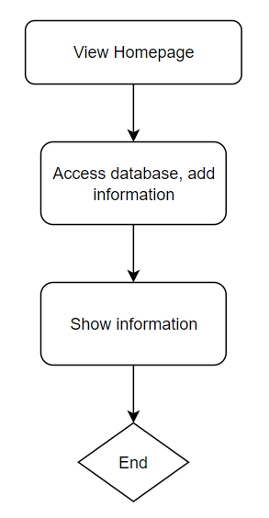

F16: The system shall display a list category.
- When the customer wants to see the information of the car, the system will access the database and get all the necessary events.
- After retrieving all necessary events, the system will print to the screen.
F17: The system shall allow customers to see all products.
- If the customer wants to see the information of the car, the system will access the database and get all the necessary information.
- After retrieving all the necessary information, the system will print to the screen.
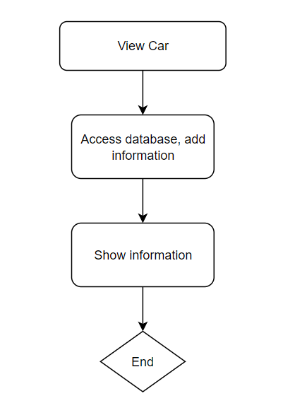
F18: The system shall display list products by category.

F19: The system shall display list products by search.
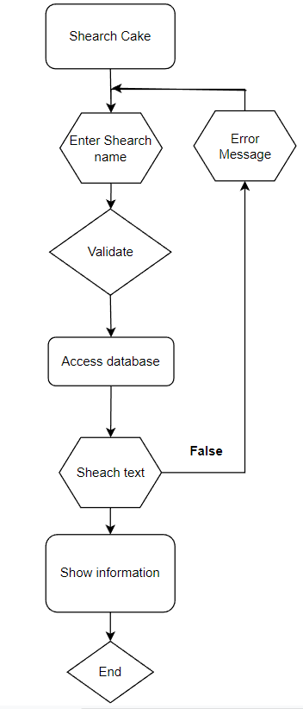

F20: The system shall display details of the product.
- When a customer wants to see the details of a car, the system will access the database and get all the details of that car.
- After getting all the details, the system will print to the screen.
F21: The system shall allow customers to sign-up information.
- When users want to sign-up, they have to fill in the information (name, date of birth, phone number, email, gender, address).
- When you press submit, the form will automatically validate (inputs cannot be blank).
- If it is empty, the system will re-enter it. Otherwise, the system accesses the database and stores customer information.
- After saving, the system checks the database. If there is an error, the customer will be forced to re-enter. If not
- it will report success and redirect to homepage.
F22: The system shall allow customers or admin to sign-up
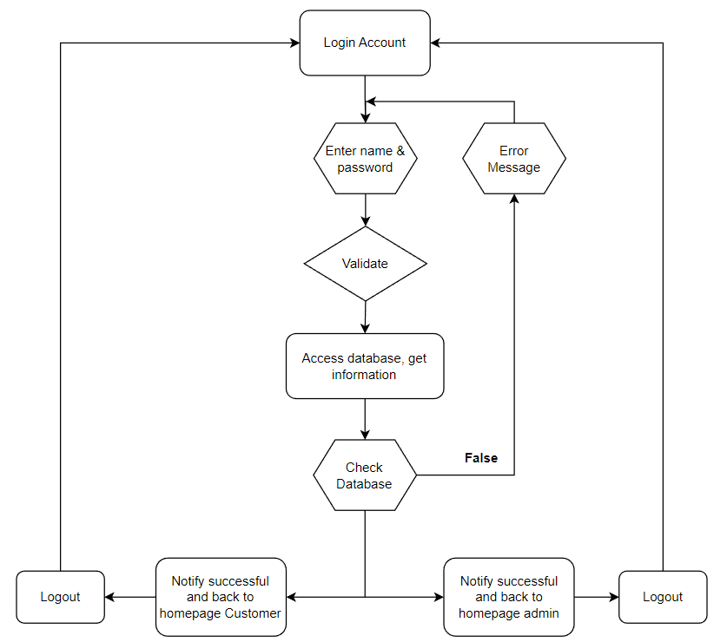

- Validation Checklists
  - Admin form

    - Username: Required

    - Contact : Required, digits:10

    - Password : required ,check pass

    - Email : Required

    - Newpass: Required

  - Login form

    - Username: Required

    - Password : required ,check pass and username

  - Car (Category) form

    - Name : Required

    - Description : Required

  - Car form

    - Car name : Required

    - Price : Required

  - Customer form

    - Name : Required

    - DoB : Required, after:1900/01/01,before:2022/01/01

    - Gender : Required

    - Contact : Required , digits :10

    - Email : Required , email

    - Address : Required

  - Sign up Client form

    - Name : Required

    - DoB : Required, after:1900/01/01,before:2022/01/01

    - Gender : Required

    - Contact : Required , digits :10

    - Email : Required , email

    - Address : Required

