InSubject: Data Structure and Algorithms

Code: CSD201

Assignment1 Report

Title: **Bus Management System**

Group number: **02**

Github: https://github.com/duongnguyen16/CSD_Assignment_GR2

Members:

1. Đặng Văn Sơn – HE190375
2. Nguyễn Xuân Dương – HE190405
3. Thân Bình Minh – HE190438
4. Nguyễn Viết Hùng – HE191209
5. Đào Thanh Thảo – HE190264

Tasks status

| Name/ Number | Content | Member | Status |
| --- | --- | --- | --- |
| **1. BookList** |  |  |  |
| 1.1 | Load data from file | Thảo | Done |
| 1.2 | Book bus | Dương | Done |
| 1.3 | Display data | Thảo | Done |
| 1.4 | Save Blist | Thảo | Done |
| 1.5 | Sort by Bcode + Pcode | Dương | Done |
| 1.6 | Payment | Dương | Done |
| **2. BusList** |  |  |  |
| 2.1. | Load data from file | Sơn | Done |
| 2.2. | Input and add to the end | Sơn | Done |
| 2.3. | Display data | Sơn | Done |
| 2.4. | Save bus list to file | Sơn | Done |
| 2.5. | Search by bus code | Sơn | Done |
| 2.6. | Delete by bus code | Dương | Done |
| 2.7. | Sort by bus code | Sơn | Done |
| 2.8 | Input & add to beginning | Sơn | Done |
| 2.9 | Add after position k | Sơn | Done |
| 2.10 | Delete position k | Sơn | Done |
| 2.11 | Search by name | Sơn | Done |
| 2.12 | Search booked by bus code | Dương | Done |
| **3. PassengerList** |  |  |  |
| 3.1. | Load data from file | Minh | Done |
| 3.2. | Input & add to the end | Minh | Done |
| 3.3. | Display data | Minh | Done |
| 3.4. | Save passenger list to file | Minh | Done |
| 3.5. | Search by pcode | Hùng | Done |
| 3.6. | Delete by pcode | Dương | Done |
| 3.7 | Search by name | Hùng | Done |
| 3.8 | Search buses by pcode | Hùng | Done |
| **4. Hoàn thiện code & sửa lỗi** |  | Dương | Done |

Tasks results (Screen short):

1. Booking list

1.1. Load data from file (Set auto)

1.2.Book bus

Input:

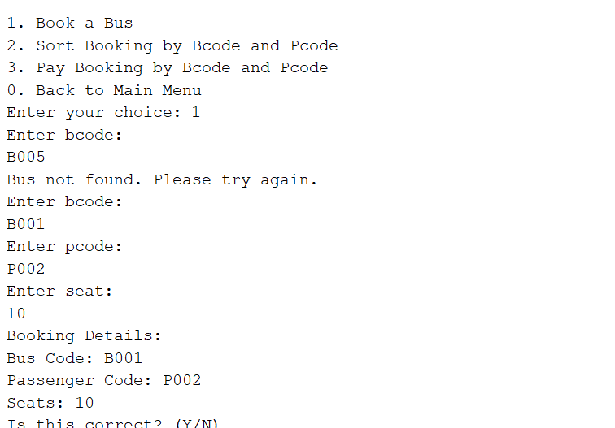

Output:

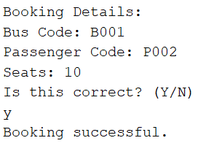

1.3.Display data(set auto)

1.4.Save date (set auto)

1.5.Sort by Bcode, Pcode

Output:

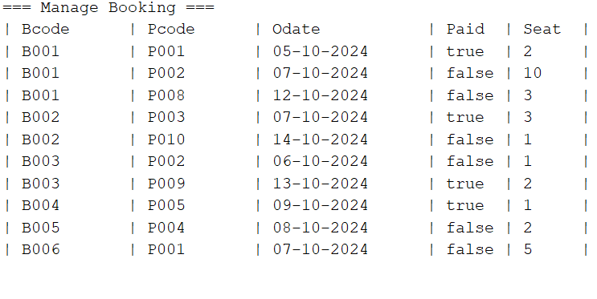

1.6. Payment confirmation:

Input:

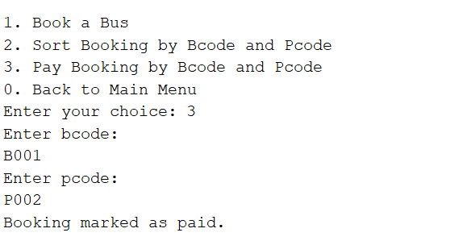

Output:

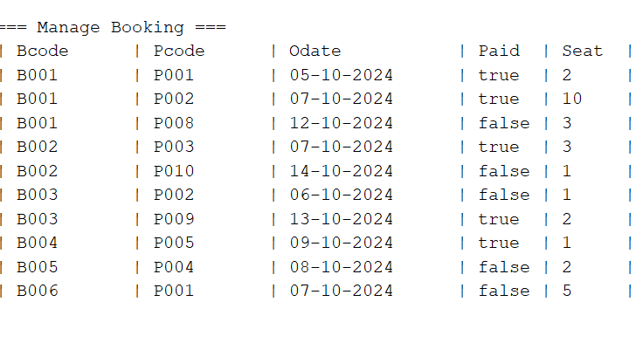

**2.BusList:**

2.1.Load data from file, save BusList, display: set auto

Input:

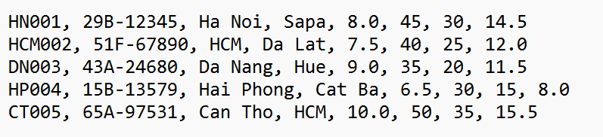

Output:

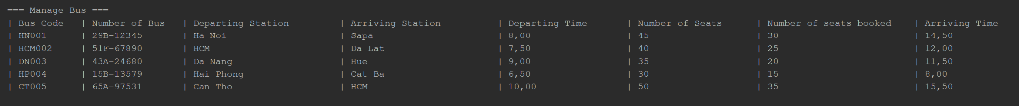

2.2. Input and add to the end:

Input:

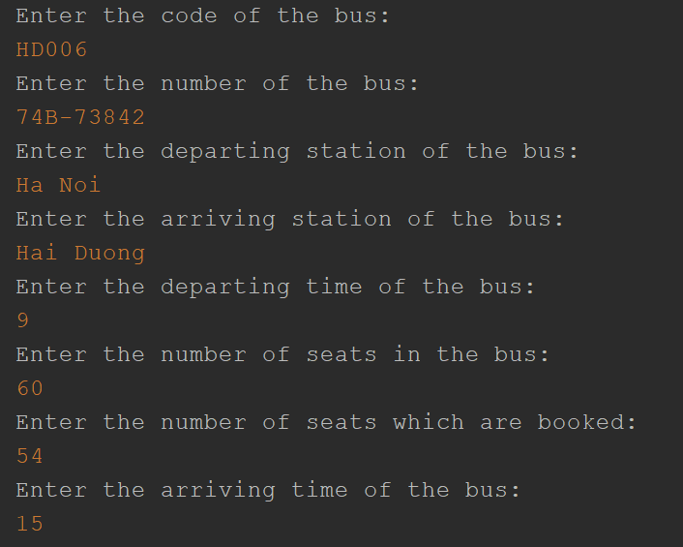

Output:



2.3. Search Bus By Code





2.4. Sort Bus By Code



2.5. Delete Bus By Code

Input: 

Output:



2.6. Input and add to the begin

Input:

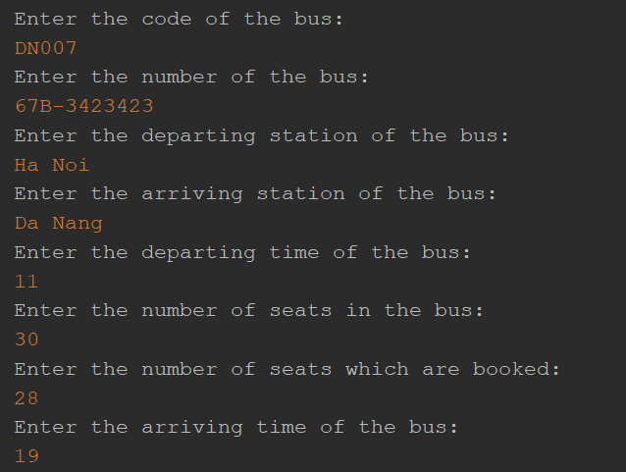

Output:



2.7. Add after position

Input:

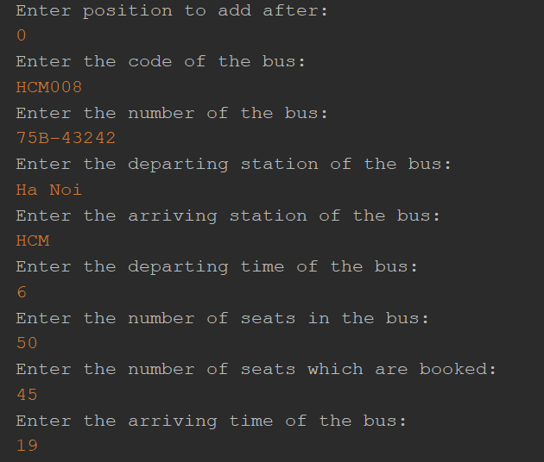

Output:

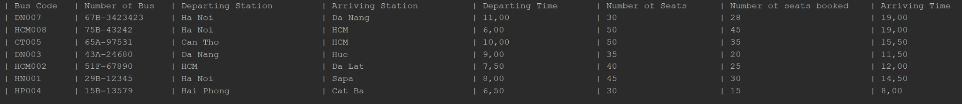

2.8. Delete bus at position

Input:

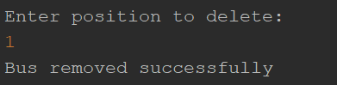

Output:



2.9. Search booked seat by code



3.Passenger List

3.1 Load data from file(Set auto)

Input:

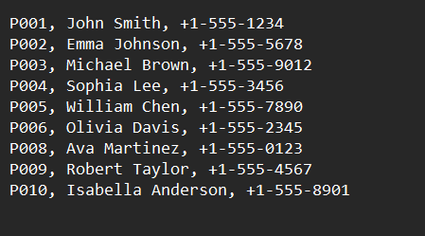

Output:

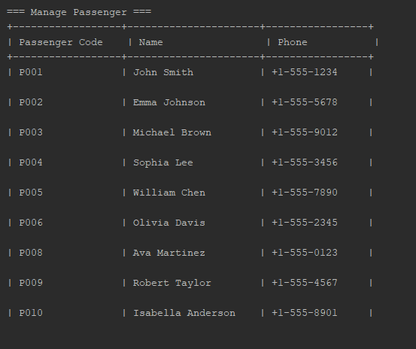

3.2 Input and add to the end:

Input:

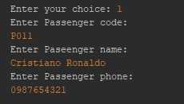

output:

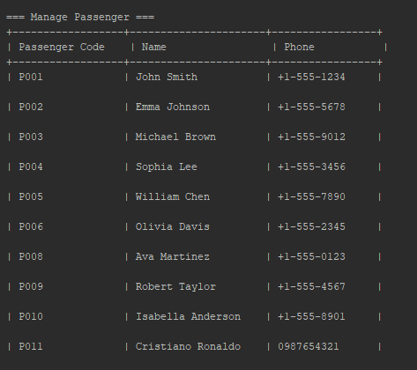

3.3 Search Passenger By code:

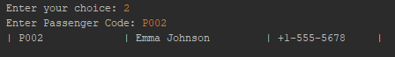



3.4 Delete Passenger by code:

input:



Output:

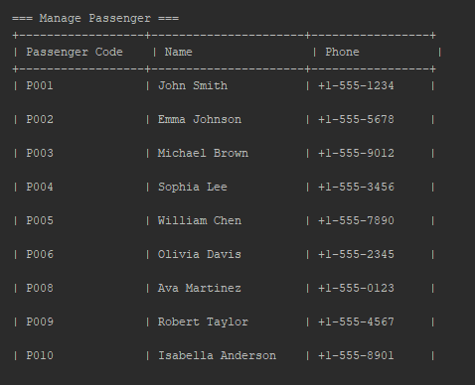

3.4 Search by Name:

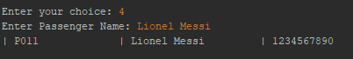

3.5 Search bus by code

Not Found:

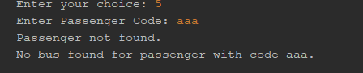

Result:

4. Check all ( Regex number, string, menu, exception ,.. )