|  |  |  |
| --- | --- | --- |
| Bin | Hex | Dec |
| 0  **00000000000**  0000000000000000000000000000000000000000000000000000 | 00000000 | 0 |
| 0  **00000000001**  0000000000000000000000000000000000000000000000000001 | 1 | 1 |

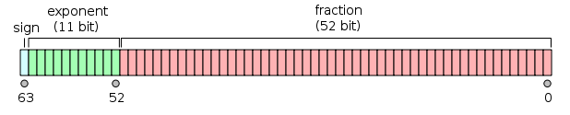

|  |  |  |
| --- | --- | --- |
| Bin | Hex | Dec |
| 0**00000000000**0000000000000000000000000000000000000000000000000000 | 00000000 | 0 |
| 0**00000000000**0000000000000000000000000000000000000000000000000001 | 1e |  |