CAPTCHA PROBLEM

Case 1:

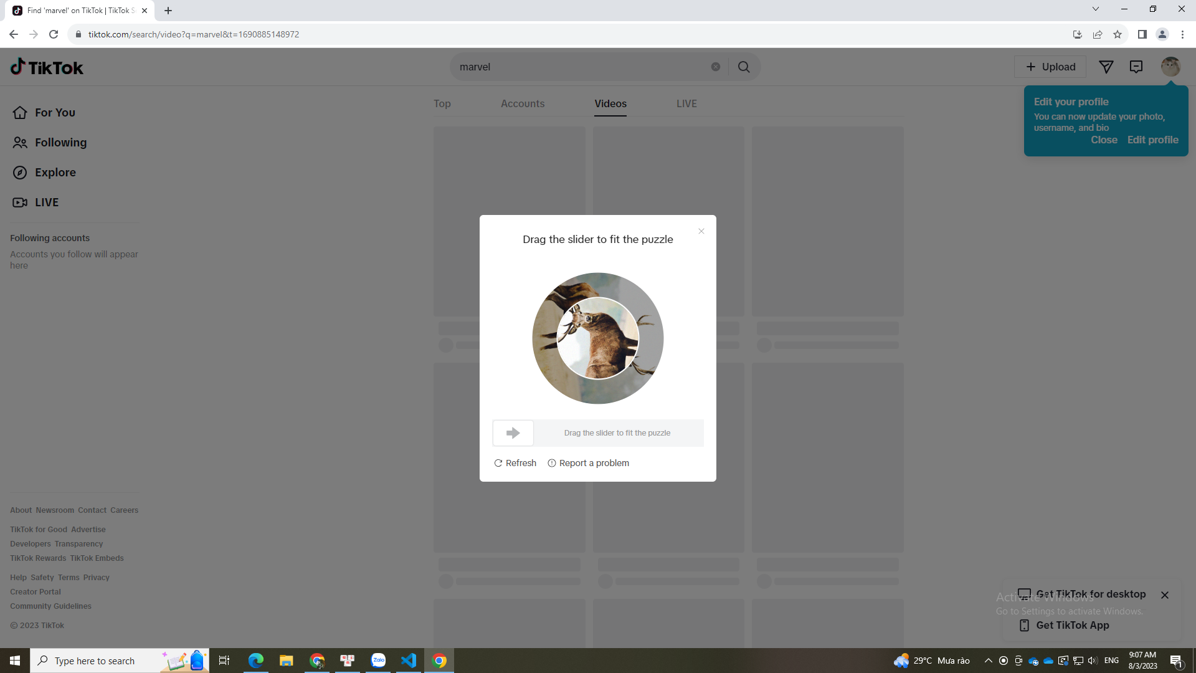

Case 2:

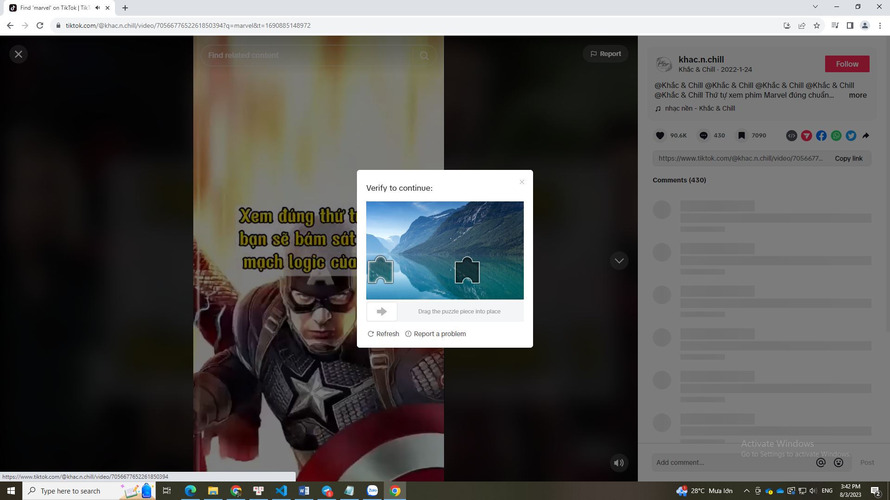

Case 3:

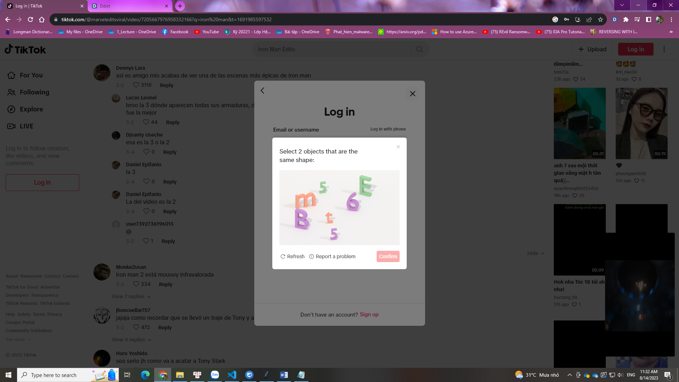

Case 4:

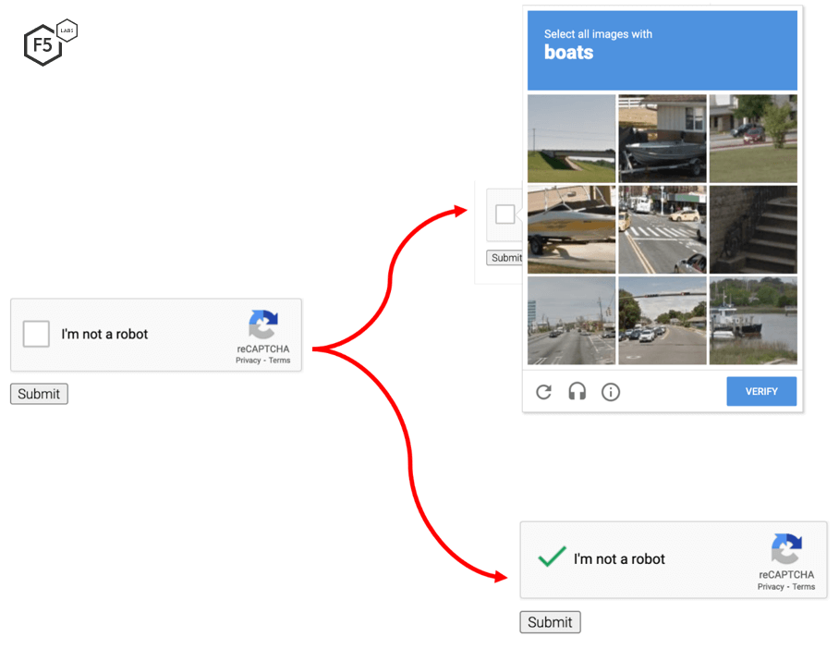

CRAWL

**Link bài viết**: "https://www.tiktok.com/@marveldc27vn/video/7057157551267400986":

**Các thông tin về tác giả:**

* "AuthorID": "https://www.tiktok.com/@marveldc27vn",
* "AuthorName": "MARVEL\u2002DC\u2002VIET\u2002NAM",

**Các thông tin về bài viết:**

* "CreateTime": "2022-01-25 21:55:35",
* "Hastag": [

"https://www.tiktok.com/tag/avengers",

"https://www.tiktok.com/tag/avengersendgame",

"https://www.tiktok.com/tag/avengerspov",

"https://www.tiktok.com/tag/avengersinfinitywar",

"https://www.tiktok.com/tag/avengerscampus",

"https://www.tiktok.com/tag/avengersassemble",

"https://www.tiktok.com/tag/avengersedit",

"https://www.tiktok.com/tag/avengersageofultron",

"https://www.tiktok.com/tag/avengers_team07",

"https://www.tiktok.com/tag/avengers_lover",

"https://www.tiktok.com/tag/superman",

"https://www.tiktok.com/tag/manofsteel",

"https://www.tiktok.com/tag/manofsteeledit",

"https://www.tiktok.com/tag/justiceleague",

"https://www.tiktok.com/tag/justiceleaguesnydercut",

"https://www.tiktok.com/tag/justiceleagueedit",

"https://www.tiktok.com/tag/captainamerica",

"https://www.tiktok.com/tag/thor",

"https://www.tiktok.com/tag/ironman",

"https://www.tiktok.com/tag/marvel"

],

* "Content": "#avengers #avengersendgame #avengerspov #avengersinfinitywar #avengerscampus #avengersassemble #avengersedit #avengersageofultron #avengers_team07 #avengers_lover #superman #manofsteel #manofsteeledit #justiceleague #justiceleaguesnydercut #justiceleagueedit #captainamerica #thor #ironman #marvel",
* "Music":"https://www.tiktok.com/music/Take-a-While6860594967262267394",
* "Like count": "345.1K",
* "Love count": "10.3K",
* "Share count": "3492",
* "Comment count": "3995",
* "Comment": {

"7057173120771916546": {

* + "Author ID": "https://www.tiktok.com/@gminh9010",
  + "Author Name": "#gminh\ud83e\udd2b\ud83e\udd47",
  + "Time CMT": "2022",
  + "ContentCMT": "m\u00e1 \ud83d\ude02 Marvel v\u1edbi DC gh\u00e9t nhau l\u1eafm \ud83d\ude02",
  + "Like": "786",
  + "Reply Count": 25,
  + "Reply": {

"7057291103947162370": {

* + - "authorID": "https://www.tiktok.com/@khanhharry1",
    - "authorName": "Kh\u00e1nh Harry",
    - "timeReply": "2022",
    - "contentReply": "Gh\u00e9t Ch\u1ee7 Y\u1ebfu L\u00e0 Fans Vs Nhau. Ch\u1ee9 Marvel V\u00e0 DC H\u1ee3p T\u00e1c R\u1ea5t Nhi\u1ec1u. V\u00e0 Ch\u1ee7 Y\u1ebfu Marvel Nh\u01b0\u1eddng N\u00ean B\u00ean DC Hay Win",

"Like": "98"

},

"7057332626667586306": {

* + - "authorID": "https://www.tiktok.com/@zio.com",
    - "authorName": "user2073658506685",
    - "timeReply": "2022",
    - "contentReply": "Nh\u01b0ng ph\u1ea3i c\u00f4ng nh\u1eadn n\u1ebfu d\u1ef1a tr\u00ean l\u00fd thuy\u1ebft th\u00ec b\u00ean dc n\u00f3 m\u1ea1nh h\u01a1n th\u1eadt, ch\u1ee9 v\u00e0o truy\u1ec7n vs phim th\u00ec do t\u00e1c gi\u1ea3 th\u00f4i",

"Like": "31"