

Requirement & Design Specification
Student Football League Management System (SFLMS)
Version: 1.0

Group 1
HE190001 – Nguyen Van A (40%)
HE190002 – Nguyen Van B (30%)
HE190003 – Nguyen Van C (30%)

Table of content
Table of content 2
I. Overview 3
1. User Requirements 3
1.1 Actors 3
1.2 Use Cases 3
a. Diagram(s) 3
b. Descriptions 4
2. Overall Functionalities 4
2.1 Screens Flow 4
2.2 Screen Descriptions 4
2.3 Screen Authorization 5
2.4 Database Design 6
a. Database Schema 6
b. Table Descriptions 7
II. Design Specifications 8
1. Staff logs in with the designated account 8
1.1. Web Service 8
1.2. Web Application: 8

I. Overview
The Student Football League Management System (SFLMS) is an enterprise-grade web application developed to digitalize, streamline, and automate university football tournament operations (7-a-side format). The system is built on a decoupled architecture utilizing ASP.NET Core Web API (.NET 8.0), OData v8, Entity Framework Core (Code-First), and Microsoft SQL Server, paired with an ASP.NET Core MVC Client implementing JWT Bearer and Cookie-based authentication.
The application eliminates paper-based team registrations, automates pitch scheduling to prevent overlaps (±90-minute collision engine), and provides real-time standings recalculation and Fair-play disciplinary tracking.

1. User Requirements

1.1 Actors
# | Actor | Description
1 | Admin (League Organizer) | Full administrative access: creates/manages tournaments, reviews team applications, allocates approved teams into groups (Group A/B), schedules fixtures with collision verification, assigns referees, and triggers manual standing recalculations.
2 | TeamManager (Team Captain) | Student team leader: manages their own team profile, maintains squad roster (validating Student Code format, age limits, and unique shirt numbers), and submits tournament entries before deadlines. Access is restricted exclusively to their assigned team.
3 | Referee (Match Official / Secretary) | On-field coordinator: updates match statuses, logs timeline incidents (goals, yellow/red cards with player attribution and minute), and submits final scores.
4 | Guest (Student / General Public) | Unauthenticated public visitor: views tournaments, inspects OData-filtered fixtures and match results, examines live standings tables, and tracks the Golden Boot leaderboard.

1.2 Use Cases

a. Diagram(s)

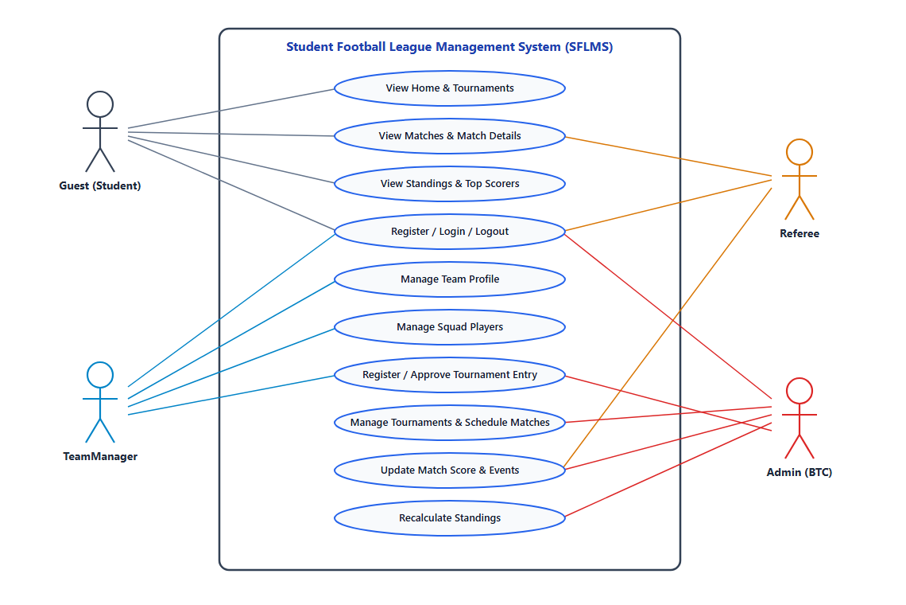

b. Descriptions

ID | Actor | Use Case | Use Case Description
UC-01 | All Users | Register / Login / Logout | Users register (TeamManager or Referee), authenticate via email and password to receive a JWT token stored in an Auth Cookie, or log out of the system.
UC-02 | Guest / Public | View Matches & Details | View tournament fixtures and results filtered by tournament, group, round, or team name; view split 2-sided match timeline events (Home left / Away right) and vertical squad lineups (Starting 7 & Substitutes).
UC-03 | Guest / Public | View Standings & Top Scorers | View dynamic group standings (MP, W, D, L, GF, GA, GD, Pts, Fair-play), Knockout Bracket, and the Top Scorers leaderboard.
UC-04 | TeamManager | Manage Team Profile | Create a new team profile (1 team per captain) or update team name, faculty/club, home kit color, and logo.
UC-05 | TeamManager | Manage Squad Players | Add, edit, or soft-delete players (IsActive = false, preserving MatchEvents & V_PlayerStats); Filtered Unique Indexes release StudentCode & JerseyNumber; blocks deletion if an Approved team in an active tournament drops below MinPlayersPerTeam or loses its only GK.
UC-06 | TeamManager | Register for Tournament | Submit team entry to an open tournament (not Cancelled/Completed) before registration deadline, verifying MinPlayersPerTeam and at least 1 Goalkeeper (GK).
UC-07 | Admin | Manage Tournaments | Create, update, and delete tournaments: hard-delete if no registrations/matches exist, or soft-delete (Cancelled + auto-cancel Scheduled/Postponed matches) if data exists; blocked if any match is InProgress or Completed.
UC-08 | Admin | Review & Approve Registrations | Review submitted team registrations (blocked if tournament is Cancelled), validate squad eligibility, assign approved teams into groups (Group A / Group B), or reject with a reason.
UC-09 | Admin | Schedule Matches | Schedule fixtures for active tournaments (not Cancelled/Completed) with pitch, date/time, and referee assignment; automatically prevents pitch or team scheduling conflicts within ±90 minutes.
UC-10 | Admin, Referee | Update Match Result & Events | Update scores, penalty shootout scores, match status, and log/delete match events (Goal, OwnGoal, PenaltyGoal, YellowCard, RedCard); deleting events auto-decrements score and recalculates Group standings or syncs Knockout bracket.
UC-11 | Admin | Recalculate Standings | Manually trigger recalculation of standings points, goal difference, and Fair-play disciplinary points for a tournament or group.
UC-12 | Admin | Manage Knockout Bracket | Generate/arrange Knockout bracket (4 or 8 teams, optional 3rd-place match), auto-advance winners/losers & set ChampionTeamId, or hard-delete Knockout bracket (404 if tournament missing; blocked if any knockout match is InProgress/Completed).

2. Overall Functionalities

2.1 Screens Flow
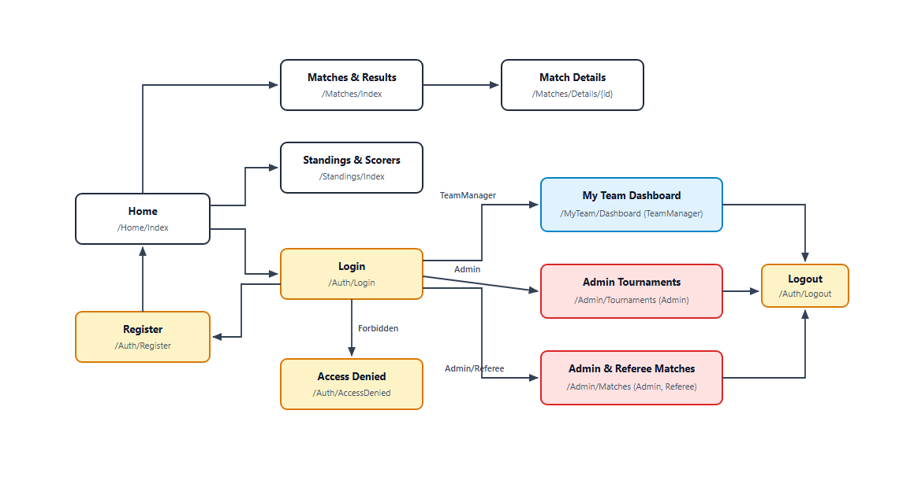

2.2 Screen Descriptions

# | Feature | Screen | Description
1 | Public Homepage | Home (/Home/Index) | Displays active tournament summary, recent/upcoming match cards (_MatchScoreCardPartial), and Top 5 goal scorers.
2 | User Login | Login (/Auth/Login) | Allows users to authenticate using email and password; decodes JWT claims and signs in using Cookie Authentication.
3 | User Registration | Register (/Auth/Register) | Allows new TeamManagers or Referees to register an account with full name, email, phone number, password, and optional student code.
4 | Authorization Error | Access Denied (/Auth/AccessDenied) | Displays an access-denied alert when a user attempts to access a page without required role permissions.
5 | Fixtures & Results | Matches (/Matches/Index) | Displays all tournament matches with filters by Tournament, Group (Group A/B), Round, and Team name search.
6 | Match Incident Log | Match Details (/Matches/Details/{id}) | Displays match scoreboard, pitch/referee metadata, split 2-sided event timeline (Home left / Away right), and vertical squad lineups split into Starting 7 & Substitutes.
7 | Leaderboard | Standings (/Standings/Index) | Displays dynamic group standings tables (_StandingsTablePartial), Knockout Bracket (_KnockoutBracketPartial), and the Top 10 Scorers leaderboard.
8 | Captain Workspace | My Team Dashboard (/MyTeam/Dashboard) | Enables TeamManager to create their team, add/delete players (_PlayerFormModalPartial), track registration status, and apply for open tournaments.
9 | League Setup | Admin Tournaments (/Admin/Tournaments) | Enables Admin to create tournaments and approve/reject pending team registrations with group allocation.
10 | Match Operations | Admin Matches (/Admin/Matches) | Enables Admin to schedule matches (±90-min collision check) and enables Admin/Referee to update scores, statuses, and match events.
11 | Knockout Bracket | Admin Knockout (/Admin/Knockout) | Enables Admin to configure, generate, view, and reset the Knockout tournament bracket.

2.3 Screen Authorization

# | Screen | Guest | TeamManager | Referee | Admin
1 | Home (/Home/Index) | X | X | X | X
2 | Login (/Auth/Login) | X | X | X | X
3 | Register (/Auth/Register) | X | X | X | X
4 | Matches (/Matches/Index) | X | X | X | X
5 | Match Details (/Matches/Details/{id}) | X | X | X | X
6 | Standings (/Standings/Index) | X | X | X | X
7 | My Team Dashboard (/MyTeam/Dashboard) |  | X
8 | Admin Matches (/Admin/Matches) |  |  | X | X
9 | Admin Tournaments (/Admin/Tournaments) |  |  |  | X
10 | Admin Knockout (/Admin/Knockout) |  |  |  | X

2.4 Database Design

Database Schema
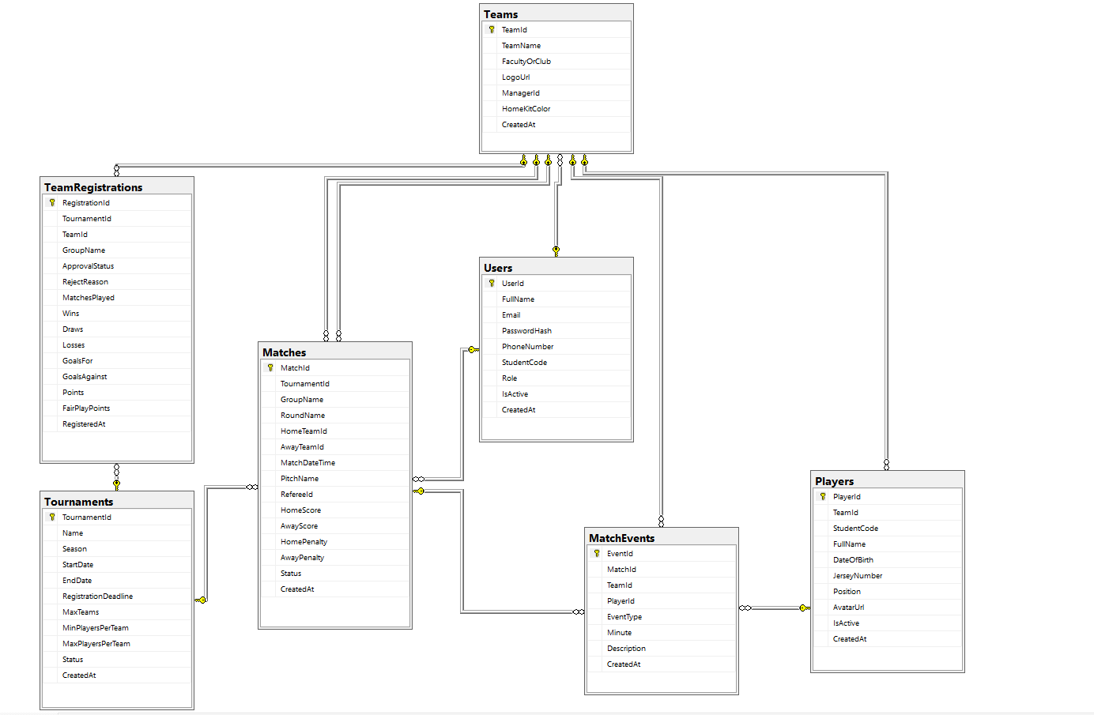

b. Table Descriptions
No | Table / View | Description
01 | Users | - Manages user accounts (FullName, Email, PasswordHash, PhoneNumber, StudentCode, Role, IsActive).  - Constraints: Unique Email, Filtered Unique StudentCode, Check Role in (Admin, TeamManager, Referee, Guest).  - Primary Key: UserId
02 | Tournaments | - Stores tournament seasons (Name, Season, StartDate, EndDate, RegistrationDeadline, MaxTeams, MinPlayersPerTeam, MaxPlayersPerTeam, GroupCount, KnockoutTeamCount, HasThirdPlaceMatch, ChampionTeamId, Status).  - Constraints: Unique Name, EndDate > StartDate, RegistrationDeadline <= StartDate.  - Primary Key: TournamentId | Foreign Key: ChampionTeamId -> Teams(TeamId)
03 | Teams | - Manages student football teams (TeamName, FacultyOrClub, LogoUrl, ManagerId, HomeKitColor).  - Primary Key: TeamId | Foreign Key: ManagerId -> Users(UserId)
04 | Players | - Stores player rosters (TeamId, StudentCode, FullName, DateOfBirth, JerseyNumber, Position, IsActive).  - Constraints: Filtered Unique Indexes (WHERE IsActive = 1) on StudentCode and (TeamId, JerseyNumber) to support soft delete, JerseyNumber 1..99, Position in (GK, DF, MF, FW).  - Primary Key: PlayerId | Foreign Key: TeamId -> Teams(TeamId)
05 | TeamRegistrations | - Tracks tournament entries & group standings (TournamentId, TeamId, GroupName, ApprovalStatus, RejectReason, MatchesPlayed, Wins, Draws, Losses, GoalsFor, GoalsAgainst, Points, FairPlayPoints).  - Primary Key: RegistrationId | Foreign Keys: TournamentId, TeamId
06 | Matches | - Stores Group & Knockout match fixtures (TournamentId, Stage, GroupName, RoundName, KnockoutRound, BranchName, BracketOrder, HomeTeamId, AwayTeamId, HomeSourceLabel, AwaySourceLabel, NextMatchId, NextMatchSlot, LoserNextMatchId, LoserNextMatchSlot, WinnerTeamId, MatchDateTime, PitchName, RefereeId, HomeScore, AwayScore, HomePenalty, AwayPenalty, Status).  - Primary Key: MatchId | Foreign Keys: TournamentId, HomeTeamId, AwayTeamId, WinnerTeamId, NextMatchId, LoserNextMatchId, RefereeId
07 | MatchEvents | - Logs match timeline incidents (MatchId, TeamId, PlayerId, EventType, Minute, Description).  - Constraints: Minute 1..120, EventType in (Goal, OwnGoal, PenaltyGoal, YellowCard, RedCard).  - Primary Key: EventId | Foreign Keys: MatchId, TeamId, PlayerId
08 | V_PlayerStats (View) | - SQL View aggregating GoalsScored, YellowCards, and RedCards per player and tournament for Top Scorers & OData (/odata/PlayerStats).

II. Design Specifications

1. User logs in with the designated account

1.1. Web Service
provide endpoint with following information:
- Endpoint
URL | /api/Auth/login
Method | POST
Body | LoginRequestDto (JSON): { "email": "string", "password": "string" }

[Insert Swagger screenshot of POST /api/Auth/login Parameters / Request Body here]

- Response:
Status Code | Content
OK - 200 | JSON (AuthResponseDto) with accessToken (JWT), expiresIn, userId, fullName, email, role, and managedTeamId.
BadRequest - 400 | Validation error JSON when Email format is invalid or Password has fewer than 6 characters.
Unauthorized - 401 | JSON: { "message": "Email hoặc mật khẩu không chính xác." } or inactive account notice.

[Insert Swagger screenshot of POST /api/Auth/login 200 OK Response here]

1.2. Web Application:

[Insert WebClient screenshot of /Auth/Login page here]

Field Name | Field Type | Description
Email | Text Box | Input field for the user to enter their registered FPT email address (e.g., admin@fpt.edu.vn, captain.se@fpt.edu.vn).
Password | Password Box | Masked input field for the user to enter their account password (minimum 6 characters).
ĐĂNG NHẬP NGAY | Button | Submits credentials to AuthController.Login, invokes POST /api/Auth/login, parses JWT claims, and signs in via Cookie Authentication.

2. TeamManager adds a player to squad

2.1. Web Service
Endpoint:
Response:

2.2. Web Application
WebClient Page: /MyTeam/Dashboard (Modal _PlayerFormModalPartial)

3. Admin reviews and approves team registration

3.1. Web Service
Endpoint:
Response:

3.2. Web Application
WebClient Page: /Admin/Tournaments

4. Admin schedules a match with collision check

4.1. Web Service
Endpoint:
Response:

4.2. Web Application
WebClient Page: /Admin/Matches

5. Referee / Admin updates match result and events

5.1. Web Service
Endpoint:
Response:

5.2. Web Application
WebClient Page: /Admin/Matches
URL | /api/teams/{teamId}/players
Method | POST (Authorize: TeamManager, Admin)
Body | PlayerCreateDto (JSON): { "studentCode": "HE170001", "fullName": "string", "dateOfBirth": "yyyy-MM-dd", "jerseyNumber": 10, "position": "FW" }
Status Code | Content
OK - 200 | JSON of created Player entity.
BadRequest - 400 | Duplicate StudentCode across system, duplicate JerseyNumber in team, or invalid DTO validation.
Unauthorized / Forbidden - 401/403 | Missing JWT token or TeamManager attempting to edit another team.
Field Name | Field Type | Description
StudentCode | Text Box | Student ID of the player (unique across all players in the league).
FullName | Text Box | Full name of the student player (max 100 characters).
DateOfBirth | Date Picker | Player's date of birth.
JerseyNumber | Number Box | Shirt number from 1 to 99 (must be unique within the team).
Position | Dropdown List | Playing position: GK (Goalkeeper), DF (Defender), MF (Midfielder), FW (Forward).
Thêm cầu thủ | Button | Submits player data to MyTeamController.AddPlayer -> POST /api/teams/{teamId}/players.
URL | /api/registrations/{id}/approval
Method | PUT (Authorize: Admin)
Body | RegistrationApprovalDto (JSON): { "status": "Approved", "groupName": "Group A", "rejectReason": null }
Status Code | Content
OK - 200 | Confirmation message with updated TeamRegistration status and GroupName.
BadRequest - 400 | Tournament is Cancelled, team has fewer players than MinPlayersPerTeam, or team lacks a Goalkeeper (GK).
NotFound - 404 | Registration record not found.
Field Name | Field Type | Description
GroupName | Dropdown List | Assigns the approved team into Group A or Group B.
RejectReason | Text Box | Optional reason entered when Admin rejects a team registration.
Phê duyệt / Từ chối | Button | Submits decision to AdminController.ApproveRegistration -> PUT /api/registrations/{id}/approval.
URL | /api/matches
Method | POST (Authorize: Admin)
Body | MatchScheduleDto (JSON): { "tournamentId": 1, "groupName": "Group A", "roundName": "Vòng 1", "homeTeamId": 1, "awayTeamId": 2, "matchDateTime": "2026-11-15T15:00:00", "pitchName": "Sân 1", "refereeId": 3 }
Status Code | Content
Created - 201 | JSON of newly scheduled Match entity.
BadRequest - 400 | Cancelled/completed tournament, same Home/Away team, unapproved teams, or pitch/team schedule collision within ±90 minutes.
Field Name | Field Type | Description
TournamentId & GroupName | Dropdown Lists | Selects the target tournament and group.
RoundName | Text Box | Round label (e.g., Vòng 1, Bán kết, Chung kết).
HomeTeamId & AwayTeamId | Dropdown Lists | Selects two distinct approved teams.
MatchDateTime & PitchName | DateTime / Text Box | Match kick-off time and pitch name (validated against ±90-minute collisions).
Lên lịch trận đấu | Button | Submits fixture to AdminController.ScheduleMatch -> POST /api/matches.
URL | /api/matches/{id}/result
Method | PUT (Authorize: Admin, Referee)
Body | MatchResultUpdateDto (JSON): { "homeScore": 2, "awayScore": 1, "status": "Completed", "events": [{ "teamId": 1, "playerId": 5, "eventType": "Goal", "minute": 23 }] }
Status Code | Content
OK - 200 | Success message; automatically triggers StandingsService for Group matches or KnockoutService to advance winners/losers for Knockout matches.
BadRequest - 400 | Invalid score range (0–50), invalid status, or invalid event minute (1–120).
Field Name | Field Type | Description
HomeScore & AwayScore | Number Boxes | Final scores for home and away teams (0–50).
Status | Dropdown List | Match status: InProgress, Completed, Postponed, Cancelled.
EventType & Minute | Dropdown / Number Box | Logs Goal, OwnGoal, PenaltyGoal, YellowCard, or RedCard at minute 1–120.
Cập nhật kết quả | Button | Submits update to AdminController -> PUT /api/matches/{id}/result and recalculates standings.

