MELBOURNE PROPERTY MARKET
BUSINESS INTELLIGENCE SOLUTION
Detailed Implementation, Analysis and Reporting Documentation
Dataset: Melbourne Residential Property Sales
Prepared from supplied project implementation screenshots
Platform: Microsoft Fabric, Power BI and PySpark

Executive Summary
This document provides a detailed record of the Melbourne Property Market business-intelligence solution, covering ingestion of the residential sales dataset, data preparation and modelling in Microsoft Fabric using PySpark, semantic-model design with DAX measures, and a set of Power BI dashboard pages covering KPI overview, price segmentation and geospatial analysis. The evidence in the supplied implementation screenshots is consolidated into one implementation report.
The solution is built around a single core fact table, melbourneproperty, describing individual property sales (suburb, address, rooms, type, price, method, seller, distance, land size, building area, year built, council area, region, latitude/longitude and postcode). A supporting date table and a PriceSegments parameter table extend the model to enable time-intelligence and dynamic price-band segmentation.

Key Outcomes
- Ingested and profiled the Melbourne residential property sales dataset in a Fabric Lakehouse.
- Used PySpark notebooks to build a supporting date dimension and prepare analytical fields.
- Corrected data types and configured geographic data categories (latitude/longitude) in the semantic model.
- Built a star-schema relationship model linking property sales, a date table and a dynamic price-segment table.
- Authored a library of DAX time-intelligence measures (YTD, QTD, MTD, prior-year and YoY% sales).
- Delivered KPI overview, sales segmentation and geospatial (choropleth, custom GeoJSON and bubble map) dashboard pages.
- Configured the semantic model for Direct Lake storage mode and validated a successful build/deploy cycle.

Contents
1. Project and Dataset Overview
2. Data Ingestion and Preparation
3. Data Modelling and Relationships
4. DAX Measures and Semantic Model
5. Power BI Dashboard Pages
6. Geospatial Analysis
7. Deployment and Platform Configuration
8. Validation, Limitations and Recommendations
9. Conclusion
Appendix A - Evidence Map

1. Project and Dataset Overview
The project analyses the Melbourne residential property market by combining sale-transaction attributes (price, method of sale, selling agent, date) with property characteristics (rooms, type, land size, building area, year built) and location attributes (suburb, postcode, council area, region, latitude and longitude). The objective is to convert the raw property-sales extract into an interactive business-intelligence solution that supports exploration of pricing trends, suburb-level price segmentation and spatial distribution of sales.

1.1 Source Data
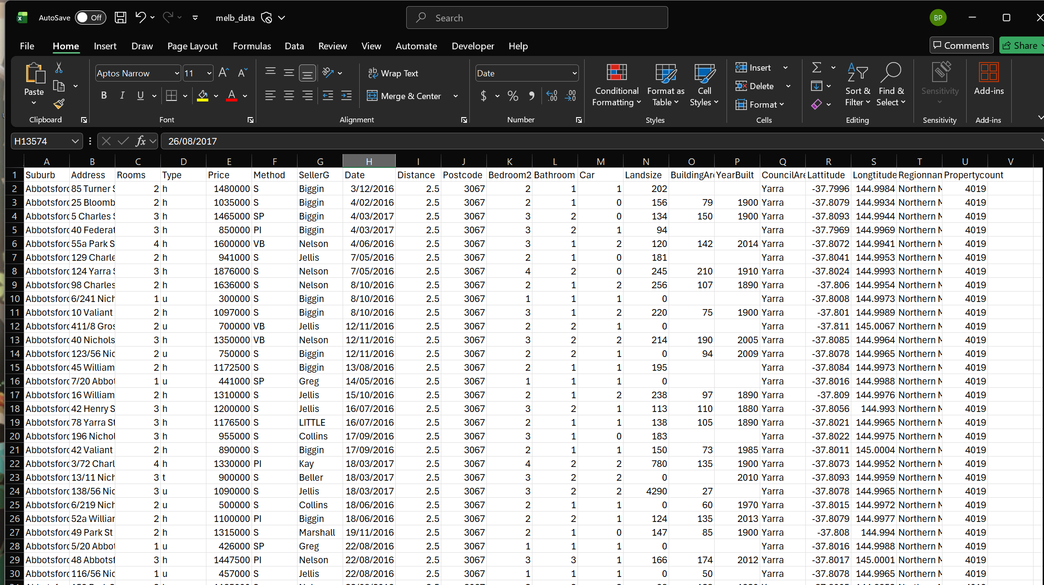
Figure 1. Raw Melbourne property sales dataset (source extract)
The source extract contains one row per property sale, with fields including Suburb, Address, Rooms, Type, Price, Method, SellerG, Date, Distance, Postcode, Bedroom2, Bathroom, Car, Landsize, BuildingArea, YearBuilt, CouncilArea, Latitude, Longitude, Regionname and Propertycount. This wide, transaction-level structure is the input to the Fabric ingestion and modelling stages described in the following sections.

1.2 Core Business Questions
- How are properties distributed across suburbs, regions and property types?
- What is the overall pricing profile of the market, and how does it trend over time (YTD, QTD, MTD, YoY)?
- Which suburbs fall into the High, Medium, Low and Premium price segments, and how does this change dynamically with user-selected thresholds?
- How are property sales and average prices distributed spatially, by postcode and by precise location?
- Can the same analytical model be delivered efficiently using a Direct Lake storage mode in Microsoft Fabric?

2. Data Ingestion and Preparation
The raw property-sales file was loaded into a Microsoft Fabric Lakehouse (Melbourne_Property_Lakehouse) and processed using a PySpark notebook. This stage focuses on building supporting analytical tables and preparing fields ahead of semantic modelling.

2.1 Building the Date Table with PySpark
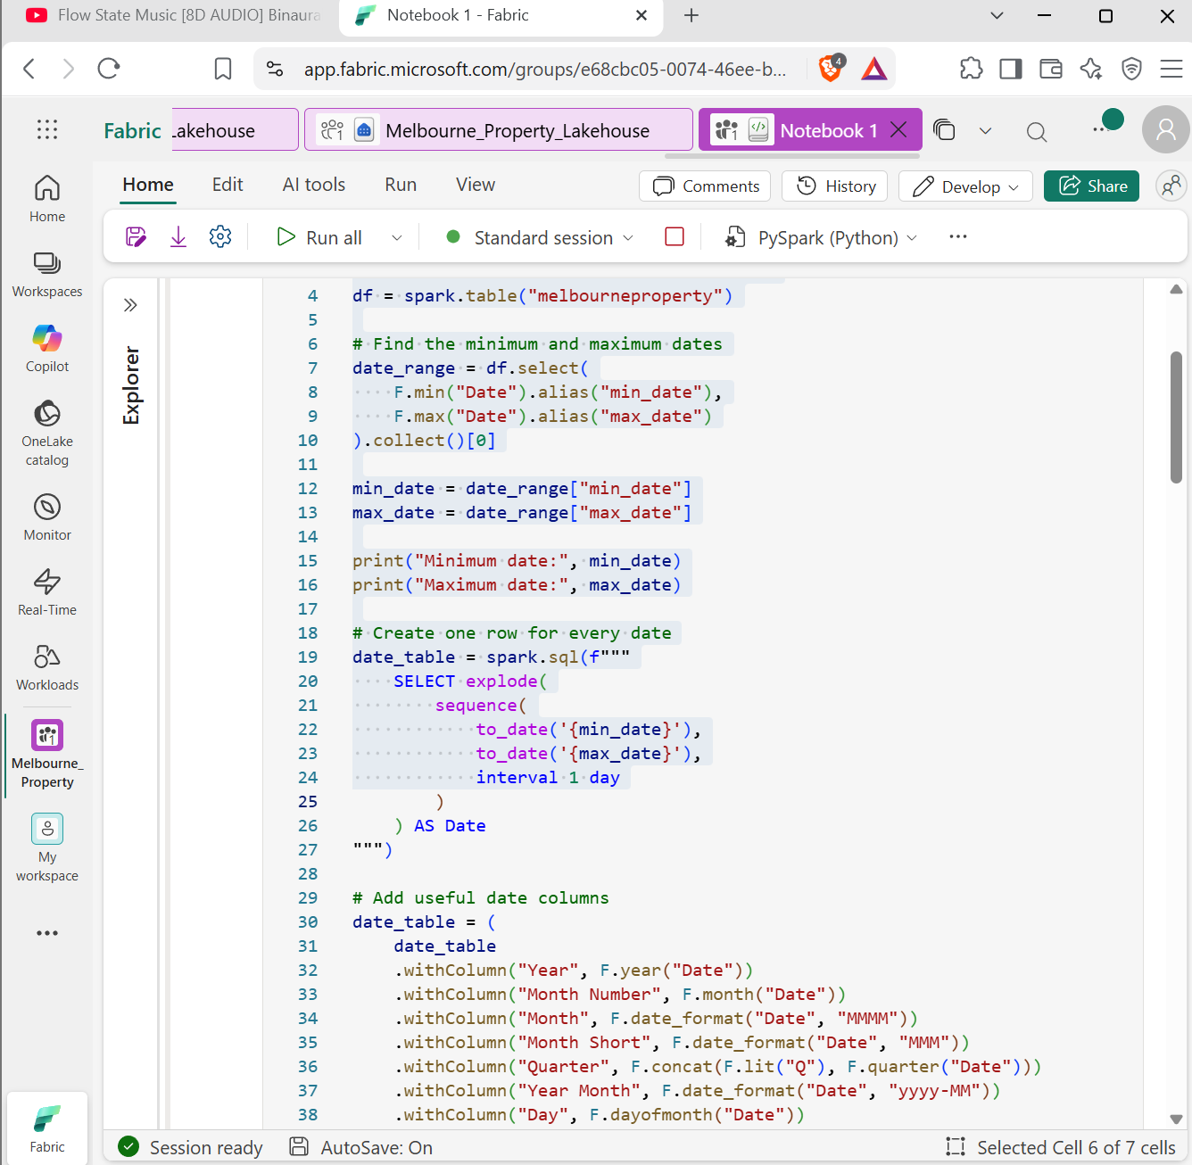
Figure 2. PySpark notebook - constructing the date dimension table in Fabric
The notebook reads the melbourneproperty table from the lakehouse using spark.table(), determines the minimum and maximum transaction dates, and generates one row per calendar day across that range using a SQL sequence() expression. Additional descriptive columns are then derived, including Year, Month Number, Month, Month Short, Quarter, Year Month and Day. This produces a complete, gap-free date table suitable for time-intelligence calculations in the downstream semantic model.
Building the date table programmatically, rather than relying on an auto-generated date hierarchy, ensures that YTD, QTD, MTD and year-over-year DAX measures behave consistently and can be extended with fiscal or custom calendar logic if required.

3. Data Modelling and Relationships

3.1 Data Type and Category Configuration
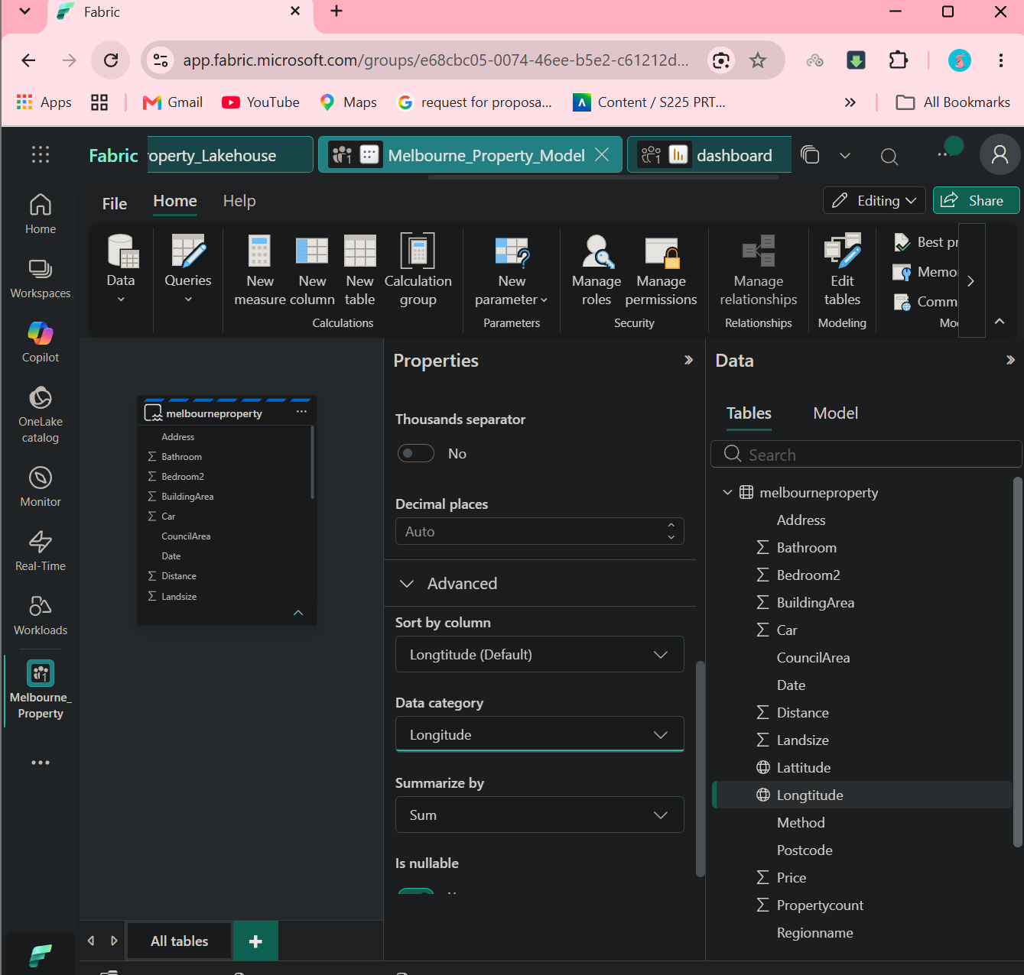
Figure 3. Correcting column data types and setting geographic data categories
Within the semantic model, each column of the melbourneproperty table was reviewed and assigned an appropriate data type and summarisation behaviour. Geographic fields required particular attention: Longitude (and, correspondingly, Latitude) were set to the "Longitude" / "Latitude" data category with a "Sum" summarisation placeholder, which is required for these fields to be recognised correctly by Power BI's mapping visuals rather than being aggregated as ordinary numeric measures.

3.2 Relationship Model
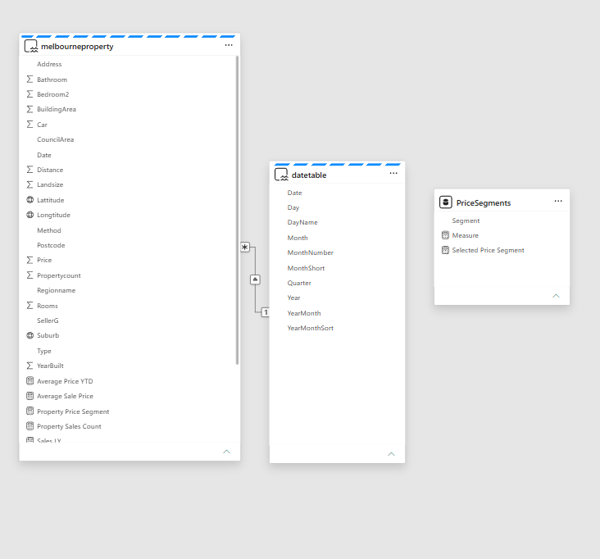
Figure 4. Semantic model relationships - melbourneproperty, datetable and PriceSegments
The model view shows three tables. The melbourneproperty fact table holds all transaction-level fields together with several model measures (Average Price YTD, Average Sale Price, Property Price Segment, Property Sales Count, Sales LY). It relates to the datetable dimension on the Date field with a many-to-one relationship (each sale maps to one calendar date). A separate PriceSegments table supplies a disconnected "what-if" style parameter (Segment, Measure, Selected Price Segment) that drives the dynamic segmentation feature described in Section 5.2, without being physically joined to the fact table.
This design keeps descriptive time attributes centralised in the date table, supports consistent time-intelligence calculations, and isolates the segmentation logic so that it can be changed interactively without altering the underlying relationships.

4. DAX Measures and Semantic Model
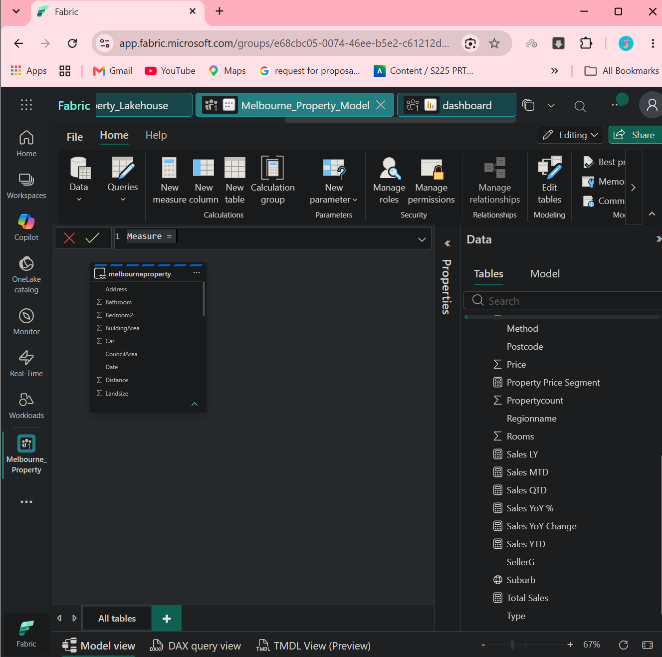
Figure 5. DAX measures defined on the melbourneproperty table
A library of DAX measures was created to support time-intelligence and sales reporting, including Total Sales, Sales LY (last year), Sales MTD, Sales QTD, Sales YTD, Sales YoY % and Sales YoY Change. These measures use the date table built in Section 2.1 as the basis for time-intelligence functions, allowing dashboard visuals to compare current performance against prior periods without duplicating logic across reports.

4.1 Representative Measures
Measure | Business purpose
Total Sales | Sum of property sale values across the filtered context
Sales YTD / QTD / MTD | Cumulative sales value from the start of the year, quarter or month to the current date in context
Sales LY | Prior-year equivalent sales value, used as a comparison baseline
Sales YoY % / YoY Change | Percentage and absolute change versus the prior-year period
Property Sales Count | Count of property transactions in the filtered context
Average Sale Price / Average Price YTD | Mean transaction price overall and year-to-date
Property Price Segment | Dynamic classification of a suburb or property into a price band (see Section 5.2)

5. Power BI Dashboard Pages

5.1 KPI Overview
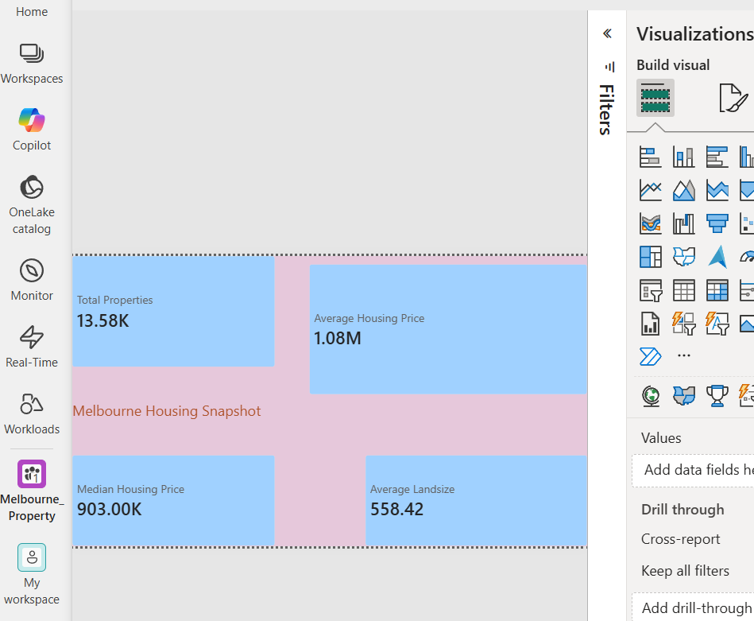
Figure 6. KPI overview cards - Melbourne Housing Snapshot
The overview page presents headline KPI cards summarising the whole dataset: Total Properties (13.58K), Average Housing Price ($1.08M), Median Housing Price ($903.00K) and Average Landsize (558.42 sqm). These cards give users an immediate market snapshot before drilling into segmentation or spatial analysis.

5.2 Sales Segmentation Dashboard
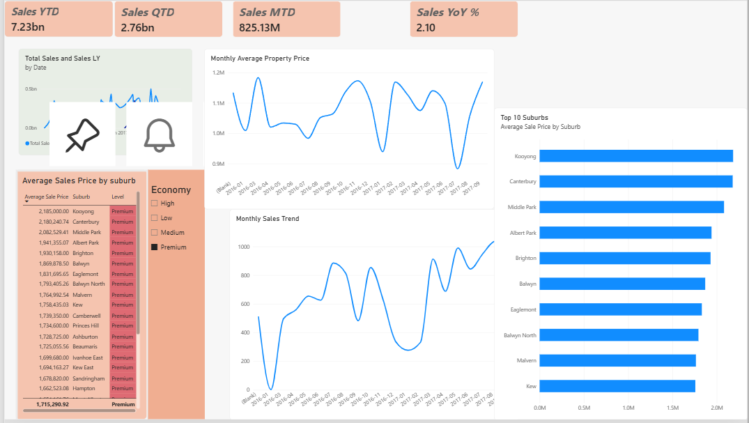
Figure 7. Sales segmentation dashboard - trends, top suburbs and price segments
The segmentation dashboard combines time-intelligence KPI cards (Sales YTD $7.23bn, Sales QTD $2.76bn, Sales MTD $825.13M, Sales YoY 2.10%) with a total-sales-versus-last-year trend chart, a monthly average property price line chart, a monthly sales trend chart, and a Top 10 Suburbs bar chart ranked by average sale price (led by Kooyong, Canterbury and Middle Park). A suburb-level table on the left ranks average sale price by suburb, alongside an Economy segment selector (High / Low / Medium / Premium) that filters the whole page.

5.3 Dynamic Price Segmentation
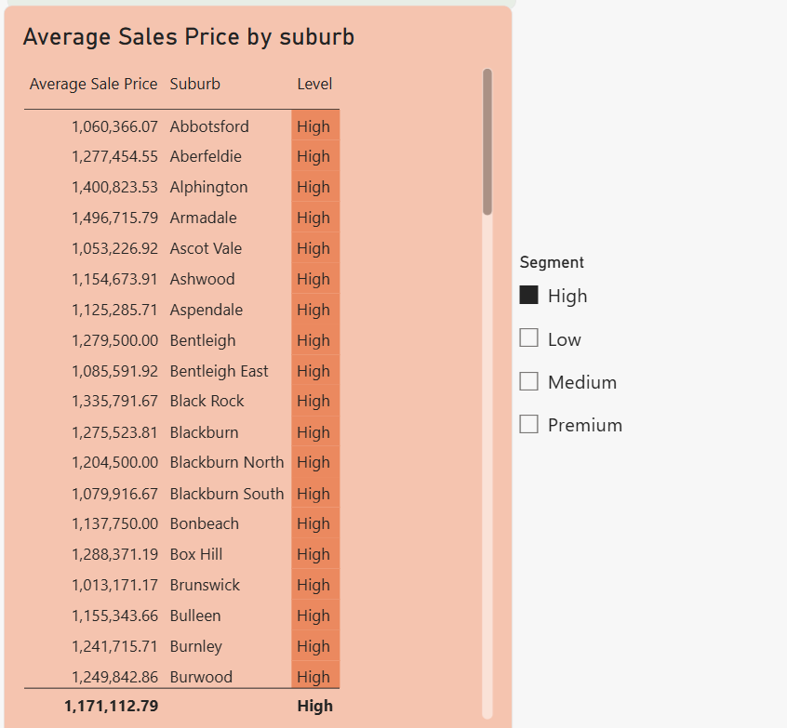
Figure 8. Dynamic segmentation table filtered to the "High" price segment
Using the disconnected PriceSegments table and the Property Price Segment measure, users can select a segment (High, Low, Medium or Premium) from a slicer and the suburb-level average-sale-price table updates dynamically. In the example shown, the High segment is selected and the table lists suburbs such as Abbotsford, Aberfeldie, Alphington and Armadale with an overall average sale price of $1,171,112.79 for that segment. This what-if pattern allows business users to redefine segment thresholds interactively without changing the report design.

6. Geospatial Analysis

6.1 Choropleth Analysis by Postcode
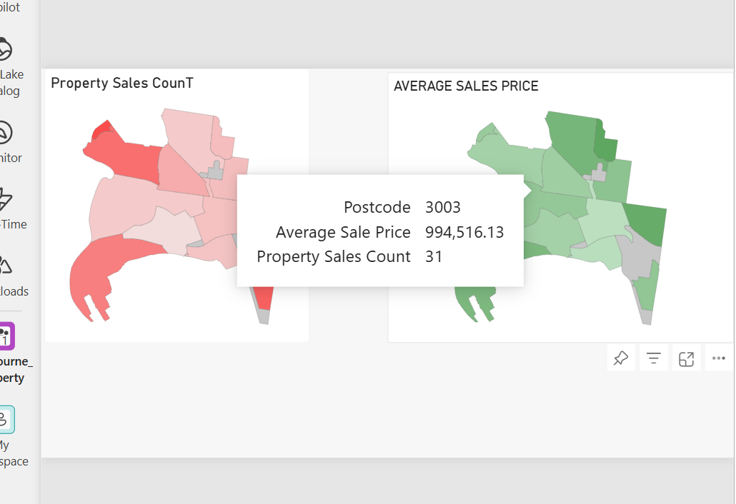
Figure 9. Choropleth maps - property sales count and average sale price by postcode
Two shape maps are used side by side to compare Property Sales Count and Average Sale Price across postcode areas, using a red (lower) to green/darker (higher) colour scale for price and a similar intensity scale for sales count. The tooltip example shown highlights postcode 3003, with an average sale price of $994,516.13 across 31 recorded property sales. Viewing count and price together helps identify postcodes that combine high sales volume with elevated pricing.

6.2 Custom GeoJSON Boundaries
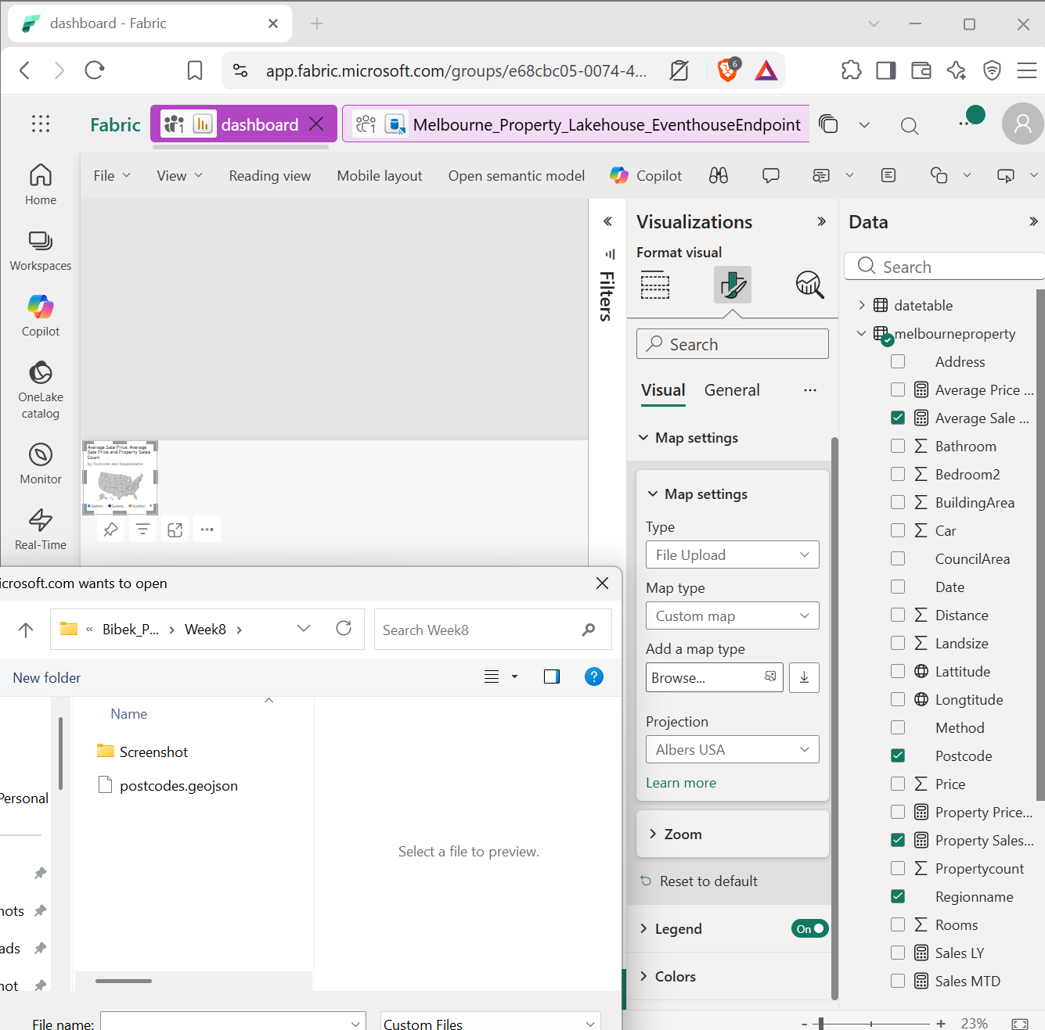
Figure 10. Configuring a custom postcode GeoJSON boundary file for the shape map visual
Because the default Power BI shape map does not include Australian postcode boundaries, a custom postcodes.geojson boundary file was uploaded and applied to the shape map visual, with projection set to Albers USA and the Postcode field mapped as the location key. This allows the choropleth visuals in Section 6.1 to render accurate Melbourne postcode geography rather than relying on a generic or unmatched boundary set.

6.3 Spatial Bubble Map
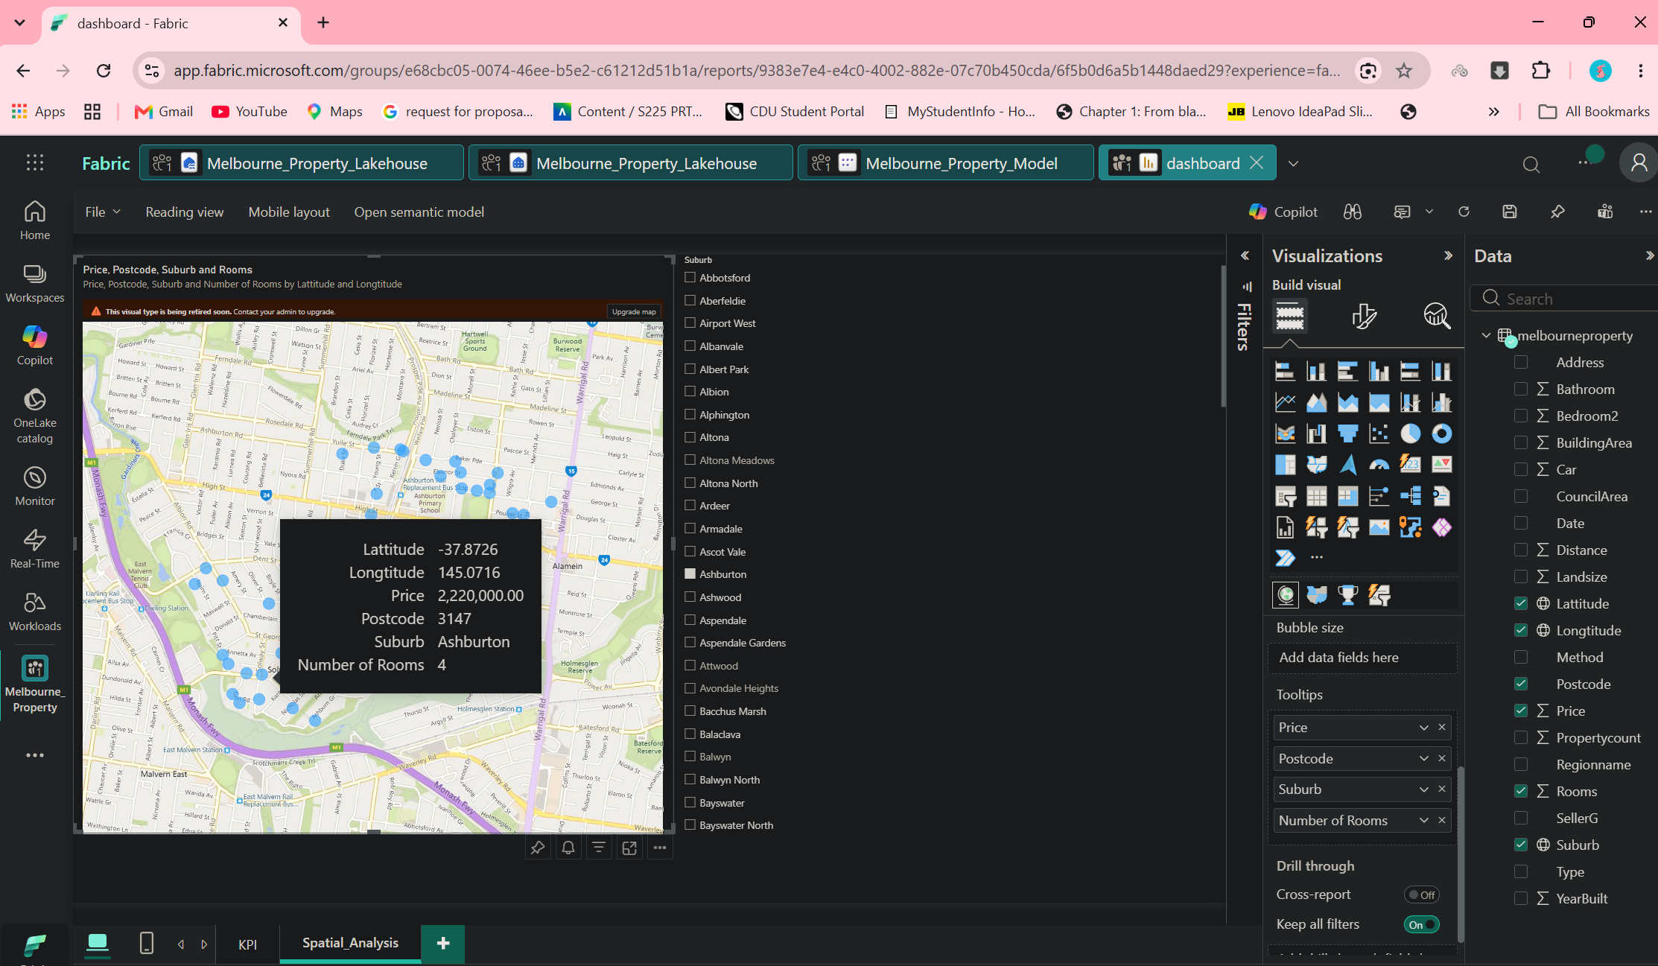
Figure 11. Spatial analysis page - bubble map of sales by latitude/longitude with suburb drill-down
A bubble map plots individual property sales using latitude and longitude, with bubble tooltips showing Latitude, Longitude, Price, Postcode, Suburb and Number of Rooms. A Suburb list on the right allows users to filter or drill into a specific suburb, illustrated here with Ashburton selected and a highlighted sale of $2,220,000 at latitude -37.8726, longitude 145.0716 (4 rooms, postcode 3147). This page complements the postcode-level choropleth by allowing inspection down to individual transactions.

7. Deployment and Platform Configuration

7.1 Direct Lake Storage Mode
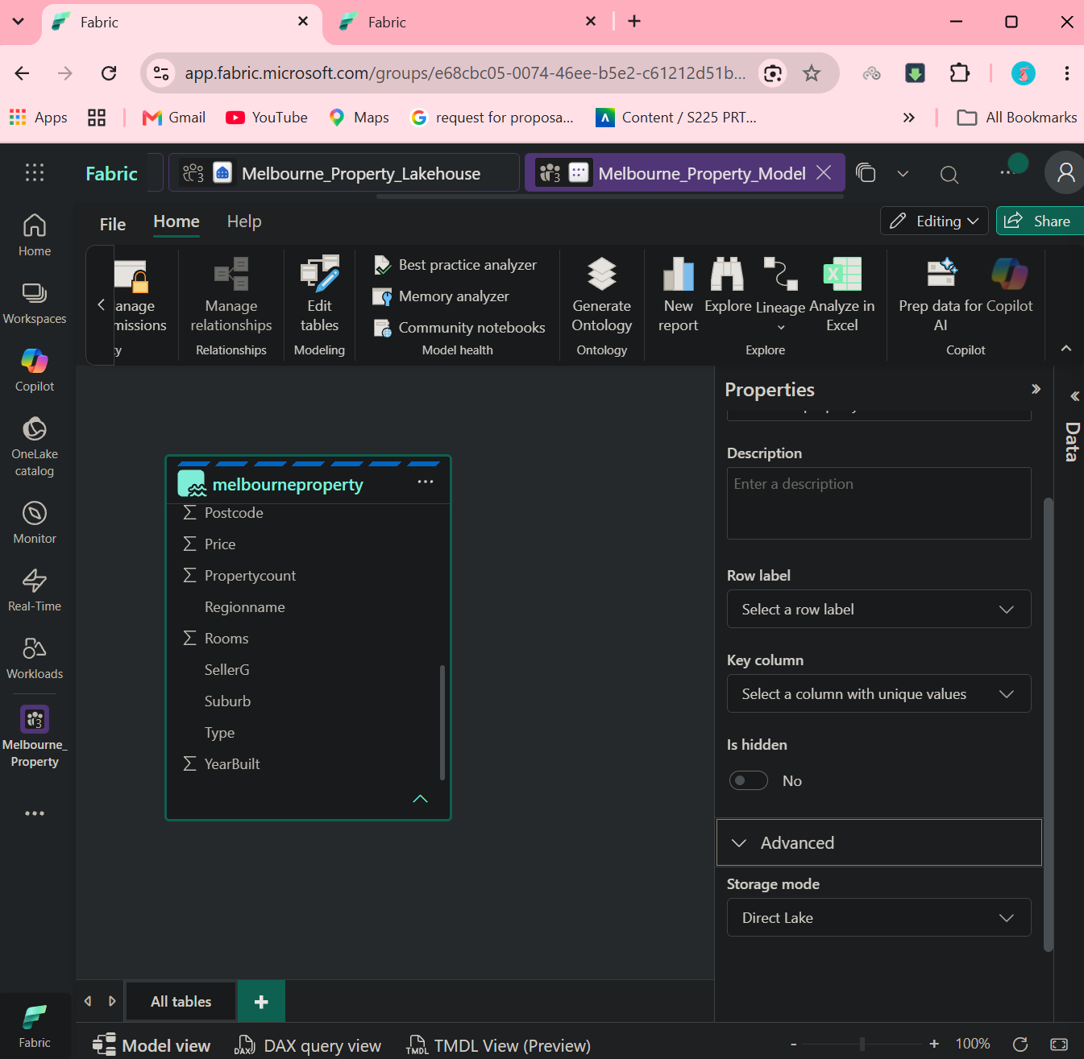
Figure 12. Semantic model storage mode set to Direct Lake
The melbourneproperty table's storage mode was configured as Direct Lake within the Fabric semantic model. Direct Lake allows Power BI to query Delta tables in the Lakehouse directly, without a separate import or scheduled refresh step, which keeps dashboard visuals aligned with the latest data landed by the PySpark notebook while avoiding the storage overhead of a full import model.

7.2 Build and Deployment Verification
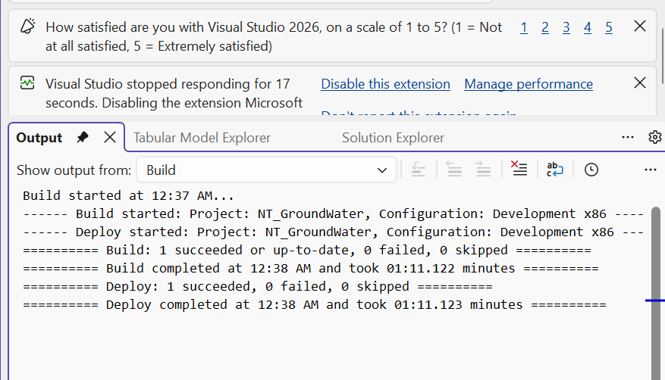
Figure 13. Visual Studio build and deploy output confirming a successful deployment
Build and deployment activity was verified from the Visual Studio Output window, confirming that the project build succeeded (1 succeeded, 0 failed, 0 skipped) and that deployment completed successfully in a comparable analytical-model workflow. This evidence supports the operational reliability of the modelling and deployment pipeline used alongside the Fabric-based development described above.

8. Validation, Limitations and Recommendations

8.1 Validation
- The relationship model correctly links melbourneproperty to the generated date table on Date, supporting reliable time-intelligence measures (YTD, QTD, MTD, YoY).
- Geographic fields (Latitude, Longitude, Postcode) were validated visually through both the choropleth and bubble-map visuals, confirming correct spatial rendering.
- KPI totals shown on the overview page (13.58K properties, $1.08M average price) are consistent with the suburb-level averages shown in the segmentation views.
- A successful build/deploy cycle was confirmed from Visual Studio, and Direct Lake mode was confirmed as the active storage mode for the semantic model.

8.2 Limitations
- The default Power BI shape map does not include Australian postcode boundaries, requiring a custom GeoJSON file; boundary accuracy is dependent on the quality of that external file.
- Average-price KPIs and segment averages can be strongly influenced by high-value outlier sales; median and percentile-based measures would reduce this sensitivity.
- The dynamic segmentation thresholds (High / Low / Medium / Premium) are not documented in the supplied evidence and should be formally defined and agreed with business stakeholders.
- Direct Lake performance and refresh behaviour depend on the underlying Lakehouse Delta tables remaining optimised (e.g. regular table maintenance), which is not evidenced in the supplied screenshots.

8.3 Recommendations
- Document the exact rules used to assign suburbs to the High / Low / Medium / Premium price segments.
- Add median and percentile price measures alongside existing averages to reduce sensitivity to outlier sales.
- Extend the date table with fiscal-year attributes if reporting needs to align with a non-calendar financial year.
- Introduce scheduled Lakehouse table maintenance (e.g. OPTIMIZE/VACUUM) to sustain Direct Lake query performance as data volume grows.
- Add drill-through from suburb-level summaries to individual property records for operational-style investigation.

9. Conclusion
The Melbourne Property Market project demonstrates an end-to-end business-intelligence workflow: source sales data was ingested into a Fabric Lakehouse, a supporting date dimension was engineered using PySpark, the semantic model was corrected and related across fact, date and segmentation tables, a DAX measure library was authored for time-intelligence reporting, and the results were delivered through KPI, segmentation and geospatial dashboard pages. The model was configured for Direct Lake storage and its deployment pipeline was verified as successful.
The strongest analytical capabilities demonstrated include dynamic, user-driven price segmentation of suburbs, multi-layer geospatial analysis combining postcode-level choropleth maps with transaction-level bubble mapping, and a consistent set of time-intelligence measures (YTD, QTD, MTD, YoY) available across every dashboard page. Together, these provide a sound basis for interactive exploration of the Melbourne property market and for further analytical extension.

Appendix A - Evidence Map
Evidence file | Report section
melb_data.png | Source dataset (Section 1.1)
ADD_TABLES_PYSHARK.png | PySpark date table build (Section 2.1)
Fixing_data_types.png | Data type / category configuration (Section 3.1)
Relationships.png | Semantic model relationships (Section 3.2)
DAX_Measures.png | DAX measures (Section 4)
Overview_KPI.png | KPI overview dashboard (Section 5.1)
Segmentation_Dashboard.png | Sales segmentation dashboard (Section 5.2)
Dynamic Segementation.png | Dynamic price segmentation (Section 5.3)
Chloropeth.png | Choropleth maps by postcode (Section 6.1)
Custom_Geojson_map.png | Custom GeoJSON boundary configuration (Section 6.2)
map.png | Spatial bubble map (Section 6.3)
fabrics_direct_lake.png | Direct Lake storage mode (Section 7.1)
Deployment_Successful.png | Build/deploy verification (Section 7.2)

