RETAIL OPERATIONS
BUSINESS INTELLIGENCE SOLUTION
Detailed Implementation, Analysis and Reporting Documentation
Dataset: Retail Store Transactions, Items, Returns and Customers
Prepared from supplied project implementation screenshots
Platform: Microsoft Fabric, Power BI and Power BI Report Builder

Executive Summary
This document records the Retail Operations business-intelligence solution, covering dataset inspection and validation, ingestion of 13 Parquet files into a Microsoft Fabric Lakehouse, semantic-model design, row-level security (RLS) for regional managers, a Power BI store sales summary, and a paginated Monthly Operational & Audit Report built in Power BI Report Builder. The evidence in the supplied screenshots is consolidated into one implementation report.
The dataset contains 598,537 rows across 13 related tables, centred on 164,968 transactions and 420,016 transaction line items for 16 stores in 8 Australian regions. Referential-integrity checks found zero invalid keys across every tested relationship and zero duplicate primary keys, supporting a reliable relational model. Headline results are total sales of 120,708,096.68, gross profit of 69,853,023.67 and refunds of 1,657,952.83.

Key Outcomes
- Inspected all 13 Parquet source tables and validated row counts, nulls, duplicates and foreign-key integrity with Python.
- Uploaded the files to the Retail_Operations Lakehouse in Fabric and exposed them as Delta tables in the dbo schema.
- Built a 13-table relational semantic model (Retail_Operations_Model) covering the geography, store, transaction, product and customer domains.
- Implemented dynamic row-level security using a RegionSecurity table, a RegionalManager role and the USERPRINCIPALNAME() function.
- Produced a Power BI store-level sales table that reconciles to the overall total of 120,708,096.68.
- Connected Power BI Report Builder to the semantic model and delivered a paginated report with KPI summary, month and year parameters and a region/store breakdown.

Contents
1. Project and Dataset Overview
2. Data Validation
3. Fabric Lakehouse Ingestion
4. Semantic Model and Relationships
5. Row-Level Security
6. Power BI Store Sales Summary
7. Paginated Reporting with Report Builder
8. Validation, Limitations and Recommendations
9. Conclusion
Appendix A - Evidence Map

1. Project and Dataset Overview
The project analyses retail operations by combining store and regional hierarchy, sales transactions, transaction line items, product and supplier reference data, promotions, customers and returns. The objective is to turn the operational source files into a governed business-intelligence solution that supports sales and profit monitoring, regional access control and repeatable monthly reporting.
Table | Rows | Analytical role
transactions | 164,968 | Sales header records (customer, store, date, channel, payment method, total amount)
items | 420,016 | Transaction line items (quantity, unit price, discount, line total, gross profit)
returns | 8,762 | Returned items with reason code, quantity and refund amount
customers | 3,157 | Customer profile (loyalty tier, age group, income level, location)
date_dim | 1,095 | Calendar dimension covering three years, with fiscal and holiday attributes
products | 342 | Product catalogue (SKU, category, brand, supplier, price, cost)
promotions | 45 | Promotion definitions and validity dates
brands | 37 | Brand reference with country of origin
categories | 36 | Product category hierarchy
districts | 35 | District level of the geographic hierarchy
suppliers | 20 | Supplier reference with lead time
stores | 16 | Store master data (type, city, opening date, district)
regions | 8 | Top level of the geographic hierarchy
Total | 598,537 | Combined project dataset

1.1 Source Data Inspection
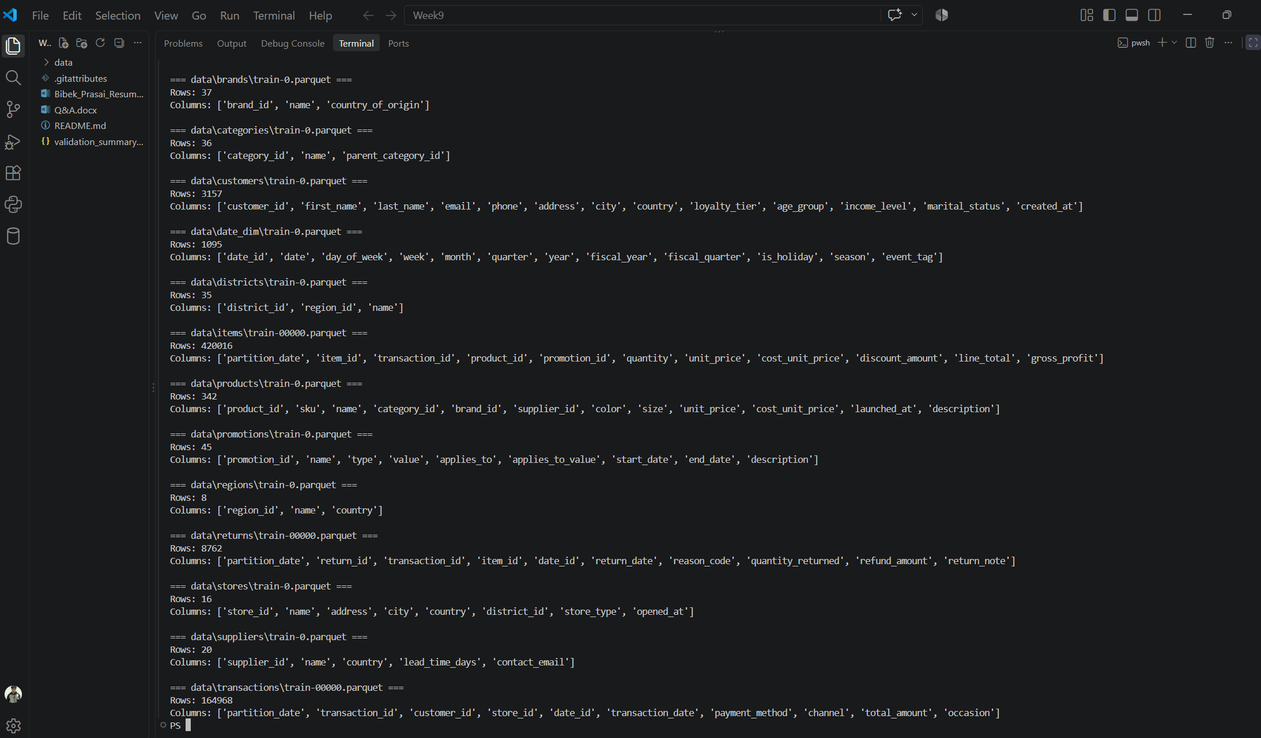
Figure 1. Terminal inspection of the Parquet source files (rows and columns per table)
A Python script in Visual Studio Code read every Parquet file under the data folder and printed the row count and column list for each table. The output confirms the structure summarised above and shows the key columns used to join tables: region_id, district_id, store_id, transaction_id, item_id, product_id, customer_id and date_id. The large items and transactions files carry a partition_date column, and the tables are stored as train-*.parquet files.

1.2 Core Business Questions
- How do sales, transactions, units and gross profit compare across regions and stores?
- How large are returns relative to sales, and where are they concentrated?
- How can regional managers be restricted to the data for their own region?
- Can the operational reporting be produced repeatedly for a chosen month and year?
- Can the same governed semantic model serve both interactive Power BI reports and paginated reports?

2. Data Validation
Before loading, the source tables were profiled for nulls and duplicate keys and tested for referential integrity. The checks were run as Python one-liners using pandas against the Parquet files.

2.1 Nulls and Duplicates
Table | Rows | Null cells | Duplicate keys
brands | 37 | 0 | 0
categories | 36 | 6 | 0
customers | 3,157 | 528 | 0
date_dim | 1,095 | 1,086 | 0
districts | 35 | 0 | 0
items | 420,016 | 315,050 | 0
products | 342 | 178 | 0
promotions | 45 | 15 | 0
regions | 8 | 0 | 0
returns | 8,762 | 396 | 0
stores | 16 | 0 | 0
suppliers | 20 | 0 | 0
transactions | 164,968 | 0 | 0

No table has duplicate primary keys, so every identifier is suitable as a relationship key. Null counts are concentrated in optional descriptive columns; the items table has the most (315,050 null cells), which is consistent with optional fields such as promotion_id being empty for line items sold without a promotion, though the screenshots do not show which columns hold them. The transactions, stores, regions, districts, brands and suppliers tables are fully populated.

2.2 Referential Integrity
Relationship tested | Child rows | Invalid keys
Region → District | 35 districts | 0
District → Store | 16 stores | 0
Store → Transaction | 164,968 transactions | 0
Transaction date → Date dimension | 164,968 transactions | 0
Transaction → Items | 420,016 items | 0
Item → Product | 420,016 items | 0
Transaction → Customer | 164,968 transactions | 0
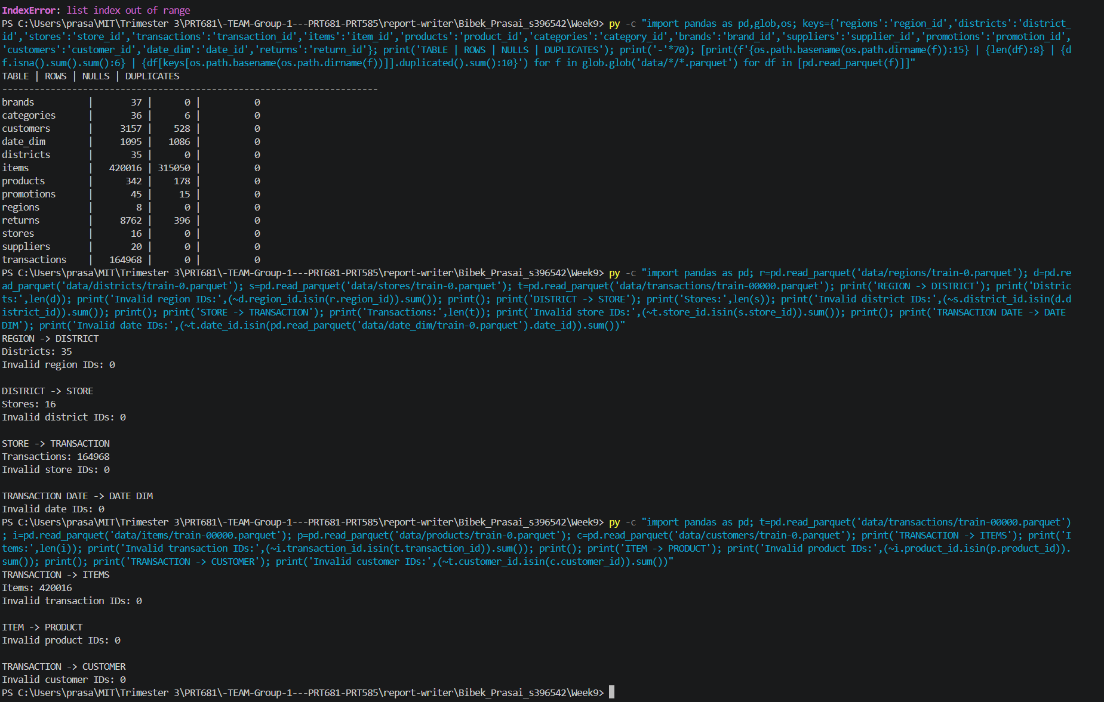
Figure 2. Null, duplicate and foreign-key validation results
The screenshot shows the summary table of rows, nulls and duplicates, followed by the relationship checks. Every check returned zero invalid identifiers, so the hierarchy from region to district to store to transaction to item to product is intact, and each transaction resolves to a valid date and customer. An IndexError from an earlier attempt is visible at the top of the terminal; the validation command was corrected and re-run successfully.

3. Fabric Lakehouse Ingestion

3.1 Uploading the Source Files
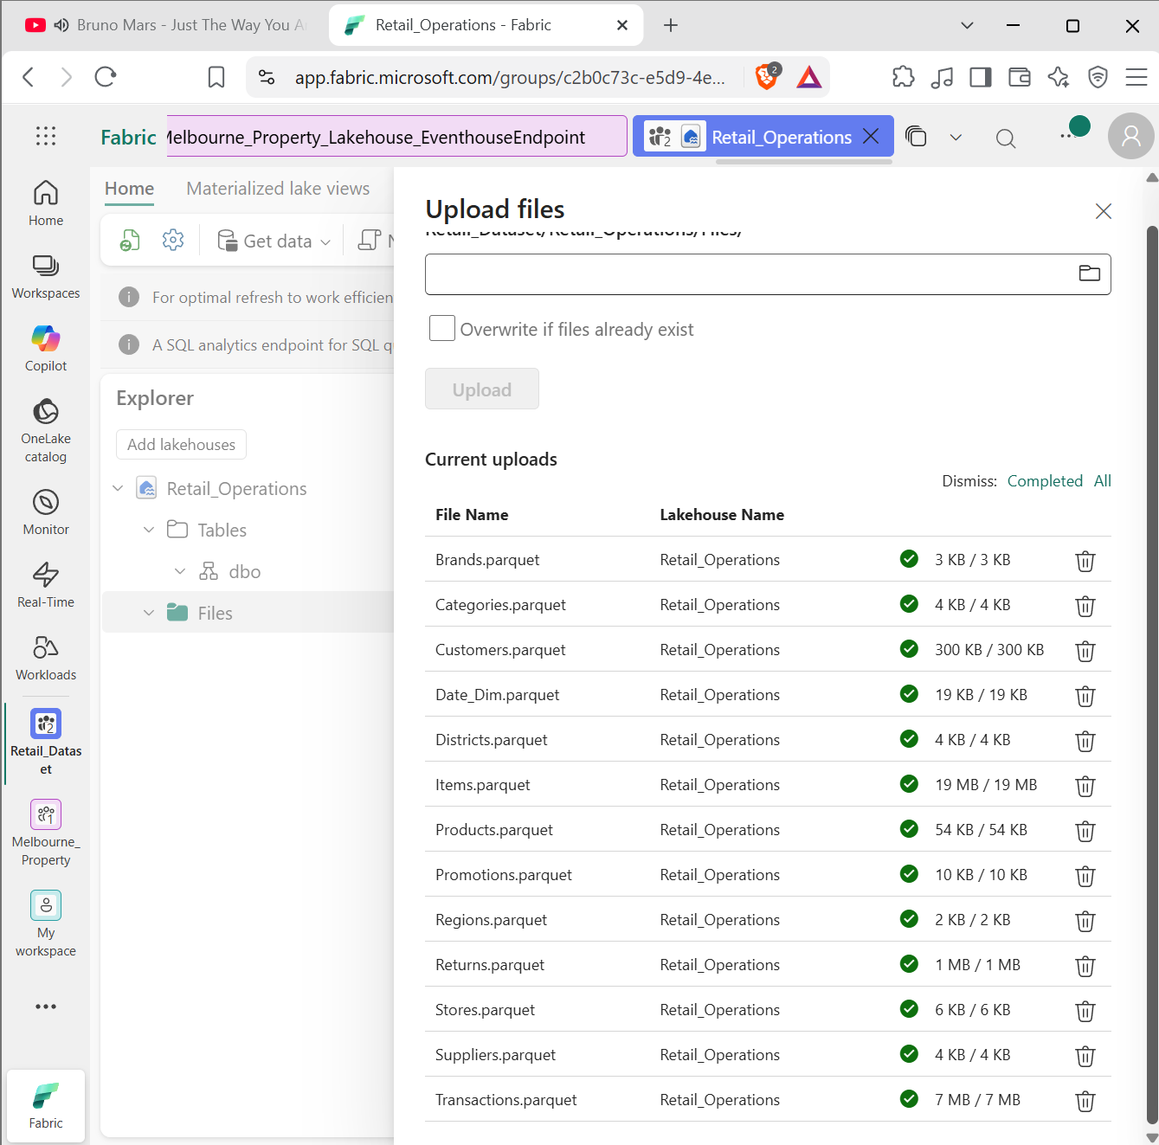
Figure 3. Uploading the Parquet files to the Retail_Operations Lakehouse
The 13 Parquet files were uploaded to the Files area of the Retail_Operations Lakehouse in the Retail_Dataset workspace. The upload panel shows every file completed successfully, with sizes ranging from 2 KB (Regions) to 19 MB (Items); the Transactions file is 7 MB and Customers 300 KB.

3.2 Lakehouse Tables
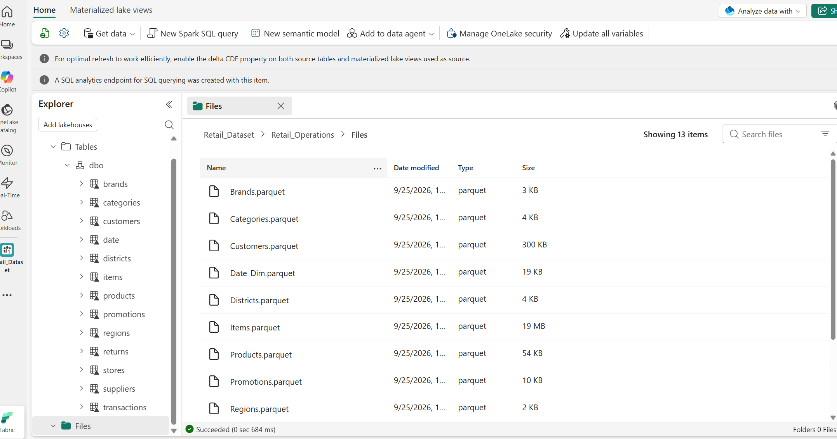
Figure 4. Lakehouse explorer showing the loaded tables and uploaded files
The Lakehouse explorer shows the dbo schema containing the tables brands, categories, customers, date, districts, items, products, promotions, regions, returns, stores, suppliers and transactions, alongside the Files folder holding the 13 source files. Loading the files as Delta tables makes them available to the SQL analytics endpoint and to a Direct Lake semantic model. The date_dim source appears as the date table in the Lakehouse.

4. Semantic Model and Relationships

4.1 Relationship Model
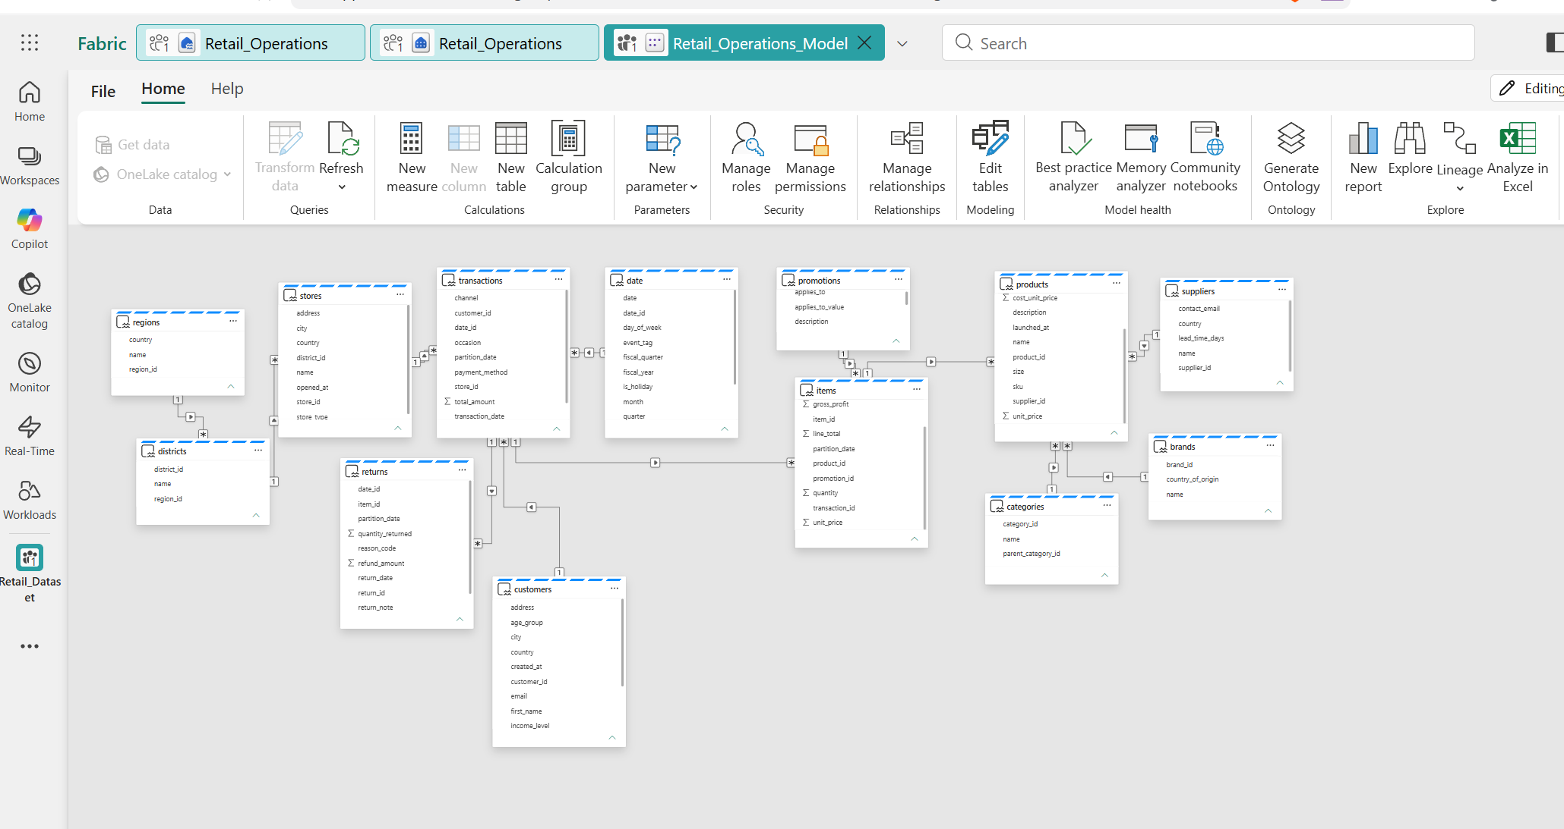
Figure 5. Retail_Operations_Model relationship diagram in Fabric
The model view of Retail_Operations_Model shows all tables related through their identifiers. The geography branch runs regions → districts → stores → transactions. Transactions relate to the date table, to customers and to items, and items relate to products and promotions. Products in turn relate to categories, brands and suppliers, while returns connect back to transactions and customers.
Transactions and items act as the central fact tables, and the descriptive tables surround them as dimensions. This reduces duplication of descriptive fields and lets a filter on a region, store, product category or date flow through to sales, units, profit and returns.

4.2 Connecting Power BI Desktop to the Model
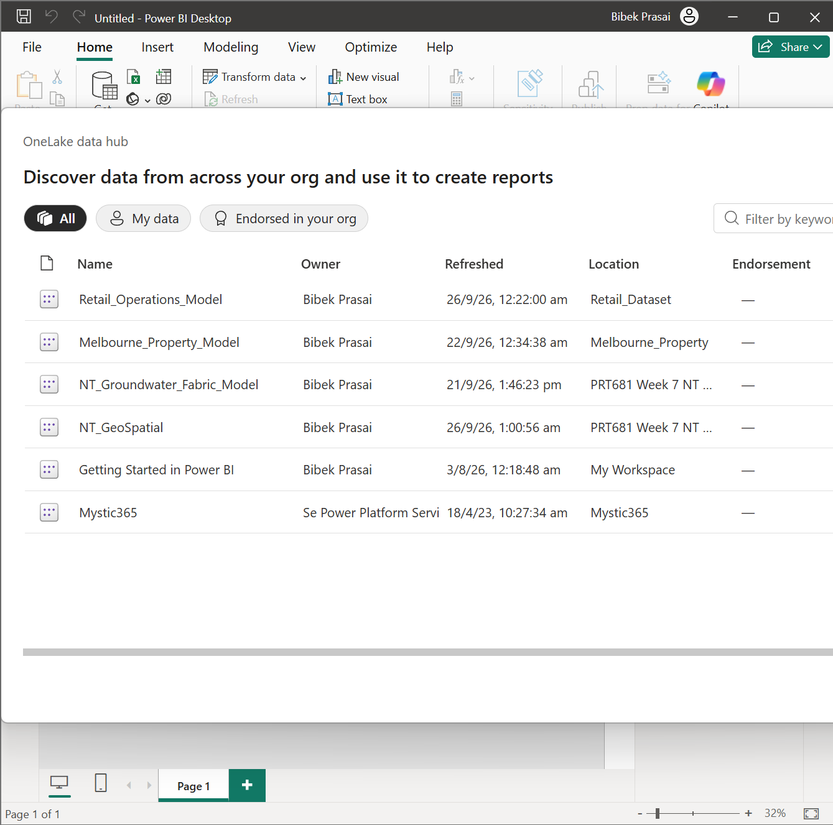
Figure 6. OneLake data hub in Power BI Desktop listing Retail_Operations_Model
Power BI Desktop connects to the published semantic model through the OneLake data hub. Retail_Operations_Model appears in the Retail_Dataset location, owned by the project author and last refreshed on 26/9/26. Because reports connect live to the shared model, measures and security rules are defined once and reused by every report.

5. Row-Level Security
Regional managers should only see data for their own region. This was implemented with a mapping table in the Lakehouse and a dynamic security role in the semantic model.

5.1 Creating the RegionSecurity Table
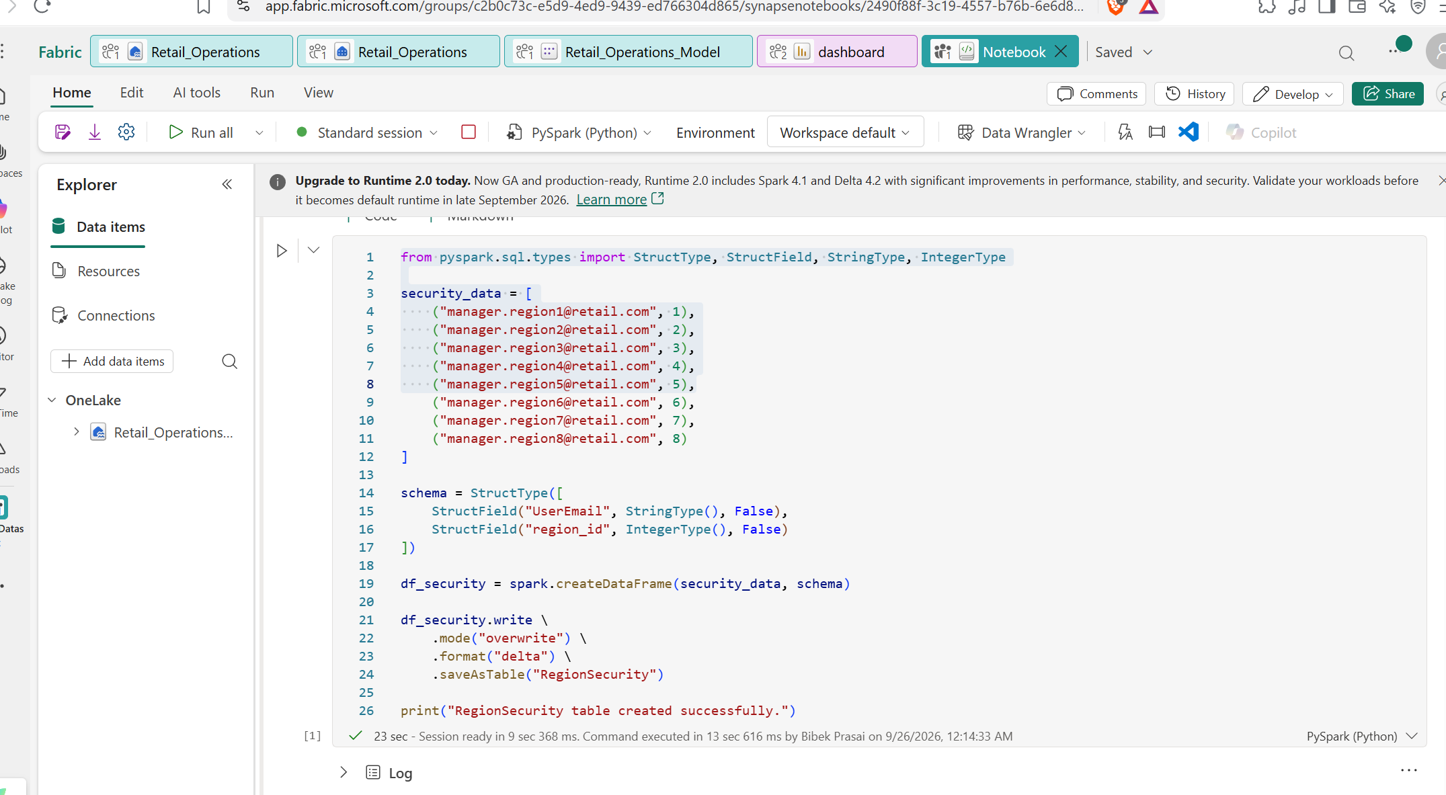
Figure 7. PySpark notebook creating the RegionSecurity Delta table
A Fabric notebook defined a list of manager email addresses (manager.region1@retail.com through manager.region8@retail.com), each paired with a region_id from 1 to 8. A two-column schema (UserEmail, region_id) was applied and the data written in overwrite mode as a Delta table named RegionSecurity. The run completed in about 23 seconds and printed a success message.

5.2 Defining the Security Role
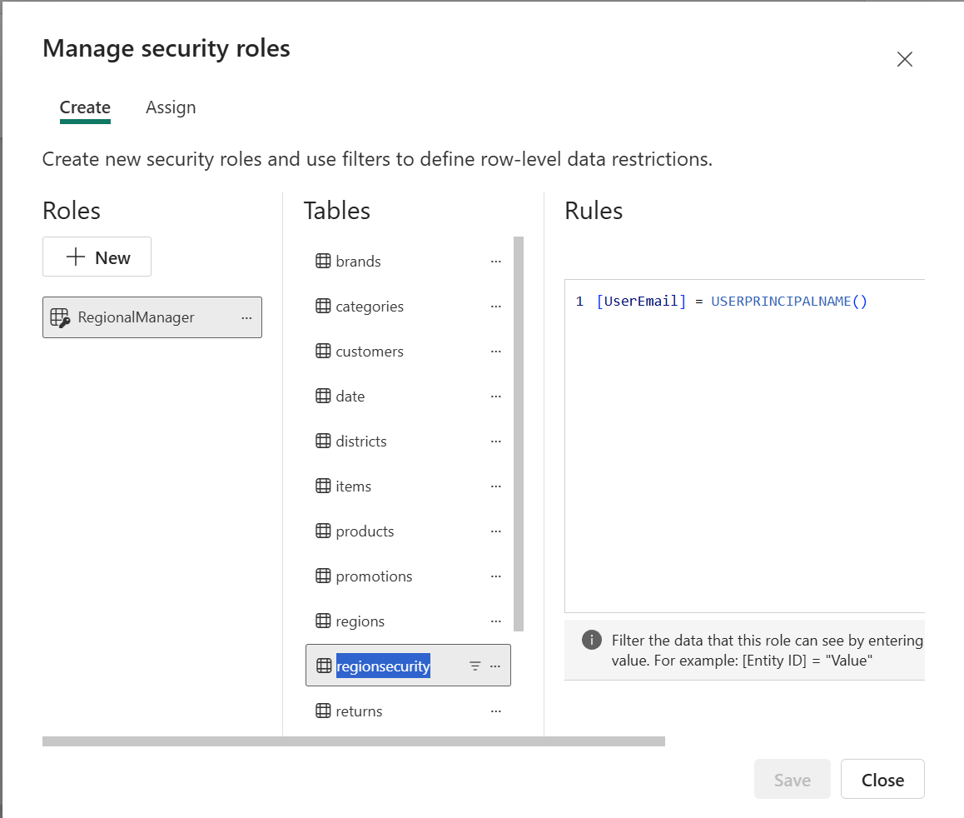
Figure 8. Creating the RegionalManager role and filter on the regionsecurity table
In Manage security roles, a RegionalManager role was created and a table filter was placed on the regionsecurity table using the expression [UserEmail] = USERPRINCIPALNAME(). This limits the mapping table to the row belonging to the signed-in user.
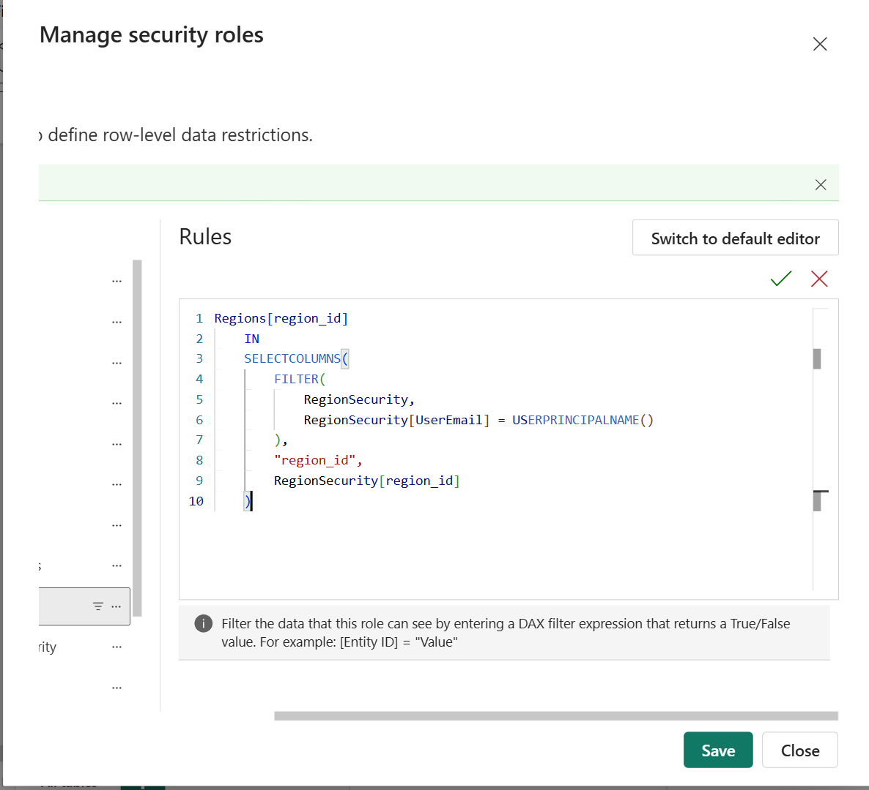
Figure 9. DAX filter on Regions that restricts rows using RegionSecurity
A second filter on the Regions table keeps only regions whose region_id appears in the current user's rows of RegionSecurity, using IN with SELECTCOLUMNS and FILTER. Because relationships propagate filters down the hierarchy, restricting Regions also restricts districts, stores, transactions and items to that region.

5.3 Assigning Members
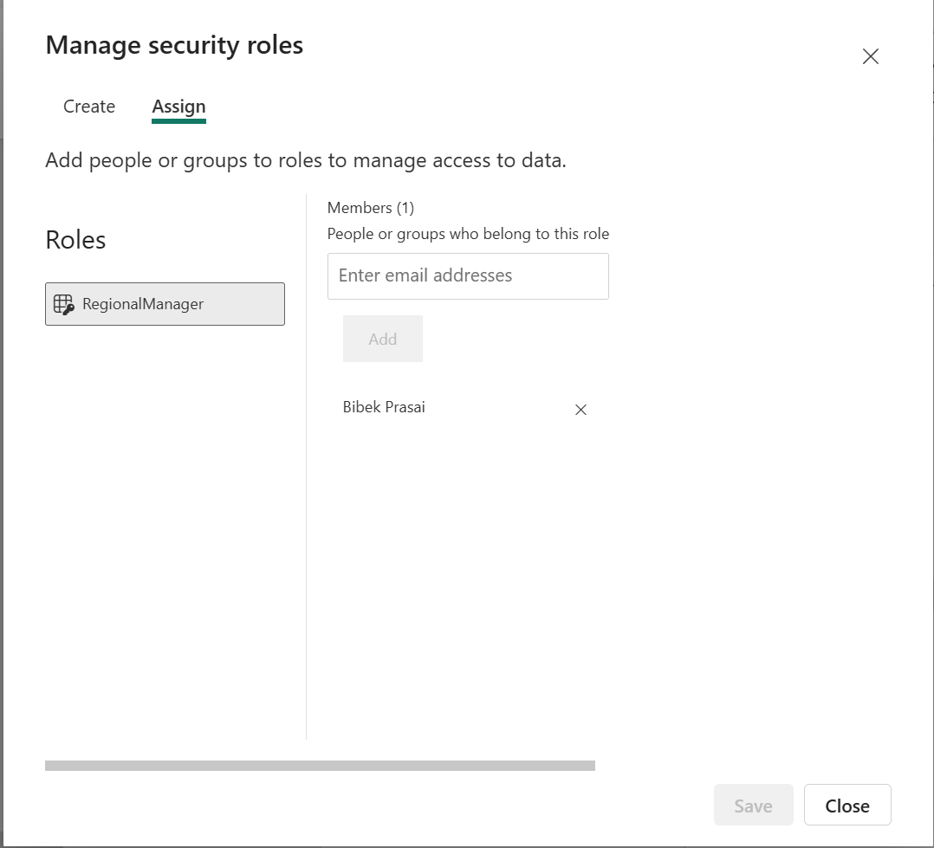
Figure 10. Assigning members to the RegionalManager role
On the Assign tab, users are added to the RegionalManager role. One member is assigned in the screenshot, allowing the rule to be tested with the project account.

5.4 Recreating the Mapping Table
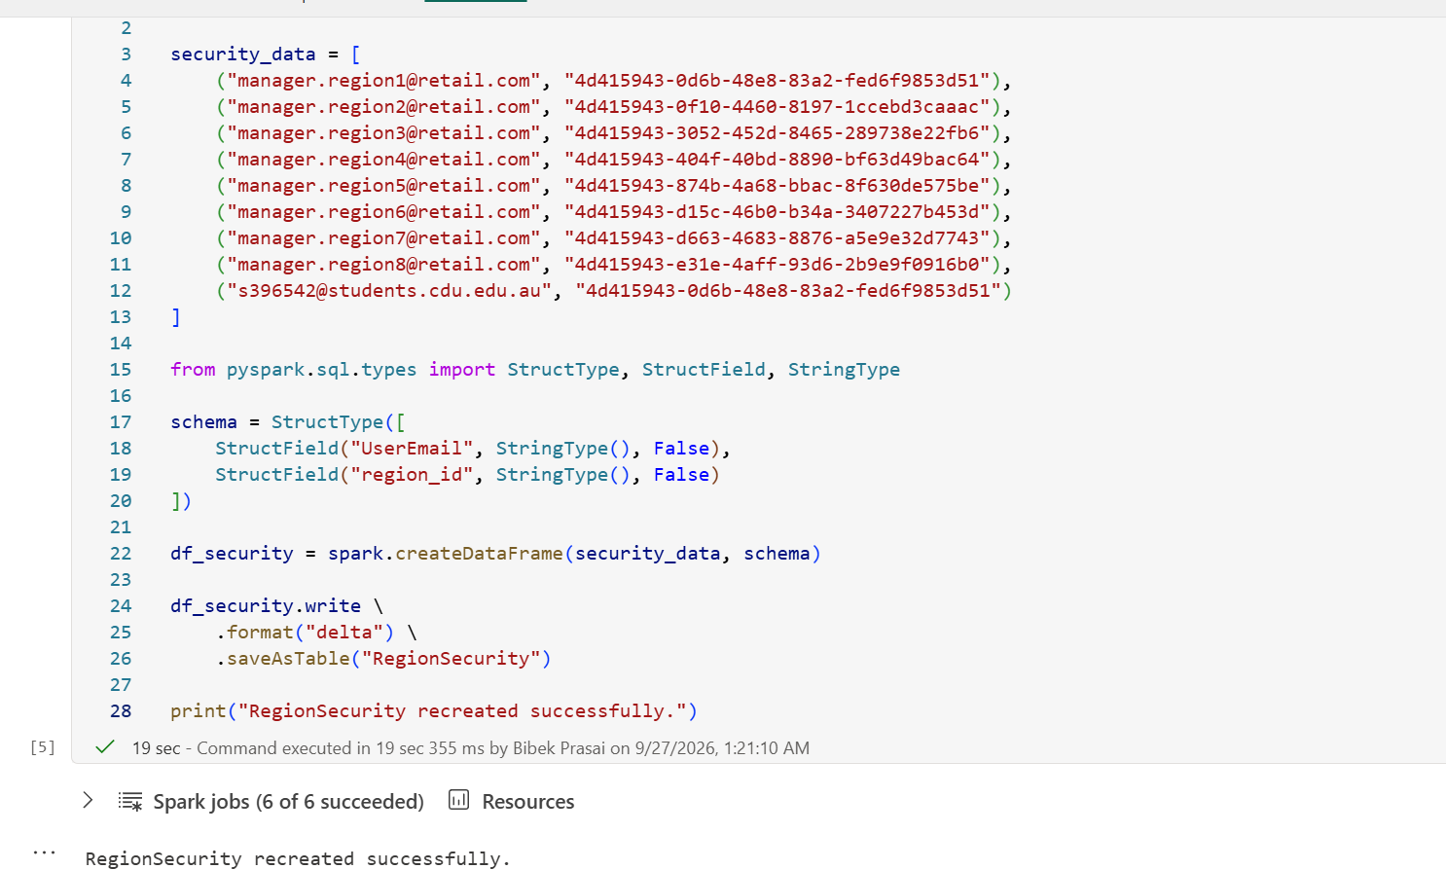
Figure 11. RegionSecurity table recreated with string region identifiers
The mapping notebook was later revised and re-run so that the region_id column is a string rather than an integer, with each manager email paired to an identifier value, and an additional test account mapped to the first region's identifier. The table was recreated successfully (all 6 Spark jobs succeeded). Keeping the key data type identical on both sides of the IN comparison is required for the security filter to match rows.

6. Power BI Store Sales Summary
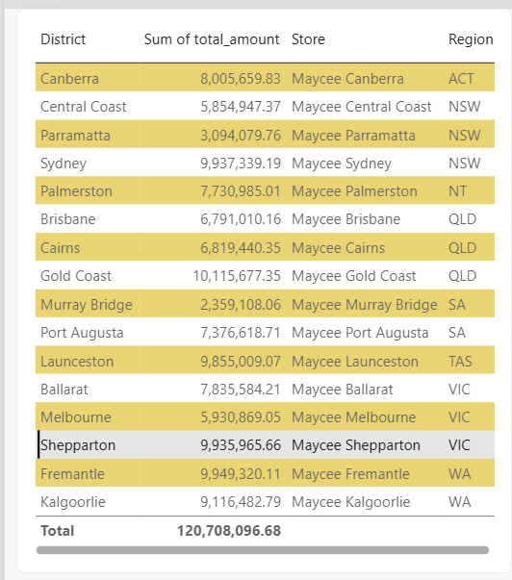
Figure 12. Power BI table of total sales by district, store and region
A Power BI table visual sums total_amount by district, store and region with banded rows and a grand total of 120,708,096.68, which matches the overall sales figure in the paginated report. The table doubles as a cross-check between the interactive and paginated layers.
Region | Stores | Total sales
ACT | Canberra | 8,005,659.83
NSW | Central Coast, Parramatta, Sydney | 18,886,366.32
NT | Palmerston | 7,730,985.01
QLD | Brisbane, Cairns, Gold Coast | 23,726,127.86
SA | Murray Bridge, Port Augusta | 9,735,726.77
TAS | Launceston | 9,855,009.07
VIC | Ballarat, Melbourne, Shepparton | 23,702,418.92
WA | Fremantle, Kalgoorlie | 19,065,802.90
Total | 16 stores | 120,708,096.68

Regional totals above are the sums of the store values shown in the table. Queensland (23.73M) and Victoria (23.70M) lead, each with three stores. Maycee Gold Coast is the highest-selling store at 10,115,677.35, and Maycee Murray Bridge is the lowest at 2,359,108.06, roughly a quarter of the top store.

7. Paginated Reporting with Report Builder
A paginated Monthly Operational & Audit Report was built in Power BI Report Builder on top of Retail_Operations_Model, providing a printable, parameter-driven view for store operations and audit.

7.1 Data Source Connection
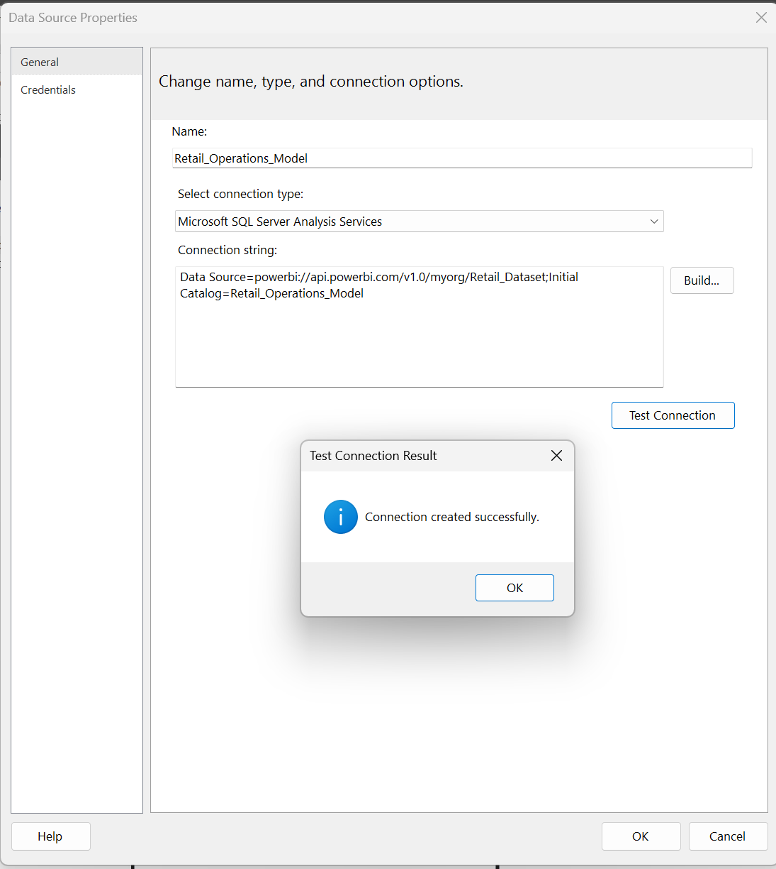
Figure 13. Report Builder data source pointing at the semantic model
The data source Retail_Operations_Model uses the Microsoft SQL Server Analysis Services connection type with a Power BI XMLA connection string that targets the Retail_Dataset workspace and the Retail_Operations_Model catalog. Test Connection returned 'Connection created successfully'.

7.2 KPI Query
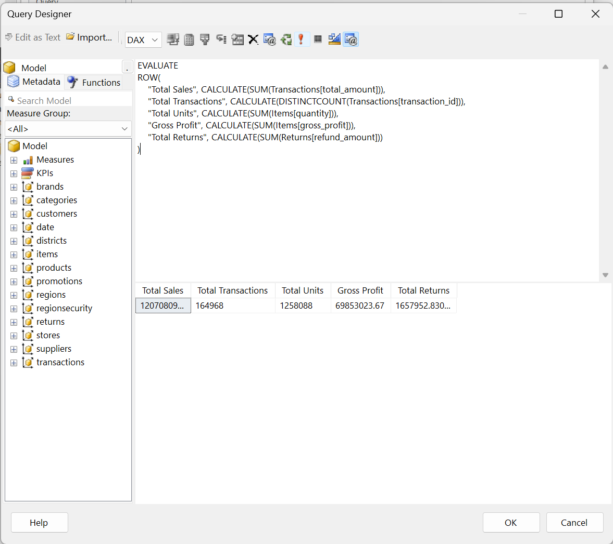
Figure 14. DAX query returning the headline KPIs
The Query Designer, in DAX mode, evaluates a single row containing five KPIs: Total Sales, Total Transactions (distinct count of transaction_id), Total Units, Gross Profit and Total Returns (sum of refund_amount). The preview returns the values in the table below.
KPI | Value | Derived insight
Total Sales | 120,708,096.68 | Average of about 731.71 per transaction
Total Transactions | 164,968 | About 7.6 units per transaction
Total Units | 1,258,088 | Gross profit of about 55.52 per unit
Gross Profit | 69,853,023.67 | Gross margin of about 57.9% of sales
Total Returns | 1,657,952.83 | Refunds equal about 1.4% of sales

7.3 Simple Report Output
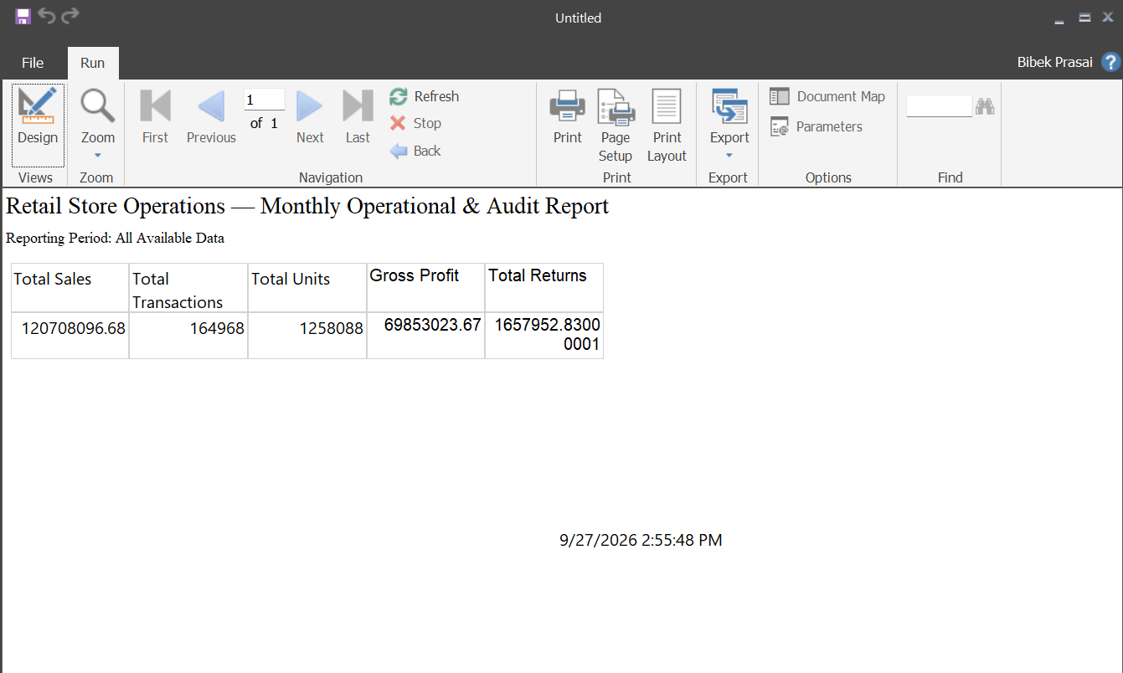
Figure 15. First run of the report showing the KPI summary
The first version of the report was run in the Report Builder preview with the title 'Retail Store Operations — Monthly Operational & Audit Report' and the subtitle 'Reporting Period: All Available Data'. It shows the KPI table with the same values as the query, plus a run timestamp, confirming that the data source, dataset and layout work end to end.

7.4 Month and Year Parameters
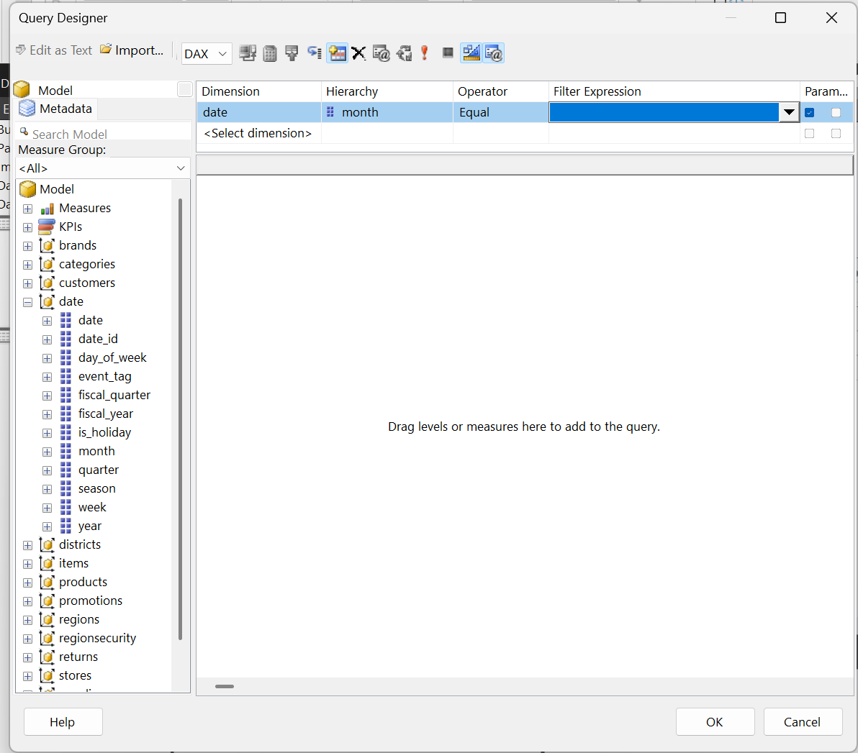
Figure 16. Adding a month filter and marking it as a parameter
A filter on the date table's month level was added in the Query Designer with the Equal operator and the parameter option ticked, which creates a report parameter. The date table exposes month, quarter, year, fiscal_year, fiscal_quarter, season, is_holiday and event_tag, so further filters can be added in the same way.
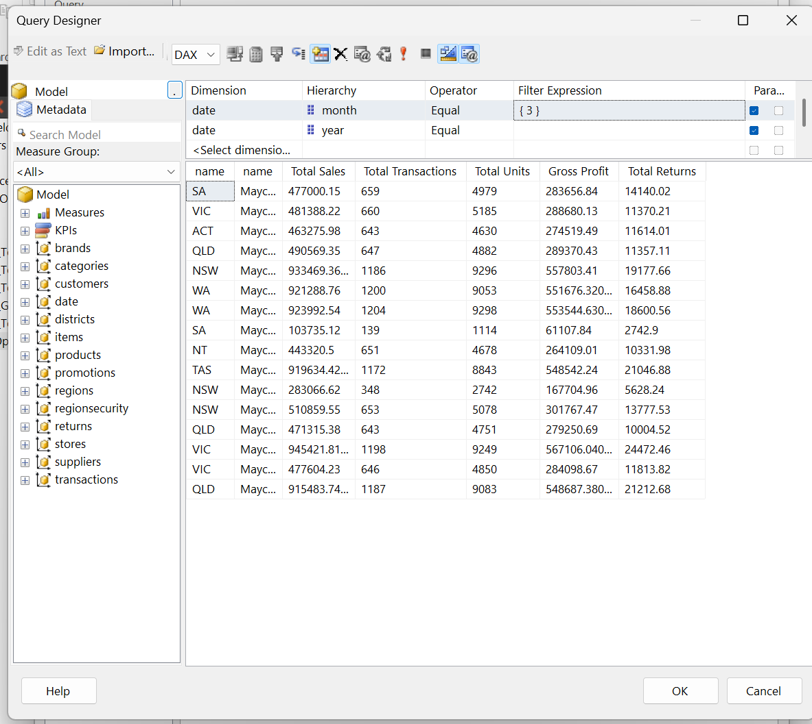
Figure 17. Query Designer with month and year filters and result preview
A second filter on year was added. In the preview, the month filter is set to {3} and the result grid returns Total Sales, Transactions, Units, Gross Profit and Returns by region and store, showing the query is filtered as intended.

7.5 Filtered Report Output
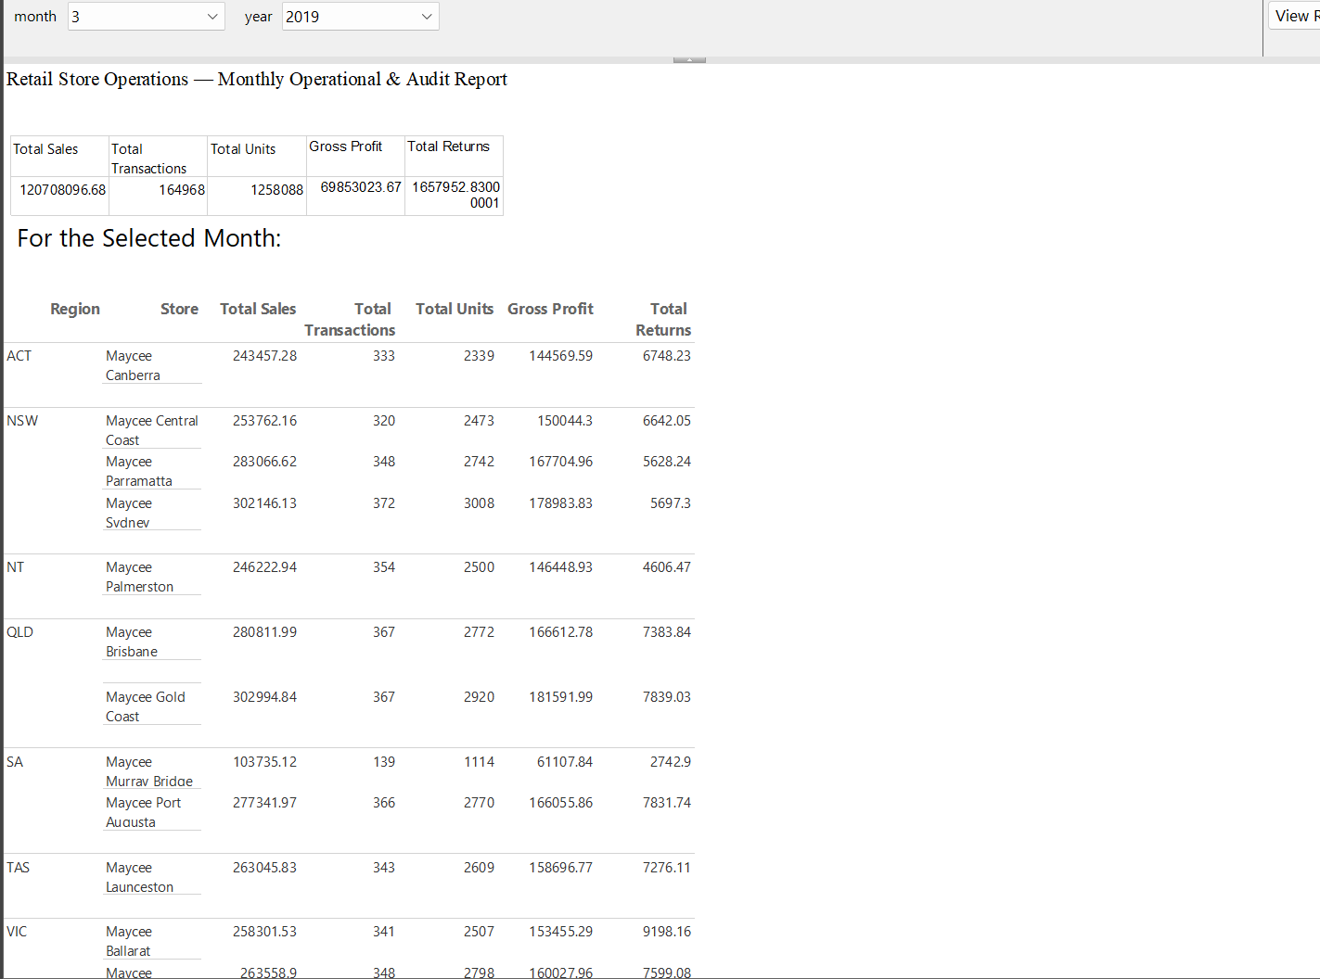
Figure 18. Rendered report with month and year parameters (month 3, year 2019)
The rendered report exposes month and year drop-downs (March 2019 selected). Below the KPI summary, a 'For the Selected Month' section lists each region and store with Total Sales, Total Transactions, Total Units, Gross Profit and Total Returns. For March 2019, for example, Maycee Sydney recorded 302,146.13 in sales from 372 transactions, and Maycee Gold Coast 302,994.84 from 367 transactions.

7.6 Full Region and Store Report
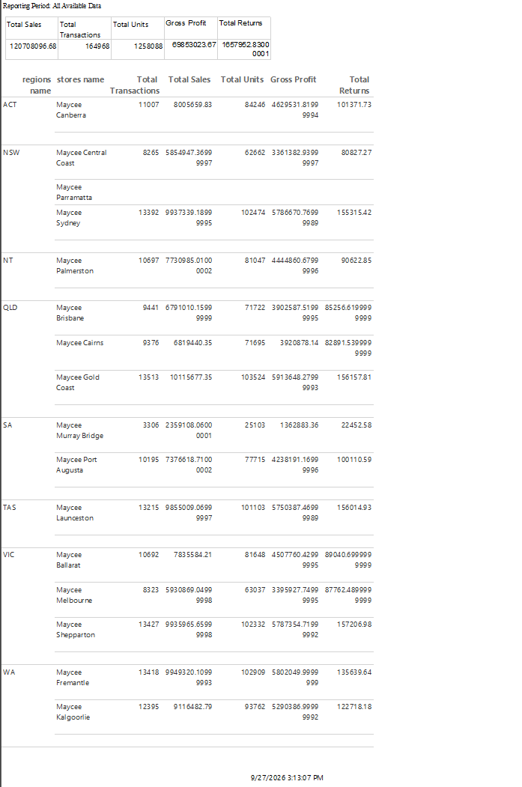
Figure 19. Paginated report for all available data by region and store
The all-data version groups stores by region and reports transactions, sales, units, gross profit and returns for each store, with a run timestamp in the footer. Store values agree with the Power BI table in Section 6: Maycee Canberra shows 8,005,659.83 and Maycee Sydney 9,937,339.19 in both. This confirms the paginated and interactive layers read the same semantic model.

8. Validation, Limitations and Recommendations

8.1 Validation Across Layers
- Source tables had zero duplicate keys and zero invalid foreign keys before modelling.
- The 13 uploaded files appear as 13 Lakehouse tables, matching the source count.
- The Report Builder KPI query and the rendered report show identical totals (120,708,096.68 sales, 164,968 transactions).
- Store-level sales in Power BI and in the paginated report agree, and regional sums add to the overall total.
- The RegionalManager role, mapping table and assignment together demonstrate dynamic row-level security tied to the signed-in user.

8.2 Limitations
- Several tables contain many null cells (items 315,050; date_dim 1,086; customers 528). The affected columns are not identified in the evidence and should be documented so that reports handle them deliberately.
- The RegionSecurity table was recreated with a different region_id data type, and the screenshots show test accounts alongside manager placeholders. Production use needs real user accounts and a single documented key type.
- In the month-filtered report, the KPI summary at the top still shows the all-period totals, so it appears not to respond to the month and year parameters.
- Report Builder displays unformatted decimals (for example 1657952.8300001), which reflects floating-point results with no number format applied.
- The screenshots evidence one paginated report and one Power BI table; the interactive dashboard pages are not shown, so visual-level findings are limited to the store sales table.

8.3 Recommendations
- Document which columns are null and why, and add handling for optional fields such as promotions on line items.
- Bind the KPI summary in the paginated report to the month and year parameters, and apply currency and integer number formats.
- Add measures for gross margin percentage, return rate and average transaction value so they are defined once in the semantic model.
- Replace placeholder manager emails with Microsoft Entra security groups and test each role with View as.
- Add drill-through from region and store summaries to transaction, product and returns detail.
- Schedule the paginated report as a monthly subscription so the audit report is delivered automatically.

9. Conclusion
The Retail Operations project demonstrates an end-to-end business-intelligence workflow: 13 source tables were inspected and validated, uploaded to a Fabric Lakehouse, modelled into a connected semantic model, secured with dynamic row-level security for regional managers, summarised in a Power BI table and delivered as a parameter-driven paginated report from Power BI Report Builder.
The strongest findings are the clean relational integrity of the data (zero invalid keys and duplicates), the 57.9% gross margin on 120.7M of sales, the low 1.4% refund rate, and the consistent totals across Power BI and Report Builder. Together with the security model, these results provide a sound basis for governed, repeatable retail reporting and for further development of interactive dashboards.

Appendix A - Evidence Map
Evidence file | Report section
Dataset_Inspection.png | Source data inspection (Section 1.1)
Data_Validation.png | Nulls, duplicates and referential integrity (Section 2)
Fabrics_Upload.png | Lakehouse file upload (Section 3.1)
Loading_Tables.png | Lakehouse tables (Section 3.2)
Relationships_Modelling.png | Relationship model (Section 4.1)
Connecting_Power_BI_Desktop.png | Power BI Desktop connection (Section 4.2)
NoteBook_Lakehouse_Connection.png | RegionSecurity table creation (Section 5.1)
Adding_Security_Roles.png | Security role and table filter (Section 5.2)
Manage_rOLE.png | Regions DAX filter (Section 5.2)
Adding_Roles.png | Role member assignment (Section 5.3)
Region_Sec_Mapping.png | Recreated mapping table (Section 5.4)
Simple_Table.png | Store sales summary (Section 6)
ReportBuilderDataConnection.png | Report Builder data source (Section 7.1)
KPI_Query_Report_Builder.png | KPI DAX query (Section 7.2)
Simple_Report_ReportBuilder.png | First report run (Section 7.3)
Month_Parameter_Filter.png | Month parameter (Section 7.4)
MonthAndYearFilter1.png | Month and year filters (Section 7.4)
MonthAndYearFilter.png | Filtered report output (Section 7.5)
Report_Builder_Report.png | Full region and store report (Section 7.6)

