NT GROUNDWATER
BUSINESS INTELLIGENCE SOLUTION
Detailed Implementation, Analysis and Reporting Documentation
PRT681 – Software Engineering Practice
Phase 4 Documentation
Dataset: NT Government Bore Locations, Water Quality and Groundwater Levels
Prepared from supplied project reports and implementation screenshots

Executive Summary
This document provides a detailed record of the NT Groundwater business-intelligence solution, covering dataset validation, SQL Server loading and analysis, Power BI modelling and dashboards, SQL Server Analysis Services (SSAS), Microsoft Fabric analysis, Power BI Service publishing and refresh configuration, and a conceptual SAP BusinessObjects reporting design. The evidence in the supplied screenshots and report outputs is consolidated into one implementation report.
The selected dataset contains 130,399 records across three related subject areas: 43,225 bore records, 84,769 water-quality records and 2,405 groundwater-level records. Relationship validation showed that all Water Quality BORE_NO values match the Bores dataset and all Groundwater Level UFI values match Bores, supporting a reliable relational model for cross-domain reporting.

Key Outcomes
- Created and validated a relational groundwater dataset centred on bore identifiers (UFI and BORE_NO).
- Loaded and transformed the data for analysis in SQL Server and Power BI.
- Built report views for bore overview, water quality and groundwater monitoring.
- Extended the analytical model through SSAS and Microsoft Fabric evidence.
- Published the Power BI report and configured sharing, access management, gateway and scheduled refresh settings.
- Defined a BusinessObjects semantic-layer design using dimensions, measures, filters and Web Intelligence report concepts.

Contents
1. Project and Dataset Overview
2. Data Validation and Database Design
3. SQL Analysis and Findings
4. Power BI Data Preparation and Model
5. Power BI Dashboard Pages
6. SSAS Analytical Model
7. Microsoft Fabric Analysis
8. Power BI Service Deployment and Refresh
9. BusinessObjects Reporting Design
10. Validation, Limitations and Recommendations
11. Conclusion

1. Project and Dataset Overview
The project analyses Northern Territory groundwater information by combining bore attributes, water-quality observations and groundwater monitoring/level information. The objective is to convert technical source data into a business-intelligence solution that supports exploration of bore distribution, bore yield, water quality, monitoring coverage and relationships between these factors.
Dataset area | Records | Primary analytical role
Bores | 43,225 | Master bore/location data and bore characteristics
Water Quality | 84,769 | Laboratory measurements such as pH, EC, TDS and hardness
Groundwater Levels | 2,405 | Groundwater monitoring observations/stations
Total | 130,399 | Combined project dataset

1.1 Core Business Questions
- How are bores distributed by status, purpose, risk class and yield class?
- How do bore yields differ by purpose, risk class and current/historical status?
- What is the overall water-quality profile and where are extreme values present?
- How concentrated is water-quality sampling around current versus historical bores?
- Can monitoring information be reliably joined to bore characteristics?
- How can the same analytical logic be delivered through Power BI, SSAS/Fabric and BusinessObjects?

2. Data Validation and Database Design

2.1 Initial Data Inspection
The supplied validation report records successful loading of all three shapefiles using GeoPandas, inspection of columns and data types, and verification that the shapefile components were usable. Profiling included missing-value analysis, duplicate-row checks, identifier uniqueness, categorical values, date ranges and water-quality sample distribution.

2.2 Identifier and Relationship Validation
Validation item | Result | Interpretation
Unique UFI in Bores | 43,225 | UFI is suitable as the Bores primary key.
Unique BORE_NO in Bores | 43,115 | BORE_NO is nearly unique but has duplicates.
Duplicated BORE_NO rows | 160 | Requires awareness when joining on BORE_NO.
Unique BORE_NO in Water Quality | 16,929 | Water quality contains repeated samples per bore.
Water Quality → Bores match | 100% | All water-quality bore numbers can be related to Bores.
Groundwater Levels → Bores match | 100% | All groundwater-level UFI values can be related to Bores.
Average WQ samples per bore | ~5 | Supports bore-level aggregation.
Maximum WQ samples per bore | 411 | Some bores have substantially deeper sampling history.

2.3 Database Import Evidence
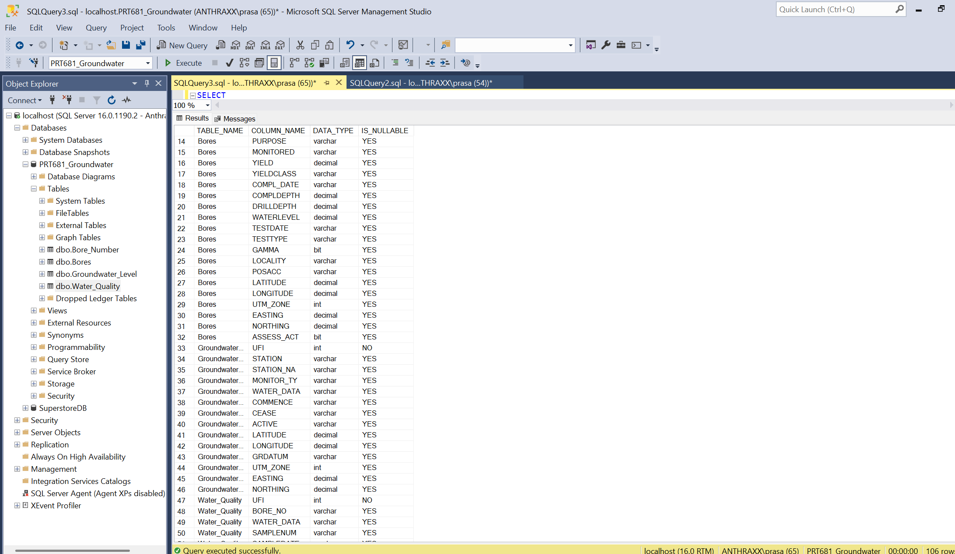
Figure 1. SQL Server database import – bore data
The screenshot documents the bore dataset after import into SQL Server Management Studio, providing evidence that source records were successfully loaded into the database environment.
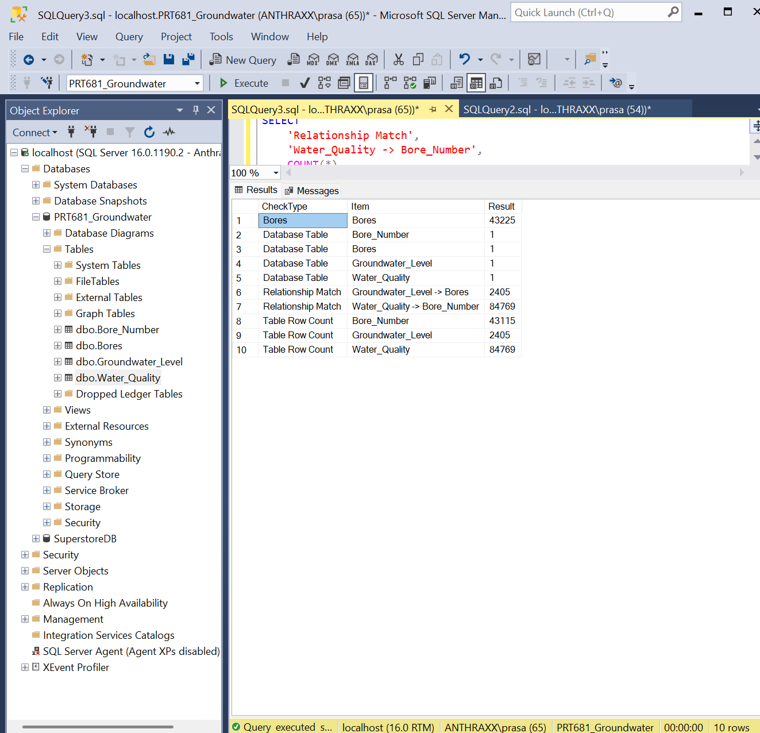
Figure 2. SQL Server database import – related data
The second import view shows additional groundwater/water-quality data in SQL Server, supporting the multi-table relational design used later in Power BI and SQL analysis.

3. SQL Analysis and Findings
SQL report outputs were used to establish baseline descriptive statistics and validate the calculations later represented visually. The results below are taken directly from the supplied analysis reports.

3.1 Bore Profile
Metric / category | Result
Current bores | 35,504
Historical bores | 7,721
Production | 24,003
Unknown purpose | 7,612
Investigation | 5,887
Monitoring | 1,803
Average yield | 3.433 L/s
Minimum yield | 0.00 L/s
Maximum yield | 1,140.00 L/s
Average drill depth | 62.061 m
Maximum drill depth | 3,840.20 m

3.2 Yield by Bore Purpose
Purpose | Bore count | Average yield (L/s) | Maximum yield (L/s)
Monitoring | 1,607 | 4.890 | 64.00
Unspecified/NULL | 2,766 | 4.142 | 150.00
Production | 21,480 | 3.590 | 1,140.00
Investigation | 4,273 | 2.936 | 62.50
Unknown | 3,694 | 1.931 | 100.00
Monitoring bores have the highest average yield in the combined non-null-yield analysis (4.89 L/s), while unknown-purpose bores have the lowest (1.93 L/s). Production bores include the overall maximum yield of 1,140 L/s.

3.3 Yield by Risk Class and Status
Category | Bore count | Average yield (L/s) | Maximum yield (L/s)
Risk 0 | 2,767 | 4.142 | 150
Risk 1 | 14,401 | 4.888 | 1,140
Risk 2 | 5,590 | 2.913 | 200
Risk 3 | 10,761 | 1.637 | 256
Risk 4 | 301 | 1.185 | 30
Current | 28,627 | 3.801 | 1,140
Historical | 5,193 | 1.406 | 125
The results indicate a clear decline in average yield from Risk Class 1 to Risk Class 4. Current bores average 3.80 L/s compared with 1.41 L/s for historical bores, making current-versus-historical status one of the strongest descriptive differences in the analysis.

3.4 Water Quality Summary
Measure | Average | Minimum | Maximum
pH | 7.180 | 2.000 | 12.400
Electrical Conductivity (EC) | 2,124.048 | 3.500 | 125,380.000
Total Dissolved Solids (TDS) | 1,261.507 | 3.000 | 79,500.000
Hardness | 484.259 | 0.340 | 45,100.000
The water-quality dataset contains 84,769 samples from 16,929 unique bores. Extreme EC and TDS values show that the dataset contains substantial variability, so dashboard users should use distributions and filters rather than relying only on overall averages.

3.5 Cross-Domain Findings
- Current bores are associated with 79,797 water-quality samples, while historical bores are associated with 5,210 samples. Monitoring is therefore strongly concentrated around current bores.
- RN007929 provides an example of a high-yield bore (256 L/s) with TDS 490, EC 690 and pH 8.2 in the supplied combined analysis.
- RN006467 has a high recorded yield (125 L/s) but much higher TDS/EC measurements, illustrating that high bore yield does not necessarily imply better water quality.
- The groundwater monitoring table successfully joins to Bores through UFI, confirming that monitoring information can be analysed together with bore characteristics.

4. Power BI Data Preparation and Model

4.1 Loading the Dataset
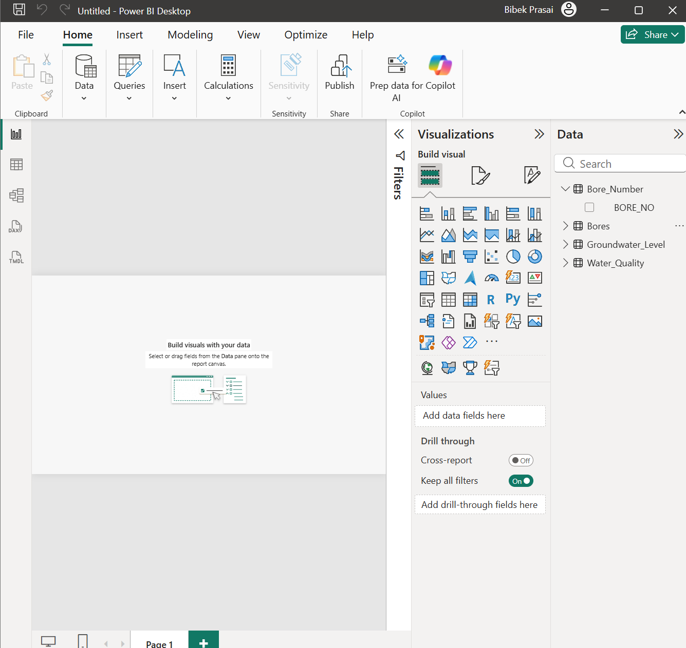
Figure 3. Loading the groundwater dataset into Power BI
The screenshot shows the initial Power BI Desktop environment used to connect to and load the project data before modelling and visualisation.

4.2 Data Transformation
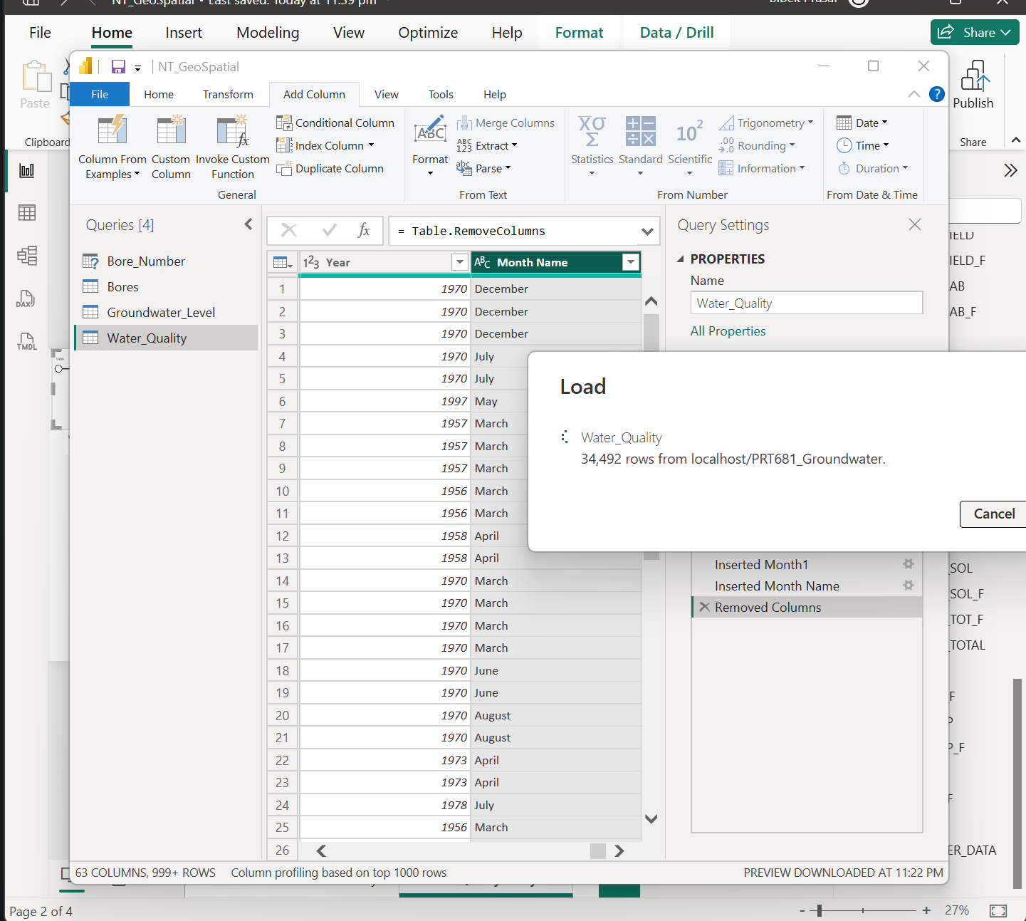
Figure 4. Transforming data in Power Query
Power Query is used to inspect and transform fields before loading them into the semantic model. This stage is important for data types, naming, null handling and preparation of analytical fields.

4.3 Relationship Model
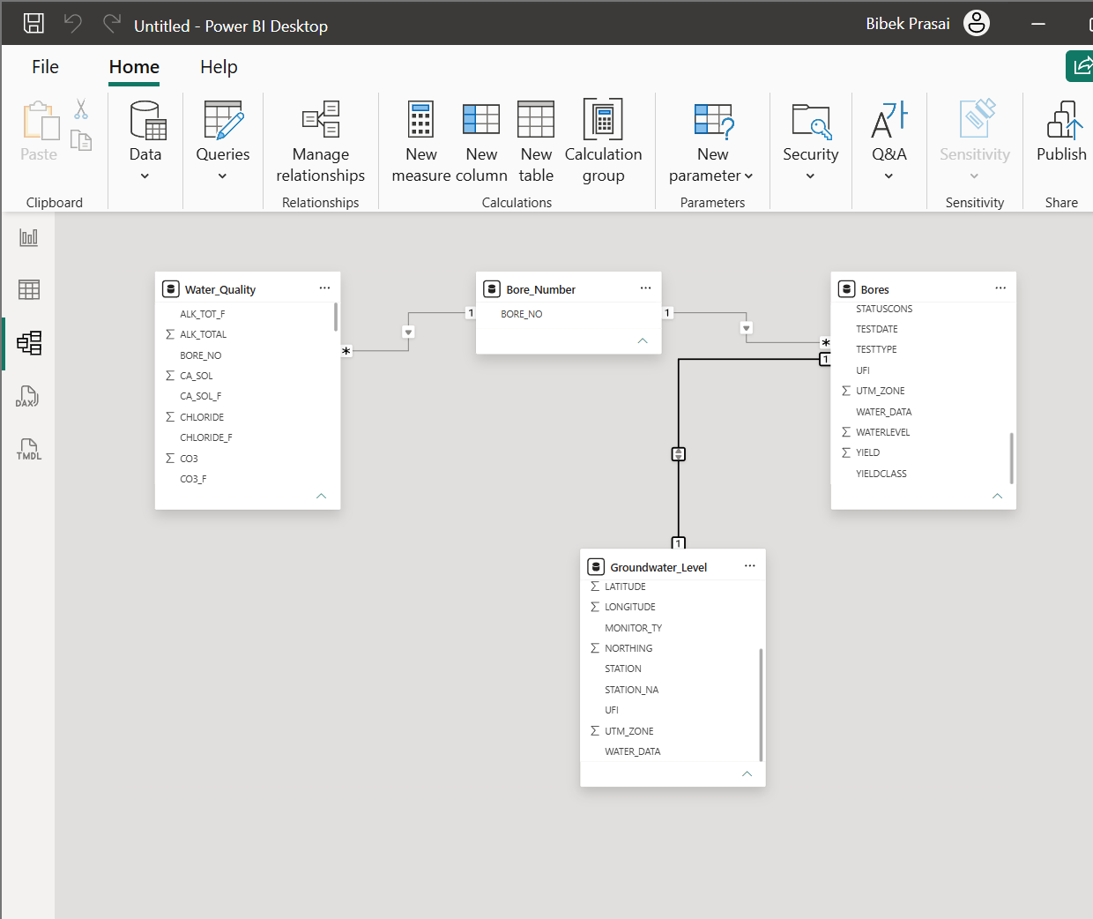
Figure 5. Power BI relationship model
The model view shows the relationships between the bore master data and related analytical tables. The design reflects the validated UFI and BORE_NO relationships from the data-profiling stage.
The Bores table functions as the central descriptive entity. Water-quality observations form a one-to-many analytical relationship by BORE_NO, while groundwater monitoring/levels are related through UFI. This design supports filtering from bore attributes into measurement tables and reduces duplication of descriptive fields.

5. Power BI Dashboard Pages

5.1 Bore Overview
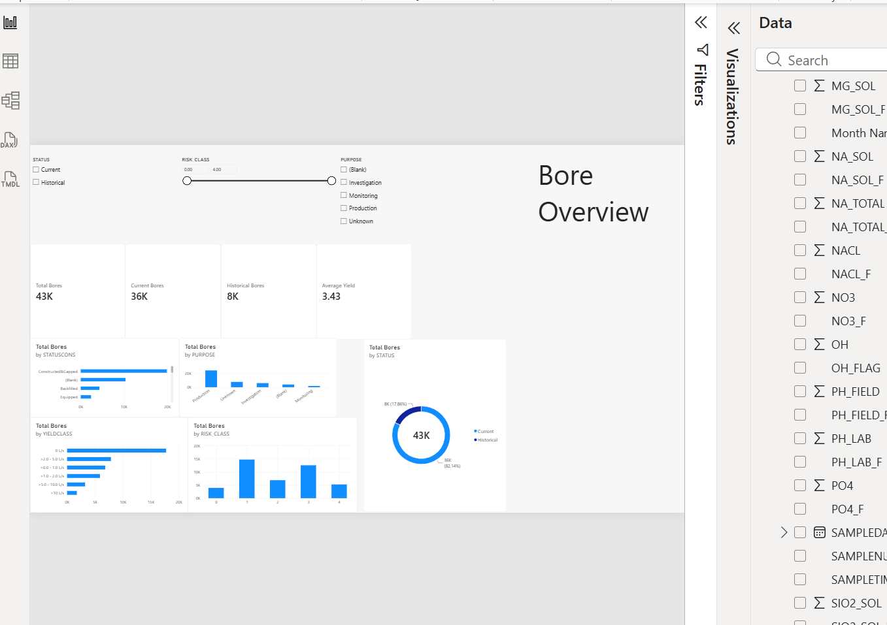
Figure 6. Bore Overview dashboard
The Bore Overview page provides high-level bore KPIs and category distributions. It is intended as the entry point for users who need a concise summary before moving into specialist water-quality or monitoring analysis.
The page can be interpreted alongside the SQL baseline: 43,225 bore records are represented in the source, with 35,504 current and 7,721 historical bores. Category charts allow users to compare purpose, risk and other bore attributes interactively.

5.2 Water Quality
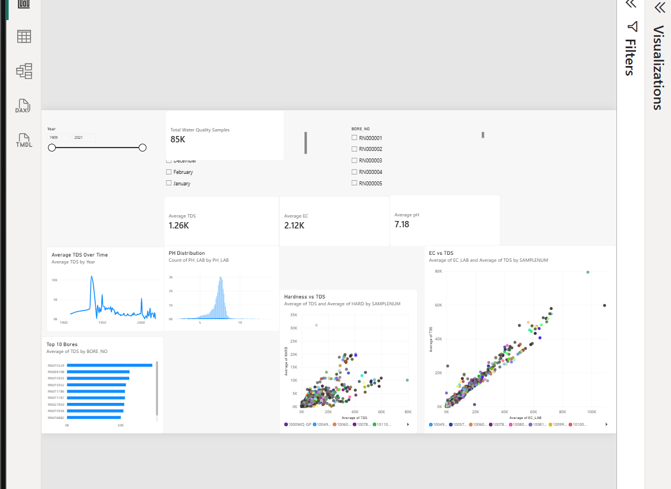
Figure 7. Water Quality dashboard
The Water Quality page combines summary cards, distribution views and analytical plots. It supports comparison of water-quality measurements across bores and can reveal outliers that would be difficult to interpret from raw rows alone.
Because the source contains 84,769 samples, aggregation and filtering are essential. The SQL baseline provides context for pH, EC, TDS and hardness, while the report visuals support exploration of individual bores and measurement relationships.

5.3 Groundwater Monitoring
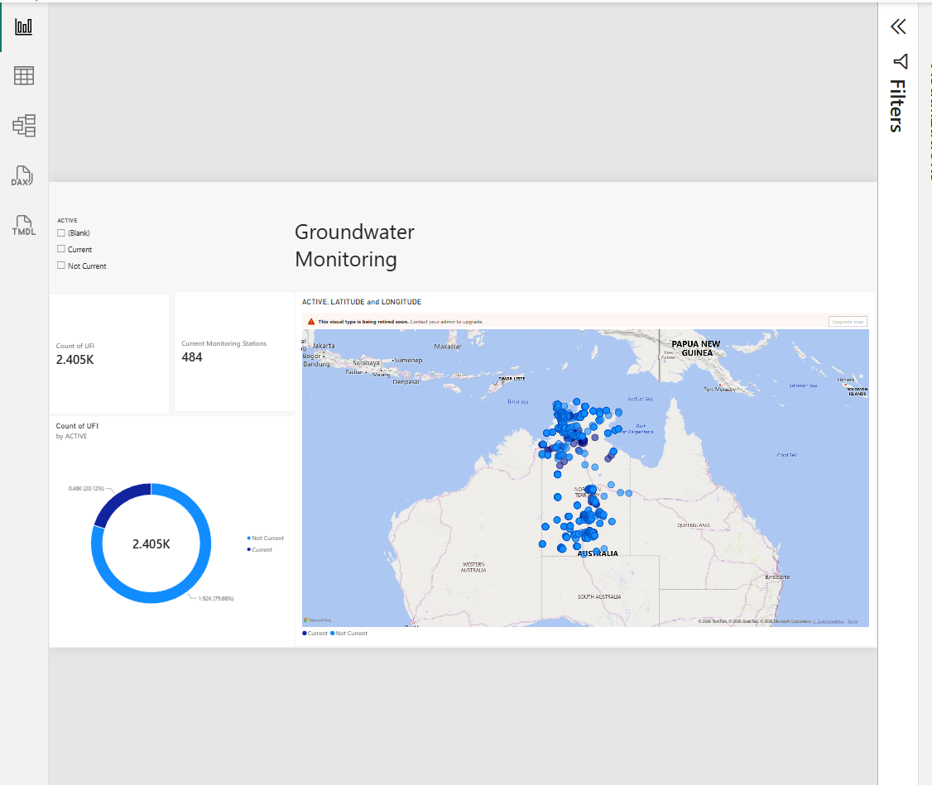
Figure 8. Groundwater Monitoring dashboard
The monitoring page uses a geographic map and summary indicators to show the spatial distribution of groundwater monitoring locations. Mapping is particularly useful for the NT dataset because location is a core dimension of the groundwater network.

6. SQL Server Analysis Services (SSAS)
SSAS extends the solution by providing an analytical/semantic model that can sit between the SQL Server data and reporting tools. The supplied screenshots document data-source configuration and model deployment in Visual Studio.

6.1 Importing Data into the SSAS Project
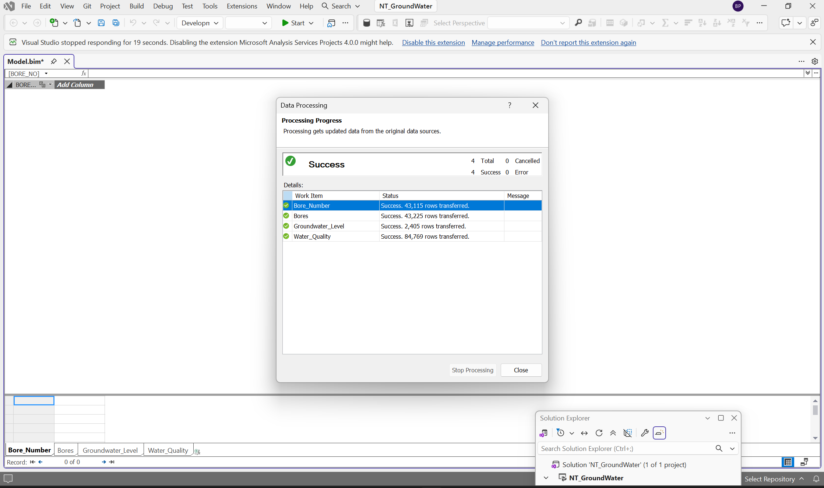
Figure 9. SSAS data import/configuration in Visual Studio
The screenshot shows the SSAS project workflow used to connect the analytical model to the groundwater data source. This creates the foundation for dimensions, measures and reusable semantic calculations.

6.2 SSAS Deployment
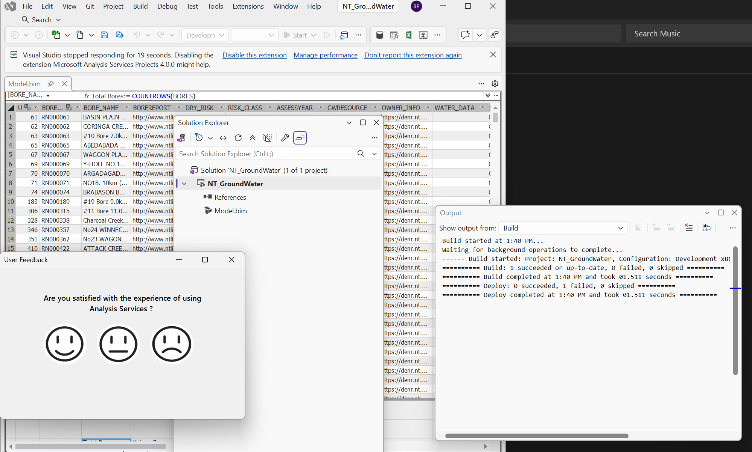
Figure 10. SSAS deployment evidence
The deployment screenshot provides evidence of the SSAS project being processed/deployed from Visual Studio. Deployment makes the analytical model available for downstream reporting and validation.
Using a semantic model provides centralised definitions for calculations and business fields. This reduces the risk of different reports implementing the same metric differently and aligns with the later BusinessObjects semantic-layer concept.

7. Microsoft Fabric Analysis
The supplied Fabric screenshots show bore-analysis data and visual-building activity in the Microsoft Fabric/Power BI environment. These views demonstrate that the project can be extended beyond a local Power BI Desktop workflow into a cloud analytics platform.
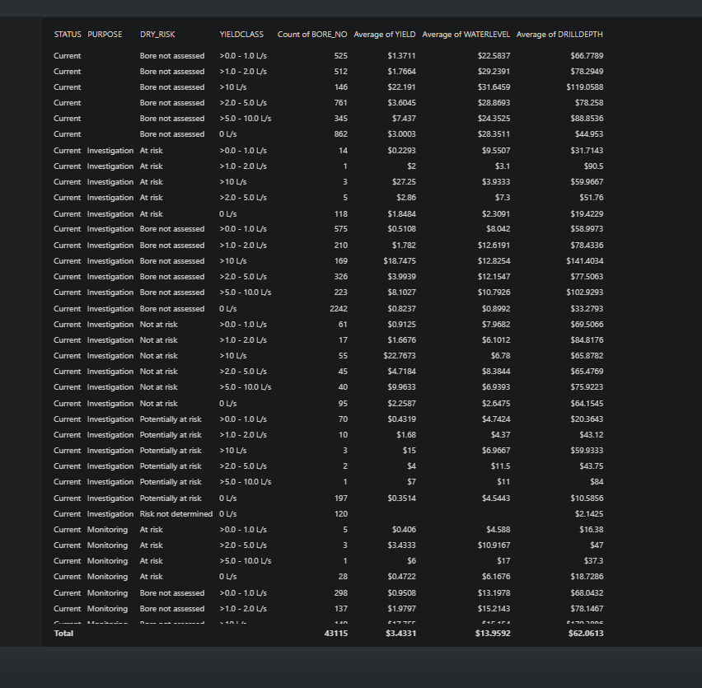
Figure 11. Bore analysis data in Microsoft Fabric
This view presents bore-analysis data in the Fabric environment, supporting inspection of the analytical dataset used for reporting.
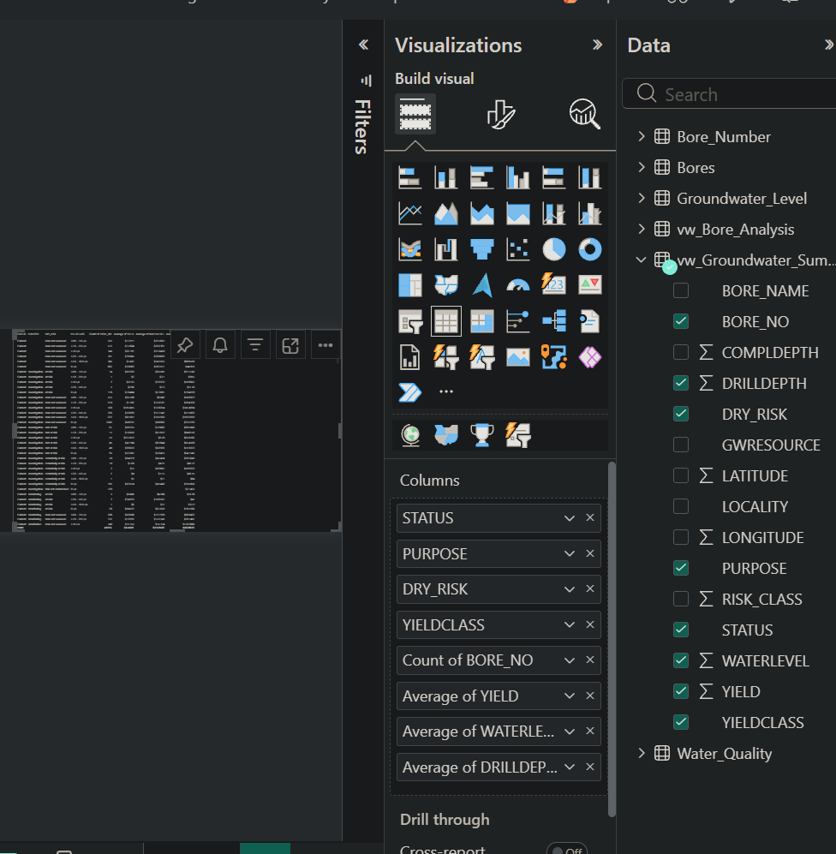
Figure 12. Building bore-analysis visuals in Fabric
The visual-building interface shows fields being selected and configured for bore analysis, demonstrating reuse of the project data in a Fabric-hosted reporting workflow.
Fabric provides a path toward centralised data engineering, semantic modelling and reporting. For this project, the main value is consistency: the same bore, water-quality and monitoring logic can be reused across cloud-hosted analytical assets.

8. Power BI Service Deployment and Refresh

8.1 Publishing the Report
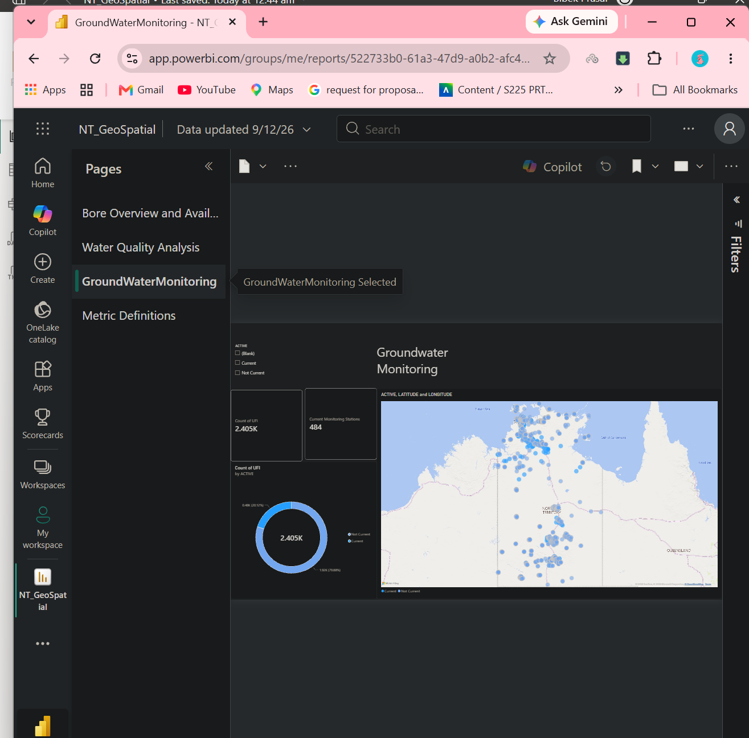
Figure 13. Published NT Groundwater report in Power BI Service
The screenshot shows the groundwater report after publication to Power BI Service. Publishing moves the report from the local development environment into a workspace where it can be shared and maintained.

8.2 Sharing and Access Management
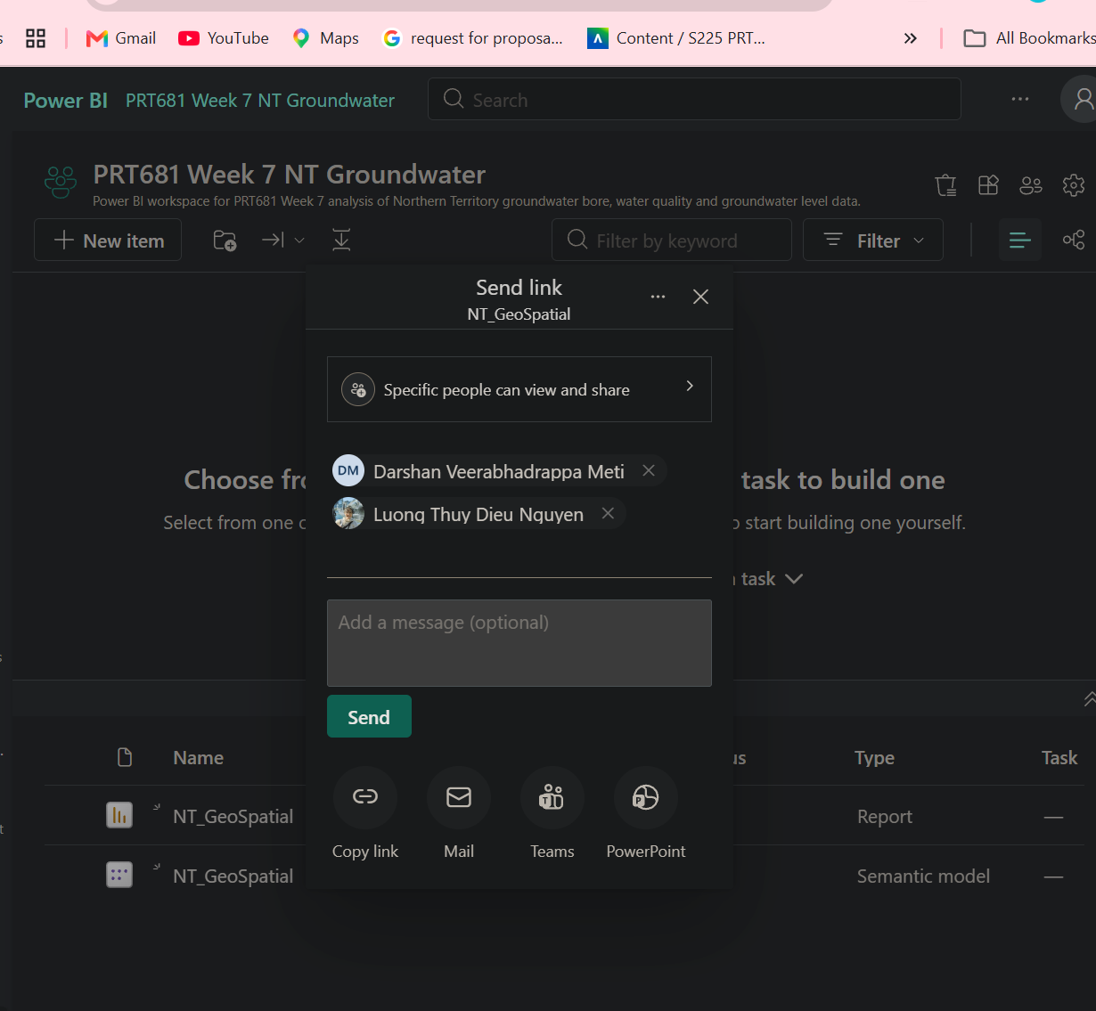
Figure 14. Sharing the Power BI report
The sharing interface provides controlled distribution of the report to intended users.
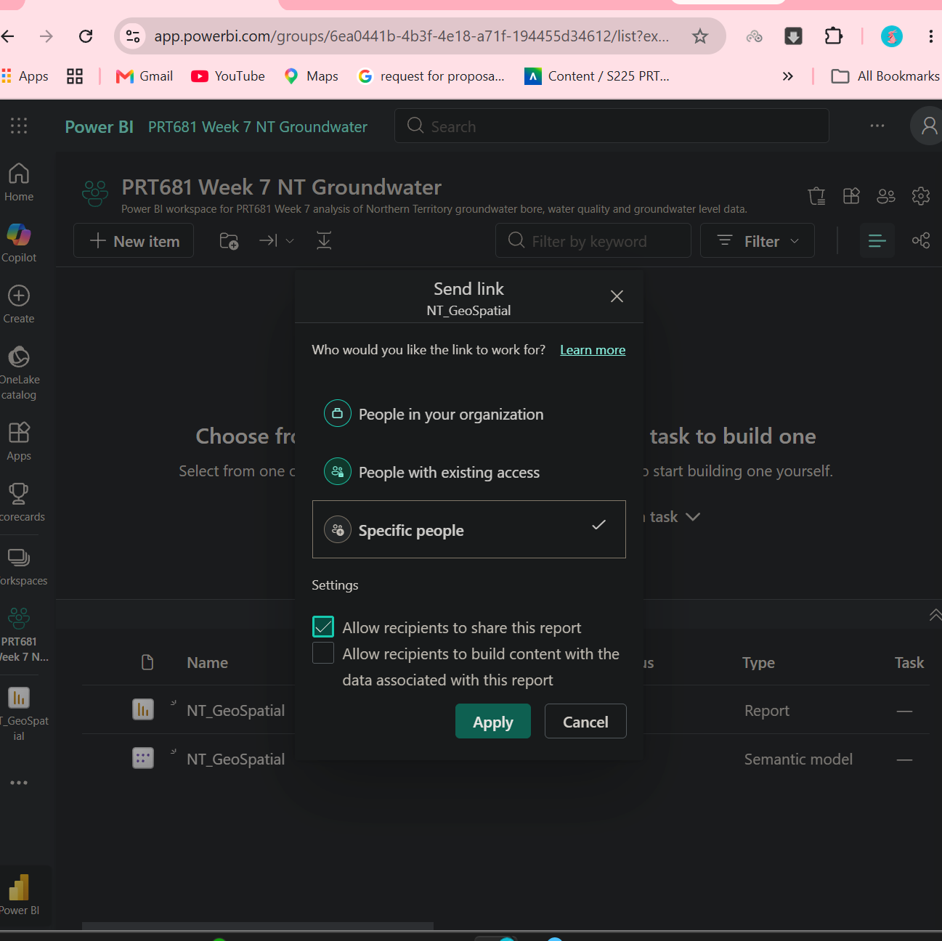
Figure 15. Managing access to the published report
Access management provides visibility and control over who can use the report, supporting governance of the published BI asset.

8.3 Manual Refresh
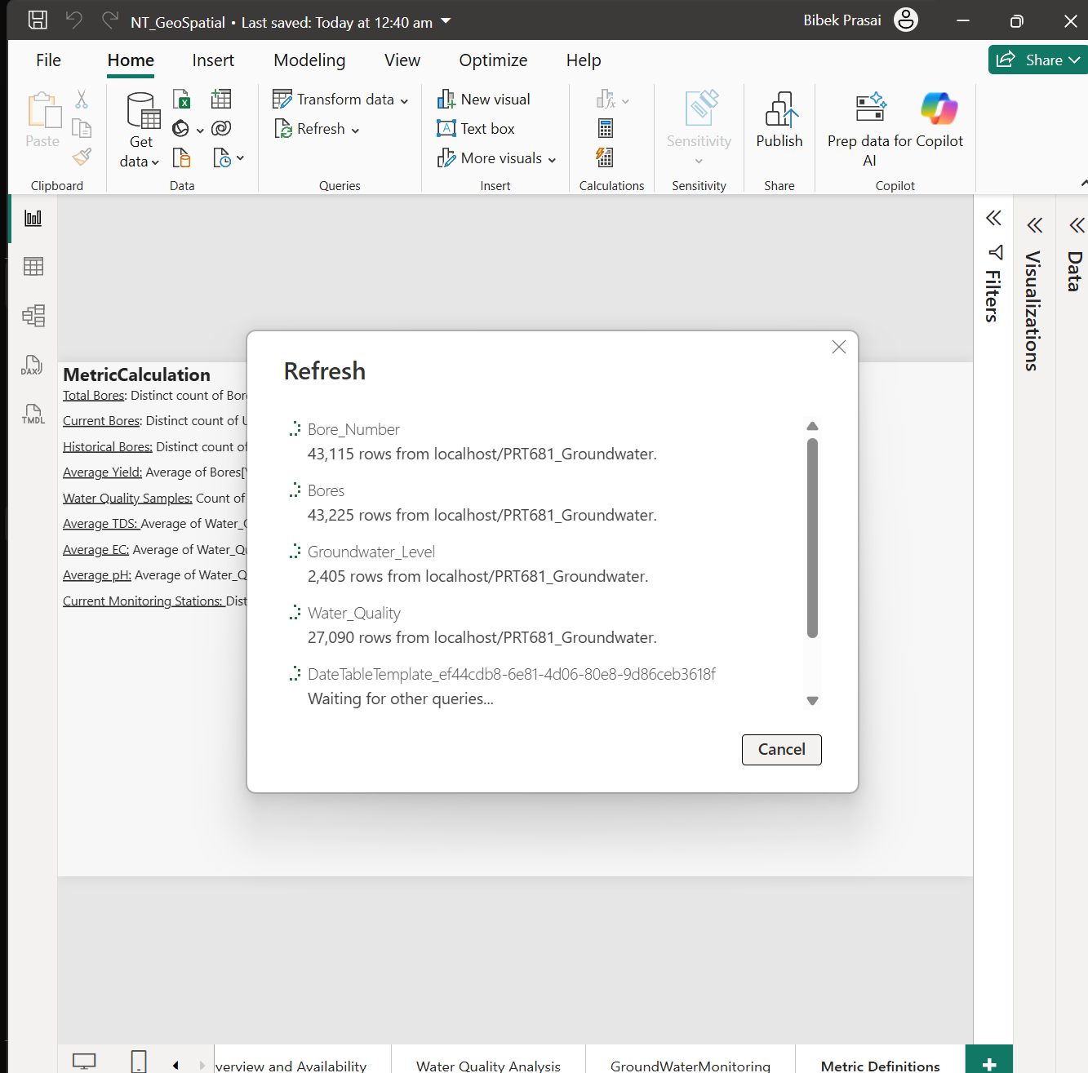
Figure 16. Power BI refresh operation
The refresh evidence shows the published semantic model being updated. Refresh is required to keep report visuals aligned with the latest data available from the source.

8.4 Data Gateway
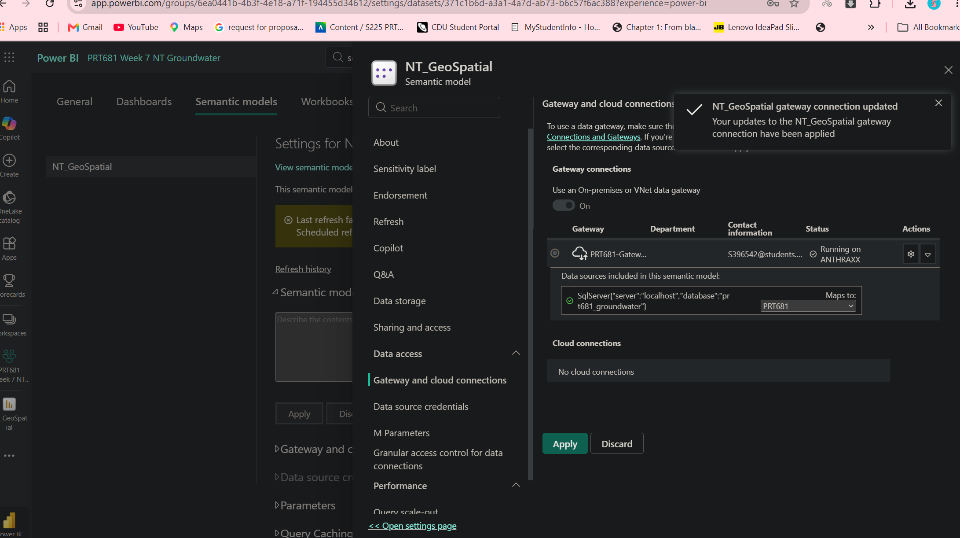
Figure 17. Power BI data gateway configuration
The gateway configuration connects Power BI Service to a data source that is not directly cloud-accessible. Correct gateway mapping and credentials are required before scheduled refresh can operate reliably.

8.5 Scheduled Refresh
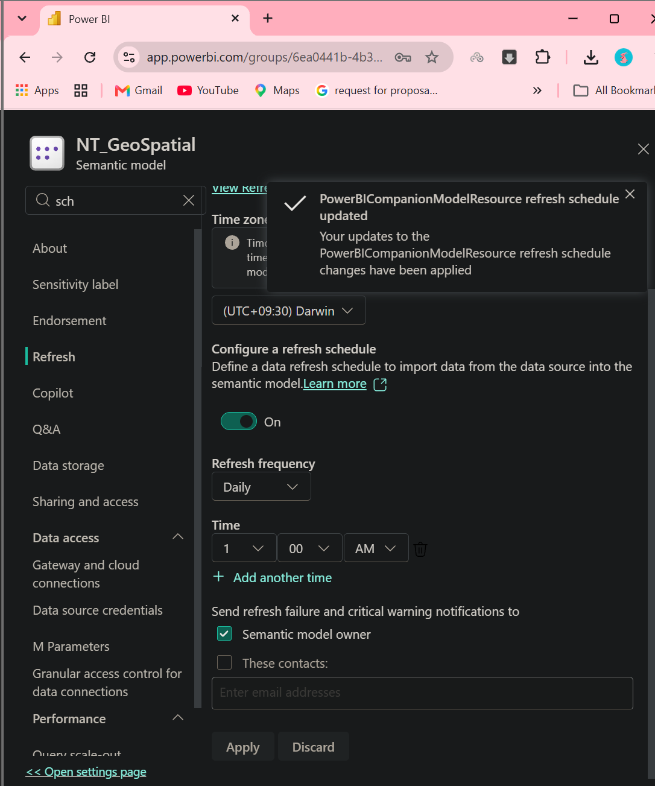
Figure 18. Scheduled refresh configuration
The scheduled-refresh settings show how automatic dataset updates are configured in Power BI Service. This reduces the need for manual refresh and supports a maintainable production-style reporting workflow.
Together, publication, sharing, access control, gateway configuration and scheduled refresh demonstrate the operational lifecycle of the BI solution rather than only its report-development stage.

9. BusinessObjects Reporting Design
SAP BusinessObjects was not available in the implementation environment, so the supplied project document maps BusinessObjects concepts onto the existing NT Groundwater solution. This demonstrates how the same reporting requirements could be implemented using a Universe semantic layer and Web Intelligence reports.

9.1 Proposed Semantic Layer
BusinessObjects element | NT Groundwater implementation
Data source | Existing NT Groundwater SQL Server dataset
Main business object | Bore
Dimensions | Bore ID, Location, Region, Bore Type, Water Quality Parameter, Date
Measures | Bore Count, Average Water Level, Average Water Quality Value
Filters | Region, Bore Type, Water Quality Parameter, Date
Business reports | Bore Analysis and Water Quality Analysis

9.2 Business-Friendly Dimensions and Measures
Type | Name | Business meaning / calculation
Dimension | Bore ID | Unique identifier for a groundwater bore
Dimension | Location | Physical location of the bore
Dimension | Region | Geographic grouping
Dimension | Bore Type | Classification of the bore
Dimension | Water Quality Parameter | Type of quality measurement
Measure | Bore Count | Count of unique bore IDs
Measure | Average Water Level | Average recorded groundwater-level value
Measure | Average Water Quality Value | Average of selected water-quality measurements

9.3 Web Intelligence – Bore Analysis
The proposed Bore Analysis query identifies the number and distribution of groundwater bores while comparing average groundwater levels across locations or regions. Users would filter by region and bore type. The expected report contains bore identifiers, location/region fields, bore count and average groundwater level, with interactive report filters.

9.4 Web Intelligence – Water Quality Analysis
The proposed Water Quality query analyses groundwater-quality measurements across bores and regions. Users select a water-quality parameter and region, and the report displays the selected parameter, bore/location information and average measured value. This provides a business-friendly way to compare areas without exposing technical database structures.

9.5 BusinessObjects Compared with Existing Power BI
Area | BusinessObjects | Existing project
Data source | SQL Server | SQL Server / existing project sources
Semantic layer | Universe | Power BI semantic model / SSAS
Query/reporting | Web Intelligence | Power BI reports
Dimensions | BusinessObjects dimensions | Model fields
Measures | BusinessObjects measures | DAX/semantic measures
Filters | Report/query filters | Power BI filters
Business reporting | Web Intelligence report | Power BI dashboard/report

10. Validation, Limitations and Recommendations

10.1 Validation Across Layers
- The database relationships were validated before report modelling: 100% of Water Quality BORE_NO values and 100% of Groundwater Level UFI values match Bores.
- SQL aggregate outputs provide an independent baseline for validating Power BI totals and averages.
- The same business concepts—dimensions, measures and filters—are carried through Power BI, SSAS and the proposed BusinessObjects design.
- Power BI Service screenshots demonstrate that the solution progresses from local development to publication, controlled access and refresh configuration.

10.2 Limitations
- BORE_NO is not fully unique in the Bores data (160 duplicated rows), so joins and distinct-count measures must be designed carefully.
- Water-quality coverage is uneven: current bores account for the large majority of samples, so comparisons with historical bores may be influenced by different sampling intensity.
- Extreme water-quality values can heavily influence averages; median, percentile and distribution-based analysis would improve interpretation.
- Some bore yield-class labels in the raw/report output appear inconsistent with individual yield values, indicating that the source classification should be reviewed before using it as a definitive analytical grouping.
- The BusinessObjects section is a conceptual mapping rather than a live SAP BusinessObjects implementation because the platform was unavailable in the environment.

10.3 Recommendations
- Create formal data-quality rules for duplicate BORE_NO values and document the authoritative key strategy.
- Add median and percentile measures for EC, TDS, hardness and yield to reduce sensitivity to extreme values.
- Add date-based trend analysis for water quality and groundwater levels where observation dates are sufficiently complete.
- Use drill-through pages from region/bore summaries to individual bore history for operational investigation.
- Document gateway ownership, credential rotation and refresh-failure handling for production deployment.
- Maintain shared measure definitions in the semantic layer so Power BI, SSAS/Fabric and any future BusinessObjects reports return consistent results.

11. Conclusion
The NT Groundwater project demonstrates an end-to-end business-intelligence workflow: source data was inspected and validated, loaded into SQL Server, analysed with SQL, transformed and modelled in Power BI, extended through SSAS and Microsoft Fabric, and deployed to Power BI Service with access and refresh configuration. The supplied evidence also shows how the same business reporting logic can be represented in a BusinessObjects semantic layer.
The strongest analytical findings include the higher average yield of current bores compared with historical bores, the decline in average yield across higher risk classes, the concentration of water-quality sampling around current bores, and the substantial variability in water-quality measurements. Together with the validated relationships between the three source areas, these results provide a sound basis for interactive groundwater reporting and further analytical development.

Appendix A – Evidence Map
Evidence file | Report section
Database_Import.png / Database_Import_2.png | Database import
LOading_dataset_in_Power_BI.png | Power BI load
Transforming_Data_using_PowerBi.png | Power Query transformation
Power_BI_Relationship.png | Power BI data model
Bore_Overview.png | Bore dashboard
Water_Quality.png | Water-quality dashboard
GroundWater_Monitoring.png | Monitoring dashboard
Visual_Studio_SSAS_Data_Import.png | SSAS data source/model
Deployment_SSAS.png | SSAS deployment
bore_analysis_fabrics (2).png / Bore_Analysis_Fabrics.png | Microsoft Fabric analysis
Publishing_PowerBI_report.png | Power BI Service publication
Sharing_PowerBI.png / Manage_Access.png | Sharing and access
refresh.png | Manual refresh
DATA_gateway.png | Gateway configuration
Scheduled_Refresh.png | Scheduled refresh
PRT681_Phase4_BusinessObjects.docx.docx | BusinessObjects conceptual design
*.rpt / Key_Findings_from_SQL.md / Data_Validation_Report.md | SQL results and validation evidence

