VIETNAM GENERAL CONFEDERATION OF LABOR
TON DUC THANG UNIVERSITY
FACULTY OF INFORMATION TECHNOLOGY


TRIEU NGOC VAN ANH – 524H0005
DUONG TRAN QUOC KHANH – 523H0040
NGUYEN VO THANH TU – 523H0189

DESIGN, IMPLEMENT, AND AUDIT
SECURE ACCESS CONTROL FOR A
UNIVERSITY RECORDS SYSTEM
GROUP ASSIGNMENT REPORT
INTRODUCTION TO INFORMATION SECURITY

HO CHI MINH CITY, 2026

VIETNAM GENERAL CONFEDERATION OF LABOR
TON DUC THANG UNIVERSITY
FACULTY OF INFORMATION TECHNOLOGY

TRIEU NGOC VAN ANH – 524H0005
DUONG TRAN QUOC KHANH – 523H0040
NGUYEN VO THANH TU – 523H0189

DESIGN, IMPLEMENT, AND AUDIT
SECURE ACCESS CONTROL FOR A
UNIVERSITY RECORDS SYSTEM
GROUP ASSIGNMENT REPORT
INTRODUCTION TO INFORMATION SECURITY
Advised by
Ph.D Huynh Ngoc Tu

HO CHI MINH CITY, 2026

ACKNOWLEDGEMENT
We would like to express our sincere gratitude to Ph.D Huynh Ngoc Tu, our instructor, for his valuable guidance throughout this group assignment on designing, implementing and auditing secure access control for the Introduction to Information Security course. His lectures on access control, software security and database security helped us turn security principles into concrete, testable controls.
We would also like to thank the Faculty of Information Technology, Ton Duc Thang University, for providing a supportive learning environment and equipping us with the foundational knowledge necessary to complete this assignment.
Due to limitations in time and knowledge, this report may inevitably contain certain shortcomings. We sincerely welcome any comments and suggestions from our instructor to further improve and refine our work.
Thank you sincerely.
Ho Chi Minh City, November 2026
Authors
(Signature and full name)
Trieu Ngoc Van Anh | Duong Tran Quoc Khanh | Nguyen Vo Thanh Tu

DECLARATION OF AUTHORSHIP
We hereby declare that this report and the accompanying source code are our own work, prepared under the guidance of Ph.D Huynh Ngoc Tu. The system design, implementation, test results and evidence presented in this report were produced by our group, and all test results were obtained by actually running the test suite against the implemented system. All external sources used are cited in the references.
In the event of any violation or misconduct, we accept full responsibility for the content of this report. Ton Duc Thang University shall not be held responsible for any intellectual property or copyright infringement committed by the team during the preparation of this report, if any.
Ho Chi Minh City, November 2026
Authors
(Signature and full name)
Trieu Ngoc Van Anh | Duong Tran Quoc Khanh | Nguyen Vo Thanh Tu

TABLE OF CONTENTS
LIST OF FIGURES vii
LIST OF TABLES x
LIST OF ABBREVIATIONS xi
ABSTRACT xii
CHAPTER 1. INTRODUCTION 1
1.1 Background and Objectives 1
1.2 Scope and Group Organization 1
CHAPTER 2. SYSTEM OVERVIEW 1
CHAPTER 3. THREAT MODEL AND SECURITY REQUIREMENTS 2
3.1 Assets, Users and Trust Boundaries 2
3.2 Threat-Model Table 3
CHAPTER 4. ACCESS-CONTROL POLICY 4
4.1 Access-Control Matrix 4
4.2 Policy Explanation 5
CHAPTER 5. SECURITY ARCHITECTURE AND IMPLEMENTATION 6
5.1 Authentication and Session Handling 6
5.2 Authorization 7
5.3 Grading and Class Management 7
5.4 Input Validation and Output Encoding 7
5.5 Security Audit Logging 8
5.6 Error Handling and Secrets 8
CHAPTER 6. DATABASE-SECURITY CONTROLS 8
CHAPTER 7. SECURITY TESTING 9
7.1 Test Plan 9
7.2 Results 9
CHAPTER 8. REMAINING RISKS AND IMPROVEMENTS 9
CHAPTER 9. CONCLUSION 10
INDIVIDUAL CONTRIBUTION SUMMARY 11
APPENDIX A. SYSTEM DEMONSTRATION 12
A.1 Interface Design 12
A.2 Authentication 12
A.3 Self-Registration and Class Catalog 14
A.4 Student Portal 17
A.5 Lecturer Workspace 20
A.6 Registrar Workspace 23
A.7 Administrator Console 27
A.8 Account Self-Service and Password Reset 29
A.9 Rejected Operations 33
A.10 Input Handling and Session Termination 36
A.11 Security Auditor Console 37
A.12 Database and Test Evidence 41
APPENDIX B. COMPLETE SECURITY TEST RESULTS 42
APPENDIX C. REQUIREMENTS TRACEABILITY AND DEMO ACCOUNTS 48
REFERENCES 50

LIST OF FIGURES
Figure 3.1. System and data-flow diagram with trust boundaries TB1–TB3 and data stores D1–D4. 2
Figure A.1. Sign-in page with the product overview and the login form. 13
Figure A.2. Wrong password: one generic error message (HTTP 401) (T02). 13
Figure A.3. Disabled account with the correct password is rejected (T03). 14
Figure A.4. SQL-injection payload in the login form: generic failure, no database error (T18). 14
Figure A.5. Student self-registration form. 15
Figure A.6. Registration rejected by server-side validation (T46). 15
Figure A.7. Account created with the STUDENT role only; the user can sign in (T45). 16
Figure A.8. Dashboard of the newly registered student (new student code). 16
Figure A.9. Class catalog: the new student joins AI305 (seat counter updated) (T51). 17
Figure A.10. Student dashboard: study statistics and quick actions (T01). 18
Figure A.11. Student profile with the self-service contact form. 18
Figure A.12. Student's own enrollments. 19
Figure A.13. Own grades: four components, course totals and the credit-weighted overall average (T06). 19
Figure A.14. Class catalog seen by student01 (enrolled, open and full classes). 20
Figure A.15. Lecturer dashboard: assigned classes, students and incomplete totals. 21
Figure A.16. Lecturer sees only the classes assigned to them. 21
Figure A.17. Roster of IS101 with the four grade components and totals (T09). 22
Figure A.18. Components saved for S2026002; the database computes the total 8.00 (confirmation toast) (T10). 22
Figure A.19. Multi-role ta01 teaches SE202 but cannot grade their own enrollment (T27). 23
Figure A.20. Lecturer catalog: an unassigned class can be taken over (T52). 23
Figure A.21. Registrar dashboard: records, enrollments and classes. 24
Figure A.22. Student search (the search text is a bound SQL parameter). 24
Figure A.23. Form for creating a student record. 25
Figure A.24. All classes with lecturer and seat usage. 25
Figure A.25. Creating a class: capacity at most 30, one optional lecturer. 26
Figure A.26. Managing class SE310: lecturer assignment, adding students, seat usage (T48). 26
Figure A.27. Registrar enrolls S2026003 in IS101 (T12). 27
Figure A.28. Administrator dashboard: account statistics only, no academic data. 28
Figure A.29. User accounts, role chips, status and role-assignment controls (T16). 29
Figure A.30. My account (student): change name and password (T53). 30
Figure A.31. My account (registrar): name locked; a wrong current password is rejected (T53/T54). 30
Figure A.32. Forgot-password request form. 31
Figure A.33. Request received: the reference code is shown once (T55). 31
Figure A.34. Administrator inbox: requester, e-mail check against the profile, approve or reject with a reply (T57). 32
Figure A.35. Status page: approved, with the administrator's reply (T56). 32
Figure A.36. One-time temporary password, revealed only to the requester (T56). 33
Figure A.37. Signing in with the temporary password forces a password change (T56). 33
Figure A.38. student01 changes the id in the URL to another student: HTTP 403 (T07). 34
Figure A.39. student01 sends a grade-modification request directly: HTTP 403 (T08). 34
Figure A.40. lecturer01 modifies a grade in unassigned NW301: HTTP 403 (T11). 34
Figure A.41. registrar01 modifies a grade: HTTP 403 (T13). 35
Figure A.42. auditor01 modifies a student record: HTTP 403 (T15). 35
Figure A.43. admin01 (ADMIN only) opens a grade page: HTTP 403 (T17). 35
Figure A.44. Assigning AUDITOR to an administrator violates separation of duties: HTTP 403 (T30). 36
Figure A.45. Stored <script> payload is displayed as plain text and does not execute (T19). 36
Figure A.46. After logout the old session is rejected: HTTP 401 (T04). 37
Figure A.47. Security Auditor dashboard: audit volume, denials and failed logins. 37
Figure A.48. Security audit log with timestamp, actor, event, target, result and details (T14). 38
Figure A.49. Audit log filtered on rejected actions (T20). 38
Figure A.50. Integrity check: the SHA-256 hash chain is intact (T42). 39
Figure A.51. Read-only view of the access-control configuration (T14). 41
Figure A.52. users.password_hash contains only Argon2id hashes (T05). 41
Figure A.53. Automated security test results (pytest) (T01–T58). 41

LIST OF TABLES
Table 3.1. Threat model 3
Table 4.1. Access-control matrix 4
Table 7.1. Test results by category 9
Table 8.1. Remaining limitations 10
Table 9.1. Individual contribution summary 11
Table B.1. Complete security test results 42
Table C.1. Security requirements, threats and verifying tests 48
Table C.2. Demo accounts (password of every account: <username>@Demo2026) 48

LIST OF ABBREVIATIONS
Abbreviation | Meaning
RBAC | Role-Based Access Control
IDOR | Insecure Direct Object Reference
SQLi | SQL Injection
XSS | Cross-Site Scripting
CSRF | Cross-Site Request Forgery
CSP | Content Security Policy
DFD | Data-Flow Diagram
SoD | Separation of Duties
DBA | Database Administrator
MFA | Multi-Factor Authentication
TLS | Transport Layer Security
HSTS | HTTP Strict Transport Security
SHA-256 | Secure Hash Algorithm, 256-bit output
OWASP | Open Worldwide Application Security Project
SR / TH / R | Security requirement / Threat / Remaining risk identifiers used in this report

ABSTRACT
This report documents the design, implementation and audit of access control for a small web-based University Records System that stores user accounts, student profiles, courses, enrollments, grades and a security audit log. A threat model with twelve threats and sixteen security requirements was derived first, followed by an access-control matrix for five roles (Student, Lecturer, Registrar, Security Auditor and System Administrator) based on default deny, least privilege and separation of duties. The system was implemented with Flask and PostgreSQL 16 and enforces authorization at three layers: an endpoint permission check, a record-level ownership or course-assignment check, and database privileges and triggers. Passwords are hashed with Argon2id, sessions are server-side, every state-changing request requires an anti-CSRF token, and sensitive events are written to an append-only, hash-chained audit log. Students can register themselves (STUDENT role only) and join classes of at most 30 students with one lecturer, and course totals are computed by the database from four weighted grade components. Every user can change their password, and forgotten passwords are reset through an administrator-approved workflow in which no one, not even the administrator, ever sees a stored password. An automated suite of 58 security tests, including the 20 mandatory tests, passed completely. The report closes with seven remaining risks and the improvements recommended for each.
Keywords: role-based access control, default deny, IDOR, Argon2id, session management, CSRF, SQL injection, XSS, audit logging, least privilege, PostgreSQL.

CHAPTER 1. INTRODUCTION

1.1 Background and Objectives
Broken access control is ranked first in the OWASP Top 10: a single missing check lets one user read or change another user's data, and in university records that means personal data and grades. The objective is to secure such a system end to end: identify the threats, define an explicit access-control policy, implement it on the server and in the database, verify it with repeatable tests, and review the remaining risks.

1.2 Scope and Group Organization
The scope covers authentication, sessions, roles, server-side and record-level authorization, the academic features, database security, validation, output encoding and audit logging. Primary responsibilities were Trieu Ngoc Van Anh: threat modeling and access-control design; Duong Tran Quoc Khanh: authentication, authorization and implementation; Nguyen Vo Thanh Tu: database security, testing and audit logging. All members reviewed the complete submission.

CHAPTER 2. SYSTEM OVERVIEW
The University Records System is a server-rendered web application written in Python 3.11 with Flask 3.1 and served by gunicorn. Data is stored in PostgreSQL 16. The application and the database run as two Docker containers defined in docker-compose.yml; both ports are published on 127.0.0.1 only. The seed data contains 11 demo accounts (including a disabled account and the multi-role teaching assistant ta01, Student and Lecturer), five classes (IS101, DB201, NW301, SE202 and the still unassigned AI305), six student profiles, eleven enrollments and six grade records.
Beyond the required operations, visitors can register a student account, students and lecturers use a class catalog to join a class or take an unassigned one, the registrar creates classes (one lecturer, at most 30 students) and arranges their lecturer and students, and lecturers enter four grade components (10/20/20/50 %). Every user can change their password, and a forgot-password request is answered by an administrator.
The interface has a role-aware sidebar and a dashboard per role; permission lists are shown only to administrators and auditors. Hiding links is a convenience; every decision is taken on the server (screens in Appendix A).

CHAPTER 3. THREAT MODEL AND SECURITY REQUIREMENTS

3.1 Assets, Users and Trust Boundaries
Assets: A1 credentials, A2 session tokens, A3 personal data, A4 grades, A5 enrollments, A6 roles and policy, A7 audit log, A8 secrets. Users: the five roles (any may be malicious or compromised), anonymous visitors and the DBA. Trust boundaries: TB1 lies between the browser and the application (every request field, URL and cookie is untrusted). TB2 lies between the application and PostgreSQL (the application uses the restricted account uni_app). TB3 is the privileged maintenance channel (the Docker host and the database superuser), which lies outside the application (Figure 3.1).
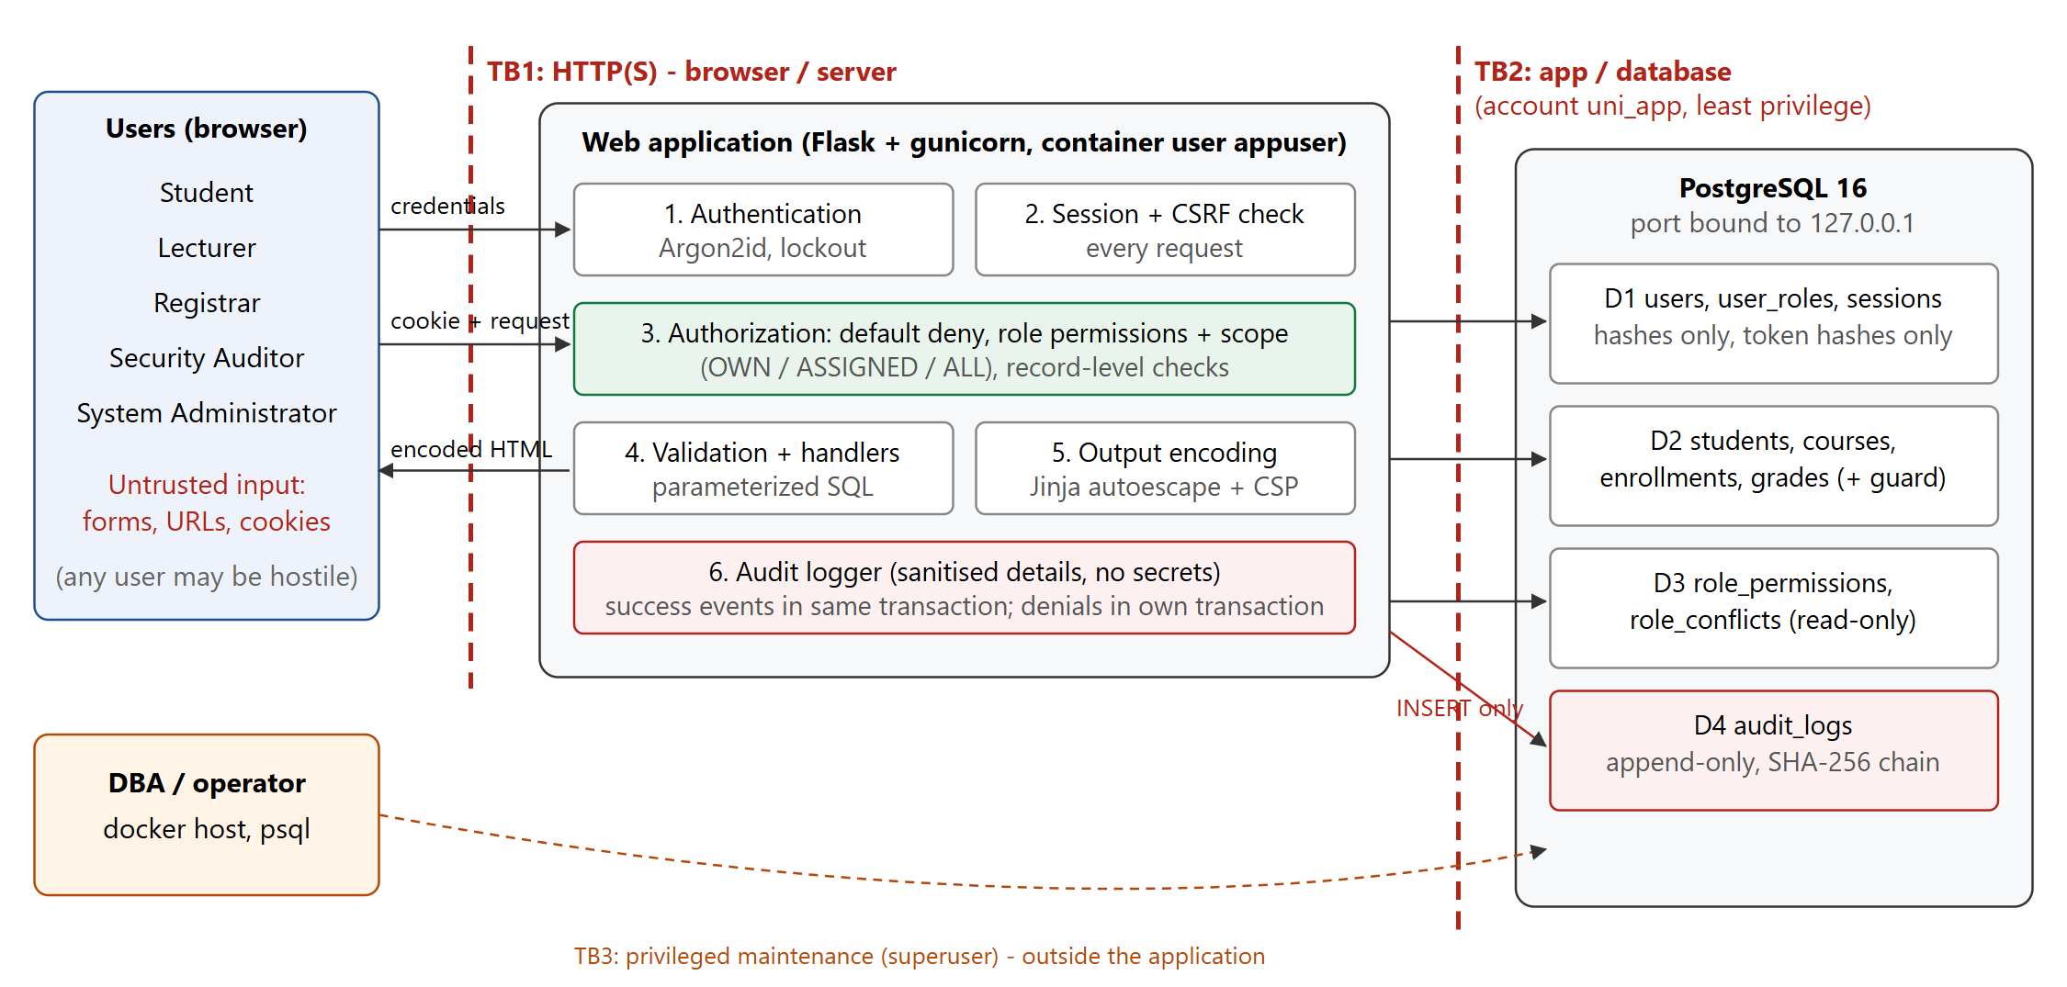
Figure 3.1. System and data-flow diagram with trust boundaries TB1–TB3 and data stores D1–D4.

3.2 Threat-Model Table
Likelihood (L) and impact (I) are rated High, Medium or Low before controls. Residual risks are in Chapter 8; the sixteen derived security requirements are traced to tests in Appendix C.
Table 3.1. Threat model
ID | Threat | Asset | Attack scenario | L | I | Mitigation / control
TH1 | Account compromise | A1, A2 | Password guessing or credential stuffing on /login; username enumeration via messages or timing. | H | H | Argon2id; one generic error; dummy hash for unknown users; lockout after 5 failures (15 min); disabled accounts rejected; LOGIN_FAILURE logged.
TH2 | Session hijacking / fixation | A2 | Stolen or planted session cookie; cookie replayed after logout. | M | H | 256-bit random token renewed at login, stored only as SHA-256; HttpOnly, SameSite=Strict; 30-min idle / 8-h absolute expiry; revoked at logout and on disable.
TH3 | Privilege escalation | A6 | Forged requests to admin routes; administrator grants themself REGISTRAR; conflicting roles combined. | M | H | Default-deny decorator on every route; no self role change; role-conflict table checked in app and by trigger; policy tables read-only.
TH4 | Insecure direct object reference | A3–A5 | Student changes /students/1/grades to /students/2/grades. | H | H | Record-level OWN / ASSIGNED / ALL check in every handler; same 403 for foreign and missing ids; RECORD_ACCESS_DENIED logged.
TH5 | SQL injection | A1–A8 | ' OR '1'='1' -- or UNION SELECT password_hash in login or search. | M | H | Bound parameters for every query; LIKE wildcards escaped; allow-list validation; least-privilege DB account; generic errors.
TH6 | Cross-site scripting | A2, A3 | Student stores <script> in the address field, which runs when staff view the profile. | M | H | Jinja2 auto-escaping (no |safe); CSP script-src 'self' with no inline script; HttpOnly cookie.
TH7 | Unauthorized grade modification | A4 | Student, registrar or unassigned lecturer posts /grades directly; teaching assistant grades their own enrollment. | H | H | grade.write only for LECTURER with scope ASSIGNED; self-grading blocked; DB trigger grades_guard repeats the checks; all attempts logged.
TH8 | Audit-log tampering | A7 | Insider deletes or edits log entries to hide an action. | M | H | App account may only INSERT/SELECT; triggers block UPDATE/DELETE/TRUNCATE; SHA-256 hash chain with verification by the auditor.
TH9 | Leakage of credentials or records | A1, A3, A8 | Secrets in Git, stack traces or SQL in error pages, tokens in logs. | M | H | .env git-ignored; debug off and generic error pages; audit details sanitized; only hashes stored; ports bound to localhost.
TH10 | Cross-site request forgery | A4, A6 | A malicious page makes a lecturer's browser submit a grade. | M | H | Per-session synchronizer token on every POST; SameSite=Strict; CSRF_REJECTED logged.
TH11 | Abuse of self-service (registration, classes) | A3–A6 | Sign-up with a forged role or by claiming another student's record; over-filling a class; a 2nd lecturer taking a class. | M | H | Sign-up always STUDENT with a NEW profile; class capacity ≤ 30 and one lecturer enforced in app and DB (trigger, UNIQUE); self-service limited to oneself; all actions logged.
TH12 | Account takeover via password reset | A1, A2 | Forged reset request; an administrator reading users' passwords. | M | H | Uniform response; secret code; admin check and approval; one-time 24 h temp password shown only to the requester; forced change.

CHAPTER 4. ACCESS-CONTROL POLICY

4.1 Access-Control Matrix
In Table 4.1, Allow means the operation is permitted, Own means only the user's own record, Assigned means only courses assigned to the lecturer, Deny means the operation is explicitly prohibited, and N/A means the role has no such object. The same policy is stored in the database table role_permissions, and the auditor can view it at /audit/policy.
Table 4.1. Access-control matrix
Resource and operation | Student | Lecturer | Registrar | Auditor | Administrator
View own profile, enrollments and grades | Own | N/A | N/A | N/A | N/A
Update own contact information | Own | Deny | via record update | Deny | Deny
View another student's profile | Deny | Assigned course only | Allow | Deny | Deny
Search, create and update student records | Deny | Deny | Allow | Deny | Deny
View courses and course roster | Deny | Assigned only | Allow | Deny | Deny
Create / drop enrollment | Deny | Deny | Allow | Deny | Deny
Create class (capacity ≤ 30) | Deny | Deny | Allow | Deny | Deny
Assign / replace / remove class lecturer (max. 1) | Deny | Deny | Allow | Deny | Deny
Join / leave a class (free seat; leave only if ungraded) | Own | Deny | via enrollment | Deny | Deny
Take an unassigned class as its lecturer | Deny | Own, only if no lecturer | Deny | Deny | Deny
View another student's grade | Deny | Assigned course only | Allow | Deny | Deny
Create / modify grade components | Deny | Assigned course only, not own enrollment | Deny | Deny | Deny
Change own password (current password required) | Own | Own | Own | Own | Own
Change own display name | Own | Own | Deny | Deny | Deny
Answer forgotten-password requests (not own) | Deny | Deny | Deny | Deny | Allow
View any stored password | Deny | Deny | Deny | Deny | Deny (not stored)
Read audit log, verify integrity, read access policy | Deny | Deny | Deny | Allow (read-only) | Deny
Create / disable / enable / unlock user | Deny | Deny | Deny | Deny | Allow (not disable self)
Assign / remove roles | Deny | Deny | Deny | Deny | Allow (not own roles, no conflicting pair, keep one admin)
Modify permissions and role definitions | Deny | Deny | Deny | Deny | Deny (DBA migration only)
Delete students, grades, users, audit entries | Deny | Deny | Deny | Deny | Deny

Every role may log in, log out and open its dashboard. Anonymous visitors may only sign in or register; registration always creates a STUDENT account with a new student profile.

4.2 Policy Explanation
Default deny. An operation is allowed only if a row in role_permissions grants it. Every route must declare its rule (@public, @login_required, @require_permission); verify_all_endpoints_declared() stops the application at start-up otherwise. Requests without a session get 401; without the permission 403, logged, with no data changed.
Least privilege. Each role holds only the permissions of its duties: the Registrar has grade.read but not grade.write, and the Administrator has no academic permission. Below the application, uni_app can neither delete academic data nor modify the policy (Chapter 6).
Separation of duties and role conflicts. The table role_conflicts forbids three combinations: ADMIN+AUDITOR (whoever manages accounts must not audit those actions), LECTURER+REGISTRAR (enrolling and grading must be done by different people) and STUDENT+REGISTRAR (a registrar must not maintain their own record). Conflicts are checked when a role is assigned and again by the trigger user_roles_conflict_guard. An administrator cannot change their own roles, so separate academic access for an administrator requires a second administrator.
Multiple roles. The effective permissions of a user are the union of the (permission, scope) pairs of all of the user's roles. The union never widens a scope. For example, ta01 (Student+Lecturer) can read their own grades (OWN) and grade SE202 (ASSIGNED), but cannot open the DB201 roster or grade their own SE202 enrollment (tests T27 and T28).
Self-service and classes. Registration ignores any role field and never links an existing record, so it cannot be used to read another student's grades. Self-service class actions act only on the user's own enrollment or teaching assignment; arranging other people remains a registrar duty (course.manage, enrollment.manage). A lecturer may take only a class without a lecturer and in which they are not enrolled. Renaming is denied to holders of ADMIN, AUDITOR or REGISTRAR (deny overrides); the administrator answers reset requests but never learns the new password.
Ownership and course-assignment checks. Handlers load the object and call can_access_student() or can_access_course(): OWN requires students.user_id = session user, ASSIGNED a course_lecturers row. For a grade the course is taken from the stored enrollment, never from the client.

CHAPTER 5. SECURITY ARCHITECTURE AND IMPLEMENTATION
Every request passes the same pipeline (Figure 3.1): session check, route access rule, CSRF token, input validation and record scope, parameterized SQL in one transaction, then auto-escaped output with security headers (CSP, X-Frame-Options DENY, nosniff, no-referrer, no-store).

5.1 Authentication and Session Handling
Passwords are hashed with Argon2id (64 MiB, 3 iterations, 4 lanes); a CHECK constraint rejects any other value. Wrong passwords, unknown, disabled and locked accounts all return "Invalid username or password.", and unknown usernames still cost one hash verification. Five failures lock an account for 15 minutes. Each login issues a new random 256-bit token. Only its SHA-256 hash is stored in the sessions table, together with the CSRF token and the expiry. Logout revokes the session on the server, and disabling an account revokes all of that account's sessions (security.py, routes/auth.py). Registration and password change apply the same policy (12–128 characters, confirmation, not containing the username); a change needs the current password (failures count towards lockout) and revokes other sessions. For a reset (routes/account.py) the requester gets a 96-bit code (stored as SHA-256); after approval a temporary password is generated on reveal, shown once, valid 24 h, and forces a password change.

5.2 Authorization
source/app/authz.py loads the user's roles and the scoped permissions from the database on every request, so a role change takes effect immediately. The decorator checks the permission. The handlers in routes/students.py and routes/courses.py then check the scope of the specific record. Grade writes additionally reject self-grading and inactive enrollments. The administration handlers enforce the self-change, role-conflict and last-administrator rules.

5.3 Grading and Class Management
A grade row holds four components; the course total score is a generated column (0.1·P1 + 0.2·P2 + 0.2·Mid + 0.5·Final), so it cannot be written by any client and stays empty until all components exist. The student page shows every component and a credit-weighted overall average. Class handlers check capacity and the single-lecturer rule before writing; the database repeats both.

5.4 Input Validation and Output Encoding
validators.py applies allow-list rules (formats, lengths, no control characters, scores 0–10 with two decimals); bodies over 64 KB are rejected. Templates are auto-escaped and use only inline SVG, one stylesheet and one script (static/app.js, usability only), so the CSP script-src 'self'; style-src 'self' holds. Toast messages come from a fixed server-side list (?notice=grade_saved), so no request text is reflected.

5.5 Security Audit Logging
audit.py records the eight required event types plus registration, lockout, CSRF, class and record events, each with timestamp, actor, event type, target, result and JSON details (e.g. old and new grade components); secret keys are stripped. Successful changes are logged in the same transaction, rejections in a separate one, so they are recorded although nothing changes.

5.6 Error Handling and Secrets
Debug mode is off; generic pages for 400–500 show no stack trace, SQL or configuration. A database guard violation (42501) becomes 403 (DB_GUARD_DENIED), a constraint violation (class full, second lecturer) 400. Secrets live only in the git-ignored .env; the container runs as an unprivileged user.

CHAPTER 6. DATABASE-SECURITY CONTROLS
- Separate accounts. The DBA account uni_dba is used only for initialization. The application connects as uni_app (password from the environment, created by database/init/00-create-roles.sh): no superuser, CREATEROLE, CREATEDB or BYPASSRLS, owns no table; CONNECT is revoked from PUBLIC.
- Table and column grants. No DELETE on users, students, enrollments or grades; UPDATE only on named columns (the four grade components, never the total; no username or class-code change); policy tables SELECT-only; audit_logs INSERT and SELECT only; password_reset_requests has no password column, no DELETE and only its workflow columns can be updated.
- Integrity triggers. grades_guard rejects any grade written by someone who is not an active, assigned lecturer, and rejects self-grading, even if the application layer were bypassed. user_roles_conflict_guard enforces separation of duties. enrollments_capacity_guard locks the class row and rejects a student beyond its capacity (≤ 30); UNIQUE (course_id) allows one lecturer and course_lecturers_guard only active LECTURERs. CHECK constraints protect formats and score ranges.
- Append-only, tamper-evident audit log. A BEFORE INSERT trigger assigns the id, a server timestamp, prev_hash and entry_hash = SHA-256(prev_hash | fields) under an advisory lock. UPDATE, DELETE and TRUNCATE are blocked for every user, including the DBA. audit_verify_chain() reports the first altered entry.
- Credential protection. Only Argon2id and SHA-256 token hashes are stored; database logins use SCRAM-SHA-256; the port is bound to 127.0.0.1.

CHAPTER 7. SECURITY TESTING

7.1 Test Plan
The suite in tests/ is automated and repeatable (pytest + requests against the running system, plus database checks). Each test declares ID, preconditions, role, action and expected result; the run records the actual result, PASS/FAIL and an evidence trace in evidence/http/. T01–T20 are mandatory; T21–T58 are original tests covering every additional control and feature.

7.2 Results
The final run on 2026-11-10 20:37:32 passed 58 of 58 tests (Table 7.1); all 20 mandatory tests T01–T20 passed. The complete table with preconditions, actions, actual results and evidence for every test is given in Appendix B.
Table 7.1. Test results by category
Category | Tests | Pass | Fail | Test IDs
Authentication | 16 | 16 | 0 | T01, T02, T03, T04, T05, T21, T22, T23, T24, T25, T45, T46, T53, T55, T56, T58
Authorization | 29 | 29 | 0 | T06, T07, T08, T09, T10, T11, T12, T13, T14, T15, T16, T17, T26, T27, T28, T29, T30, T31, T32, T33, T34, T47, T48, T49, T50, T51, T52, T54, T57
Injection / validation | 6 | 6 | 0 | T18, T19, T35, T36, T37, T38
Audit log | 5 | 5 | 0 | T20, T39, T40, T41, T42
Database security | 2 | 2 | 0 | T43, T44
Total | 58 | 58 | 0 | T01–T20 mandatory, T21–T58 original

Defects were found only in three tests (T24, T35, T42) and corrected.

CHAPTER 8. REMAINING RISKS AND IMPROVEMENTS
The final review checked the suggested areas against the actual code and configuration; Table 8.1 lists the remaining limitations; role explosion is low because permissions use scopes.
Table 8.1. Remaining limitations
# | Limitation (verified) | L | I | Risk | Recommended improvement | Implemented
R1 | No multi-factor authentication. | M | H | High | TOTP/WebAuthn for staff roles. | No
R2 | Reset depends on a manual identity check; admin-created and demo passwords are not force-changed. | M | M | Medium | Verified e-mail/SMS reset; force change of initial passwords. | Partly (change + approved one-time reset)
R3 | HTTP only on localhost; Secure cookie and HSTS inactive. | L | H | Medium | TLS proxy, COOKIE_SECURE=true, HSTS. | Partly (config switch)
R4 | No encryption at rest; no backups. | L | H | Medium | Encrypted volume and backups, restore tests. | No
R5 | A DB superuser can disable triggers and rebuild the hash chain. | L | H | Medium | Anchor chain heads in WORM storage / SIEM. | Partly (append-only + chain)
R6 | Lockout can be abused; no per-IP rate limit. | M | L | Low | Per-IP throttling, CAPTCHA. | Partly (admin unlock)
R7 | No break-glass access; no CSRF token on login. | L | M | Low | Two-admin emergency role; login CSRF token. | No
R8 | Sign-up has no e-mail check or CAPTCHA; lecturers take open classes without approval. | M | L | Low | E-mail verification, throttling, approval of teaching. | Partly (STUDENT only, logged)

CHAPTER 9. CONCLUSION
The group derived twelve threats and a default-deny, least-privilege policy with separation of duties, and implemented it at three layers: endpoint decorator, record-level scope check, and database privileges and triggers. All 58 automated tests passed, including the 20 mandatory tests. The main open risks are MFA, an automated reset channel, TLS, encryption at rest and external protection of the audit log.

INDIVIDUAL CONTRIBUTION SUMMARY
Each member's full statement (tasks completed, repository commits, technical decisions, problems solved, approximate hours and the contributions of the other members) is submitted separately in contribution/member-a.pdf, member-b.pdf and member-c.pdf. All members reviewed the complete submission.
Table 9.1. Individual contribution summary
Member | Primary responsibility | Summary of contribution
Trieu Ngoc Van Anh  524H0005 | Threat modeling and access-control design | Threat model (assets, trust boundaries, DFD, 12 threats), security requirements, access-control matrix and policy explanation, role permissions and conflicts, remaining-risk review; report chapters 1, 3, 4 and 8; demo segment 1.
Duong Tran Quoc Khanh  523H0040 | Authentication, authorization and implementation | Authentication (Argon2id, lockout, sessions, CSRF), default-deny authorization with record-level scopes, application routes and user interface, registration, classes and four-component grading, account self-service and password reset; report chapters 2 and 5; demo segment 2.
Nguyen Vo Thanh Tu  523H0189 | Database security, testing and audit logging | Database schema, least-privilege grants and guard triggers, append-only hash-chained audit log, Docker set-up, 58 automated tests, evidence and screenshots; report chapters 6 and 7 and the appendices; demo segment 3.

APPENDIX A. SYSTEM DEMONSTRATION
This appendix walks through the implemented system screen by screen, grouped by role. Every screenshot was captured automatically from the running application by tests/capture_screenshots.py (seed data, 1440 × 900 viewport). The figure captions name the test case that the screen illustrates, so each image can be traced to Appendix B.

A.1 Interface Design
The interface, branded UniRecords, uses one layout for all roles. A dark sidebar lists only the sections that the user's permissions allow, grouped as Overview, My studies, Academic, Administration and Security. A top bar shows a breadcrumb, the signed-in user with role badges and a logout button. Each page starts with a header and summary tiles, followed by cards holding tables or forms. Status is colour-coded consistently: grades by band (excellent, good, pass, fail), enrollments and accounts by badges, and audit results as Success, Denied or Failure.
Interaction is enhanced by the external script static/app.js: smooth page transitions, entrance animations, count-up statistics, a loading state on buttons, confirmation dialogs before destructive actions (drop, disable) and auto-hiding confirmation toasts. The script carries no security logic. Animations are disabled for users who prefer reduced motion, and the layout adapts to mobile screens with a slide-in menu. Because the icons are inline SVG and all styles and scripts are served from the application itself, the strict Content Security Policy remains unchanged.

A.2 Authentication
The sign-in page (Figure A.1) combines a product panel with the login form. The password field can be revealed with the eye button, and a link leads new students to registration. Whatever the reason for a failure (wrong password, unknown user, disabled or locked account, or an injection payload), the page shows the same message, as Figures A.2–A.4 show.
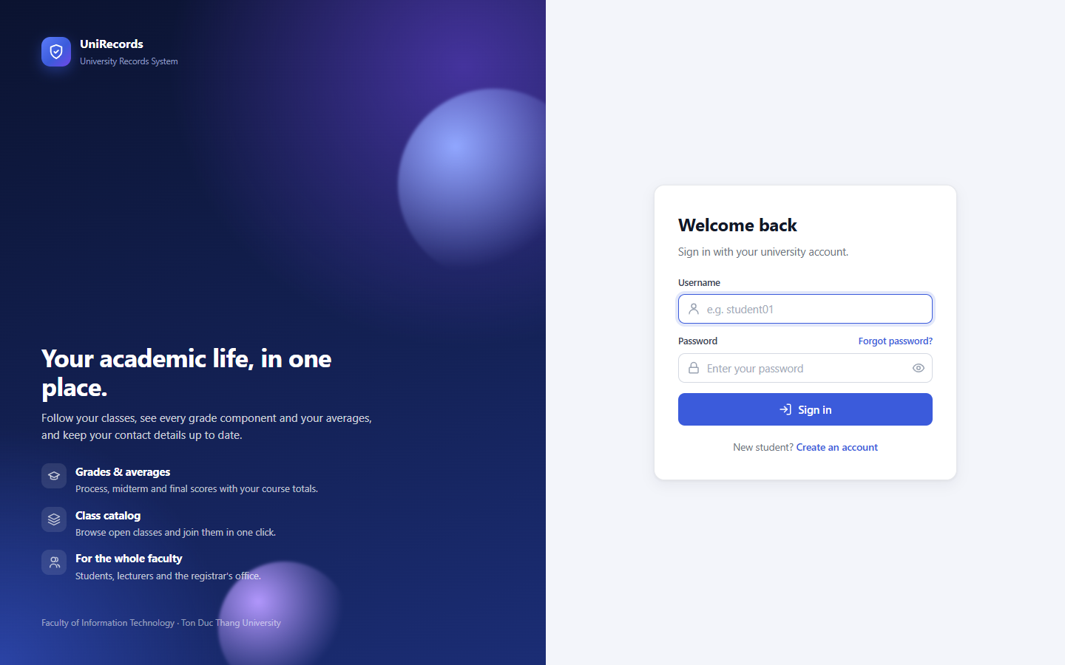
Figure A.1. Sign-in page with the product overview and the login form.
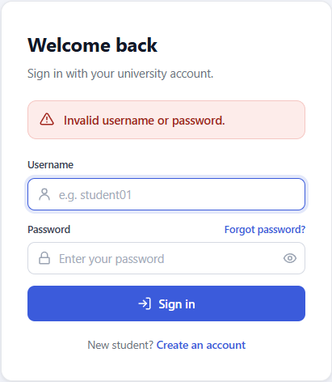
Figure A.2. Wrong password: one generic error message (HTTP 401) (T02).
Figure A.3. Disabled account with the correct password is rejected (T03).
Figure A.4. SQL-injection payload in the login form: generic failure, no database error (T18).

A.3 Self-Registration and Class Catalog
A visitor creates a student account with name, username, e-mail and a confirmed password. Invalid input is rejected on the server with all messages at once. A successful sign-up returns to the login page with a confirmation; the new student receives a fresh student code and can immediately join an open class from the catalog, whose cards show lecturer, credits and seat usage.
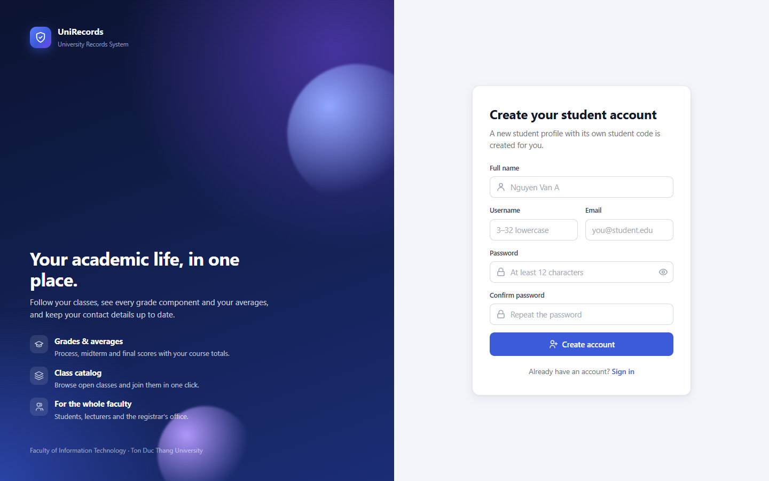
Figure A.5. Student self-registration form.
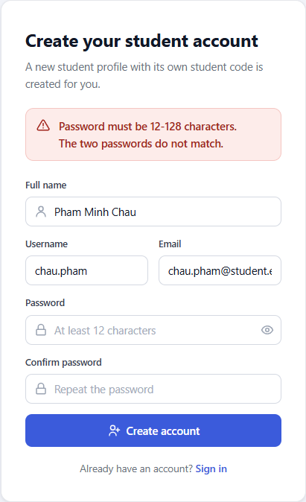
Figure A.6. Registration rejected by server-side validation (T46).
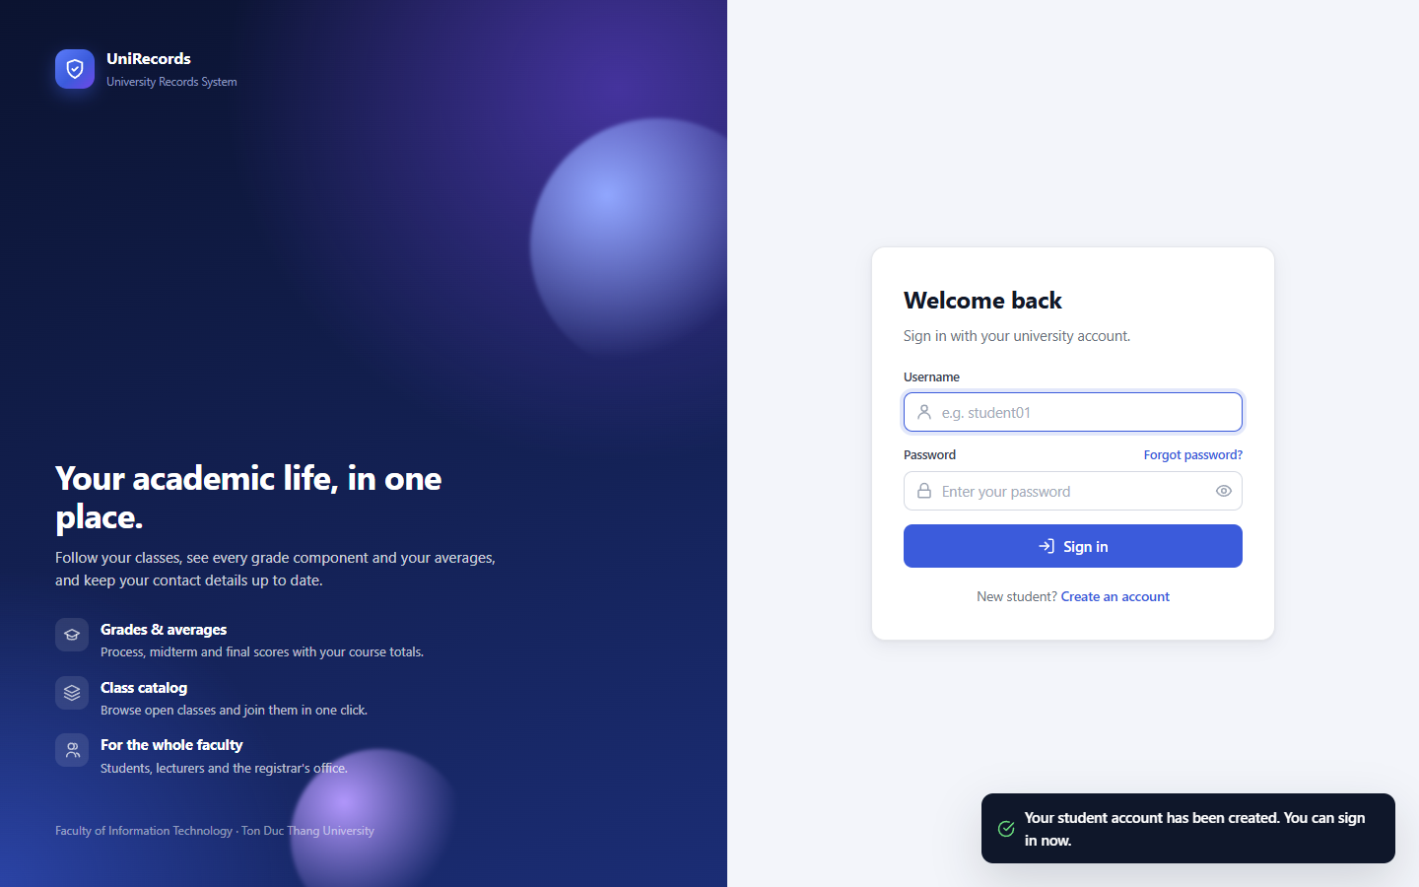
Figure A.7. Account created with the STUDENT role only; the user can sign in (T45).
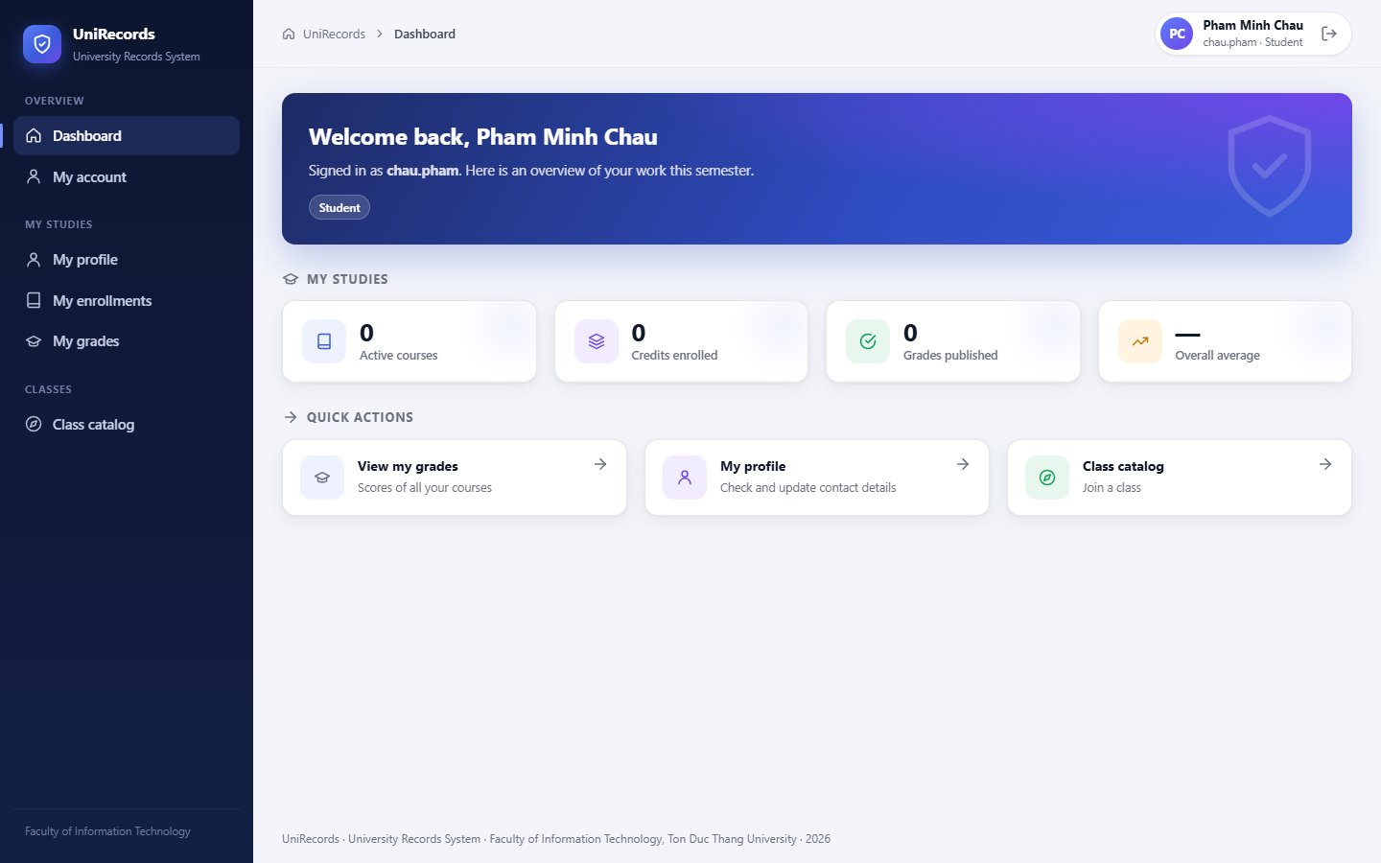
Figure A.8. Dashboard of the newly registered student (new student code).
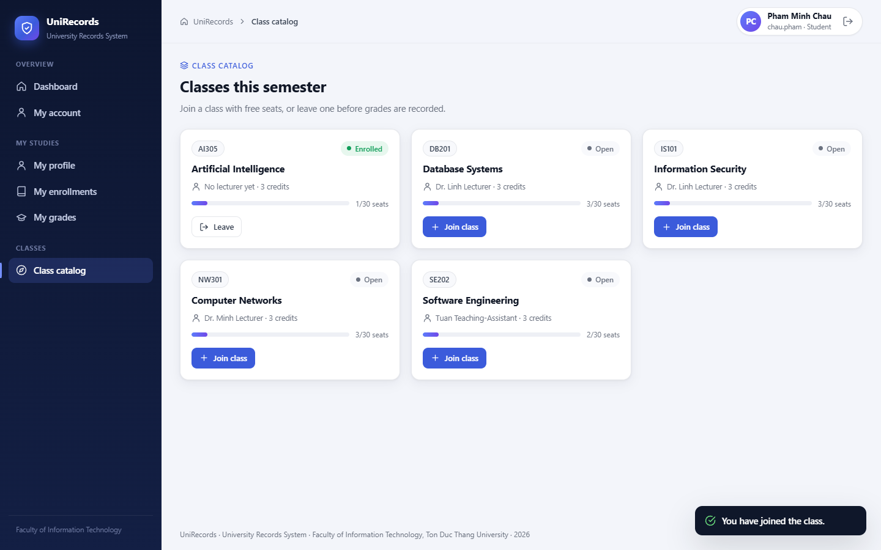
Figure A.9. Class catalog: the new student joins AI305 (seat counter updated) (T51).

A.4 Student Portal
A student's dashboard summarises their own studies (active courses, credits, published grades and the average) and offers quick actions. The profile page shows the official record next to a self-service form limited to email, phone and address. The grade page lists the four components of every course, the colour-coded total and the credit-weighted overall average. The catalog shows enrolled, open and full classes; a class cannot be left once grades exist.
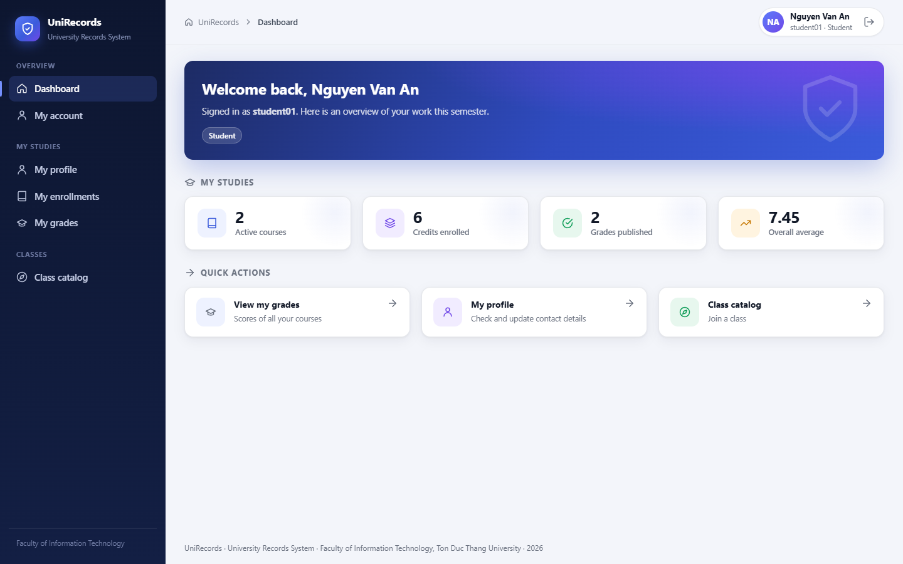
Figure A.10. Student dashboard: study statistics and quick actions (T01).
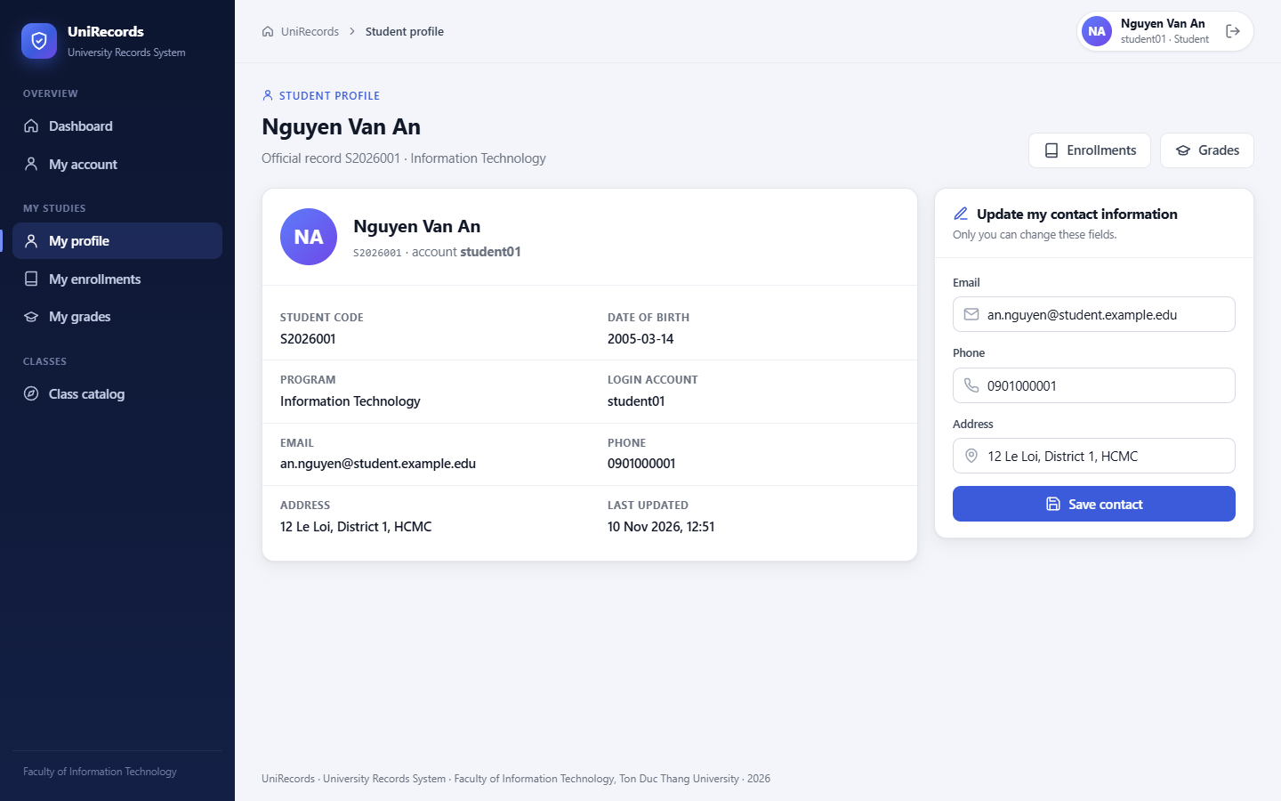
Figure A.11. Student profile with the self-service contact form.
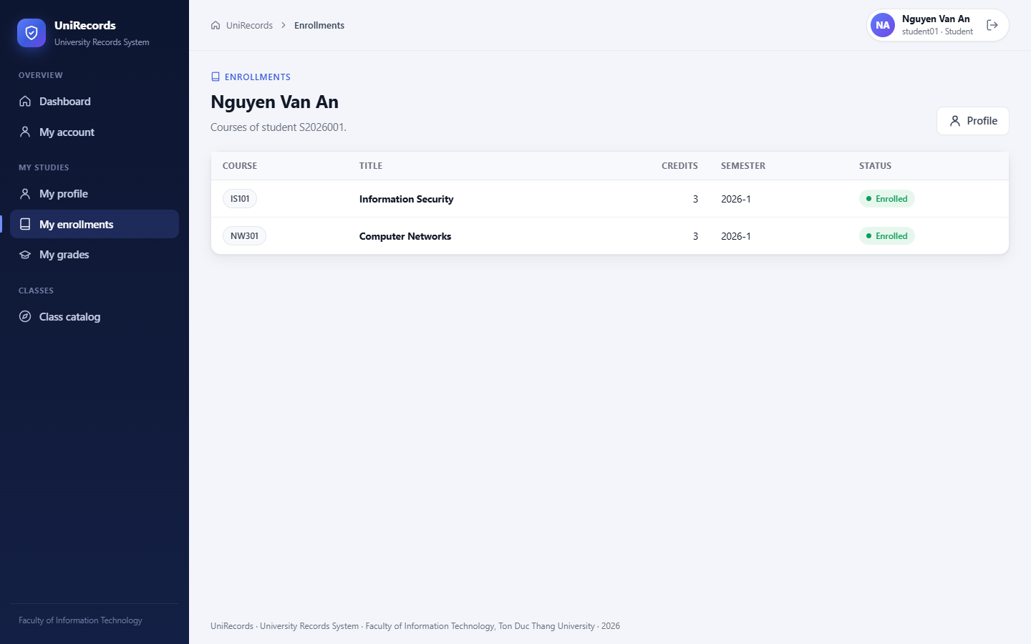
Figure A.12. Student's own enrollments.
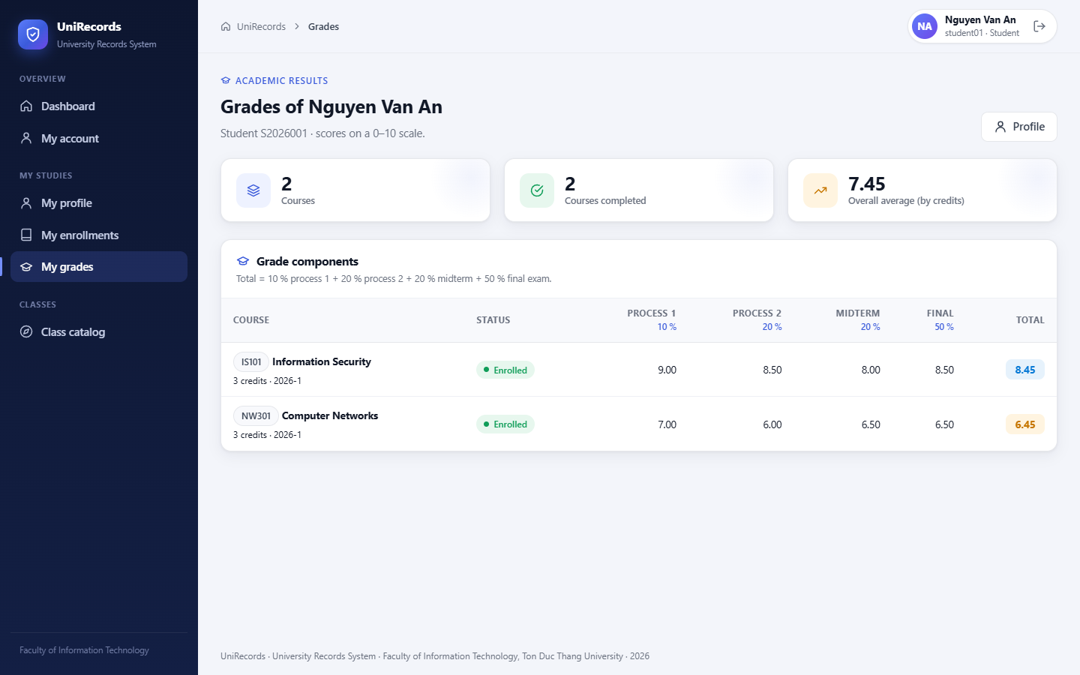
Figure A.13. Own grades: four components, course totals and the credit-weighted overall average (T06).
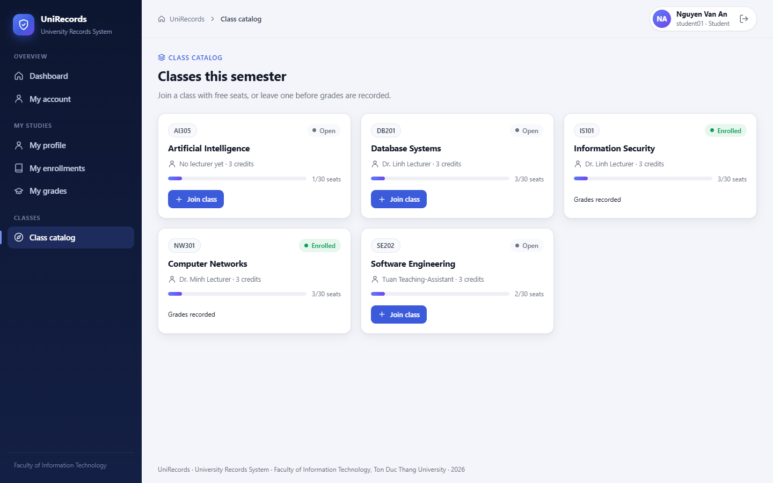
Figure A.14. Class catalog seen by student01 (enrolled, open and full classes).

A.5 Lecturer Workspace
Lecturers see only their assigned classes. The roster has one input per grade component with its weight and the computed total. After saving, a toast confirms the change, which is audited with old and new values. For the multi-role account ta01, the own SE202 enrollment shows "Own enrollment" instead of inputs; the server and the database trigger reject such a request anyway (T27). In the catalog a lecturer can take a class that has no lecturer.
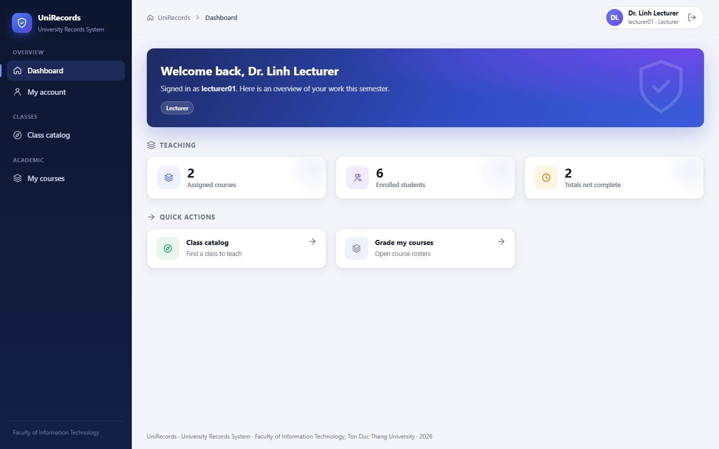
Figure A.15. Lecturer dashboard: assigned classes, students and incomplete totals.
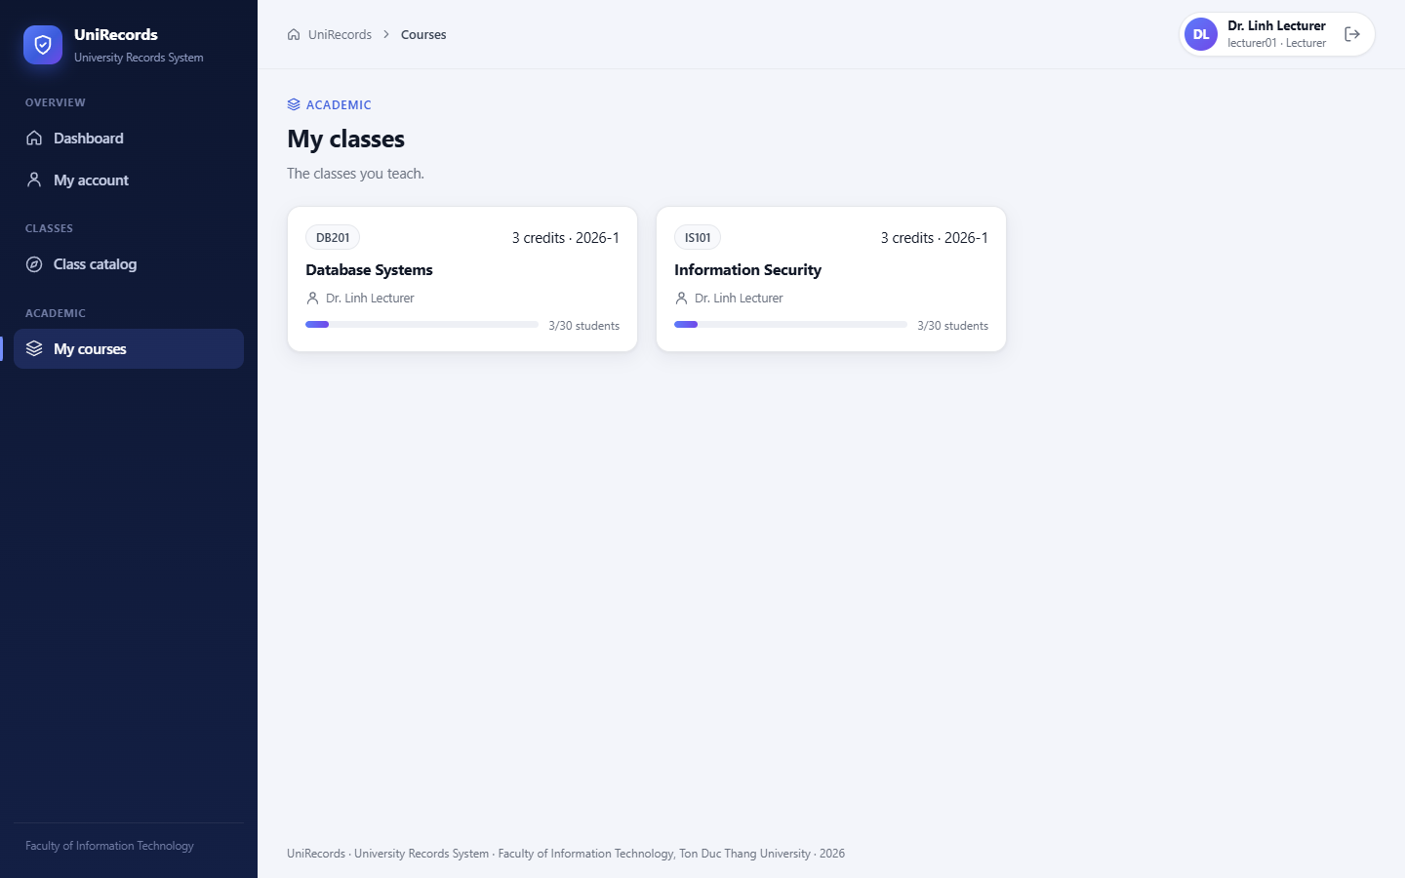
Figure A.16. Lecturer sees only the classes assigned to them.
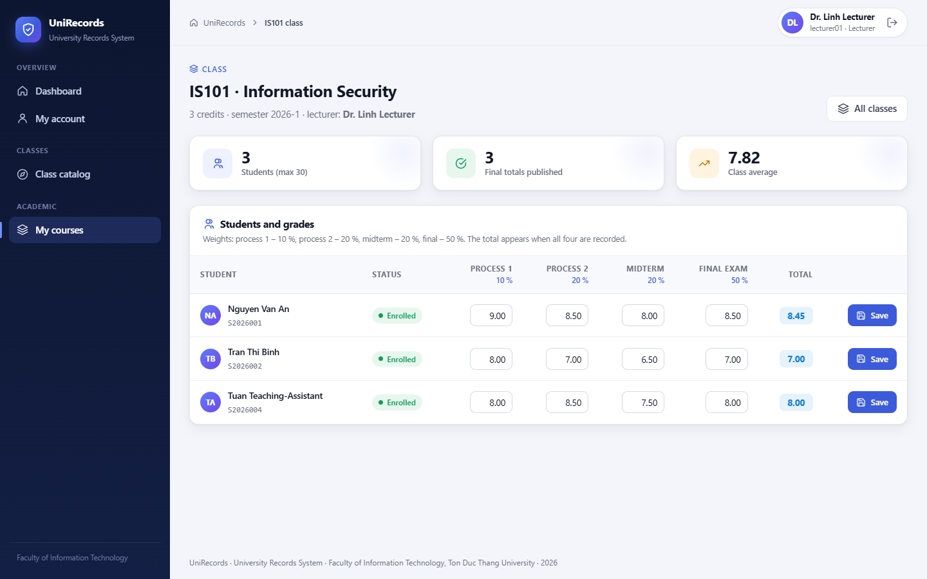
Figure A.17. Roster of IS101 with the four grade components and totals (T09).
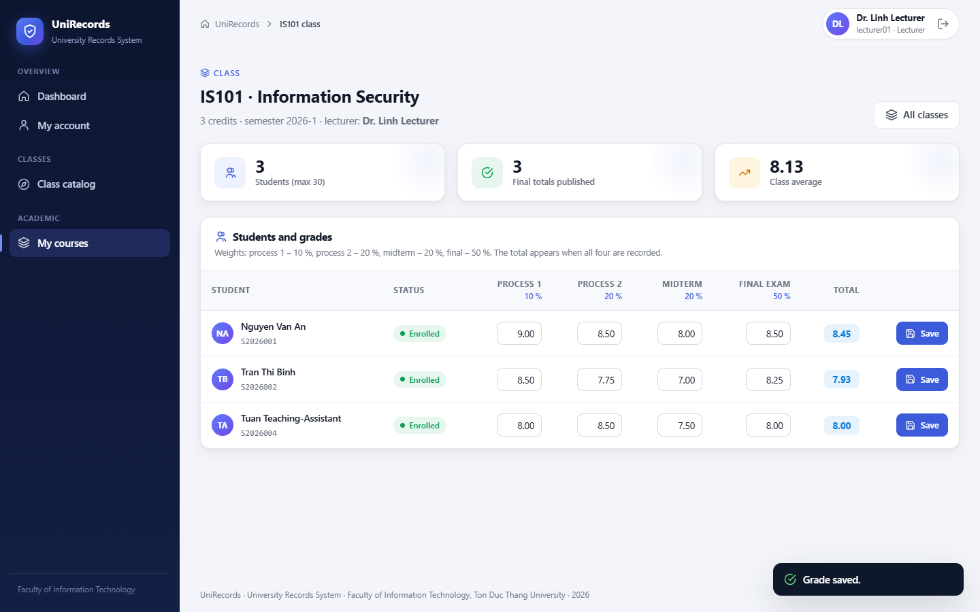
Figure A.18. Components saved for S2026002; the database computes the total 8.00 (confirmation toast) (T10).
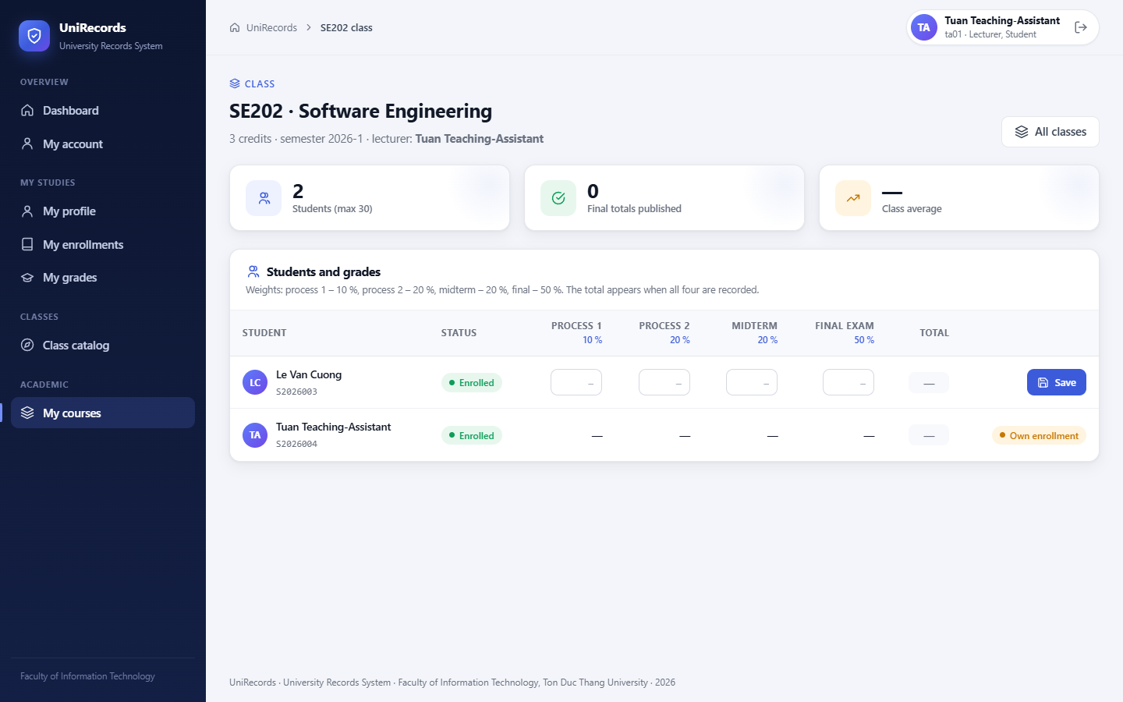
Figure A.19. Multi-role ta01 teaches SE202 but cannot grade their own enrollment (T27).
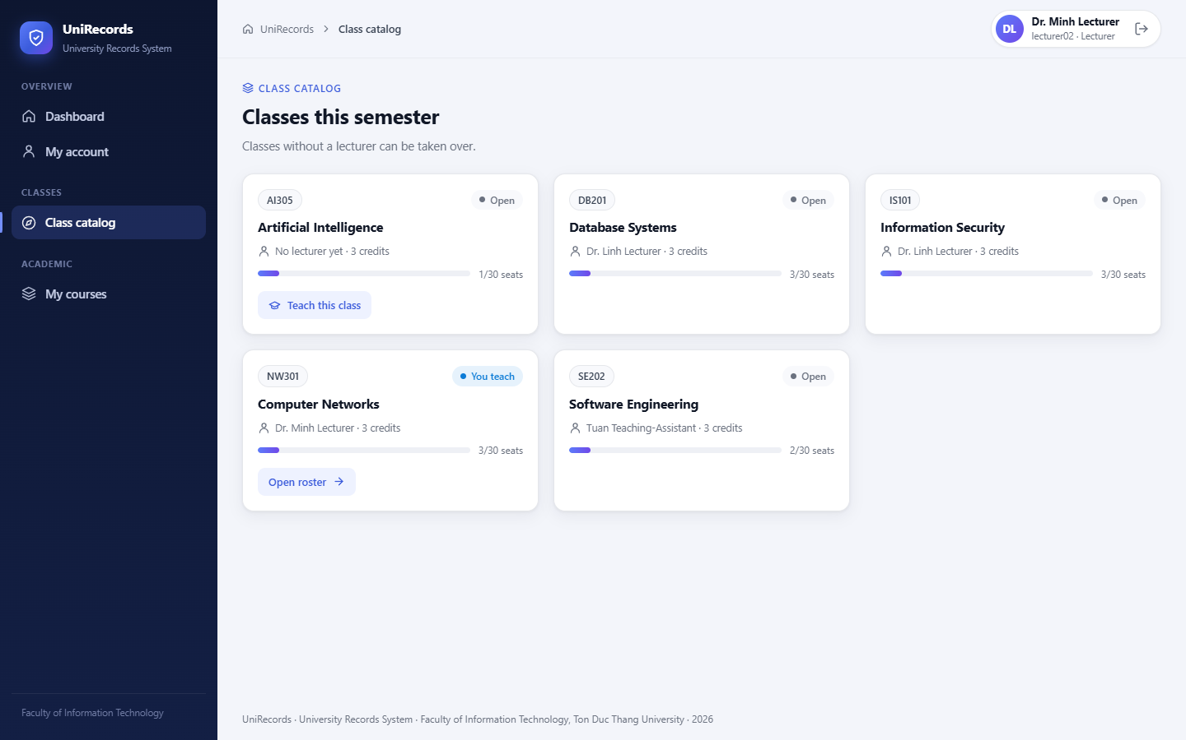
Figure A.20. Lecturer catalog: an unassigned class can be taken over (T52).

A.6 Registrar Workspace
The registrar works with all student records (searchable list, creation form) and all classes. A new class gets a code, title, credits, semester, a capacity of at most 30 and optionally its lecturer. The class page lets the registrar replace or remove the single lecturer, add students by code while seats remain, and remove students. The registrar can view grades but has no grade input anywhere.
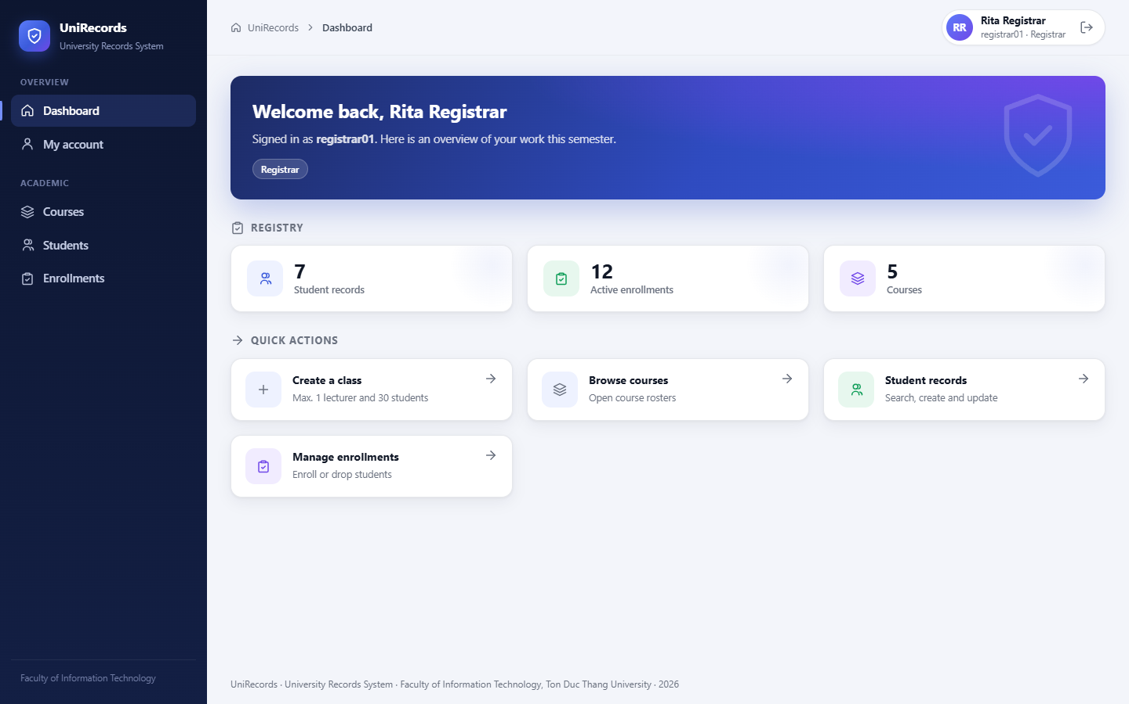
Figure A.21. Registrar dashboard: records, enrollments and classes.
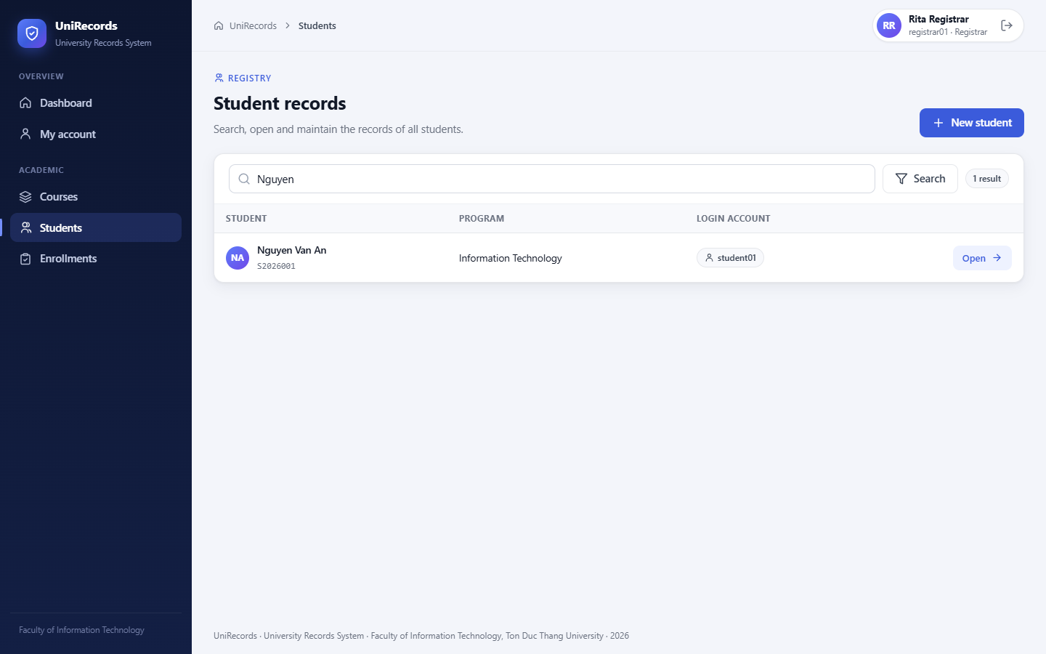
Figure A.22. Student search (the search text is a bound SQL parameter).
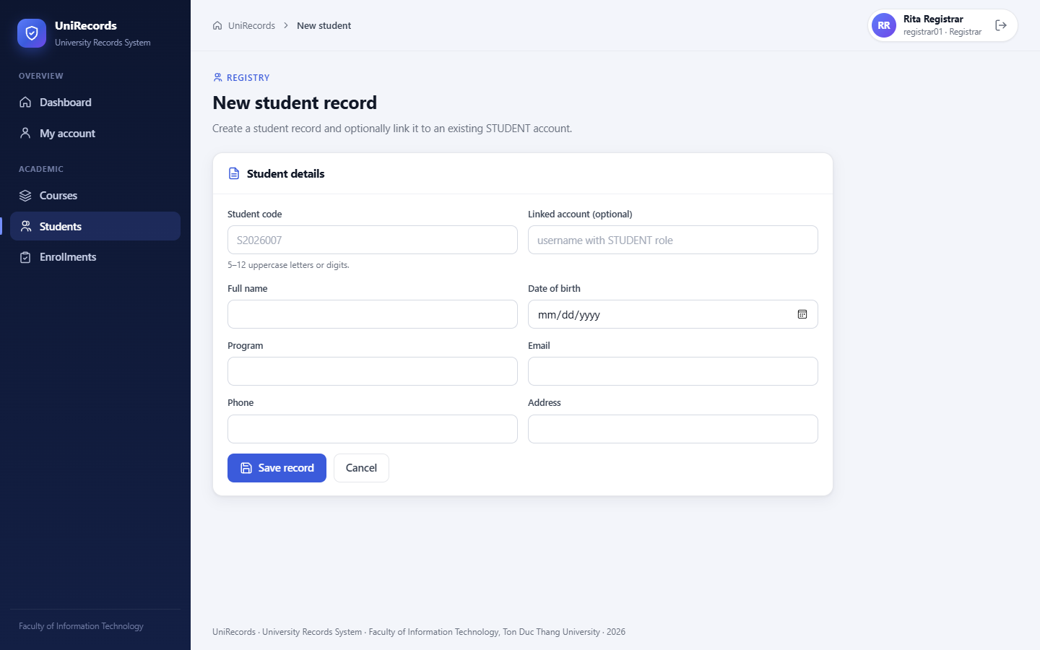
Figure A.23. Form for creating a student record.
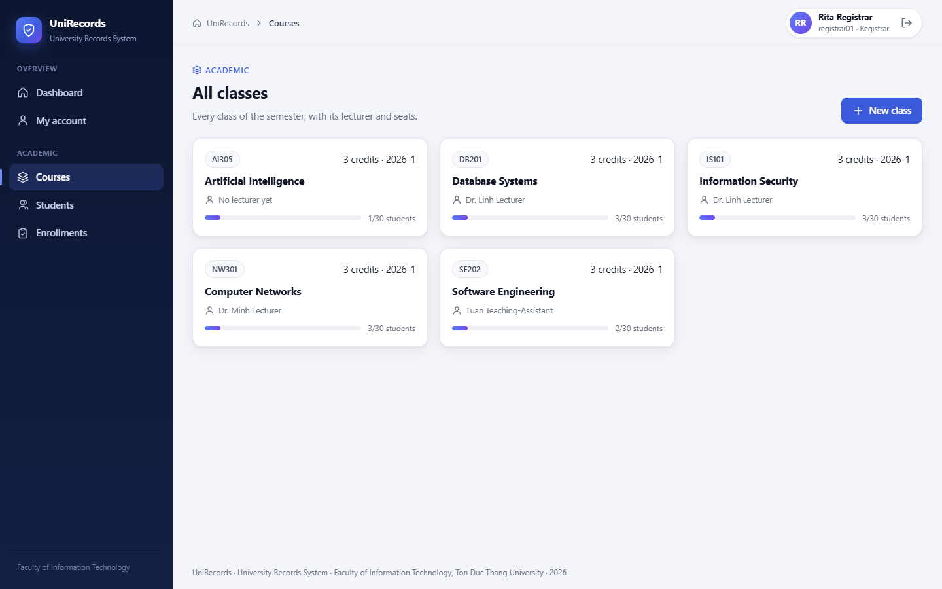
Figure A.24. All classes with lecturer and seat usage.
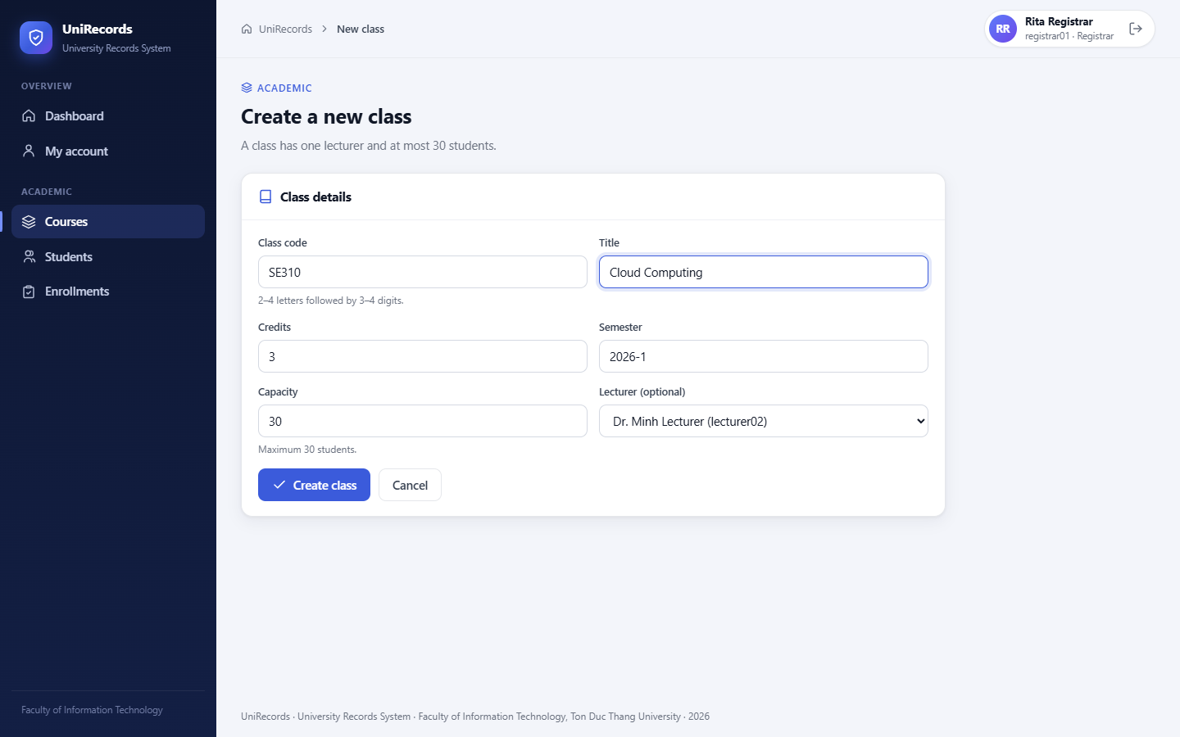
Figure A.25. Creating a class: capacity at most 30, one optional lecturer.
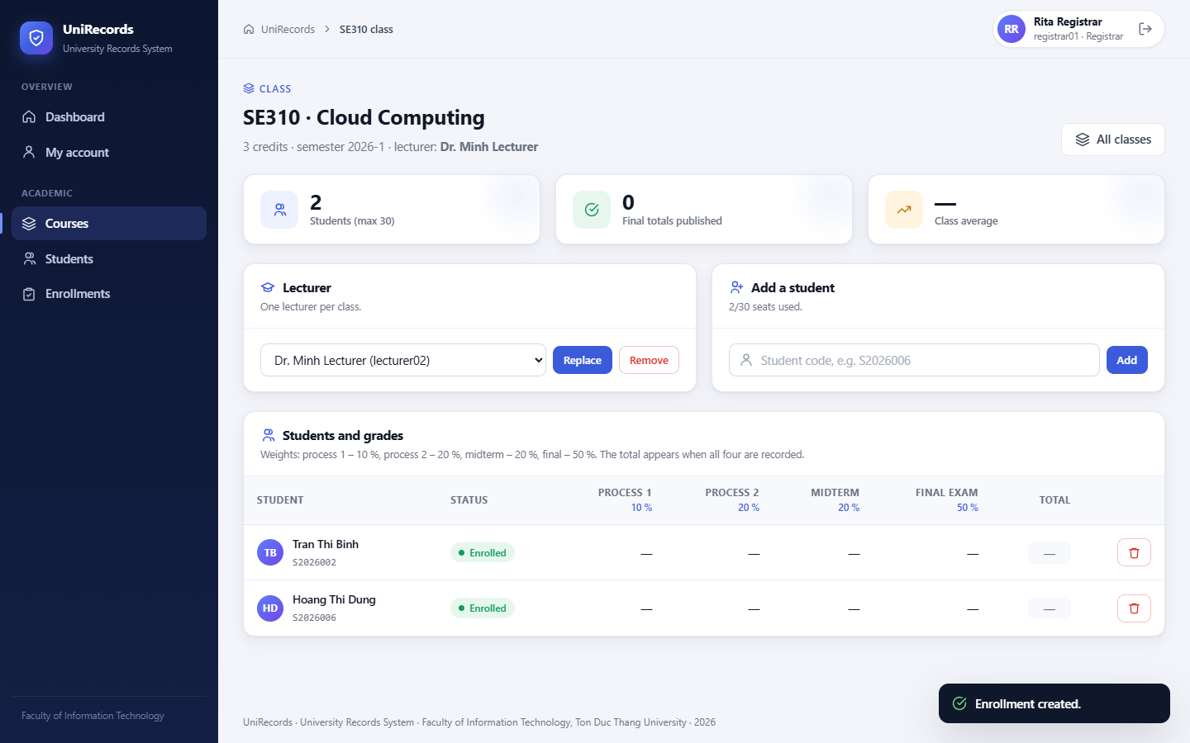
Figure A.26. Managing class SE310: lecturer assignment, adding students, seat usage (T48).
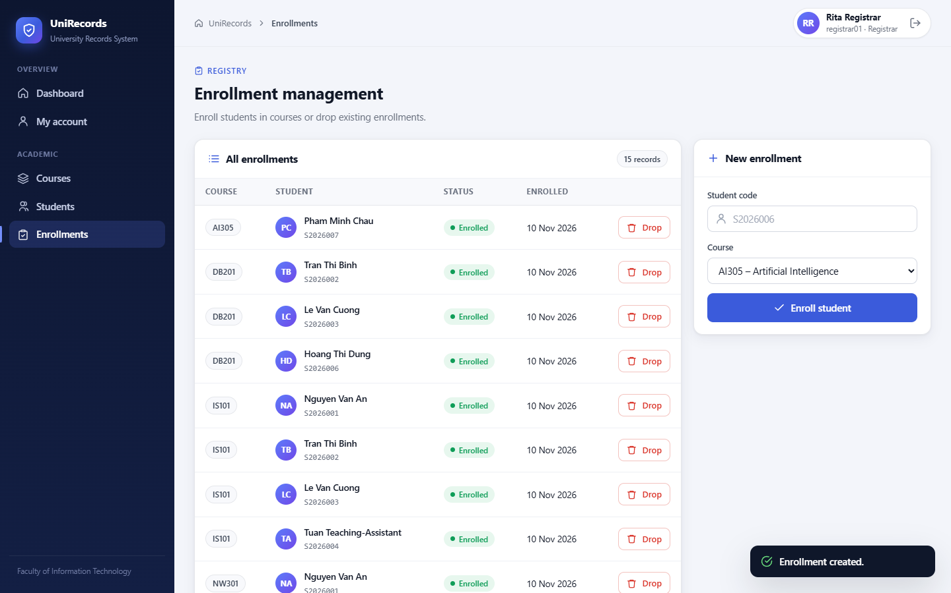
Figure A.27. Registrar enrolls S2026003 in IS101 (T12).

A.7 Administrator Console
The administrator's dashboard contains account statistics only, with no academic figures. The Users & roles page lists every account with role chips and its status (active, locked or disabled). It provides account actions and role assignment, and a Safeguards card states the separation-of-duties rules that the server enforces.
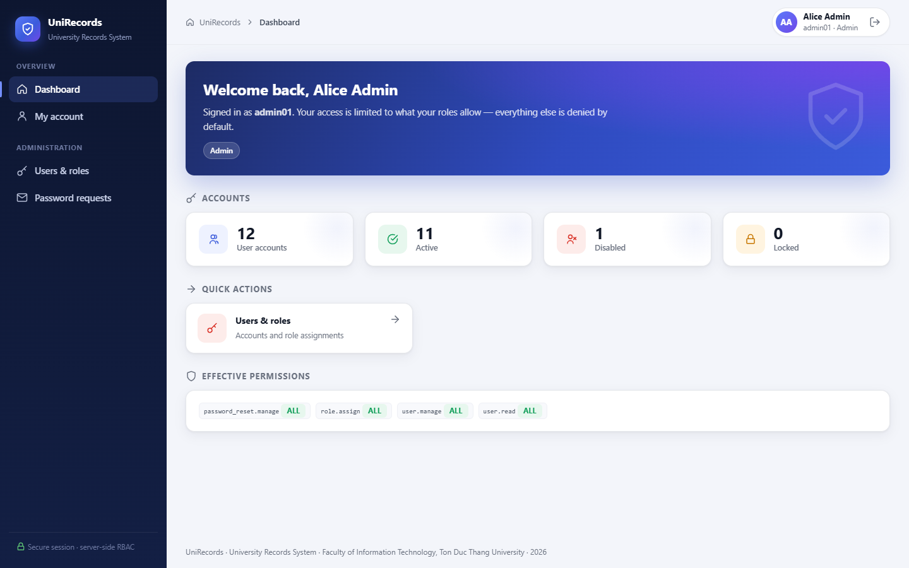
Figure A.28. Administrator dashboard: account statistics only, no academic data.
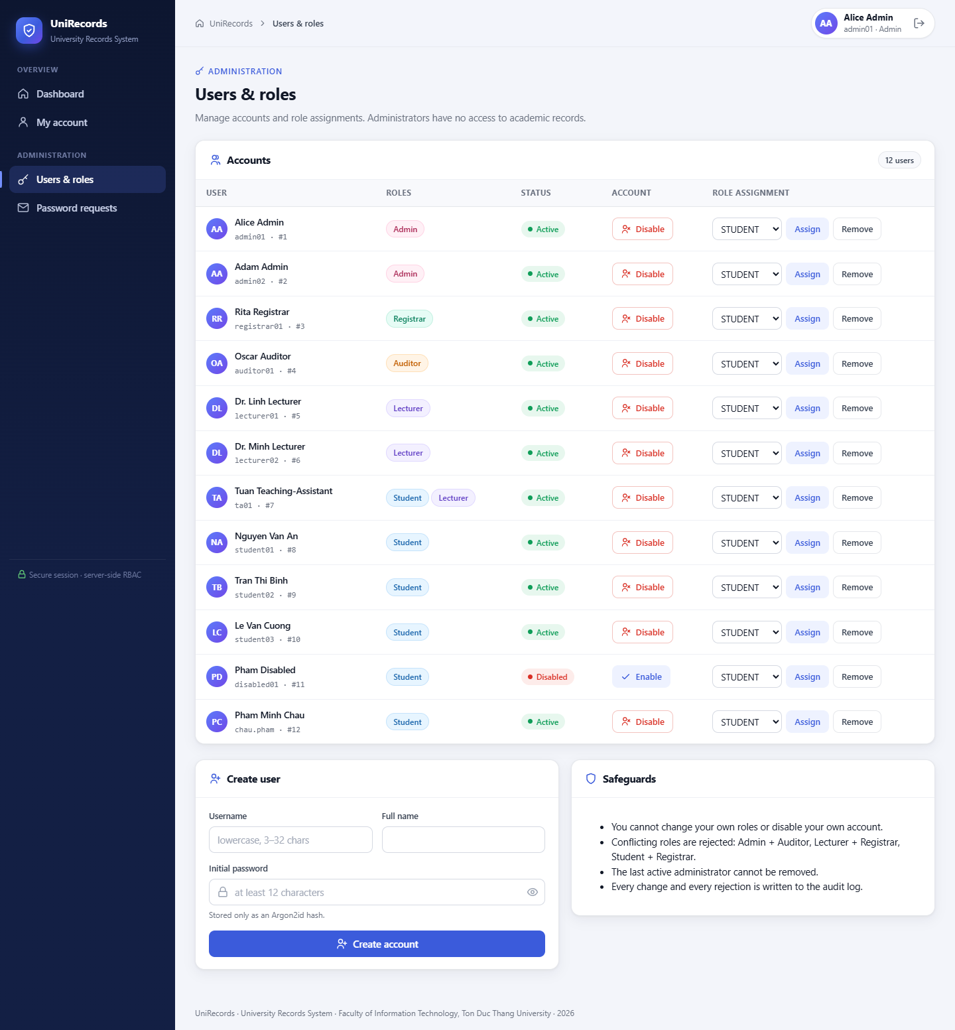
Figure A.29. User accounts, role chips, status and role-assignment controls (T16).

A.8 Account Self-Service and Password Reset
Every role has a My account page. Students and lecturers can rename themselves; staff names are locked, and every role can change its password after confirming the current one. A forgotten password starts with a public request that returns a reference code once. The administrator's inbox shows the requester, whether the e-mail matches the profile and the message, with Approve and Reject plus a reply. With the code, the requester reads the reply and reveals a one-time temporary password; signing in with it leads straight to a forced password change.
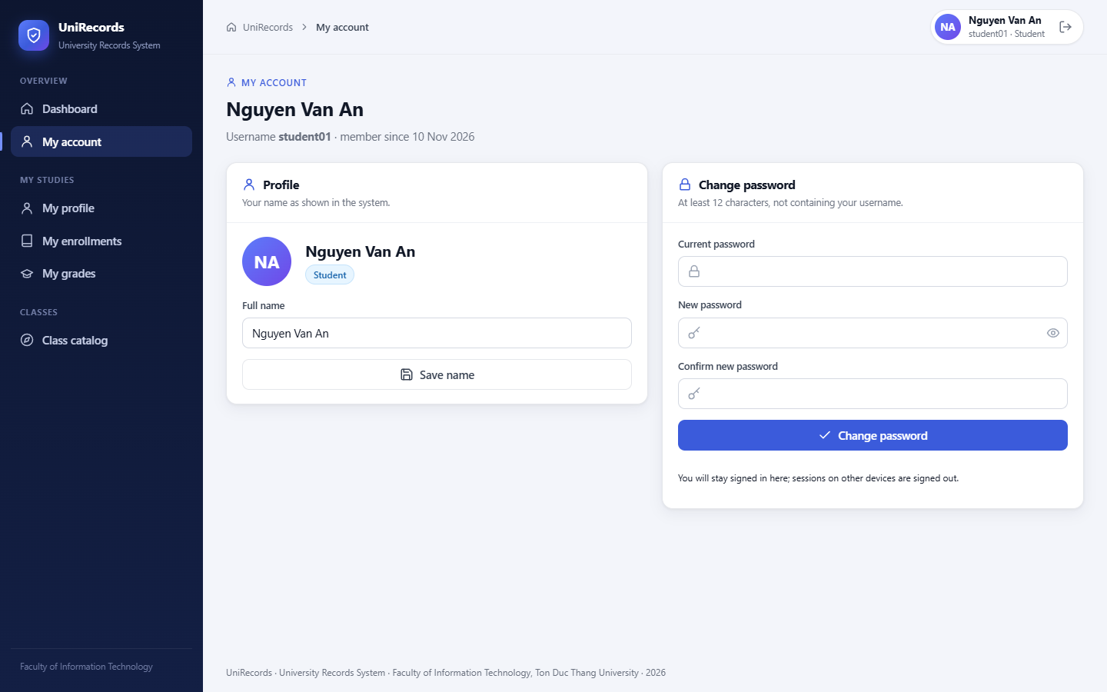
Figure A.30. My account (student): change name and password (T53).
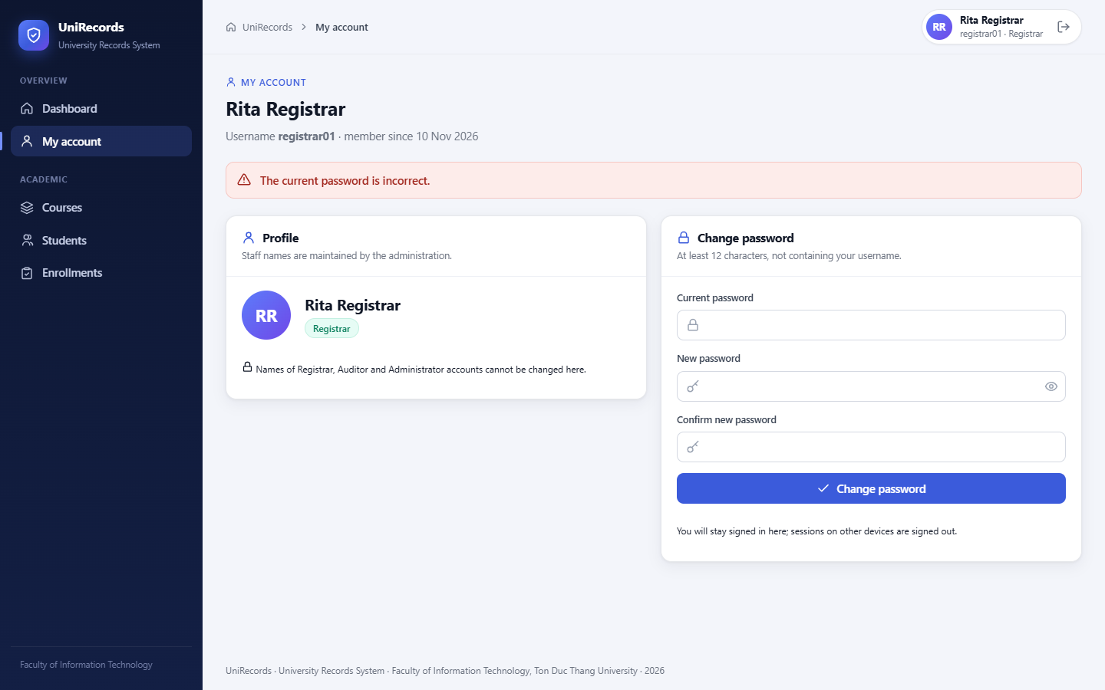
Figure A.31. My account (registrar): name locked; a wrong current password is rejected (T53/T54).
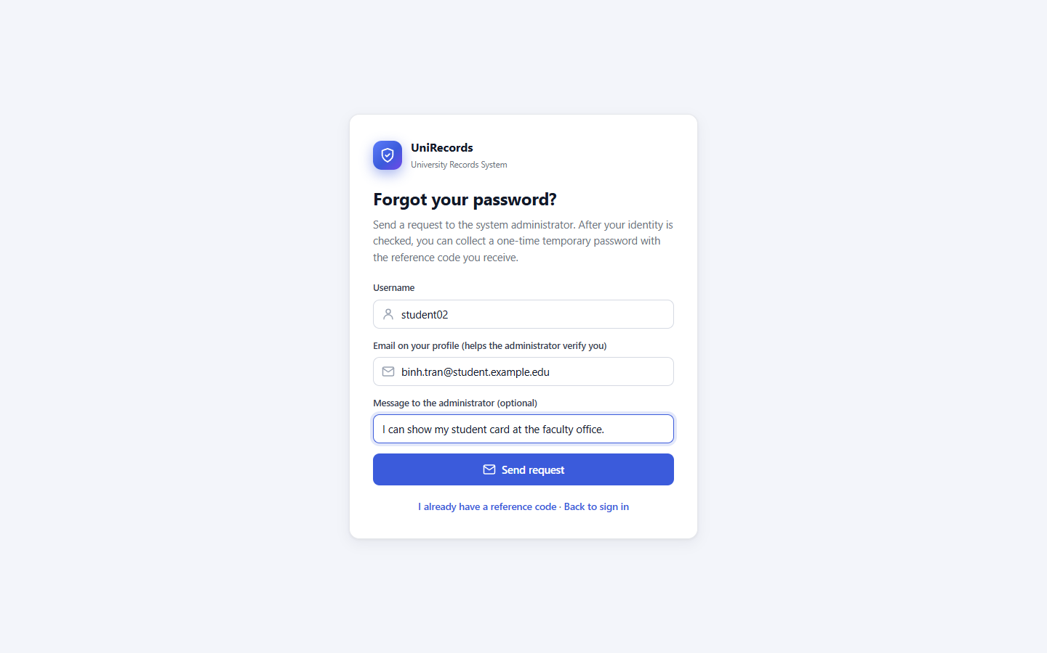
Figure A.32. Forgot-password request form.
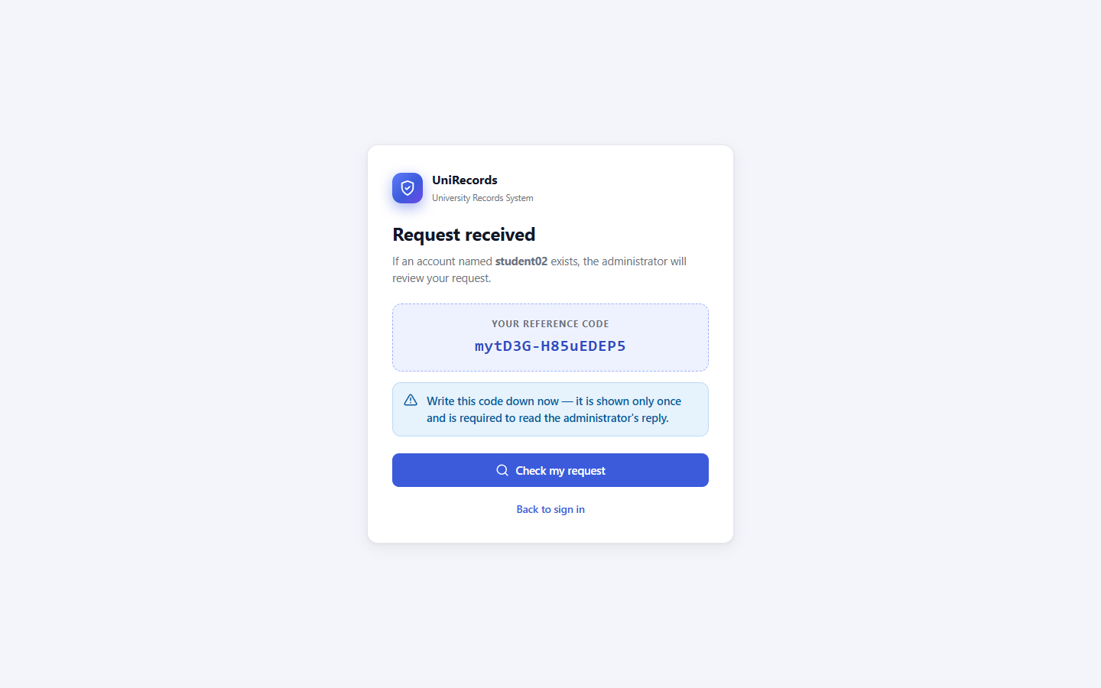
Figure A.33. Request received: the reference code is shown once (T55).
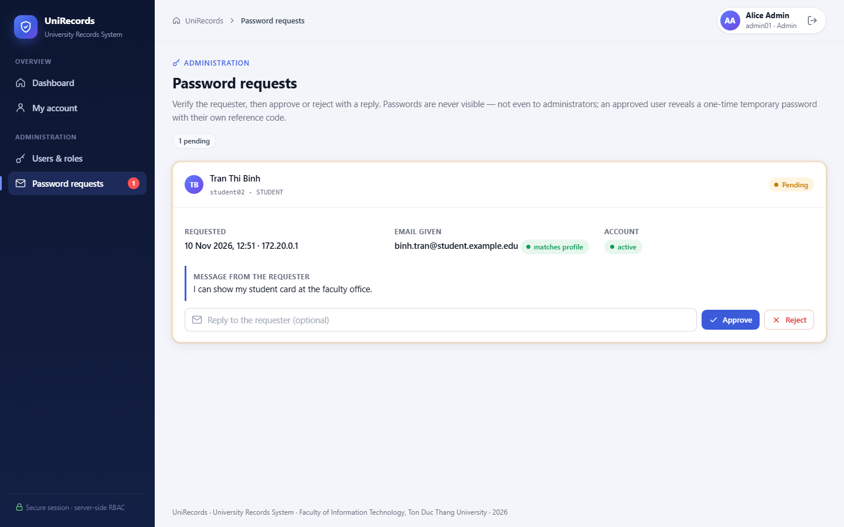
Figure A.34. Administrator inbox: requester, e-mail check against the profile, approve or reject with a reply (T57).
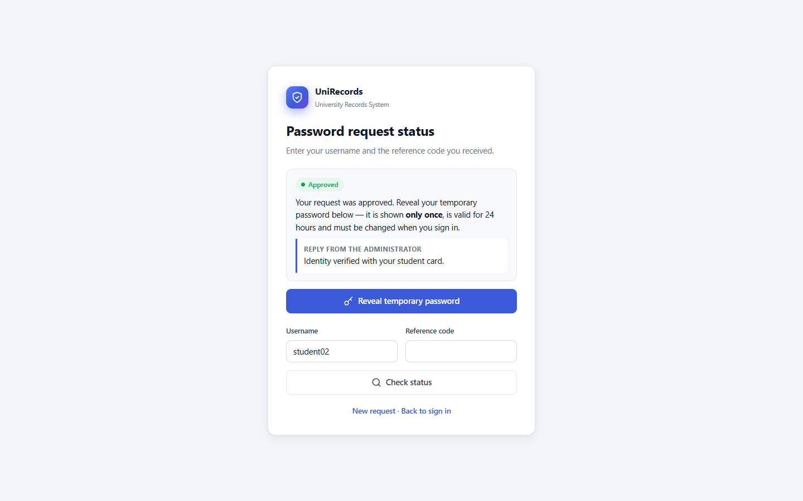
Figure A.35. Status page: approved, with the administrator's reply (T56).
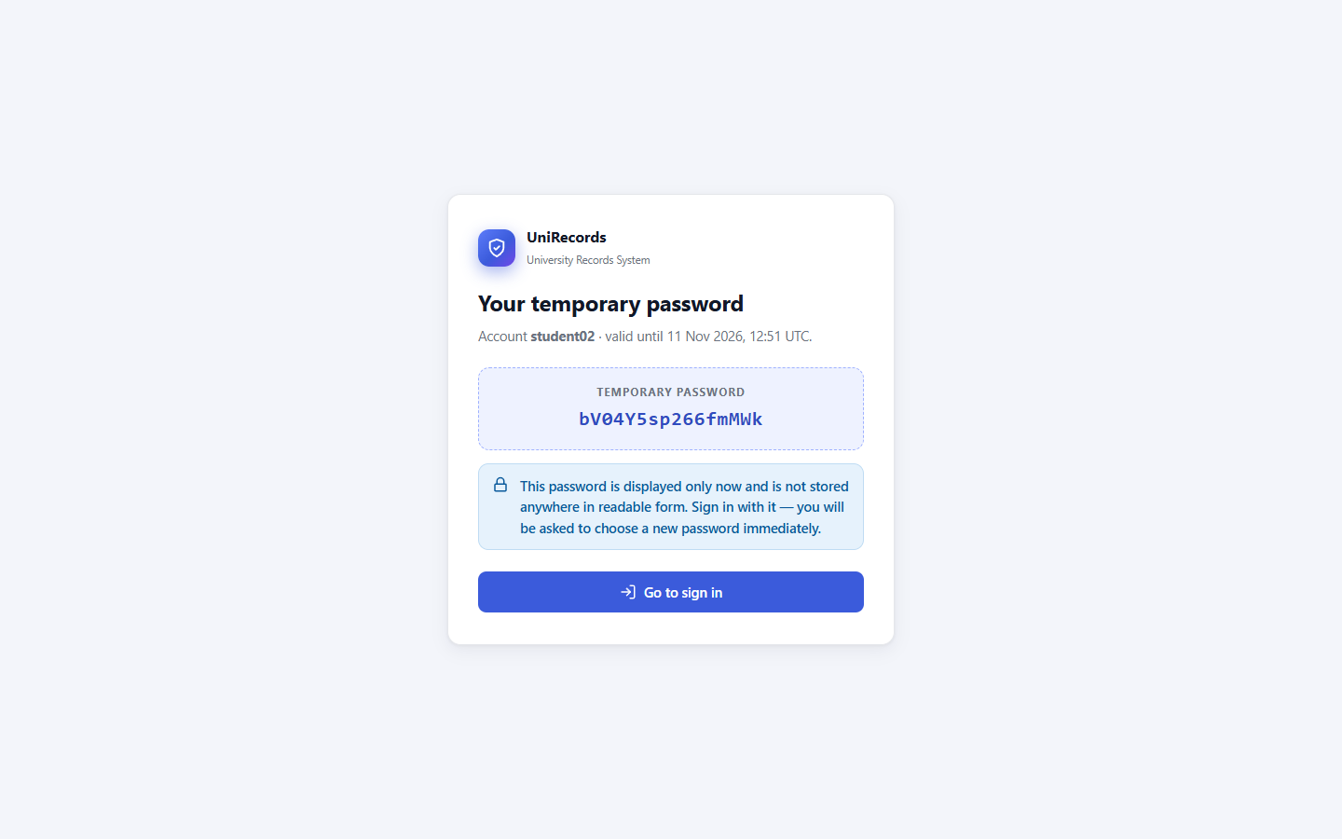
Figure A.36. One-time temporary password, revealed only to the requester (T56).
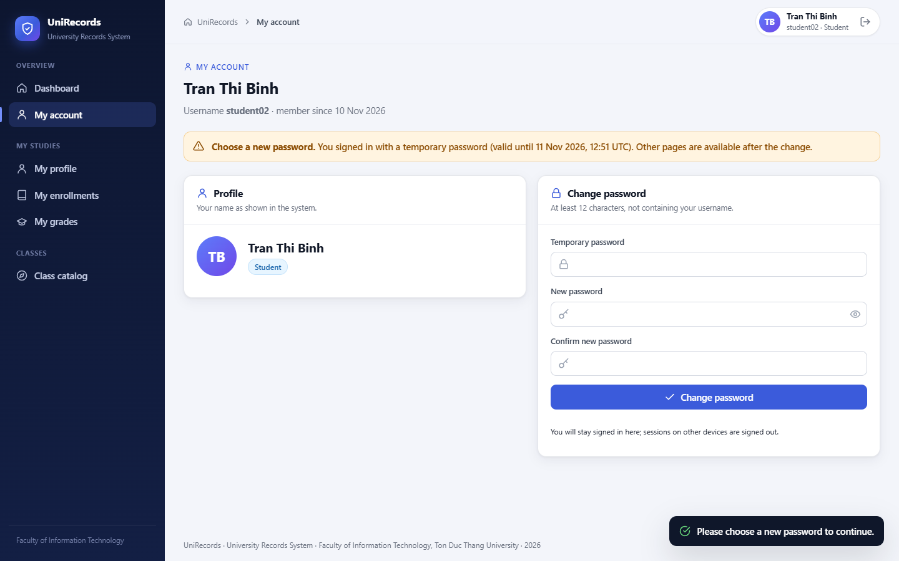
Figure A.37. Signing in with the temporary password forces a password change (T56).

A.9 Rejected Operations
Unauthorized requests receive a uniform Access denied page (HTTP 403) that gives no detail about the protected resource. The figures below were produced by requests that bypass the user interface: a changed id in the URL (IDOR), or a hand-crafted POST with a valid CSRF token. They demonstrate that hiding a button is not the control; the server-side check is.
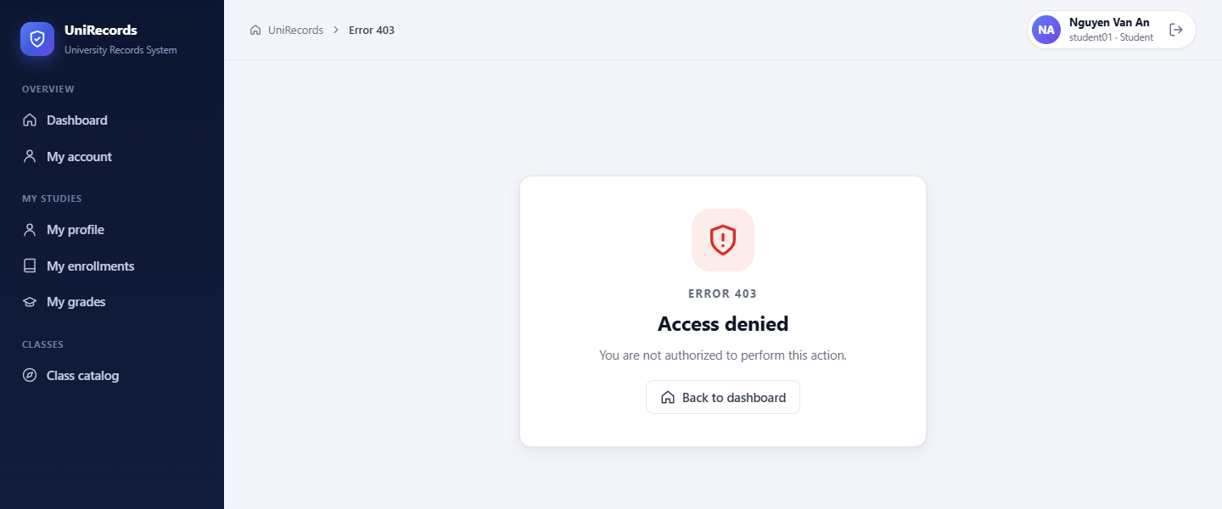
Figure A.38. student01 changes the id in the URL to another student: HTTP 403 (T07).
Figure A.39. student01 sends a grade-modification request directly: HTTP 403 (T08).
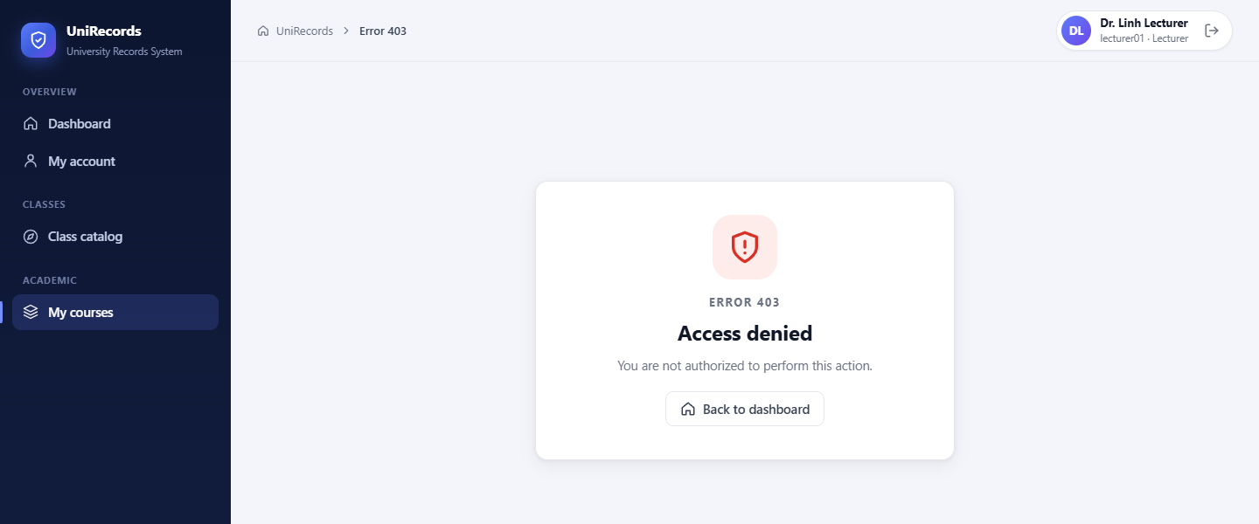
Figure A.40. lecturer01 modifies a grade in unassigned NW301: HTTP 403 (T11).
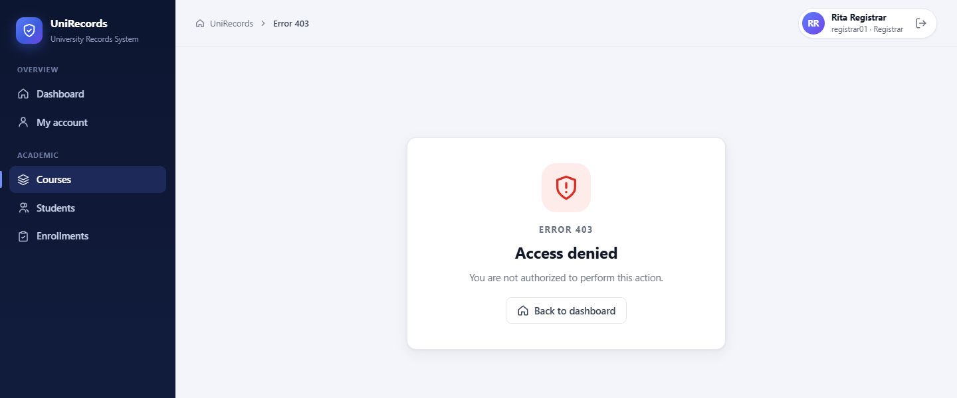
Figure A.41. registrar01 modifies a grade: HTTP 403 (T13).
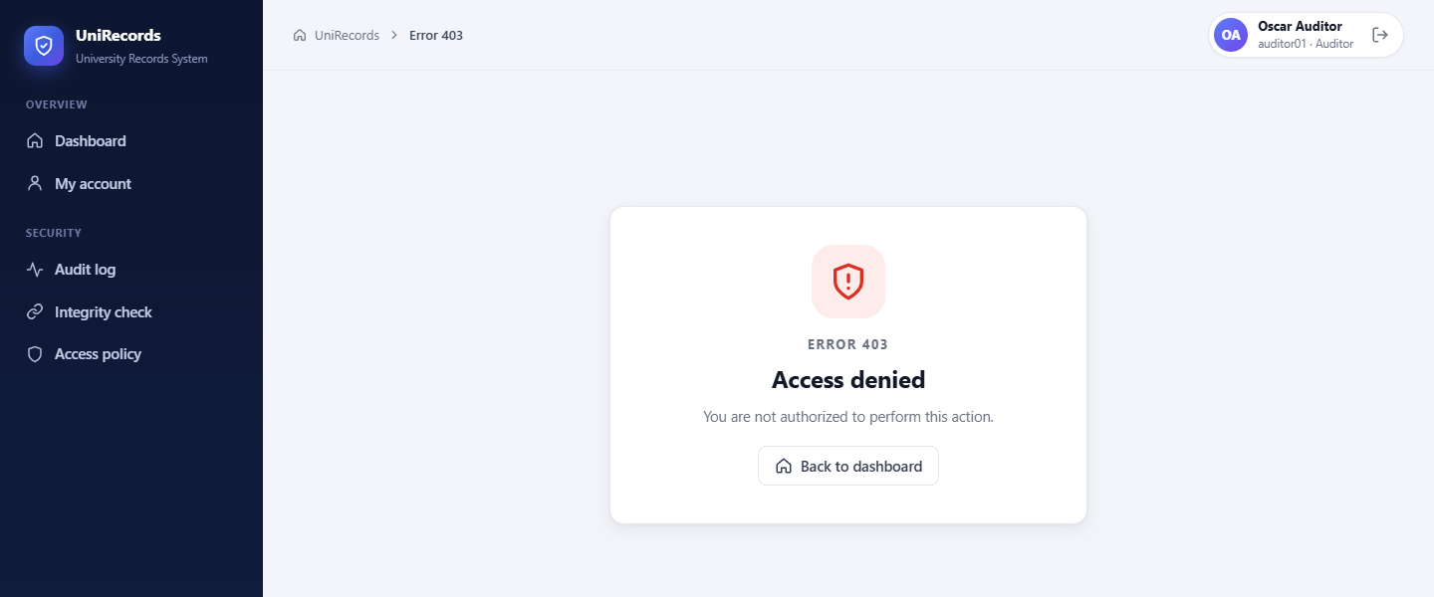
Figure A.42. auditor01 modifies a student record: HTTP 403 (T15).
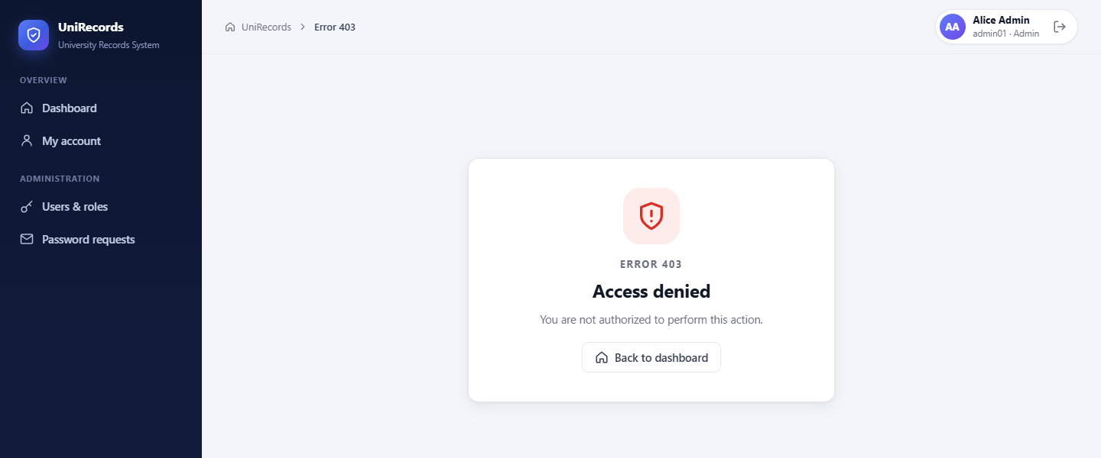
Figure A.43. admin01 (ADMIN only) opens a grade page: HTTP 403 (T17).
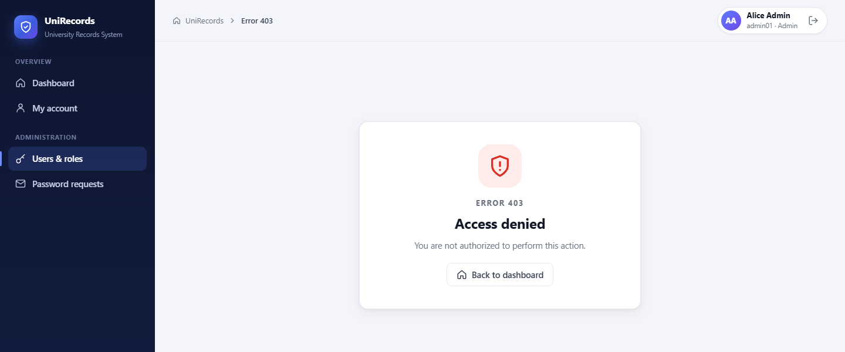
Figure A.44. Assigning AUDITOR to an administrator violates separation of duties: HTTP 403 (T30).

A.10 Input Handling and Session Termination
A stored script payload is rendered as text because of auto-escaping, and the CSP would block it anyway. After logout, the previous session is revoked on the server, and any request with it receives the sign-in-required page (HTTP 401).
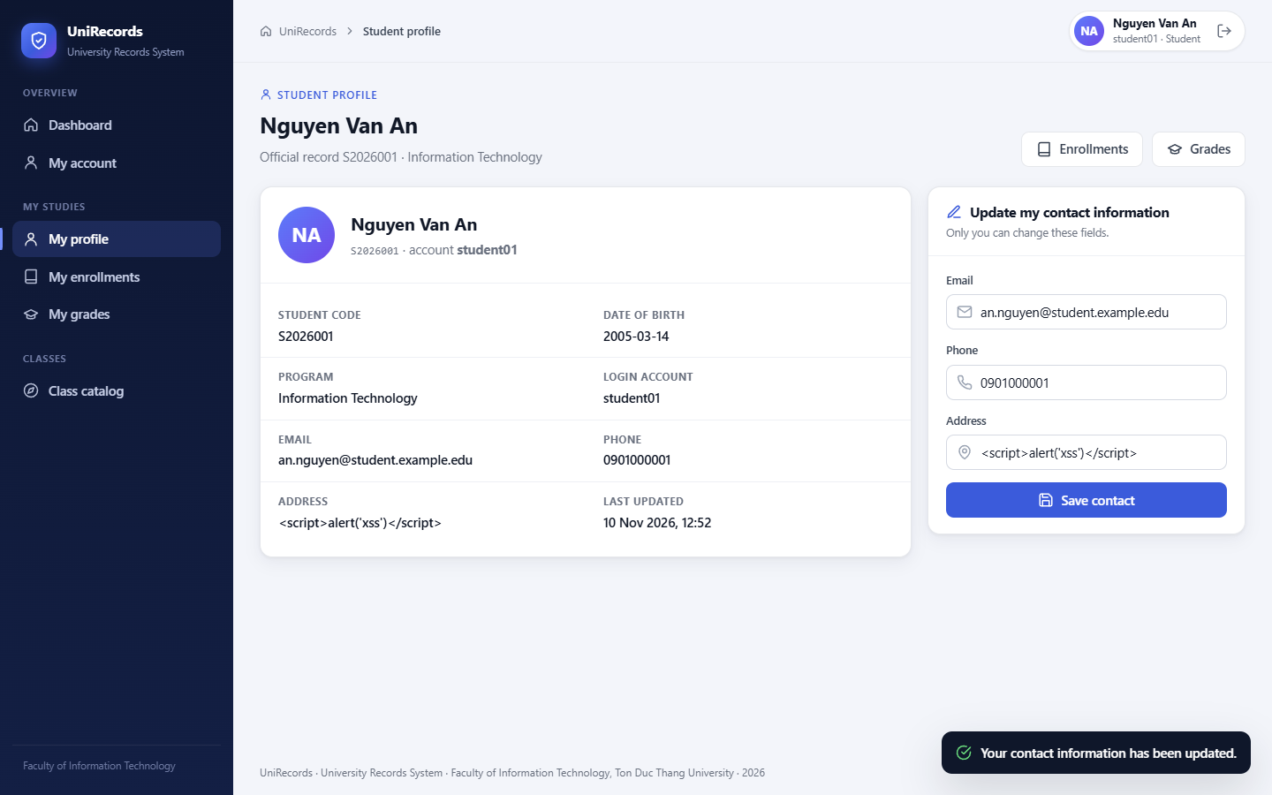
Figure A.45. Stored <script> payload is displayed as plain text and does not execute (T19).
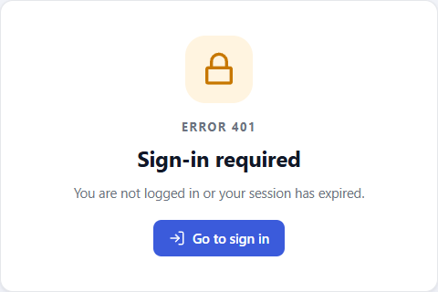
Figure A.46. After logout the old session is rejected: HTTP 401 (T04).

A.11 Security Auditor Console
The auditor's dashboard monitors audit volume, denied actions and failed logins. The audit log can be filtered by event type, result and actor, and the details of each entry are shown as key–value chips. The integrity page recomputes the SHA-256 hash chain in the database. The policy page renders the permission matrix, role conflicts and role assignments directly from the database, read-only.
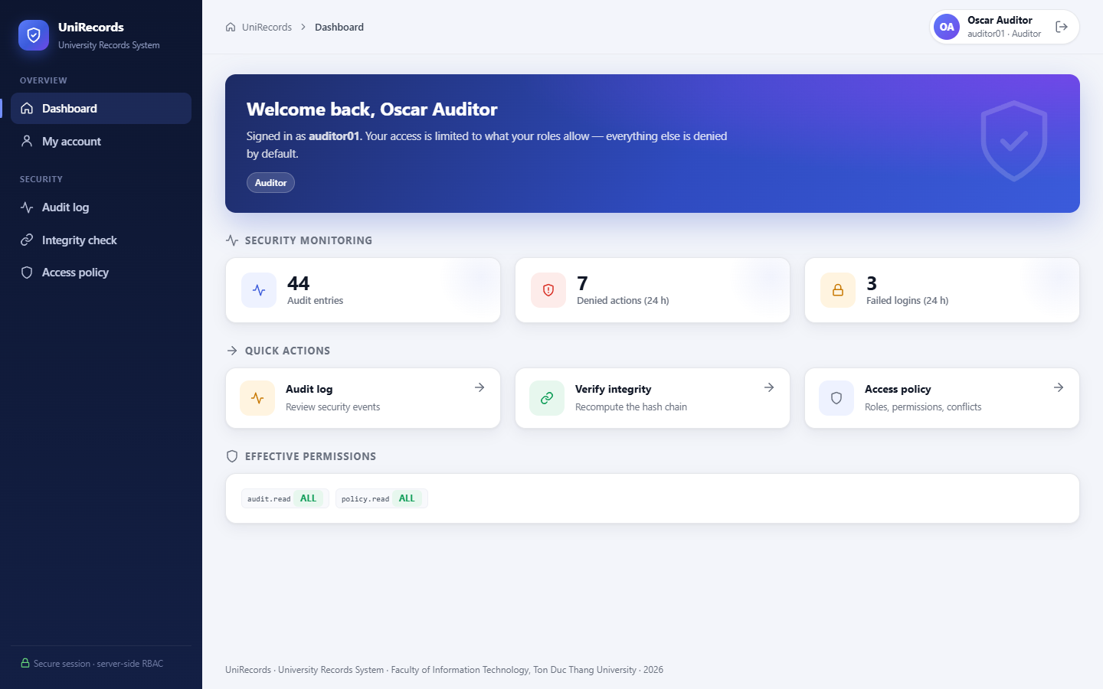
Figure A.47. Security Auditor dashboard: audit volume, denials and failed logins.
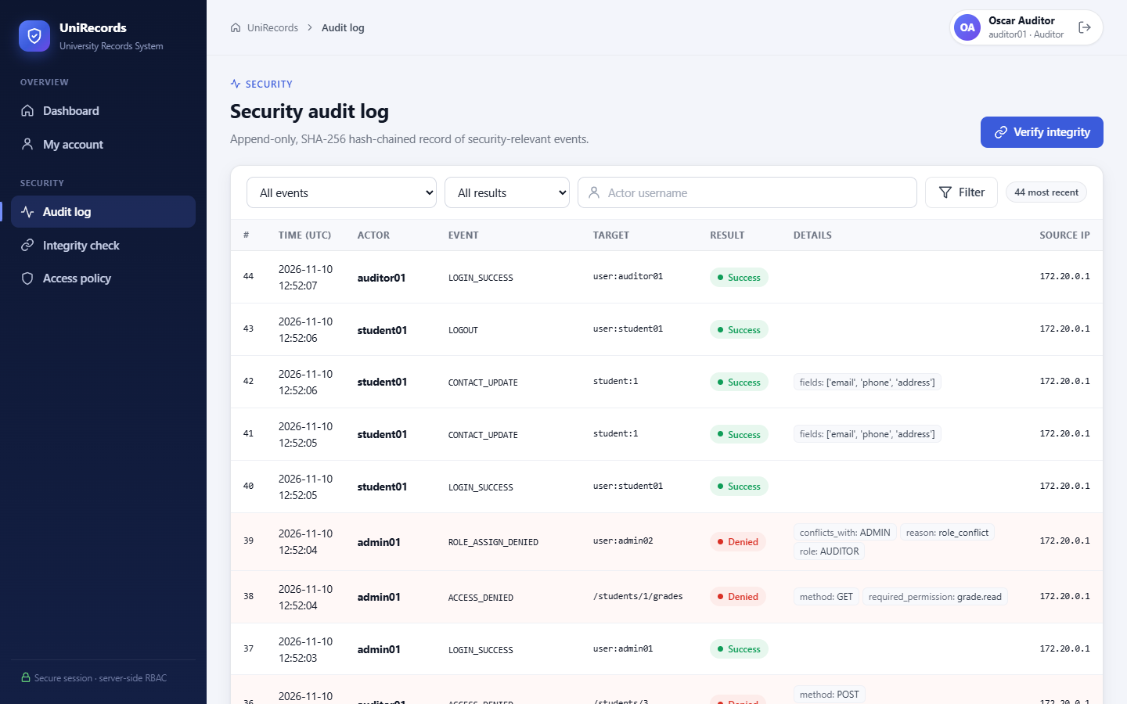
Figure A.48. Security audit log with timestamp, actor, event, target, result and details (T14).
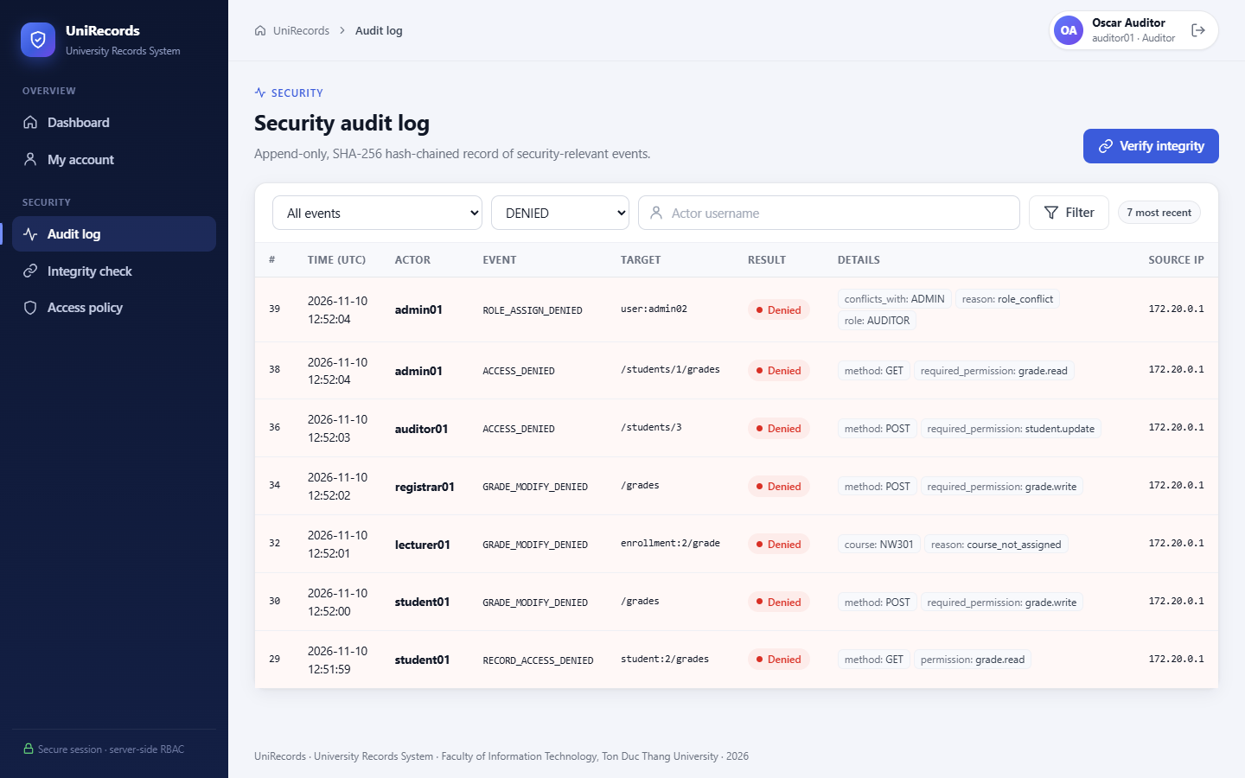
Figure A.49. Audit log filtered on rejected actions (T20).
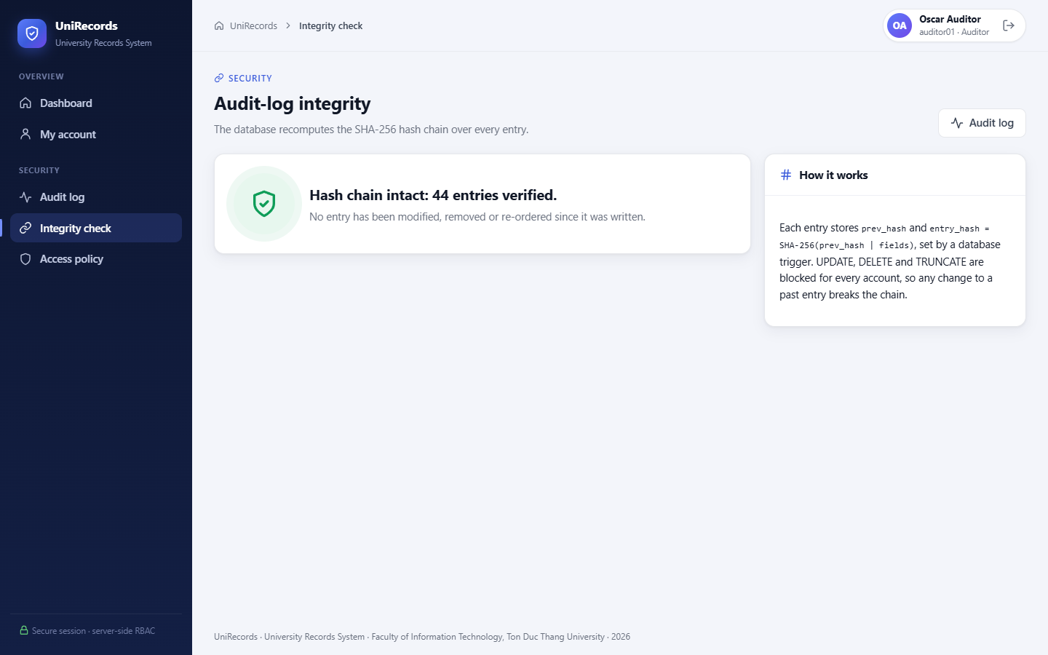
Figure A.50. Integrity check: the SHA-256 hash chain is intact (T42).
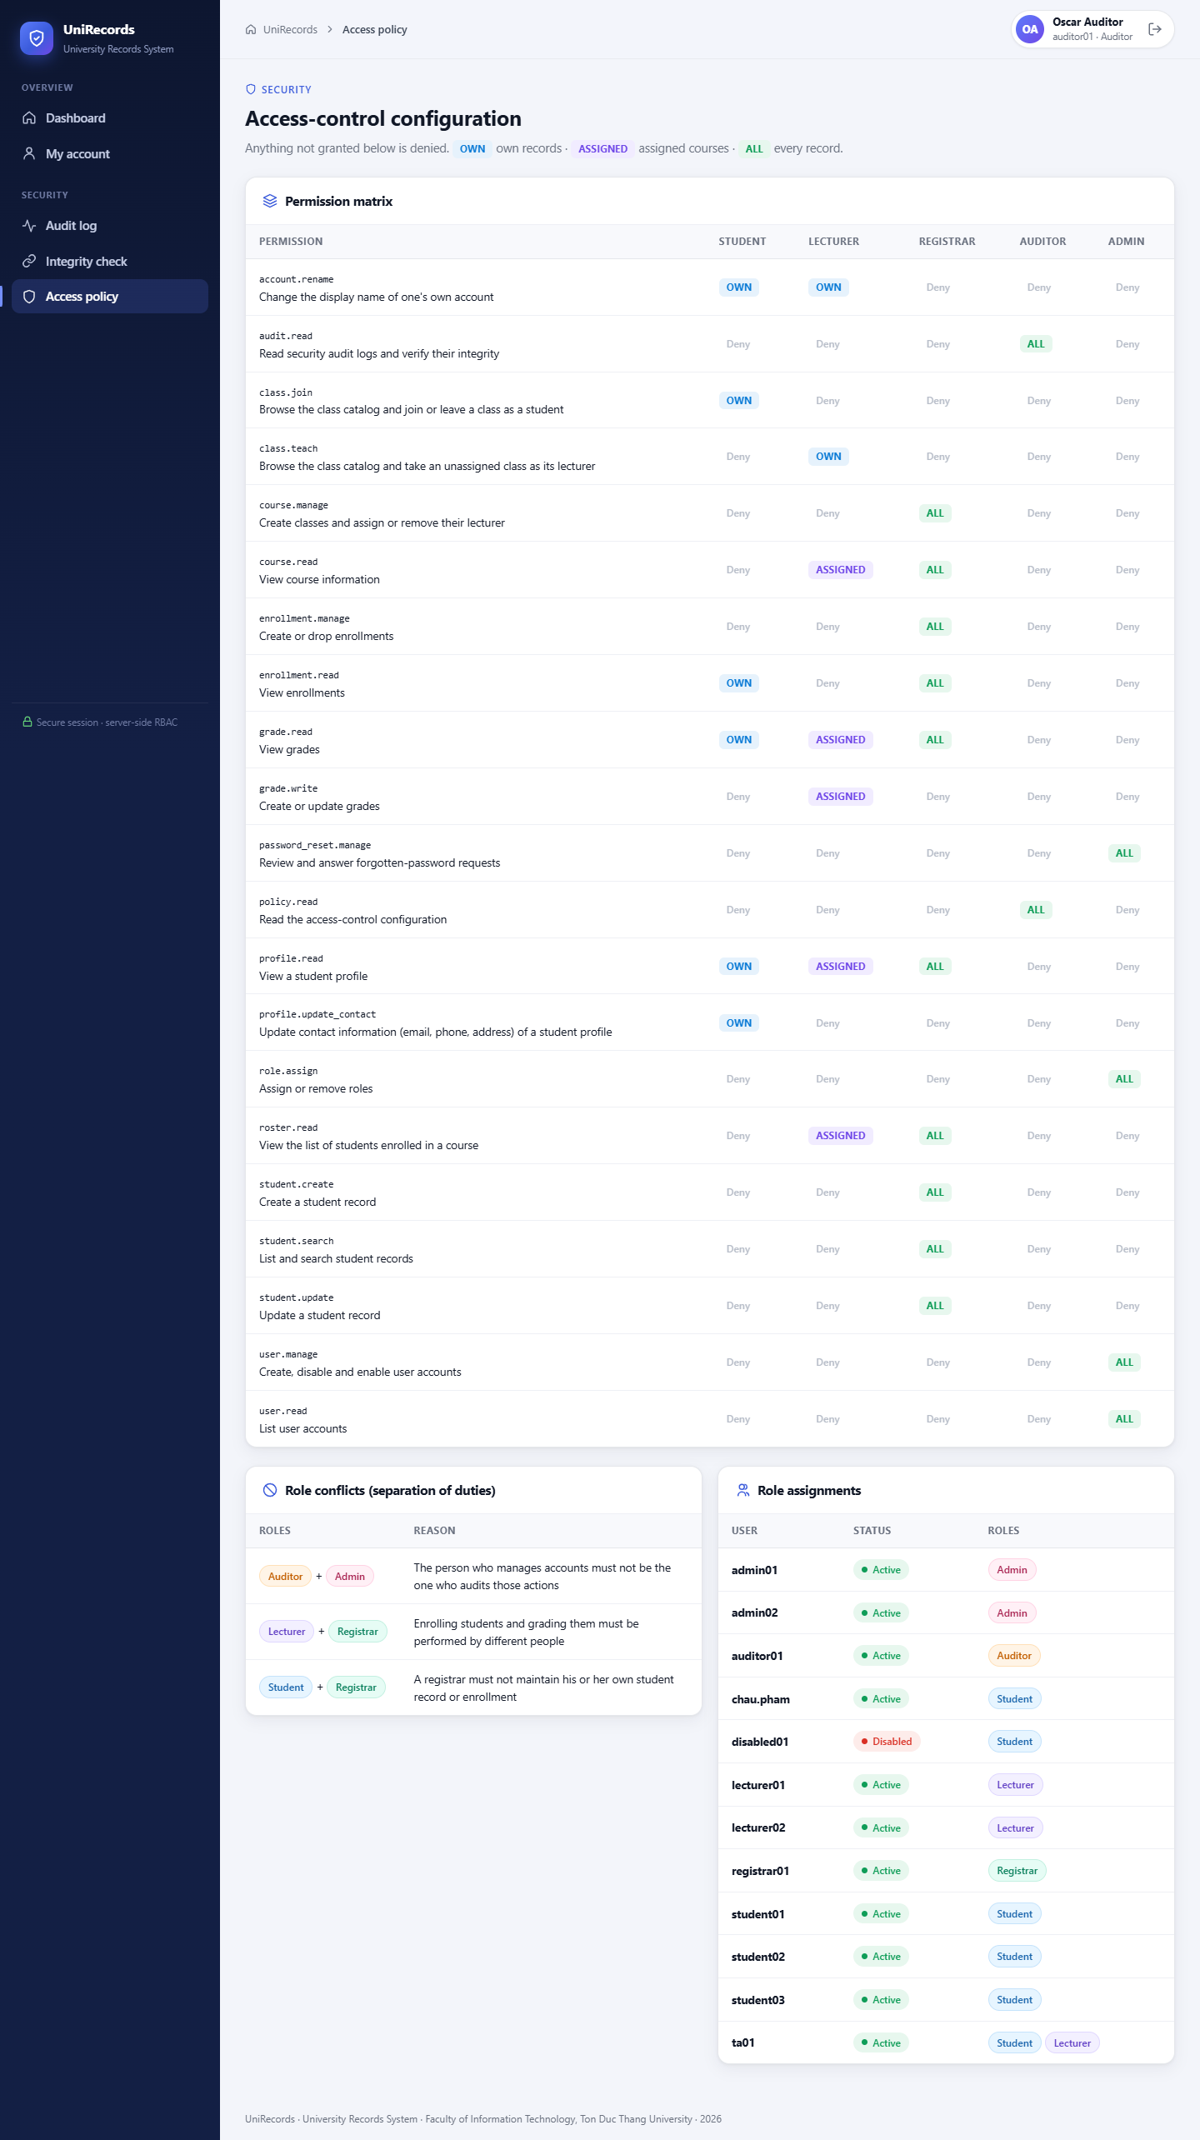
Figure A.51. Read-only view of the access-control configuration (T14).

A.12 Database and Test Evidence
The last two figures show the content of the users table, which holds only Argon2id hashes, and the automatically generated test report.
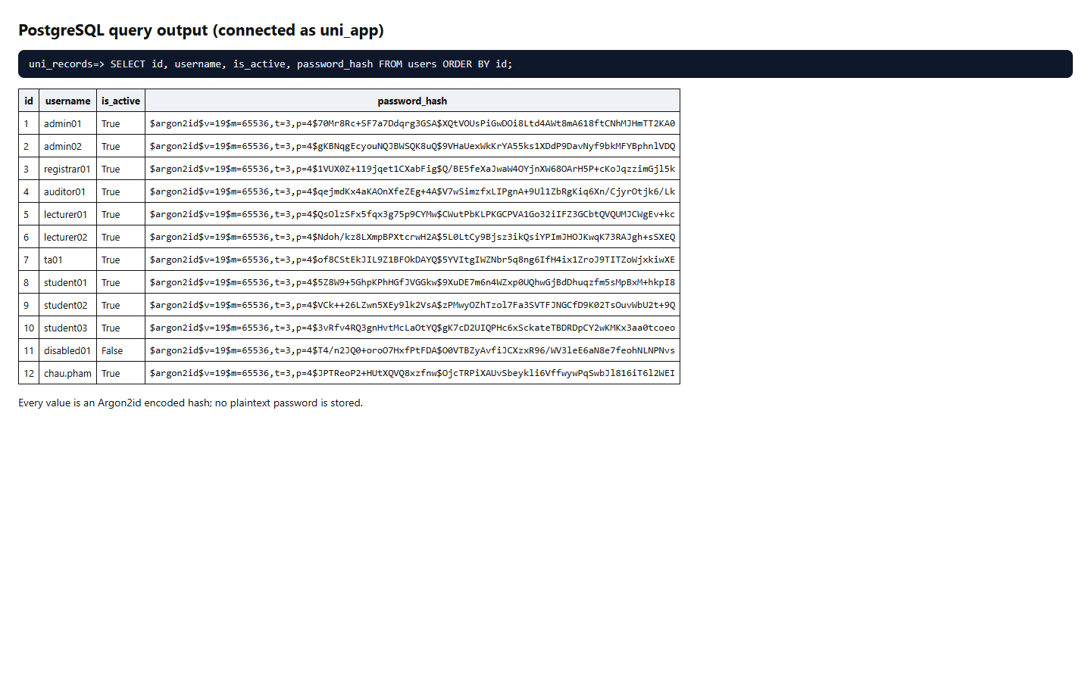
Figure A.52. users.password_hash contains only Argon2id hashes (T05).
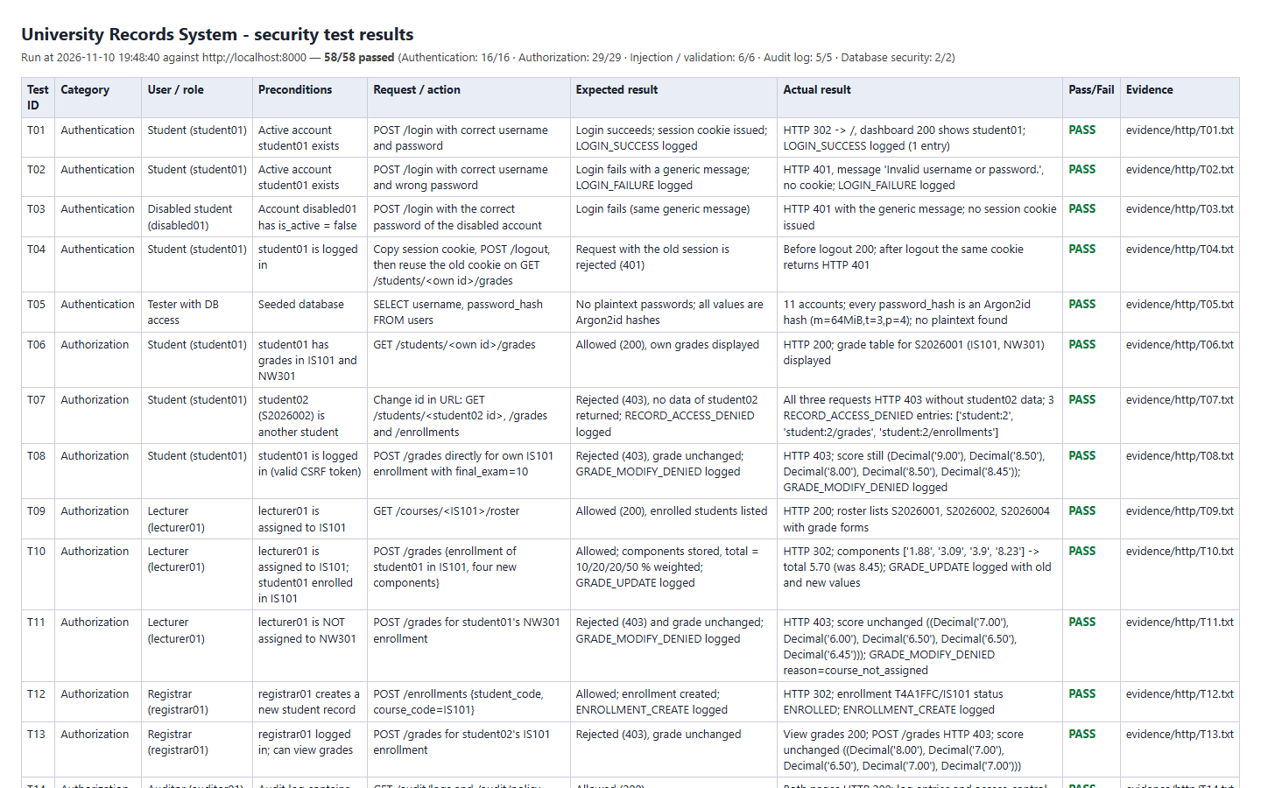
Figure A.53. Automated security test results (pytest) (T01–T58).

APPENDIX B. COMPLETE SECURITY TEST RESULTS
Generated from tests/results/results.json (run at 2026-11-10 20:37:32, 58/58 passed). Reproduce with python -m pytest tests. Raw request and response traces are stored in evidence/http/.
Table B.1. Complete security test results
ID | User / role | Preconditions | Request / action | Expected result | Actual result | Pass/ Fail | Evidence
T01 | Student (student01) | Active account student01 exists | POST /login with correct username and password | Login succeeds; session cookie issued; LOGIN_SUCCESS logged | HTTP 302 -> /, dashboard 200 shows student01; LOGIN_SUCCESS logged (1 entry) | PASS | http/T01.txt
T02 | Student (student01) | Active account student01 exists | POST /login with correct username and wrong password | Login fails with a generic message; LOGIN_FAILURE logged | HTTP 401, message 'Invalid username or password.', no cookie; LOGIN_FAILURE logged | PASS | http/T02.txt
T03 | Disabled student (disabled01) | Account disabled01 has is_active = false | POST /login with the correct password of the disabled account | Login fails (same generic message) | HTTP 401 with the generic message; no session cookie issued | PASS | http/T03.txt
T04 | Student (student01) | student01 is logged in | Copy session cookie, POST /logout, then reuse the old cookie on GET /students/<own id>/grades | Request with the old session is rejected (401) | Before logout 200; after logout the same cookie returns HTTP 401 | PASS | http/T04.txt
T05 | Tester with DB access | Seeded database | SELECT username, password_hash FROM users | No plaintext passwords; all values are Argon2id hashes | 11 accounts; every password_hash is an Argon2id hash (m=64MiB,t=3,p=4); no plaintext found | PASS | http/T05.txt
T06 | Student (student01) | student01 has grades in IS101 and NW301 | GET /students/<own id>/grades | Allowed (200), own grades displayed | HTTP 200; grade table for S2026001 (IS101, NW301) displayed | PASS | http/T06.txt
T07 | Student (student01) | student02 (S2026002) is another student | Change id in URL: GET /students/<student02 id>, /grades and /enrollments | Rejected (403), no data of student02 returned; RECORD_ACCESS_DENIED logged | All three requests HTTP 403 without student02 data; 3 RECORD_ACCESS_DENIED entries: ['student:2', 'student:2/grades', 'student:2/enrollments'] | PASS | http/T07.txt
T08 | Student (student01) | student01 is logged in (valid CSRF token) | POST /grades directly for own IS101 enrollment with final_exam=10 | Rejected (403), grade unchanged; GRADE_MODIFY_DENIED logged | HTTP 403; score still (Decimal('9.00'), Decimal('8.50'), Decimal('8.00'), Decimal('8.50'), Decimal('8.45')); GRADE_MODIFY_DENIED logged | PASS | http/T08.txt
T09 | Lecturer (lecturer01) | lecturer01 is assigned to IS101 | GET /courses/<IS101>/roster | Allowed (200), enrolled students listed | HTTP 200; roster lists S2026001, S2026002, S2026004 with grade forms | PASS | http/T09.txt
T10 | Lecturer (lecturer01) | lecturer01 is assigned to IS101; student01 enrolled in IS101 | POST /grades {enrollment of student01 in IS101, four new components} | Allowed; components stored, total = 10/20/20/50 % weighted; GRADE_UPDATE logged | HTTP 302; components ['9.52', '2.69', '0.86', '3.12'] -> total 3.22 (was 8.45); GRADE_UPDATE logged with old and new values | PASS | http/T10.txt
T11 | Lecturer (lecturer01) | lecturer01 is NOT assigned to NW301 | POST /grades for student01's NW301 enrollment | Rejected (403) and grade unchanged; GRADE_MODIFY_DENIED logged | HTTP 403; score unchanged ((Decimal('7.00'), Decimal('6.00'), Decimal('6.50'), Decimal('6.50'), Decimal('6.45'))); GRADE_MODIFY_DENIED reason=course_not_assigned | PASS | http/T11.txt
T12 | Registrar (registrar01) | registrar01 creates a new student record | POST /enrollments {student_code, course_code=IS101} | Allowed; enrollment created; ENROLLMENT_CREATE logged | HTTP 302; enrollment T275584/IS101 status ENROLLED; ENROLLMENT_CREATE logged | PASS | http/T12.txt
T13 | Registrar (registrar01) | registrar01 logged in; can view grades | POST /grades for student02's IS101 enrollment | Rejected (403), grade unchanged | View grades 200; POST /grades HTTP 403; score unchanged ((Decimal('8.00'), Decimal('7.00'), Decimal('6.50'), Decimal('7.00'), Decimal('7.00'))) | PASS | http/T13.txt
T14 | Auditor (auditor01) | Audit log contains entries | GET /audit/logs and /audit/policy | Allowed (200) | Both pages HTTP 200; log entries and access-control matrix displayed | PASS | http/T14.txt
T15 | Auditor (auditor01) | Student S2026003 exists | POST /students/<id> (update record) and POST /students/<id>/contact | Rejected (403); record unchanged | Both requests HTTP 403; student row identical before and after | PASS | http/T15.txt
T16 | Admin (admin01) | admin01 creates a fresh account without roles | POST /admin/users/<id>/roles {role=AUDITOR, action=assign} | Allowed; role assigned; ROLE_ASSIGN logged | HTTP 302; roleba462c now has AUDITOR; ROLE_ASSIGN logged by admin01 | PASS | http/T16.txt
T17 | Admin (admin01) | admin01 has only the ADMIN role | GET /students/<id>/grades, /courses/<id>/roster, /students | Rejected (403) | All three requests HTTP 403; no grade data returned | PASS | http/T17.txt
T18 | Anonymous | Application running | POST /login with SQL-injection strings in username and password | No unauthorized access or database error (401 generic message); users table intact | 4 payloads: all HTTP 401 with the generic message, no session, no SQL error text; users table intact | PASS | http/T18.txt
T19 | Student (student01) + Registrar | student01 logged in | Store <script>alert('xss')</script> in own address; view profile as student and registrar | Value stored but rendered HTML-escaped; CSP forbids inline script; script does not execute | Payload stored verbatim in DB but output as &lt;script&gt;... for both viewers; CSP script-src 'self' present; no executable script in the page | PASS | http/T19.txt
T20 | Registrar (registrar01) + Auditor (auditor01) | registrar01 logged in | Registrar attempts POST /grades; auditor opens /audit/logs?result=DENIED | Rejection appears in audit log with timestamp, actor, event, target, result DENIED | Entry #83 2026-11-10 13:34:03 registrar01 GRADE_MODIFY_DENIED /grades DENIED {'method': 'POST', 'required_permission': 'grade.write'}; visible to auditor | PASS | http/T20.txt
T21 | Anonymous | Username 'nosuchuser' does not exist | POST /login with unknown username, compare with wrong-password response | Identical status and message (no username enumeration) | Both return HTTP 401 with the same generic message | PASS | http/T21.txt
T22 | Admin (admin01) + new user | admin01 creates a fresh account | 5 wrong passwords, then the correct password | Account locked: correct password rejected; ACCOUNT_LOCKED logged | After 5 failures the correct password returns 401 (generic message); locked_until set; ACCOUNT_LOCKED logged | PASS | http/T22.txt
T23 | Student (student01) | None | Inspect Set-Cookie of a successful login and the sessions table | Cookie is HttpOnly and SameSite=Strict; DB stores only a SHA-256 hash of the token | Set-Cookie has HttpOnly; SameSite=Strict; raw token absent from DB, only its SHA-256 hash is stored | PASS | http/T23.txt
T24 | Student (student01) | Attacker plants a known session cookie in the victim browser | Set cookie to attacker value, then log in | Server issues a new random token (no session fixation) | A new token was issued; the planted value is not a valid session (401) | PASS | http/T24.txt
T25 | Admin (admin01) + new user | New user is logged in | admin01 disables the account while its session is active; user sends a request | Existing session is invalidated immediately (401); USER_DISABLE logged | Session valid before (200); after disabling, the same session gets 401; USER_DISABLE logged | PASS | http/T25.txt
T26 | Lecturer (lecturer01) | lecturer01 is not assigned to NW301 | GET /courses/<NW301>/roster and /students/<id of student only in NW301 & DB201> | Roster rejected (403); profile of a student taught in DB201 allowed | NW301 roster 403; S2026003 profile 200 and only DB201 grade visible (NW301 grade hidden) | PASS | http/T26.txt
T27 | Student+Lecturer (ta01) | ta01 is the lecturer of SE202 and also enrolled in SE202 | POST /grades for own SE202 enrollment, then for student03's SE202 enrollment | Self-grading rejected (403, unchanged); grading another student allowed | Own grade: 403, unchanged (None), reason=self_grading; other student: 302, score set to 4.89 | PASS | http/T27.txt
T28 | Student+Lecturer (ta01) | ta01 holds STUDENT and LECTURER roles | GET own grades, SE202 roster (assigned), DB201 roster (not assigned) | Union of role permissions: own grades 200, SE202 200, DB201 403 | 200 / 200 / 403 as expected (permissions are the union, scopes still enforced) | PASS | http/T28.txt
T29 | Admin (admin01) | admin01 holds ADMIN | POST /admin/users/<own id>/roles {role=REGISTRAR, action=assign} | Rejected (403): administrators cannot change their own roles | HTTP 403; admin01 still has only ADMIN; ROLE_ASSIGN_DENIED logged | PASS | http/T29.txt
T30 | Admin (admin01) | admin02 holds ADMIN; ADMIN/AUDITOR is a declared role conflict | POST /admin/users/<admin02>/roles {role=AUDITOR, action=assign} | Rejected (403) - separation of duties; role not added | HTTP 403; ROLE_ASSIGN_DENIED {'role': 'AUDITOR', 'reason': 'role_conflict', 'conflicts_with': 'ADMIN'} | PASS | http/T30.txt
T31 | Student (student01) | student02 has contact data | POST /students/<student02 id>/contact {email=attacker} | Rejected (403); student02 contact unchanged | HTTP 403; contact of S2026002 unchanged | PASS | http/T31.txt
T32 | Lecturer (lecturer01) | lecturer01 logged in | POST /grades for an assigned course WITHOUT the CSRF token | Rejected (403), unchanged; CSRF_REJECTED logged | HTTP 403; score unchanged ((Decimal('8.00'), Decimal('7.00'), Decimal('6.50'), Decimal('7.00'), Decimal('7.00'))); CSRF_REJECTED logged | PASS | http/T32.txt
T33 | Anonymous | No session | GET /students/1/grades, /audit/logs, /admin/users; POST /grades | Rejected (401) for every request | All four requests HTTP 401 | PASS | http/T33.txt
T34 | Admin (admin01) | admin01 has only the ADMIN role | GET /audit/logs and /audit/policy | Rejected (403): the administrator does not audit himself/herself | Both HTTP 403 | PASS | http/T34.txt
T35 | Registrar (registrar01) | registrar01 logged in | GET /students?q=<SQL-injection payloads> (OR 1=1, UNION SELECT password_hash, quotes) | Payload treated as literal text: no extra rows, no hashes, no database error | All payloads HTTP 200 with 'No matching students.', no hashes or SQL errors; a normal search still works | PASS | http/T35.txt
T36 | Lecturer (lecturer01) | lecturer01 assigned to IS101 | POST /grades with a component = 11, -1, abc, 8.555, NaN, 1e1, 10.01, all components empty, and enrollment_id = 1 OR 1=1 | Each rejected with 400 by server-side validation; grade unchanged | All 9 invalid inputs HTTP 400; score unchanged ((Decimal('8.00'), Decimal('7.00'), Decimal('6.50'), Decimal('7.00'), Decimal('7.00'))) | PASS | http/T36.txt
T37 | Registrar / Anonymous | Application running | Trigger errors: unknown URL, non-integer id, wrong method, oversized body, overlong search | Generic error pages; no stack trace, SQL or configuration disclosed | 404/404/404/405/413/400 with generic messages; no stack trace, SQL or config | PASS | http/T37.txt
T38 | Student (student01) | student01 logged in | POST own contact with invalid email, invalid phone, control characters, 250-char address | Rejected with 400; record unchanged | All 5 invalid inputs HTTP 400 with validation messages; record unchanged | PASS | http/T38.txt
T39 | Application DB account and DBA | Audit log contains entries | UPDATE/DELETE/TRUNCATE audit_logs as uni_app, then UPDATE/DELETE as the DBA | uni_app: permission denied; DBA: blocked by append-only trigger; log unchanged | All 6 attempts raised errors (uni_app: 42501 permission denied; DBA: 42501 'audit_logs is append-only'); no row changed | PASS | http/T39.txt
T40 | Tester with DB access | Previous tests performed logins, logouts and password-bearing requests | Search every audit entry for demo passwords, session tokens and secret keys | No password, session token or DB credential appears in the log | Scanned 85 entries: no demo password, current session token, DB password, password hash or secret key name found | PASS | http/T40.txt
T41 | Tester with DB access | Full test suite has exercised all sensitive operations | Check that every required event type exists and each entry has all mandatory fields | All required event types present; timestamp, actor, event, target, result filled | All 11 required event types present; no entry lacks timestamp/actor/event/target/result | PASS | http/T41.txt
T42 | Auditor (auditor01) and DBA | Audit log contains entries | Verify hash chain via /audit/verify; then, as DBA inside a rolled-back transaction, disable the trigger, alter one entry and re-verify | Intact chain verified; the tampered entry is detected; rollback leaves log intact | Intact chain verified; tampering with entry #4 detected (first_bad_id=4); after rollback chain intact again | PASS | http/T42.txt
T43 | Application DB account (uni_app) | Grade of S2026002 in IS101 exists | Bypass the web layer: UPDATE grades.final_exam directly as uni_app with updated_by = registrar01 and = lecturer02 (not assigned) | grades_guard trigger rejects both (42501); score unchanged | Both direct updates rejected by the trigger (updated_by=registrar01: grade_guard: writer is not an assigned lecturer; updated_by=lecturer02: grade_guard: writer is not an assigned lecturer); score unchanged ((Decimal('8.00'), Decimal('7.00'), Decimal('6.50'), Decimal('7.00'), Decimal('7.00'))) | PASS | http/T43.txt
T44 | Application DB account (uni_app) | Application connects as uni_app | As uni_app: DELETE grades/students, UPDATE role_permissions, change username, CREATE TABLE, read pg_authid; inspect role attributes | All denied (insufficient privilege); uni_app is not superuser and owns no table | All 8 statements rejected with 42501 (insufficient privilege); uni_app: no superuser/createrole/createdb/bypassrls, owns 0 tables | PASS | http/T44.txt
T45 | Anonymous → new student | Username does not exist | POST /register with valid data plus forged fields role=ADMIN and is_admin=1; log in | Account created with exactly the STUDENT role and a NEW student profile; forged fields ignored; USER_REGISTER logged | HTTP 302; roles = ['STUDENT']; new profile S2026008; login works; /admin/users 403; USER_REGISTER logged | PASS | http/T45.txt
T46 | Anonymous | student01 already exists | POST /register with: short password, mismatching confirmation, password containing the username, existing username, invalid username | Each rejected with 400; no account created | All 5 invalid registrations HTTP 400 with a validation message; user count unchanged | PASS | http/T46.txt
T47 | Lecturer (lecturer01) + Student (student02) | student02 enrolled in DB201 (lecturer01) | Lecturer saves 4 components; then only 3 components; student02 opens own grades page | Total = 10/20/20/50 % weighted (computed by DB); total empty while a component is missing; student sees all components, totals and overall average | Total 8.13 = 0.1×8 + 0.2×7.5 + 0.2×6 + 0.5×9.25; total NULL with a missing component; student page shows components, total and overall average | PASS | http/T47.txt
T48 | Registrar / Admin / Lecturer / Student | None | POST /courses (create class) as registrar01 (capacity 30 and 31, duplicate code) and as admin01, lecturer01, student01 | Registrar: created + COURSE_CREATE logged; capacity 31 and duplicate code → 400; others → 403 | TFL3078 created (capacity 30, logged); capacity 31 and duplicate code 400; admin01 / lecturer01 / student01 403 | PASS | http/T48.txt
T49 | Registrar + Lecturers + DB account | Registrar creates a class taught by lecturer01 | lecturer02 tries to take the class; direct INSERT of a 2nd lecturer as uni_app; registrar replaces the lecturer | Take-over 403; DB rejects 2nd lecturer (unique violation); replacement leaves exactly 1 lecturer | Take-over 403; direct INSERT 23505 (unique course_id); after replacement the class has exactly one lecturer (lecturer02) | PASS | http/T49.txt
T50 | Registrar + DB account | Registrar creates a class with capacity 2 | Enroll 3 students through the UI; then INSERT a 3rd enrollment directly as uni_app | Third enrollment rejected (400) by the app and (23514) by the capacity trigger; 2 students remain | UI: 302, 302, 400 (class full); direct INSERT 23514 'class is full (capacity 2)'; 2 active students | PASS | http/T50.txt
T51 | Student (self-registered) + student01 | Open class with free seats; student01 has grades in IS101 | New student joins a class, joins again, leaves; student01 tries to leave graded IS101 | Join 302 (ENROLLED, CLASS_JOIN logged); duplicate join 400; leave 302 (DROPPED); leaving a graded class 400 | Join 302 → ENROLLED (logged); second join 400; leave 302; leaving graded IS101 400 | PASS | http/T51.txt
T52 | Lecturer (lecturer02) + Student (student01) | Registrar creates a class without a lecturer | student01 POSTs /classes/<id>/teach and /courses/<id>/lecturer; lecturer02 takes the class and opens the roster | Student requests 403; lecturer02 becomes the only lecturer (COURSE_LECTURER_ASSIGN) and can open the roster | Student 403 / 403; lecturer02 assigned (only lecturer); roster 200 | PASS | http/T52.txt
T53 | Student, Lecturer, Registrar, Auditor, Admin (fresh accounts) | admin01 creates one account per role | Each user POSTs /account/password with a wrong current password, then with the correct one; old password and an older second session are tested | Wrong current password 400 (PASSWORD_CHANGE_FAILURE); change 302 for every role; old password rejected, new accepted; other sessions revoked | All roles ['STUDENT', 'LECTURER', 'REGISTRAR', 'AUDITOR', 'ADMIN']: wrong current 400, change 302, other session 401, old password 401, new password 302; PASSWORD_CHANGE(_FAILURE) logged | PASS | http/T53.txt
T54 | Student, Lecturer vs Registrar, Auditor, Admin | Seed accounts | POST /account/name as each role | Student and lecturer: 302, name changed (student record too); registrar, auditor, admin: 403, unchanged | {'student03': (302, True), 'lecturer02': (302, True), 'registrar01': (403, False), 'auditor01': (403, False), 'admin01': (403, False)} (status, changed); student record name follows the account name | PASS | http/T54.txt
T55 | Anonymous | student02 exists; 'ghostuser' does not | POST /forgot-password for an existing and a non-existing username | Identical response with a reference code (no enumeration); request stored without any password; account unchanged | Both 200 with identical text apart from the code; table has no password column; only the SHA-256 of the code is stored; password unchanged | PASS | http/T55.txt
T56 | Anonymous requester + Admin (admin01) | Fresh student account files a request | Admin approves with a reply; requester checks status, reveals the temporary password twice, logs in, opens another page, changes the password | Reveal works once (2nd → 403); temp login forced to /account; other pages redirect until changed; temp password never stored or logged in plaintext | Approve 302; status shows reply; reveal 200 once, then 403; temp login → /account, other pages 302 until changed, then 200; temp password and code absent from DB and audit log | PASS | http/T56.txt
T57 | Student, Registrar, Auditor vs Admin | At least one pending request | Non-admins GET /admin/password-requests and POST an approval; admin opens the list and approves own request | Non-admins 403; admin list shows requests but no password or hash; approving own request 403 | student01/registrar01/auditor01 403 (list and approve); admin list 200 without hashes or passwords; own request 403; request still PENDING | PASS | http/T57.txt
T58 | Anonymous + Admin | Requests exist | Status with a wrong code; reject flow; reveal after rejection; expired temporary password | Wrong code 404 without details; rejected request shows the reply and cannot be revealed (403); expired temporary password cannot log in | Wrong code 404; rejected request shows reply, reveal 403; expired temporary password 401 (generic message) | PASS | http/T58.txt

APPENDIX C. REQUIREMENTS TRACEABILITY AND DEMO ACCOUNTS
Table C.1. Security requirements, threats and verifying tests
ID | Security requirement | Threats | Verified by
SR1 | Username/password login; passwords stored only as Argon2id hashes. | TH1, TH9 | T01, T05
SR2 | Generic login errors; no account enumeration; disabled accounts cannot log in. | TH1 | T02, T03, T21
SR3 | Repeated failed logins lock the account temporarily. | TH1 | T22
SR4 | Random server-side sessions, HttpOnly/SameSite cookies, renewed at login, invalid after logout or disabling. | TH2 | T04, T23, T24, T25
SR5 | Every endpoint denied unless explicitly permitted; checked on the server. | TH3, TH7 | T08, T13, T15, T17, T33, T34
SR6 | Records accessible only to the owner, the assigned lecturer or the registrar. | TH4 | T06, T07, T09, T26, T31
SR7 | Grade components written only by the assigned lecturer, never for their own enrollment; total computed by the DB; enforced in the DB too. | TH7 | T10, T11, T27, T43, T47
SR8 | Role changes only by administrators, not on themselves, no conflicting combinations. | TH3 | T16, T28, T29, T30
SR9 | Parameterized SQL, server-side validation, output encoding. | TH5, TH6 | T18, T19, T35, T36, T38
SR10 | State-changing requests require an anti-CSRF token. | TH10 | T32
SR11 | Sensitive actions and rejections in an append-only, tamper-evident log without secrets. | TH8, TH9 | T20, T39, T40, T41, T42
SR12 | No stack trace, SQL or configuration in errors; least-privilege DB account; no secrets in the repository. | TH5, TH9 | T37, T44
SR13 | Self-registration creates only STUDENT accounts with a new profile and validates input. | TH11 | T45, T46
SR14 | Classes are created only by the registrar; one lecturer and at most 30 students per class; self-service limited to oneself. | TH11, TH3 | T48, T49, T50, T51, T52
SR15 | Every user can change their password (current password, policy, other sessions revoked); only students and lecturers can rename. | TH1, TH2 | T53, T54
SR16 | Password reset: uniform request response, secret code, admin approval, one-time 24 h temporary password visible only to the requester, forced change; no stored or admin-visible passwords. | TH12 | T55, T56, T57, T58

Table C.2. Demo accounts (password of every account: <username>@Demo2026)
Username | Role(s) | Notes
admin01, admin02 | ADMIN | Two administrators (dual control for role changes)
registrar01 | REGISTRAR
auditor01 | AUDITOR
lecturer01 | LECTURER | Assigned IS101, DB201
lecturer02 | LECTURER | Assigned NW301 (AI305 has no lecturer yet)
ta01 | STUDENT + LECTURER | Student S2026004 (IS101, NW301, SE202); lecturer of SE202
student01, student02, student03 | STUDENT | S2026001, S2026002, S2026003
disabled01 | STUDENT | Disabled account (S2026005)

REFERENCES
[1] OWASP Foundation, "OWASP Top 10:2021," 2021. [Online]. Available: https://owasp.org/Top10/
[2] OWASP Foundation, "Authorization Cheat Sheet," OWASP Cheat Sheet Series, 2024.
[3] OWASP Foundation, "Password Storage Cheat Sheet" and "Session Management Cheat Sheet," OWASP Cheat Sheet Series, 2024.
[4] OWASP Foundation, "Cross-Site Request Forgery Prevention Cheat Sheet," OWASP Cheat Sheet Series, 2024.
[5] A. Biryukov, D. Dinu, D. Khovratovich and S. Josefsson, "Argon2 Memory-Hard Function for Password Hashing and Proof-of-Work Applications," RFC 9106, IETF, Sep. 2021.
[6] P. Grassi et al., "Digital Identity Guidelines: Authentication and Lifecycle Management," NIST SP 800-63B, 2017 (updated 2020).
[7] D. F. Ferraiolo, R. Sandhu, S. Gavrila, D. R. Kuhn and R. Chandramouli, "Proposed NIST Standard for Role-Based Access Control," ACM Trans. Inf. Syst. Secur., vol. 4, no. 3, pp. 224–274, 2001.
[8] The PostgreSQL Global Development Group, "PostgreSQL 16 Documentation: Privileges, Triggers and Client Authentication," 2023.
[9] W3C, "Content Security Policy Level 3," W3C Working Draft, 2024.
[10] W3C, "Media Queries Level 5: prefers-reduced-motion," W3C Working Draft, 2023.
[11] Pallets Projects, "Flask 3.1 Documentation – Security Considerations," 2024.

