VIETNAM GENERAL CONFEDERATION OF LABOR
TON DUC THANG UNIVERSITY
FACULTY OF INFORMATION TECHNOLOGY


NGUYEN THANH TUNG – 523H0192
DUONG TRAN QUOC KHANH – 523H0040
NGUYEN NAM PHONG – 523H0168

TECHHAVEN: AN E-COMMERCE WEBSITE
FOR COMPUTERS AND COMPUTER
COMPONENTS BUILT WITH NODE.JS
FINAL PROJECT REPORT
WEB PROGRAMMING WITH NODE.JS

HO CHI MINH CITY, 2026

VIETNAM GENERAL CONFEDERATION OF LABOR
TON DUC THANG UNIVERSITY
FACULTY OF INFORMATION TECHNOLOGY

NGUYEN THANH TUNG – 523H0192
DUONG TRAN QUOC KHANH – 523H0040
NGUYEN NAM PHONG – 523H0168

TECHHAVEN: AN E-COMMERCE WEBSITE
FOR COMPUTERS AND COMPUTER
COMPONENTS BUILT WITH NODE.JS
FINAL PROJECT REPORT
WEB PROGRAMMING WITH NODE.JS
Advised by
Lecturer Duong Huu Phuoc

HO CHI MINH CITY, 2026

ACKNOWLEDGEMENT
We would like to express our sincere gratitude to our lecturer, Duong Huu Phuoc, for the guidance given throughout the final project of the Web Programming with Node.js course. The lectures and the detailed project description showed us how to turn a list of requirements into a working, deployable web application, and the emphasis on quality pushed us to care about validation, concurrency and deployment rather than only about pages that look right.
We would also like to thank the Faculty of Information Technology, Ton Duc Thang University, for providing a supportive learning environment and equipping us with the foundational knowledge necessary to complete this project.
Due to limitations in time and knowledge, this report may inevitably contain certain shortcomings. We sincerely welcome any comments and suggestions from our lecturer to further improve and refine our work.
Thank you sincerely.
Ho Chi Minh City, November 2026
Authors
(Signature and full name)
Nguyen Thanh Tung | Duong Tran Quoc Khanh | Nguyen Nam Phong

DECLARATION OF AUTHORSHIP
We hereby declare that this report and the accompanying source code are our own work, prepared under the guidance of our lecturer, Duong Huu Phuoc. The system design, implementation, test results and screenshots presented in this report were produced by our group, and all test results were obtained by actually running the tests against the implemented system. The demo data were generated by our seed script. All external sources are cited in the references.
In the event of any violation or misconduct, we accept full responsibility for the content of this report. Ton Duc Thang University shall not be held responsible for any intellectual property or copyright infringement committed by the team during the preparation of this report, if any.
Ho Chi Minh City, November 2026
Authors
(Signature and full name)
Nguyen Thanh Tung | Duong Tran Quoc Khanh | Nguyen Nam Phong

TABLE OF CONTENTS
LIST OF FIGURES vii
LIST OF TABLES x
LIST OF ABBREVIATIONS xi
ABSTRACT xii
CHAPTER 1. INTRODUCTION 1
1.1 Background and Objectives 1
1.2 Scope and Group Organization 1
CHAPTER 2. SYSTEM OVERVIEW 3
CHAPTER 3. REQUIREMENTS ANALYSIS 5
3.1 Actors and Use Cases 5
3.2 Business Rules 5
3.3 Non-Functional Requirements 6
CHAPTER 4. SYSTEM ARCHITECTURE AND DESIGN 8
4.1 Overall Architecture 8
4.2 Asynchronous Communication and Stateless Design 9
4.3 Database Design 10
4.4 API Design 11
4.5 Main Processing Flows 12
CHAPTER 5. IMPLEMENTATION 14
5.1 Accounts and Authentication 14
5.2 Catalogue, Search and Product Images 14
5.3 Cart, Checkout and Loyalty 15
5.4 Real-Time Reviews and Notifications 16
5.5 Administration and Dashboards 16
5.6 Storefront Features Inspired by Live Stores 16
5.7 AI Features 17
5.8 Security Measures 18
CHAPTER 6. DEPLOYMENT, SCALING AND BONUS FEATURES 20
6.1 Docker Compose Deployment 20
6.2 Horizontal Scaling 20
6.3 Bonus Features 21
6.4 Highlights Beyond the Requirements 21
CHAPTER 7. TESTING 24
7.1 Test Plan 24
7.2 Results 24
CHAPTER 8. REMAINING LIMITATIONS AND IMPROVEMENTS 26
CHAPTER 9. CONCLUSION 27
INDIVIDUAL CONTRIBUTION SUMMARY 28
APPENDIX A. SYSTEM DEMONSTRATION 30
A.1 Interface Design 30
A.2 Landing Page and Catalogue 30
A.3 Product Details and Reviews 34
A.4 Cart and Checkout 36
A.5 Accounts, Orders and Shopping Aids 41
A.6 Administrator Console 50
A.7 AI Assistant, E-mail, Responsive Design and Infrastructure 58
APPENDIX B. COMPLETE TEST RESULTS 66
APPENDIX C. REQUIREMENTS TRACEABILITY AND DEMO ACCOUNTS 69
REFERENCES 71

LIST OF FIGURES
Figure 3.1. Use-case diagram of TechHaven 5
Figure 4.1. System architecture 8
Figure 4.2. Asynchronous channels between services 9
Figure 4.3. Entity-relationship diagram 11
Figure 4.4. Checkout sequence 13
Figure 4.5. Order status state machine 13
Figure 6.1. Docker Compose deployment 20
Figure A.1. Landing page 28
Figure A.2. Shop by need and Hot Deals with page numbers 28
Figure A.3. Category section with brand tabs and pagination 29
Figure A.4. Catalogue in grid view 29
Figure A.5. Laptops filtered by brand and price, sorted by price, list view 30
Figure A.6. Products on sale sorted by the biggest discount 30
Figure A.7. ElasticSearch suggestions while typing 31
Figure A.8. Product page with a 10-image gallery and variants 31
Figure A.9. Full-screen image viewer 32
Figure A.10. Original price, discount badge and five-line overview 32
Figure A.11. Ratings, AI sentiment summary and labelled comments 33
Figure A.12. A comment from another browser appears instantly (WebSocket) 33
Figure A.13. Mini-cart after "Add to cart" 34
Figure A.14. Cart with a valid discount code 34
Figure A.15. Checkout step 1 - shipping (guest) 35
Figure A.16. Checkout step 2 - payment 35
Figure A.17. Checkout step 3 - review and confirm 36
Figure A.18. Saved addresses with the default pre-selected 36
Figure A.19. Spending loyalty points 37
Figure A.20. Order success screen after a guest checkout 38
Figure A.21. Registration with e-mail, full name and address 39
Figure A.22. Sign-in page 39
Figure A.23. Password recovery 40
Figure A.24. Profile, password and addresses 41
Figure A.25. Order history 42
Figure A.26. Order details with status history 43
Figure A.27. Tracking an order without signing in 44
Figure A.28. Products selected for comparison 45
Figure A.29. Comparison of three laptops 46
Figure A.30. Wish list 47
Figure A.31. Image manager with 4 of 10 images 48
Figure A.32. Product form with 10 of 10 images; the 11th file is skipped 49
Figure A.33. Variants with selling price, original price, cost and stock 49
Figure A.34. Product management 50
Figure A.35. Category management 50
Figure A.36. Simple dashboard 51
Figure A.37. Actionable insights on the simple dashboard 51
Figure A.38. Advanced dashboard - yearly view (default) 52
Figure A.39. Advanced dashboard - custom range grouped by week 53
Figure A.40. Order list, newest first, 20 per page 53
Figure A.41. Order details and status update 54
Figure A.42. User management 54
Figure A.43. Discount codes with usage and orders 55
Figure A.44. AI assistant (Gemini): gaming laptops under 30 million VND and a follow-up question (Vietnamese) 56
Figure A.45. AI assistant (Gemini): a specific graphics card (English) 56
Figure A.46. Mailpit inbox with the e-mails sent by the shop 57
Figure A.47. Order confirmation e-mail 57
Figure A.48. Landing page on a phone 58
Figure A.49. Product page on a phone 59
Figure A.50. Cart on a phone 60
Figure A.51. Catalogue on a tablet 61
Figure A.52. Durable queues in RabbitMQ 62

LIST OF TABLES
Table 2.1. Technologies used 4
Table 3.1. Business rules 6
Table 4.1. Services 8
Table 4.2. Asynchronous messages 9
Table 4.3. Main tables and constraints 11
Table 4.4. Main REST endpoints (prefix /api) 12
Table 5.1. Features observed on live stores and their implementation 17
Table 5.2. Security measures 18
Table 6.1. Distribution of 100 concurrent requests over 5 API replicas 21
Table 6.2. Features that exceed the project description 21
Table 7.1. Test results by category 22
Table 8.1. Remaining limitations 24
Table 9.1. Individual contribution summary 26
Table B.1. Complete test results 63
Table C.1. Rubric items, implementation and verification 66
Table C.2. Demo accounts and test data 67

LIST OF ABBREVIATIONS
Abbreviation | Meaning
AI | Artificial Intelligence
API | Application Programming Interface
CI/CD | Continuous Integration / Continuous Delivery
COD | Cash on Delivery
CRUD | Create, Read, Update, Delete
CSRF | Cross-Site Request Forgery
ERD | Entity-Relationship Diagram
JWT | JSON Web Token
LLM | Large Language Model
OAuth | Open Authorization
REST | Representational State Transfer
SEO | Search Engine Optimisation
SKU | Stock Keeping Unit
SMTP | Simple Mail Transfer Protocol
SPA | Single-Page Application
SQL | Structured Query Language
UI / UX | User Interface / User Experience
VAT | Value-Added Tax
VND (₫) | Vietnamese Dong
WS | WebSocket
E## / U## | End-to-end / unit test identifiers used in this report

ABSTRACT
This report documents the design, implementation and testing of TechHaven, an e-commerce website that sells only computers and computer components. The back end is written in JavaScript on Node.js with Express 5, the front end is a React single-page application with Bootstrap 5, and PostgreSQL stores the business data. The site implements every customer feature of the assignment - a landing page with New Products, Best Sellers and category sections, a paginated catalogue with sorting, filtering and keyword search, product pages with variants that each track their own stock, comments and star ratings updated in real time over WebSockets, a cart that updates without reloading, a three-step checkout that also works for guests, 5-character discount codes limited to 10 uses, a 10% loyalty programme, order tracking and Google sign-in - and an administration area with a simple and an advanced dashboard and management of products, categories, users, orders and discount codes. Administrators can attach from 1 to 10 illustration images to each product by upload, drag and drop or https link, reorder them and choose the cover. After studying live Vietnamese computer stores, the storefront also offers promotional prices with discount badges, key-specification chips, a wish list, product comparison, recently viewed products, "Buy now", a mini-cart, order tracking without an account, an image viewer, and per-page SEO metadata with a sitemap.
The system follows a microservices architecture designed for horizontal scaling: an Nginx gateway load-balances three stateless API replicas and two realtime replicas, while the mailer, search and assistant services are decoupled through RabbitMQ and Redis publish/subscribe. All four bonus features are implemented: a GitHub Actions CI/CD pipeline, the microservices architecture, ElasticSearch product search, and AI features - a shopping-assistant chatbot that recommends products from the live catalogue in Vietnamese or English with replies written by Google Gemini, and sentiment analysis of product comments. All 15 containers start with docker compose up -d, and every e-mail is delivered to a built-in Mailpit inbox unless Gmail is configured. Twenty-five unit tests, a 66-step end-to-end scenario (including the delivery of the confirmation e-mail), automated browser walkthroughs on desktop, tablet and phone viewports, and scaling and fault-injection experiments all passed. Google sign-in is implemented but requires the deployer's OAuth credentials and could not be tested end to end.
Keywords: Node.js, Express, React, PostgreSQL, e-commerce, microservices, RabbitMQ, ElasticSearch, WebSocket, sentiment analysis, chatbot, Docker Compose, horizontal scaling.

CHAPTER 1. INTRODUCTION

1.1 Background and Objectives
Computers and computer components are expensive, come in many configurations and are compared carefully before purchase, so an online store for them must present variants with their own price and stock, help customers narrow down a large catalogue, show trustworthy reviews and make checkout fast - also for visitors who do not want an account. The shop owner, in turn, needs to process orders, control inventory, run promotions and understand sales over time, and the system must cope with traffic peaks by adding servers.
The objective of this project is to build and deploy such a store, TechHaven, as required by the final project of the Web Programming with Node.js course (502070): a back end on a Node.js framework, any front-end framework, every customer and administrator feature of the project description, a responsive interface, a design for horizontal scaling, and deployment with Docker Compose so that the whole system starts with docker compose up -d. The group also targeted all four bonus features: a CI/CD pipeline, a microservices architecture with asynchronous communication, AI-related features, and ElasticSearch for product search. Finally, the storefront was compared with live Vietnamese computer stores (GEARVN, Phong Vu) and the shopping aids customers expect there were added, without adding any administrator feature beyond those the description allows.

1.2 Scope and Group Organization
The scope covers the customer store, the administration area, the supporting services and their deployment. As required, there are two user types: customers and a single administrator. Payment is simulated (cash on delivery, bank transfer and a demo card gateway that never stores card data); every e-mail goes to a built-in Mailpit inbox (http://localhost:8025), or through Gmail SMTP when an account is configured; Google sign-in requires an OAuth client created by the deployer; the AI assistant uses Google Gemini through a free-tier API key supplied by the deployer, and answers with its own rules when no key is configured; the demo catalogue ships with three or four real photos of every product, which the API loads into the database on the first start, so the store shows them without any internet access. The work was organised in modules - API and database, customer pages, administration pages, supporting services and DevOps, and testing; the contribution of each member is summarised in the Individual Contribution Summary.

CHAPTER 2. SYSTEM OVERVIEW
TechHaven is a single-page web application backed by a set of Node.js services. Visitors can browse a landing page with New Products, Best Sellers and five category sections, open a dedicated catalogue with pagination, eight sort orders and filters by brand, price range, rating, stock and category, and search with typo tolerance and suggestions. A product page shows the gallery (1 to 10 images), the variants with their own price and stock, the specifications, and a review section where anyone can comment and signed-in users can rate with stars; new comments and ratings appear on every open page without reloading.
The cart is re-priced by the server on every change and shows the subtotal, the discount, 10% VAT, the shipping fee and the loyalty points to be earned. Checkout has three steps (shipping, payment, review). A guest who checks out gets an account automatically and receives a link to set a password; a signed-in customer has the default address pre-filled, can choose another saved address and can spend loyalty points. After the order the customer sees a success screen and receives a confirmation e-mail, and can later follow the status history of every order.
The administrator works in a separate area with a simple dashboard (users, new users, orders, revenue, best sellers) and an advanced dashboard (yearly by default, or quarterly, monthly, weekly or a custom range, with orders, revenue, profit, products and product types sold). The administrator manages products - variants, inventory and from 1 to 10 illustration images per product - categories, users (view, edit, ban), orders (newest first, 20 per page, period filters, status changes) and discount codes, and nothing else, as the project description requires.
Shopping aids common on live stores complete the experience: promotional prices with the original price struck through and a "-x%" badge, a Hot Deals section, key-specification chips on product cards, brand pills and tags, a wish list, comparison of up to four products, recently viewed products, "Buy now", a mini-cart drawer, order tracking with the order number and e-mail, an image viewer, floating hotline and back-to-top buttons, and an AI shopping assistant. Every product list - including the landing-page sections and related products - has page numbers. Table 2.1 lists the technologies used.
Table 2.1. Technologies used
Layer | Technology | Purpose
Front end | React 18, React Router, Vite, Bootstrap 5, Chart.js, Socket.IO client | Single-page store and admin dashboard, responsive layout, charts, live updates
Back end | Node.js 22, Express 5, pg, bcryptjs, jsonwebtoken, multer | REST API, authentication, validation, image upload
Database | PostgreSQL 16 | Business data, transactions, row locks, uploaded images
Messaging | RabbitMQ 3.13, Redis 7 publish/subscribe | Asynchronous e-mail jobs and domain events; live notifications; rate limits
Search | ElasticSearch 8.15 | Full-text product search, typo tolerance, suggestions
AI | sentiment (AFINN-165) + Vietnamese lexicon, rule-based intent parser, Google Gemini API (@google/genai, gemini-3.5-flash-lite) | Review sentiment analysis; shopping-assistant chatbot
Realtime / mail | Socket.IO 4, Nodemailer, Mailpit | WebSocket push; SMTP delivery to the Mailpit inbox or Gmail
Deployment | Docker, Docker Compose, Nginx 1.27 | Containers, reverse proxy and load balancer
Quality | node --test, end-to-end script, Puppeteer, GitHub Actions | Unit, API and UI tests; continuous integration

CHAPTER 3. REQUIREMENTS ANALYSIS

3.1 Actors and Use Cases
A Guest is any visitor who has not signed in and can browse, search, comment, use the cart and check out. A Customer is signed in, inherits every guest use case, and can also rate products, manage the profile and addresses, follow orders and spend loyalty points. The single Administrator manages the shop (Figure 3.1).
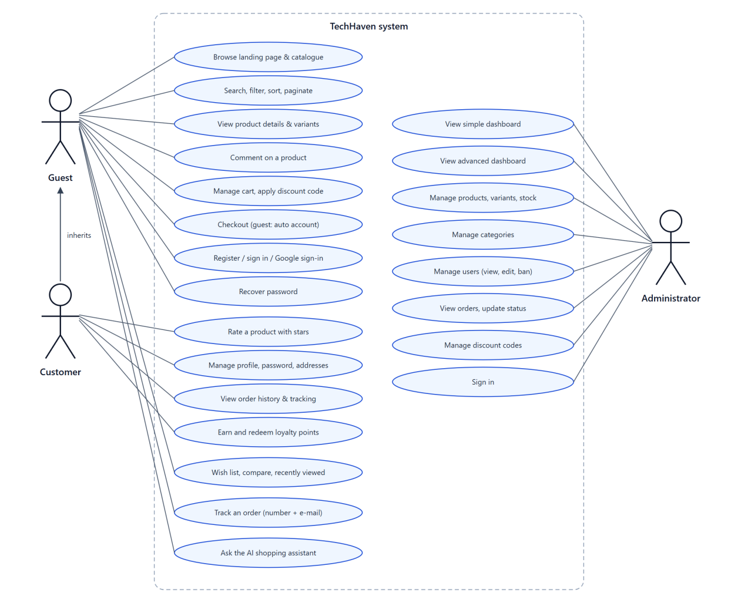
Figure 3.1. Use-case diagram of TechHaven

3.2 Business Rules
The project description fixes several rules precisely. Table 3.1 states them as implemented; the pricing rules live in one module (services/api/src/lib/pricing.js) shared by the cart preview and the checkout, so the two can never disagree.
Table 3.1. Business rules
Rule | Implementation
Registration | Only e-mail, full name and shipping address are entered. The password is chosen afterwards through a one-time link sent by e-mail (valid 72 hours).
Guest checkout | If the e-mail has no account, one is created during checkout with the address and a set-password link is e-mailed; the order appears in the history after sign-in.
Users | Customers and exactly one administrator (partial unique index on users.role).
Variants | Every demo product has at least two variants; each has its own SKU, price, cost and stock.
Product images | From 1 to 10 illustration images per product (PNG, JPG, WEBP or GIF up to 3 MB, or an https link); the first image is the cover.
Product page | Name, price, brand, variants, at least three images and an overview of at least five lines shown next to the price; comments and stars below.
Pagination | Every product list shows page numbers, even with a single page: catalogue, search, landing-page sections, related and recently viewed products, wish list, admin list.
Promotions | A variant may have an original price, which must be higher than the selling price; the discount percentage is computed from both.
Discount codes | Exactly 5 letters or digits, created by the administrator, no expiry, usage limit 1 to 10; effect shown before payment.
Tax and shipping | VAT 10% on the subtotal after discount; shipping 30,000₫, free from 5,000,000₫.
Loyalty points | Earned points = floor(10% × total / 1,000); 1 point = 1,000₫; usable immediately on the next order.
Reviews | Anyone may comment; star ratings require sign-in but no purchase; one rating per user and product.
Orders | pending → confirmed → shipping → delivered; pending or confirmed → cancelled; every change is time-stamped.

3.3 Non-Functional Requirements
- Deployment: the whole system starts with docker compose up -d; dependencies are installed inside the images.
- Horizontal scaling: stateless services behind a load balancer; adding instances needs no code change.
- Responsiveness and usability: layouts for phone, tablet and desktop; formatted prices (75,299,000₫) and dates; no full-page reloads for the cart, comments and ratings.
- Load time: the administration pages and Chart.js are split into separate files that load only when the administrator opens them, so a shopper downloads about 96 KB of compressed JavaScript instead of 173 KB; static files are compressed by the gateway and cached for one year.
- Security: hashed passwords, httpOnly cookies, parameterised SQL, server-side validation, rate limiting, file-signature checks on uploads.
- SEO and navigation: categories and tags, per-page titles and meta descriptions, Product structured data (JSON-LD), robots.txt and sitemap.xml.
- Reliability: checkout in one database transaction; e-mail and indexing are asynchronous and retried.

CHAPTER 4. SYSTEM ARCHITECTURE AND DESIGN

4.1 Overall Architecture
The browser talks to one entry point, the gateway (Nginx). Requests under /api/ are spread round-robin over the API replicas, WebSocket connections under /socket.io/ over the realtime replicas, and all other paths are served by the frontend container (Figure 4.1). The gateway re-resolves service names through Docker DNS every five seconds, so replicas added with docker compose up -d --scale api=5 join the rotation automatically, and it retries another replica if one does not answer within two seconds.
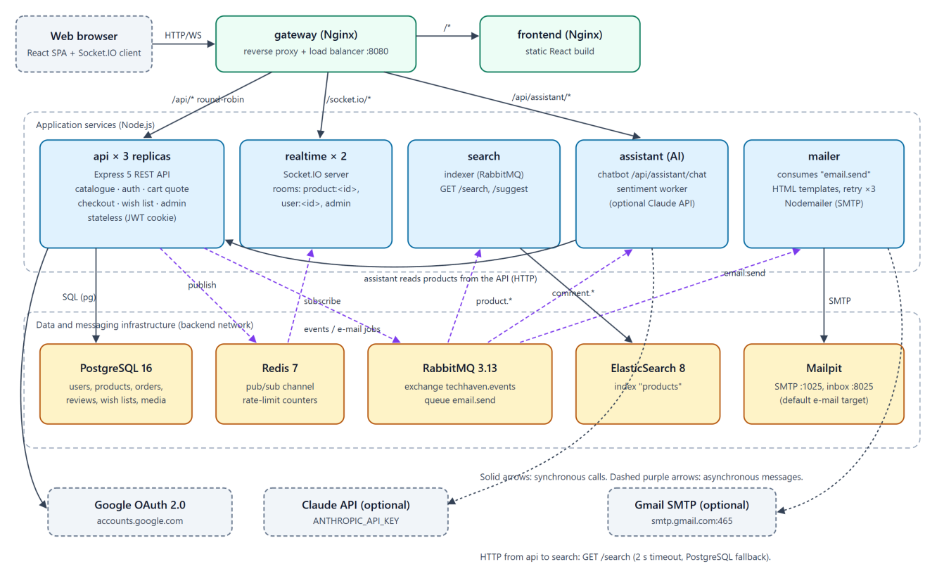
Figure 4.1. System architecture
Table 4.1. Services
Service | Responsibility | Instances
gateway | Public entry point; reverse proxy, load balancing, WebSocket upgrade | 1
frontend | React store and admin dashboard served by Nginx | 1
api | Catalogue, accounts, cart pricing, checkout, loyalty, reviews, administration, image upload; schema migration and seeding | 3 (scalable)
realtime | Socket.IO connections; relays events from Redis to rooms | 2 (scalable)
mailer | Consumes the e-mail queue; renders templates; sends through SMTP | 1
search | Keeps the ElasticSearch index in sync; search and suggest API | 1
assistant | AI: shopping-assistant chatbot and sentiment analysis of comments | 1
postgres, redis, rabbitmq, elasticsearch, mailpit | Data, pub/sub and rate limits, message broker, search index, e-mail inbox | 1 each

4.2 Asynchronous Communication and Stateless Design
Only two interactions are synchronous: browser to API, and API to the search service for keyword queries (2-second timeout with a PostgreSQL fallback). Everything else travels through RabbitMQ and Redis (Figure 4.2, Table 4.2), so a slow mail server or a restarting search service never blocks a customer.
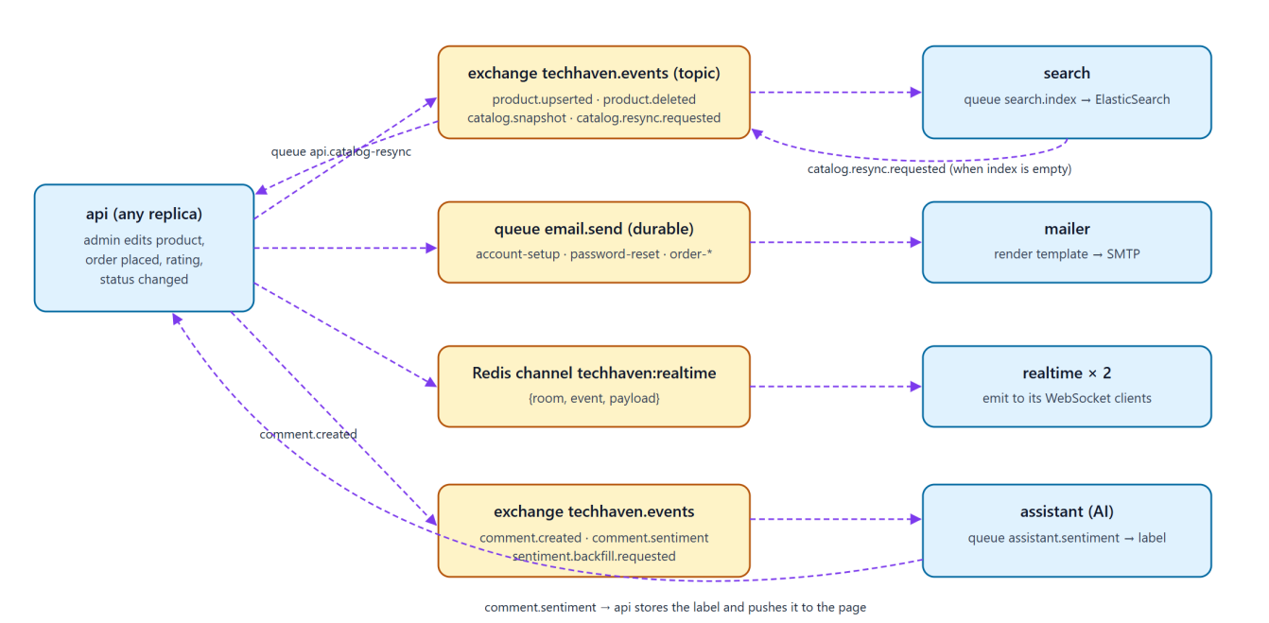
Figure 4.2. Asynchronous channels between services
Table 4.2. Asynchronous messages
Channel | Producer → consumer | Purpose
Queue email.send (durable) | api → mailer | Account setup, password reset, order confirmation and status e-mails; retried up to 3 times.
Exchange techhaven.events: product.upserted / product.deleted | api → search | Keep the index in sync after product edits (including images), sales and ratings.
catalog.snapshot / catalog.resync.requested | api ↔ search | Full re-index when the index is empty; the shared queue makes exactly one API replica answer.
comment.created / comment.sentiment | api → assistant → api | Every new comment is classified; the label is stored and pushed to the product page. sentiment.backfill.requested re-sends unclassified comments.
Redis channel techhaven:realtime | api → every realtime replica | comment:new, comment:sentiment, rating:updated, order:status, order:new pushed to WebSocket rooms.

Any API replica can serve any request: sessions are signed JWT cookies; carts live in the browser and are re-priced by the server; uploaded images are stored in PostgreSQL rather than on a container disk; rate limits are counted in Redis; start-up seeding is serialised with a PostgreSQL advisory lock; and WebSockets use the WebSocket transport only, so no sticky sessions are needed.

4.3 Database Design
Figure 4.3 shows the 15 tables of services/api/src/schema.sql. Order lines copy the product name, price and cost, so order history and profit stay correct after a product is edited or deleted. Product images are rows of product_images (ordered by position; the first is the cover) that point either to an uploaded file in media or to an https link.
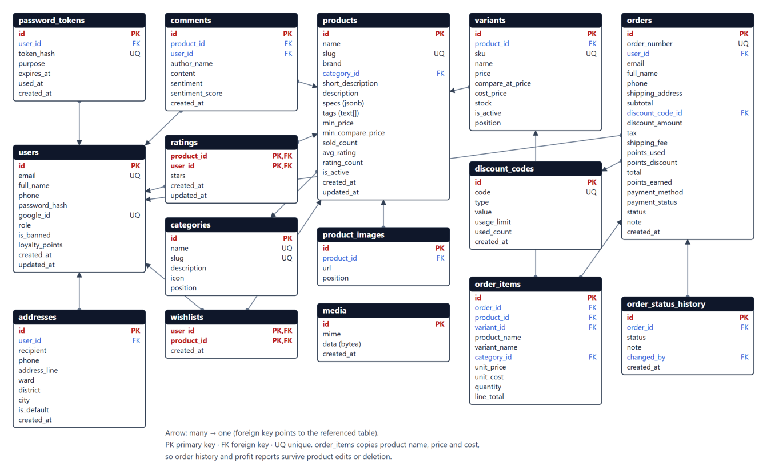
Figure 4.3. Entity-relationship diagram
Table 4.3. Main tables and constraints
Table | Key columns and constraints
users | email and google_id unique; password_hash nullable (guest or Google accounts); one administrator; loyalty_points ≥ 0
addresses | one default address per user (partial unique index); up to 10 per user
products / variants | slug and sku unique; price > 0; stock ≥ 0; optional compare_at_price (original price); read-model columns min_price, min_compare_price, sold_count, avg_rating
product_images / media | 1 to 10 rows per product, ordered by position; media stores uploaded bytes and the detected MIME type
discount_codes | code matches ^[A-Z0-9]{5}$; usage_limit 1-10; used_count ≤ usage_limit
orders / order_items | status limited to five values; snapshot of contact, address, prices, cost, discount and points
order_status_history | every status change with time, note and administrator
comments / ratings | guests may comment; sentiment label and score set by the assistant; one rating (1-5) per user and product
wishlists | (user_id, product_id) primary key; wish lists of signed-in customers

4.4 API Design
Table 4.4. Main REST endpoints (prefix /api)
Group | Endpoints | Access
Authentication | POST /auth/register, /auth/login, /auth/logout, /auth/forgot-password, /auth/set-password, /auth/change-password; GET /auth/me, /auth/google, /auth/google/callback | Public
Profile | GET, PUT /profile; GET, POST /profile/addresses; PUT, DELETE /profile/addresses/:id; POST /profile/addresses/:id/default | Customer
Catalogue | GET /home, /categories, /brands, /tags, /products (incl. onSale, sort=discount), /products/:slug, /products/by-slugs, /search/suggest, /config | Public
Wish list | GET /wishlist; PUT, DELETE /wishlist/:productId; POST /wishlist/merge | Customer
AI assistant | POST /assistant/chat (assistant service, routed by the gateway) | Public
SEO | /robots.txt, /sitemap.xml (gateway → GET /seo/robots.txt, /seo/sitemap.xml) | Public
Reviews | GET, POST /products/:id/comments; PUT /products/:id/rating | Public / rating: signed in
Cart, orders | POST /cart/quote, /orders, /orders/lookup (number + e-mail); GET /orders, /orders/:number | Public / history: signed in
Admin catalogue | GET, POST /admin/products; GET, PUT, DELETE /admin/products/:id; POST /admin/uploads (1-10 images); PATCH /admin/variants/:id/stock; categories CRUD | Administrator
Admin other | GET /admin/dashboard/summary, /advanced; users, orders (PATCH status), discounts | Administrator

4.5 Main Processing Flows
Checkout (Figure 4.4). While the cart changes, the browser calls POST /cart/quote. When the order is placed, the API repeats the calculation inside one transaction after locking the variants, the discount code and the buyer with SELECT ... FOR UPDATE; the code usage is incremented only while used_count < usage_limit, so the last unit or the last use can never be sold twice. E-mail and re-indexing happen after the commit through RabbitMQ.
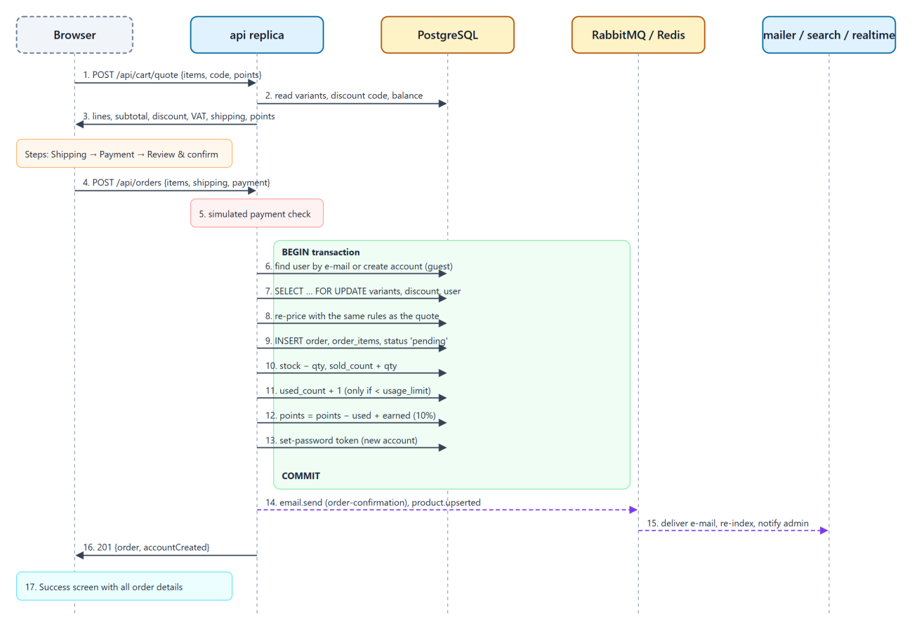
Figure 4.4. Checkout sequence
Order status (Figure 4.5). The API accepts only the transitions of the state machine; each change is stored in order_status_history, e-mailed and pushed to the customer's open pages. Cancelling restores stock, refunds the points used, removes the points earned and releases the discount use.
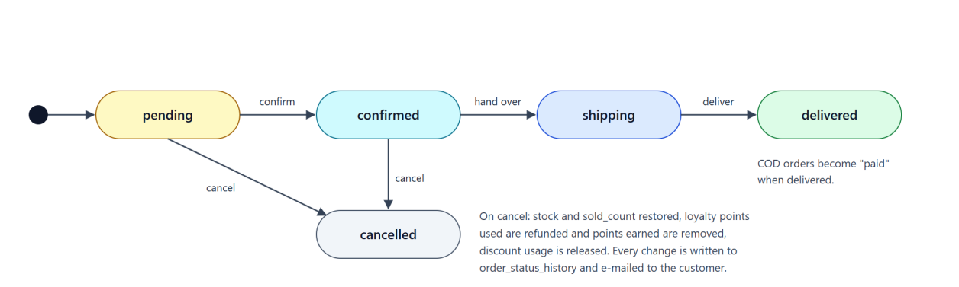
Figure 4.5. Order status state machine

CHAPTER 5. IMPLEMENTATION
The source is organised as one folder per service (frontend, gateway, services/api, services/realtime, services/mailer, services/search, services/assistant) plus tests and .github/workflows. On the first start the API creates the schema and loads deterministic demo data: 9 categories, 118 products (13 or 14 per category, so every category spans two catalogue pages) with 264 variants - two or three per product - and three or four real product photos each (shipped in services/api/src/seed/images and stored in the media table) (about half of them on promotion), 160 customers, about one thousand orders since January 2024, six discount codes, and ratings and comments in English and Vietnamese. Screens of every feature are shown in Appendix A.

5.1 Accounts and Authentication
Passwords are hashed with bcrypt; after sign-in the API issues a JWT in an httpOnly, SameSite=Lax cookie that every replica can verify. Registration stores only e-mail, name and address and sends a one-time link (stored as a SHA-256 hash, single use) to choose the password; the same mechanism serves password recovery (link valid one hour). Google sign-in uses the OAuth 2.0 authorization-code flow with a signed state cookie; a new Google user gets an account, and an existing account with the same verified e-mail is linked. Customers can edit the profile, change the password and manage up to ten addresses with one default.

5.2 Catalogue, Search and Product Images
Product cards and filters are built by lib/catalog.js with parameterised SQL and a whitelist of sort orders (newest, best selling, name A-Z and Z-A, price ascending and descending, rating, biggest discount, relevance). Every product list uses the same paginated component with page numbers - the catalogue (12 per page), the landing-page sections, related and recently viewed products and the wish list - so pagination works "everywhere products are listed", as the description requires. Keyword queries go to the search service, which combines an exact multi-field match with a typo-tolerant match on names and brands (fuzziness AUTO:5,8, so model numbers like 4070 are never fuzzed); if the service is unavailable the API falls back to SQL. The product page shows an overview of at least five lines (the first lines of the description) next to the price, above the variants.
Product image management. Each product has from 1 to 10 illustration images. In the product form the administrator can drop files on the upload area or browse for them, paste an https link, drag tiles to reorder them, move any image to the cover position and remove images; a counter shows how many of the 10 slots are used, files beyond the limit are skipped with a message, and the upload area is disabled when the product is full (Figure A.31, Figure A.32). The rules are enforced on the server as well (lib/images.js):
- POST /api/admin/uploads accepts up to 10 files of at most 3 MB per request and detects the real format from the file signature (PNG, JPEG, GIF, WEBP); a file whose content is not an image is rejected even if its name and declared type say otherwise.
- Uploaded bytes are stored in the media table with the detected MIME type and served from /api/media/:id, so every API replica can serve every image.
- Saving a product requires between 1 and 10 distinct images, each either an uploaded file or an https URL; the order of the list becomes the gallery order and the first image is the cover.
- The product page shows a gallery with previous/next buttons, keyboard arrows, an "n / N" counter, thumbnails and a full-screen viewer (Figure A.8, Figure A.9).

5.3 Cart, Checkout and Loyalty
The cart is kept in the browser so guests can shop without an account, but every change calls POST /cart/quote, which returns authoritative prices, stock warnings, the discount status, VAT, shipping and points. Checkout re-prices everything inside a transaction with row locks, creates the order, its lines and the first history entry, decrements stock, increments the best-seller counter and the code usage, and updates the loyalty balance (points used are subtracted and the 10% earned is added immediately). Guests receive an automatically created account. The confirmation e-mail is queued after the commit and delivered by the mailer to the Mailpit inbox (Figure A.47) or through Gmail.

5.4 Real-Time Reviews and Notifications
A product page joins the Socket.IO room of that product. When a comment or rating is saved, the API publishes the event on Redis; each realtime replica emits it to its own clients in the room, so every viewer sees it without reloading. The same channel delivers the sentiment label of new comments, order status changes to customers and new orders to the administrator.

5.5 Administration and Dashboards
The simple dashboard aggregates customers, new customers, orders, revenue, a 12-month chart, orders by status and the best sellers, and adds actionable insights: orders to confirm and to ship, out-of-stock and low-stock variants with links, and discount codes close to their limit. The advanced dashboard groups orders by year (default), quarter, month, week or day over a chosen range and reports orders, revenue, profit, units and product types sold; profit is item revenue minus item cost, discounts and redeemed points. Order management offers 20 orders per page, newest first, with period filters, and status changes limited to the state machine. User management allows viewing, editing and banning customers; discount management shows each code's usage and the orders that used it. No administrator feature beyond those listed in the description was added.

5.6 Storefront Features Inspired by Live Stores
Two large Vietnamese computer stores, GEARVN and Phong Vu, were studied in November 2026. Table 5.1 lists what customers find there and how TechHaven implements it. All additions are on the customer side; none changes the rules highlighted in the description (registration fields, guest checkout, discount codes, administrator scope).
Table 5.1. Features observed on live stores and their implementation
Feature on live stores | TechHaven implementation
Original price struck through, "-x%" badge, deal section with the biggest discounts | Optional original price per variant (admin form); badge on cards and product page; Hot Deals section; "On sale" filter and "Biggest discount" sort
Key specifications on product cards (CPU, RAM, GPU, screen) | Up to three specification chips chosen by priority from the product specs
Brand logos / brand tabs inside category sections | Brand pills on catalogue pages and the home page; brand tabs in each landing-page category section
Shopping by need (students, gaming, design) | "Shop by need" tiles linked to product tags
Wish list, compare products | Heart and compare buttons on cards; wish list stored in the account (or the browser for guests, merged at sign-in); comparison of up to four products with "differences only"
Recently viewed products | Kept in the browser and shown on the home and product pages
"Buy now" next to "Add to cart"; cart preview | Buy now goes straight to checkout; a mini-cart drawer opens after "Add to cart"
Order tracking from the header | "Track order" page with order number and e-mail, no account needed
Zoomable product gallery | Full-screen viewer with keyboard navigation
Floating hotline / chat buttons, back to top | Floating hotline, AI assistant and back-to-top buttons
Banners with promotions | Rotating hero slides linking to deals and needs

5.7 AI Features
The assistant microservice provides the AI bonus features (Figure A.44, Figure A.45, Figure A.11):
- Shopping assistant chatbot. A rule-based parser (intent.js) understands Vietnamese and English questions - budgets such as "dưới 30 triệu", "under 8m" or "tầm 20tr", product types, intended uses (gaming, office, students, design, programming), brands, model numbers such as "RTX 4070" and store-policy questions. The assistant queries the live catalogue through the API and returns only in-stock products that match, as clickable cards, relaxing the filters step by step when nothing matches. Google Gemini then writes the reply text from those products only (gemini-3.5-flash-lite through the @google/genai SDK, with the key in GEMINI_API_KEY; a free-tier key can be created in Google AI Studio). The model was chosen by measurement: gemini-3.8-flash needed 6 to 27 seconds per reply on the free tier, the lite model about 1.5 to 2 seconds with equally correct Vietnamese. Gemini receives only the candidate products with prices already formatted for the language of the customer, the store policies and the last six turns, and is told to reply in plain text in that language and to mention policies only when asked, so it cannot recommend products the shop does not sell. Follow-up questions keep the context: after "Tư vấn laptop gaming dưới 30 triệu", the question "Có mẫu nào rẻ hơn không?" reuses the product type, use and budget of the previous request and sorts by price. Any error - an invalid key, the free-tier quota being used up, more than 25 seconds - falls back to the template reply, so the feature also works without a key; the engine field of each response tells which path answered (gemini or rules). Figures A.44 and A.45 and the final end-to-end run were answered by Gemini.
- Sentiment analysis of reviews. Each new comment is published on RabbitMQ; the assistant scores it with the AFINN-165 lexicon for English and a Vietnamese lexicon with negation handling ("không tốt" is negative) and publishes a positive / neutral / negative label, which the API stores and pushes to open product pages. The product page shows the share of positive, neutral and negative comments ("What buyers say"). On start-up the assistant asks for comments that were never analysed, so the seeded comments are classified too.

5.8 Security Measures
Table 5.2. Security measures
Threat | Measure
Password theft | bcrypt hashes; 8-72 characters with letters and digits; one-time tokens stored as SHA-256 hashes with expiry.
Session theft, XSS | httpOnly SameSite=Lax cookie; React and e-mail templates escape output; X-Content-Type-Options: nosniff.
CSRF | SameSite cookies and JSON-only endpoints; signed OAuth state.
SQL injection | Parameterised queries; whitelisted sort keys.
Broken access control | requireAuth / requireAdmin guards; customers read only their own orders, addresses and wish list; order lookup needs the order number and the matching e-mail.
Malicious uploads | Images only, detected from file signatures; 3 MB per file; at most 10 per request and per product.
Brute force and spam | Redis rate limits on sign-in, e-mail sending, comments, checkout and order lookup; per-IP limit on the assistant; generic answers on password recovery.
AI misuse | The chatbot only receives catalogue data, may only recommend listed products and never asks for personal data; message length is limited.

CHAPTER 6. DEPLOYMENT, SCALING AND BONUS FEATURES

6.1 Docker Compose Deployment
docker-compose.yml defines 12 services (15 containers with replicas) on two networks; health checks order the start-up, and only ports 8080 (website), 8025 (e-mail inbox) and 15672 (RabbitMQ management) are published (Figure 6.1). No npm install is needed on the host.
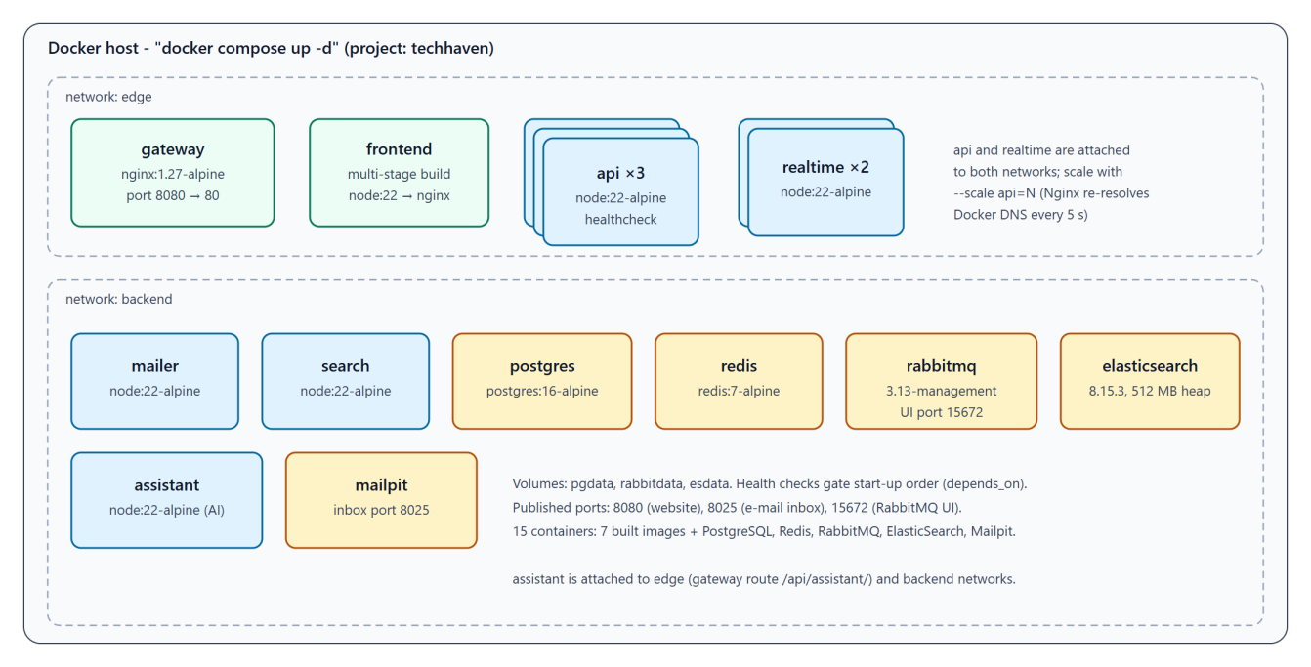
Figure 6.1. Docker Compose deployment

6.2 Horizontal Scaling
The API was scaled from three to five replicas while running and 100 concurrent requests were sent through the gateway; each response carries an X-Instance header naming the container that served it (Table 6.1). With one replica stopped, 60 requests still succeeded within 2.1 s: the gateway waits at most 2 s (proxy_connect_timeout 2s) before retrying another replica (proxy_next_upstream_tries 3); before these settings were added the same test took 60 s.
Table 6.1. Distribution of 100 concurrent requests over 5 API replicas
Replica (container id) | Requests served
2aa160b6aa8b | 24
2d20883e3a2b | 17
2e7aae086a73 | 18
9f415172cdb3 | 22
e4ec64cb7174 | 19
Total (187 ms) | 100

6.3 Bonus Features
- CI/CD (GitHub Actions). .github/workflows/ci.yml runs on every push to main and every pull request: unit tests of the API, the mailer and the assistant, checks of the other services and the React build; then it builds the whole stack with docker compose up -d --build --wait, waits for the search index, runs the 66-step end-to-end scenario through the gateway and tears the stack down.
- Microservices with asynchronous communication. Besides the front end and the data stores there are five Node.js services (api, realtime, mailer, search, assistant) connected through a durable RabbitMQ queue, a topic exchange and Redis publish/subscribe (Section 4.2). Stopping the search service does not break search, stopping the mailer only delays e-mails, and stopping the assistant leaves the shop working.
- AI features. Shopping-assistant chatbot and sentiment analysis of comments (Section 5.7).
- ElasticSearch. The products index uses lower-casing and ASCII folding and a search_as_you_type field; filters, sorting and pagination run inside ElasticSearch, and the index follows product changes through RabbitMQ events.

6.4 Highlights Beyond the Requirements
The project description fixes a minimum for each feature. TechHaven meets every minimum and, wherever this was allowed, goes further in the customer store, the supporting services and the engineering practice. The administrator area deliberately contains only the functions listed in the description, as the description requires; the improvements on that side make the required functions more complete rather than adding new ones. Table 6.2 lists the most important points where the delivered system exceeds the description.
Table 6.2. Features that exceed the project description
# | Area | Project description | TechHaven
1 | AI shopping assistant | Bonus item: "a smart chatbot that can suggest products". | Chat bubble on every page; answers in Vietnamese and English, understands budget, category, brand and use (e.g. "gaming laptop under 30 million"), keeps the context of follow-up questions and recommends only real products from the live catalogue with price, stock and a link. Google Gemini writes the answer; a rule-based engine answers when no key or quota is available, so the feature never breaks.
2 | AI sentiment analysis | Bonus item, listed as one example among several AI features. | Implemented in addition to the chatbot: every comment receives a positive / neutral / negative label asynchronously through RabbitMQ, the label appears live through WebSocket, and the product page shows a sentiment summary.
3 | Search | Keyword search; ElasticSearch as a bonus. | ElasticSearch with ASCII folding and typo tolerance ("samsng" finds Samsung), suggestions while typing, and filters, sorting and pagination executed inside the index, which follows every product change through RabbitMQ events.
4 | Sorting and filtering | At least 4 sort orders; at least 3 filters including brand and min/max price. | 8 sort orders (name A-Z / Z-A, price ascending / descending, newest, best selling, rating, biggest discount) and 8 filters (brand, min/max price, rating, in stock, on sale, category, tags, keyword).
5 | Product presentation | At least 3 images, 2 variants and a 5-line description. | Gallery of up to 10 images with thumbnails, keyboard navigation and a full-screen viewer; original price struck through with a -x% badge; specification table; every one of the 118 products has at least two variants with independent price and stock.
6 | Shopping aids of live stores | Not required. | Hot Deals and "Shop by need" sections, brand tabs, wish list, comparison of up to 4 products, recently viewed products, "Buy now", and order tracking by order number and e-mail without an account - modelled on GEARVN and Phong Vu (Table 5.1).
7 | Payment and e-mail | Multi-step checkout and a confirmation e-mail. | Cash on delivery, bank transfer and a simulated card gateway with approve / decline test cards that never stores card data; e-mails for order confirmation, set-password links for automatic accounts, password recovery and every order status change, delivered to a built-in Mailpit inbox so the grader can read them without any configuration.
8 | Data integrity | Not specified. | Prices, VAT, shipping, discounts and points are recalculated on the server; checkout runs in one transaction with row locks, so stock can never go negative and a discount code can never be used more than its limit, even under concurrent orders. Order status follows a state machine and every change is recorded.
9 | Architecture and scaling | Horizontal scaling; at least 3 services for the microservices bonus. | Five Node.js services (api, realtime, mailer, search, assistant) with RabbitMQ queues and Redis pub/sub; 3 API and 2 realtime replicas behind Nginx out of the box, scaled live to 5 API replicas with an X-Instance header that proves the load balancing.
10 | Security | Secure implementation. | bcrypt password hashes, JWT in httpOnly SameSite cookies, parameterised SQL, server-side validation, rate limiting on sign-in and e-mail endpoints, upload validation by file content, and banned users blocked on every request (Table 5.2).
11 | Quality assurance | Not specified; CI/CD as a bonus. | 25 unit tests and a 66-check end-to-end scenario (including the delivery of the confirmation e-mail) run automatically on GitHub Actions; a layout audit of 27 pages at three screen widths.
12 | Demo data and performance | Enough data to demonstrate pagination. | 118 products in 9 categories, 160 customers and about 1,000 orders since January 2024, so every category has several pages and both dashboards show meaningful trends; the administrator pages and charts are loaded only when needed to keep the store fast.
These additions were chosen to make the store closer to a real computer shop rather than to add volume: each one is covered by the automated tests or by the screenshots in Appendix A, and each one can be seen in the demonstration video.

CHAPTER 7. TESTING

7.1 Test Plan
Four kinds of tests were used. Unit tests (node --test) cover the pricing, loyalty, discount, validation, image, e-mail template, sentiment and chatbot-parsing rules. The end-to-end scenario tests/e2e-api.mjs drives the running stack through the gateway with separate guest, customer and administrator sessions and also checks that the confirmation e-mail arrives in the Mailpit inbox. Automated browser walkthroughs (Puppeteer with Microsoft Edge) exercise the main journeys on desktop, tablet and phone viewports, including the image manager, the mini-cart, comparison, wish list, order tracking and the AI assistant, and fail on any JavaScript error; they produced the screenshots in Appendix A. Fault-injection experiments add replicas and stop containers during traffic.

7.2 Results
The final runs passed 25 of 25 unit tests and 66 of 66 end-to-end checks (Table 7.1); the complete list is in Appendix B. The browser walkthroughs reported no JavaScript errors.
Table 7.1. Test results by category
Category | Tests | Pass | Fail | Test IDs
Pricing, discount and loyalty rules | 7 | 7 | 0 | U04-U10
Input validation | 5 | 5 | 0 | U11-U15
Image rules | 3 | 3 | 0 | U01-U03
E-mail templates | 3 | 3 | 0 | U16-U18
Sentiment analysis, chatbot parsing, Gemini prompt and follow-up context | 7 | 7 | 0 | U19-U25
Load balancing | 1 | 1 | 0 | E01
Catalogue, search, product page | 8 | 8 | 0 | E02-E09
Reviews | 3 | 3 | 0 | E10, E11, E13
Accounts and access control | 5 | 5 | 0 | E12, E14-E16, E30
Discount codes | 5 | 5 | 0 | E17-E20, E26
Checkout and loyalty | 6 | 6 | 0 | E21-E25, E27
Orders and status history | 6 | 6 | 0 | E28, E29, E31-E34
Guest checkout and order tracking | 4 | 4 | 0 | E35, E36, E51, E52
Product images (1-10) | 7 | 7 | 0 | E37-E43
Deals, specs, compare, wish list, SEO | 8 | 8 | 0 | E44-E50, E53
AI assistant and sentiment | 5 | 5 | 0 | E54-E58
E-mail delivery (Mailpit) | 1 | 1 | 0 | E59
Dashboards | 7 | 7 | 0 | E60-E66
Total | 89 | 89 | 0

The browser walkthroughs found five defects, all corrected before the final run. Two had the same cause: React effects written as arrow expressions returned the value of window.scrollTo and scrollIntoView, which recent Chromium versions return as a promise, and React then tried to call it as a clean-up function - the second case blanked the whole page after the chatbot answered. Every effect was rewritten with a block body so this cannot recur. The others were an invalid phone pattern attribute, a discount code lost when the checkout page was reloaded, and dashboard charts without a fixed height. The fault-injection runs also led to the gateway fail-over settings in Section 6.2.
A final automated layout audit opened 27 pages (store, customer area and administration) at 1366, 768 and 375 pixels wide - 81 page views - and reported any horizontal page scrolling, element sticking out of its card, clipped button text, broken image or JavaScript error; every screenshot was also reviewed by eye. It led to these corrections: on discounted product cards the original price and the discount badge now sit on their own line above the price, because long prices pushed the View button out of the card; on phones the View button is hidden (the whole card is a link), the stars no longer wrap and the card padding is reduced so prices fit at 360 pixels; the order-items table hides the image and unit-price columns on phones; the brand filter shows the ten largest brands with a "+N more" button and becomes one swipeable row on phones; the comparison table keeps its label column visible while scrolling sideways; the nine category tiles fit on one row on wide screens; counts use the singular when needed ("1 item"); and the brand on generated product images moved to the bottom so discount badges no longer cover it. After these changes the audit reported no layout problem and no JavaScript error.

CHAPTER 8. REMAINING LIMITATIONS AND IMPROVEMENTS
The final review compared the implementation with every requirement of the project description (Appendix C). Table 8.1 lists the limitations that remain and the recommended improvement for each.
Table 8.1. Remaining limitations
# | Limitation (verified) | Impact | Recommended improvement
1 | Google sign-in could not be tested end to end without the deployer's OAuth credentials. | Medium | Create the OAuth client, set the variables in .env and repeat the sign-in scenario before the demonstration.
2 | Payment is simulated. | Medium | Integrate a real gateway (e.g. VNPay or Stripe) with refunds for cancelled paid orders.
3 | All replicas run on one Docker host; PostgreSQL, Redis, RabbitMQ and ElasticSearch are single instances. | Medium | Deploy on a cluster with replicated or managed data services.
4 | The chatbot's own understanding is rule-based; free-form phrasing is handled well only when the Gemini key is configured, and the Gemini free tier has daily request limits. | Low | Use a paid Gemini tier in production, or extend the intent rules with real customer questions.
5 | The cart and the recently viewed list are stored in the browser and do not follow a customer to another device. | Low | Synchronise them with the account of signed-in customers.
6 | Uploaded images that are removed from a product stay in the media table. | Low | Add a periodic clean-up of media rows no longer referenced by any product.
7 | The demo product photos were collected from manufacturer and retailer pages for this non-commercial course project; their copyright remains with their owners. | Low | Replace them with photos licensed by the brands, using the image manager, before any commercial use.

CHAPTER 9. CONCLUSION
The group built and deployed TechHaven, an e-commerce website for computers and computer components that implements every customer and administrator feature of the project description, follows its mandatory rules for registration, guest checkout, discount codes, loyalty points and the administrator scope, and starts with a single Docker Compose command. Administrators can attach 1 to 10 illustration images to each product, and the storefront offers the shopping aids of live computer stores. The back end is a set of five Node.js services - a stateless Express API scaled behind Nginx, a Socket.IO realtime service, a mailer, an ElasticSearch-based search service and an AI assistant - connected through RabbitMQ and Redis, and all four bonus features were completed. All 89 automated tests passed. The most useful lessons were to keep every price rule in one tested module, to rely on database transactions and row locks for stock and discount limits, to validate uploads by content rather than by declared type, to move slow work out of the request path, and to ground an AI assistant in the shop's own data. Beyond the minimum of the description, the store offers an AI shopping assistant grounded in its own catalogue, AI sentiment labels on reviews, typo-tolerant search and the shopping aids of live computer stores (Section 6.4).

INDIVIDUAL CONTRIBUTION SUMMARY
The work was divided into three modules of comparable size, one per member. Each member owned a module from design to testing, while the analysis of the project description, the integration of the modules and the final testing were done together. Table 9.1 summarises each member's responsibility; the work was shared equally, about one third each.
Table 9.1. Individual contribution summary
Member | Primary responsibility | Summary of contribution
Nguyen Thanh Tung  523H0192 | Storefront, search and real-time module  Share of work: 33.3% | • Landing page (New Products, Best Sellers, category sections, Hot Deals) and the product catalogue with grid/list view, pagination on every product list, eight sort orders and the brand/price/rating filters.  • Product detail page: image gallery and viewer, variants with independent price and stock, comments and star ratings.  • Realtime service (Socket.IO replicas fed by Redis pub/sub) for live comments and ratings; search service with ElasticSearch (typo tolerance, suggestions).  • Cart, mini-cart and the three-step checkout interface; responsive layout for phone, tablet and desktop; SEO metadata.
Duong Tran Quoc Khanh  523H0040 | Core API, database and deployment module  Share of work: 33.3% | • PostgreSQL schema and the Express API: registration with e-mail, name and address only, sign-in, Google OAuth, profile, change and recovery of passwords, multiple delivery addresses.  • Server-side pricing: cart quote, VAT and shipping, discount codes, loyalty points, transactional checkout with row locks, guest checkout with automatic accounts, order tracking and status history.  • Mailer service and the RabbitMQ events; Docker Compose for 15 containers, the Nginx gateway with load balancing and the horizontal-scaling evidence.
Nguyen Nam Phong  523H0168 | Administration, AI and quality module  Share of work: 33.3% | • Administrator console: simple dashboard and advanced dashboard (year, quarter, month, week, custom range), product, category, inventory and image management, orders, users and discount codes.  • Assistant microservice: shopping chatbot grounded in the live catalogue (Gemini with a rule-based fallback, Vietnamese and English) and sentiment analysis of comments.  • Demo data seeding, unit and end-to-end tests, the GitHub Actions CI pipeline, the report and the demonstration video.

APPENDIX A. SYSTEM DEMONSTRATION
This appendix walks through the implemented system screen by screen. All screenshots were captured automatically from the running Docker Compose stack with the seeded demo data.

A.1 Interface Design
The store uses a dark navy header with the search box, wish list, cart and account menu, a category bar, white cards on a light background and a sky-blue accent colour; prices are formatted as 13,490,000₫ and statuses are colour-coded. The administrator area has its own sidebar layout.

A.2 Landing Page and Catalogue
The landing page shows rotating slides, category tiles, "Shop by need", Hot Deals, New Products, Best Sellers and five category sections with brand tabs; every section has page numbers (Figure A.1 to Figure A.3). The catalogue offers grid or list view, pagination, nine sort orders, brand pills, tags and filters by brand, price range, rating, stock and promotion (Figure A.4 to Figure A.6); search results come from ElasticSearch and suggestions appear while typing (Figure A.7).
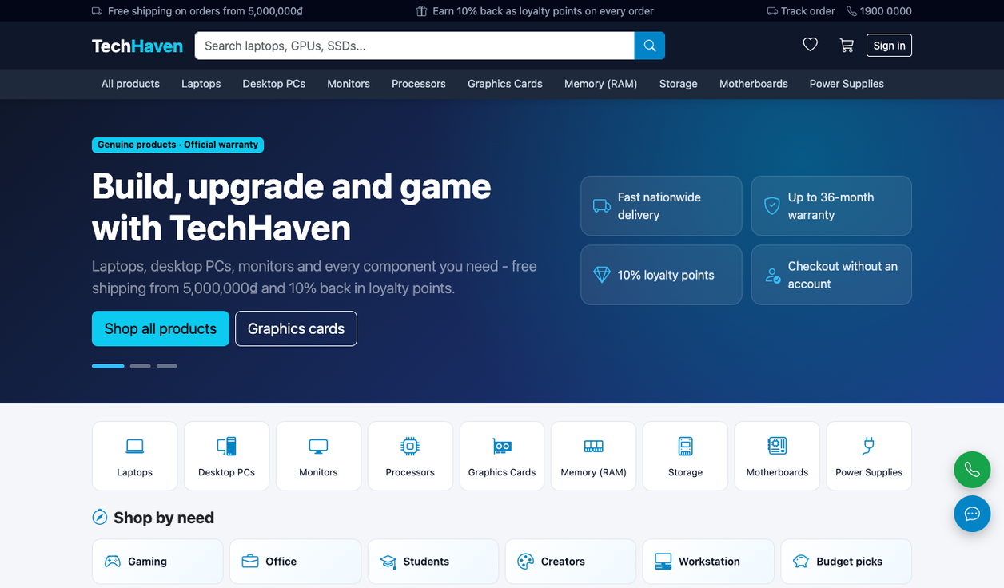
Figure A.1. Landing page
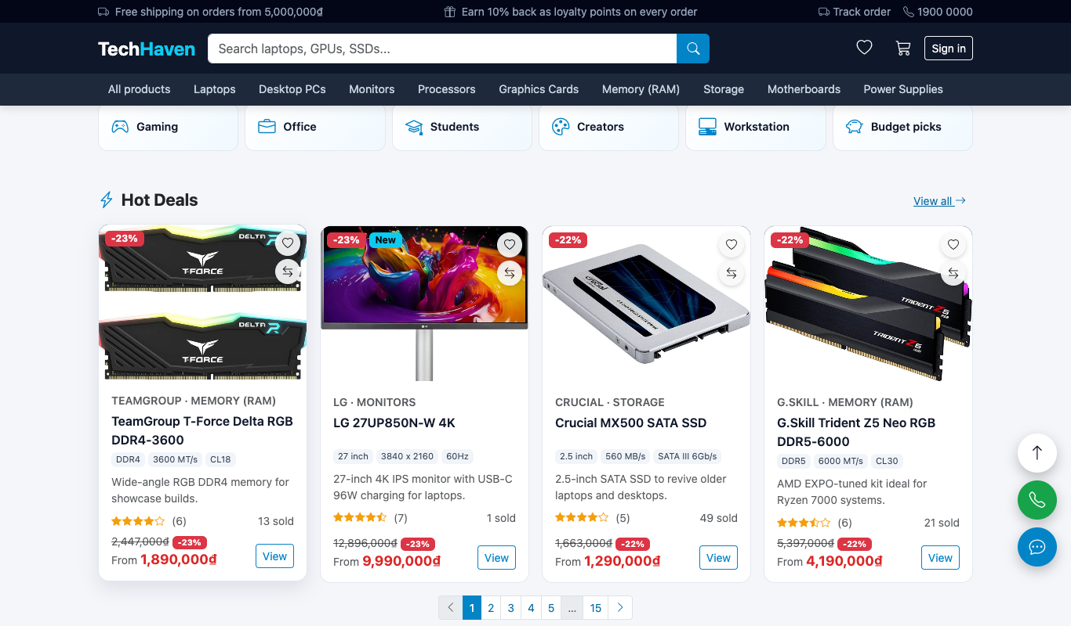
Figure A.2. Shop by need and Hot Deals with page numbers
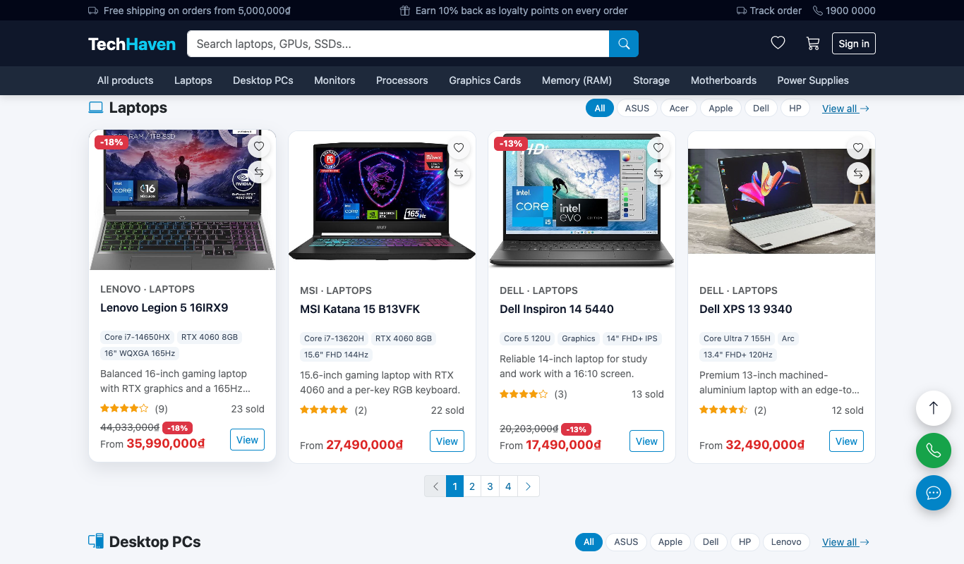
Figure A.3. Category section with brand tabs and pagination
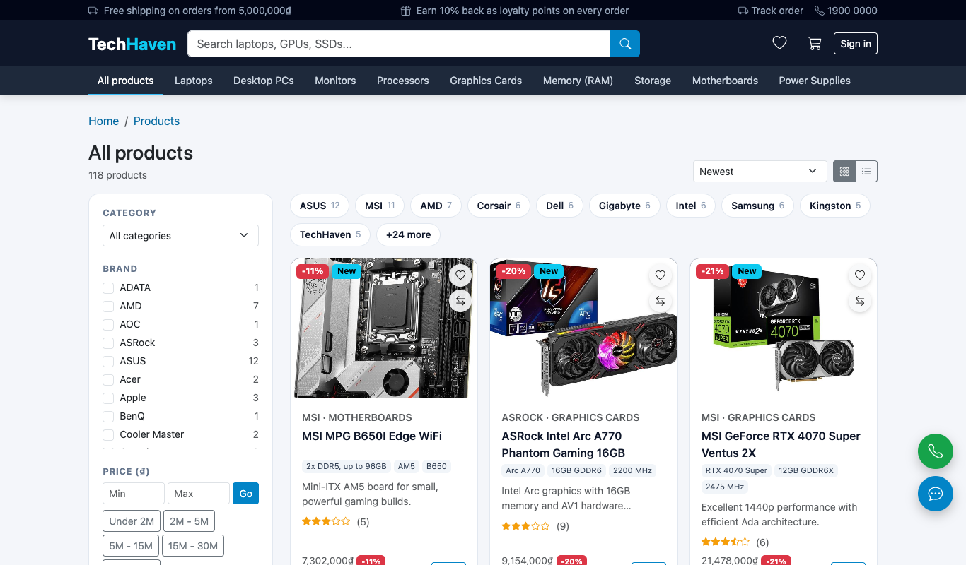
Figure A.4. Catalogue in grid view
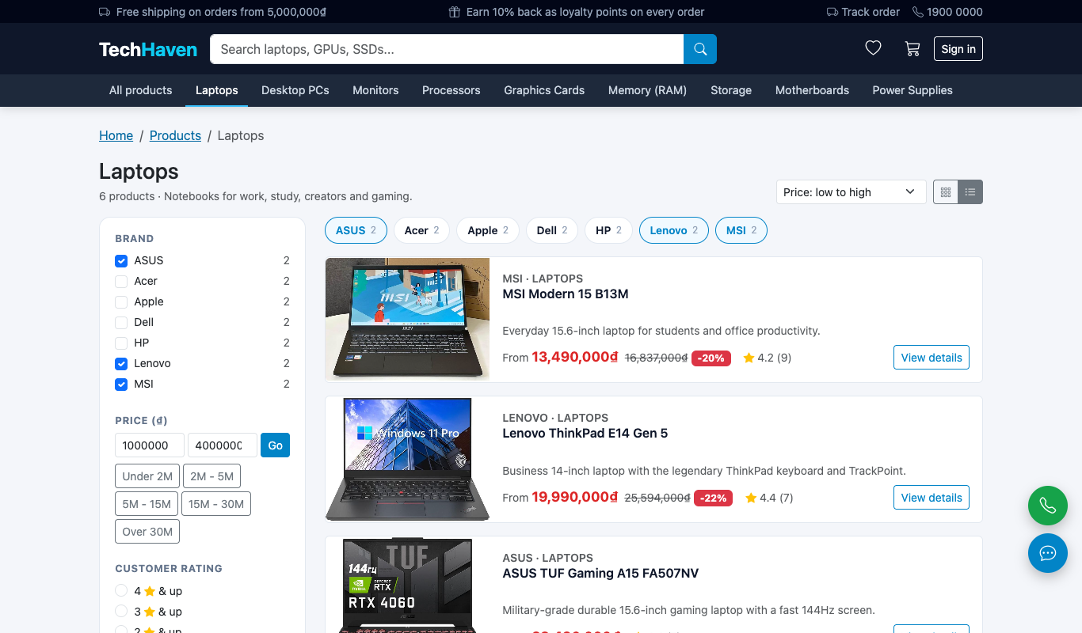
Figure A.5. Laptops filtered by brand and price, sorted by price, list view
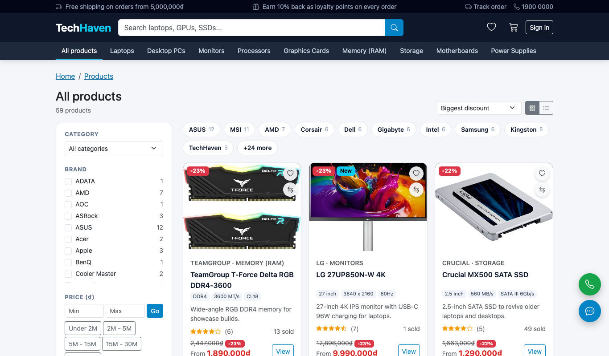
Figure A.6. Products on sale sorted by the biggest discount
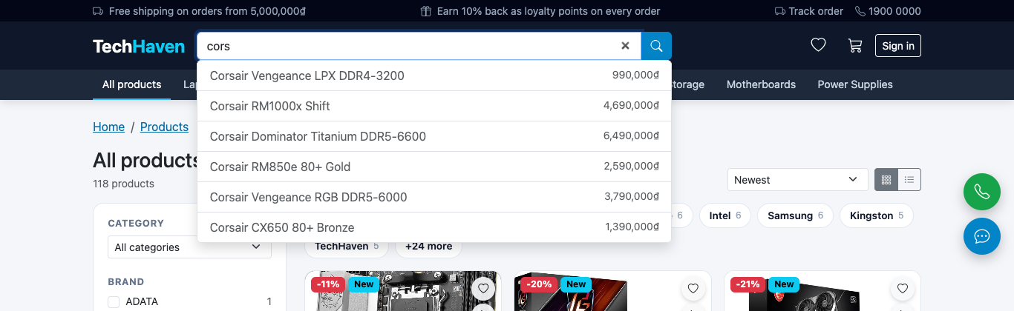
Figure A.7. ElasticSearch suggestions while typing

A.3 Product Details and Reviews
The product page shows the gallery (up to ten images, full-screen viewer), the selling and original prices, the overview of at least five lines, the variants with their own price and stock, "Buy now", wish list and compare (Figure A.8 to Figure A.10). Comments and star ratings appear in real time and each comment receives an AI sentiment label; the rating panel summarises what buyers say (Figure A.11, Figure A.12).
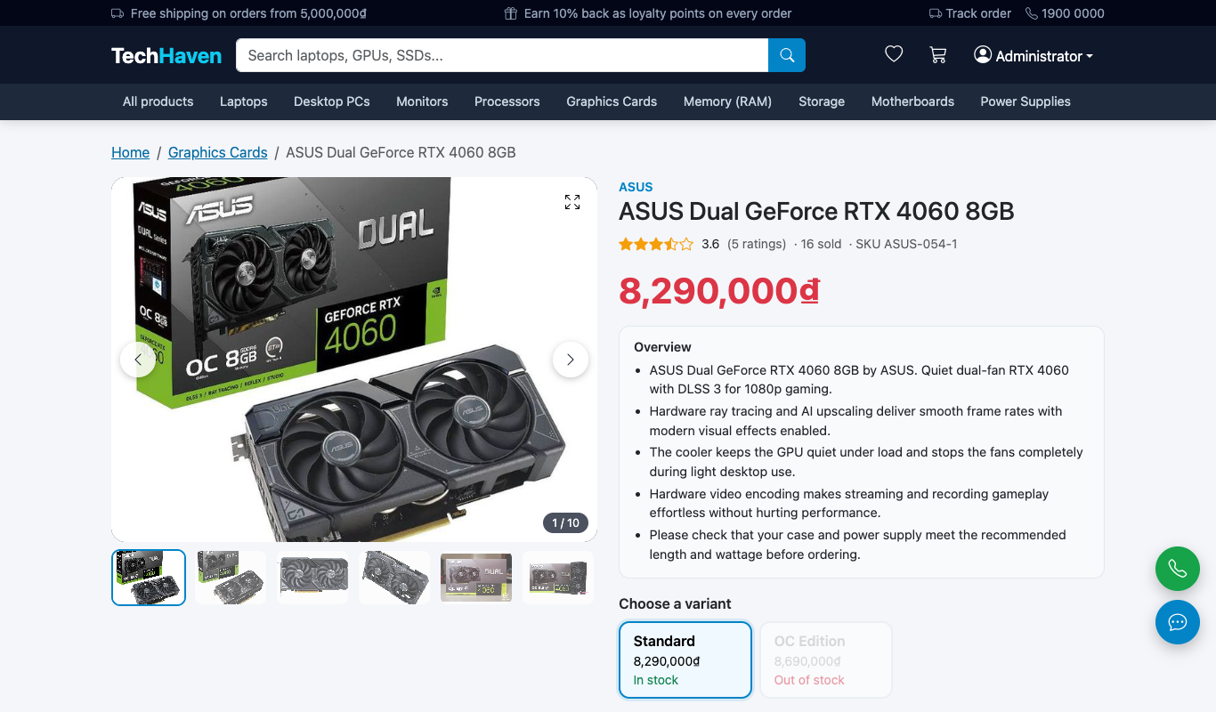
Figure A.8. Product page with a 10-image gallery and variants
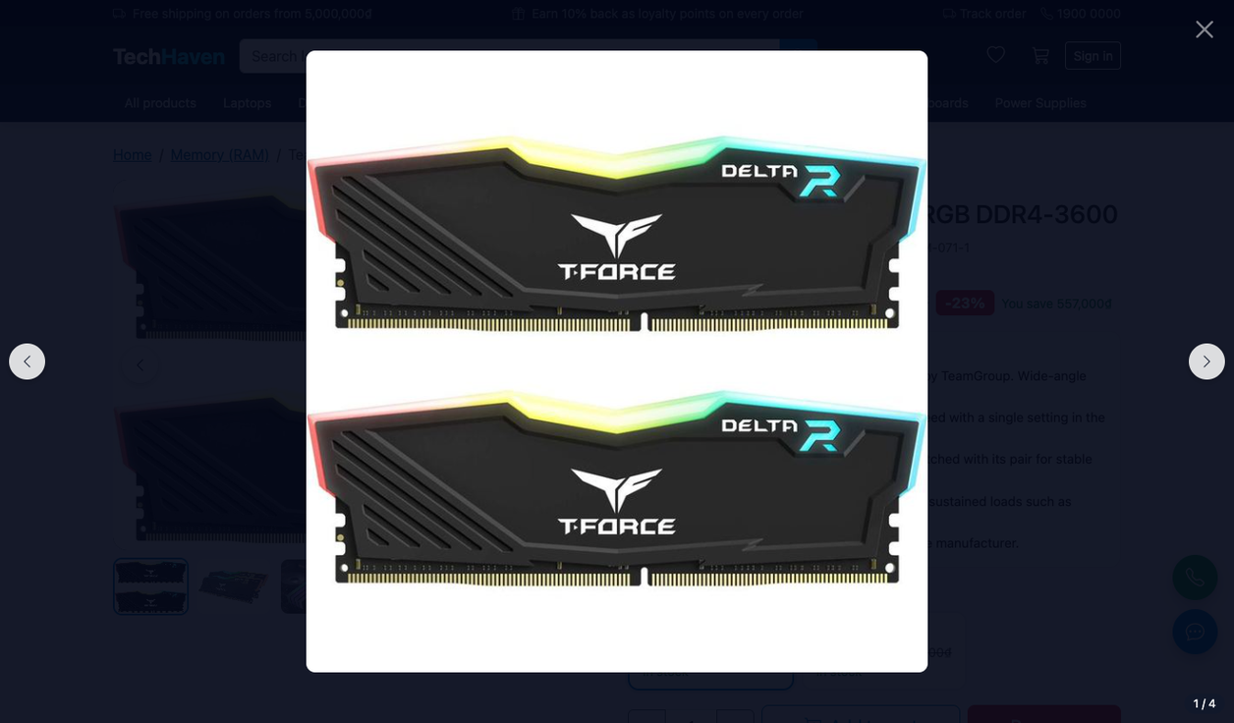
Figure A.9. Full-screen image viewer
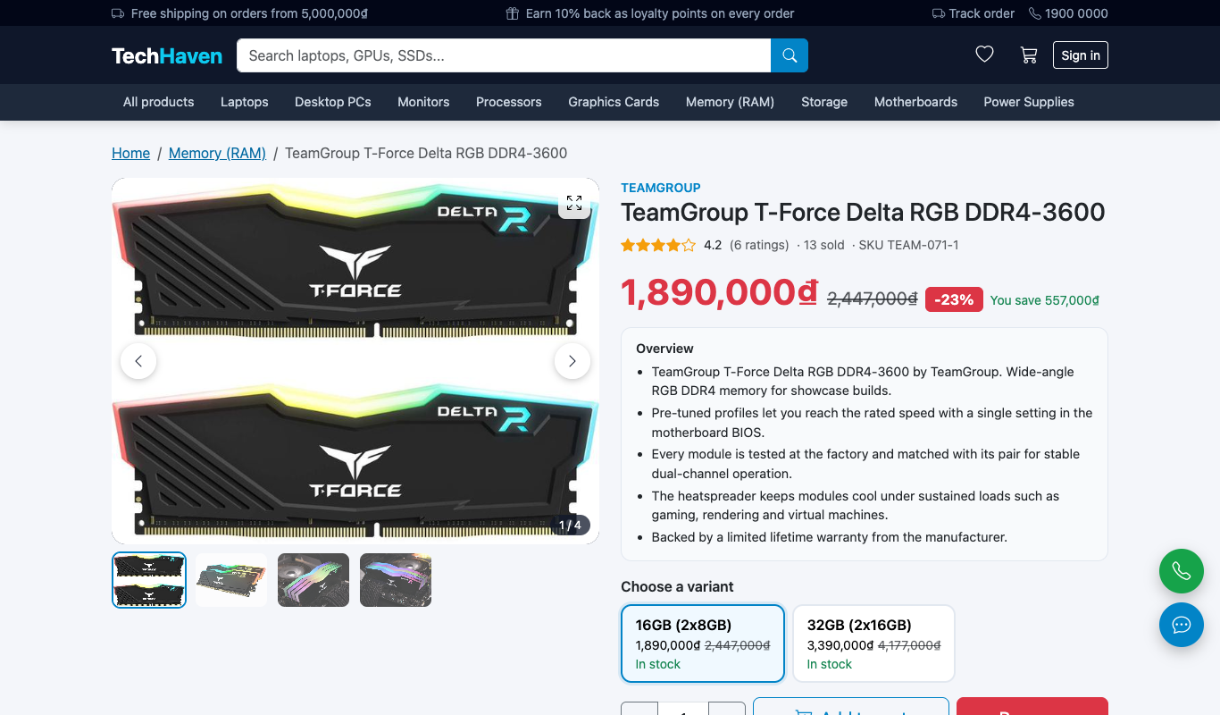
Figure A.10. Original price, discount badge and five-line overview
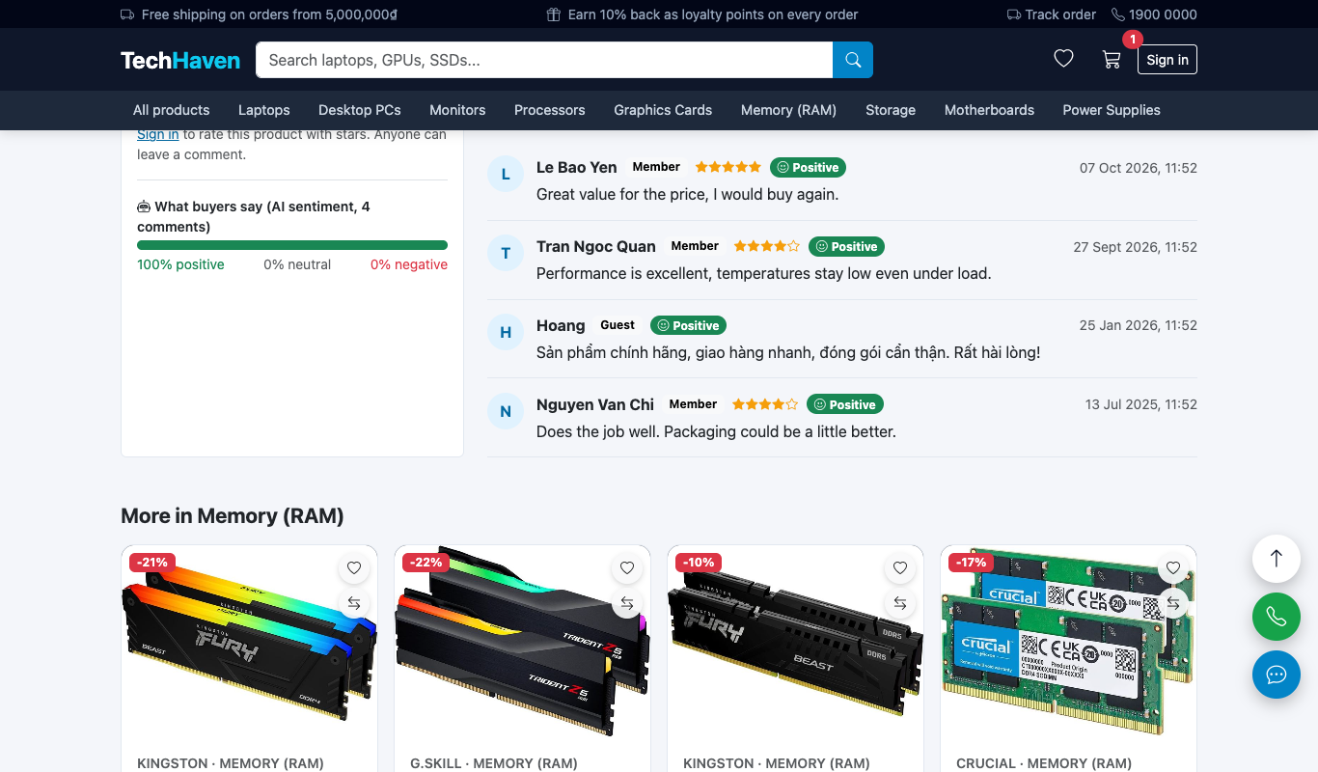
Figure A.11. Ratings, AI sentiment summary and labelled comments
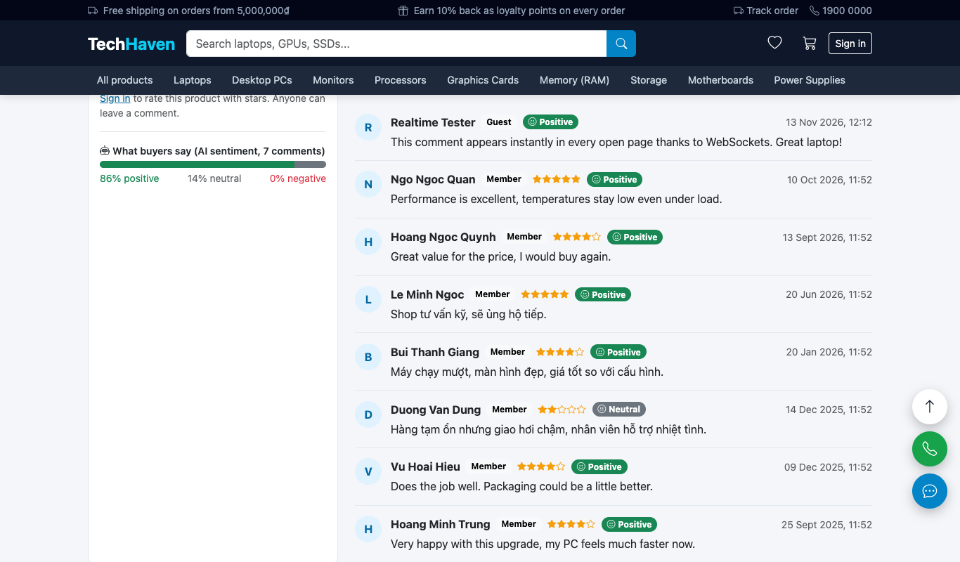
Figure A.12. A comment from another browser appears instantly (WebSocket)

A.4 Cart and Checkout
Adding a product opens the mini-cart (Figure A.13). The cart updates totals without reloading and shows the effect of a discount code before payment (Figure A.14). Checkout has three steps; a signed-in customer has saved addresses with the default pre-selected and can spend loyalty points (Figure A.15 to Figure A.19). The success screen shows all order information and, for a guest, explains that an account was created (Figure A.20).
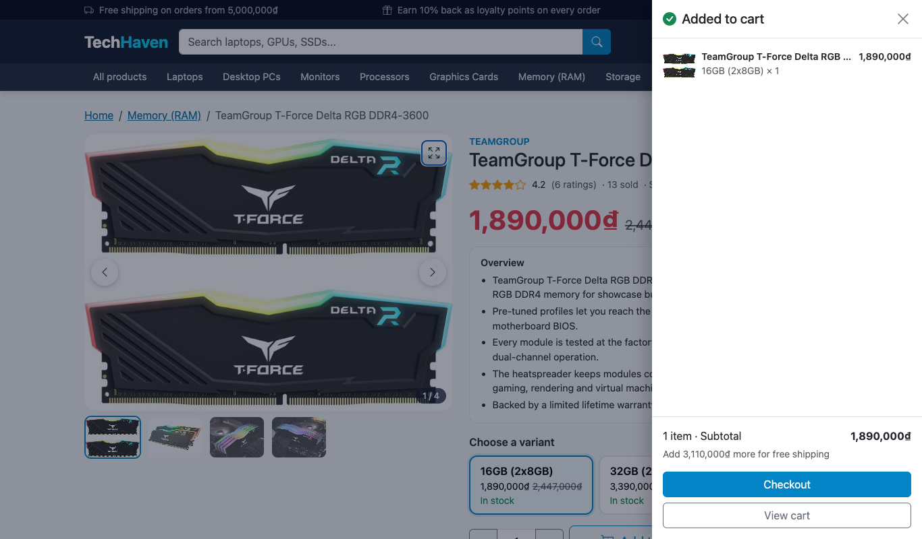
Figure A.13. Mini-cart after "Add to cart"
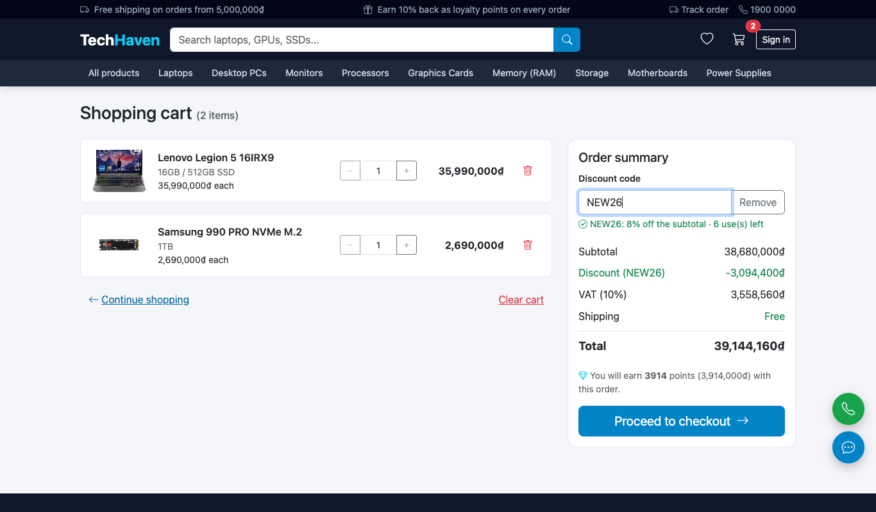
Figure A.14. Cart with a valid discount code
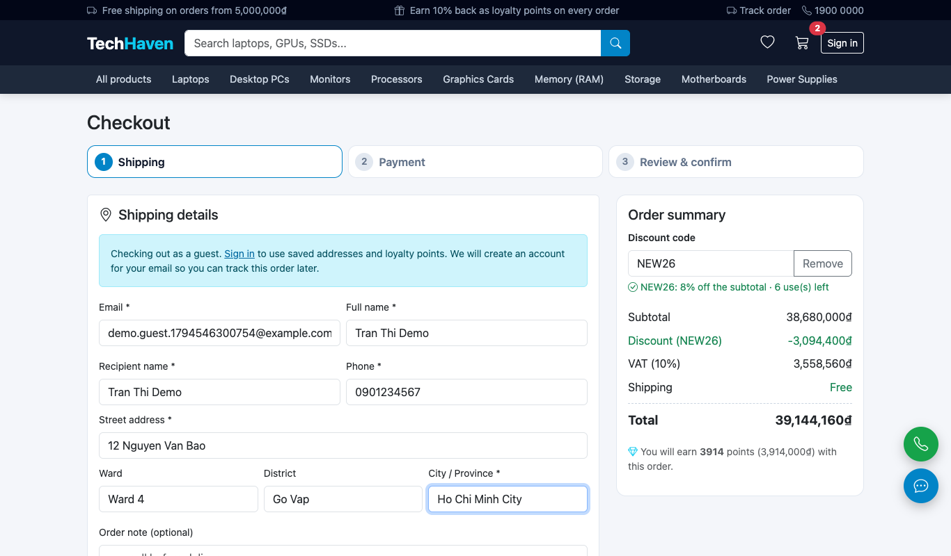
Figure A.15. Checkout step 1 - shipping (guest)
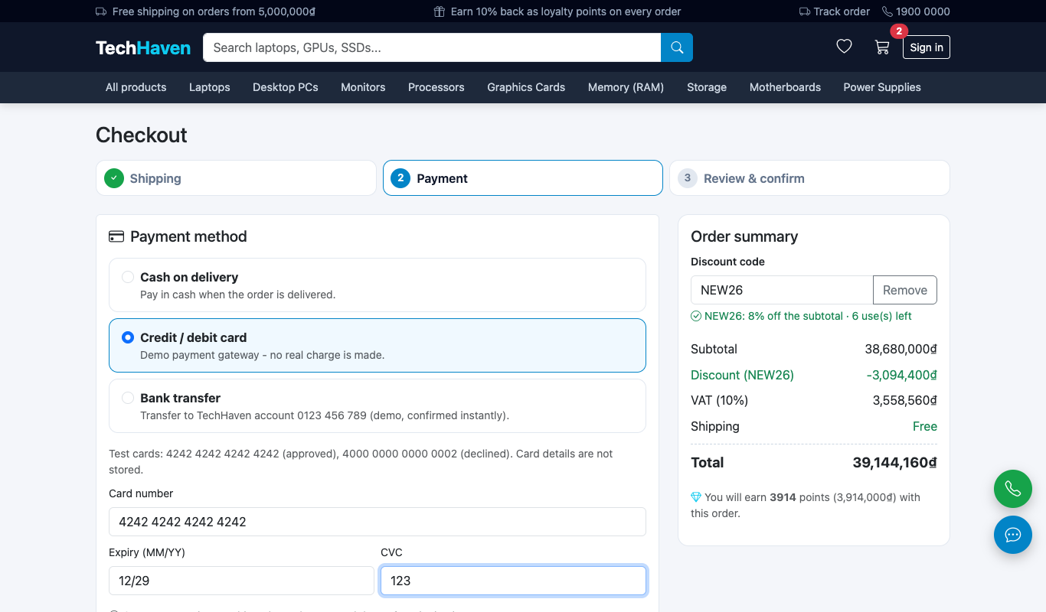
Figure A.16. Checkout step 2 - payment
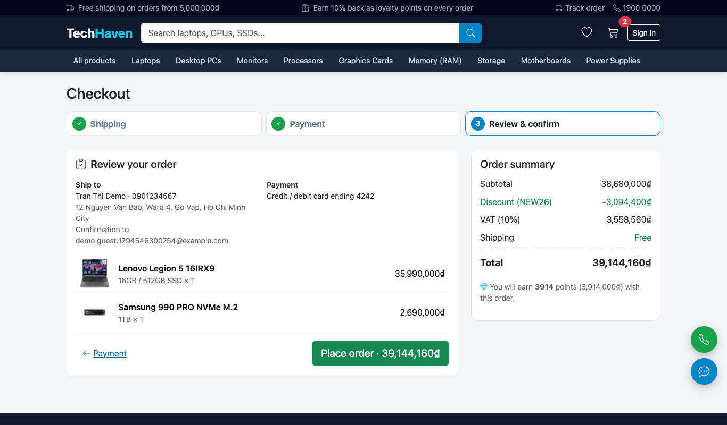
Figure A.17. Checkout step 3 - review and confirm
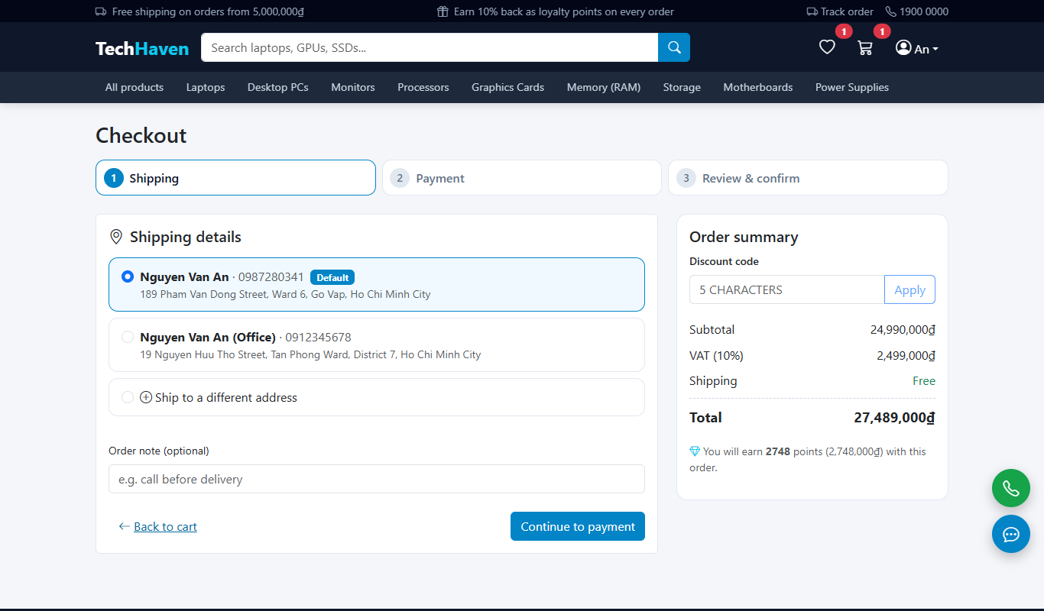
Figure A.18. Saved addresses with the default pre-selected
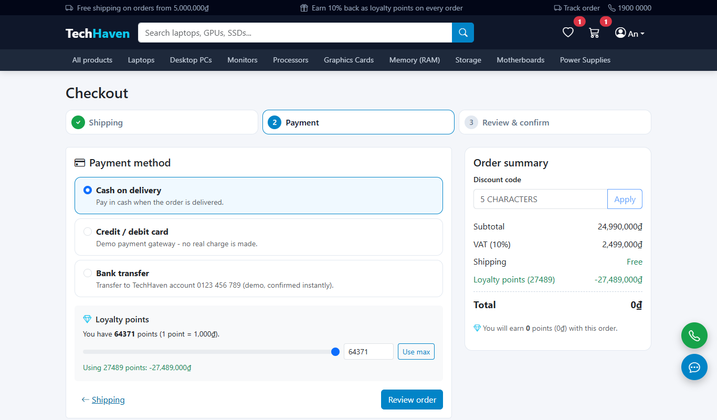
Figure A.19. Spending loyalty points
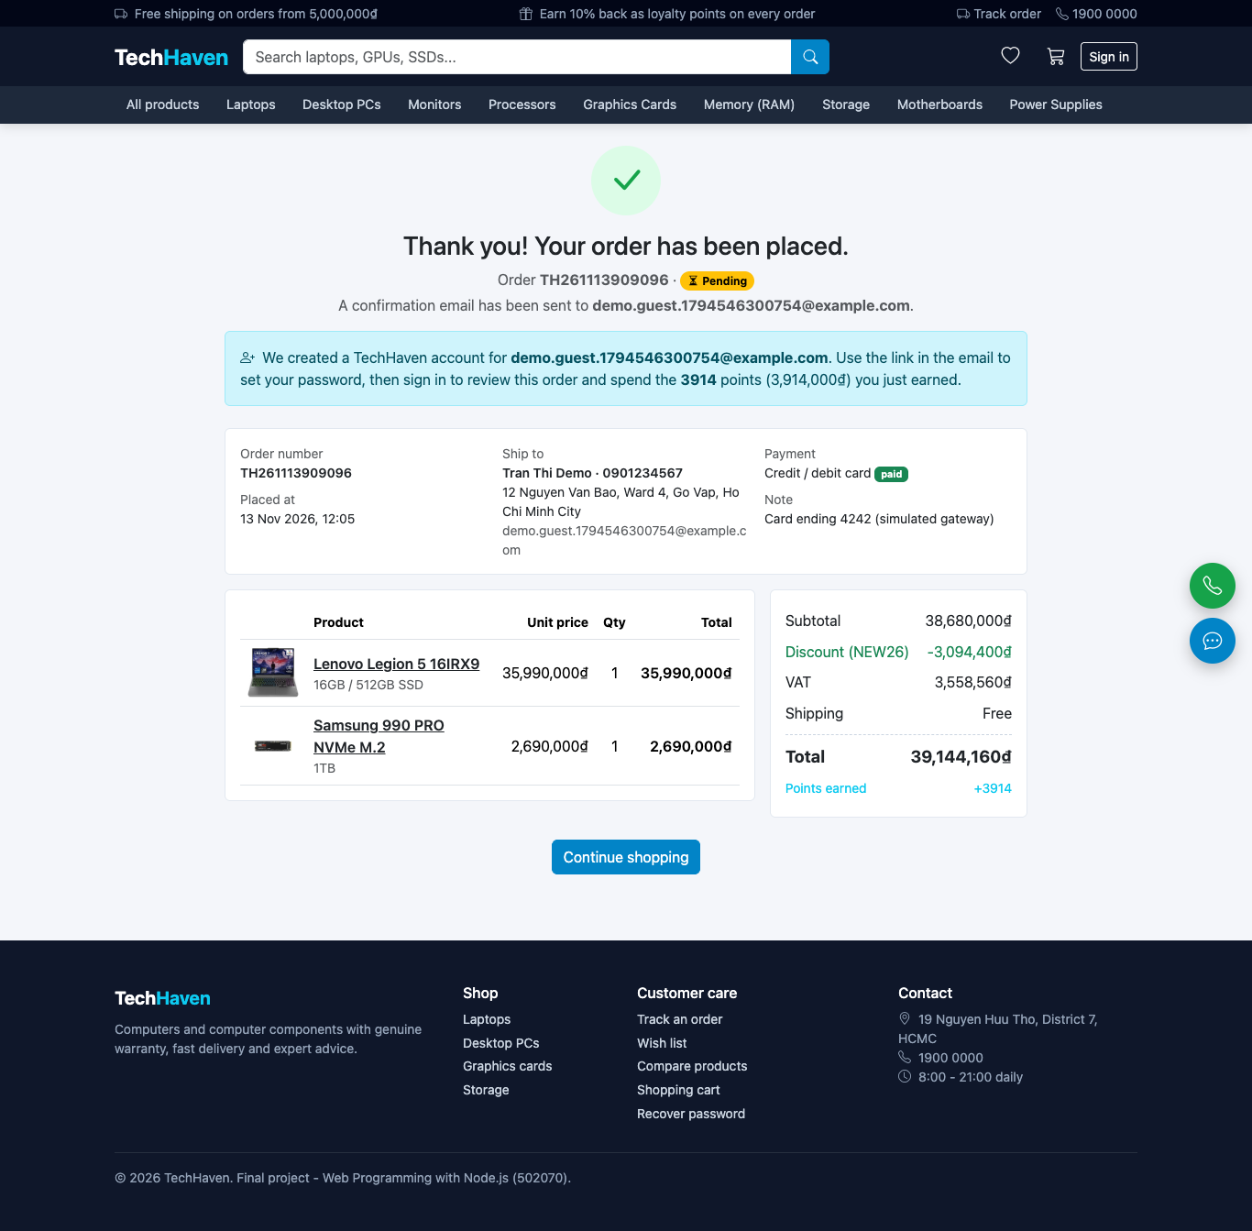
Figure A.20. Order success screen after a guest checkout

A.5 Accounts, Orders and Shopping Aids
Registration asks only for e-mail, full name and address; sign-in offers e-mail and password or Google; recovery sends a reset link (Figure A.21 to Figure A.23). In these screenshots Google sign-in is shown as not configured because no OAuth client was set. The profile page manages personal data, the password and several addresses; the order pages show the history and the status timeline, newest first (Figure A.24 to Figure A.26). Any order can also be tracked with its number and e-mail (Figure A.27), and products can be compared or saved to the wish list (Figure A.28 to Figure A.30).
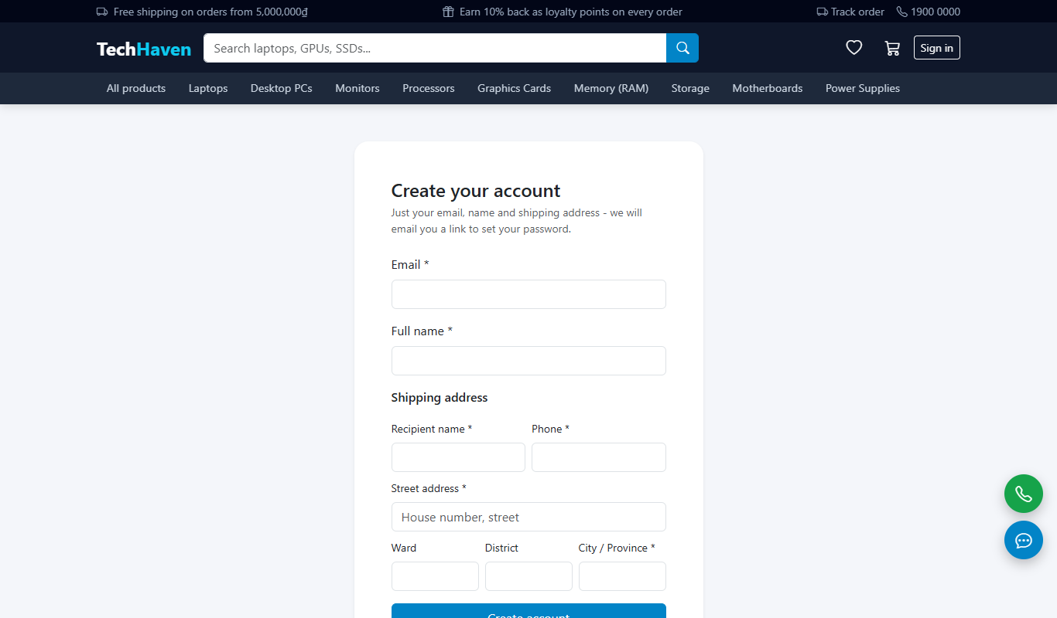
Figure A.21. Registration with e-mail, full name and address
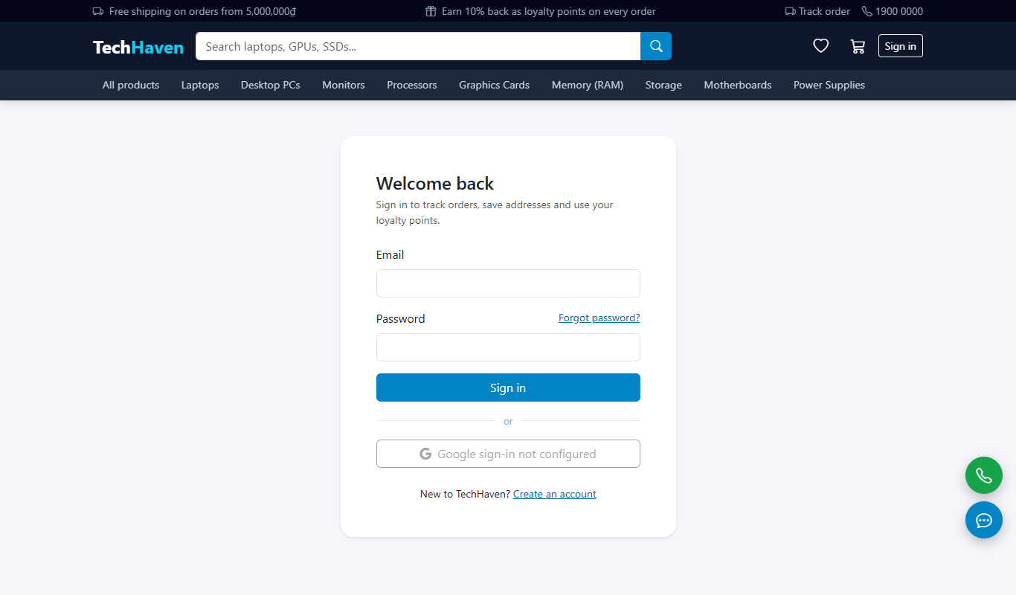
Figure A.22. Sign-in page
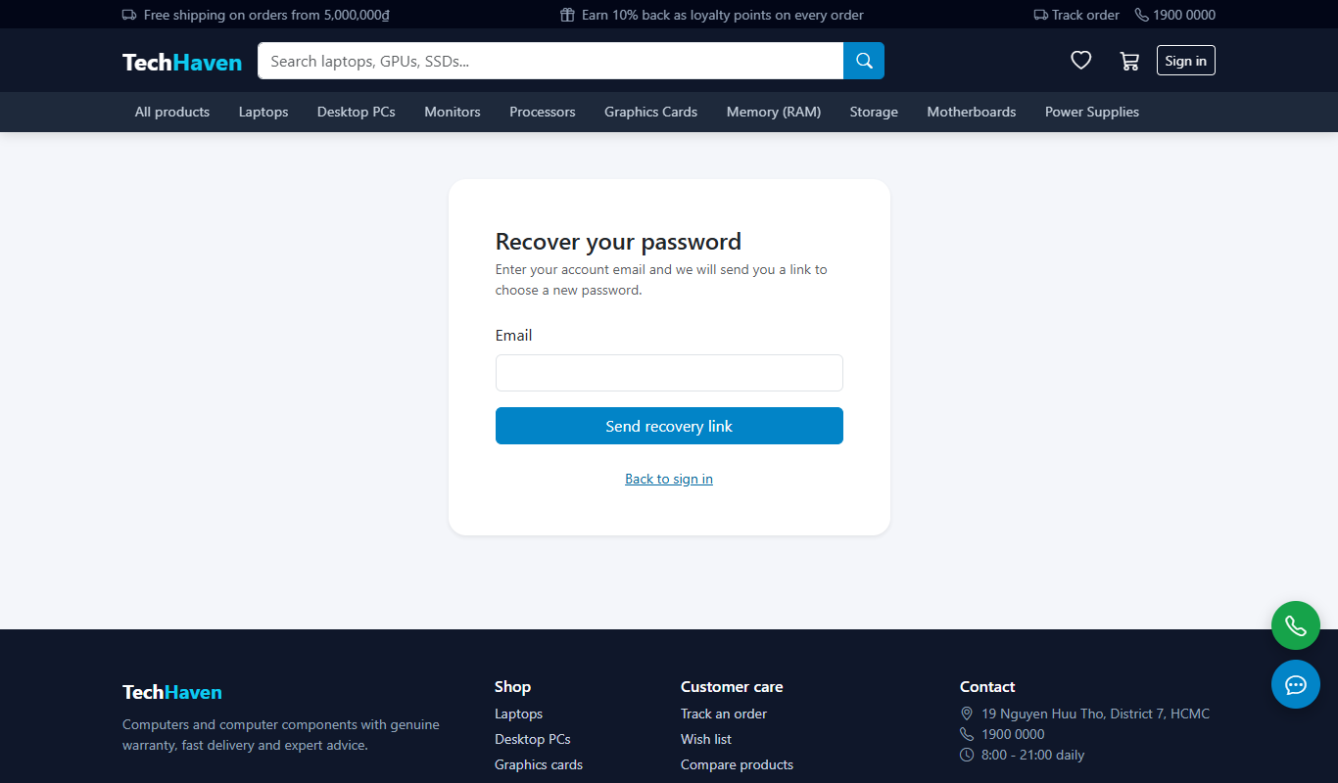
Figure A.23. Password recovery
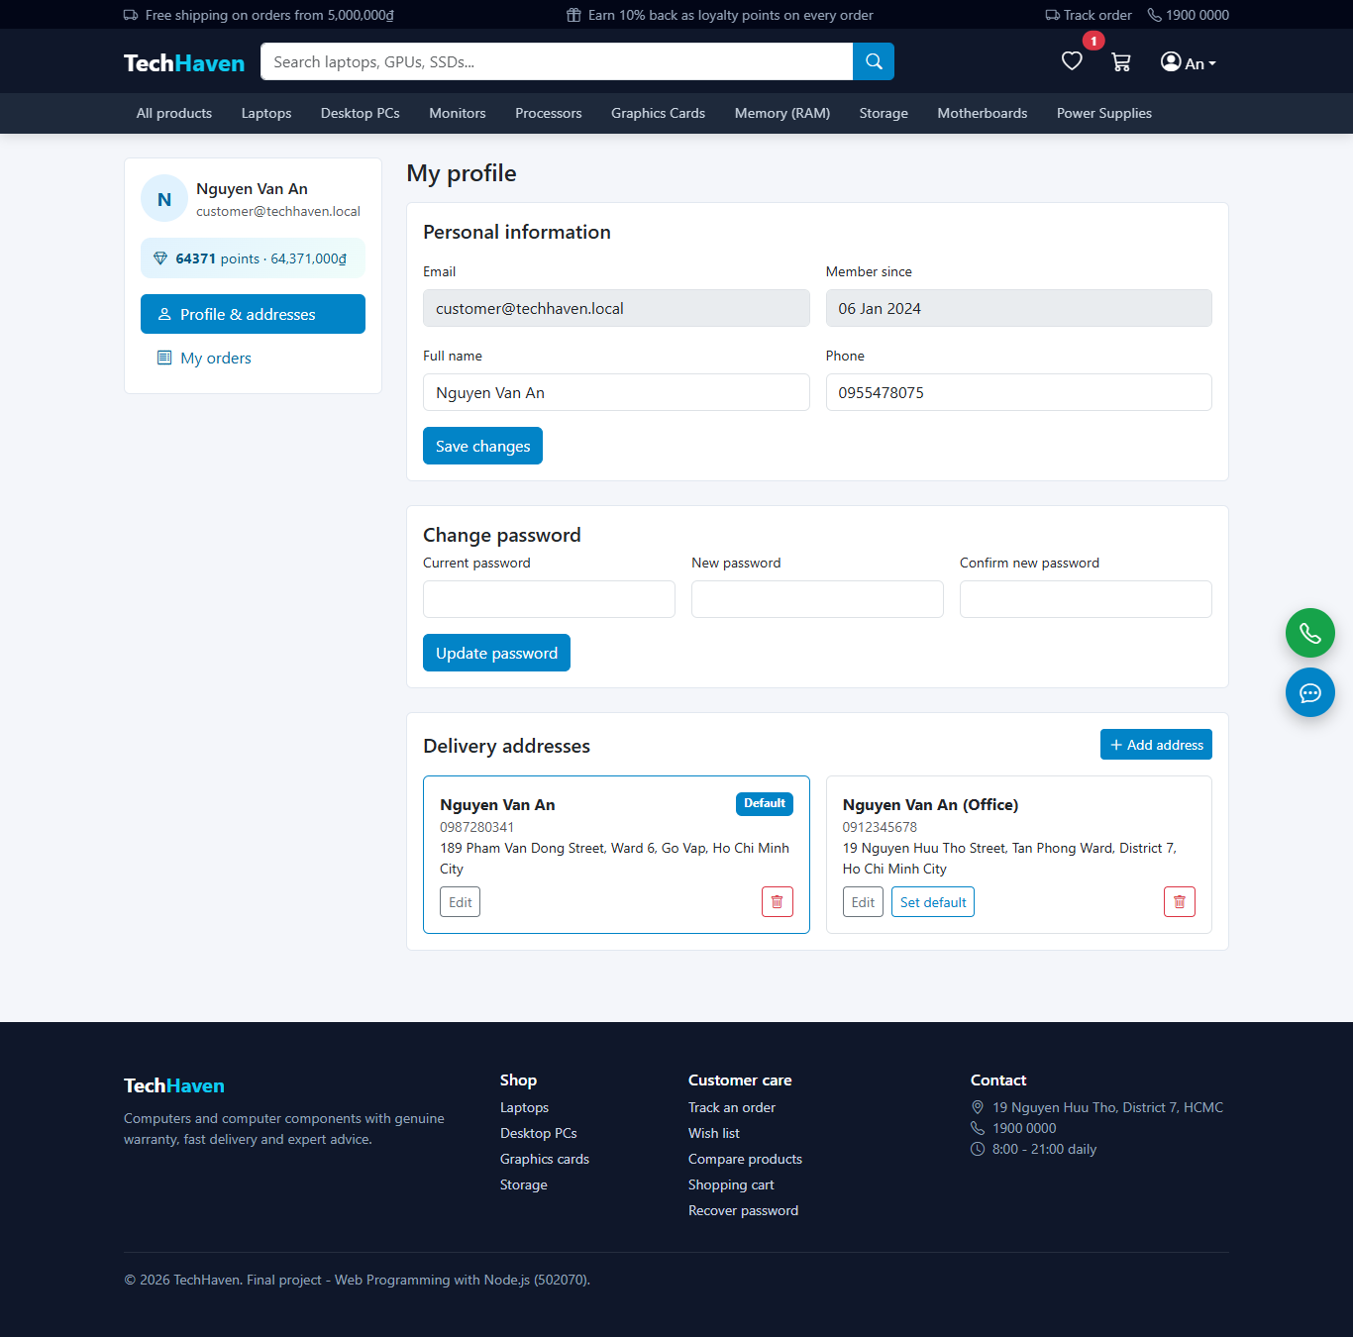
Figure A.24. Profile, password and addresses
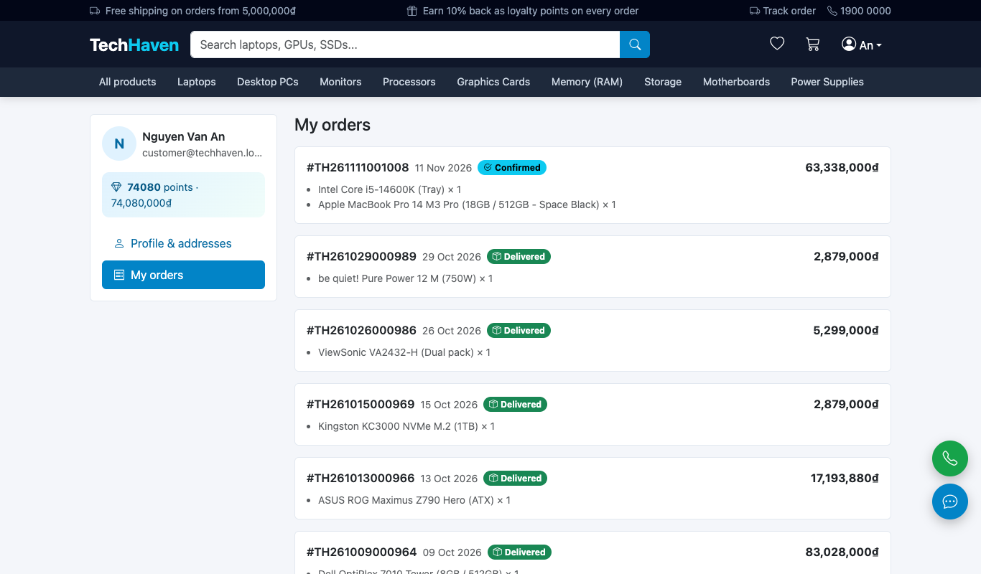
Figure A.25. Order history
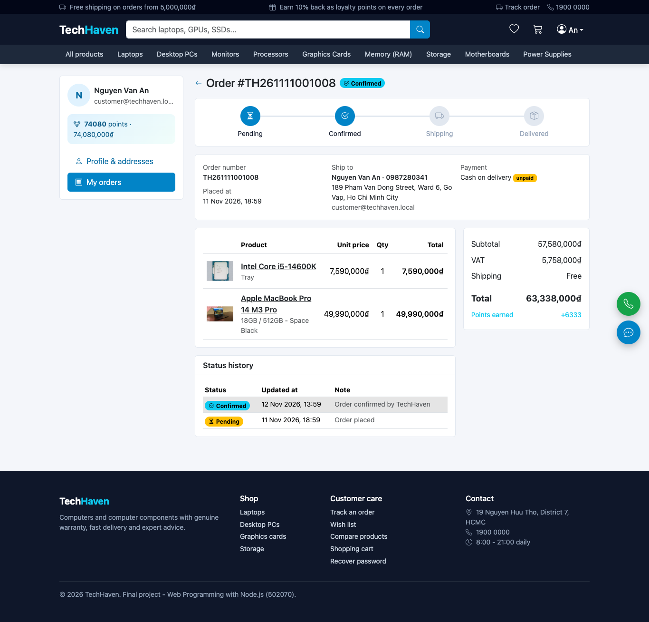
Figure A.26. Order details with status history
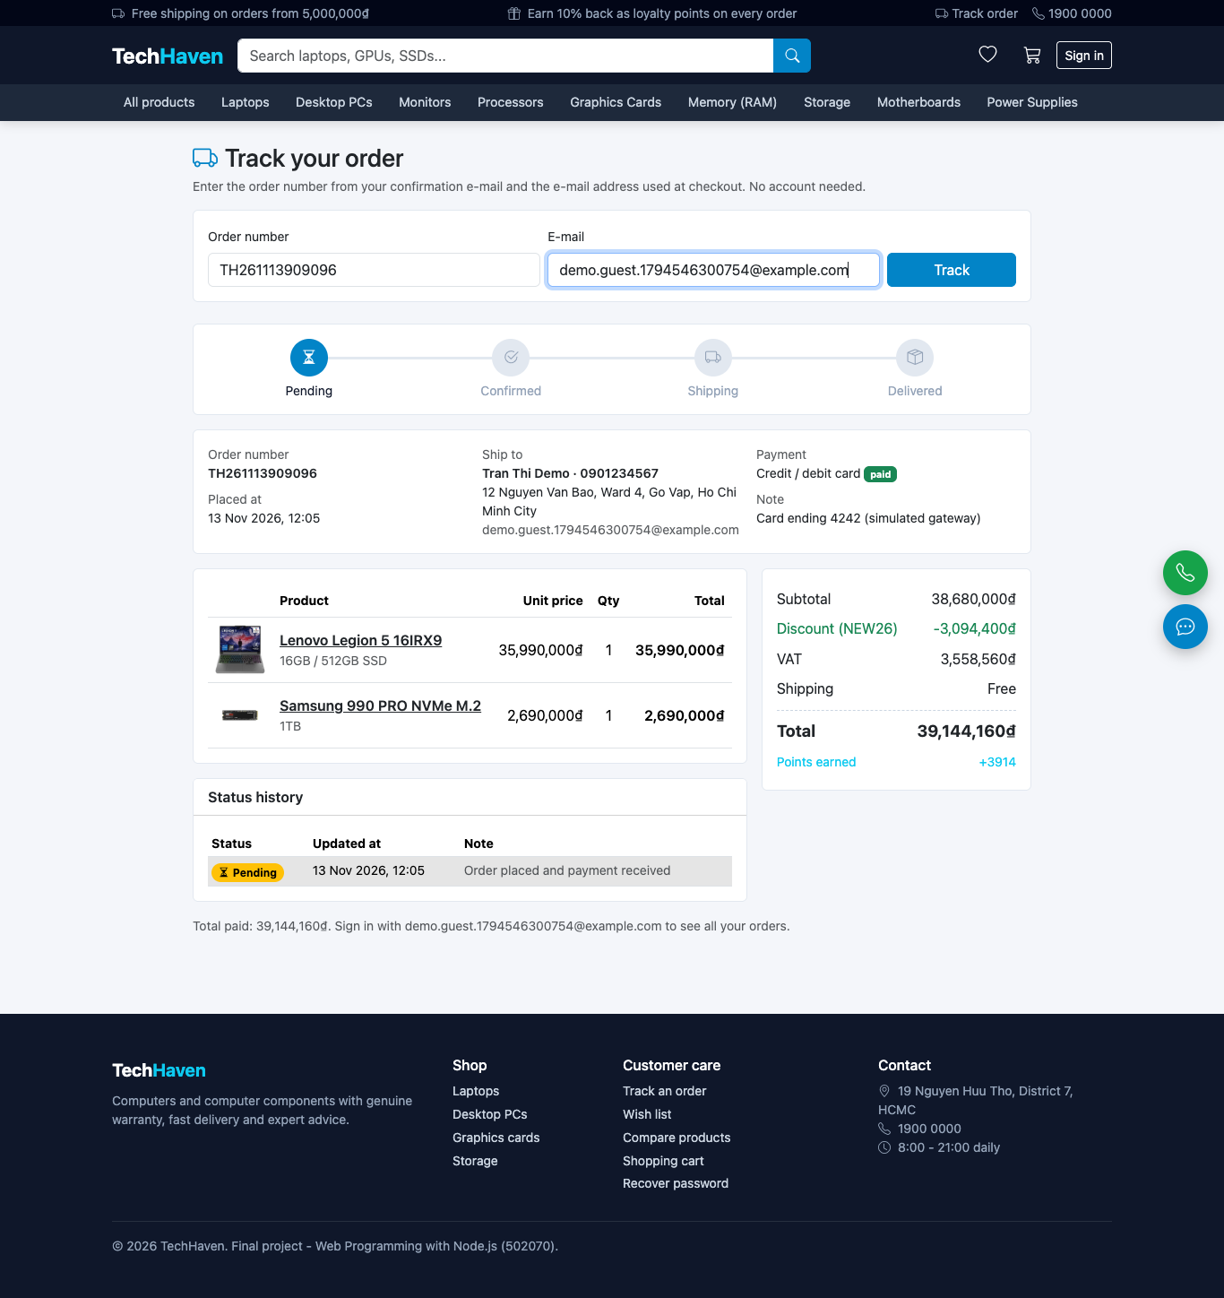
Figure A.27. Tracking an order without signing in
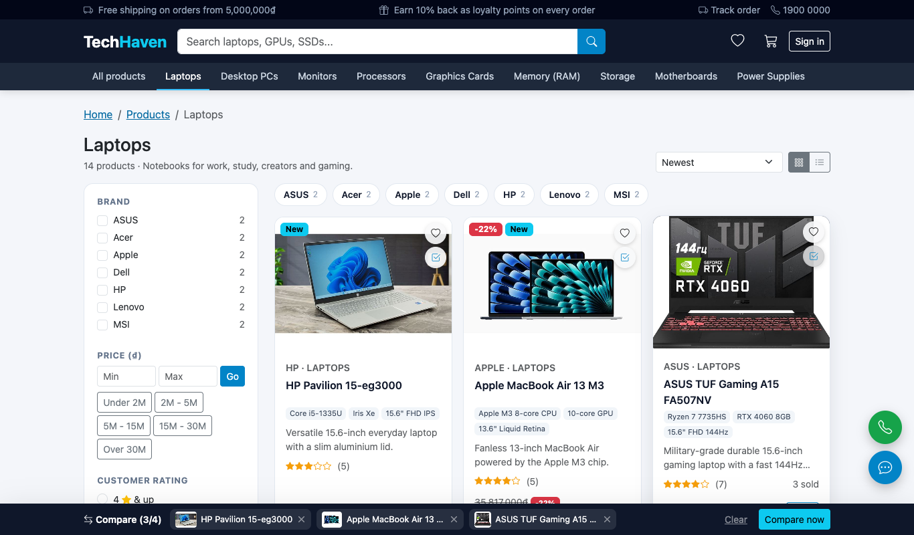
Figure A.28. Products selected for comparison
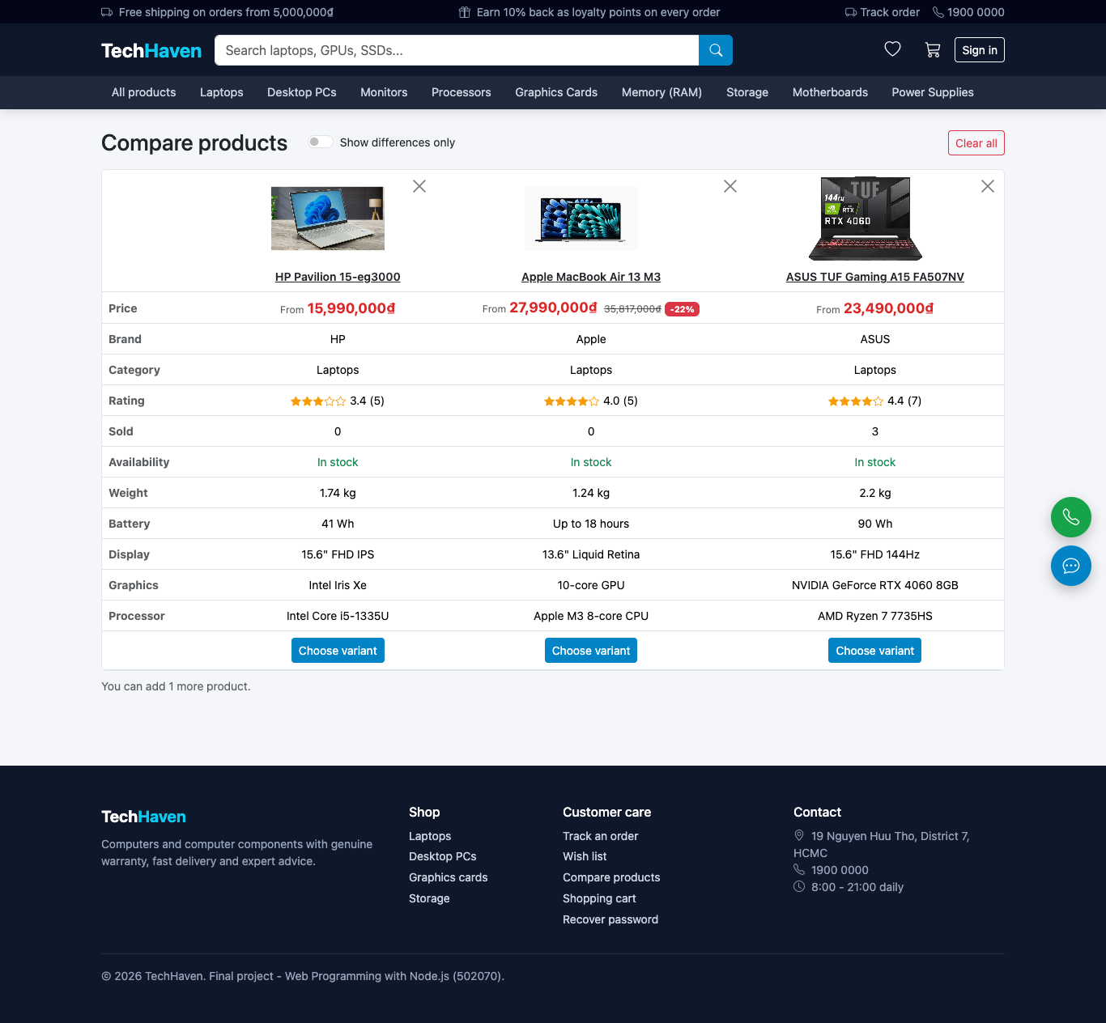
Figure A.29. Comparison of three laptops
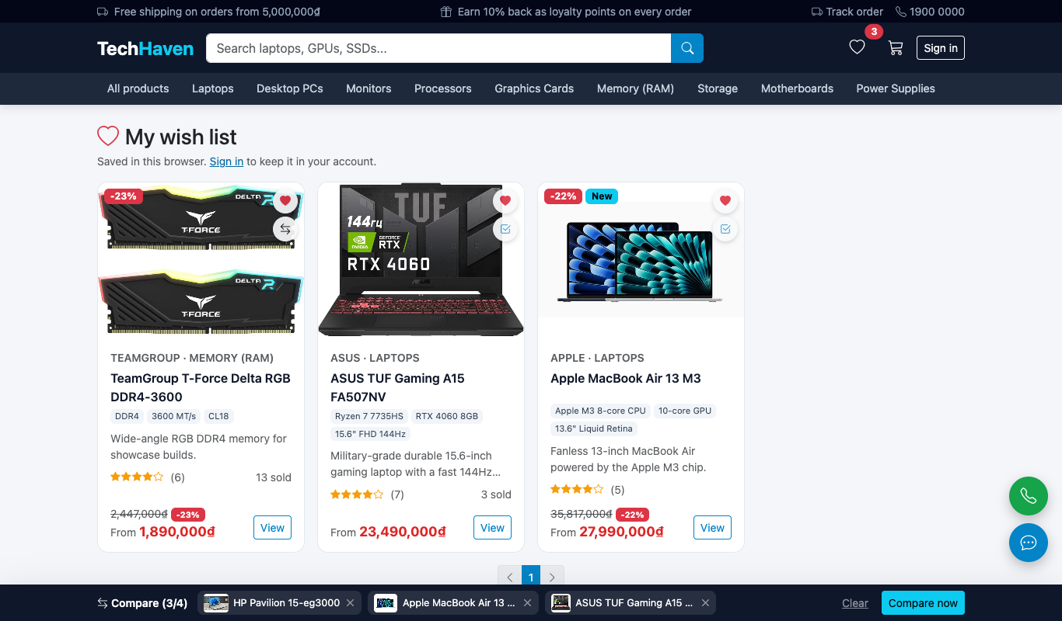
Figure A.30. Wish list

A.6 Administrator Console
The product form contains the image manager: Figure A.31 shows it with four uploaded images and Figure A.32 after reaching the limit of ten, with the cover moved to another image, the upload area disabled and the eleventh file skipped. Each variant has an optional original price (Figure A.33). The other figures show categories, the simple dashboard with its "Needs attention" insights, the advanced dashboard, orders, users and discount codes (Figure A.34 to Figure A.43).
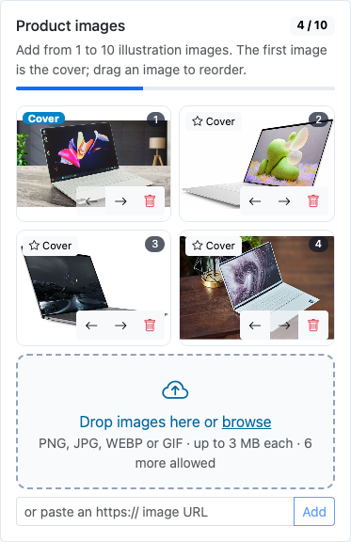
Figure A.31. Image manager with 4 of 10 images
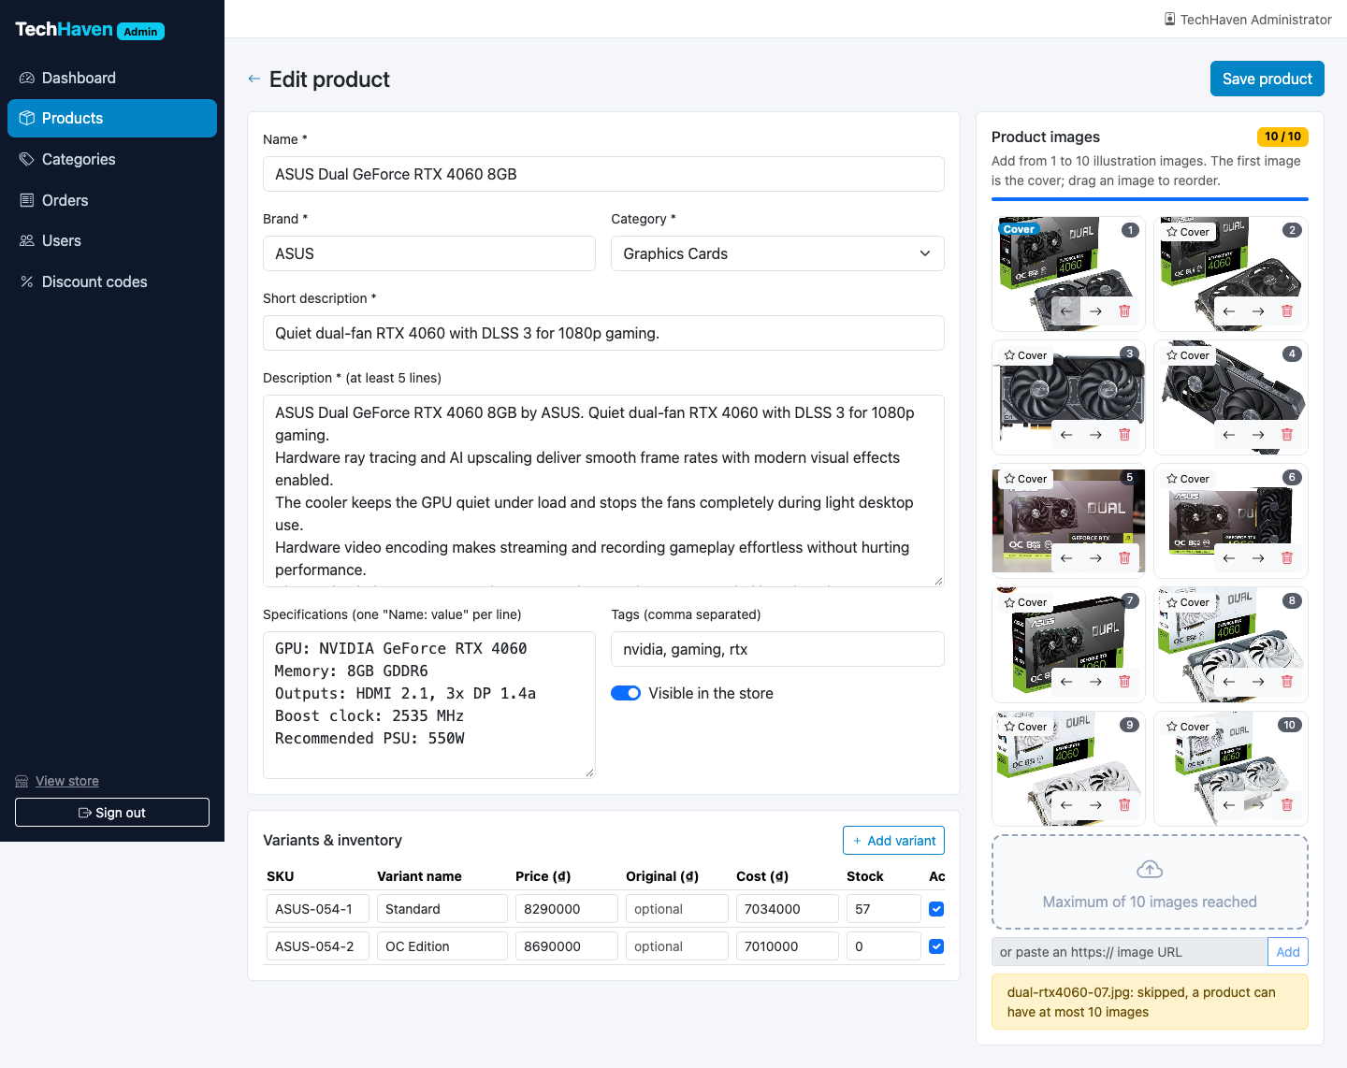
Figure A.32. Product form with 10 of 10 images; the 11th file is skipped
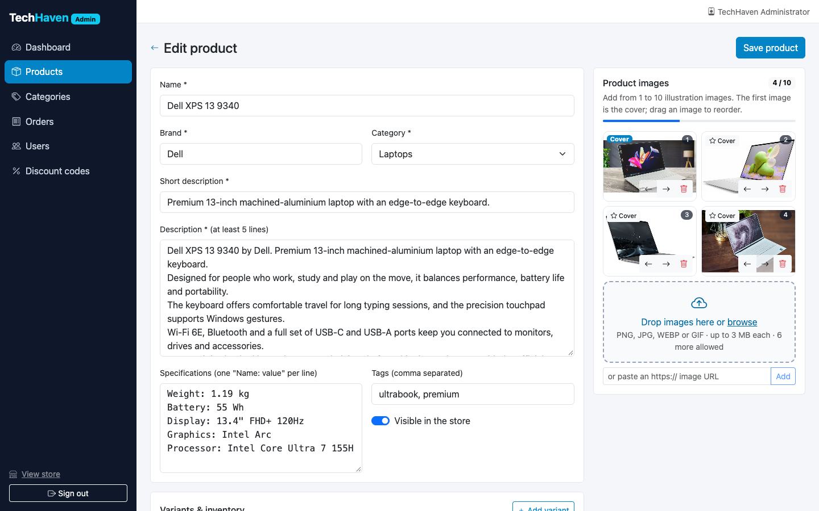
Figure A.33. Variants with selling price, original price, cost and stock
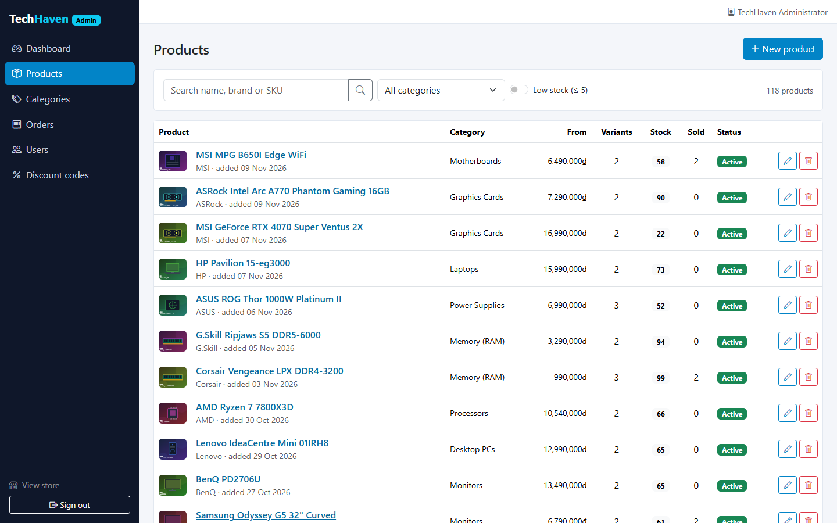
Figure A.34. Product management
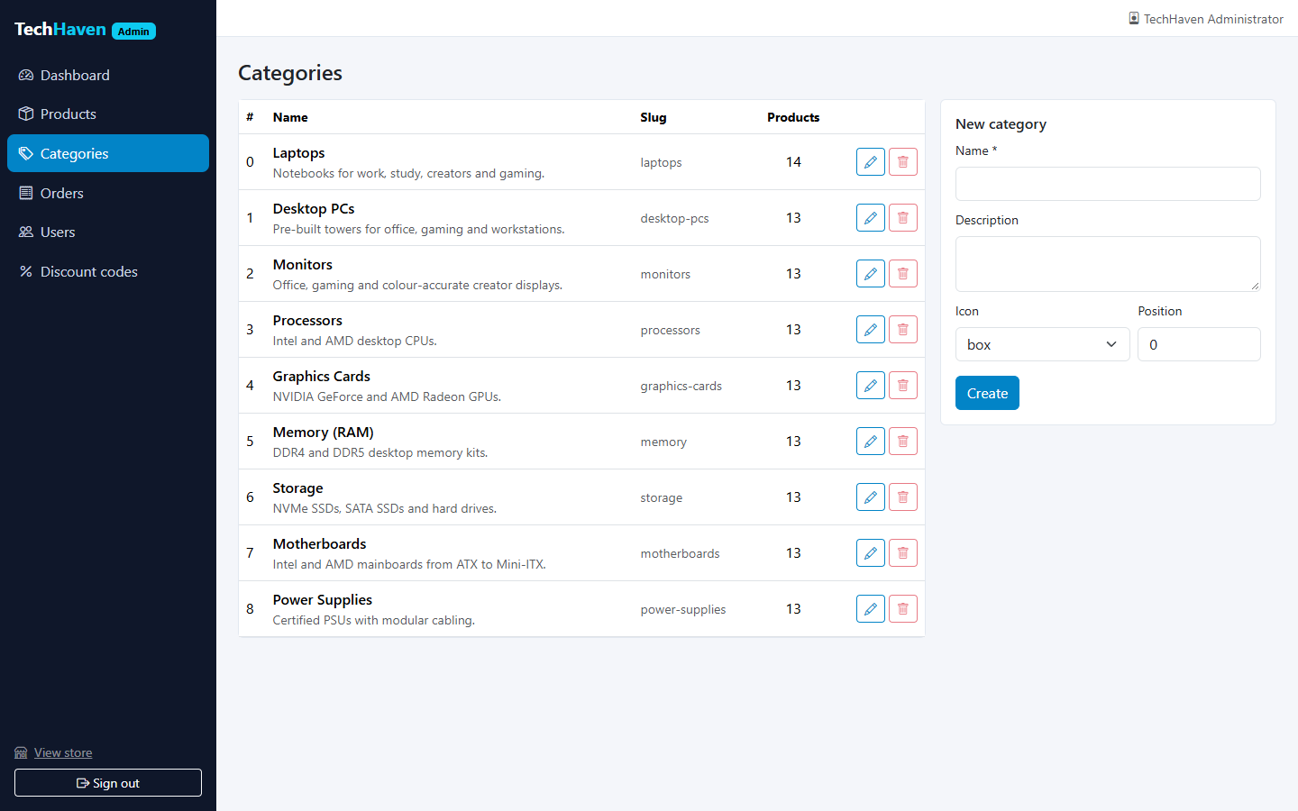
Figure A.35. Category management
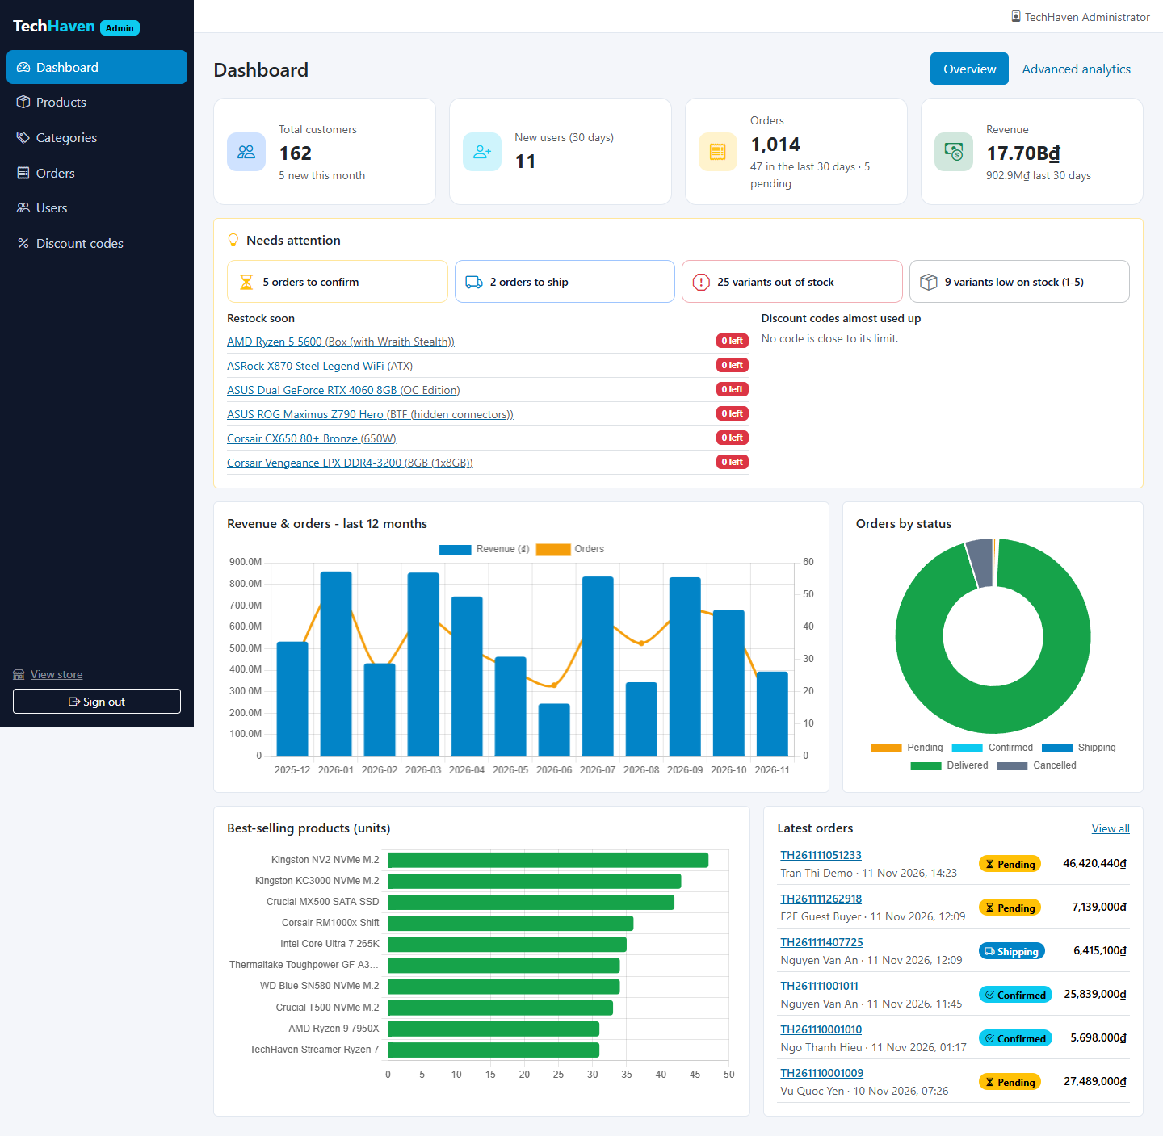
Figure A.36. Simple dashboard
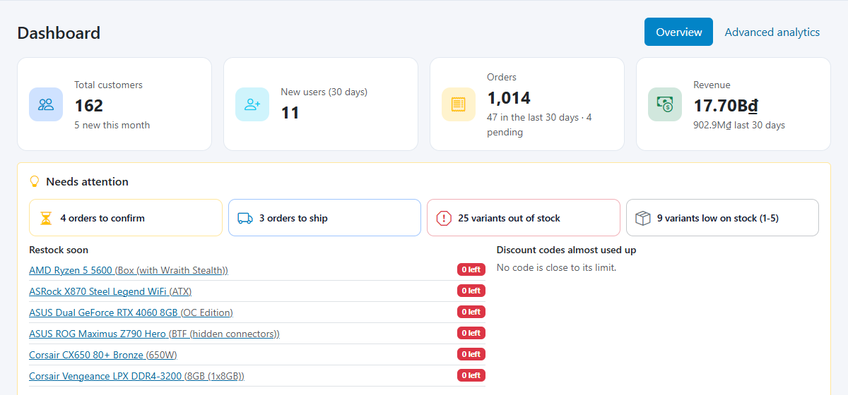
Figure A.37. Actionable insights on the simple dashboard
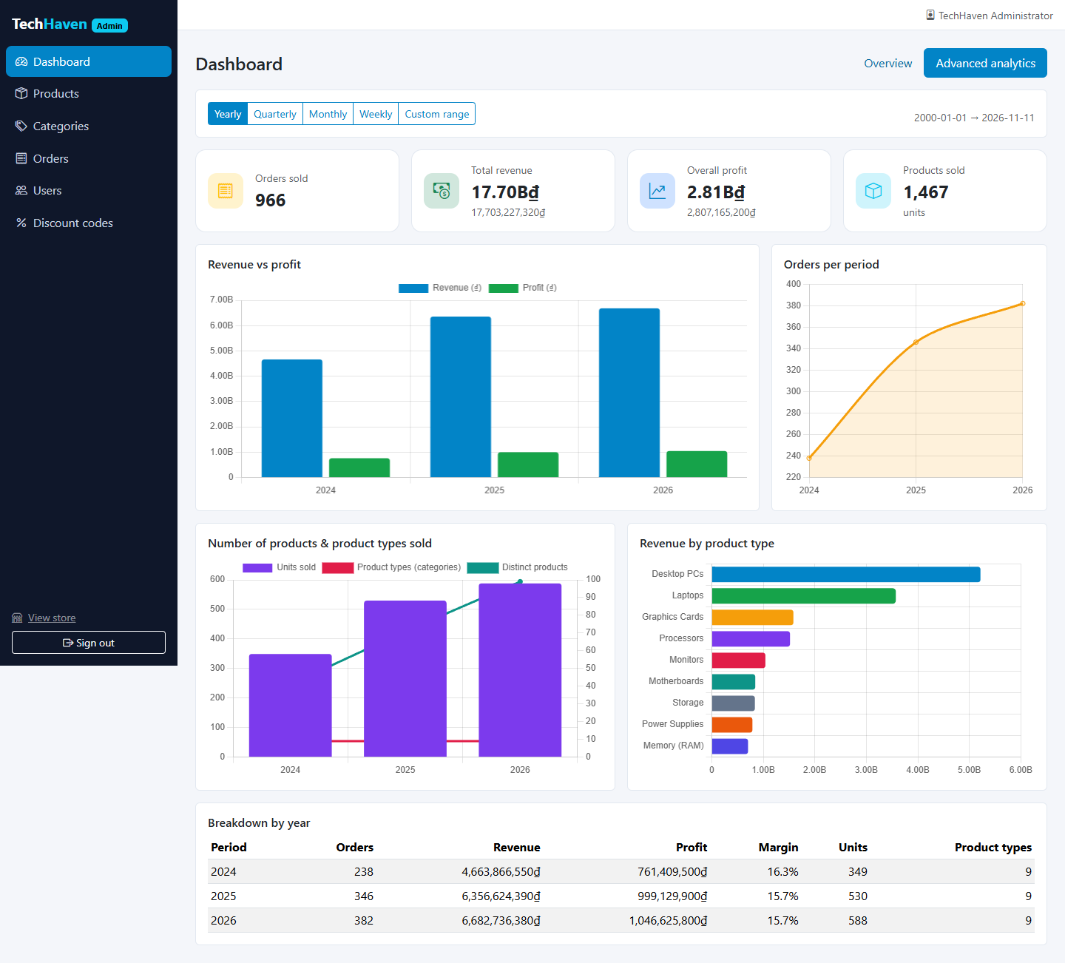
Figure A.38. Advanced dashboard - yearly view (default)
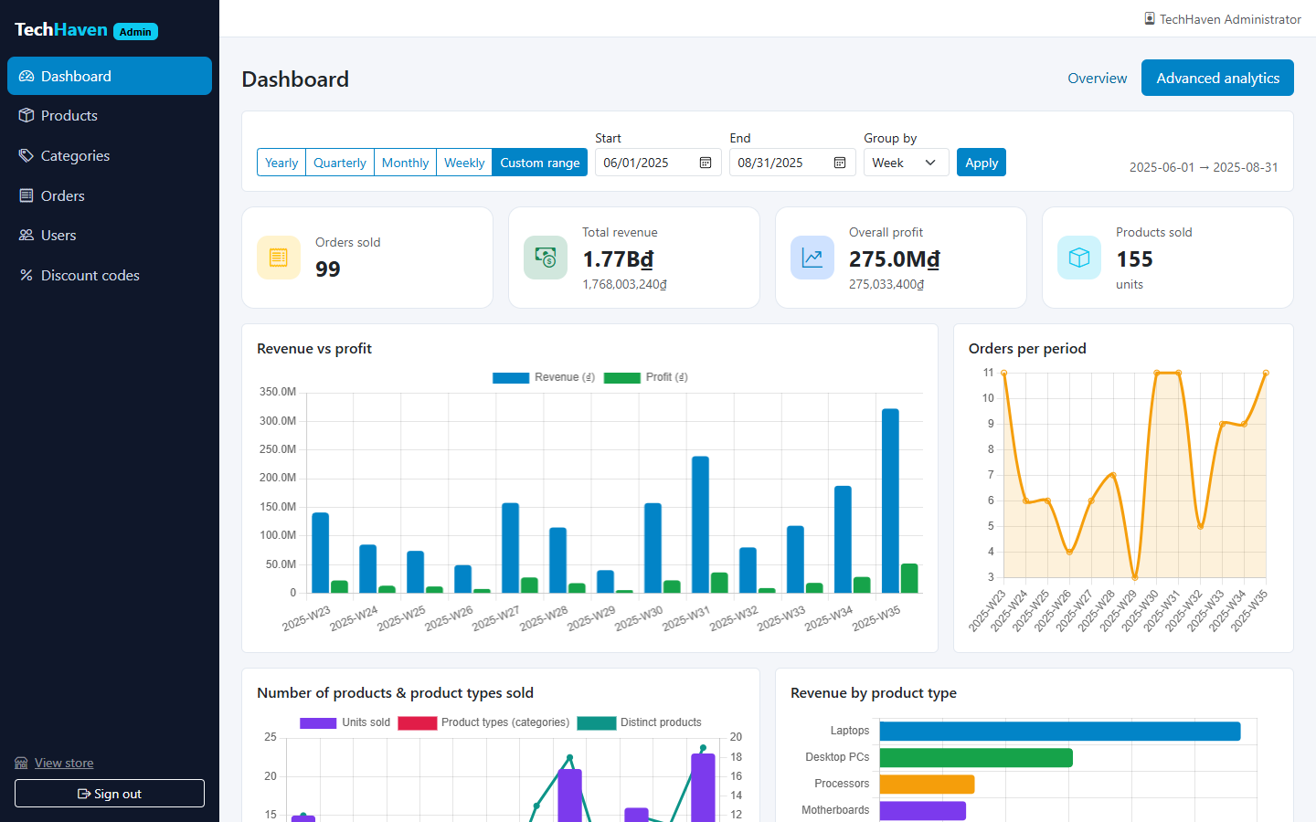
Figure A.39. Advanced dashboard - custom range grouped by week
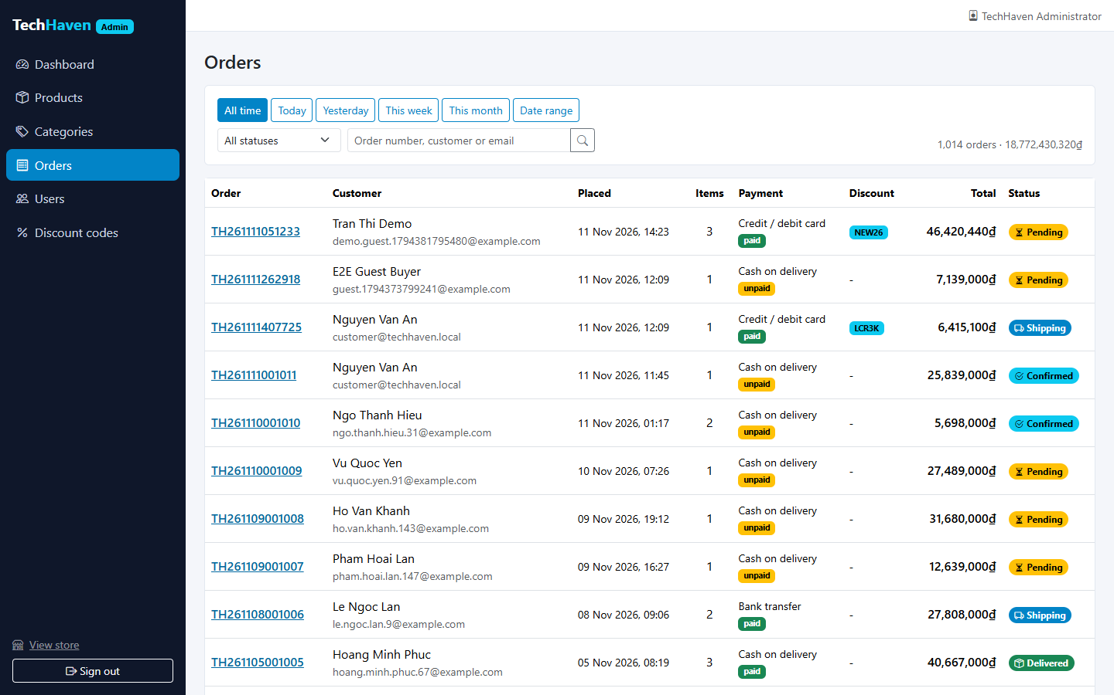
Figure A.40. Order list, newest first, 20 per page
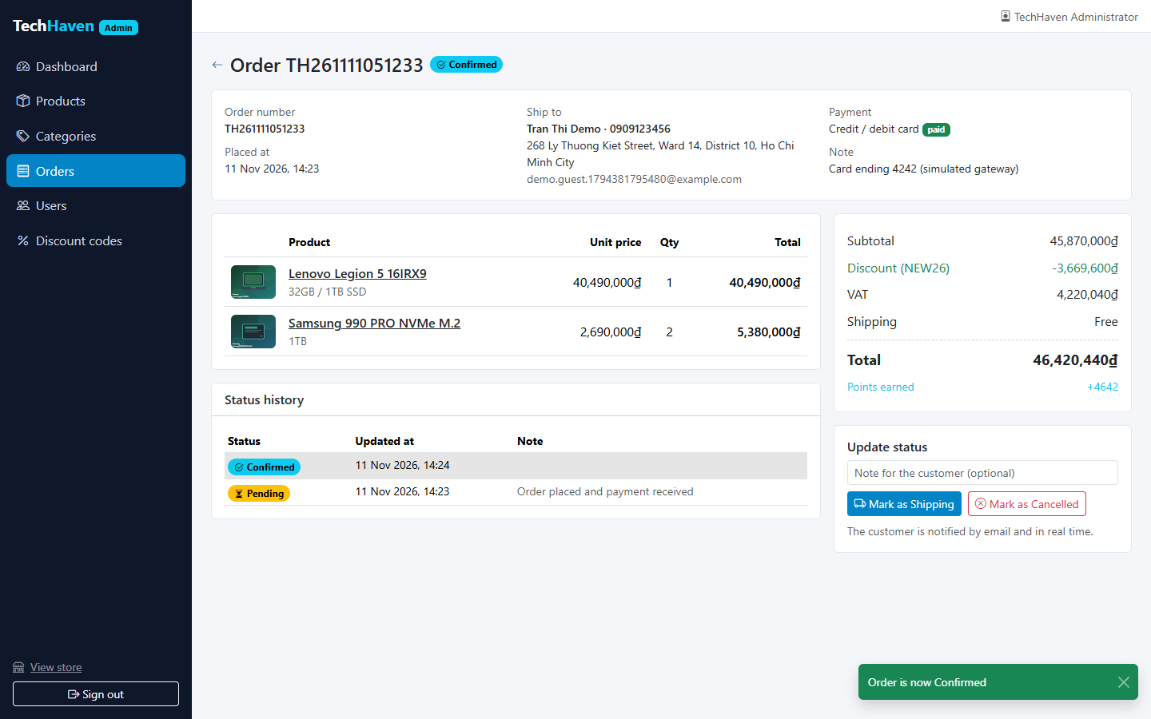
Figure A.41. Order details and status update
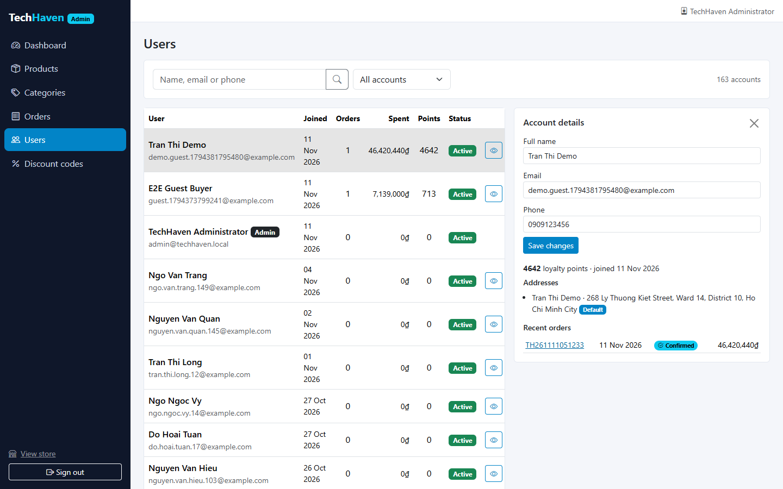
Figure A.42. User management
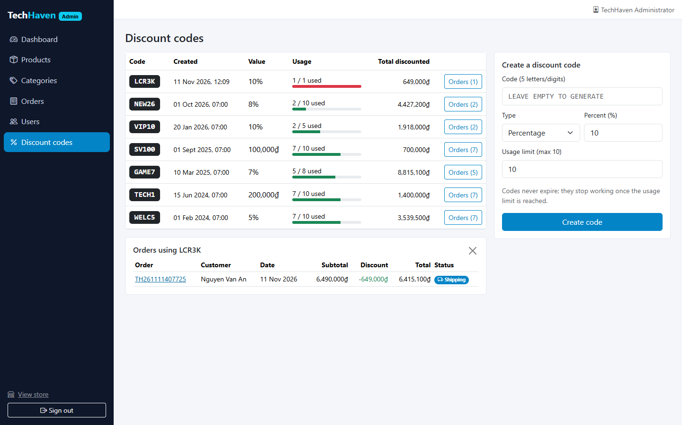
Figure A.43. Discount codes with usage and orders

A.7 AI Assistant, E-mail, Responsive Design and Infrastructure
The AI assistant answers in Vietnamese and English with products from the catalogue (Figure A.44, Figure A.45). Every e-mail sent by the shop appears in the Mailpit inbox (Figure A.46, Figure A.47). Figure A.48 to Figure A.51 show the store on a phone (390 × 844) and a tablet (820 × 1180), and Figure A.52 the durable queues in RabbitMQ.
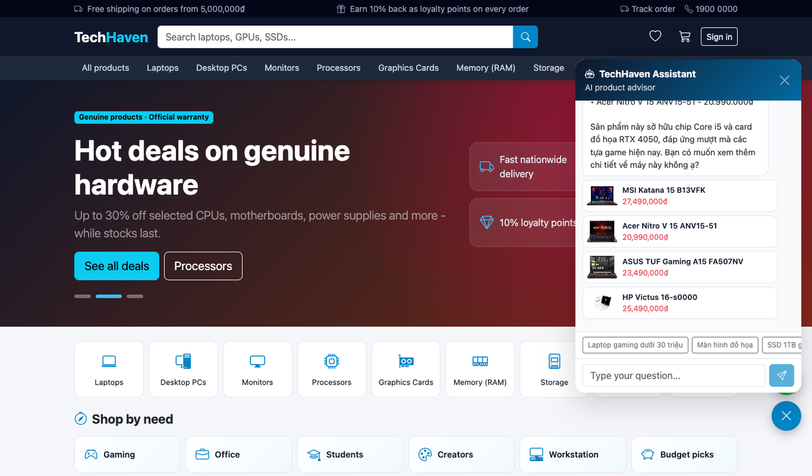
Figure A.44. AI assistant (Gemini): gaming laptops under 30 million VND and a follow-up question (Vietnamese)
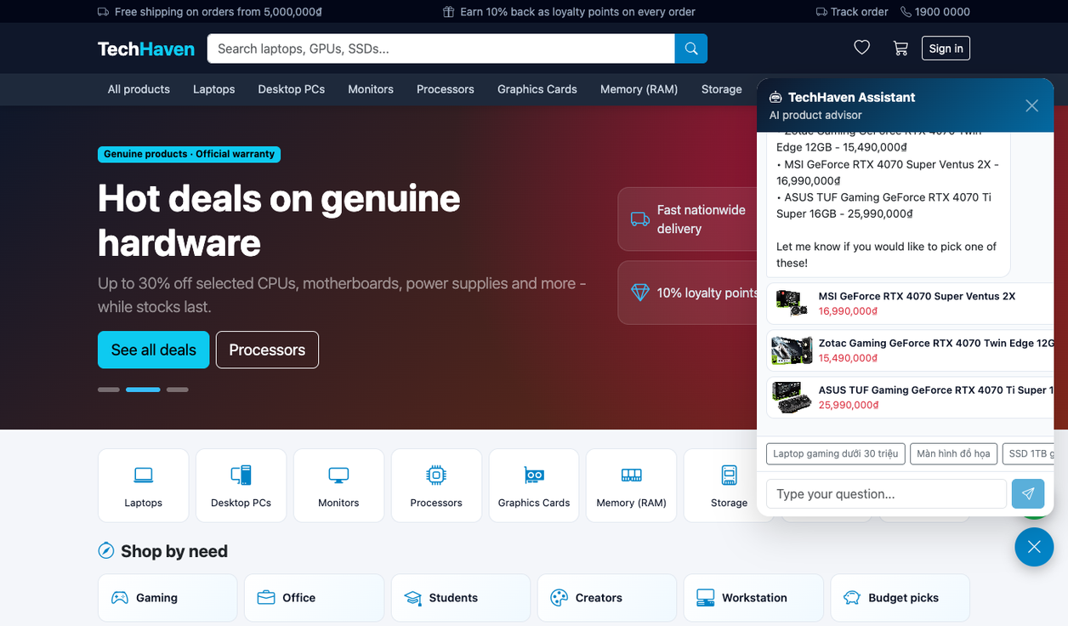
Figure A.45. AI assistant (Gemini): a specific graphics card (English)
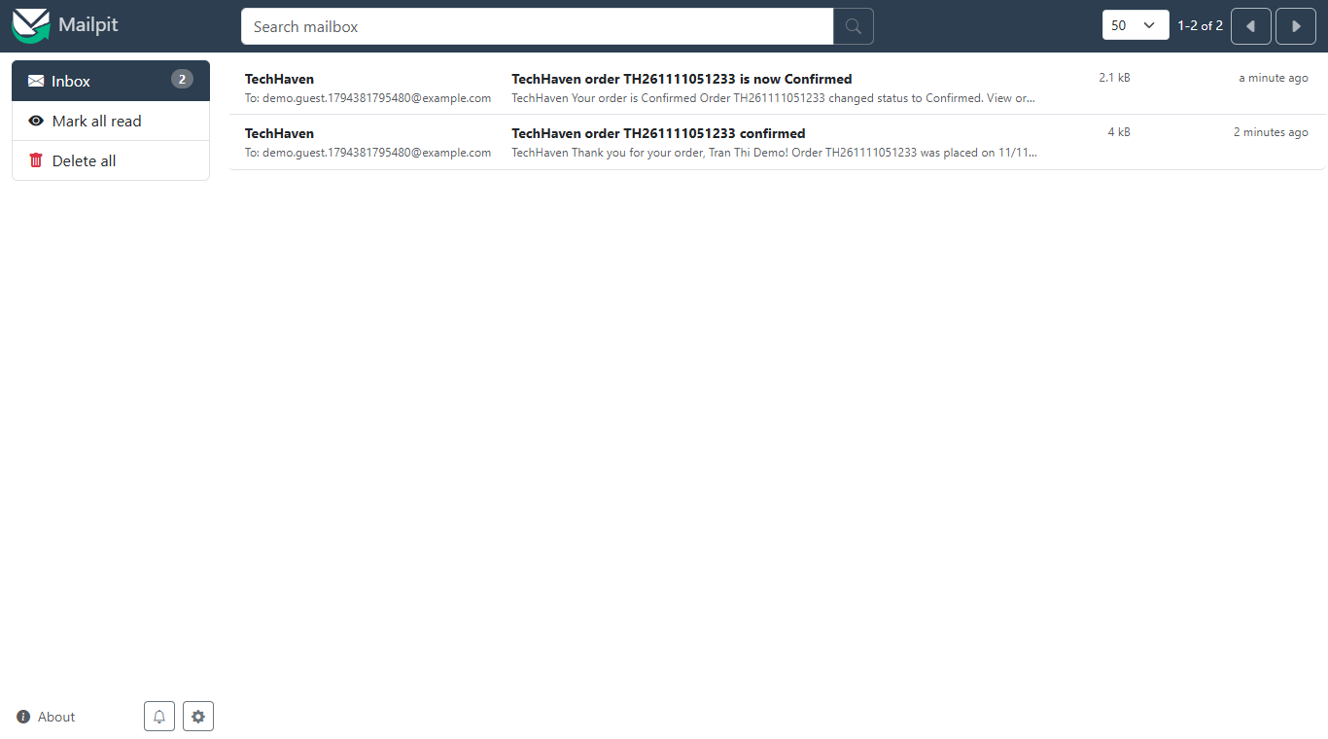
Figure A.46. Mailpit inbox with the e-mails sent by the shop
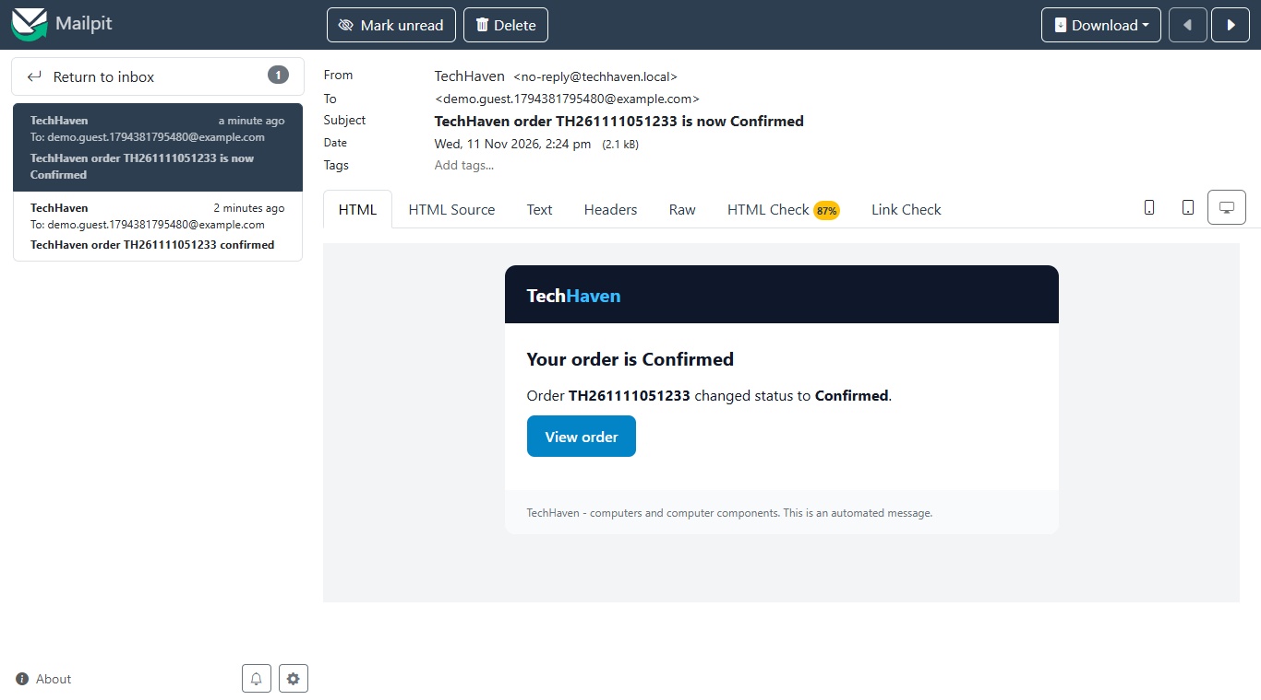
Figure A.47. Order confirmation e-mail
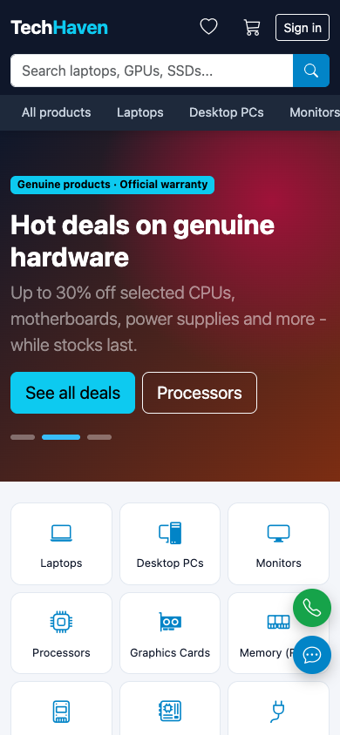
Figure A.48. Landing page on a phone
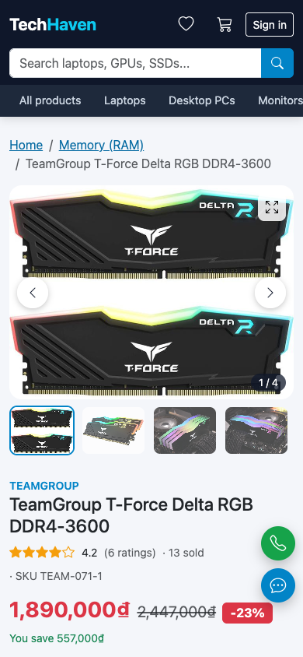
Figure A.49. Product page on a phone
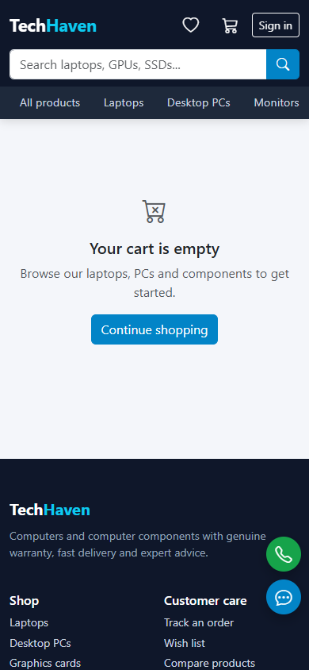
Figure A.50. Cart on a phone
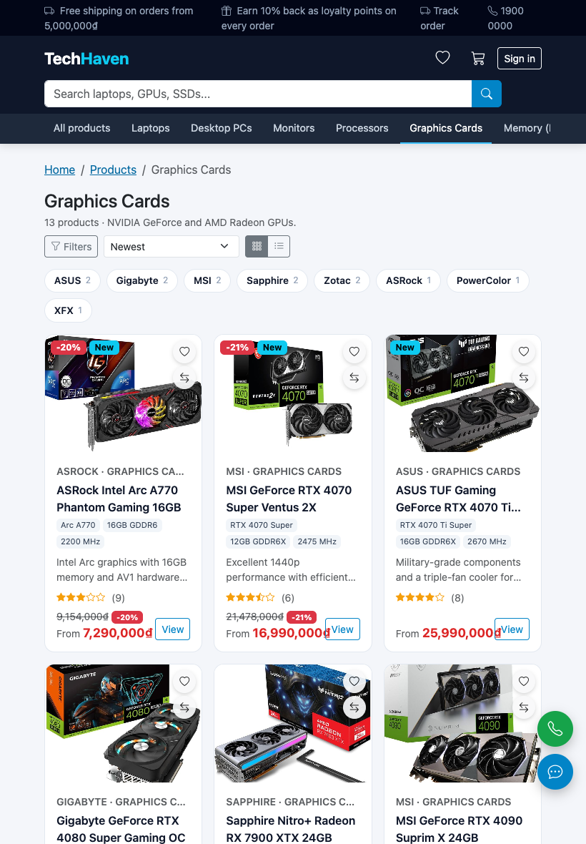
Figure A.51. Catalogue on a tablet
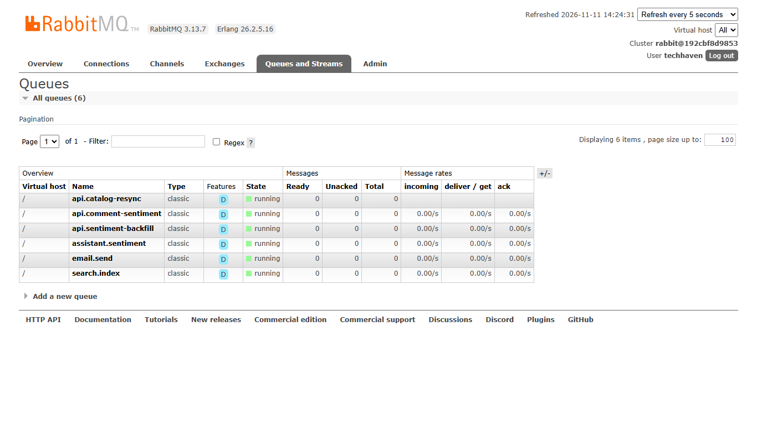
Figure A.52. Durable queues in RabbitMQ

APPENDIX B. COMPLETE TEST RESULTS
Generated from Bonus/unit-test-output.txt and Bonus/e2e-test-output.txt (final run: 25 of 25 unit tests and 66 of 66 end-to-end checks passed).
Table B.1. Complete test results
ID | Type | Test case | Result
U01 | Unit | image type is detected from the file signature | Pass
U02 | Unit | a product needs between 1 and 10 images | Pass
U03 | Unit | duplicates are removed and only safe sources are accepted | Pass
U04 | Unit | loyalty: 1,000,000 VND earns 100 points worth 100,000 VND | Pass
U05 | Unit | discount codes are exactly five alphanumeric characters | Pass
U06 | Unit | percent and fixed discounts never exceed the subtotal | Pass
U07 | Unit | quote: tax, shipping fee and total | Pass
U08 | Unit | quote: free shipping above the threshold | Pass
U09 | Unit | quote: points are capped by balance and by the order total | Pass
U10 | Unit | quote: discount is applied before tax | Pass
U11 | Unit | email is normalised and validated | Pass
U12 | Unit | phone accepts 9-15 digits with separators | Pass
U13 | Unit | password policy requires letters and digits | Pass
U14 | Unit | slugify handles Vietnamese characters | Pass
U15 | Unit | int enforces bounds and fallback | Pass
U16 | Unit | order confirmation lists items, totals and escapes HTML | Pass
U17 | Unit | guest checkout mail contains the set-password link | Pass
U18 | Unit | every template renders | Pass
U19 | Unit | sentiment: English comments | Pass
U20 | Unit | sentiment: Vietnamese comments with negation | Pass
U21 | Unit | budget parsing in both languages | Pass
U22 | Unit | intent: category, usage, brand, model, FAQ and language | Pass
U23 | Unit | intent: product words are not read as uses or policy questions | Pass
U24 | Unit | LLM prompt: grounded turns and Gemini conversion | Pass
U25 | Unit | follow-up questions keep the previous request | Pass
E01 | End-to-end | requests are served by several API replicas | Pass
E02 | End-to-end | landing page has New, Best Sellers and >= 3 category sections | Pass
E03 | End-to-end | catalogue is paginated | Pass
E04 | End-to-end | sort by name A-Z | Pass
E05 | End-to-end | sort by price high-low | Pass
E06 | End-to-end | filter by brand + price range + rating | Pass
E07 | End-to-end | keyword search uses ElasticSearch | Pass
E08 | End-to-end | search tolerates typos | Pass
E09 | End-to-end | product detail: >= 2 variants, >= 3 images, >= 5 description lines | Pass
E10 | End-to-end | guests can comment | Pass
E11 | End-to-end | guests cannot rate | Pass
E12 | End-to-end | customer can sign in | Pass
E13 | End-to-end | signed-in customer can rate | Pass
E14 | End-to-end | customer has several delivery addresses with a default | Pass
E15 | End-to-end | admin can sign in | Pass
E16 | End-to-end | customer cannot open admin API | Pass
E17 | End-to-end | discount code must be 5 characters | Pass
E18 | End-to-end | usage limit is capped at 10 | Pass
E19 | End-to-end | admin creates a code | Pass
E20 | End-to-end | quote shows the discount effect before paying | Pass
E21 | End-to-end | quote applies loyalty points | Pass
E22 | End-to-end | customer checkout succeeds | Pass
E23 | End-to-end | order totals match the quote | Pass
E24 | End-to-end | loyalty: earned = 10% of total in points | Pass
E25 | End-to-end | points spent and earned are applied immediately | Pass
E26 | End-to-end | code is rejected after reaching its usage limit | Pass
E27 | End-to-end | declined card does not create an order | Pass
E28 | End-to-end | order history lists the new order first | Pass
E29 | End-to-end | order detail has status history | Pass
E30 | End-to-end | another user cannot read the order | Pass
E31 | End-to-end | admin order list (today) is newest first | Pass
E32 | End-to-end | invalid status transition is rejected | Pass
E33 | End-to-end | admin moves order to shipping | Pass
E34 | End-to-end | customer sees status history newest first | Pass
E35 | End-to-end | guest checkout succeeds and creates an account | Pass
E36 | End-to-end | auto-created account is linked to the order | Pass
E37 | End-to-end | admin uploads several images at once | Pass
E38 | End-to-end | uploaded image is served with its detected type | Pass
E39 | End-to-end | a file that is not really an image is rejected | Pass
E40 | End-to-end | more than 10 files in one upload is rejected | Pass
E41 | End-to-end | a product must keep at least 1 image | Pass
E42 | End-to-end | a product cannot have more than 10 images | Pass
E43 | End-to-end | saving 10 images keeps their order on the product page | Pass
E44 | End-to-end | on-sale filter returns discounted products, biggest discount first | Pass
E45 | End-to-end | product cards carry key specifications | Pass
E46 | End-to-end | compare / recently viewed: products by slugs with specifications | Pass
E47 | End-to-end | original price must be higher than the selling price | Pass
E48 | End-to-end | wish list needs sign-in | Pass
E49 | End-to-end | customer saves and merges wish-list items | Pass
E50 | End-to-end | customer removes a wish-list item | Pass
E51 | End-to-end | guest tracks an order with its number and e-mail | Pass
E52 | End-to-end | order lookup with a wrong e-mail is refused | Pass
E53 | End-to-end | SEO: robots.txt and sitemap.xml list categories, tags and products | Pass
E54 | End-to-end | assistant recommends real laptops within the budget (Vietnamese) | Pass
E55 | End-to-end | assistant finds a specific model (English) | Pass
E56 | End-to-end | assistant answers store-policy questions | Pass
E57 | End-to-end | new comments are classified by the sentiment service (RabbitMQ) | Pass
E58 | End-to-end | product page includes the sentiment summary | Pass
E59 | End-to-end | order confirmation e-mail reaches the guest inbox | Pass
E60 | End-to-end | simple dashboard has users, orders, revenue, best sellers | Pass
E61 | End-to-end | simple dashboard has actionable insights | Pass
E62 | End-to-end | advanced dashboard (year) | Pass
E63 | End-to-end | advanced dashboard (quarter) | Pass
E64 | End-to-end | advanced dashboard (month) | Pass
E65 | End-to-end | advanced dashboard (week) | Pass
E66 | End-to-end | advanced dashboard (custom range) | Pass

APPENDIX C. REQUIREMENTS TRACEABILITY AND DEMO ACCOUNTS
Table C.1 maps every item of the grading rubric to its implementation and the evidence that verifies it.
Table C.1. Rubric items, implementation and verification
Rubric item | Implementation | Verified by
1 Social media authentication | Google OAuth 2.0 (routes/auth.js) | Code review; needs deployer credentials (Table 8.1 #1)
2-3 Profile, change password | routes/profile.js, /auth/change-password | Browser walkthrough (Figure A.24)
4 Password recovery | /auth/forgot-password, /auth/set-password, mailer | Mailpit inbox; Figure A.23
5 Multiple delivery addresses | /profile/addresses | E14; Figure A.18
6-7 Purchase history and details | GET /orders, /orders/:number | E28-E30, E34; Figure A.25, A.26
8 Landing page | Home page sections | E02; Figure A.1, A.2
9-10 Catalogue by category, pagination everywhere | GET /products, PagedProducts component | E03; Figure A.2, A.3, A.4
11-12 Product details (5+ line overview) and variants | GET /products/:slug | E09; Figure A.8, A.10
14-16 Search, filtering, ordering | search service, lib/catalog.js | E04-E08, E44
17-18 Display and update cart | lib/cart.jsx, POST /cart/quote, mini-cart | E20, E21; Figure A.13, A.14
19 Checkout (incl. guest) | POST /orders | E22, E23, E27, E35, E36
20 Discount codes | routes/orders.js, admin/discounts.js | E17-E20, E26; U05, U06
21 E-mail after order | RabbitMQ email.send → mailer → Mailpit / Gmail | E59; U16, U17; Figure A.47
22-23 Comments, ratings, real-time update | routes/reviews.js, realtime service | E10, E11, E13; Figure A.12
24 Loyalty programme | lib/pricing.js, checkout | E21, E24, E25; U04, U09
25 Product management (incl. 1-10 images) | admin/products.js, lib/images.js, ImageManager | E37-E43, E47; U01-U03; Figure A.31-A.33
26 User management | admin/users.js | E36; Figure A.42
27-28 Simple and advanced dashboards | admin/dashboard.js | E60-E66; Figure A.36-A.39
29-30 Order list, details, status | admin/orders.js | E31-E33; Figure A.40, A.41
31 Discount management | admin/discounts.js | E17-E19; Figure A.43
34 Responsive | Bootstrap grid and breakpoints | Figure A.48-A.51
35 Horizontal scaling | Nginx + stateless replicas | E01; Table 6.1
Bonus: CI/CD | .github/workflows/ci.yml | Local runs of the same commands; GitHub screenshot by the team
Bonus: microservices | api, realtime, mailer, search, assistant | Section 6.2; Figure A.52
Bonus: AI | assistant service | E54-E58; U19-U23; Figure A.44, A.45
Bonus: ElasticSearch | search service | E07, E08; Figure A.7

Table C.2. Demo accounts and test data
Item | Value
Administrator | admin@techhaven.local / Admin@123
Customer with history | customer@techhaven.local / Customer@123
Discount codes with uses left | NEW26, SV100, GAME7, TECH1, VIP10, WELC5
Test cards | 4242 4242 4242 4242 (approved), 4000 0000 0000 0002 (declined); any future expiry and CVC
E-mail inbox | http://localhost:8025 (Mailpit)
RabbitMQ management | http://localhost:15672 - techhaven / techhaven

REFERENCES
[1] OpenJS Foundation, "Node.js Documentation," 2024. [Online]. Available: https://nodejs.org/docs/latest/api/
[2] Express, "Express 5.x API Reference," 2024. [Online]. Available: https://expressjs.com/en/5x/api.html
[3] Meta Platforms, "React Documentation," 2024. [Online]. Available: https://react.dev/
[4] The PostgreSQL Global Development Group, "PostgreSQL 16 Documentation," 2024. [Online]. Available: https://www.postgresql.org/docs/16/
[5] D. Hardt, Ed., "The OAuth 2.0 Authorization Framework," IETF RFC 6749, 2012.
[6] M. Jones, J. Bradley and N. Sakimura, "JSON Web Token (JWT)," IETF RFC 7519, 2015.
[7] I. Fette and A. Melnikov, "The WebSocket Protocol," IETF RFC 6455, 2011.
[8] Socket.IO, "Socket.IO v4 Documentation," 2024. [Online]. Available: https://socket.io/docs/v4/
[9] RabbitMQ, "AMQP 0-9-1 Model Explained," 2024. [Online]. Available: https://www.rabbitmq.com/tutorials/amqp-concepts
[10] Elastic, "Elasticsearch Guide 8.15," 2024. [Online]. Available: https://www.elastic.co/guide/en/elasticsearch/reference/8.15/
[11] Docker Inc., "Docker Compose Documentation," 2024. [Online]. Available: https://docs.docker.com/compose/
[12] NGINX, "HTTP Load Balancing," 2024. [Online]. Available: https://docs.nginx.com/nginx/admin-guide/load-balancer/http-load-balancer/
[13] GitHub, "GitHub Actions Documentation," 2024. [Online]. Available: https://docs.github.com/en/actions
[14] OWASP Foundation, "OWASP Top 10:2021," 2021. [Online]. Available: https://owasp.org/Top10/
[15] OWASP Foundation, "File Upload Cheat Sheet," OWASP Cheat Sheet Series, 2024. [Online]. Available: https://cheatsheetseries.owasp.org/cheatsheets/File_Upload_Cheat_Sheet.html
[16] F. Å. Nielsen, "A new ANEW: Evaluation of a word list for sentiment analysis in microblogs," in Proc. ESWC2011 Workshop on Making Sense of Microposts, 2011, pp. 93-98.
[17] Google, "Gemini API Documentation," 2026. [Online]. Available: https://ai.google.dev/gemini-api/docs
[18] Schema.org, "Product," 2024. [Online]. Available: https://schema.org/Product
[19] Sitemaps.org, "Sitemaps XML format," 2024. [Online]. Available: https://www.sitemaps.org/protocol.html
[20] Axllent, "Mailpit Documentation," 2024. [Online]. Available: https://mailpit.axllent.org/docs/
[21] N. Provos and D. Mazières, "A Future-Adaptable Password Scheme," in Proc. USENIX Annual Technical Conference, 1999, pp. 81-91.
[22] S. Newman, Building Microservices, 2nd ed. Sebastopol, CA, USA: O'Reilly Media, 2021.
[23] M. Kleppmann, Designing Data-Intensive Applications. Sebastopol, CA, USA: O'Reilly Media, 2017.

