Software Requirements Specification

English Sound

Version 1.0 approved

Prepared by

Bùi Anh Tuấn

Nguyễn Hữu Nhân

Hồ Tấn Việt

Nguyễn Phan Quốc Thịnh

December 12, 2018

Table of Contents

1. Introduction 1

1.1 Purpose 1

1.2 Document Conventions 1

1.3 Definitions, Acronyms and Abbreviations 1

1.4 References 1

2. High Level Requirements 1

2.1 Product Perspective 1

Use Case Description 1

2.2.1 Diagram 1

2.2.2 User Description 3

2.2.3 Use Case Description 3

2.2.4 Use Case & User Permission Mapping 4

2.3 Operating Enviroment 4

2.4 Assumption and Dependencies 4

3. FUNCTIONAL REQUIREMENT 4

3.1 Module 01 4

3.1.1 UC05: Search field 8

3.1.2 UC06: Language field 8

3.1.3 UC07: View History 9

4. Mockup Screen 9

4.1 SC01: Welcome Screen 9

5. Nonfunctional Requirements 9

5.1 Accessbility 9

5.2 Volume 10

5.3 Precision 10

5.4 Performance 10

5.5 Compatibility 10

5.6 Maintainability 10

5.7 Safety 10

5.8 Portability 10

6. System Constraint 10

6.1 Database 10

6.2 Device 11

6.3 Programming Language 11

Revision History

|  |  |  |  |
| --- | --- | --- | --- |
| **Name** | **Date** | **Reason For Changes** | **Version** |
|  |  |  |  |
|  |  |  |  |

# Introduction

## Purpose

This Requirement Specification was talked about the function of the English sound project(English Dictionary.

## Document Conventions

None

## Definitions, Acronyms and Abbreviations

|  |  |  |
| --- | --- | --- |
| **#** | **Abbreviation** | **Explaination** |
| 1 | SRS | Software Requirement Specification |
| 2 | UC | Use Case |
| 3 | SC | Screen |
| 4 | MS | Messages |

## References

|  |  |  |  |  |
| --- | --- | --- | --- | --- |
| **Title** | **Author** | **Version** | **Date** | **Source Location** |
|  |  |  |  |  |

# High Level Requirements

## Product Perspective

Simple to say, It look like any Dictionary applications function that you can find. You just need enter the word or a sentence or paragraph you will receive the meaning of it. Now we do the same but adding audio, game and exercise for you to practice English, beside that we also record you the score for your training period,words you have seached and recommend 1 new word every day.

## Use Case Description

### Diagram

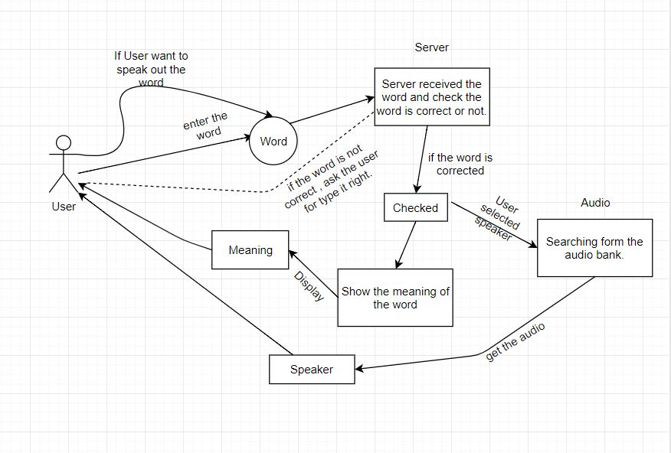

Diagram : User and Server in Searching step

Diagram : Dictionary System

|  |  |  |  |
| --- | --- | --- | --- |
| **#** | **ID** | **Name** | **Brief Description** |
| 1 | UC01 | Search field | User can enter the words or sentences to find the meaning |
| 2 | UC02 | Description section | User can see the word they enter and the meaning of that one |
| 3 | UC03 | Audio | User can hear the sound of that word |
| 4 | UC04 | View History | User can see the words they enter all the times |
| 5 | UC05 | Practice | User can practice the word that they have learned. |
| 6 | UC06 | Exercise | User can join the exercise to improve their skill of vocabulary or grammar. |
| 7 | UC07 | Nofication | The application will give the user 1 new word everyday. |

### Use Case & User Permission Mapping

|  |  |  |  |
| --- | --- | --- | --- |
| **Use Case** | **Use Case Name** | **Admin** | **Guest** |
| UC01 | Search field | X | X |
| UC02 | Language field | X | X |
| UC03 | View History | X | X |
| UC04 | Audio | X | X |
| UC05 | Practice | X |  |
| UC06 | Exercise | X |  |
| UC07 | Nofication | X |  |

## Operating Enviroment

## Assumption and Dependencies

# FUNCTIONAL REQUIREMENT

## Module 01

### UC05: Search field

|  |  |  |  |  |  |
| --- | --- | --- | --- | --- | --- |
| **ID** | **Name** | **Account** | **Trigger** | **Pre-condition** | **Post condition** |
| UC05 | Search field | Admin/Account Manager/Guest | Admin/Account Manager/Guest enter any word or sentences and press search button. |  | Find the specific word to translate. |

Activities

|  |  |  |  |
| --- | --- | --- | --- |
| **User** | | **System** | |
| Main flow: Search successful | | | |
| 1 | User enter the words or sentences. |  | |
|  |  | 2 | Check this is words or not Check this is sentences or not. |
| 3 | Translate from English to Vietnamese or vice versa. |  |  |

System Messages

|  |  |
| --- | --- |
| MS11 | This is not the words The word or sentence that user entered contain the special characters. |

### UC06: Language field

|  |  |  |  |  |  |
| --- | --- | --- | --- | --- | --- |
| **ID** | **Name** | **Account** | **Trigger** | **Pre-condition** | **Post condition** |
| UC06 | Language field | Admin/Account Manager/Guest |  |  | Translate a word or a sentence from English to Vietnamese or vice versa |

Activities

|  |  |  |  |
| --- | --- | --- | --- |
| **User** | | **System** | |
| Main flow: Search successful | | | |
| 1 | Enter a word which don’t have any special characters. |  |  |
|  |  | 2 | Translate this word from English to Vietnamese when user enter the word to search correct. |

### UC07: View History

|  |  |  |  |  |  |
| --- | --- | --- | --- | --- | --- |
| **ID** | **Name** | **Account** | **Trigger** | **Pre-condition** | **Post condition** |
| UC07 | View History | Admin/Account Manager/Guest | Admin/Account Manager/Guest click the view history button |  | See the word they looked up |

Activities

|  |  |  |  |
| --- | --- | --- | --- |
| **User** | | **System** | |
| Main flow: View History page | | | |
|  |  | 1 | Show the user the word history list |

# System Features

## Tra cứu từ vựng

### Description and Priority

<Provide a short description of the feature and indicate whether it is of High, Medium, or Low priority. You could also include specific priority component ratings, such as benefit, penalty, cost, and risk (each rated on a relative scale from a low of 1 to a high of 9).>

### Stimulus/Response Sequences

Người dùng gõ từ cần tìm kiếm vào ô , 1 danh sách các từ liên quan sẽ hiện ra bên dưới.

Người dùng chọn từ cần tra cứu , sau đó chạm vào dòng.

Trang chứa thông tin về từ đó sẽ hiện ra.

### Functional Requirements

<Itemize the detailed functional requirements associated with this feature. These are the software capabilities that must be present in order for the user to carry out the services provided by the feature, or to execute the use case. Include how the product should respond to anticipated error conditions or invalid inputs. Requirements should be concise, complete, unambiguous, verifiable, and necessary. Use “TBD” as a placeholder to indicate when necessary information is not yet available.>

<Each requirement should be uniquely identified with a sequence number or a meaningful tag of some kind.>

REQ-1: Thông tìn về từ vựng phải chính xác.

REQ-2: Phải tìm được từ vựng người dùng cần tìm.

REQ-3: Nếu không tìm được từ vừng người dùng cần tìm , cho phép người dùng đóng góp.

## Nghe từ vựng

### Description and Priority

### Stimulus/Response Sequences

### Functional Requirements

## Chỉnh sửa từ vựng

### Description and Priority

### Stimulus/Response Sequences

### Functional Requirements

## Đóng góp từ vựng

### Description and Priority

### Stimulus/Response Sequences

### Functional Requirements

# Nonfunctional Requirements

## Accessbility

User enter 1 character and show the list of the words that have that character.

User can use their voice to fill the word automatically.

## Volume

Number of user can access at least 100 peoples.

## Precision

The word must be translated when the words or sentenced have uppercases in any location.

The word received from user’s voice must be filled corect.

Audio must be spoken correct depends on the description.

## Performance

The word that user look up show the result under 5s.

The web application is responsive.

## Compatibility

The application must run on web browser.

The application run on windows 7 or higher.

## Maintainability

All functions can be possibly colliped.

Add more functions when needed.

## Safety

The account management system will check the account activity when the bad behavior appear (pollitic, system security,…).

## Portability

The application run on device with any hardware:

* PC or laptop with minimum CPU core 2 duo, 2GB of rams or modern one.

# System Constraint

## Database

The application translate the word through firebase or MySQL

## Device

The application run only on destop or laptop.

## Programming Language

Can write with the scripting language(HTML/CSS,JavaScript,PHP,...) or high level language (C/C++, python,java,...).