LAB 4 for Operating Systems

***Name****: Trần Thanh Dương*

***Student’s Code****: SE160185*

***Class****: AI1601*

## Step 1: Create a shell script file using command sudo nano fib.sh

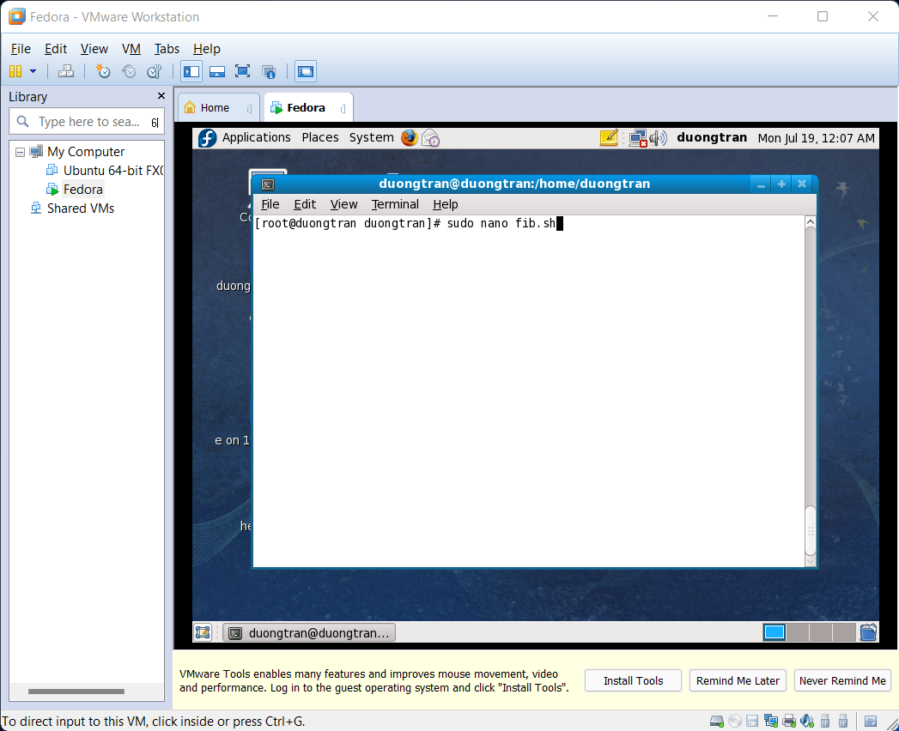

## Step 2: Insert this code to print out first N Fibonacci numbers

#!/bin/sh  
echo "Input N: "  
read N  
  
a=0  
b=1   
   
echo "The Fibonacci series is : "  
   
**for** (( i=0; i<N; i++ ))  
**do**  
 echo -n "$a "  
 fn=$((a + b))  
 a=$b  
 b=$fn  
**done**  
  
# Pause for watching  
read x

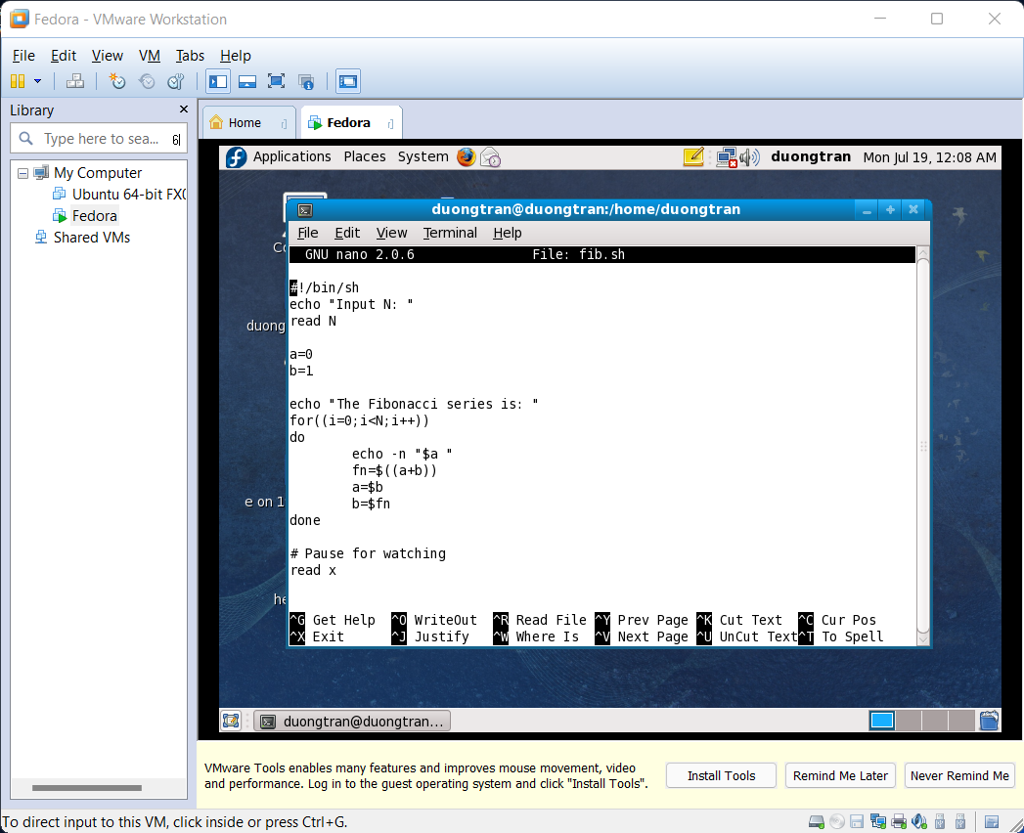

## Step 3: Compile and run shell script

* Use command chmod u+x fib.sh for assigning execute mode to file name.
* ./fib.sh for running script.

