LAB 1 – DBI202

Name: Trần Thanh Dương

Roll Number: SE160185

Class: AI1602

# Exercise 1: Music Database

1. Disk(**disk_id**: integer; title: String; year_of_production: integer)
2. Song(**track_number**: integer; disk_id: integer; title: String)
3. Person(**person_id**: integer; name: String; nationality: String)
4. Author(**person_id**: integer; track_number: integer; authorship_type: string)
5. Performer(**person_id**: integer; track_number: integer; instrument_name: string)

In this database schema,

* **Bold text** is referred to **Primary key**.
* Underlined text is referred to Foreign key.
* **“nvarchar”** is a set of Unicode character data as string.

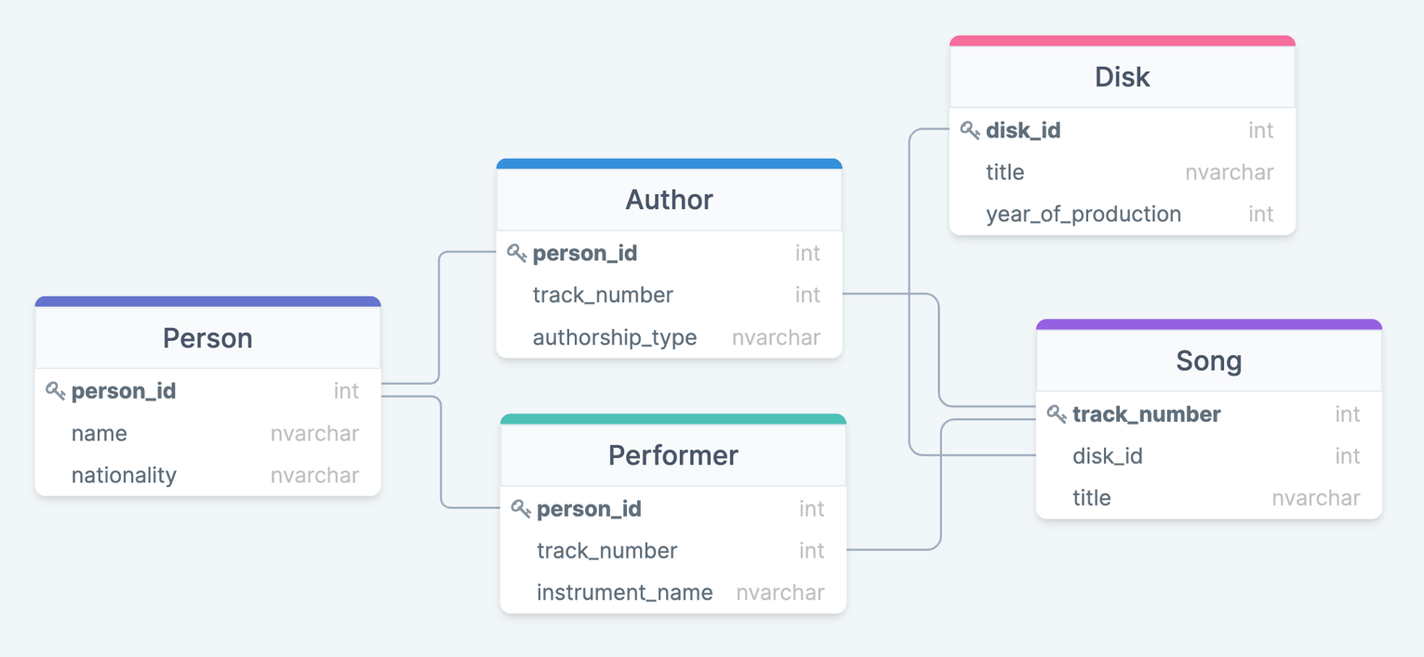

# Exercise 2: Relational Algebra

1. πFirstname, Lastname, Salary(σDepartment_id == 103(Employee))
2. πFirstname, Lastname, Salary(σgender == “Nam”(Employee))
3. πFirstname, Lastname, Salary(σgender == “Nữ” AND Salary > 7000000(Employee))
4. πFirstname, Lastname, Salary(σgender == “Nam” AND Department_id == 103 AND Salary > 6000000(Employee))
5. πFirstname, Lastname, Salary(σgender == “Nữ” AND Department_id == 102 AND Salary >= 4000000 (Employee))
6. πDept_name(σDept_name == “HR”(Department))
7. COUNT(σgender == “Nam”(Employee))
8. COUNT(σgender == “Nữ” AND Department_id == 102(Employee))
9. COUNT(σgender == “Nam” AND Department_id == 101 AND Salary >= 7000000(Employee))
10. SUM(πSalary(σDepartment_id == 103(Employee)))