ASSIGNMENT 1

1.1 Write a program to perform following operations on Link List

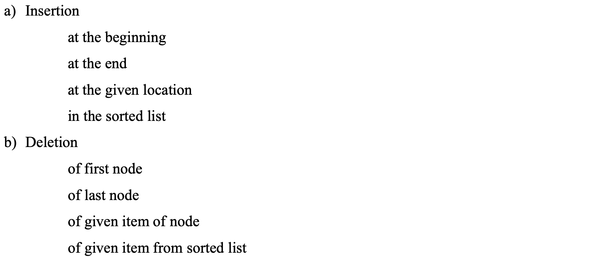

1.2 Write a java program to implement a stack using an linked list with push, pop, empty operations and demo that operations.