1. Copy chrome shotcut & paste to desktop

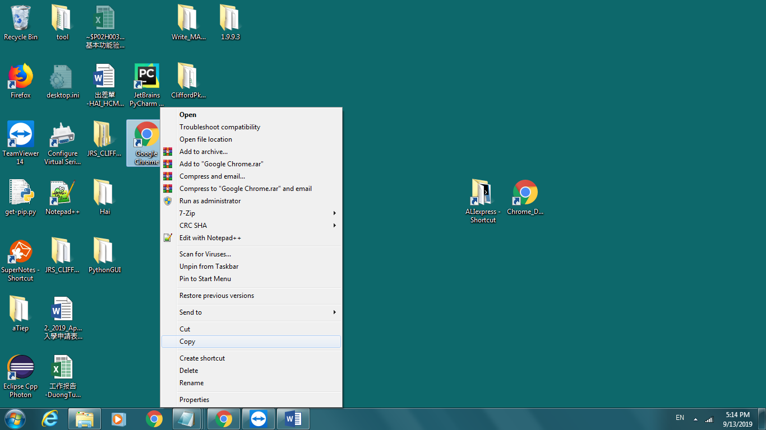

1. Property

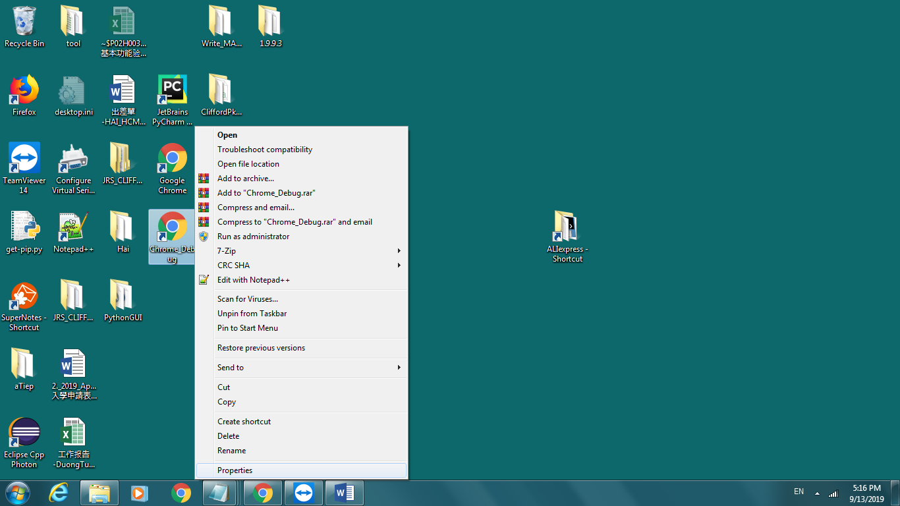

1. Change target:

"C:\Program Files (x86)\Google\Chrome\Application\chrome.exe" --remote-debugging-port=9022 --user-data-dir="D:\ ALIexpress\chrome_configure_tmp"

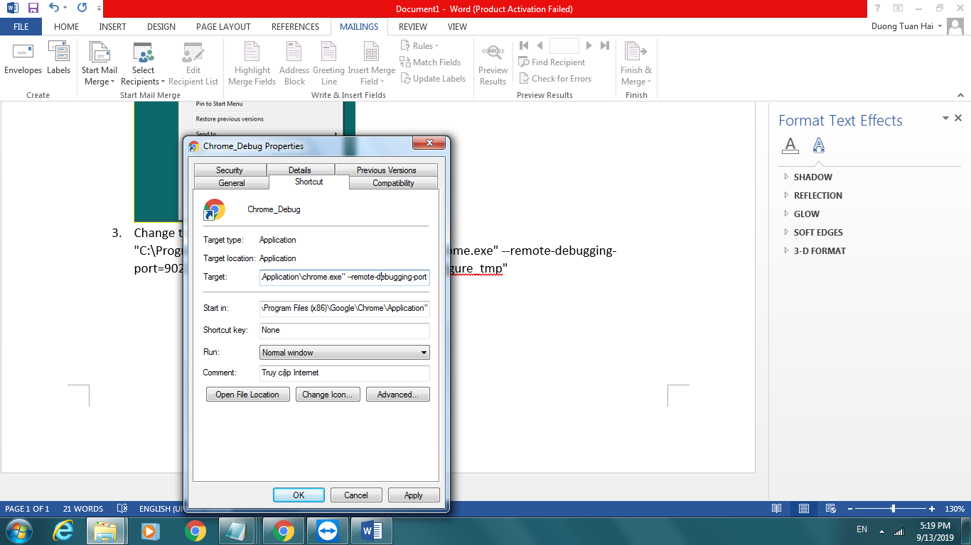

1. Run aliExpress.exe

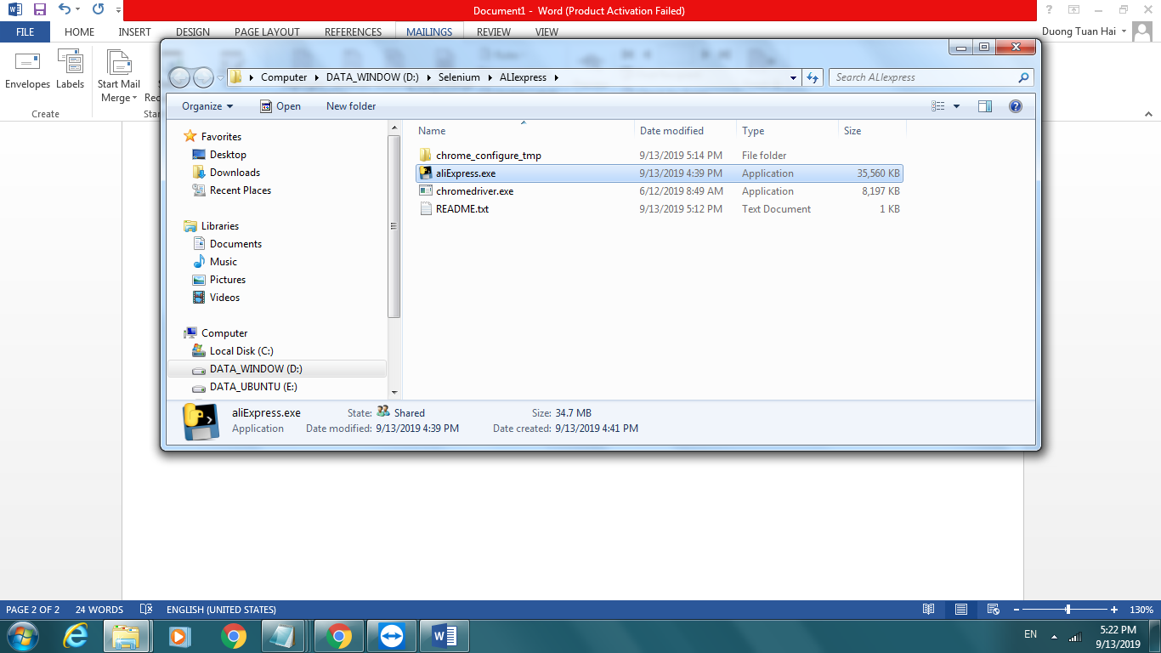

1. Input your store’s link and page num

