Rapid Embedded Systems
Design and Programming Course

Digital I/O
Issue 1.0

IC2002
CS200558-Duong Van Hoa
CE200736-Nguyen Quoc Kiet
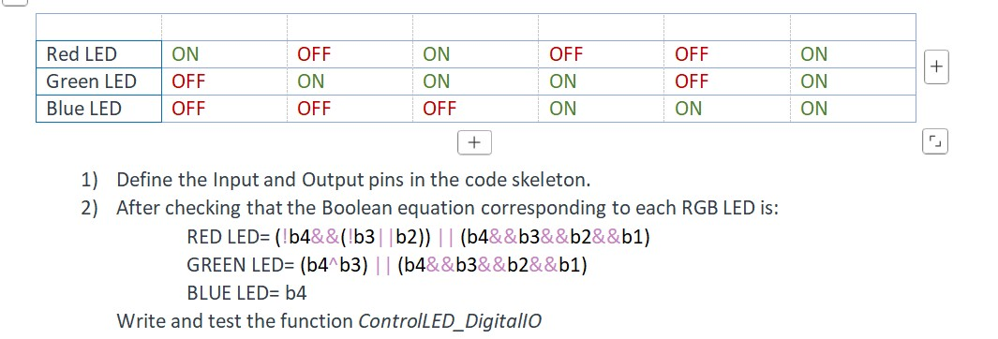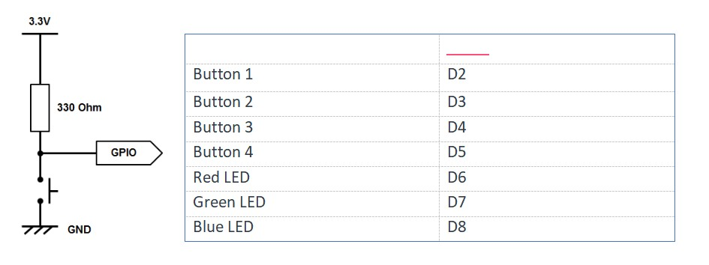

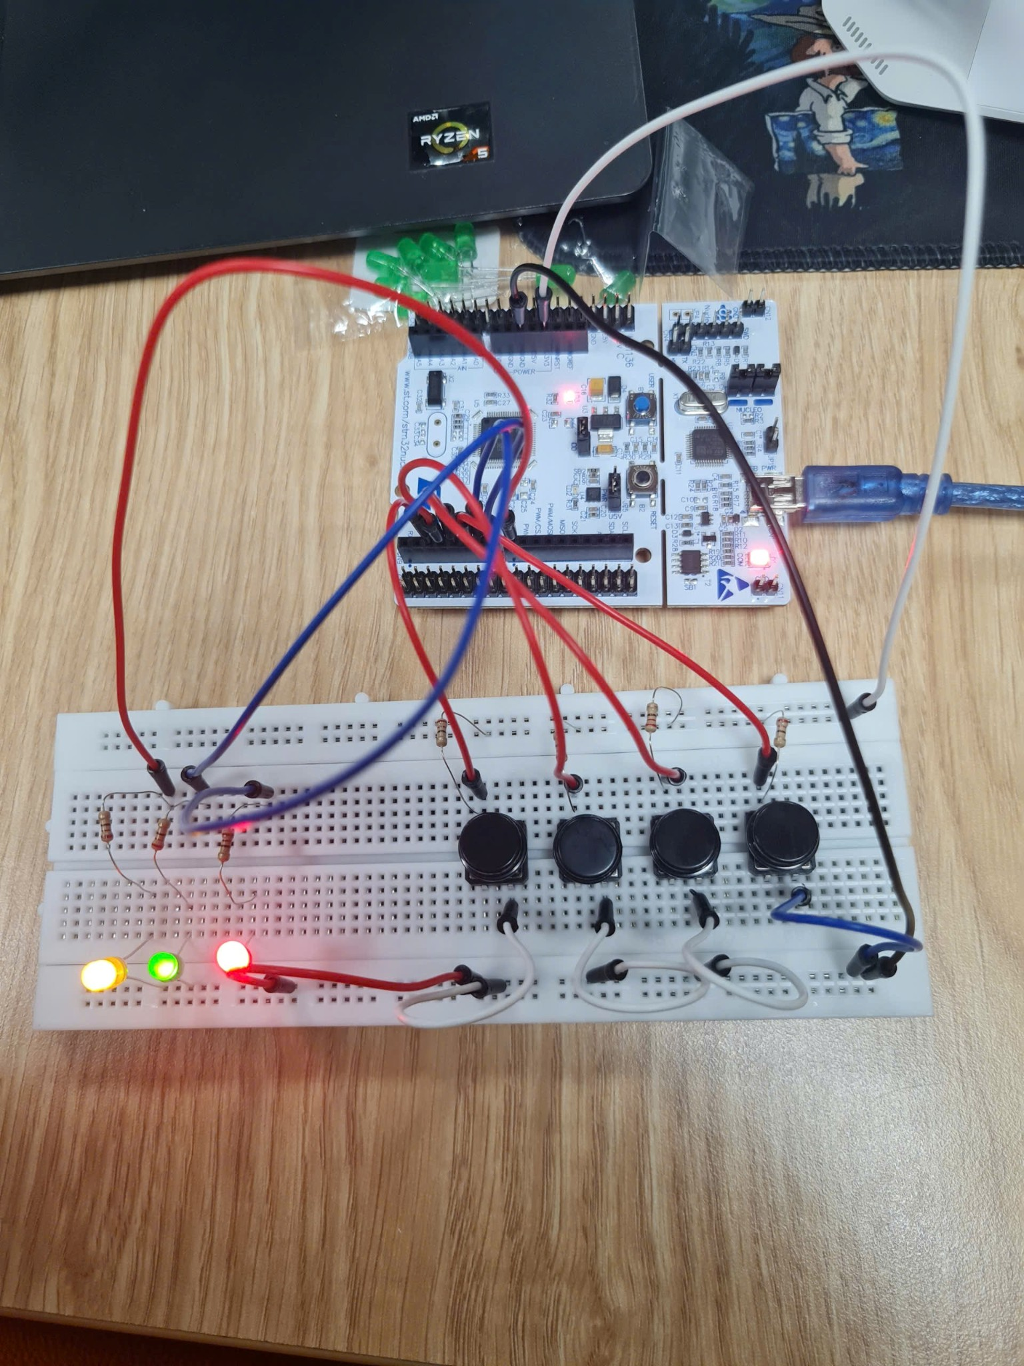
Main Code

#include "mbed.h"
// Individual Digital Input pins for buttons
DigitalIn b1(D2);
DigitalIn b2(D3);
DigitalIn b3(D4);
DigitalIn b4(D5);

// Individual Digital Output pins for RGB LED
DigitalOut rled(D6);
DigitalOut gled(D7);
DigitalOut bled(D8);
// Bus configurations
BusIn buttonsbus(D2, D3, D4, D5);
BusOut ledsbus(D6, D7, D8);
void ControlLED_DigitalIO(){
// RED LED logic: Active when (b4 is 0 AND (b3 is 0 OR b2 is 1)) OR
when all buttons are pressed
rled = (!b4 && (!b3 || b2)) || (b4 && b3 && b2 && b1);
// GREEN LED logic: Active when b4 and b3 are different (XOR), OR when
all buttons are pressed
gled = (b4 ^ b3) || (b4 && b3 && b2 && b1);
// BLUE LED logic: Directly follows the state of button b4
bled = b4; }
void ControlLED_BusIO(){
switch (buttonsbus){
// Cases 0 to 3: Only RED LED is ON
case 0 ... 3:
ledsbus = 0b001; // bled=0, gled=0, rled=1
break;
// Cases 4 to 5: Only GREEN LED is ON
case 4 ... 5:
ledsbus = 0b010; // bled=0, gled=1, rled=0
break;
// Cases 6 to 7: Both RED and GREEN LEDs are ON
case 6 ... 7:
ledsbus = 0b011; // bled=0, gled=1, rled=1
break;
// Cases 8 to 11: Both GREEN and BLUE LEDs are ON
case 8 ... 11:
ledsbus = 0b110; // bled=1, gled=1, rled=0
break;
// Cases 12 to 14: Only BLUE LED is ON
case 12 ... 14:
ledsbus = 0b100; // bled=1, gled=0, rled=0
break;
// Case 15: All buttons pressed -> All LEDs are ON (White)
case 15:
ledsbus = 0b111; // bled=1, gled=1, rled=1
break;
default:
ledsbus = 0b000; // Turn off all LEDs as a safety default
break;
}
}
int main()
{
// Infinite loop to continuously sample inputs and update outputs
while(1) {
// Toggle comments below to switch between execution methods
// ControlLED_DigitalIO();
ControlLED_BusIO();
}
}

