PRACTICE ASSIGNMENT
Simulating PWM, Timer, and Periodic Interrupts on Wokwi
Course | Microcontrollers / Embedded Systems | Student name | Duong Van Hoa
Platform | Wokwi - Arduino Uno | Student ID | CS200558
Duration | 01 practice session | Group/Class | IC2002_G4
Submission format | Word/PDF report + screenshots of results | Submission date | ........................................

1. Practice Objectives
- Convert a program written with the Mbed API into an Arduino program that can run on Wokwi.
- Control an LED using PWM to create a fade-in/fade-out brightness effect.
- Use a periodic interrupt with TimerOne to toggle an LED every 2 seconds.
- Use millis() to measure the execution time of a program segment.
- Test, observe, and explain the operation of PWM, Timer, and interrupt mechanisms in simulation.

2. Preparation Requirements
- Open Wokwi and create a new Arduino Uno project.
- Create all required files: sketch.ino, libraries.txt, and diagram.json.
- Connect an external LED to pin D5 through a 220 ohm resistor to observe PWM output.
- Open the Serial Monitor to check the printed startup time.
- Understand the basic rule: analogWrite() receives a value from 0 to 255, while TimerOne uses microseconds as its unit.

3. Required Hardware Diagram
Device | Connection Pin | Description | Expected Result
Arduino Uno | D5 | Outputs PWM to control the external LED | The LED continuously fades in and out
External LED + 220 ohm resistor | Anode: D5; Cathode: GND through R | Used to observe the PWM duty cycle | Brightness changes according to the loop
Built-in LED | D13 | Toggled inside the ISR | Blinks every 2 seconds
Serial Monitor | 9600 baud | Displays the startup time | Approximately 0.500 seconds

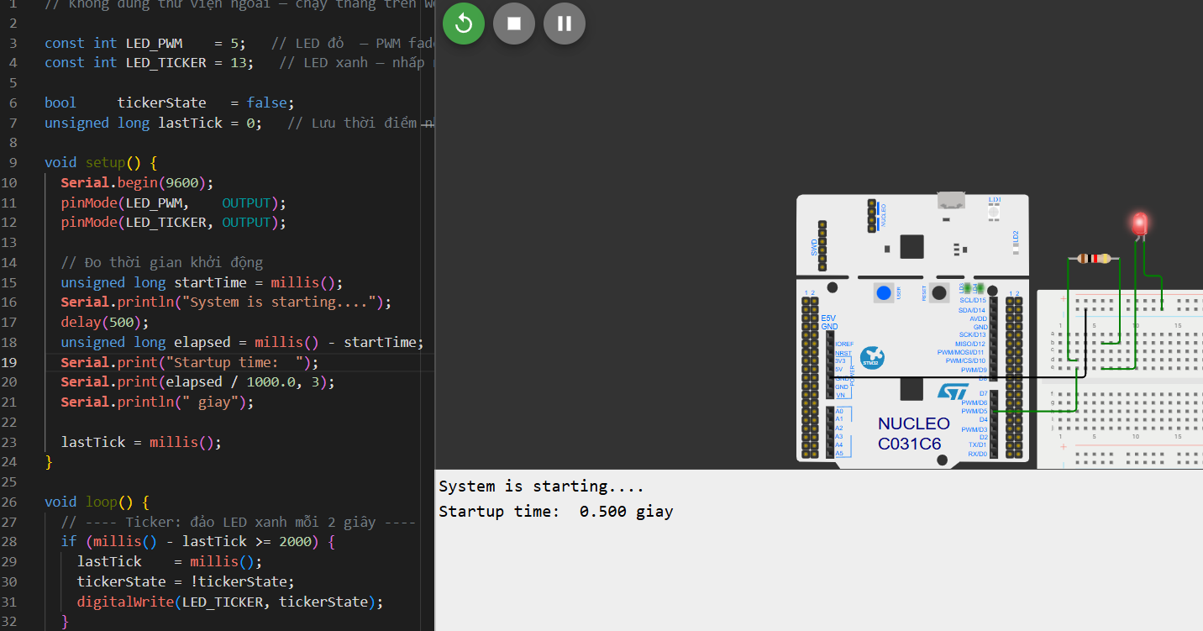

4. Sample Code to Run on Wokwi
Students create the sketch.ino file and enter the following content:
// Không dùng thư viện ngoài — chạy thẳng trên Wokwi

const int LED_PWM = 5; // LED đỏ — PWM fade
const int LED_TICKER = 13; // LED xanh — nhấp nháy 2s

bool tickerState = false;
unsigned long lastTick = 0; // Lưu thời điểm nhấp nháy cuối

void setup() {
Serial.begin(9600);
pinMode(LED_PWM, OUTPUT);
pinMode(LED_TICKER, OUTPUT);

// Đo thời gian khởi động
unsigned long startTime = millis();
Serial.println("System is starting....");
delay(500);
unsigned long elapsed = millis() - startTime;
Serial.print("Startup time: ");
Serial.print(elapsed / 1000.0, 3);
Serial.println(" giay");

lastTick = millis();
}

void loop() {
// ---- Ticker: đảo LED xanh mỗi 2 giây ----
if (millis() - lastTick >= 2000) {
lastTick = millis();
tickerState = !tickerState;
digitalWrite(LED_TICKER, tickerState);
}

// ---- PWM: fade in 0 → 255 ----
for (int p = 0; p <= 255; p += 13) {
analogWrite(LED_PWM, p);

// Kiểm tra ticker ngay trong vòng lặp để không bị bỏ lỡ
if (millis() - lastTick >= 2000) {
lastTick = millis();
tickerState = !tickerState;
digitalWrite(LED_TICKER, tickerState);
}

delay(100);
}

// ---- PWM: fade out 255 → 0 ----
for (int p = 255; p >= 0; p -= 13) {
analogWrite(LED_PWM, p);

if (millis() - lastTick >= 2000) {
lastTick = millis();
tickerState = !tickerState;
digitalWrite(LED_TICKER, tickerState);
}

delay(100);
}
}

5. Report Questions
Question 1. In an Arduino program, how is analogWrite() different from digitalWrite()? When should PWM be used?
Difference: digitalWrite() outputs a continuous binary voltage state, which is either completely HIGH (5V) or completely LOW (0V). analogWrite(), on the other hand, outputs a Pulse Width Modulation (PWM) signal, which switches rapidly between HIGH and LOW states to simulate an intermediate analog voltage based on a duty cycle value ranging from 0 to 255.
When to use PWM: PWM should be used when you need to control components that require variable power or analog-like behavior rather than simple on/off states. Common examples include dimming/fading an LED (as seen in this assignment), controlling the speed of a DC motor, or positioning a servo motor.

........................................................................................................................................
........................................................................................................................................
Question 2. What does Timer1.initialize(2000000) mean? What is the unit of this parameter?
Meaning: It configures and starts Timer1 to trigger a hardware timer overflow at a specified period. In this assignment, it sets up the timer to invoke an interrupt every 2 seconds.
Unit: The unit of this parameter is microseconds ($\mu s$). Thus, 2000000 microseconds equals exactly 2.0 seconds.

........................................................................................................................................
........................................................................................................................................
Question 3. Why is tickerState declared as volatile?
Reason: The tickerState variable is modified inside an Interrupt Service Routine (flip()) and read inside the main program execution flow. Declaring it as volatile tells the compiler compiler optimization engine not to store this variable in a CPU register, forcing it to look up and reload the value directly from RAM every time it is accessed. This ensures that the main loop always sees the immediate, updated state changed by the interrupt.
........................................................................................................................................
........................................................................................................................................
Question 4. What could happen if the PWM pin is changed from D5 to D9 or D10 while TimerOne is being used? Briefly explain.
Explanation: On the Arduino Uno (ATmega328P), the TimerOne library utilizes Timer 1 (a 16-bit hardware timer). Hardware Timer 1 is also directly responsible for generating the hardware PWM signals on pins D9 and D10.
Consequence: If you change the PWM pin to D9 or D10, initializing or attaching interrupts via TimerOne will overwrite or conflict with the hardware registers configuration needed for standard analogWrite() PWM on those pins. This will break the PWM functionality on D9/D10, causing the fading effect to fail or the LED to behave unexpectedly. (Pin D5 uses Timer 0, which is why it remains unaffected by TimerOne).

........................................................................................................................................
........................................................................................................................................
Question 5. Compare using millis() for time measurement with using TimerOne to generate a periodic interrupt.
Using millis():
- Nature: Software-based polling mechanism.
- Pros: Very simple to use, doesn't lock up or conflict with hardware timers, and can run indefinitely without blocking standard PWM outputs.
- Cons: Requires constant checking in the main loop (polling). If the main loop has heavy blocks or delay() functions, the precision drops, and actions can be delayed or missed entirely.
Using TimerOne periodic interrupt:
- Nature: Hardware-driven asynchronous mechanism.
- Pros: Highly precise and accurate down to the microsecond level. It stops whatever the CPU is currently doing (even a delay()) to run the ISR code immediately, ensuring the action happens exactly every 2 seconds.
- Cons: Consumes a hardware resource (Timer 1), conflicts with PWM on pins D9/D10, and if the ISR takes too long to execute, it can crash or lag the main system loop.

........................................................................................................................................
........................................................................................................................................
Question 6. From the original Mbed code, create a comparison table of the equivalent components in Arduino/Wokwi.
Mbed Component / CodeArduino / Wokwi EquivalentDescription#include "mbed.h"#include <TimerOne.h>
Including core libraries / timer library dependencies.
PwmOut led_pwm(LED1);const int LED_PWM = 5;
Declaring the hardware PWM control pin.
Ticker flipper;Timer1.initialize(2000000);
Initializing periodic hardware timer triggers.
flipper.attach(&flip, 2.0);Timer1.attachInterrupt(flip);
Attaching an Interrupt Service Routine (ISR) function to a timer.
DigitalOut led_ticker(LED2);const int LED_TICKER = 13;
Declaring the digital output pin for checking status.
Timer t;millis() (with unsigned long)
Mechanisms used to track and calculate elapsed execution times.
t.start(); ... t.stop();unsigned long startTime = millis();
Capturing reference time points to calculate durations.
wait(0.5);delay(500);
Halting the execution thread for a set amount of milliseconds.
led_pwm = p; (Range 0.0 to 1.0)analogWrite(LED_PWM, p); (Range 0 to 255)
Writing the duty cycle variable value to a PWM output pin.
while(1) { ... }void loop() { ... }
Main endless operational loop structure for embedded execution.

........................................................................................................................................
........................................................................................................................................

// Original Mbed code
#include "mbed.h"

// 1. Cấu hình PWM: Sử dụng chân LED1 (hoặc chân bất kỳ hỗ trợ PWM như D3, D5, D6...)
PwmOut led_pwm(LED1);

// 2. Cấu hình Ticker: Tạo một bộ ngắt định kỳ (Bản chất là dùng Hardware Timer ở Compare Mode)
Ticker flipper;
DigitalOut led_ticker(LED2); // Đèn LED thứ 2 để quan sát ngắt

// 3. Cấu hình Timer: Bộ đếm thời gian để đo khoảng thời gian chạy code
Timer t;

// Hàm xử lý ngắt (ISR) cho Ticker - Tự động gọi mỗi khi bộ đếm đạt mốc cài sẵn
void flip() {
led_ticker = !led_ticker; // Đảo trạng thái đèn LED2
}

int main() {
// --- KHỞI TẠO TICKER (COMPARE MODE) ---
// Cứ đúng 2.0 giây, phần cứng sẽ kích hoạt ngắt và gọi hàm flip()
flipper.attach(&flip, 2.0);

// --- KHỞI TẠO PWM ---
// Cài đặt chu kỳ xung PWM mặc định là 20ms (0.020 giây)
led_pwm.period(0.020f);

// --- SỬ DỤNG TIMER ĐỂ ĐO THỜI GIAN KHỞI ĐỘNG ---
t.start(); // Bắt đầu bấm giờ
printf("He thong dang khoi dong...\n");
wait(0.5); // Giả lập một tác vụ tốn 0.5 giây
t.stop(); // Dừng bấm giờ
printf("Thoi gian khoi dong mat: %f giay\n", t.read());

// --- VÒNG LẶP CHÍNH (XỬ LÝ PWM) ---
while(1) {
// Tăng dần độ sáng đèn LED từ 0% đến 100% (Duty Cycle từ 0.0 đến 1.0)
for(float p = 0.0f; p <= 1.0f; p += 0.05f) {
led_pwm = p; // Gán Duty Cycle cho chân PWM
wait(0.05); // Chờ 50ms giữa mỗi bước tăng
}

// Giảm dần độ sáng đèn LED từ 100% về 0%
for(float p = 1.0f; p >= 0.0f; p -= 0.05f) {
led_pwm = p;
wait(0.05);
}
}
}

