EMBEDDED SYSTEMS PROGRAMMING WITH MBED OS
LAB 4 ASSIGNMENT
Timer Interrupt, PWM Audio Player, and RGB LED Visualizer
Item | Information
Course | Embedded Systems / Microcontroller Programming
Platform | STM32 NUCLEO-F401RE
Framework | Mbed OS
Lab Package | Lab 4
Topic | Ticker Timer Interrupt, PWM Speaker, DigitalIn Buttons, PWM RGB LED
Submission | Completed source code, answers, and evidence of circuit testing

Student Information
Field | Student Input
Student Name | Nguyen Quoc Kiet  Duong Van Hoa
Student ID | CE200736-NQK  CS200558-DVH
Class | IC2002
Date | 30/06/2026

General Submission Instructions
- Build the circuit exactly as described in the connection table.
- Complete all missing code sections marked with blanks or TODO comments.
- Compile and run the program on the STM32 NUCLEO-F401RE board.
- Capture one photo of the circuit and one short video or screenshot showing the expected behavior.
- Answer all lab questions using short, clear explanations.
Important Safety Note
Always connect a common GND between the STM32 board and external devices. Use a piezo buzzer or low-current speaker. If using external LEDs, place a current-limiting resistor (220Ω–330Ω) in series with each LED.

Lab 4 - Timer Interrupt, PWM Audio Player, and RGB LED Visualizer

1. Objective
In this lab, students build a simple audio player using a PWM speaker and a timer interrupt. A Ticker object is used to move from one note to the next without using a blocking delay. Two push buttons are used to control volume and music speed. In addition, an RGB LED is used as a visual indicator that reflects the current note, beat, and speaker output.

2. Learning Outcomes
- Use PwmOut to generate audio signals for a speaker or piezo buzzer.
- Use DigitalIn with PullDown mode to read push buttons.
- Use PwmOut to control RGB LED brightness.
- Use Ticker to call an interrupt service routine periodically.
- Explain how PWM period determines sound pitch or note frequency.
- Explain how PWM duty cycle affects sound loudness.
- Use arrays to store musical notes and beat duration values.
- Explain why __WFI() can be used to wait for timer interrupts.

3. Required Hardware
Component | Quantity | Purpose
STM32 NUCLEO-F401RE | 1 | Main microcontroller board
Piezo speaker / passive buzzer | 1 | PWM audio output
Push button | 2 | Volume and speed control
RGB LED or 3 separate LEDs | 1 | Visual melody indicator
330Ω resistor | 3 | Current limiting for LED channels
Breadboard | 1 | Circuit assembly
Jumper wires | Several | Connections

4. Circuit Connections
Device | Device Pin | STM32 Connection | Description
Speaker / buzzer | Positive / Signal | D3 | PWM audio output
Speaker / buzzer | Negative / GND | GND | Ground
Button 1 - Volume | One side | D4 | Digital input for volume control
Button 1 - Volume | Other side | 3.3V | Pressed button gives logic HIGH
Button 2 - Speed | One side | D7 | Digital input for speed control
Button 2 - Speed | Other side | 3.3V | Pressed button gives logic HIGH
Red LED | Anode via 330Ω | D5 | PWM visual indicator for note
Red LED | Cathode | GND | Ground
Green LED | Anode via 330Ω | D6 | PWM visual indicator for beat
Green LED | Cathode | GND | Ground
Blue LED | Anode via 330Ω | D9 | PWM visual indicator for speaker output
Blue LED | Cathode | GND | Ground

Simple wiring view
Speaker/Buzzer: D3 ---- Speaker/Buzzer ---- GND
Button 1 (Volume): 3.3V ---- Push Button ---- D4
Button 2 (Speed): 3.3V ---- Push Button ---- D7
Red LED: D5 ---- 330Ω ---- LED ---- GND
Green LED: D6 ---- 330Ω ---- LED ---- GND
Blue LED: D9 ---- 330Ω ---- LED ---- GND
The program enables internal PullDown resistors using volume.mode(PullDown) and speed.mode(PullDown). Therefore, when a button is not pressed, the input reads 0. When it is pressed, the input reads 1.

5. Functional Requirements
Input / Output | Pin | Required Behavior
Speaker / buzzer | D3 | Generate PWM audio output.
Button 1 - Volume | D4 | When pressed, play louder using duty cycle 0.8. When not pressed, play softer using duty cycle 0.2.
Button 2 - Speed | D7 | When pressed and held, slow down the music by adding extra delay. When released, return to normal speed.
Red LED | D5 | Display brightness related to the current note value.
Green LED | D6 | Display brightness related to the current beat value.
Blue LED | D9 | Display brightness related to current speaker PWM duty cycle.
Ticker Timer | Internal | Call timer_ISR() to move from one note to the next.

6. Key Theory
Concept | In this Lab | Meaning
PWM period | Speaker.period(0.005 * note[current]); | Changes frequency, so it changes the musical note / pitch.
PWM duty cycle | Speaker = 0.8 or Speaker = 0.2; | Changes how long the signal is HIGH in each cycle, so it changes loudness.
Timer interrupt | timer.attach(&timer_ISR, ...); | Schedules the next note without blocking the CPU.
RGB LED indicator | RedLed = note[current]; GreenLed = beat[current]; BlueLed = Speaker; | LED brightness reflects the melody state.
note[] | Mi, Fa, So, No, ... | Stores which note should be played.
beat[] | b1, b2, b3, b4, ... | Stores how long each note should last.
No | No = 0 | Represents a silent pause.

7. Starter Code - Fill in the Missing Parts
Complete the code by filling in the blanks. Do not change the given pin assignments unless instructed by the teacher.

#include "mbed.h"

using namespace std::chrono;

#define SPEAKER D3

#define RED_LED D5

#define GREEN_LED D6

#define BLUE_LED D9

#define BUTTON_1 D4

#define BUTTON_2 D7

#define Do 0.5

#define Re 0.45

#define Mi 0.4

#define Fa 0.36

#define So 0.33

#define La 0.31

#define Si 0.3

#define No 0

#define b1 0.5

#define b2 0.25

#define b3 0.125

#define b4 0.075

float note[] = {

Mi, No, Mi, No, Mi, No,

Mi, No, Mi, No, Mi, No,

Mi, No, So, No, Do, No, Re, No, Mi, No,

Fa, No, Fa, No, Fa, No, Fa, No,

Fa, No, Mi, No, Mi, No, Mi, No, Mi, No,

Mi, Re, No, Re, Mi,

Re, No, So, No

};

float beat[] = {

b3, b3, b3, b3, b2, b2,

b3, b3, b3, b3, b2, b2,

b3, b3, b3, b3, b3, b3, b3, b3, b2, b1,

b3, b3, b3, b3, b3, b3, b3, b3,

b3, b3, b3, b3, b3, b3, b4, b4, b4, b4,

b2, b3, b3, b2, b2,

b2, b2, b2, b2

};

// TODO 1: Create DigitalIn objects for two buttons

DigitalIn volume(BUTTON_1);

DigitalIn speed(BUTTON_2);

// TODO 2: Create PWM output for speaker

PwmOut Speaker(SPEAKER);

// TODO 3: Create PWM outputs for RGB LED

PwmOut RedLed(RED_LED);

PwmOut GreenLed(GREEN_LED);

PwmOut BlueLed(BLUE_LED);

// TODO 4: Create a Ticker object

Ticker timer;

static int k = 0;

void timer_ISR()

{

// TODO 5: Calculate total number of notes

int total_notes = sizeof(note) / sizeof(float);

int current = k;

// TODO 6: Check whether the current note is a silent pause

if (note[current] == No)

{

Speaker = 0;

}

else

{

// TODO 7: Set PWM period to control pitch

Speaker.period(0.005 * note[current]);

// TODO 8: Set PWM duty cycle to control volume

if (volume)

{

Speaker = 0.8;

}

else

{

Speaker = 0.2;

}

}

// TODO 9: Update RGB LED values

RedLed = note[current];

GreenLed = beat[current];

BlueLed = Speaker.read();

// TODO 10: Move to the next note

k++;

// TODO 11: Restart song if all notes have been played

if (k >= total_notes)

{

k = 0;

}

float extra_delay = 0.0;

// TODO 12: If speed button is pressed, slow down the music

if (speed)

{

extra_delay = 0.5;

}

// TODO 13: Attach timer interrupt for the next note duration

timer.attach(

&timer_ISR,

milliseconds((int)(((beat[current] / 2) + 0.5 + extra_delay) * 1000))

);

}

int main()

{

// TODO 14: Enable internal PullDown resistors

volume.mode(PullDown);// noi nguon

speed.mode(PullDown);//noi nguon

// TODO 15: Turn off speaker and LEDs at the beginning

Speaker = 0.0;

RedLed = 0.0;

GreenLed = 0.0;

BlueLed = 0.0;

// TODO 16: Start the first timer interrupt after 100 ms

timer.attach(&timer_ISR, 100ms);

while (true)

{

// TODO 17: Put CPU into sleep mode while waiting for interrupts

__WFI();

}

}
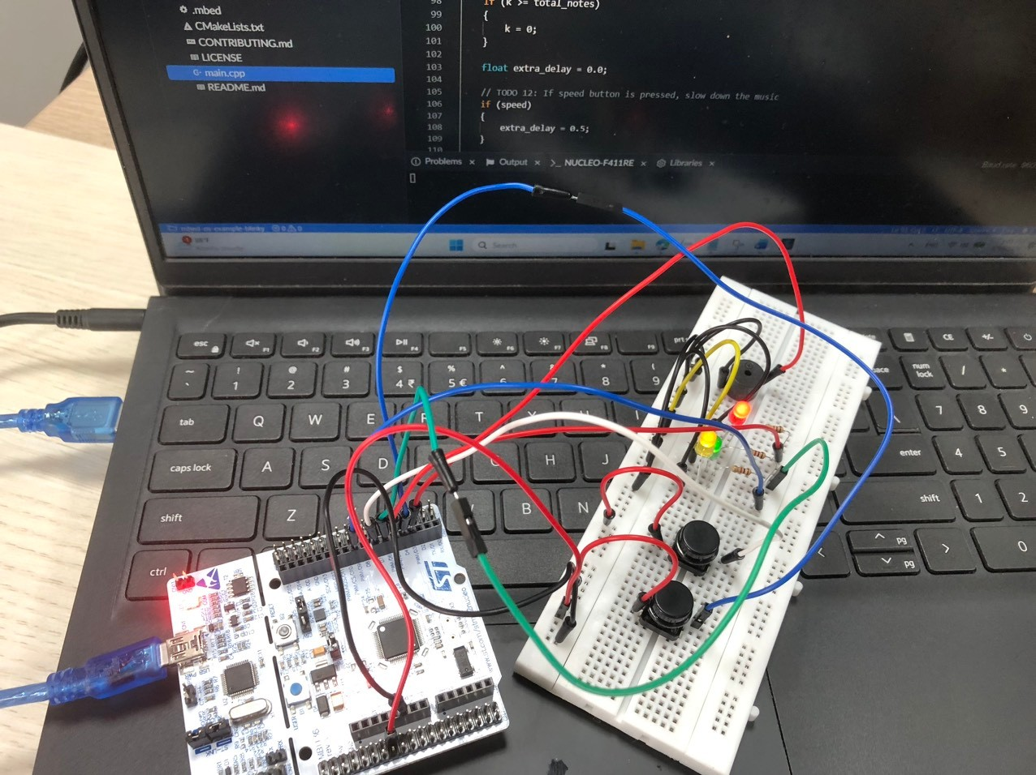

8. Example Format
DigitalIn volume(BUTTON_1);
PwmOut Speaker(SPEAKER);
PwmOut RedLed(RED_LED);
Speaker.period(0.005 * note[current]);
Speaker = 0.8;
RedLed = note[current];
These examples show how to create input/output objects, set the PWM period, set the PWM duty cycle, and update the RGB LED channels.

9. Expected Observation
☐ The speaker plays a repeated melody.
☐ When Button 1 is not pressed, the sound is softer.
☐ When Button 1 is pressed and held, the sound becomes louder.
☐ When Button 2 is not pressed, the melody plays at normal speed.
☐ When Button 2 is pressed and held, the melody becomes slower.
☐ When Button 2 is released, the melody returns to normal speed.
☐ The RGB LED brightness changes while the melody plays.
☐ The program does not use blocking delay inside the main loop.

10. Student Questions
Here are the clear, concise answers to your questions based on "Lab4_Timer_PWM_Audio_Player_RGB_Assignment.docx":
1. What is the role of the note[] array?
It stores the sequential arrangement of musical notes (pitches) and pauses that form the melody of the song.
2. What is the role of the beat[] array?
It stores the duration values for each corresponding note, defining exactly how long each note or pause should be held before moving to the next one.
3. Why does Speaker.period() affect the musical note or pitch?
The PWM period directly determines the frequency of the electrical signal ($\text{Frequency}=1/\text{Period}$). Changing the frequency alters how fast the speaker cone vibrates, which physically changes the pitch or musical note you hear.
4. Why does Speaker = 0.8 make the sound louder than Speaker = 0.2?
The duty cycle (0.2 or 0.8) determines how long the signal stays HIGH during each cycle. A duty cycle of 0.8 keeps the signal HIGH for 80% of the time, delivering significantly more average electrical power to the speaker than a 20% duty cycle, resulting in a louder sound.
5. What does No represent in the note[] array?
No has a value of 0 and represents a silent musical pause or rest. When encountered, the speaker duty cycle is set to 0 to stop producing sound.
6. Why do we need total_notes = sizeof(note) / sizeof(float)?
sizeof(note) calculates the total memory size of the entire array in bytes, while sizeof(float) calculates the memory size of a single floating-point number. Dividing them gives the exact total number of elements in the array, ensuring the program knows when the song ends and avoids reading out-of-bounds memory.
7. What is the purpose of timer.attach(&timer_ISR, 100ms) in main()?
It initializes the hardware timer to schedule and execute the very first interrupt (timer_ISR) after a brief 100 ms setup delay, effectively kickstarting the song playback.
8. Why is timer.attach() called again inside timer_ISR()?
Because each individual musical note can have a completely different duration (beat value). Calling timer.attach() dynamically at the end of the ISR reschedules the next interrupt to occur exactly when the current note's time is up.
9. If the speed button is not pressed, what is the value of extra_delay?
The value of extra_delay is 0.0, meaning no additional time is added to the note's duration calculation.
10. If the speed button is pressed and held, what happens to the music speed?
The music speed slows down dramatically because an additional 0.5 seconds of delay is added onto every single note duration.
11. Is the speed button in this code a hold-to-slow button or a press-to-toggle button? Explain.
It is a hold-to-slow button. The if (speed) condition directly checks the live, real-time hardware state of the button pin during each interrupt execution. Therefore, the music slows down only while the button is actively held down and immediately returns to normal speed as soon as it is released.

Appendix A - Mbed Commands to Remember
Command / Syntax | Used For | Example | Important Note
DigitalIn name(pin); | Create digital input object | DigitalIn volume(D4); | Used for buttons or digital sensors.
name.mode(PullDown); | Enable internal pull-down | volume.mode(PullDown); | Input reads 0 when not pressed.
PwmOut name(pin); | Create PWM output object | PwmOut Speaker(D3); | Pin must support PWM.
pwm.period(seconds); | Set PWM period | Speaker.period(0.002); | Changing period changes frequency / pitch.
pwm = value; | Set PWM duty cycle | Speaker = 0.8; | Value range is 0.0 to 1.0.
Ticker timer; | Create timer interrupt object | Ticker timer; | Used for scheduled ISR calls.
timer.attach(&ISR, time); | Schedule interrupt function | timer.attach(&timer_ISR, 100ms); | Calls ISR after the selected time.
milliseconds(value) | Create millisecond duration | milliseconds(500); | Useful with std::chrono.
sizeof(array)/sizeof(type) | Count array elements | sizeof(note)/sizeof(float); | Prevents reading past the array.
__WFI(); | Wait for interrupt | __WFI(); | CPU sleeps until interrupt occurs.

Appendix B - Key Concept Summary
Concept | Code Example | Meaning
Pitch / Note | Speaker.period(0.005 * note[current]); | PWM period determines frequency, so it determines high or low sound.
Volume | Speaker = 0.8; / Speaker = 0.2; | PWM duty cycle determines loudness.
Pause | if (note[current] == No) Speaker = 0; | No means silence.
Beat duration | beat[current] | Controls how long the current note lasts.
Normal speed | extra_delay = 0.0; | No additional time is added.
Slow speed | extra_delay = 0.5; | Each note is extended, so music becomes slower.
RGB note display | RedLed = note[current]; | Red channel brightness follows the note value.
RGB beat display | GreenLed = beat[current]; | Green channel brightness follows beat duration.
RGB speaker display | BlueLed = Speaker; | Blue channel brightness follows speaker PWM duty cycle.
First timer start | timer.attach(&timer_ISR, 100ms); | Starts the first interrupt.
Next note scheduling | timer.attach(&timer_ISR, milliseconds(...)); | Schedules the next note based on beat[current].

