IDstudent: CS200558
Name: Duong Van Hoa

Lab Assignment: STM32 Nucleo F401RE External Interrupt and Pull-Up Button
Objective
Students will learn how to use GPIO input, internal pull-up resistors, and external interrupts (InterruptIn) on the STM32 Nucleo F401RE board. The application will toggle an LED whenever a push button is pressed.

Required Components
- STM32 Nucleo F401RE
- 1 Push Button
- 1 LED
- 1 Resistor 220 Ω
- Breadboard and jumper wires
- Wokwi simulator or real hardware
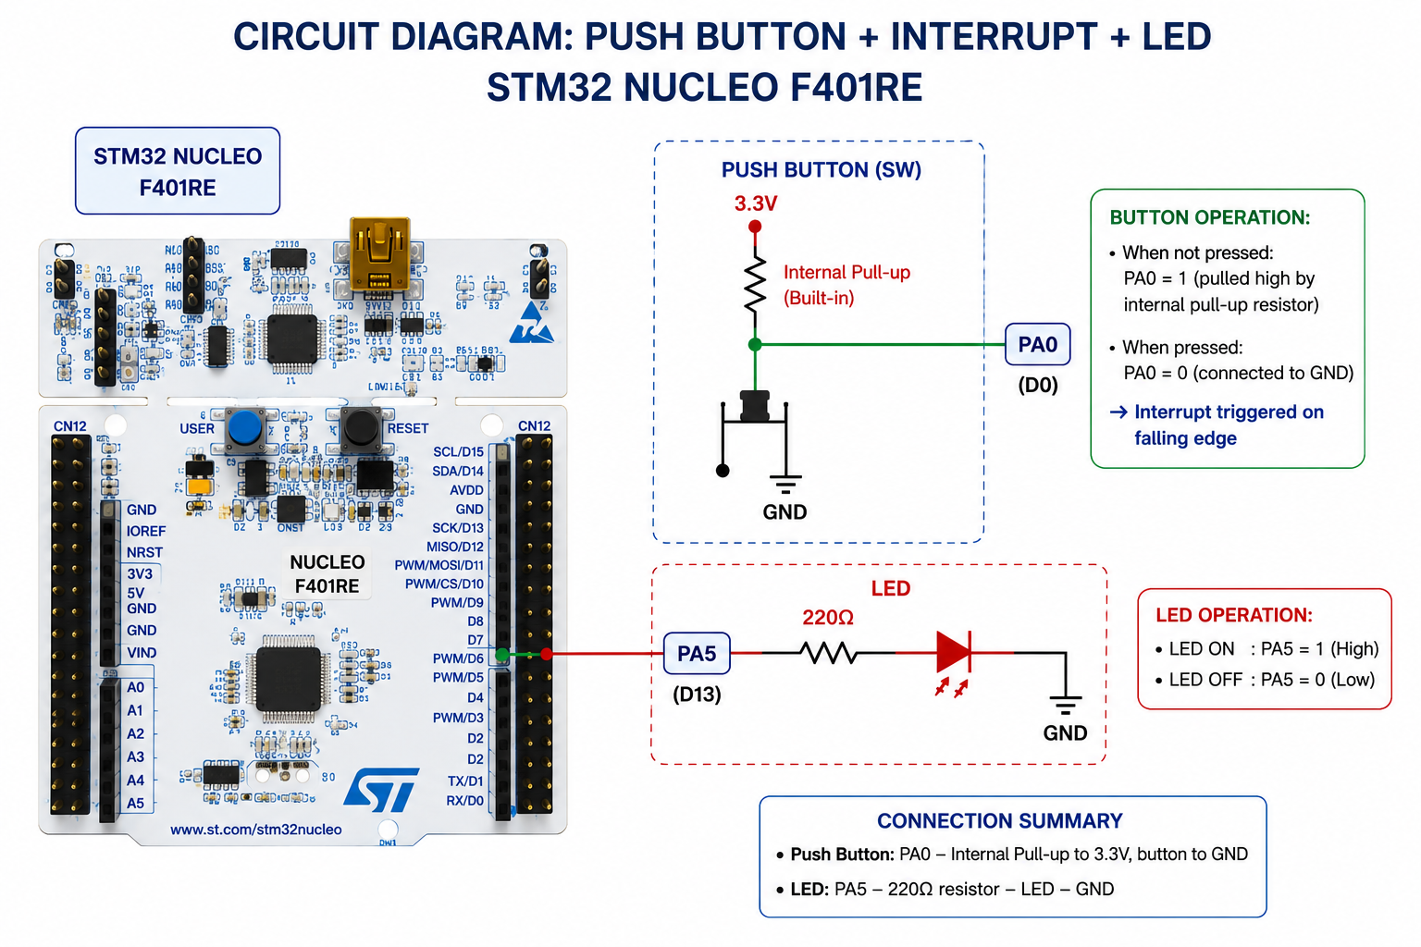

Circuit Connections
LED: PA5 (D13) -> 220 Ω resistor -> LED -> GND
Button: PA0 -> Push Button -> GND
Use the internal PullUp resistor in software.

Reference Program
#include "mbed.h"
DigitalOut led(PA_5);
InterruptIn button(PA_0);
volatile bool led_state = false;
void Button_ISR()
{
led_state = !led_state;
led = led_state;
}
int main()
{
button.mode(PullUp);
button.fall(&Button_ISR);
while (true)
{
ThisThread::sleep_for(100ms);
}
}

Student Tasks
- Build the circuit in Wokwi or on real hardware.
- Compile and run the program.
//main code
// Tương đương: DigitalOut led(PA_5); và InterruptIn button(PA_0);
#define LED_PIN PA5
#define BUTTON_PIN PA0

volatile bool led_state = false;

// Tương đương: void Button_ISR()
void Button_ISR()
{
led_state = !led_state;
digitalWrite(LED_PIN, led_state); // Tương đương: led = led_state;
}

// Tương đương: int main()
void setup()
{
// Thiết lập PA5 là đầu ra
pinMode(LED_PIN, OUTPUT);

// Tương đương: button.mode(PullUp);
pinMode(BUTTON_PIN, INPUT_PULLUP);

// Tương đương: button.fall(&Button_ISR);
attachInterrupt(digitalPinToInterrupt(BUTTON_PIN), Button_ISR, FALLING);
}

// Tương đương: while (true)
void loop()
{
// Tương đương: ThisThread::sleep_for(100ms);
delay(100);
}

- Verify that each button press toggles the LED state.
Press the button once — LED turns ON.
Press again — LED turns OFF.
The toggle is handled by: led_state = !led_state; led = led_state; inside Button_ISR.

- Explain why an internal pull-up resistor is required.
An internal pull-up resistor is necessary to establish a default, stable electrical state when the button is not pressed.
- Button released: The resistor gently "pulls" the voltage at pin PA0 up to 3.3V (Logic 1).
- Without it: When the button is open, the pin would be disconnected from both power and ground. This is called a floating pin, where ambient electrical noise can cause the microcontroller to randomly read 0s and 1s, leading to erratic LED behavior.

- Explain why an interrupt is more efficient than polling.
• Polling requires the CPU to constantly run a loop checking the button status over and over. This wastes massive amounts of processing power and keeps the CPU running at full power unnecessarily.
• Interrupts allow the CPU to completely ignore the button and perform other tasks (or go into a low-power sleep mode, as seen with ThisThread::sleep_for(100ms)). The hardware only wakes up the CPU or pauses its current task for a microsecond when the button event actually happens.

- Capture screenshots of the circuit and program execution.
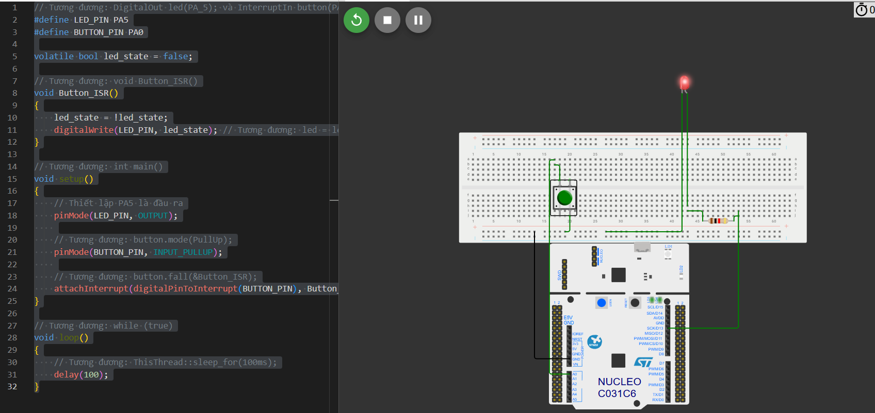

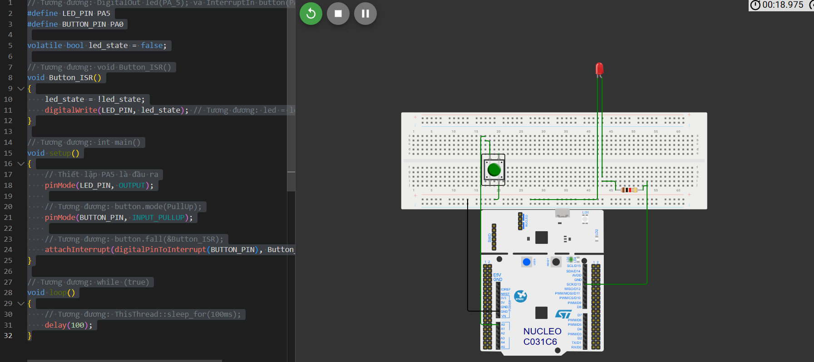

Questions
- What is the difference between polling and interrupt-based input handling?
Feature | Polling | Interrupt-based
Mechanism | CPU actively and continuously checks the pin state. | Hardware alerts the CPU only when a state change occurs.
CPU Efficiency | Very low; wastes clock cycles in a continuous loop. | Very high; CPU is free to execute other code or sleep.
Responsiveness | Delayed if the CPU is busy with a long-running task. | Immediate; the Interrupt Service Routine (ISR) preempts standard code.

- What is a falling-edge interrupt?
A falling-edge interrupt triggers the moment a signal transitions from a high voltage state to a low voltage state (Logic 1 to Logic 0). In this circuit, because of the pull-up resistor, the pin sits at 3.3V. The exact instant you press the button, the pin connects to GND, forcing the voltage down to 0V. This high-to-low drop is the "falling edge" that fires the Button_ISR() function.
- What would happen if the pull-up resistor was removed?
If removed, the circuit would lose its default reference voltage when the button is unpressed. Pin PA0 would become a floating input. As a result:
- The voltage would fluctuate randomly due to electromagnetic interference.
- The system would register ghost button presses, causing the LED to toggle sporadically even if nobody is touching the button.

- Why is the shared variable declared as volatile?
The volatile keyword tells the compiler optimizer that the value of led_state can change unexpectedly outside the normal program flow (specifically, inside the asynchronous Interrupt Service Routine).
Without volatile, the compiler might optimize the main() loop by caching the variable's value in a CPU register, assuming nothing in the main execution path changes it. Marking it volatile forces the microcontroller to read the variable fresh from RAM every single time it is accessed, ensuring the main thread always sees the true, updated state modified by the ISR.

Extension Challenge
Modify the program so that each button press cycles through RED, GREEN, BLUE, and OFF using an RGB LED.

Extension Challenge: RGB LED Color Cycling
Objective: Modify the program so that each button press cycles through RED → GREEN → BLUE → OFF.
Wiring (example pin assignments):
- RED LED: PA1 → 220 Ω → LED → GND
- GREEN LED: PA4 → 220 Ω → LED → GND
- BLUE LED: PA5 → 220 Ω → LED → GND
- Button: PA0 → Button → GND (internal PullUp enabled)
How it works:
- state is incremented on every button press using the modulo operator (% 4) to wrap back to 0 after reaching 3.
- Each LED is assigned a dedicated state value; only one LED is on at a time.
- The variable state is declared volatile because it is shared between Button_ISR and the main loop.
💡 For a true RGB LED (common cathode), connect R/G/B pins to the respective resistors and common cathode to GND. Adjust pin assignments to match your actual hardware.

