EMBEDDED SYSTEMS PROGRAMMING WITH MBED OS
UART LED Control Using Mbed IDE Terminal
Item |  |  | Information
 | Course |  | Embedded Systems / Microcontroller  Programming
 | Platform |  | STM32 NUCLEO-F401RE
 | Framework |  | Mbed OS
 | Lab Package |  | Lab 5
 | Topic |  | UART Receive, BufferedSerial / Serial  Terminal, DigitalOut LED Control
 | Submission |  | Completed source code, answers, and evidence of circuit testing

Student Information
Field |  | Student Input
 | Student Name | Nguyen Nhu Van Anh - Le Hieu Dat -  Duong Van Hoa - Nguyen Quoc Kiet
 | Student ID | CE200171 - CE200509 -  CS200558 - CE200736
 | Class | IC2002
 | Date | 02/07/2026

General Submission Instructions
- Build the circuit exactly as described in the connection table.
- Complete all missing code sections marked with blanks or TODO comments.
- Compile and run the program on the STM32 NUCLEO-F401RE board.
- Open the serial monitor / terminal in Mbed IDE and send characters A, B, and C.
- Capture one photo of the circuit and one screenshot or short video showing UART control of the LEDs.
- Answer all lab questions using short, clear explanations.
Important Safety Note: Always connect a common GND between the STM32 board and external devices. Use a 220Ω–330Ω resistor in series with each LED. Do not connect LEDs directly to GPIO pins without a resistor.
UART LED Control Using Mbed IDE Terminal

1. Objective
In this lab, students implement a simple UART receive application. The STM32
NUCLEO-F401RE receives characters from the Mbed IDE terminal and uses them to control three LEDs. When the user sends A, B, or C, the corresponding LED should turn ON. The program also prints feedback text to the terminal so that the received command can be verified.

2. Learning Outcomes
· Create a UART serial interface using Mbed OS.
· Understand the purpose of USBTX and USBRX.
· Use terminal input from Mbed IDE to send characters to the board.
· Read one character at a time from UART.
· Use DigitalOut to control external LEDs.
· Use if / else or switch-case logic to process commands.
· Print feedback text to the terminal using printf().

3. Required Hardware
Component |  | Quantity |  | Purpose
 | STM32 NUCLEO-F401RE | 1 |  | Main microcontroller board
 | LED | 3 |  | Visual output devices
 | 220Ω–330Ω resistor | 3 |  | Current limiting for LEDs
 | Breadboard | 1 |  | Circuit assembly
 | Jumper wires | Several |  | Connections
 | USB cable | 1 |  | Board power and UART terminal connection

4. Hardware Setup / Circuit Connections
Device |  | Device Pin | STM32 Connection | Description
 | Red LED | Anode via  220Ω–330Ω | D5 | LED controlled by  UART command A
 | Red LED | Cathode | GND | Ground
 | Green LED | Anode via  220Ω–330Ω | D6 | LED controlled by  UART command B
 | Green LED | Cathode | GND | Ground
 | Blue LED | Anode via  220Ω–330Ω | D7 | LED controlled by  UART command C
 | Blue LED | Cathode | GND | Ground
 | USB UART TX | Internal USB interface | USBTX | Transmit line to PC terminal
 | USB UART RX | Internal USB interface | USBRX | Receive line from  PC terminal
Simple wiring view
D5 ---- 330Ω ---- Red LED ---- GND
D6 ---- 330Ω ---- Green LED ---- GND
D7 ---- 330Ω ---- Blue LED ---- GND
USB cable connected to the NUCLEO board provides the UART link used by the Mbed IDE terminal.

5. Functional Requirements
Input / Output | Pin / Source | Required Behavior
UART input USBRX / terminal Receive one character from
the Mbed IDE terminal.
UART output USBTX / terminal Print received command
and LED status feedback.
Red LED D5 Turn ON when command A
or a is received.
Green LED D6 Turn ON when command B
or b is received.
Blue LED D7 Turn ON when command C
or c is received.
Other commands Terminal Print an invalid command
message and keep current
rule or turn all LEDs OFF
depending on the student
solution.

6. Key Theory
Concept | In this Lab | Meaning
UART BufferedSerial pc(USBTX, Asynchronous serial
USBRX, 115200); communication between the
board and the PC terminal.
DigitalOut DigitalOut redLed(D5); Controls the logic level of
an LED pin.
Serial input pc.read(...) or Reads user commands sent
Serial.available()/read style from the terminal.
logic
Terminal feedback printf("Received: A"); Helps verify the program
behavior.
Character command A, B, C Each letter maps to one
LED output.

7. Starter Code - Fill in the Missing Parts
Complete the code by filling in the blanks. Do not change the required pin assignments unless instructed by the teacher.
#include "mbed.h"
#include <cstdio>
// TODO 1: Create UART serial interface
BufferedSerial pc(USBTX, USBRX, 9600);
// TODO 2: Create three LED outputs
DigitalOut redLed(D5);
DigitalOut greenLed(D6);

DigitalOut blueLed(D7);
int main()
{
// TODO 3: Initialize all LEDs to OFF
redLed = 0;
greenLed = 0;
blueLed = 0;
printf("UART LED Control Ready\r\n");
printf("Send A, B, or C from the terminal\r\n");
while (true)
{
char cmd;
// TODO 4: Read one character from UART
if (pc.readable()) {
pc.read(&cmd, 1);
// TODO 5: Ignore newline and carriage return if needed
if (cmd == '\n' || cmd == '\r')
{
continue; }
printf("Received: %c\r\n", cmd);
// TODO 6: Process UART command
if (cmd == 'A' || cmd == 'a')
{
redLed = 1;
greenLed = 0;
blueLed = 0;
printf("Red LED ON\r\n");
}
else if (cmd == 'B' || cmd == 'b')
{
redLed = 0;
greenLed = 1;
blueLed = 0;
printf("Green LED ON\r\n");
}
else if (cmd == 'C' || cmd == 'c')
{
redLed = 0;
greenLed = 0;
blueLed = 1;
printf("Blue LED ON\r\n");
} else
{
// TODO 7: Print invalid command message
printf("Invalid command! Please enter A, B, or C.\r\n");
}
}
}
}

8. Example Format
DigitalOut redLed(D5);
BufferedSerial pc(USBTX, USBRX, 115200); if (cmd == 'A') { redLed = 1; } printf("Received: %c\r\n", cmd);
These examples show how to create LED output objects, create a UART serial interface, compare received characters, and print feedback text to the terminal.

9. Expected Observation
☐ When the terminal sends A or a, the red LED turns ON.
☐ When the terminal sends B or b, the green LED turns ON.
☐ When the terminal sends C or c, the blue LED turns ON.
☐ The terminal prints the received character.
☐ Invalid commands produce an error message.

10. Student Questions
- What is the role of BufferedSerial in this program?
Answer: BufferedSerial establishes and manages the UART (Universal Asynchronous
Receiver-Transmitter) serial communication link between the STM32 microcontroller and the PC terminal. It utilizes software buffers to store incoming and outgoing bytes in the background, ensuring that data is not lost even if the microcontroller is busy processing other tasks when a character arrives.
- What is the difference between USBTX and USBRX?
Answer: USBTX (Transmit): The dedicated pin/line used by the STM32 to send serial data out to the PC terminal.
USBRX (Receive): The dedicated pin/line used by the STM32 to receive serial data coming in from the PC terminal.
- Why do we use a resistor in series with each LED?
Answer: We use a resistor for current limiting. LEDs have very low internal resistance once they start conducting; without a series resistor, they would draw excessive current from the STM32 GPIO pin. This would permanently damage the LED and potentially burn out the microcontroller's output pin.
- What is the role of DigitalOut?
Answer: DigitalOut is an Mbed OS class used to configure a specific GPIO pin as a digital output. It allows the software to control the physical voltage level of the pin—setting it to 1 (High / 3.3V) to turn the LED on, or 0 (Low / 0V) to turn the LED off.
- Why do we ignore \n and \r from the terminal?
Answer: When you type a command and press Enter on a serial terminal, the software typically appends carriage return (\r) and/or newline (\n) characters to the data stream. If the program does not explicitly catch and ignore these characters using a continue statement, it will process them as separate inputs and repeatedly trigger the else block
(printing an "Invalid command" error).
- What happens when the user sends the character A?
Answer: When the character 'A' (or 'a') is received:
- The pc.read() function captures the byte into the cmd variable.
- The program evaluates the if (cmd == 'A' || cmd == 'a') condition as true.
- The Red LED pin (D5) is driven high (redLed = 1), turning it ON.
- The Green (D6) and Blue (D7) LED pins are driven low (0), turning them OFF.
- A confirmation message "Red LED ON\r\n" is transmitted back to the PC terminal via printf().
- How can the program be modified so that LEDs toggle instead of simply turning ON? Answer: Instead of explicitly setting the selected LED to 1 and forcing the others to 0, you can use the logical NOT operator (!) to invert the current state of the pin.
- What is the purpose of printf() in this lab?
Answer: The printf() function redirects standard output text over the UART link to the
PC serial monitor. In this lab, its purpose is to provide user feedback and debugging verification by confirming which character the board received and displaying the operational status of the LEDs.

11. Suggested Terminal Test Procedure
- Open the serial monitor / terminal in Mbed IDE.
- Set the baud rate to 115200.
- Type A and press Enter. Observe the red LED and terminal message.
- Type B and press Enter. Observe the green LED and terminal message.
- Type C and press Enter. Observe the blue LED and terminal message.
- Type X and press Enter. Observe the invalid command message.

12. Challenge Tasks
· Add command O to turn all LEDs OFF.
· Add command T to toggle the currently selected LED.
· Add command R so that all LEDs blink three times.
· Modify the code to use switch-case instead of if-else.

13. Image
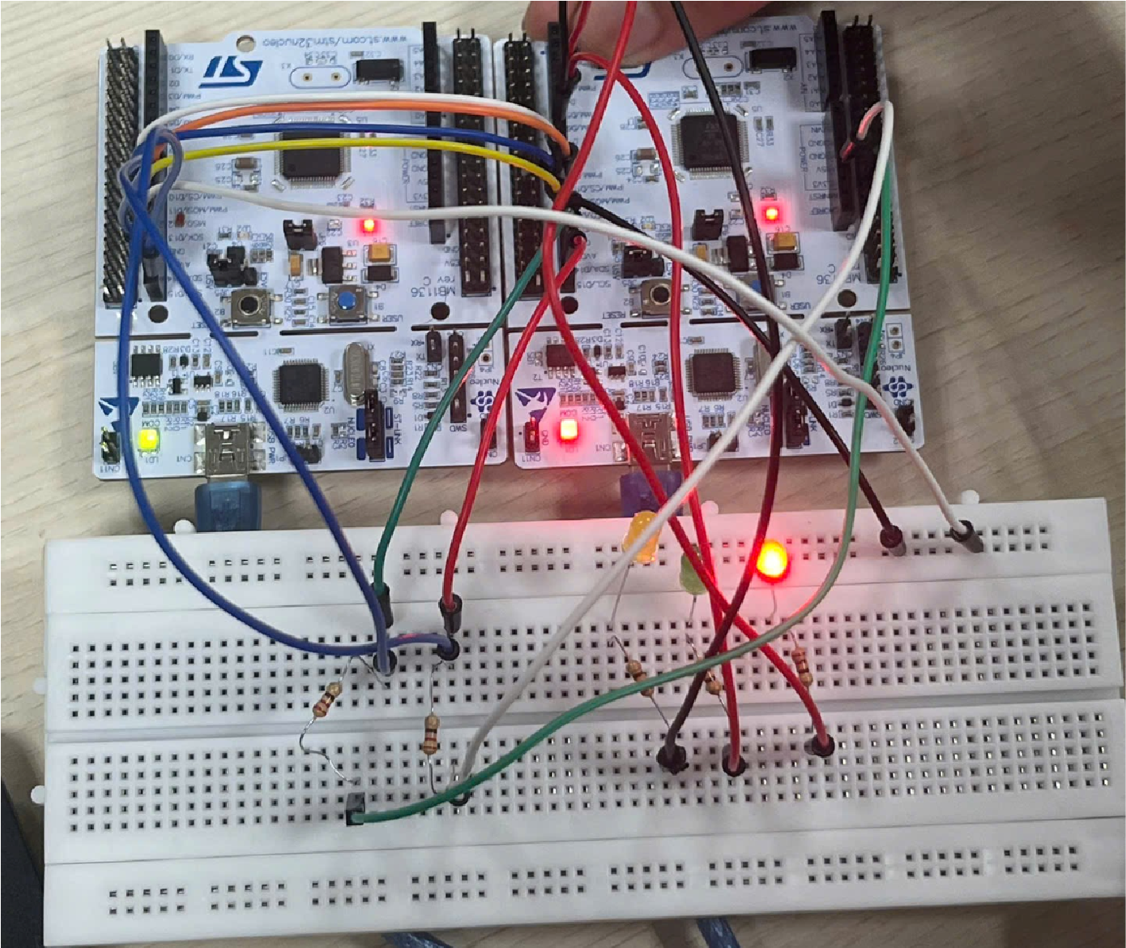
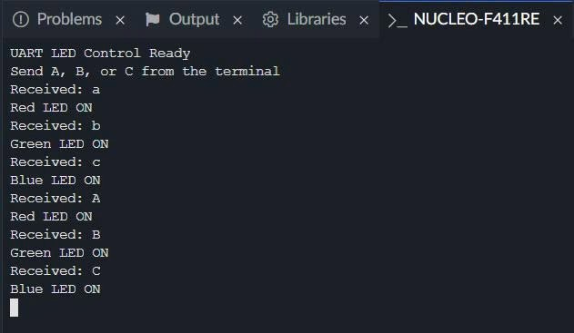

Mbed Commands to Remember
Command / Syntax |  | Used For | Example | Important Note
 | BufferedSerial pc(tx, rx, baud); | Create UART  interface | BufferedSerial pc(USBTX, USBRX,  115200); | Used for serial communication with the PC terminal.
 | pc.readable() | Check if data is available | if (pc.readable()) | Avoids reading when no character has arrived.
 | pc.read(&cmd, 1); | Read one byte from  UART | pc.read(&cmd, 1); | Reads one  character into variable cmd.
 | DigitalOut name(pin); | Create digital output object | DigitalOut redLed(D5); | Used for LED control.
 | led = 1; | Set pin HIGH | redLed = 1; | Usually turns the LED ON in this lab wiring.
 | led = 0; | Set pin LOW | redLed = 0; | Usually turns the LED OFF in this lab wiring.
 | printf(...) | Print text to terminal | printf("Received:  %c\r\n", cmd); | Useful for debugging and user feedback.
 | if / else if / else | Decision logic | if (cmd == 'A') | Used to map commands to LED outputs.

Key Concept Summary
Concept |  | Code Example | Meaning
 | UART transmit/receive | BufferedSerial pc(USBTX,  USBRX, 115200); | Creates the serial communication channel between board and terminal.
 | Receive a command | pc.read(&cmd, 1); | Reads one character sent by the user.
 | Red LED control | redLed = 1; | Turns the red LED ON.
 | Green LED control | greenLed = 1; | Turns the green LED ON.
 | Blue LED control | blueLed = 1; | Turns the blue LED ON.
 | Ignore Enter key | if (cmd == '\n' || cmd == '\r') | Prevents line-ending characters from being processed as commands.
 | Feedback text | printf("Received: %c\r\n", cmd); | Shows terminal confirmation of the command.

Suggested Grading Rubric
Category |  | Score |  | Criteria
 | Circuit wiring | 20 |  | Correct UART/LED setup and common GND; neat breadboard wiring.
 | Code completion | 35 |  | All blanks completed correctly; program compiles and runs.
 | Lab behavior | 25 |  | A/B/C commands control the correct LEDs and terminal feedback works.
 | Questions | 10 |  | Answers are clear and technically correct.
 | Presentation | 10 |  | Submission is clean, complete, and includes evidence of testing.

