EMBEDDED SYSTEMS PROGRAMMING WITH MBED OS
SPI Communication Between Two Boards
Master-to-Slave LED Control Using Two NUCLEO-F401RE Boards
Item |  | Information
 | Course | Embedded Systems / Microcontroller  Programming
 | Platform | 2 × STM32 NUCLEO-F401RE
 | Framework | Mbed OS
 | Lab Package | Lab 5.3
 | Topic | SPI Master/Slave Communication,  Inter-board Data Transfer, LED Control
 | Submission | Completed source code for both boards, answers, and evidence of circuit testing

Student Information
Field |  | Student Input
 | Student Name | Nguyen Nhu Van Anh - Le Hieu Dat -  Duong Van Hoa - Nguyen Quoc Kiet
 | Student ID | CE200171 - CE200509 -  CS200558 - CE200736
 | Class | IC2002
 | Date | 02/07/2026

General Submission Instructions
- Build the SPI circuit exactly as described in the connection table.
- Program one board as SPI Master and the other board as SPI Slave.
- Complete all missing code sections marked with blanks or TODO comments.
- Compile and run the programs on both STM32 NUCLEO-F401RE boards.
- Capture one photo of the circuit and one screenshot or short video showing the LED control result.
- Answer all lab questions using short, clear explanations.

Important Safety Note
Always connect a common GND between the two boards. Connect MOSI to MOSI, MISO to MISO, SCK to SCK, and CS from the Master to the Slave chip-select input. Do not connect LEDs without 220Ω–330Ω current-limiting resistors.
SPI Communication Between Two Boards

1. Objective
In this lab, students implement an SPI communication link between two STM32
NUCLEO-F401RE boards. One board acts as the SPI Master (controller) and sends one-byte command data to the second board, which acts as the SPI Slave (target). The Slave board uses the received byte to control three LEDs. The goal is to understand how synchronous serial communication works and how the Master controls the transfer timing using the SPI clock.

2. Learning Outcomes
· Create an SPI interface on the STM32 NUCLEO-F401RE.
· Understand the function of MOSI, MISO, SCK, and CS lines.
· Configure one board as SPI Master and another as SPI Slave.
· Send one-byte control data from the Master board.
· Receive control data on the Slave board.
· Use received SPI data to control LEDs.
· Print debug information to the serial terminal using printf().

3. Required Hardware
Component | Quantity |  | Purpose
STM32 NUCLEO-F401RE 2 One board as Master, one
board as Slave
LED 3 Visual output on the Slave
board
220Ω–330Ω resistor 3 Current limiting for LEDs
Breadboard 2 or 1 large Circuit assembly
Jumper wires Several Connections between
boards and LEDs
USB cable 2 Board power and serial
terminal access

4. Hardware Setup / Circuit Connections
Connection | Master Board | Slave Board |  | Description
SPI MOSI | D11 | D11 |  | Master Out Slave In data line
SPI MISO | D12 | D12 |  | Slave Out Master In data line
SPI SCK | D13 | D13 |  | SPI clock line
Chip Select (CS) | D10 | D10 input / chip select |  | Master selects the Slave before transfer
Common Ground | GND | GND |  | Required common reference
Red LED | - | D5 via 220Ω–330Ω |  | Turns ON when command A is received
Green LED | - | D6 via 220Ω–330Ω |  | Turns ON when command B is received
Blue LED | - | D7 via 220Ω–330Ω |  | Turns ON when command C is received
Simple wiring view

Master D11 (MOSI) -------- Slave D11 (MOSI)
Master D12 (MISO) -------- Slave D12 (MISO)
Master D13 (SCK) -------- Slave D13 (SCK)
Master D10 (CS) -------- Slave D10 (CS)
Master GND -------- Slave GND

Slave D5 ---- 330Ω ---- Red LED ---- GND
Slave D6 ---- 330Ω ---- Green LED ---- GND
Slave D7 ---- 330Ω ---- Blue LED ---- GND
5. Functional Requirements
Board / I/O Pin / Interface |  |  | Required Behavior
Master Board D11/D12/D13/D10 Send one command byte
over SPI.
Slave Board D11/D12/D13/D10 Receive the command byte
from the Master.
Slave Red LED D5 Turn ON when command A
is received.
Slave Green LED D6 Turn ON when command B
is received.
Slave Blue LED D7 Turn ON when command C
is received.
Serial terminal USBTX/USBRX Display sent/received
debugging messages.

6. Key Theory
Concept | In this Lab | Meaning
SPI bus MOSI + MISO + SCK + CS Four-wire synchronous
serial communication
between boards.
Master SPI master(D11, D12, D13); Initiates transfer and
generates the SPI clock.
Slave Connected to Receives data only when
MOSI/MISO/SCK/CS selected by CS.
Chip Select DigitalOut cs(D10); Selects the Slave before
data transfer.
DigitalOut redLed(D5); Used to control LEDs based
on received data.
Received command A / B / C Selects which LED should
turn ON.

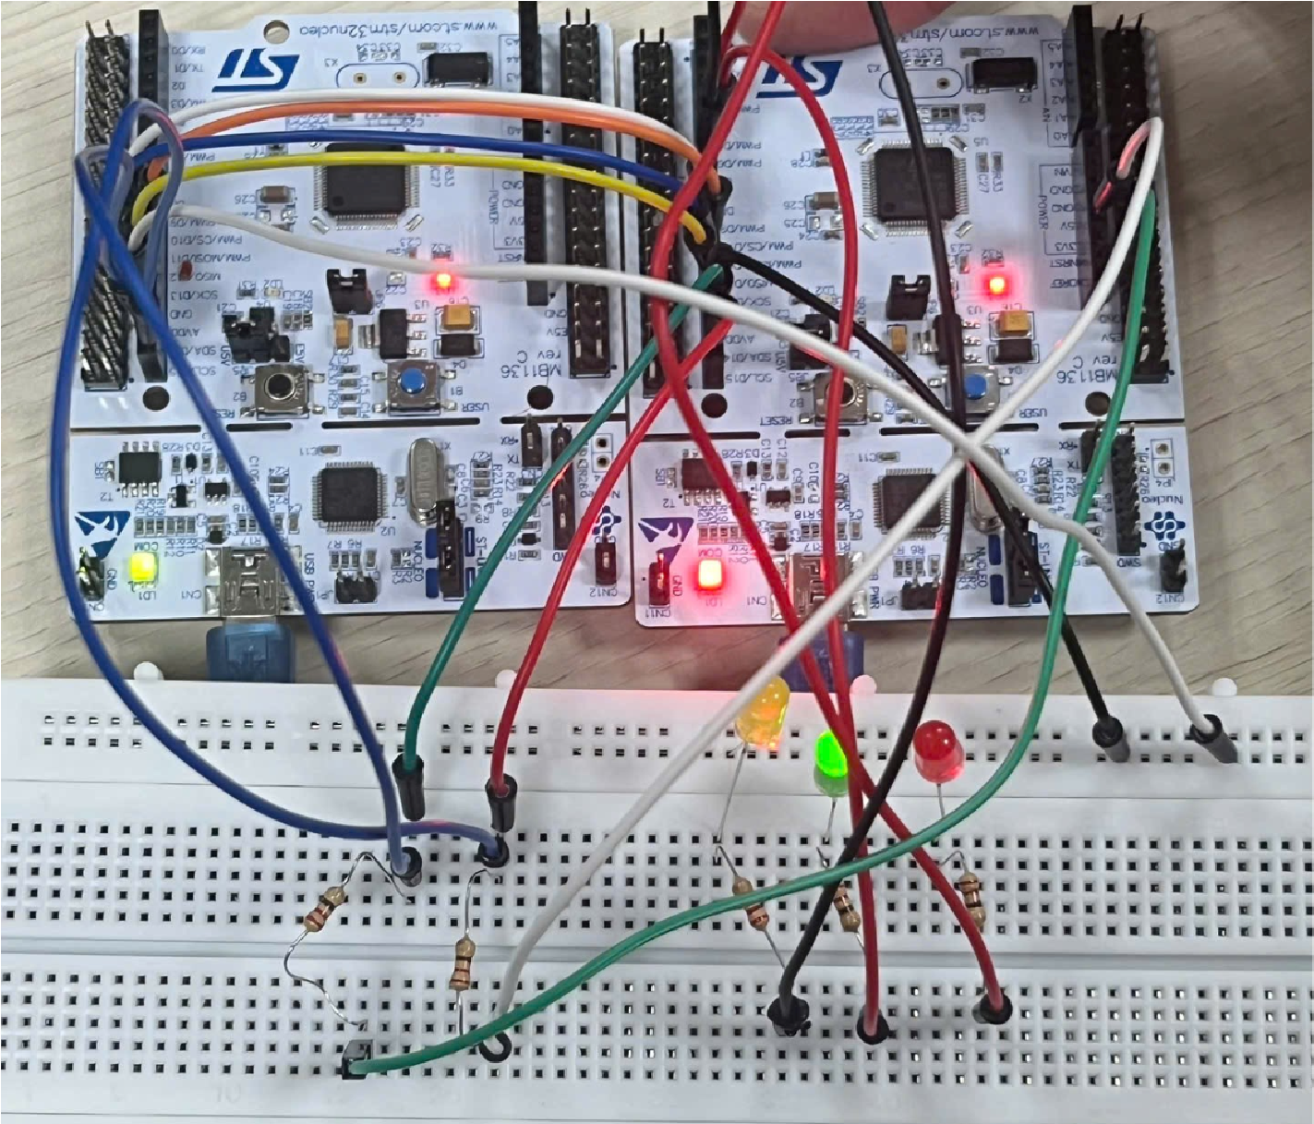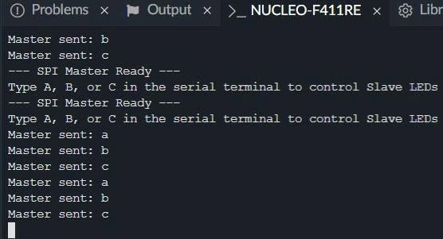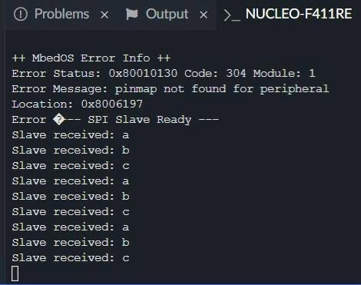

7. Starter Code - Master Board (Fill in the Missing Parts)
#include "mbed.h"
#include <cstdio>
#define MOSI_PIN D11
#define MISO_PIN D12
#define SCK_PIN D13
#define CS_PIN D10

// Khởi tạo SPI Master và chân Chip Select (CS)
SPI master(MOSI_PIN, MISO_PIN, SCK_PIN);
DigitalOut cs(CS_PIN);

char tx;

int main()
{
master.format(8, 0); master.frequency(100000);
cs = 1;

printf("--- SPI Master Ready ---\r\n"); printf("Type A, B, or C in the serial terminal to control Slave LEDs\r\n"); while (true)
{
// Đọc ký tự từ Serial Terminal char cmd = getchar();

// Bỏ qua các ký tự xuống dòng if (cmd == '\n' || cmd == '\r')
{ continue;
}

// Lưu ký tự vào biến truyền tx = cmd; cs = 0;
ThisThread::sleep_for(1ms); // Chờ một chút ngắn để Slave kịp đáp ứng

// Truyền 1 byte dữ liệu qua SPI master.write(tx);

// Hủy kích hoạt Slave (Kéo chân CS lên mức Cao) ThisThread::sleep_for(1ms);
cs = 1;

printf("Master sent: %c\r\n", tx);
}
}

8. Starter Code - Slave Board (Fill in the Missing Parts)
#include "mbed.h"
#include <cstdio>

#define RED_LED D5
#define GREEN_LED D6
#define BLUE_LED D7

// Khởi tạo các chân Output cho LED
DigitalOut redLed(RED_LED);
DigitalOut greenLed(GREEN_LED);
DigitalOut blueLed(BLUE_LED);

// Khởi tạo SPI Slave (Bỏ qua chân CS phần cứng bằng NC để tránh lỗi kẹt xung đột) SPISlave slave(D11, D12, D13, NC);

char rx; int main()
{ slave.format(8, 0); redLed = 0; greenLed = 0; blueLed = 0;

printf("--- SPI Slave Ready ---\r\n");

while (true)
{
// Kiểm tra xem có tín hiệu SPI truyền đến hay không if (slave.receive())
{
// Đọc 1 byte dữ liệu nhận được từ Master rx = slave.read();

printf("Slave received: %c\r\n", rx);

// Điều khiển LED dựa trên ký tự nhận được
if (rx == 'A' || rx == 'a')
{ redLed = 1;

greenLed = 0; blueLed = 0;
} else if (rx == 'B' || rx == 'b')
{ redLed = 0; greenLed = 1; blueLed = 0;
} else if (rx == 'C' || rx == 'c')
{
redLed = 0; greenLed = 0; blueLed = 1;
} else
{
// Nếu nhận ký tự khác, tắt hết LED redLed = 0; greenLed = 0; blueLed = 0;
}
}
}
}

9. Example Format
SPI master(D11, D12, D13); DigitalOut cs(D10); master.format(8, 0); master.frequency(1000000); cs = 0; master.write(tx); cs = 1;
SPISlave slave(D11, D12, D13, D10); if (slave.receive()) rx = slave.read();
These examples show how to create SPI master/slave interfaces, configure the bus, select the Slave, and transfer one byte.

10. Expected Observation
☐ When the Master sends A, the Slave red LED turns ON.
☐ When the Master sends B, the Slave green LED turns ON.
☐ When the Master sends C, the Slave blue LED turns ON.
☐ The Master terminal prints the sent character.
☐ The Slave terminal prints the received character.
☐ The two boards communicate through MOSI, MISO, SCK, CS, and GND.

11. Student Questions
- What is the role of MOSI in SPI communication?
Answer: MOSI (Master Out, Slave In) is the data line used to send data from the Master to the Slave.
- What is the role of MISO in SPI communication?
Answer: MISO (Master In, Slave Out) is the data line used to send data from the Slave to the Master.
- What is the role of SCK in SPI communication?
Answer: SCK (Serial Clock) is the clock signal generated by the Master to synchronize data transfer between the Master and the Slave.
- Why is the CS line required in SPI communication?
Answer: The CS (Chip Select) line is used to select which Slave device the Master wants to communicate with. Only the selected Slave responds to the communication.
- What is the difference between an SPI Master and an SPI Slave?
Answer: The Master controls the communication by generating the clock signal and selecting the Slave. The Slave responds only when its CS line is activated by the Master.
- What happens when the Slave receives the character A?
Answer: When the Slave receives the character 'A', it performs the programmed action, such as turning on an LED or executing another predefined task.
- What is the purpose of slave.receive() in the SPI Slave code?
Answer: slave.receives() checks whether the Slave has received data from the Master. It lets the program know when new data is available to read.
- Why must both boards use the same SPI format and mode?
Answer: Both boards must use the same SPI format and mode to ensure that data is sampled and transmitted at the correct clock timing. If the settings are different, the communication may fail or produce incorrect data.

12. Suggested Test Procedure
- Power both NUCLEO boards using separate USB cables.
- Verify that MOSI, MISO, SCK, CS, and GND are correctly connected between the two boards.
- Open a serial terminal for the Master board and a serial terminal for the Slave board.
- Type A on the Master terminal and observe the Slave red LED.
- Type B on the Master terminal and observe the Slave green LED.
- Type C on the Master terminal and observe the Slave blue LED.
- Check the printed debugging messages on both terminals.

13. Challenge Tasks
· Add command O so that the Master can turn all Slave LEDs OFF.
· Modify the Slave so that it sends one status byte back to the Master using MISO.
· Expand the protocol so digits 1, 2, 3 select blink patterns instead of simple ON/OFF.
· Use a second SPI Slave and add another chip-select line on the Master.

Appendix A - Mbed Commands to Remember
Command / Syntax |  | Used For | Example | Important Note
 | SPI master(mosi, miso, sclk); | Create SPI  Master interface | SPI master(D11, D12,  D13); | Used on the board that starts communication.
 | master.format(bits, mode); | Set SPI data format | master.format(8, 0); | Both Master and Slave must use the same format.
 | master.frequency(hz)  ; | Set SPI clock speed | master.frequency(100000  0); | 1 MHz is common in simple labs.
 | master.write(value); | Send one byte over SPI | master.write(tx); | Returns the byte received from the Slave at the same time.
 | SPISlave slave(mosi, miso, sclk, ssel); | Create SPI  Slave interface | SPISlave slave(D11,  D12, D13, D10); | Used on the receiving board.
 | slave.receive(); | Check for SPI event | if (slave.receive()) | Detects whether the Slave has been selected and data is available.
 | slave.read(); | Read byte from  SPI bus | rx = slave.read(); | Reads the received byte.
 | DigitalOut led(pin); | Create LED output object | DigitalOut redLed(D5); | Used to control LEDs.

Appendix B - Key Concept Summary
Concept |  | Code Example | Meaning
Master initialization SPI master(D11, D12, D13); Creates the controller side of the SPI bus.
Slave initialization | SPISlave slave(D11, D12,  D13, D10); | Creates the target side of the SPI bus.
Chip Select | cs = 0; ... cs = 1; | The Master selects the Slave before transfer and releases it afterward.
Send one byte | master.write(tx); | Transfers one command byte from Master to Slave.
Receive one byte | rx = slave.read(); | Reads the command byte on the Slave board.
LED action | if (rx == 'A') redLed = 1; | Maps received data to LED behavior.

Appendix C - Suggested Grading Rubric
Category |  | Score | Criteria
 | Circuit wiring | 20 | Correct MOSI, MISO, SCK, CS, GND, and LED wiring; neat breadboard layout.
 | Code completion | 35 | All blanks completed correctly for both Master and Slave; programs compile and run.
 | Lab behavior | 25 | Master sends data correctly; Slave receives data and controls LEDs correctly.
 | Questions | 10 | Answers are clear and technically correct.
 | Presentation | 10 | Submission is clean, complete, and includes evidence of testing.

