EMBEDDED SYSTEMS PROGRAMMING WITH MBED OS
I2C Communication Between Two Boards
Master-to-Slave LED Control Using Two NUCLEO-F401RE Boards
Item |  | Information
 | Course | Embedded Systems / Microcontroller  Programming
 | Platform | 2 × STM32 NUCLEO-F401RE
 | Framework | Mbed OS
 | Lab Package | Lab 5.2
 | Topic | I2C Master/Slave Communication, LED  Control, Inter-board Data Transfer
 | Submission | Completed source code for both boards, answers, and evidence of circuit testing

Student Information
Field |  | Student Input
 | Student Name | Nguyen Nhu Van Anh - Le Hieu Dat -  Duong Van Hoa - Nguyen Quoc Kiet
 | Student ID | CE200171 - CE200509 -  CS200558 - CE200736
 | Class | IC2002
 | Date | 02/07/2026

General Submission Instructions
- Build the I2C circuit exactly as described in the connection table.
- Program one board as I2C Master and the other board as I2C Slave.
- Complete all missing code sections marked with blanks or TODO comments.
- Compile and run the programs on both STM32 NUCLEO-F401RE boards.
- Capture one photo of the circuit and one screenshot or short video showing the LED control result.
- Answer all lab questions using short, clear explanations.
Important Safety Note: Always connect a common GND between the two boards. Connect SDA to SDA and SCL to SCL. Do not swap these lines. If pull-up resistors are not provided on the boards or by the circuit, add suitable pull-up resistors to the I2C lines.
I2C Communication Between Two Boards

1. Objective
:In this lab, students implement an I2C communication link between two STM32
NUCLEO-F401RE boards. One board acts as the I2C Master (controller) and sends a command byte to the second board, which acts as the I2C Slave (target). The Slave board uses the received data to control LEDs. The goal is to understand how two embedded boards exchange data over the I2C bus.

2. Learning Outcomes
· Create an I2C interface on the STM32 NUCLEO-F401RE.
· Understand the function of SDA and SCL lines.
· Configure one board as I2C Master and another as I2C Slave.
· Send one-byte control data from the Master board.
· Receive control data on the Slave board.
· Use received I2C data to control LEDs.
· Print debug information to the serial terminal using printf() or Serial.print().

3. Required Hardware
Component | Quantity |  | Purpose
STM32 NUCLEO-F401RE 2 One board as Master, one
board as Slave
LED 3 Visual output on the Slave
board
220Ω–330Ω resistor 3 Current limiting for LEDs
Breadboard 2 or 1 large Circuit assembly
Jumper wires Several Connections between
boards and LEDs
USB cable 2 Board power and serial
terminal access

4. Hardware Setup / Circuit Connections
Connection | Master Board | Slave Board | Description
I2C SDA | D14 | D14 | Data line of the I2C bus
I2C SCL | D15 | D15 | Clock line of the I2C bus
Common Ground | GND | GND | Required common reference
Red LED | - | D5 via 220Ω–330Ω | Turns ON when command A is received
Green LED | - | D6 via 220Ω–330Ω | Turns ON when command B is received
Blue LED | - | D7 via 220Ω–330Ω | Turns ON when command C is received
Simple wiring view

Master D14 (SDA) -------- Slave D14 (SDA)
Master D15 (SCL) -------- Slave D15 (SCL)
Master GND -------- Slave GND

Slave D5 ---- 330Ω ---- Red LED ---- GND
Slave D6 ---- 330Ω ---- Green LED ---- GND
Slave D7 ---- 330Ω ---- Blue LED ---- GND

5. Functional Requirements
Board / I/O Pin / Address |  | Required Behavior
Master Board D14/D15 Send one command byte
over I2C.
Slave Board Address 0x20 Receive the command byte
from the Master.
Slave Red LED D5 Turn ON when command A
is received.
Slave Green LED D6 Turn ON when command B
is received.
Slave Blue LED D7 Turn ON when command C
is received.
Serial terminal USBTX/USBRX or Arduino Display sent/received
Serial debugging messages.

6. Key Theory
Concept | In this Lab | Meaning
I2C bus SDA + SCL Two-wire serial
communication between
boards.
Master I2C master(D14, D15); Initiates communication and
sends data.
Slave Address 0x20 Waits for the Master and
responds to received data.
Slave address 0x20 Unique address used by the
Master to reach the Slave.
DigitalOut redLed(D5); Used to control LEDs based
on received data.
Received command A / B / C Selects which LED should
turn ON.
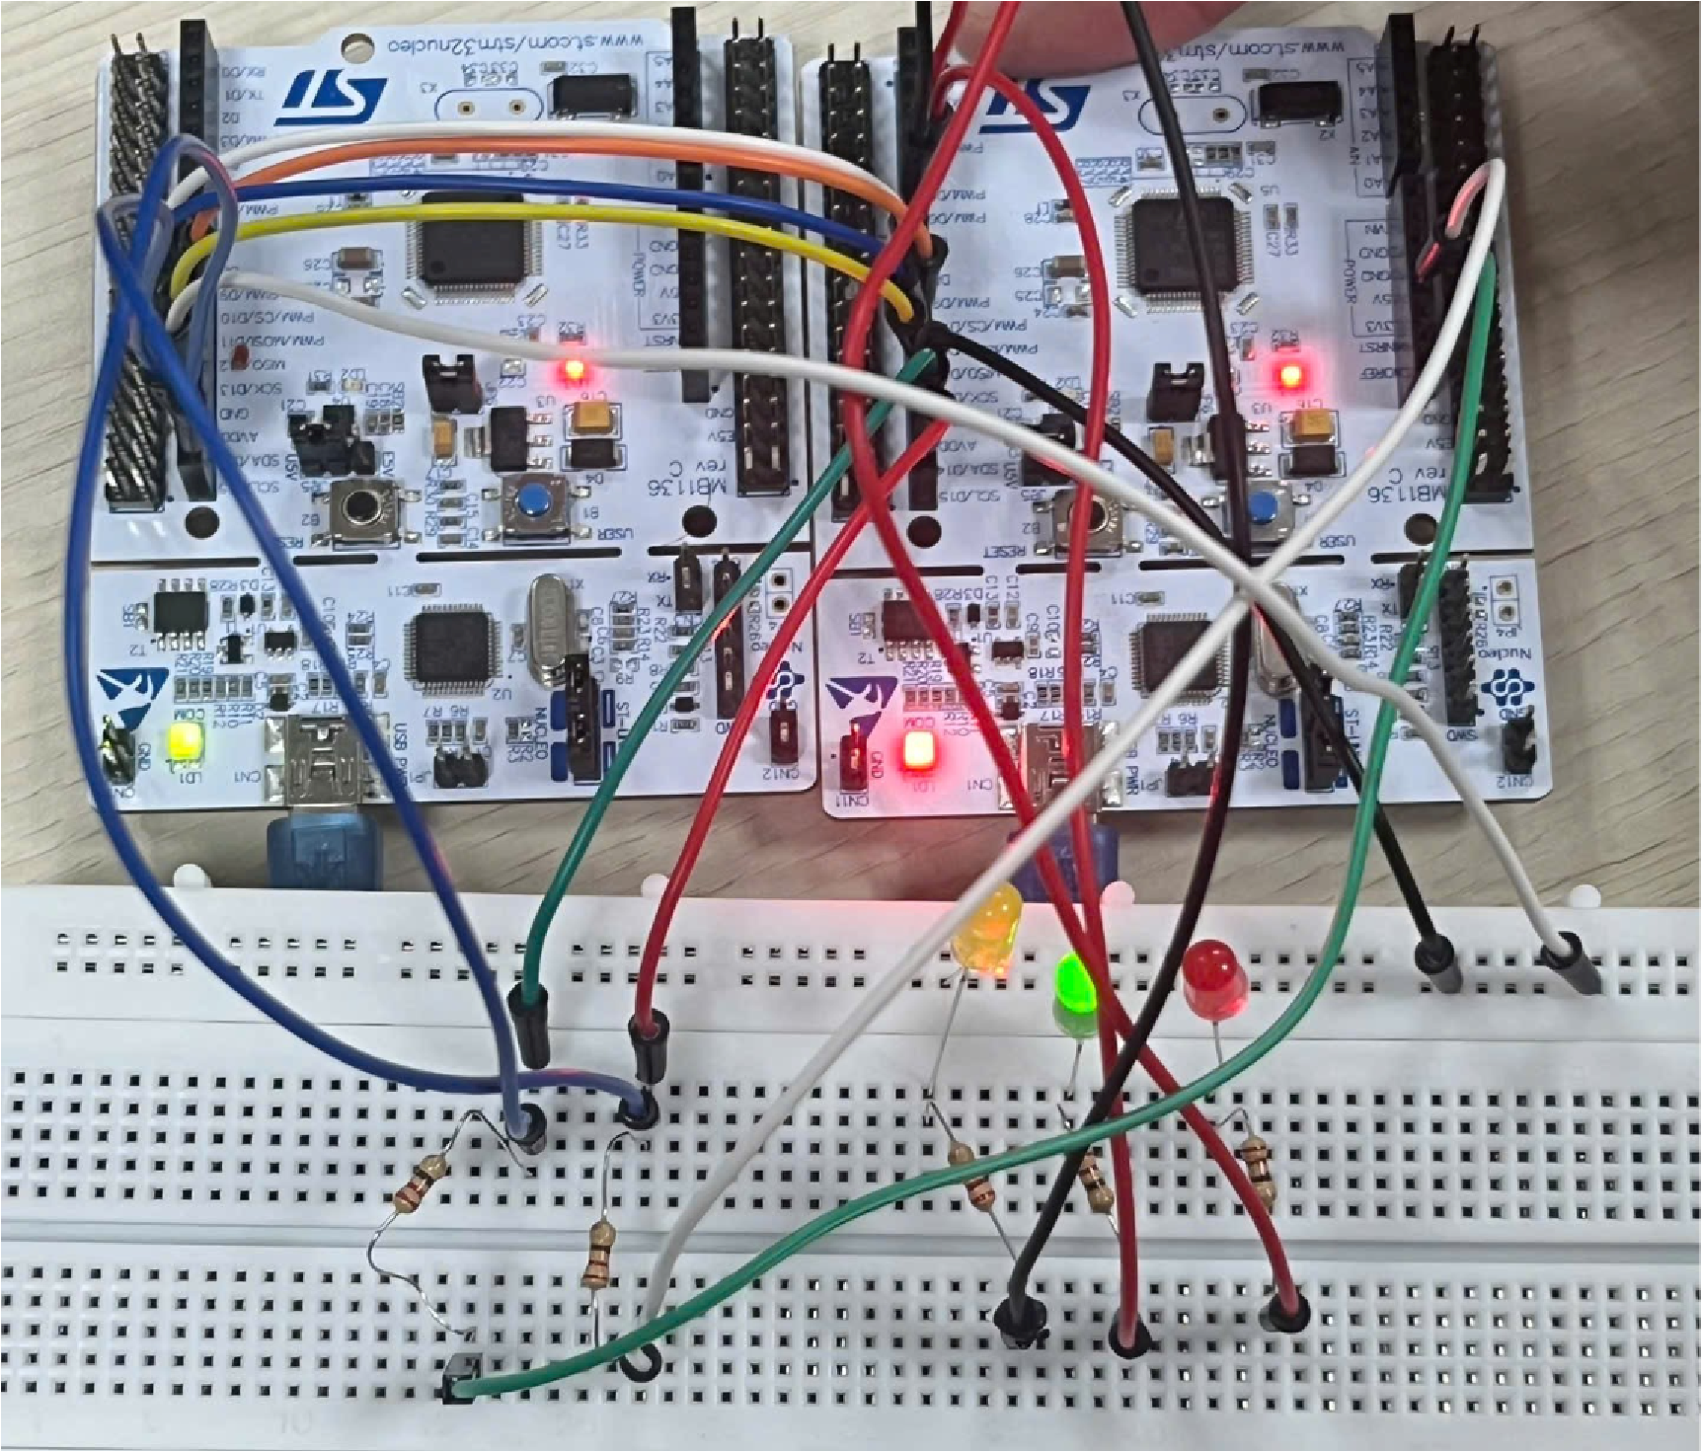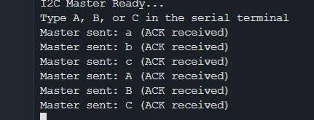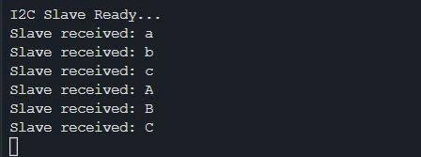

7. Starter Code - Master Board (Fill in the Missing Parts)
#include "mbed.h"
#include <cstdio>
#define SDA_PIN D14
#define SCL_PIN D15

I2C master(SDA_PIN, SCL_PIN); const int SLAVE_ADDR = 0x20 << 1;
char tx; int main()
{
master.frequency(100000);

printf("I2C Master Ready...\r\n"); printf("Type A, B, or C in the serial terminal\r\n");

while (true)
{
char cmd = getchar(); if (cmd == '\n' || cmd == '\r')
{ continue;
}

// Lưu ký tự hợp lệ vào biến truyền tx tx = cmd; int ack = master.write(SLAVE_ADDR, &tx, 1); if (ack == 0) { printf("Master sent: %c (ACK received)\r\n", tx);
} else {
printf("Master sent: %c (NACK/Error - No response from Slave!)\r\n", tx);
}
}
}

8. Starter Code - Slave Board (Fill in the Missing Parts)
#include "mbed.h"
#include <cstdio>

// Định nghĩa các chân điều khiển LED trên Slave Board
#define RED_LED D5
#define GREEN_LED D6
#define BLUE_LED D7

DigitalOut redLed(RED_LED);
DigitalOut greenLed(GREEN_LED);
DigitalOut blueLed(BLUE_LED);
I2CSlave slave(D14, D15);

char rx; int main()
{
redLed = 0; greenLed = 0; blueLed = 0; slave.address(0x20 << 1);

printf("I2C Slave Ready...\r\n");

while (true)
{ int status = slave.receive(); if (status == I2CSlave::WriteAddressed)
{
slave.read(&rx, 1); printf("Slave received: %c\r\n", rx);
if (rx == 'A' || rx == 'a')
{ redLed = 1; greenLed = 0; blueLed = 0;
} else if (rx == 'B' || rx == 'b')
{ redLed = 0; greenLed = 1; blueLed = 0;
} else if (rx == 'C' || rx == 'c')
{
redLed = 0; greenLed = 0; blueLed = 1;
} else { redLed = 0; greenLed = 0; blueLed = 0;
}
}
}
}

9. Example Format
I2C master(D14, D15); const int SLAVE_ADDR = 0x20 << 1; master.write(SLAVE_ADDR, &tx, 1); I2CSlave slave(D14, D15); slave.address(0x20 << 1); slave.read(&rx, 1);
These examples show how to create I2C master/slave interfaces, set the address, and transfer one byte.

10. Expected Observation
☐ When the Master sends A, the Slave red LED turns ON.
☐ When the Master sends B, the Slave green LED turns ON.
☐ When the Master sends C, the Slave blue LED turns ON.
☐ The Master terminal prints the sent character.
☐ The Slave terminal prints the received character.
☐ The two boards communicate through SDA and SCL only, with a common GND.

11. Student Questions
- What is the role of SDA in I2C communication?
Answer: SDA (Serial Data) is the data line used to transmit and receive data between the Master and the Slave devices.
- What is the role of SCL in I2C communication?
Answer: SCL (Serial Clock) is the clock line generated by the Master to synchronize data transmission on the SDA line.
- Why must the two boards share a common GND?
Answer: A common GND provides the same voltage reference for both boards, ensuring reliable communication and correct signal interpretation.
- What is the difference between an I2C Master and an I2C Slave?
Answer: The Master controls the communication by generating the clock and initiating data transfer. The Slave responds only when its address is called by the Master.
- Why does the Master use a slave address?
Answer: The Master uses the slave address to identify and communicate with a specific Slave device on the I2C bus.
- What happens when the Slave receives the character A?
Answer: When the Slave receives the character 'A', it executes the programmed action, such as turning on an LED or performing another predefined task.
- What is the purpose of slave.receive()?
Answer: slave.receive() checks whether the Slave has received data from the Master. It allows the program to detect incoming communication before reading the data.
- Why is the slave address often written as 0x20 << 1 in Mbed examples?
Answer: 0x20 << 1 shifts the 7-bit I2C address left by one bit to create the 8-bit address format used by the Mbed I2C library. The least significant bit is reserved for the read/write operation.

12. Suggested Test Procedure
- Power both NUCLEO boards using separate USB cables.
- Verify that SDA, SCL, and GND are correctly connected between the two boards.
- Open a serial terminal for the Master board and a serial terminal for the Slave board.
- Type A on the Master terminal and observe the Slave red LED.
- Type B on the Master terminal and observe the Slave green LED.
- Type C on the Master terminal and observe the Slave blue LED.
- Check the printed debugging messages on both terminals.

13. Challenge Tasks
· Add command O so that the Master can turn all Slave LEDs OFF.
· Modify the Slave so that it sends an ACK text back to the Master.
· Expand the protocol so digits 1, 2, 3 select blink patterns instead of simple ON/OFF. · Use a second Slave board with a different I2C address.

14. Image

Appendix A - Mbed Commands to Remember
Command / Syntax | Used For | Example | Important Note
I2C master(sda, scl); Create I2C I2C master(D14, D15); Used on the board
Master interface that starts
communication.
master.frequency(hz)  ; | Set I2C bus speed | master.frequency(100000  ); | 100 kHz is common for simple labs.
master.write(addr, buf, len); | Send bytes to  Slave | master.write(SLAVE_AD  DR, &tx, 1); | Writes one or more bytes.
I2CSlave slave(sda,  scl); | Create I2C  Slave interface | I2CSlave slave(D14,  D15); | Used on the receiving board.
slave.address(addr); | Set Slave address | slave.address(0x20 <<  1); | Address must match the Master target address.
slave.receive(); | Check for I2C event | int status = slave.receive(); | Detects whether the Slave has been addressed for write or read.
slave.read(&rx, 1); | Read data from  Master | slave.read(&rx, 1); | Reads one byte into rx.
DigitalOut led(pin); | Create LED output object | DigitalOut redLed(D5); | Used to control LEDs.

Appendix B - Key Concept Summary
Concept | Code Example | Meaning
Master initialization I2C master(D14, D15); Creates the controller side of the I2C bus.
Slave initialization | I2CSlave slave(D14, D15); | Creates the target side of the I2C bus.
Slave address | slave.address(0x20 << 1); | Identifies the Slave board on the I2C bus.
Send one byte | master.write(SLAVE_ADDR,  &tx, 1); | Transfers one command byte from Master to Slave.
Receive one byte | slave.read(&rx, 1); | Reads the command byte on the Slave board.
LED action | if (rx == 'A') redLed = 1; | Maps received data to LED behavior.

Appendix C - Suggested Grading Rubric
Category |  | Score | Criteria
 | Circuit wiring | 20 | Correct SDA, SCL, GND, and LED wiring; neat breadboard layout.
 | Code completion | 35 | All blanks completed correctly for both Master and Slave; programs compile and run.
 | Lab behavior | 25 | Master sends data correctly; Slave receives data and controls LEDs correctly.
 | Questions | 10 | Answers are clear and technically correct.
 | Presentation | 10 | Submission is clean, complete, and includes evidence of testing.

