# CMS

## Manager Category

http://app.webdigital.vn/demo/goaman/admincp/category/

Change to Category Management

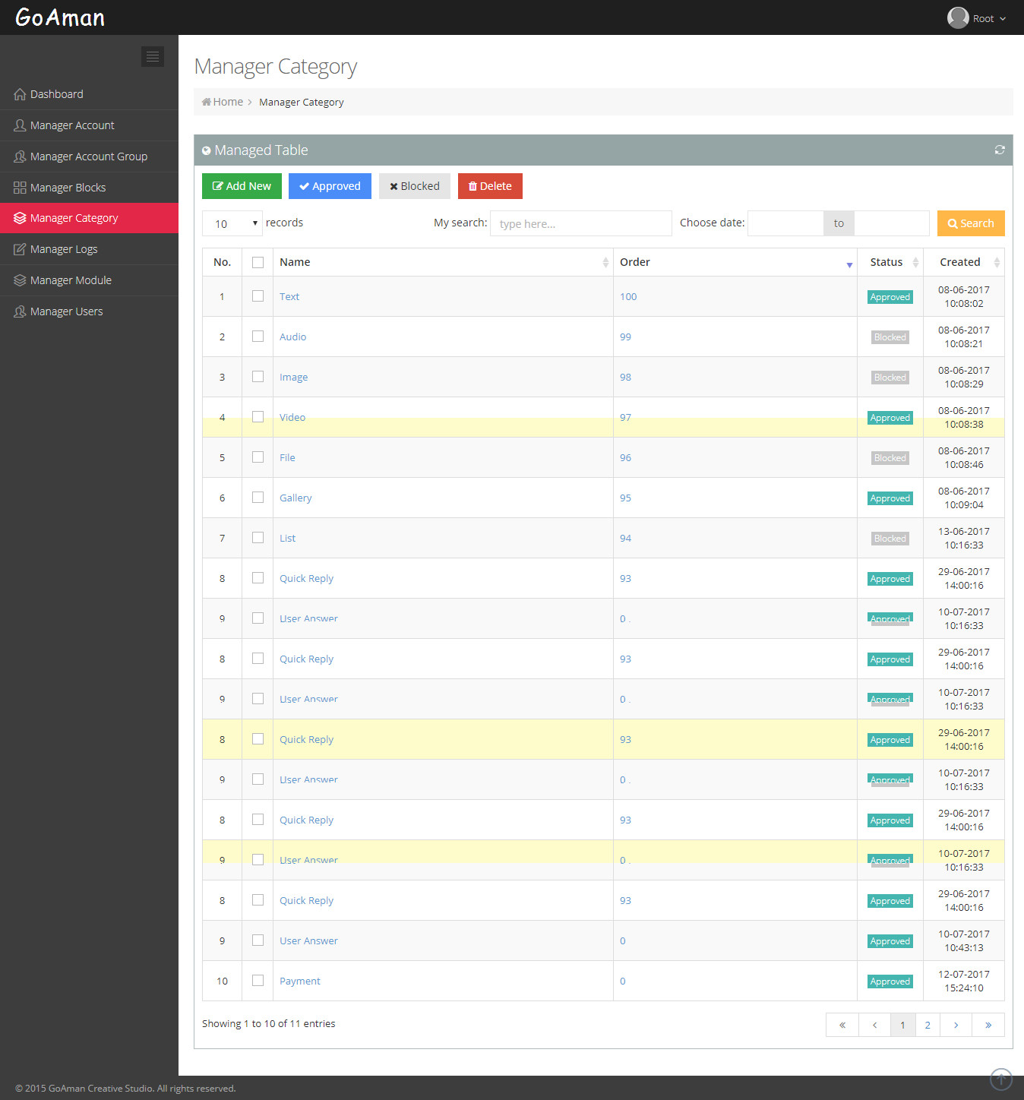

## Manager Blocks

<http://app.webdigital.vn/demo/goaman/admincp/blocks/>

Change to Category Management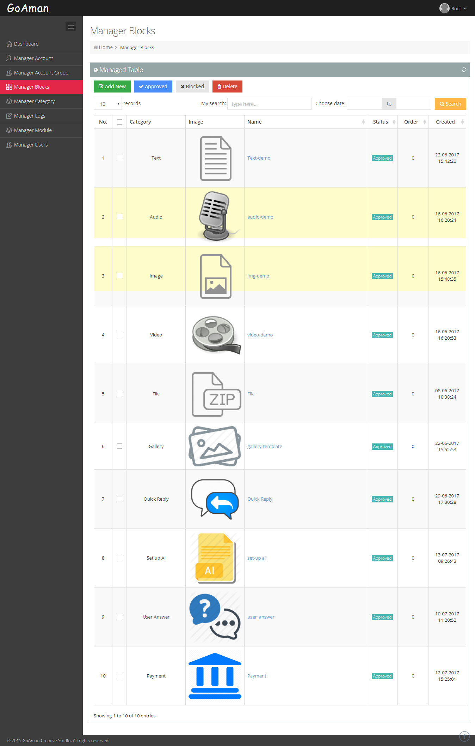

### Detail

<http://app.webdigital.vn/demo/goaman/admincp/blocks/update/40>

HTML

<section class=**"sample-interface-text"** **data-script-name="block_run_script_text">**

<div class=**"container"**>

<div class=**"row"**>

<div class=**"col-sm-4 col-md-4 reponsive"**></div>

<div class=**"col-sm-4 col-md-4 reponsive-fix"**>

<div class=**"content"**>

<div class=**"form-group"**>

<div class=**"in-put"**>

<div class=**"all"** data-type=**"all"**>

<p data-type=**"content"** class=**"text"**>**Content (required)**</p>

<span class=**"glyphicon glyphicon-trash"** aria-hidden=**"true"**></span>

</div>

</div>

<div class=**"box-bt-fix"**></div>

<div class=**"bu-tton"**>

<button class=**"btn btn-default accordion"**><span class=**"glyphicon glyphicon-plus"** aria-hidden=**"true"**></span>*&nbsp;***ADD BUTTON**</button>

</div>

<div class=**"panel"**>

<div class=**"en-ter-bt"**>

<input placeholder=**"Enter text"** type=**"text"** class=**"form-control"**>

</div>

<div class=**"en-ter-block"**>

<div class=url-link>

<ul class=**"nav nav-tabs"**>

<li class=**"active"**><a href=**"#"**><span class=**"glyphicon glyphicon-align-left"** aria-hidden=**"true"**></span>**Block**</a></li>

<li><a class=**"color-red"** href=**"#a"**><span class=**"glyphicon glyphicon-paperclip"** aria-hidden=**"true"**></span>**URL**</a></li>

<li><a class=**"color-red"** href=**"#b"**><span class=**"glyphicon glyphicon-earphone"** aria-hidden=**"true"**></span>**Phone call**</a></li>

</ul>

<div class=**"tab-content clearfix"**>

<div class=**"tab-pane active"** id=**"a"**>

<input placeholder=**"Enter text"** type=**"text"** class=**"form-control"**>

</div>

</div>

</div>

</div>

</div>

</div>

</div>

</div>

<div class=**"col-sm-4 col-md-4 reponsive"**></div>

</div>

</div>

</section>

# block.js

D:\xampp\htdocs\2017_Goaman_Chatbot\CODE\assets\js\block.js

## block_raw_html_tojson_all

***function*** block_raw_html_tojson_all**(){**

***var*** json_text **=** ''**;**

***var*** json_data **=** **{};**

$**(**"#container .row-element"**).**each**(*function*(){**

***var*** block_jele **=** $**(*this*);**

***var*** block_generated_id **=** block_jele**.**attr**(**'id'**);**

***var*** block_selector **=** '#'**+**block_generated_id**;**

***var*** **check_card_text** **=** block_jele**.**find**(**'section[**data-script-name=block_run_script_text**]'**).**length **>=** 1**;**

***var*** check_card_video **=** block_jele**.**find**(**'section[data-script-name=block_run_script_video]'**).**length **>=** 1**;**

***var*** check_card_gallery **=** block_jele**.**find**(**'.gallery-box'**).**length **>=** 1**;**

***if*(**check_card_text**){**

***var*** text_jele **=** $**(**'.content .form-group .in-put p[data-type=content]'**,** block_selector**);**

***if*(**text_jele**.**length **==** 0**){**

text_jele **=** $**(**'.content .form-group .in-put p[data-type=title]'**,** block_selector**);**

**}**

***var*** obj_text **=** text_jele**.**text**();**

// TODO

***var*** obj_buttons **=** **[];**

$**(**'.content .form-group .button-bt h5[data-type=button]'**,** block_selector**).**each**(*function*(){**

***var*** button_jele **=** $**(*this*);**

***var*** button_obj **=** **block_raw_html_tojson_all_button(button_jele);**

obj_buttons**.**push**(**button_obj**);**

**});**

***var*** obj**;**

***if*(**obj_buttons **&&** obj_buttons**.**length**){**

obj **=** **{**

***type : 'text',***

***content : obj_text,***

**json : {**

**attachment: {**

**type: "template",**

**payload: {**

**template_type: "button",**

**text: obj_text,**

**buttons: obj_buttons**

**}**

**}**

**}**

**};**

**}** ***else*** **{**

obj **=** **{**

***type : 'text',***

***content : obj_text,***

**json : {**

**text: obj_text**

**}**

**};**

**}**

json_data**[**block_generated_id**]** **=** obj**;**

**}** ***else*** ***if*(**check_card_video**){**

// ...

**}** ***else*** ***if*(**check_card_gallery**){**

// ...

**}**

**});**

json_text **=** $**.**toJSON**(**json_data**);**

// pr('block_raw_html_tojson_all - json_text = ' + json_text);

***return*** json_text**;**

**}**

## block_raw_html_tojson_all_button => Postback

***function*** **block_raw_html_tojson_all_button(button_jele){**

// TODO

***var*** button_text **=** button_jele**.**text**();**

***var*** button_type **=** 'web_url'**;**

***var*** button_url **=** button_jele**.**attr**(**'data-payload'**);**

***var*** button_obj **=** **{**

title**:** button_text

**};**

***if*(**button_url**){**

***if*(**button_url**.**indexOf**(**'#'**)** **!=** **-**1**){**

button_type **=** 'postback'**;**

***var*** button_number **=** button_url**.**replace**(**'#'**,**''**);**

**button_obj.payload = button_number;**

**}** ***else*** **{**

button_obj**.**url **=** button_url**;**

**}**

**}** ***else*** **{**

button_obj**.**url **=** "https://www.google.com.vn/"**;** // Default for blank url

**}**

button_obj**.**type **=** button_type**;**

***return*** button_obj**;**

**}**

# main.js

D:\xampp\htdocs\2017_Goaman_Chatbot\CODE\assets\js\main.js

***function*** cookie_upload**(**url**,** json_text**){**

***var*** store_var_permanent_json **=** $**.**toJSON**(**store_var_permanent**);**

store_var_permanent **=** **{};** // Reset

$**.**post**(**url**,** **{**'cookie_data'**:**store_var_permanent_json**,** **'json_text' : json_text},*function*(**response**){**

pr**(**'response = ' **+** response**);**

**});**

**}**

# Home.php

D:\xampp\htdocs\2017_Goaman_Chatbot\CODE\application\modules\home\controllers\Home.php

## save_permanent_cookie

**function** save_permanent_cookie(){

$return_data = [];

$is_permanent = builder_check_permanent();

**if**($is_permanent){

$cookie_data = $this->input->post('cookie_data');

$insert['cookie_data'] = $cookie_data;

$insert['created'] = date('Y-m-d H:i:s');

$query = $this->model->insert('chatbot_flow', $insert);

**$json_text = $this->input->post('json_text');**

// Clear db

$sql = 'TRUNCATE chatbot_question';

$this->db->query($sql);

$json_data = json_decode($json_text);

**foreach**($json_data **as** $key => $obj){

$question_data['type'] = $obj->type;

**if**($question_data['type'] === 'user_answer'){

$question_data['question'] = '';

}**else**{

$question_data['question'] = $obj->content;

}

**if**(!**empty**($obj->json)){

$question_data['json'] = json_encode($obj->json);

}

$this->model->insert('chatbot_question', $question_data);

}

$return_data['status'] = 'success';

}

**echo** json_encode($return_data);

**exit**();

}

## chat

Final step to return json for Node.js

Example: Card User answer

* Mapping question
* Group question => Contain questions before Card User answer

**function** chat(){

$jsonData = @file_get_contents('php://input');

@json_decode($jsonData, **TRUE**);

$arrayData = (json_last_error() === JSON_ERROR_NONE) ? json_decode($jsonData, **TRUE**) : **array**();

$question_id_previous = !**empty**($arrayData['question_id_previous']) ? (**int**)($arrayData['question_id_previous']) : 0;

$question_id_selected = !**empty**($arrayData['question_id_selected']) ? (**int**)($arrayData['question_id_selected']) : 0;

**if**(!**empty**($question_id_selected)){

$next_question = $this->model->get('*','chatbot_question', "id = {$question_id_selected}");

} **else** {

$question_list = $this->model->fetch('*','chatbot_question','','id','asc');

$next_question = '';

**foreach**($question_list **as** $question){

$question_id = $question->id;

**if**($question_id > $question_id_previous){

$next_question = $question;

**break**;

}

}

}

$json_text = '';

**if**(!**empty**($next_question)){

$json_text = $this->chat_json_get($next_question);

} **else** {

$data['command'] = 'restart';

$data['question'] = [

'text' => 'Chatbot will be restarted AGAIN'

];

$data['question_id'] = 0;

$json_text = json_encode($data, **true**);

}

**echo** $json_text;

**exit**;

}

**function** chat_json_get($question){

$result = '';

**if**(!**empty**($question)){

$question_id = $question->id;

**if**(!**empty**($question->json)){

$card_obj = json_decode($question->json);

**if**(**empty**($card_obj->quick_replies)){

**unset**($card_obj->quick_replies);

}

$return_obj = $card_obj;

}

$data = [];

**if**(!**empty**($return_obj)){

$data['command'] = 'next';

**$data['question'] = $return_obj;**

$data['question_id'] = $question_id;

}

$result = json_encode($data, **true**);

}

**return** $result;

}

# app.js – NodeJS

***function*** sendGetData**(**senderID**,** question_id_selected**)** **{**

***var*** url **=** 'http://app.webdigital.vn/demo/goaman/home/chat'**;**

***var*** question_id_selected **=** ***typeof*(**question_id_selected**)** **!=** 'undefined' **?** question_id_selected **:** 0**;**

***var*** send_data **=** **{**

question_id_previous**:** question_id_arr**[**senderID**],**

question_id_selected**:** question_id_selected**,**

user_fb_id**:** senderID

**}**

console**.**log**(**'send_data'**);**

console**.**log**(**send_data**);**

getData**(**url**,** send_data**,** ***function*(**error**,** data**){**

***if*(**error**)** **{**

***return*** console**.**error**(**error**);**

**}**

***var*** data_json **=** JSON**.**parse**(**data**);**

console**.**log**(**'data_json'**);**

console**.**log**(**data_json**);**

console**.**log**(**data_json**.**question**);**

***if*(**data_json**.**command **==** 'restart'**){**

question_id_arr**[**senderID**]** **=** 0**;**

// stage_arr[senderID] = 0;

**}** ***else*** **{**

***var*** question_id_current **=** data_json**.**question_id**;**

question_id_arr**[**senderID**]** **=** question_id_current**;**

console**.**log**(**'sendGetData - question_id_current = ' **+** question_id_current**);**

**}**

***var*** messageData **=** **{**

recipient**:** **{**

id**:** senderID

**},**

**message: data_json.question**

**};**

callSendAPI**(**messageData**);**

**});**

**}**