**Python Freezing Analysis 1.4**

NOTE 1: These instructions are for Windows with Anaconda installed

NOTE 2: This code only works with the following video extensions: .mov, .wmv, .mp4

NOTE 3: If using the code for the first time, follow the “Installing Required Libraries” and “Setting Parameters” section first

1. Organise the data folders and the .py file as shown below:
   1. No folders other than ones containing data to be analysed should be in the same folder as the Python script
   2. Naming of data folders does not matter

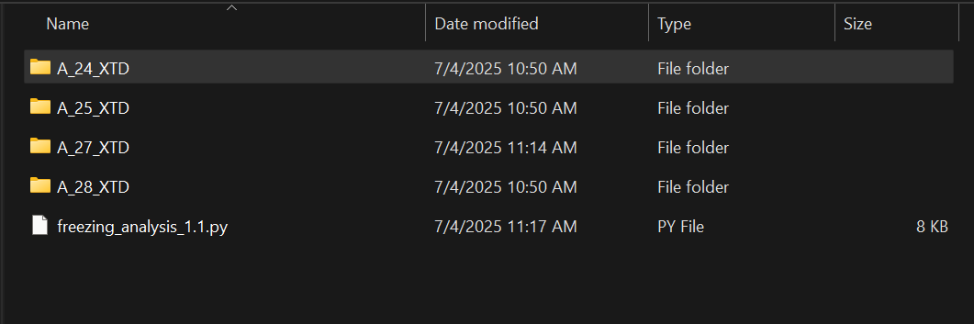

1. Each data folder should have only two files: the Coldstage TSV file containing temperature data and the video file in .wmv or .mov
   1. Other files present won’t affect the code, but it’s best to leave the folders as least cluttered as possible, since the plots will be generated in the same folder as the data.

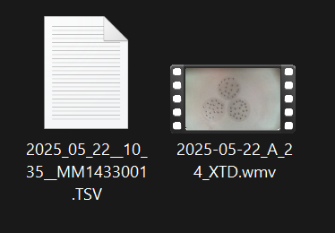

1. Open the “Spyder” app.
   1. Go to the search bar at the bottom left of Windows and type in “Spyder” or open Spyder through Anaconda Navigator
   2. In Spyder, go to the top left menu under ”File” and select “Open”
   3. Find and open the Freezing Analysis Code
      1. Make sure the code selected is in the right folder (the folder with the data that needs to be analysed)
2. To begin analysis, click anywhere on the left window with the code and press “Ctrl + Enter” or press “Run” on the top menu bar
   1. The code should then print the location of the file in the console (bottom right window)
   2. The code will cycle through each data folder in the same folder as the code
      1. The code will ask whether to analyse each folder. Type “Y” to continue or “N” to skip to the next folder. Lowercase is okay. Typing anything other than “Y” is considered a “N”
   3. The code will ask for the number of plates in the trial. Input an integer (ie: 1, 2, 3)
   4. The code will output the number of droplets detected and ask whether manual detection is needed
      1. Answering “Y” opens the detected_droplets image in an interactive window
      2. Left/right click on droplets to add/remove them
      3. Close the window when finished
   5. The code will prompt for the Video Time, File Time, and Skip Seconds for each detected folder in the console
      1. Make sure to input these times correctly and press “Enter”
      2. The input cannot be changed after pressing “Enter”
      3. To stop and rerun the code, press the red square at the top right of the console and start again from Step 4
3. Repeat for each detected folder
   1. The code will run the analysis after every folder input until there are no folders remaining
      1. There will be a pause after inputting the times for each folder. Simply wait and let the code complete its analysis
   2. The code will sometimes quickly open and close a new window. That's it downloading images (no need to worry about it bugging out).
4. The code will output a Brightness Derivative plot, a Binary Detected Droplets map, and a Detected Droplets image in the same folder that the data is stored in (ie: all data for sample A_28 will be stored in the A_28 folder)
5. The code will output a Freezing Results Excel sheet in the same folder as it. Open this file to find the freezing points of the droplets
   1. If the code successfully completes, it will print the name of the downloaded Excel file in the console
   2. Open the excel file to make sure all droplets have a corresponding freezing temperature. If some droplets a missing a temperature, try lowering the prominence parameter (“Setting Parameters” section of this document)
   3. Or, refer to *Bertram Group OneDrive > SOPs > Droplet Freezing Experiments > Droplet Freezing Data Analysis (MATLAB)_July 2024.docx* for manual analysis instructions
   4. The folder should look like this once the code is done (pretend code is the updated number)

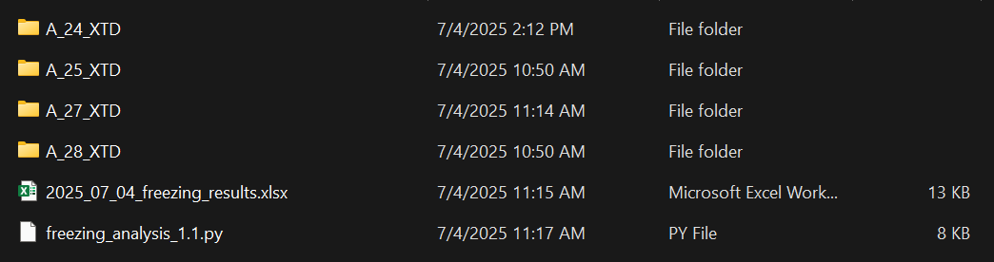

* 1. **Make sure to copy all necessary information from the Excel file before re-running code (for redoing trials or another reason) in the same folder as it will write over the old file**

**Installing Required Libraries**

1. Go to the bottom left search bar and type in “Anaconda Navigator”. Open it.
2. In Anaconda, open “CMD.exe prompt”

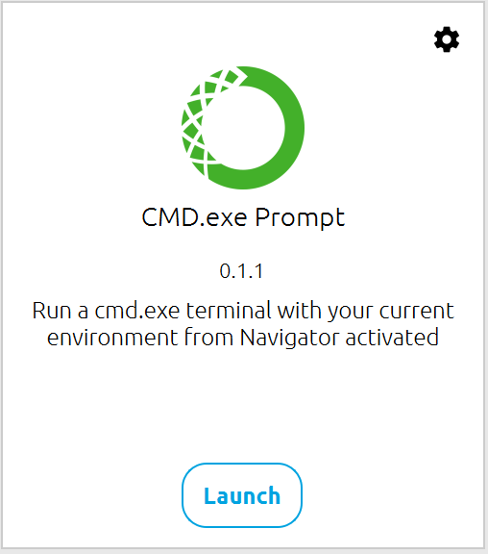

1. Paste this line in the terminal and press enter
   1. “pip install opencv-python numpy pandas matplotlib scipy openpyxl”
   2. This will install all the required libraries, skipping those that have already been installed
2. This step only has to be done once; the first time before using the code

**Setting Parameters**

Parameters should be revised whenever changing camera, resolution, or lighting

Parameters were found to be ideal for the conditions listed below; however, these are not the “best”. If you find a better value, please add an update to this document.

[Current] PTZ Pro 2 with Green LEDs and 576p Resolution:

* Prominence: 30
* Radius: 6
* Brightness: 139

Old Windows LifeCam with Green LEDs and 1080p Resolution :

* Prominence: 30
* Radius: -
* Brightness: -

**Common errors**

1. Code detecting background noise
   1. Increase the following parameters: min_radius & binary_threshold
   2. Increase min_radius only in increments of 1 because it is very sensitive
      1. Increase this if the code detects very small droplets outside the plate
   3. Binary_threshold can be increased in increments of 5
      1. Increase this if the code is detecting large droplets outside the plate
   4. Be patient, as increasing both values can lead to detecting too litle droplets

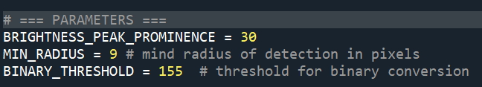**These parameters must be edited according to video resolution, droplet size, and lighting**

1. Code not detecting droplets
   1. Inversely to the problem above, if the code isn’t detecting many droplets, decrease min_radius & binary_threshold
   2. Decreasing binary_threshold usually has better results, but be careful not to detect too much background
2. Mis-identifying or outputting blank freezing temps
   1. If the code is detecting the droplet, but doesn’t output a freezing point for the droplet, check the first derivative of brightness plot.
   2. Raise or lower the “brightness_peak_prominance” value according to the peaks on that plot
      1. Code detects freezing point at the highest peak *only* if it’s above the prominence threshold
3. Console outputting “no access” to Excel file
   1. The Excel file is likely open. Close the file and run the code again
   2. If the code is still having issues editing the file; close Spyder, delete the excel file (or move it out of the folder), and run the code again