# Part 1 - MNIST Clustering Example

The MNIST dataset of handwritten digits (derived from a larger dataset called NIST). Its initial purpose was to train classifiers to understand hand-written postal addresses.

Each image is of size 28 x 28, where each pixel value is between 0 – 255. This tutorial walks you through how to apply KMeans to cluster these images.

**Step 1 – Feature Extraction**

First, we need to decide how to extract features from the raw images. One idea is to transform the 2-D image (28 x 28) into a flat vector (of size 784). The vector values must be normalized so that each entry is between 0 and 1.

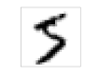

0 – 255

…

0 – 255

…

0 - 1

…

0 - 1

*Normalize vector by 255, so that each entry is between 0 and 1*

*Flatten image into 28*28 = 784 vector*

*Each image (gray scale) is 28 x 28 pixels (0 – 255)*

We will use the sum squared euclidian distance to compare two vectors. $Given X=\left\{x_{1} , x_{2}, ⋯, x_{784}\right\}$ and $Y=\left\{y_{1} , y_{2}, ⋯, y_{784}\right\}$, the distance between the two vectors is given by: *d( X , Y ) = $\sum_{i=1}^{784}{{ (x_{i}-y_{i})}^{2}}$*

**Step 2 – Train KMeans**

We will use PYSpark and MLlib for this problem. Will feed-in the raw data to KMeans and train the model, and then evaluate the resulting model.

You can download the data from : <http://yann.lecun.com/exdb/mnist/>

**Sample Code**

mnist_train = sc.textFile(fileNameTrain) # ingest the comma delimited file

def parsePoint(line):

values = line.split(',’)

values = [0 if e == '' else int(e) for e in values]

return values[1:] *# values[0] is the label, which can be discarded*

mnist_train = mnist_train.filter(lambda x:x !=header) *# remove the header (1st line)*

parsedData = data.map(parsePoint) *# parse file into a RDD of lists*

clusters = KMeans.train(trainingData, 2, maxIterations=10,initializationMode="random")

Method to initialize cluster centers

# iterations

K = # of clusters

RDD of training data

Once we have obtained the clusters, we can compute the sum of squared distances using:

clusters.computeCost( data )

Given a new data point, to classify which cluster this data point belongs to, we can use :

clusters.predict ( data )

Code is given by MNIST_Kmeans.py. To run the example using Spark, type:

<path-to-spark>/bin/spark-submit MNIST_KMeans.py

Note, if you wanted to apply hierarchical clustering, then use Bisecting KMeans instead.

# **Part 2 – LDA for Document Clustering**

Consider the problem of clustering documents, possibly based on topics. One approach is to apply the standard KMeans algorithm using Cosine Similarity measure to generate the clusters. Unfortunately, PySpark’s KMeans only uses a Euclidean measure, so its not appropriate for this problem. So, let us consider another approach.

Latent Dirichlet allocation (LDA) is a [topic model](http://en.wikipedia.org/wiki/Topic_model) that generates topics based on word frequency from a set of documents. LDA is particularly useful for finding reasonably accurate mixtures of topics within a given document set.

LDA assumes documents are produced from a mixture of topics. Those topics then generate words based on their probability distribution. In other words, LDA assumes a document is made from the following steps:

1. Determine the number of words in a document. Let’s say our document has 6 words.
2. Determine the mixture of topics in that document. For example, the document might contain 1/2 the topic “health” and 1/2 the topic “vegetables.”
3. Using each topic’s multinomial distribution, output words to fill the document’s word slots. In our example, the “health” topic is 1/2 our document, or 3 words. The “health” topic might have the word “diet” at 20% probability or “exercise” at 15%, so it will fill the document word slots based on those probabilities.

Given this assumption of how documents are created, LDA backtracks and tries to figure out what topics would create those documents in the first place.

Data cleaning is absolutely crucial for generating a useful topic model: as the saying goes, “garbage in, garbage out.” The steps below are common to most natural language processing methods:

* Tokenizing: converting a document to its atomic elements.
* Stopping: removing meaningless words.

See Topics_LDA.py

# Part 3 – Clustering Tweets By Language

Tweets are mostly raw, not tagged with geo location or language. One task is to use KMeans to cluster a training set of tweets by language. Then, given a new tweet, classify the cluster this tweet belongs to and hence classify the language of the tweet.

The full tutorial is found here: <https://databricks.gitbooks.io/databricks-spark-reference-applications/twitter_classifier/index.html>

# Part 4 – Power Iteration Clustering

KMeans has several weaknesses, including:

* Assumes that clusters are of spherical shape

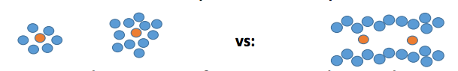

* Assume that clusters are of equal size

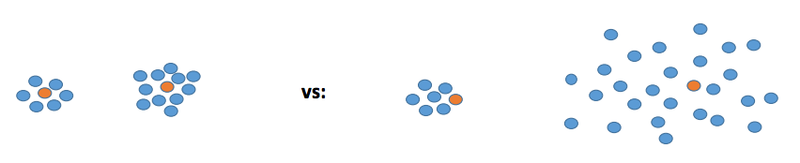

* Sensitive to outliers

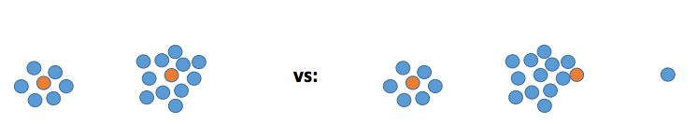

Spectral clustering is another method that use the eigenvectors of a graph Laplacian matrix 𝐿(𝐺) to cluster a graph.

Given: data points 𝑥𝑖 and a similarity function s(𝑥𝑖 , 𝑥𝑖) between them, 𝑘

1. Construct (normalized) graph Laplacian 𝐿 (𝐺 (𝑉, 𝐸)) = 𝐷 − 𝑊

2. Find the 𝑘 eigenvectors corresponding to the 𝑘 smallest eigenvalues of 𝐿

3. Let U be the n × 𝑘 matrix of eigenvectors

4. Use 𝑘-means to find 𝑘 clusters 𝐶′ letting $x_{i}^{'}$ be the rows of U

5. Assign data point 𝑥𝑖 to the 𝑗th cluster if $x_{i}^{'}$ was assigned to cluster 𝑗

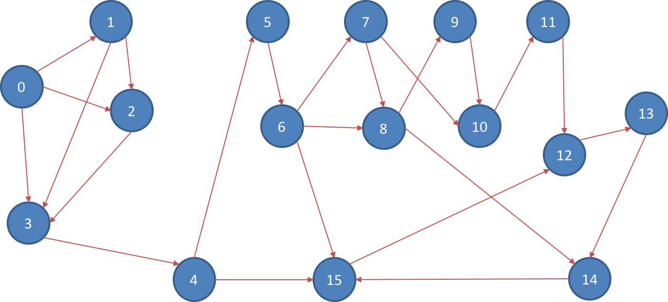

Power Iteration Clustering is a spectral clustering method for clustering vertices of a graph given pairwise similarities as edge properties, described in [Lin and Cohen, Power Iteration Clustering](http://www.icml2010.org/papers/387.pdf).

Assume we have the above graph, we can see that there are basically two cliques in the graph assuming that each edge has an equal weight. Our goal is to find a “cut” or “cuts” in the graph.

Graph_pic.py provides example code.