NLP

Function words vs content words :-

Function words :-
Function words are also known as grammatical words or closed-class words. These words primarily serve grammatical functions and often have a fixed syntactic role in a sentence. They are generally less meaningful and less information on their own and are used to convey relationships between other words or provide structural information. Examples of function words include articles (e.g., "a," "an," "the"), conjunctions (e.g., "and," "but"), prepositions (e.g., "in," "on," "at"), pronouns (e.g., "he," "she," "it," "they"), auxiliary verbs (e.g., "is," "are," "has," "have"), and determiners (e.g., "this," "that," "these," "those").

Content Words :-

Content words, also known as lexical words or open-class words, carry the primary meaning in a sentence. They provide the main content or information and are typically nouns, verbs, adjectives, and adverbs. Content words convey the core message and contribute to the overall semantics of a sentence. Examples of content words include nouns (e.g., "cat," "house," "book"), verbs (e.g., "run," "eat," "sleep"), adjectives (e.g., "beautiful," "happy," "tall"), and adverbs (e.g., "quickly," "carefully," "often").
Content words are often more diverse and context-dependent, playing a crucial role in understanding the meaning and nuances of a sentence.

Example Sentence: "She is reading a book."
Function Words: "She," "is," "a" Content Words: "reading," "book"
In this example, the function words are "She," "is," and "a." These words primarily serve grammatical functions and provide structural information. "She" is a pronoun that refers to a female person, "is" is an auxiliary verb indicating the present tense, and "a" is an indefinite article.
The content words in the sentence are "reading" and "book." These words carry the main meaning and contribute to the overall semantics of the sentence. "Reading" is a verb that describes the action being performed, and "book" is a noun representing the object being read.
By distinguishing between function words and content words, we can focus on the essential information (content words) while abstracting away the grammatical structure (function words). This differentiation is beneficial for various NLP tasks, such as understanding the meaning of a sentence, extracting key information, or generating coherent text.

Type – Token Ratio:-
Token type disctinction is a distinciton that seperates a concept from objects which are particular instance of concepts.
The TTR is a useful tool in analyzing the complexity and richness of a language or text. As the text length increases, TTR becomes small. It’s not a good measure, so we will calculate TTR running average(may be 1000 words )( as shown in the figure ).

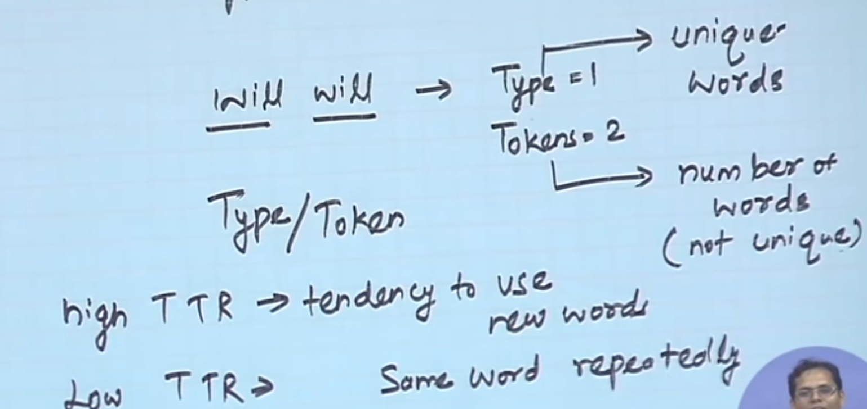
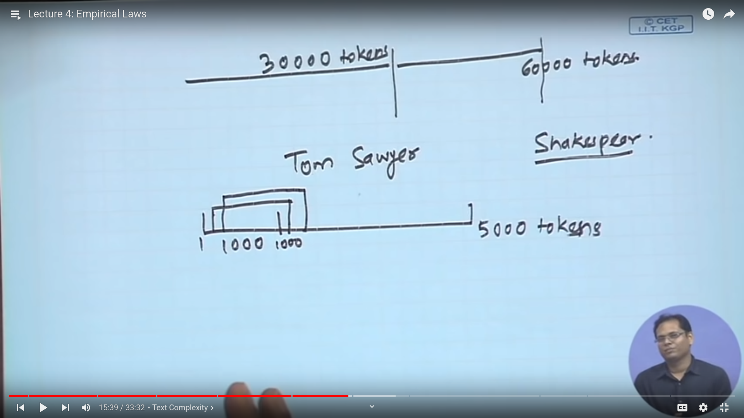

Zip’s Law:-

It is a probability distribution of words,tells how the vocabularies distributions behave.Zipf's law has been used to study the relationship between word frequency and it’s position( rank )

1. Count the frequency of each word type in a large corpous.
2. List the word types in decreasing order of their frequency.

Ex:-

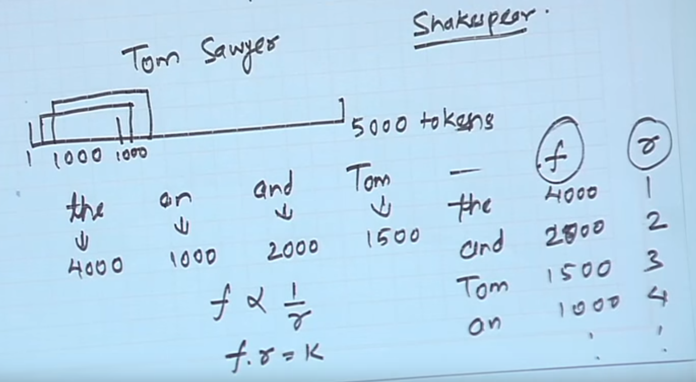

Where f ==> frequency
r ==> rank ( position )
k ==> constant.

In other words, the most frequent word occurs approximately twice as often as the second most frequent word, three times as often as the third most frequent word, and so on.
More formally, if we have a collection of words ordered by their frequency of occurrence in descending order (most frequent to least frequent), Zipf's Law can be expressed as:
Frequency of word(i) ≈ Constant / Rank(i)

EX:-
Sentence: "The cat chased the mouse."
Word: Frequency: the: 2 cat: 1 chased: 1 mouse: 1
In this example, we can see that the word "the" is the most frequent and appears twice, while the words "cat," "chased," and "mouse" each appear once. This distribution follows Zipf's Law as the most frequent word occurs approximately twice as often as the second most frequent word.
The probability of word can be calculated as P_{r} = f_{r} / N.
Where f_{r} = frequency of word
N = no of tokens.

In practical terms, Zipf's Law means that a few words occur very frequently in a language, while the vast majority of words are relatively rare. This is a common observation in natural language processing and linguistics. For example, in the English language, common words like "the," "and," "is," "of," etc., occur very frequently, while less common words like "elephant," "deliberate," "hypothesis," etc., occur much less often.
Zipf's Law has important implications in various areas:
- Text Compression: Zipf's Law suggests that we can achieve significant compression in text data by focusing on the most frequent words and representing them more efficiently.
- Language Models: When building language models or processing natural language data, accounting for the skewed distribution of word frequencies can improve the efficiency and accuracy of algorithms.
- Information Retrieval: Zipf's Law can guide the design of search engines and information retrieval systems, as focusing on the most common words is likely to yield better results.
- Linguistic Studies: Linguists use Zipf's Law to analyze the structure and evolution of languages, as it provides insights into how word frequencies may change over time.
- Data Analysis: In various fields, the presence of Zipfian distributions can be a valuable insight when dealing with large datasets, helping to identify meaningful patterns and outliers.
Overall, Zipf's Law is a fundamental principle that helps us understand and work with the distribution of word frequencies in natural language, leading to more efficient and effective NLP and language processing techniques.

Number of meanings and Word frequency:-
The most common words (e.g., "the," "and," "is," etc.) have a high frequency of occurrence, while less common words have lower frequencies. Many words in natural languages have multiple meanings or can be used in various contexts. For instance, the word "bank" can mean a financial institution, the side of a river, or even a place to store something. The word "run" can be used in different contexts like "to run a marathon," "to run a business," or "to run a program."

Here's the indirect relationship between word frequency and number of meanings:
- High-Frequency Words: The most common words in a language tend to be very basic and have relatively simple meanings. They are typically function words like articles, pronouns, prepositions, etc., that play a fundamental role in sentence structure.
- Low-Frequency Words: As the frequency of words decreases, the chances of encountering words with multiple meanings increase. Less common words often include nouns, verbs, and adjectives with more specific or specialized meanings.
The number of meanings( m ) is direct propotional to square root of frequency ( f )

We also have a relation between f and r. From these we can say that
Rank 10000 ==> 2.1 meanings
Rank 5000 ==> 3 meanings
Rank 2000 ==> 4.6 meanings

Word Length and Word frequencies :-

Word frequencies is inversely propotional to the word length.

