# Content

## 1. Getting Started:

## 2. Designs:

Wireframe of Homepage Page

Wireframe of CV Page

Wireframe of Biodata Page

Wireframe of Contact Page

## 3. Sketches:

Sketches of Homepage

Sketches CV Page

Sketches Biodata Page

Sketches Contact Page

## 4. Final Design

Design of Home Page

Design of CV Page

Design of Biodata Page

Design of Contact Page

## 5. Logo I have used

## 6. Conclusion

## 7. Reference

Getting Started

Before I started making my website, I took a look at the best designs made using HTML and CSS and found many websites. Many of the designs were made using Bootstrap but the designs made using HTML and CSS were more very much good and attractive. By looking at those attractive websites I got some good ideas and got some inspirations from those websites and being able to create by my own. I started creating website and finally completed in the 12 week. I looked over many websites, collected many ideas, many codes and finally created a simple and attractive website. The link of my github acoount is <https://github.com/dupilop/CSY1018-Assignment1.git> .

Designs

Wireframes Designs:

Wireframe of Home Page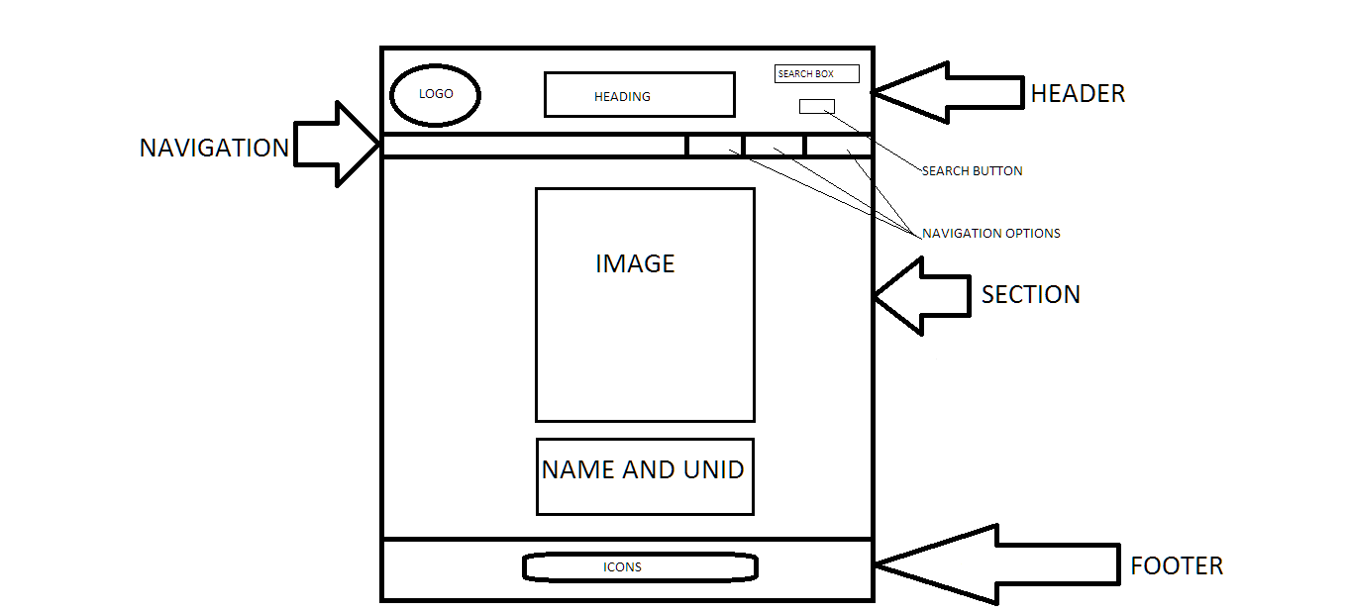

Wireframe of CV Page

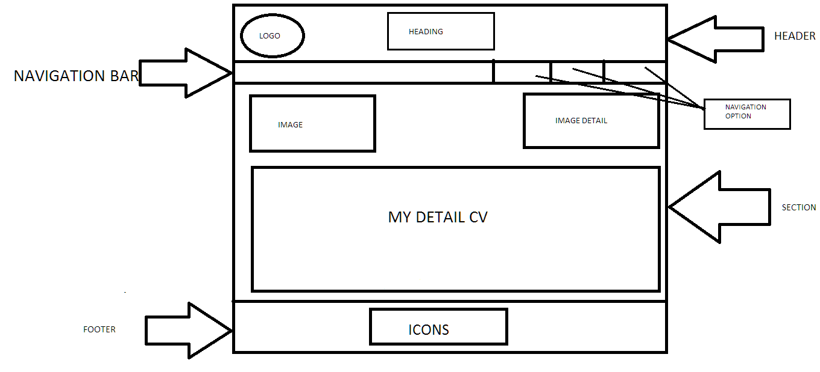

Wireframe of Biodata Page

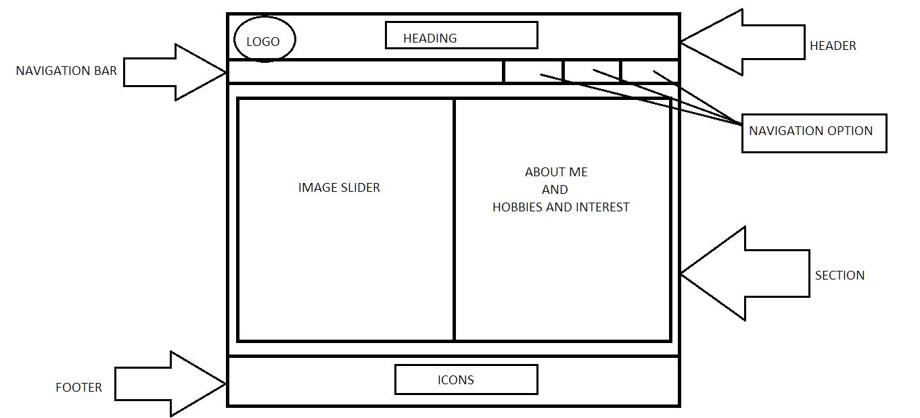

Wireframe of Contact Page

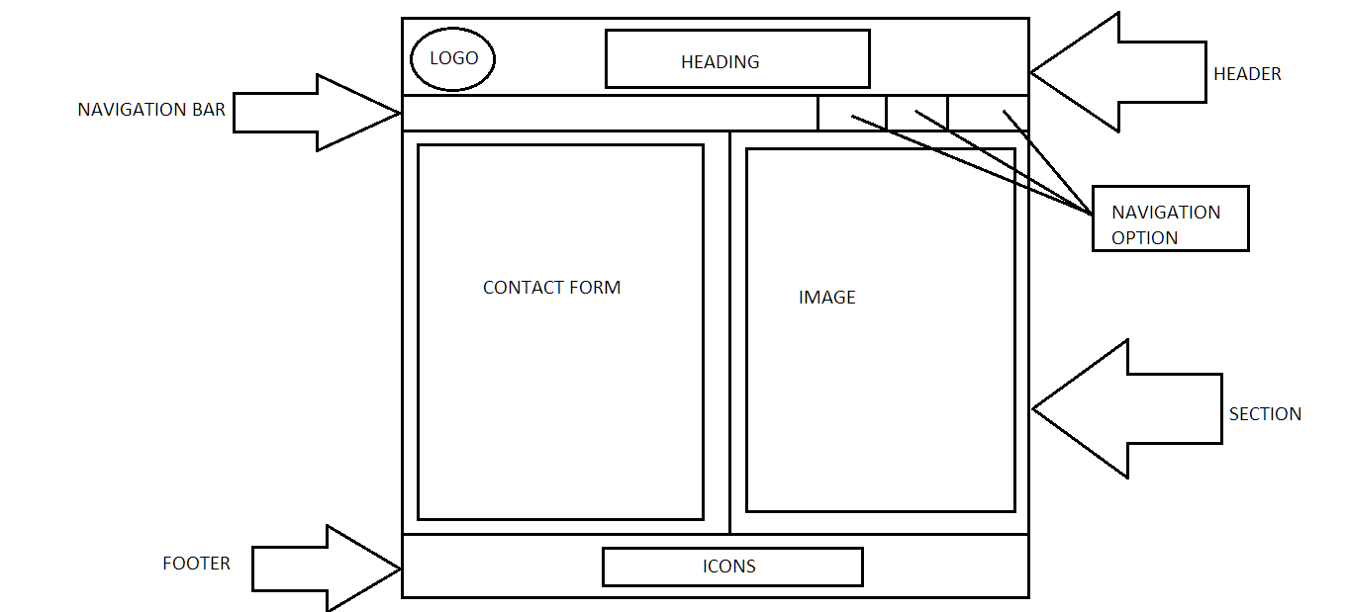

Sketches

Sketches Homepage

I want my home page to be simple and attractive and user friendly. I will divide my home page into three part: Header, Section and Footer. And there is also a navigation bar in the middle of header and section. In the Header, I will give a log in the top left and a heading to my website in the middle and a search in the top right of my website. In the section, I will provide my image and my name and UNID putting them in middle. And finally In the Footer, I will provide the icons of networking sites like Facebook, Twitter, Linked In, and RSS in the bottom center so that people can visit those websites. And finally a home page is made.

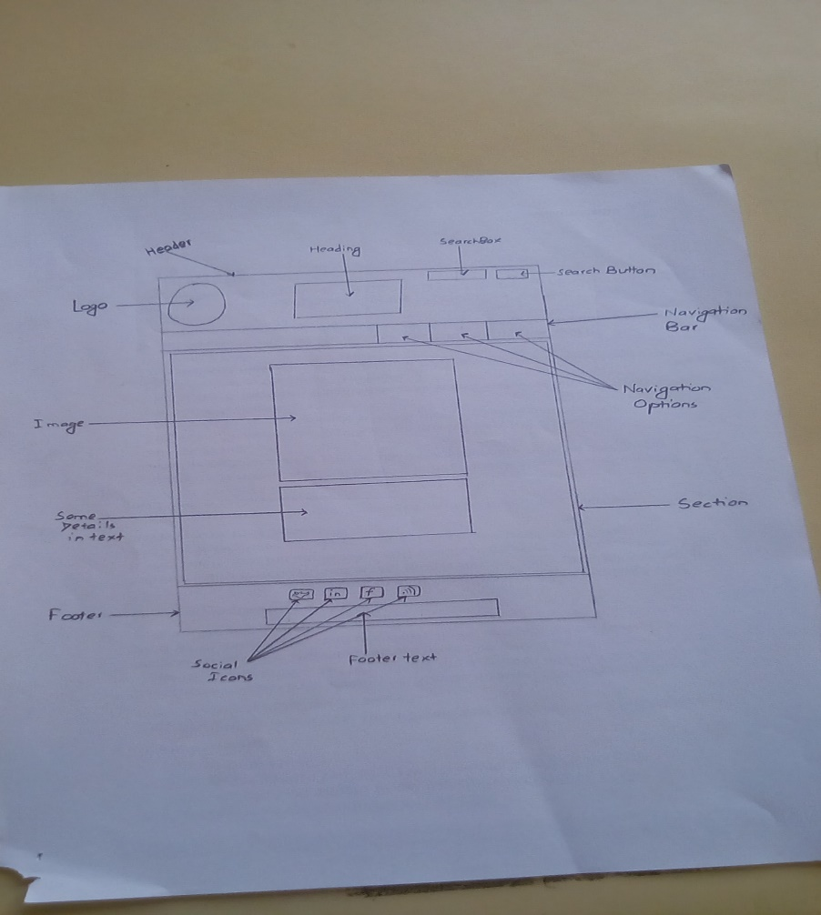

Sketches Curriculum Vitae (C. V.)

In CV page, I have also divided into three parts: Header, Section and Footer. There is also a Navigation bar in the middle of Header and Section. At first in the Header, there is a logo and a heading in the top of the website. In the Section, there is an image and detail CV of my detail. And in the Footer, there is an icon of Facebook, Twitter, Linked In and RSS in the bottom center so that people can visit those websites. And finally a CV page is made.

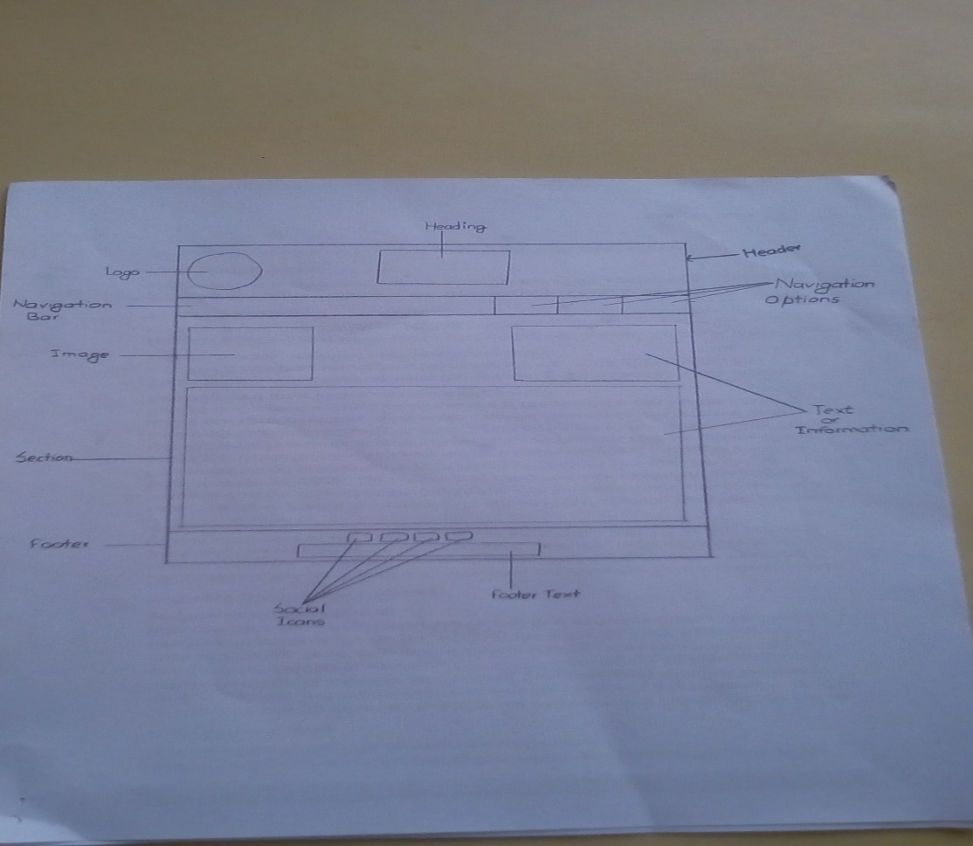

Sketches of Biodata

In this Biodata page, I have divided it into three parts: Header, Section and Footer. And In between Header and Section there is a navigation bar. In the Header part, there is a logo and a heading. And In the Section, there is an image slider that changes the image after every 3 second. And similarly, there is a detail about me and My Hobbies and Interests. Finally in the footer, there is an icon of Facebook, Twitter, Linked In and RSS in the bottom center so that people can visit those websites. And finally a Biodata page is made.

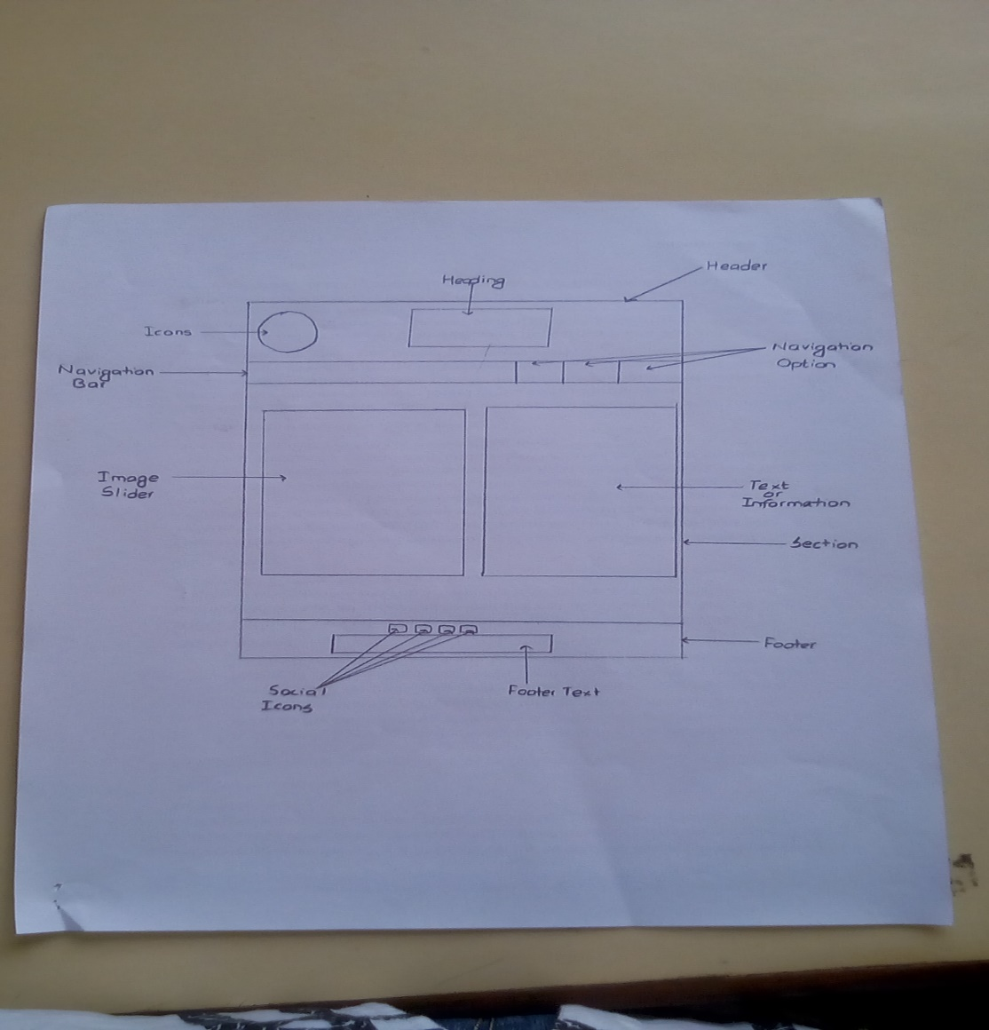

Sketches Contact

In the Contact page, I have divided into three parts: Header, Section and Footer. And there is a Navigation Bar in between Header and Section. In the Header, there is a logo and heading. In the Section, there is a Contact form and an image. The feedback about the page can be given in this form and submitted. And image is also found in this website. Finally in the Footer, there is an icon of Facebook, Twitter, Linked In and RSS in the bottom center so that people can visit those websites. And finally a Contact page is made.

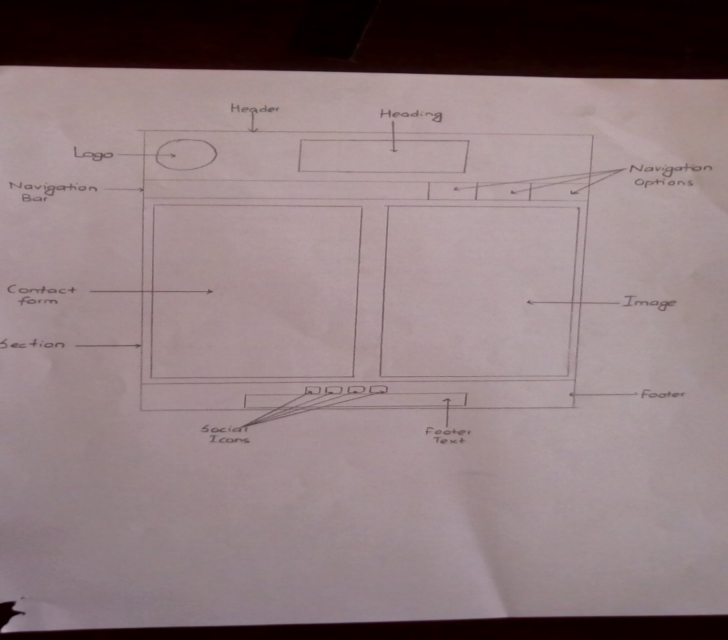

## 4. Final Design

Design of Home Page

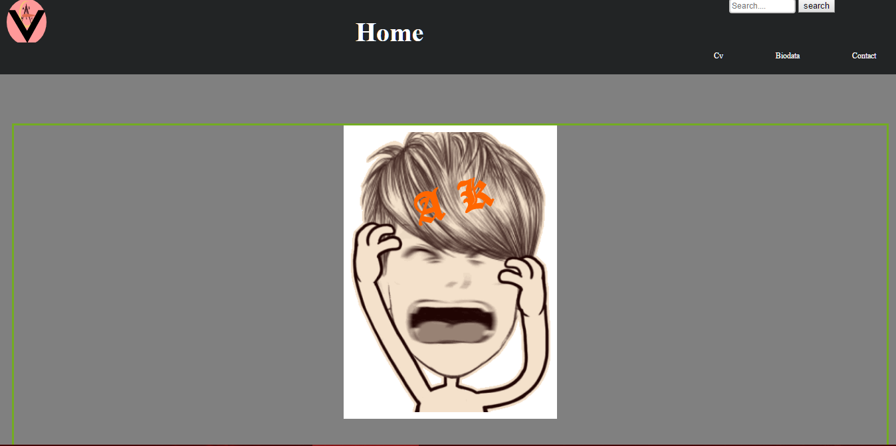

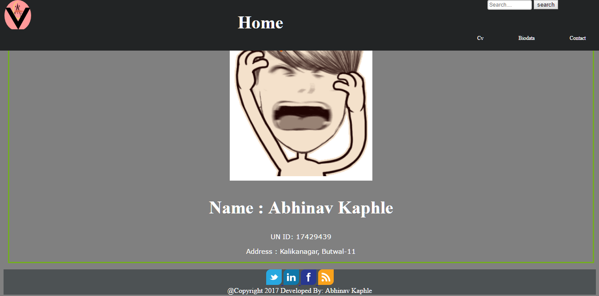

Design of CV Page

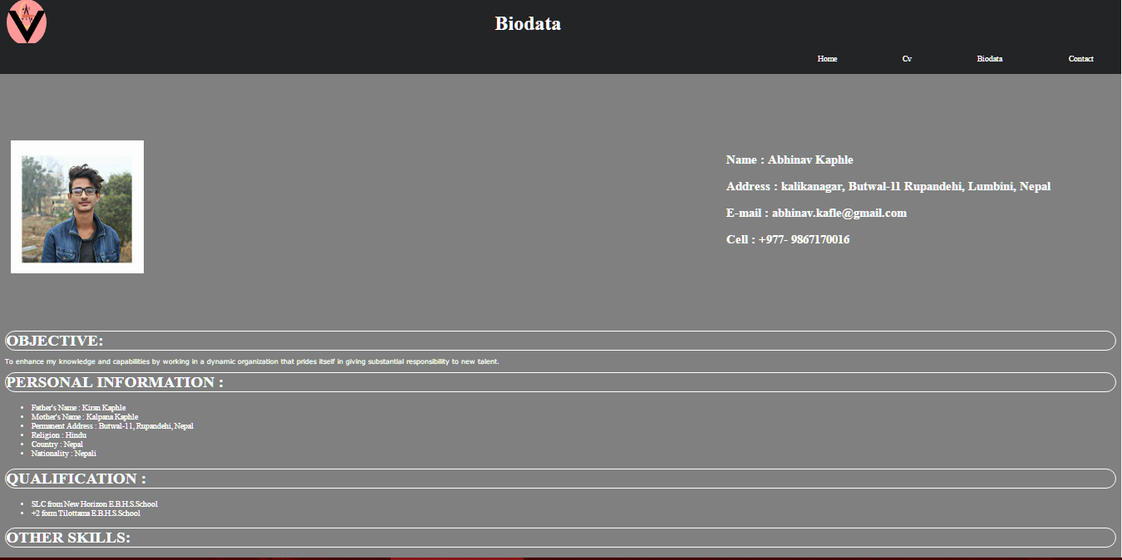

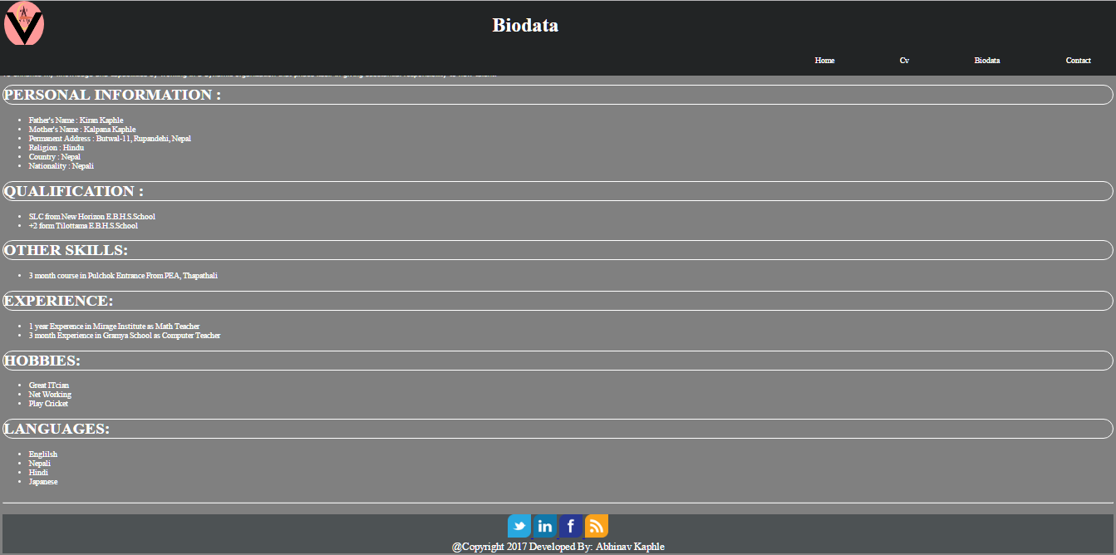

Design of Biodata Page

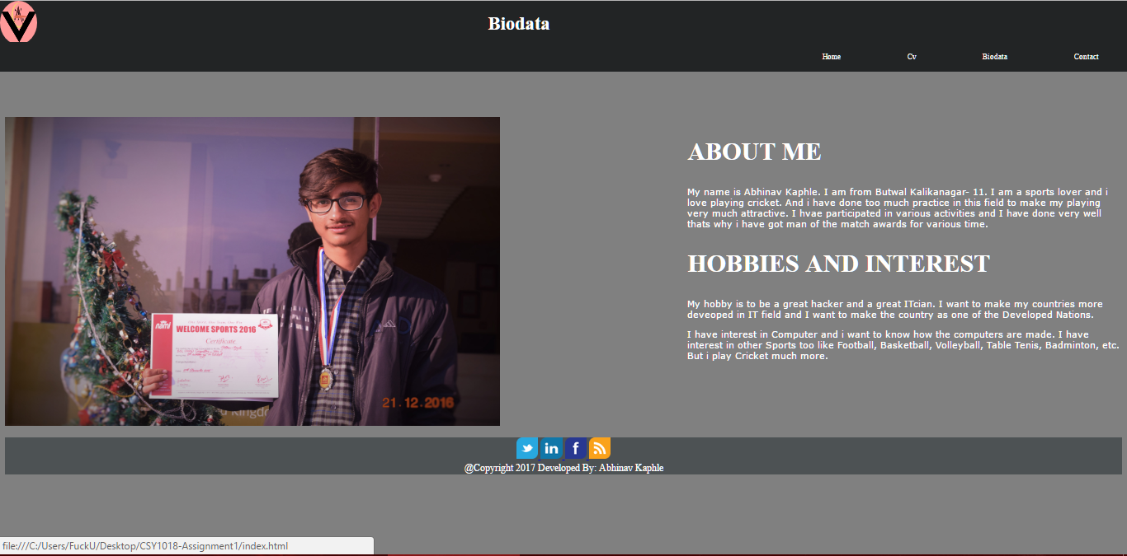

Design of Contact Page

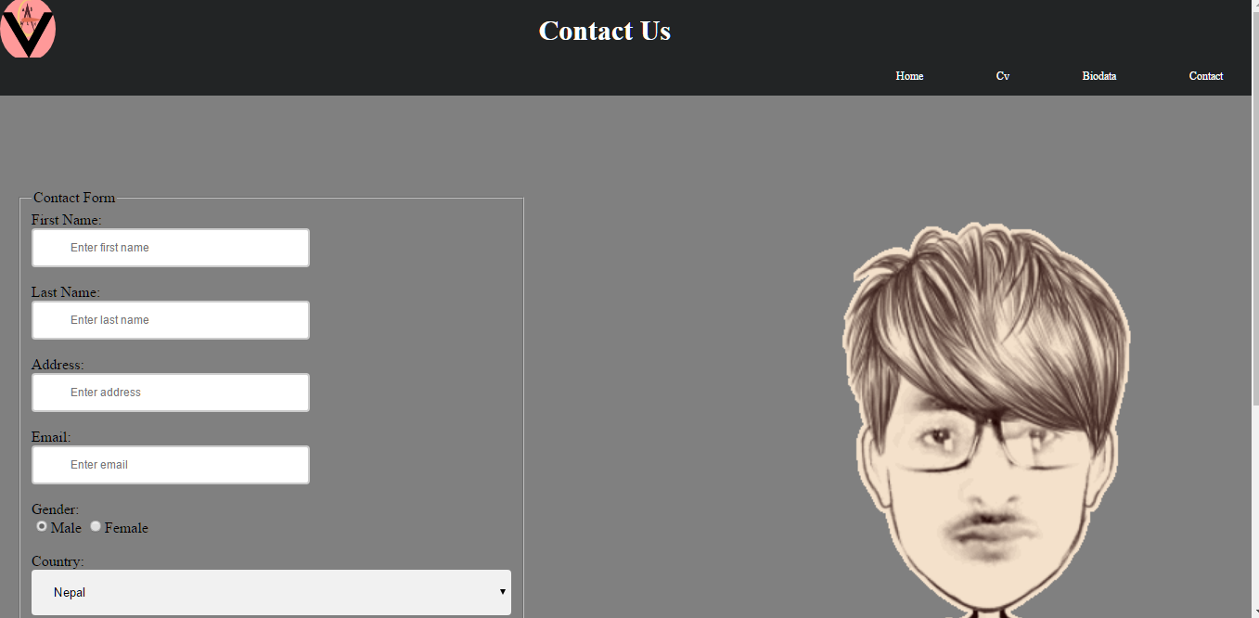

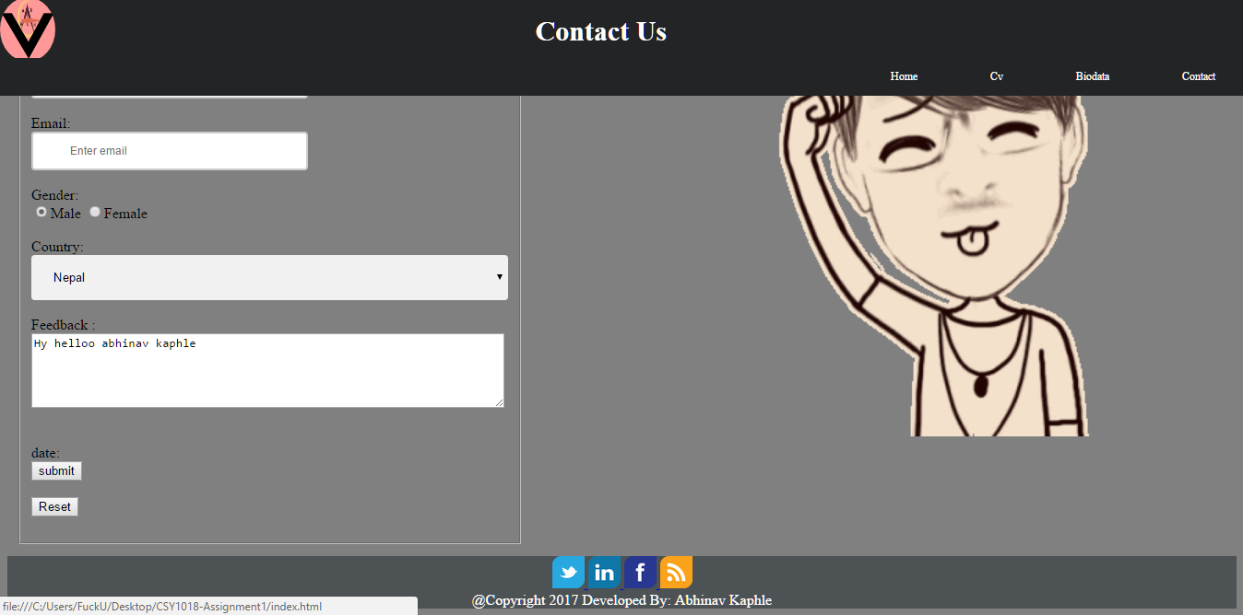

## LOGO I HAVE USED:

### C:\Users\FuckU\Desktop\CSY1018-Assignment1\images\logo.png

I made this logo from online logo maker. It took some hours to make this logo and I have made it so simple. I have used my own name ‘ABHINAV’ in the logo. It looks good and simple. It has (.png) extension and it is of size 8.83 KB (9,047 bytes).

## 6. CONCLUSION

This is the final design of my web page. I have created it with a great effort and many research. I have made this much page and I have used different HTML and CSS tags for making this website more attractive.

1. What difficulties I have got while making this website?

I have faced many difficulties and after many research I have found and made this website. I have got difficulties while making position fixed to the header part. I have researched in many different website and made it possible. I have also got difficulty while making Image Slider. It was not possible without my effort on research. I have tried many different codes and finally found a code which was too easy and matched in my website too. The key frame tag was found to make it possible. And made it attractive making good padding and using it in the website. Another I got difficulties in making my website mobile responsive. I tried for many hours and got succeed after many efforts.

1. What I missed due to lack of time and could improve them?

I have missed many things in my website due to lack of time. If there was still much more time for this project I could have used many tags and css properties. I could have made background in 3D mode. I could have added many more animations and made my website more attractive. I could have added better image slider tags that could be more attractive than my one. I could have added much more color combinations. I could have made my home page more attractive and add much more animations and tags. I could have made much better by adding some more hover properties.

In this way I could make my website much more attractive. I could make much good website in the coming future and be a good web developer.

# 7. REFERENCE:

**Sliding the picture:**

QNimate. 2017. Image Slider Using HTML And CSS Only. [ONLINE] Available at: <http://qnimate.com/creating-a-slider-using-html-and-css-only/>. [Accessed 07 April 2017].

**Animated search button:**

Tryit Editor v3.3. 2017. Tryit Editor v3.3. [ONLINE] Available at: <https://www.w3schools.com/howto/tryit.asp?filename=tryhow_css_anim_search>. [Accessed 07 April 2017].

**HTML AND CSS OTHER HELP:**

W3Schools Online Web Tutorials. 2017. W3Schools Online Web Tutorials. [ONLINE] Available at: [https://www.w3schools.com](https://www.w3schools.com/). [Accessed 07 April 2017].