Textures & Overlay System
16×16 Natural Surface Tiles · Environmental Overlay Pipeline · Property-Driven Blending
All base tiles and overlays shown at 8× scale (128×128). Original resolution: 16×16 pixels. Tiles generated programmatically — this document is both spec and render output.

1. Texturing Philosophy
All surface textures are 16×16 pixel art — a constraint that forces every pixel to carry meaning. Natural surfaces follow consistent palette logic: a base colour, a shadow colour (15–25% darker), a highlight colour (15–25% lighter), and 1–2 variation colours for texture complexity. Tiles are designed to tile seamlessly on all four edges.

Overlays are a separate semi-transparent layer system applied dynamically on top of base surfaces based on environmental property readings (H, R, W, accumulation). A stone tile in a wet cave is different from the same stone tile in a desert — the geometry does not change, but the moisture, erosion, and weathering overlays blend over it and shift it into something that reads correctly for the context.

Layer | Resolution | Purpose
Base Surface | 16×16 opaque PNG | The geological or biological identity of the surface — what the material is
Environmental Overlay | 16×16 RGBA PNG | The current condition of that surface — how the environment has affected it
Blend Result | 16×16 composite | Alpha-composite of all active overlays applied to the base, in stacking order

2. Base Surface Tile Catalogue
Every tile is shown at 8× scale (128×128 display pixels from a 16×16 source). Palette values are given in the notes beneath each group.

2.1 Geological Surfaces

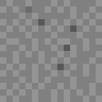  Stone  Grey, crack lines | 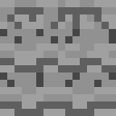  Cobblestone  Irregular block faces | 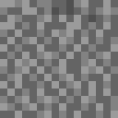  Gravel  Mixed pebbles | 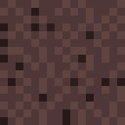  Volcanic Rock  Dark red-grey

Geological Palette Notes
Stone: 128,128,128 base | 148,148,148 highlight | 88,88,88 crack
Cobble: 120,120,120 face | 160,160,160 highlight | 70,70,70 mortar gap
Gravel: 100,100,100 base | 155,155,155 light pebble | 60,60,60 deep gap
Volcanic: 80,55,55 red-grey base | 115,85,80 ridge | 40,25,25 fissure

2.2 Soil, Sand and Organic Ground

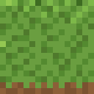  Grass  Mixed greens, dirt base | 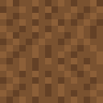  Dirt  Warm brown mix | 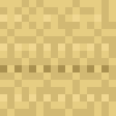  Sand  Warm tan, ripple lines | 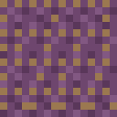  Mycelium  Purple-tinged fibrous soil

Soil Palette Notes
Grass: 106,158,64 base | 125,184,73 blade tip | 62,108,34 depth | 122,82,48 dirt (rows 14–15)
Dirt: 122,82,48 base | 140,95,56 light | 90,55,30 deep shadow
Sand: 210,185,115 base | 240,215,145 ripple crest | 170,145,80 trough
Mycelium: 110,70,110 purple base | 150,100,150 fibre highlight | 155,120,80 soil patch

2.3 Cold Climate Surfaces

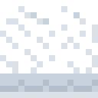  Snow  White, blue-shadow base | 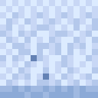  Ice  Crystalline blue-white | 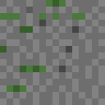  Moss Stone  Grey + green moss patches | 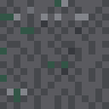  Wet Cave Stone  Dark grey + moss veins

Cold and Moisture Palette Notes
Snow: 255,255,255 peak | 220,225,232 mid | 160,175,195 compressed base (bottom rows)
Ice: 220,235,255 surface | 140,170,215 mid depth | 100,130,180 deep crevice
Crystal pattern: diagonal offset geometry suggesting facet planes.
Moss Stone: 110,110,110 stone | 75,120,60 moss highlight | 55,95,42 moss shadow
Cave Stone: 90,90,95 base | 50,85,70 moss pocket | 55,57,62 wet depression

2.4 Wood, Leaf and Water Surfaces

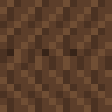  Oak Bark  Warm brown, vertical grain | 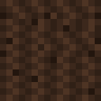  Pine Bark  Darker, rougher grain | 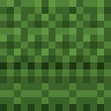  Leaf Canopy  Stippled greens | 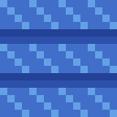  Water Surface  Diagonal ripple, deep blue

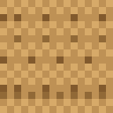  Desert Rock  Orange-tan, heat cracks | Gravel Path  (repeat for comparison) | Snow  (compare cold surfaces) | Ice  (compare cold surfaces)

Wood, Leaf, Water Palette Notes
Oak Bark: 92,62,42 base | 112,78,52 ridge highlight | 55,36,24 groove shadow
Vertical grain: alternating light-base-dark columns at ~2–3px width.
Pine Bark: 60,40,28 base (darker than oak) | 95,65,45 ridge | 35,22,14 crack
Leaves: 60,100,40 mass | 95,150,65 highlight tip | 30,55,18 deep shadow
Stippled: no two adjacent pixels (including diagonal) share same value.
Water: 45,80,170 deep | 65,110,200 mid | 100,160,230 ripple crest
Diagonal ripple: 45° lines, 4px bright then 4px mid-deep repeating.
Desert Rock: 190,145,85 face | 230,190,125 highlight | 130,90,45 heat crack

3. Overlay Tile Catalogue
Overlay tiles use the full RGBA channel — pixels range from fully transparent (α = 0) to semi-opaque (α = 180). The base surface shows through at all points. Overlays are shown below at 8× scale against a white background so their pixel pattern is visible despite partial transparency.

  Moisture  Blue dots, α 0–180 |   Frost  Crystal growth, α 80–180 | 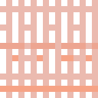  Heat / Arid  Red-orange cracks, α 70–150 | 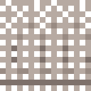  Erosion  Brown pitting, α 90–160

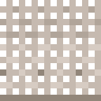
Mud
Brown film, α 80–150

Overlay | Alpha range | Pixel pattern intent
Moisture | 0 – 180 | Sparse droplet matrix. Denser and higher-alpha as H increases. Zero-alpha pixels = dry surface beneath.
Frost | 80 – 180 | Dendritic crystal growth branching from corner inward. Alpha peaks at crystal centres. Asymmetric for directional character.
Heat / Arid | 70 – 150 | Primary crack (full row width) + branch cracks (partial). High-alpha at crack centres, sparse shimmer dots between cracks.
Erosion | 90 – 160 | Isolated pit pixels with high alpha surrounded by transparent surface. Bottom rows denser — simulates accumulated wear.
Mud | 80 – 150 | Horizontal film streaks. Thicker at bottom rows (gravity flow). Thinner near top (surface drying).

4. Blended Demonstrations
Left: base surface. Centre: isolated overlay. Right: alpha-composited result. The right column is what the game engine renders.

Base Surface | Overlay Tile | Blended Result
Stone | Moisture | 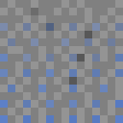  Wet Stone
Sand | Heat | 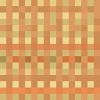  Cracked Desert
Grass | Frost | 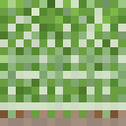  Frosted Grass
Cobblestone | Erosion | 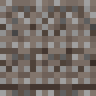  Weathered Cobble
Dirt | Mud | 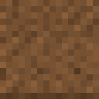  Muddy Ground
Oak Bark | Moisture | 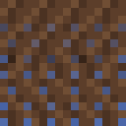  Rain-Soaked Bark
Desert Rock | Erosion | 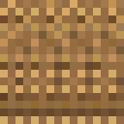  Wind-Worn Desert
Snow | Moisture | 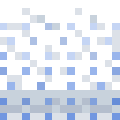  Wet Melting Snow

5. Environmental Property → Overlay Mapping
Each overlay is driven by one or more environmental property values from the Resonance Bending system (H, R, W, P, L, S, B). The table below gives exact activation thresholds and intensity scaling formulas.

Overlay | Primary | Threshold | Intensity formula
Moisture | H | H > 0.35 | intensity = clamp((H − 0.35) / 0.45, 0.0, 1.0). At H=0.35: 10% alpha. At H=0.80: 100%. Also activates at 100% during any active rain event regardless of H.
Frost | R | R < 0.10 | intensity = clamp((0.10 − R) / 0.10, 0.0, 1.0). Full crystal density at R=0. Crystal count and branch length also scale with intensity.
Heat / Arid | R | R > 0.60 | intensity = clamp((R − 0.60) / 0.40, 0.0, 1.0). Hairline cracks at R=0.60. Full deep cracking and shimmer at R=1.0. Crack width scales with intensity.
Erosion | Time | Age > 30 days | Cumulative accumulation, not instantaneous. Accrues 2% per in-game day when H > 0.4 AND W > 0.2 simultaneously. Resets to 0 if block is replaced.
Mud | H + W | H > 0.6 AND W > 0.3 | intensity = clamp((H−0.6)*0.8 + (W−0.3)*0.4, 0.0, 1.0). Soil-category surfaces only. Does not apply to stone, wood, or water tiles.

5.1 Overlay Application Order (Bottom to Top)
Stacking order — applied sequentially, each blended onto running composite
1. EROSION — applied first (closest to base material, represents physical wear)
2. MOISTURE — water settles into erosion pits and surface depressions
3. MUD — mud film forms where moisture and wind combine on soil surfaces
4. HEAT — heat-crack pattern overlaid on geological surfaces
5. FROST — crystals form on top of all other layers (surface-most)

Note: HEAT and FROST are physically mutually exclusive but not code-enforced.
Transitional states (e.g. volcanic surface at altitude during cold snap) will show
both simultaneously and look unusual — which is the correct visual outcome.

5.2 Surface Category Restrictions
Surface | Moisture | Frost | Heat | Erosion | Mud | Notes
Stone / Geological | ✓ | ✓ | ✓ | ✓ | ✗ | No mud — no organic binder
Soil (grass, dirt) | ✓ | ✓ | Partial | ✗ | ✓ | Heat causes soil crack separately
Sand / Desert | ✗ | ✗ | ✓ | ✓ | ✗ | Too dry for moisture, frost, mud
Wood / Bark | ✓ | ✓ | ✗ | ✓ | ✗ | Wood chars rather than cracks
Water Surface | ✗ | ✓ (freeze) | ✗ | ✗ | ✗ | Frost converts water to ice tile
Snow / Ice | ✓ | ✗ | ✗ | ✗ | ✗ | Already frozen — no further frost
Volcanic Rock | ✗ | ✗ | ✓ | ✓ | ✗ | Always-hot — no moisture or frost
Mycelium | ✓ | ✗ | ✗ | ✗ | ✗ | Biological — no frost or heat

6. Complete Reference Grid
All base tiles at 6× scale (96×96) for side-by-side comparison. Three rows of six tiles each.

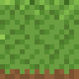  Grass | 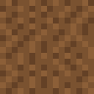  Dirt | 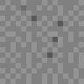  Stone | 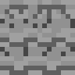  Cobble | 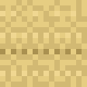  Sand | 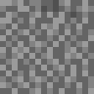  Gravel
  Snow | 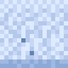  Ice | 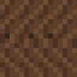  Oak Bark | 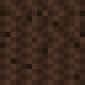  Pine Bark | 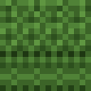  Leaves |   Water
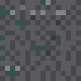  Cave Stone | 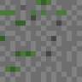  Moss Stone | 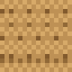  Desert | 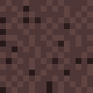  Volcanic | 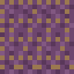  Mycelium | 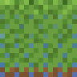  Wet Grass

6.2 All Overlay Tiles at 6× Scale
  Moisture  α 0–180 |   Frost  α 80–180 | 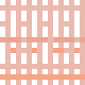  Heat/Arid  α 70–150 | 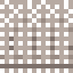  Erosion  α 90–160 | 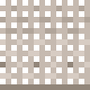  Mud  α 80–150

7. Implementation Technical Specification

7.1 PNG Format
Tile file specification
Format: PNG-32 (RGBA) — 8 bits per channel, 4 channels
Dimensions: 16 × 16 pixels (all base and overlay tiles)
Colour space: sRGB (gamma-corrected display)
Alpha: Pre-multiplied for overlay tiles; fully opaque (255) for base tiles
Filter: None (filter type 0 per scanline) — optimal for small solid-colour tiles
Compression: zlib level 6

Naming convention:
Base tile: surface_<name>.png (e.g. surface_stone.png)
Overlay tile: overlay_<name>.png (e.g. overlay_moisture.png)
Variant: surface_<name>_<variant>.png (e.g. surface_grass_autumn.png)

7.2 GPU Blend Equation
GLSL fragment shader — overlay application
// Porter-Duff 'over' composite for a single overlay:
vec4 base = texture(base_sampler, uv);
vec4 ov = texture(overlay_sampler, uv);
float a = ov.a * overlay_intensity; // intensity from property system
vec4 result = vec4(mix(base.rgb, ov.rgb, a), 1.0);

// For N stacked overlays (applied in order: erosion, moisture, mud, heat, frost):
vec4 acc = base;
for (int i = 0; i < NUM_OVERLAYS; i++) {
if (overlay_intensity[i] > 0.001) {
vec4 ov_i = texture(overlay_sampler[i], uv);
float a_i = ov_i.a * overlay_intensity[i];
acc.rgb = mix(acc.rgb, ov_i.rgb, a_i);
}
}
FragColor = acc;

7.3 CPU Property-to-Intensity Mapping
C++ / Java pseudo-code — runs once per second per surface zone
float computeOverlayIntensity(EnvProps p, SurfaceAccum accum) {
float moisture = clamp((p.H - 0.35f) / 0.45f, 0.0f, 1.0f);
float frost = clamp((0.10f - p.R) / 0.10f, 0.0f, 1.0f);
float heat = clamp((p.R - 0.60f) / 0.40f, 0.0f, 1.0f);
float erosion = min(accum.erosionDays / 50.0f, 1.0f);
float mud = 0.0f;
if (p.H > 0.6f && p.W > 0.3f)
mud = clamp((p.H-0.6f)*0.8f + (p.W-0.3f)*0.4f, 0.0f, 1.0f);
// Push to surface material uniform buffer
uniforms.intensities = {moisture, frost, heat, erosion, mud};
}
// Erosion accumulation (tick once per in-game day):
if (p.H > 0.4f && p.W > 0.2f)
accum.erosionDays = min(accum.erosionDays + 1, 50);

7.4 Seasonal Palette Variants
Surface | Spring | Summer | Autumn | Winter | Trigger condition
Grass | Yellow-green | Deep green | Amber-green | Frost-bleached | L crossing below 0.5 for autumn; R < 0.1 for winter frost-bleach
Leaves | Pale new-flush | Deep green | Orange-crimson | Bare branch tile | L decline past 0.5 triggers autumn palette swap
Dirt | Wet dark brown | Standard warm | Dry lighter | Frost-grey | H drives seasonal wet/dry shift; R < 0.05 adds frost overlay
Water | Clear blue-green | Deep blue | Slightly dark | → Ice tile | R < 0.05 replaces water tile with ice tile entirely
Sand | Standard | Standard | Standard | + frost overlay | Sand palette is stable; only frost overlay applies in cold

End of Textures & Overlay System Document
16×16 tiles rendered in-document via pure-JS PNG encoder. No external image assets required — tiles are procedurally generated from palette + pattern data.

