Quiz over Images Name_______________________________
Period_____

val R2D2 = 

Match each expression to the image it represents below.

_____ 1. R2D2.rotate(90.degrees).beside(
R2D2.rotate(90.degrees)).beside(
R2D2.rotate(90.degrees))
_____ 2. R2D2.rotate(90.degrees).above(
R2D2.rotate(90.degrees).beside(
R2D2.rotate(90.degrees)), XAlign.Right)
_____ 3. R2D2.above(R2D2.beside(R2D2)).rotate(90.degrees)
_____ 4. R2D2.beside(R2D2).beside(R2D2)
_____ 5. R2D2.beside(R2D2).above(R2D2)
_____ 6. R2D2.above(R2D2).beside(R2D2)
_____ 7. R2D2.rotate(180.degrees).beside(
R2D2.rotate(180.degrees)).beside(
R2D2.rotate(180.degrees))
_____ 8. R2D2.beside(R2D2).beside(R2D2).rotate(90.degrees)
_____ 9. R2D2.rotate(45.degrees).above(
R2D2.rotate(45.degrees)).above(
R2D2.rotate(45.degrees))
_____ 10. R2D2.rotate(45.degrees).cropBottom(34).above(
R2D2.rotate(45.degrees).cropBottom(34)).above(
R2D2.rotate(45.degrees).cropBottom(34))
_____ 11. R2D2.above(R2D2).above(R2D2).rotate(45.degrees)
_____ 12. R2D2.flipVertical().beside(
R2D2.flipVertical()).beside(
R2D2.flipVertical())
_____ 13. R2D2.cropLeft(24).rotate(45.degrees).above(
R2D2.cropLeft(24).rotate(45.degrees)).above(
R2D2.cropLeft(24).rotate(45.degrees))
_____ 14. R2D2.above(R2D2).above(R2D2)
_____ 15. R2D2.flipHorizontal().beside(
R2D2.flipHorizontal()).beside(
R2D2.flipHorizontal())

A. 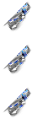 B. 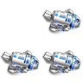 C.  D. 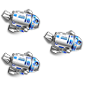 E. 
F. 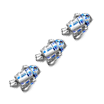 G.  H.  J. 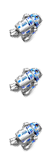 K. 
L.  M. 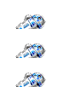 N.  O.  P. 

