Pioneer CAC-Vxxx CD Autochangers comprehension guide
V180M, V3000, V3200, V5000 models

Document revisions
Date (M/D/Y) | Author | Version | Description/Updates
04/02/2020 | DJ | V1.0.0 | Initial release
07/29/2020 | DJ | V1.0.1 | Better presentation & explanations, fixed some typo.
09/04/2020 | DJ | V1.0.2 | Add caution for shipping screws.
09/24/2020 | DJ | V1.0.3 | Add serialcheck.sh toolscript
10/01/2020 | DJ | V1.0.4 | Compacting
11/16/2020 | DJ | V1.0.5 | Correction of V5000 serial cable section
06/09/2025 | DJ | V1.0.6 | Compression of pictures

1. Document revisions 1
2. Not usable easily 1
3. Manuals 1
4. No serial port on your computer? 2
5. The cable 2
5.1. For V180M 2
5.2. For V3000/3200 3
5.3. For V5000 4
6. Test your connection 5
6.1. With Linux 5
6.2. With Windows 6
6.2.a) Port detection 6
6.2.b) Check usability 6
6.2.c) Final transmission tests 7
7. Controller/commands (programming) 8

Note: If your device’s model name begins with DRM-xxxx, it’s a SCSI CD/DVD changer. This is beyond the scope of this document.

Not usable easily
Pioneer CAC series CD autochangers (or can be also named “jukeboxes”) are not autonomous. They need to be entirely controlled by a computer with an old school serial connection (RS-232C or RS-442A).

Manuals
Please read the original PDF user manual according to your model, they are available in this GitHub repository. Have a look to understand how they works, like loading & removing discs.

Note: For the CAC-V3000/3200 models: please be sure to set the left CD player address at number 1. Check user manual at chapter “PLAYER ADDRESS SETTING MODE” (page n°14/44).
Caution! Some models has shipping screws included to lock the carriage assy for transport. Please be sure to REMOVE them (if installed)
BEFORE POWERING ON the device!

No serial port on your computer?
Serial ports or not used anymore and had been replaced by USB ports. If you don’t have one you can buy an RS232-USB adapter (like FTDI FT232 or Prolific PL2303) on eBay, Amazon, AliExpress... (about 10€).
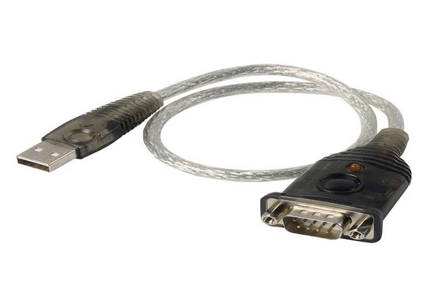
Note: The CAC-V5000 model is RS-422A only, be sure to purchase a RS422-USB adapter, not a RS232 one.

The cable
The needed cable depends on model you have.

For V180M
Use a standard D-Sub DE-9 female (computer side) to D-Sub DE-9 male (CAC side) straight type cable. This kind of generic cable can be bought on Internet like eBay, AliExpress, Amazon, etc.... Do not use a Null-Modem (crossed) type cable, it will not work.
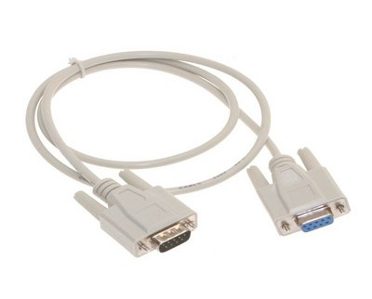

For V3000/3200
You have to build your own cable. These models requires a DA15 connector (not used in regular computing). Here is the pinout for RS-232C connector (check user manual for RS-422A):
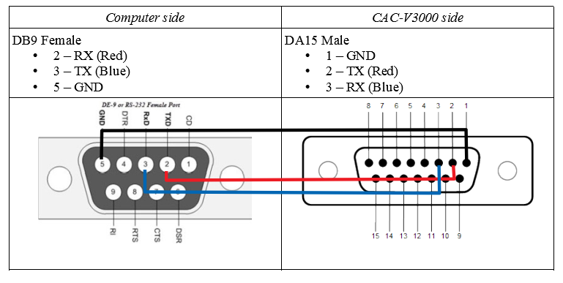
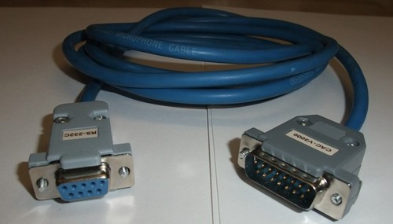

Parts:
- a female DE-9 connector (for computer side)
- a male DA-15 connector (for autochanger side)
- standard microphone XLR cable (3 poles for GND, RX, TX)
- soldering stuff and skills

For V5000
Here again you have to build your own custom cable with two DE-9 connectors. RS-422A use 5 wires instead of 3 wires on RS-232C. Rx and Tx datalines uses 2 wires each (balanced) labeled A or B. Tx and Rx signals continues to be crossed but polarity (- and + OR A and B) need to be respected. Here is a picture taken from the web:
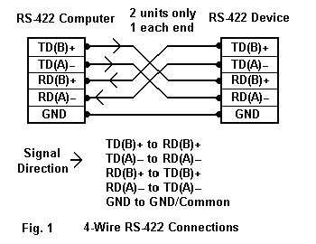
From the Pioneer user manual and service manual about DE-9 connector:
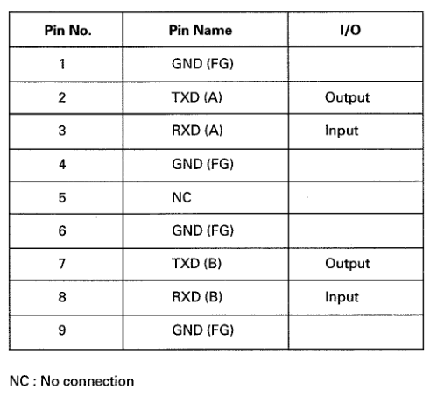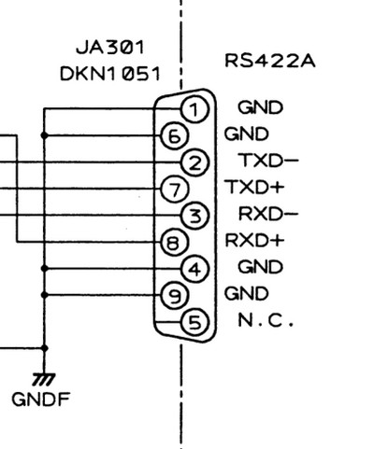
The final pinout which is working for my USB adapter bought from eBay:
USB DE-9 side *** |  | CAC-V5000 DE-9 side
1 | TX + | 8 | RX + (B)
2 | TX - | 3 | RX - (A)
3 | RX + | 7 | TX + (B)
4 | RX - | 2 | TX - (A)
5 | GND | 1,4,6,9 | GND
6 | Not described
7 | Not described
8 | Not described
9 | Not described

*** = Pinout on USB<->RS-422A adapter is not standardized, check manual of yours.

Test your connection
Connect your serial cable and power on the autochanger.

With Linux
I created a tiny interactive shell script in Bash (serialcheck.sh) to easily test the good connection to your autochanger. Download-it and run-it in a shell terminal.
The script shows you a detected serial ports list. Answer questions and that’s it.
jonathan@dellpioneer:~$ bash /opt/ccc/tools/serialcheck.sh
Welcome to CCC autochanger serial checker script v1 for Linux.

This tiny script is interactive and will ask you some questions.
Listing serial ports... 7 found.

Device | Physical port
------ | -------------
ttyS0 | /devices/platform/serial8250/tty/ttyS0
ttyS1 | /devices/platform/serial8250/tty/ttyS1
ttyS2 | /devices/platform/serial8250/tty/ttyS2
ttyS3 | /devices/platform/serial8250/tty/ttyS3
ttyUSB0 | /devices/pci0000:00/0000:00:1d.0/usb2/2-1/2-1.2/2-1.2:1.0/ttyUSB0/tty/ttyUSB0
ttyUSB1 | /devices/pci0000:00/0000:00:1d.0/usb2/2-1/2-1.3/2-1.3:1.0/ttyUSB1/tty/ttyUSB1
ttyUSB2 | /devices/pci0000:00/0000:00:1d.0/usb2/2-1/2-1.4/2-1.4:1.0/ttyUSB2/tty/ttyUSB2

Please select a serial port:
1) ttyS0
2) ttyS1
3) ttyS2
4) ttyS3
5) ttyUSB0
6) ttyUSB1
7) ttyUSB2
#? 5
You have chosen ttyUSB0.
Please select an autochanger model:
1) CAC-V180M
2) CAC-V3000/V3200/V5000
#? 1
You have chosen CAC-V180M.
Speed set to 4800bps.
Applying stty settings... OK.
Trying to communicate with the autochanger...
Command '?X' send! Waiting for reply...
Congratulations! Your autochanger answered correctly with 'P150904'.
Do you want to send custom commands (manual mode) now? Y(es) or N(o)
Manual mode entered. Type your command and press Enter (for each one).
Warning: All chars will be sent as is! There is no verification.
Type 'exit' to terminate this program.
Command: ?Z
Command '?Z' send!
XXX
Command: ?P
Command '?P' send!
P20
Command: exit
Manual mode exited.
Goodbye.
jonathan@dellpioneer:~$

With Windows

Port detection
Serial ports can be listed with the “Device Manager”. On Windows serial ports are labeled COM followed by a number.

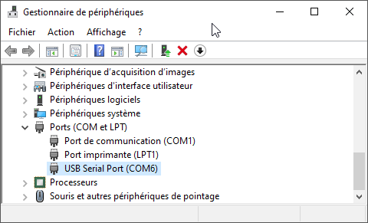

Check usability
Download & install CompuPhase Termite program (very simple to use & easy for communicate with our Pioneer jukeboxes). Open Termite and go to settings.

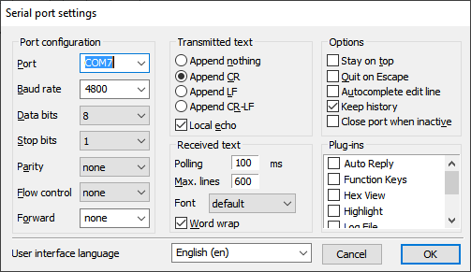

- Select your serial port number (COM1, COM2, COM…)
- Baud rate = 4800 or 9600 (according to autochanger models & settings)
- Data bits = 8
- Stop bits = 1
- Parity = none
- Flow control = none
- Forward = none
- Please sure to be connected

Final transmission tests
- For CAC-V3000/V3200/V5000 models:

  - Type “1PS!!” (without the quotes) in the bottom text zone and press Enter. Confirm that the Pioneer jukebox re-initialize itself.
  - Now type “1PS1ZS” (without the quotes) in the bottom text zone and press Enter. Confirm that the Pioneer jukebox tries to load disc n°1.

- For CAC-V180M model:

  - Type “!!” (without the quotes) in the bottom text zone and press Enter. Confirm that the Pioneer returns “E04”.
  - Type “1ZS” (without the quotes) in the bottom text zone and press Enter. Confirm that the Pioneer jukebox tries to load disc n°1.

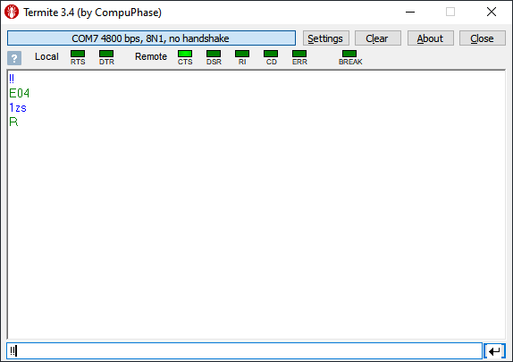

Controller/commands (programming)
As you have guessed, you have to dialogue with ASCII text commands to control your changer. Obviously it’s a raw way to use it. In the past a lot of owners programmed themselves a controller software according for their usage with C, Pascal, BASIC or Visual Basic languages. Few professional and user friendly commercial software existed but no one has leaked nowadays.

Programming manuals are available in the /programming directory on the GitHub repo.
