

**TRIBHUVAN UNIVERSITY**

**INSTITUTE OF ENGINEERING**

**THAPATHALI CAMPUS**

**Proposal**

**On**

**My Hostel**

**Submitted By:**

Anmol Kumar Gupta (THA077BCT011)

Anil Byar (THA077BCT009)

Amrit Kumar Jaiswal (THA077BCT008)

Shailendra Rawal (THA077BCT041)

**Submitted To:**

Department of Electronics and Computer Engineering

Thapathali Campus

Kathmandu, Nepal

**Under the Supervision of**

Er. Saroj Shakya

July, 2021

# Abstract

In this digital world, each and every business wants to store their data in digital form rather than in written form. An organized and systematic solution is required for such business entities. Hostel is one of such business that also has its data and the owner of the hostel requires a proper record management system to keep record of its students in digital way. The information stored by hostel administration can be general student details, contact information, guardian details, etc. Looking into traditional way, these information are being created and stored in written form due to which it becomes a bit difficult to maintain, modify and store such records. Therefore, a computer based Data Management System would help the hostel administration to maintain their data and information in efficient way.

Considering this, we created a Database Management System which would help the hostel administration to easily store their data in computer. We are planning to utilize the powerful database management system, data retrival and data manipulation. We will provide more ease for managing the data than manually writing in the document. Proposed management system will eliminate all the manual intervetion and increase the speed of whole process.

*Keywords: Hostel, Students, Database, Record, Management, System, C Programming, File Handling*

# Table of Contents

Abstract i

List of Figures iv

List of Tables v

List of Abbreviations vi

1. INTRODUCTION 1

1.1 Background 1

1.2 Motivation 1

1.3 Problem Definition 1

1.4 Objectives 1

1.5 Project Application 2

1.6 Scope of Project 2

2. LITERATURE REVIEW 3

2.1 Student Record System in C: Mini C Project 3

2.2 Hostel Management System 3

3. PROPOSED SYSTEM ARCHITECTURE 5

3.1 Flowchart 5

3.2 Project Design 5

3.2.1 Home Page (Admin Login) 6

3.2.2 Main Menu 6

3.3 Tools and Environment 7

3.3.1 IDE Used 7

3.3.2 Programming Language Used 7

4. METHODOLOGY 8

4.1 Admin Login 8

4.2 Main Menu 8

4.2.1 Student Registration 9

4.2.2 View All Student Details 9

4.2.3 Search Student Details 10

4.2.4 Students Access 10

4.2.5 Update Student Details 10

4.2.6 Delete Student Record 10

4.2.7 Exit 11

5. TIME ESTIMATION 12

6. FEASIBILITY ANALYSIS 13

6.1 Economic Feasibility 13

6.2 Technical Feasibility 13

6.3 Operational Feasibility 13

6.3.1 Software Requirements 13

6.3.2 Hardware Requirements 13

References 14

# List of Figures

Figure 3-1 : Flowchart 4

Figure 3-2 : Front Page of My Hostel Program 5

Figure 3-3 : Main Menu of My Hostel Program 6

Figure 4-1 : Flowchart of Admin Login 7

# List of Tables

Table 5‑1 : Time Estimation Gantt Chart 12

# List of Abbreviations

|  |  |
| --- | --- |
| DMS | Data Management System |
| GCC | GNU Compiler Collection |
| HDD | Hard Drive Disk |
| IDE | Integrated Development Environment |
| MB | Mega Byte |
| MHz | Mega Hertz |
| RAM | Random Access Memory |

# 1. INTRODUCTION

My Hostel is a program which would help the hostel administration to keep their student’s data and information in digital form rather than in handwritten documents. It would also assist them to modify and delete the students record as per the need.

## 1.1 Background

Most of the students who come to study at another place by leaving their home like to stay in hostel. Hostel is considered as the second home for the students. Hostel administration has to keep records of their students. Keeping this thing in mind, we came with an idea to create a program to manage the records of the student so that it would help the hostel administration and improve their data management system. Tasks such as adding new student’s data, modifying existing student’s data, deleting student’s data, finding student’s data etc. are essential tasks for hostel administration. Our proposed program would help the hostel administration to perform these tasks in efficient manner.

## 1.2 Motivation

Student record management is tedious process by manual way, since it involves work load time consumption. My Hostel (Student Database Management System) is a program developed for managing various activities in the hostel. For the past few years the numbers of hostels are increasing rapidly. With [Complete Management System](https://itsourcecode.com/free-projects/vb-net/complete-hotel-management-system/), we can easily manage the student details. [1]

## 1.3 Problem Definition

Thinking ourselves as hostel owner, we looked for a program to manage our data and information in efficient manner but programs available were paid and not easily available for a general people. We all realized that we should think of making a database management system using C Programming knowledge and skills to bring a solution for all the hostel administration who are in search of this type of program.

## 1.4 Objectives

The main objectives of our project are listed below:

* To develop Hostel Students Data Management program and demonstrate it to the department faculties.
* To help hostel administration in maintaining their students record in organized way.

## 1.5 Project Application

Our proposed project can have following applications:

* This program will help the hostel administration to keep all the details of their students.
* It will also provide them facility to retrive, update or delete record of any student.
* This program can replace the traditional handwritten record keeping practice to digital form.

## 1.6 Scope of Project

Our proposed project can be very useful for hostel business entities. Since, we are aiming to make our program simple and easy to use, so even a non-technical person can also use our program to keep record of his/her hostel students. Owner of the hostel himself/herself can use our program and keep their students record as they are being carrying in handwritten document. There is no need of any specific person to be hired to run our program.

# 2. LITERATURE REVIEW

There are some programs which allows to perform the tasks like adding the student info, view the added student, search the students, delete the added students, etc. Some of those programs are mentioned below:

## 2.1 Student Record System in C: Mini C Project

The mini-project “Student Record System Project in C” is a console application using the C programming language. In this console application, you can do basic Student Record tasks like adding the student info, view the added student, search the students, etc. This application is based on[file handling in C](https://aticleworld.com/file-handling-in-c/), where file-related function like [fopen](https://aticleworld.com/fopen-in-c/), [fread](https://aticleworld.com/fread-in-c/), [fwrite](https://aticleworld.com/fwrite-in-c/), etc are used. Good thing is that “Student Record System Project” is password-protected, so only authorized persons able to login to this application. The program is divided in different functions. Each function of the program extensively use in the [file handing function](https://aticleworld.com/file-handling-in-c/). [2]

## 2.2 Hostel Management System

Hostel Management System is based on a concept to maintain data of the students of a college living in different hostel premises. Before stepping into the main system a user has to pass through login system to get access, then only he/she can use the features of the system which includes Adding, Removing, Updating and Viewing student’s records of a particular hostel. Talking about the features of Hostel Management System, while entering student’s record he/she has to provide roll number, name, date of birth, age, city, phone number, email id, father’s name, father’s phone number, room number, and select hostel name. There are two methods to check a user’s account in detail i.e by roll number or by student’s name. He/she can view students of a particular hostel. The other listing record displays student’s name with roll number, address and contact detail. This system helps in easy data management of student in a hostel as it is not time-consuming. [3]

With our proposed project, we would like to work on similar techniques to build a new Student Record Management System mainly focused to hostel. Our project would be user-friendly to the hostel administration and would help them in performing their record management task in efficient way.

# 3. PROPOSED SYSTEM ARCHITECTURE

The project ‘My Hostel’ features various record management functions. The proposed architecture of our project can be described in following sub-headings below:

## 3.1 Flowchart

Admin Login

Add New Data

Search Data

Modify Data

Print Details

Exit

?

Yes

Delete Data

Main Menu

No

Figure 3- : Flowchart

## 3.2 Project Design

The proposed flowchart of the project ‘My Hostel’ is shown above. It is supposed to be developed using various user defined functions and in-built library files of C Programming language. At first, it will contain a homepage that will enable the admin to enter the password in order to login into the Record Management System program. The background color for our entire program will be set to blue by using the function *system("COLOR 1F").* Similarly, it will contain various other parts which are described below:

### 3.2.1 Home Page (Admin Login)

This will be the first page of our program which will ask the admin to enter the password in order to login into the Record Management System program. It will also display greeting message.

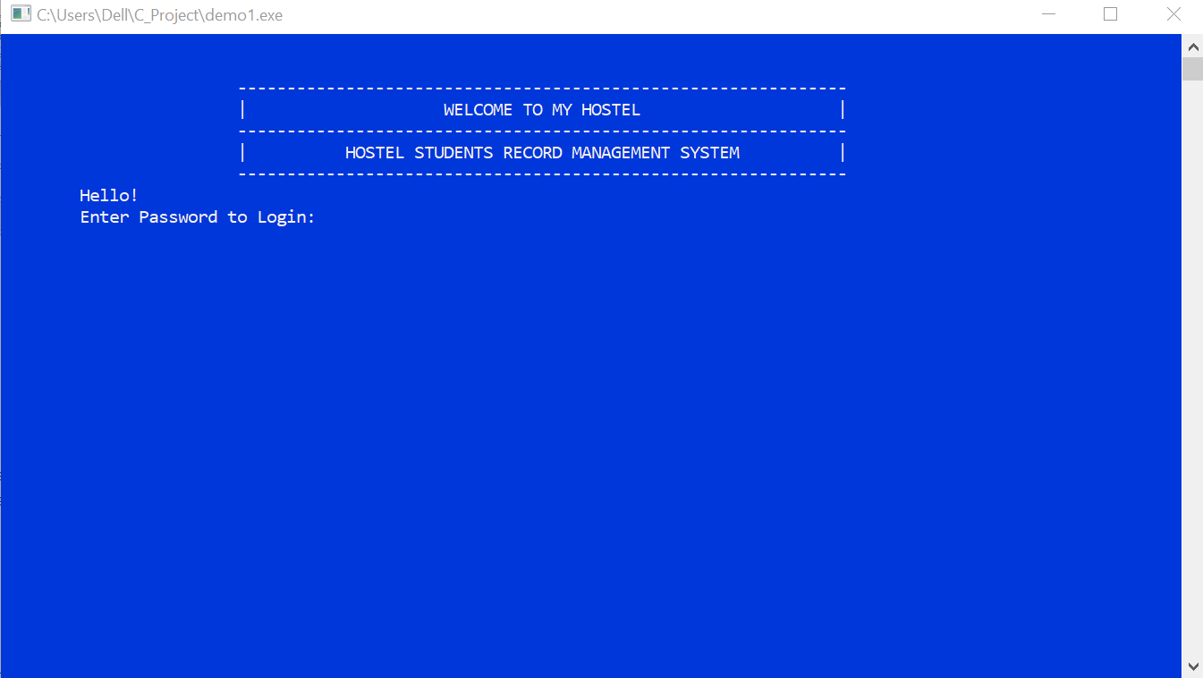

###### Figure 3- : Front Page of My Hostel Program

### 3.2.2 Main Menu

After entering correct password, admin will be able to access Main Menu which will allow him/her to perform various record management tasks like Student Registration, View All Students Details, Search Student Details, Student Access, Update Student Details, Delete Student Record or exit the program. The system current date and time will be also displayed in this page by using *time.h* standard library.

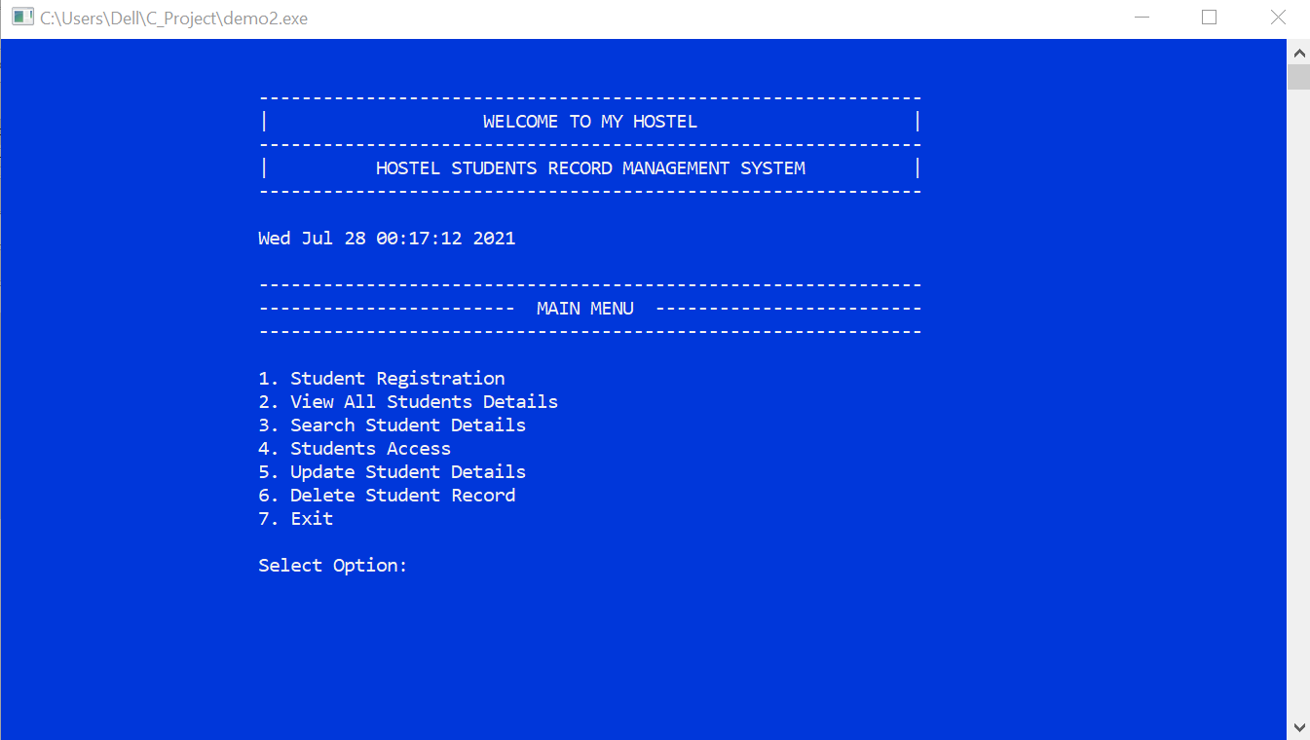

###### Figure 3- : Main Menu of My Hostel Program

## 3.3 Tools and Environment

### 3.3.1 IDE Used

**Visual Studio Code 2021:** VS Code is used in our project for writing and compiling code.

### 3.3.2 Programming Language Used

**C:** C Language is used in our project.

# 4. METHODOLOGY

## 4.1 Search Hostels

The main functionality of the program is to search the hostels. In this section, the user will be at first asked about whether he/she is looking for Boys Hostel or Girls Hostel. After confirming the category of hostel the user is searching for, the program will provide the facility of searching the hostel either by name or location. According to the option selected by the user, the program will further ask the name or location (if search by location is selected by the user) and then it will display the desired hostels.

## 4.2 Boys Hostel

Under this section the program will display

### 4.2.1 Student Registration

Student Registration will add the details of new student. The program will ask the admin to enter following details of students:

* Form/Student No.
* Name
* Mobile No.
* School/College
* Guardian Name
* Guardian Mobile
* Date of Enrollment
* Room No

After entering every details, record of a new student is created with details entered by the admin. For creating and storing record of the students, use of structures and file handling will be done in our project.

### 4.2.2 View All Student Details

After admin select this action, the program shows details of every student entered during registration process in formatted view. The data stored during student registration will be accessed and displayed on the console screen using file handling functions.

### 4.2.3 Search Student Details

This section helps admin to search student details using either room number or student name. First, we will read all students data from file and then compare the room number or student name provided by the admin. If room number was given then, we will show the list of students with the provided room number. If student name was given then we will show list of students whose name contains at least one substring same as user input name.

### 4.2.4 Students Access

Contact Details of a student is one of the frequently required data for hostel administration. Considering this in mind, our program will contain a section for quickly accessing the contact details of every students. Admin can view the contact number of every students in list view through Student Access.

### 4.2.5 Update Student Details

After admin selects to update details of students, we will first ask for student name, then we will show list of students whose name contains at least one substring same as user input name. Admin, then, have to provide serial number corresponding to the student whose details need to be updated. Then we will ask for every update for every detail. If some detail is to be updated then new data should be entered otherwise left it blank. We will then store all data from binary file and rewrite the file updating the student detail.

### 4.2.6 Delete Student Record

This section helps to delete complete details of a student. This will done by reading the datafile and storing the data in some temporary variable. We ask admin for student name whose record is to be deleted. We then show admin a list of students with similar name and ask for serial number corresponding to the student whose record is to be deleted. Then we read the whole datafile and store the data in temporary variable temp and search for student with the given name and write the file with all student data except the student whose data need to be deleted.

### 4.2.7 Exit

The program can be terminated by performing this action. After working, the program needs to be exited. This option helps to exit the program without any error. All the data entered will be remained in the local drive of admin’s computer system and won’t be lost after terminating the program. It will use *exit(1)* to exit the program.

# 5. TIME ESTIMATION

###### Table 5‑ : Time Estimation Gantt Chart

# 6. FEASIBILITY ANALYSIS

## 6.1 Economic Feasibility

It is a C based program and hence it doesn’t require much budget. It can be run using only a proper functioning computer. So, the cost of the project is minimum.



## 6.2 Technical Feasibility

It works on the features of C like library functions, various user defined functions and file handling. So, this program has less technical complexity.

## 6.3 Operational Feasibility



Application requires 32-bit (or more) operating system with a compatible compiler for C.

### 6.3.1 Software Requirements

For the program to run computer must meet the following software specifications:

* Operating System: - WINDOWS 98 or newer.
* Application Software: - Visual Studio or Code::Blocks with GCC or any C compiler.

### 6.3.2 Hardware Requirements

For the program to run computer must meet the following hardware specifications:

* Intel Core2 Duo 1333 MHz or higher.
* 4MB caches memory or higher.
* 128 GB HDD and 1GB RAM or higher

# References

|  |  |
| --- | --- |
| [1] | H. M. S. D. Design, "itsourcecode.com," [Online]. Available: https://itsourcecode.com/free-projects/database-design-projects/database-design-for-hostel-management-system/. [Accessed 25 July 2021]. |
| [2] | Almendra. [Online]. Available: https://aticleworld.com/student-record-system-project-in-c/. [Accessed 26 July 2021]. |
| [3] | F. Ros. [Online]. Available: https://code-projects.org/hostel-management-system-in-c-programming-with-source-code/. [Accessed 26 July 2021]. |
| [4] | "Geeksforgeeks," [Online]. Available: https://www.geeksforgeeks.org/beep-function-in-c-with-examples/. [Accessed 28 July 2021]. |