Supplementary Information

Human-induced salinity changes impact marine organisms and ecosystems

Till Röthig, Stacey M. Trevathan-Tackett, Christian R. Voolstra, Cliff Ross, Samuel Chaffron, Paul J. Durack, Laura M. Warmuth, Michael Sweet

Correspondence to: tillroethig@gmail.com

Supplementary Material & Methods

Salinity projections
For the calculation of Figure 1 results, the 2071-2100 temporal climatologies of phase 6 Coupled Model Intercomparison Project (CMIP6) climate models that contributed to the ScenarioMIP SSP1-2.6, SSP3-7.0, and SSP5-8.5 experimental designs were assessed to illustrate the range of future scenarios. SSP1-2.6 covers a low GHG emissions scenario with global CO₂ emissions cut to net zero around 2075. SSP3-7.0 represents intermediate emission projections at current level emissions until 2050 without reaching net zero within this century. SSP5-8.5 projects a very high emission scenario where current CO₂ emissions triple by 2075 (for details see¹ and Figure SPM.8 therein https://www.ipcc.ch/report/ar6/wg1/figures/summary-for-policymakers/figure-spm-8). In the situation where multiple single model realizations were available, a single model realization mean was calculated before the multi-model mean was calculated. For the upper (a) panel the Durack and Wijffels (2010, updated, 1950-2020) observed near-surface salinity was assessed, for the middle (b - d) the CMIP6 “so” salinity variable was assessed for the model top layer, notionally 5 m depth, and for (e - f) the CMIP6 “mrro” total runoff variable was assessed. Supplementary Tables S2 – S4 below capture all model data that were used in construction of Figure 1, and the data that were used for the coral modeling presented in Figure 4.

Predicted vulnerability of open ocean salinity changes on plankton communities
Global-ocean plankton network inference
To reconstruct a global marine plankton co-occurrence network across kingdoms of life, we analyzed data from 115 stations from the Tara Oceans expeditions (2009-2013) covering several organismal size fractions and all major oceanic provinces² across an extensive latitudinal temperature gradient from pole to pole (Supplementary Figure S1a). Via a dedicated probabilistic learning algorithm³, we predicted ecological interactions between plankton taxa from compositional abundances inferred from sequencing data. The resulting integrated species association network⁴ counts a total of 20,810 nodes corresponding to Operational Taxonomic Units (OTUs) and 86,026 edges corresponding to potential biotic interactions (Supplementary Figure S1b).

Network community detection and environmental niche inference
We detected five communities in the plankton network (Supplementary Figure S1 a, b) using an eigenvector-based network community detection algorithm⁵ implemented in the networkx 2.3 python package. To assign biomes to these communities, OTUs abundance tables were Centered-Log Ratio (CLR) transformed and aggregated by community for each size fraction. CLR values for each community were grouped by biome, and a KW test was run to verify mean differences of communities among biomes. Environmental optimum and tolerance range were calculated with the robust optimum (RO) method⁶. For each OTU and a selection of environmental parameters, we determined the ecological optimum reflecting the optimal OTU living conditions relative to a given environmental parameter, and a tolerance range around this optimum defined by lower and upper bounds.

Network-based robustness analyses
In order to simulate the effects of environmental change and predict their impact on the stability of the plankton community structures, we designed a network attack procedure mimicking the potential effect of each environmental parameter’s variations onto the network. We progressively removed network nodes by bins (n = 200 nodes until the 10000th node, then n = 1000 nodes) corresponding to environmental ranges, ordered from the smallest to the largest tolerance ranges for each parameter (within a given range, the nodes are randomly sorted). At each step, we computed the graph natural connectivity⁷, a graph robustness metric, for the global interactome and for subgraphs corresponding to communities extracted from the network. By doing so we could evaluate the vulnerability (or loss of robustness / stability) of the plankton network at the global and community levels. Wilcoxon’s rank sum tests were performed to compare distributions of natural connectivity for network environmental perturbations versus random perturbations.

Coral distribution models

Coral occurrences
Data of coral occurrences were derived from the Global Biodiversity Interface Facility (GBIF, https://www.gbif.org/) with the rgbif package⁸ (3.6.0) in RStudio⁹ (1.4.1717). Geographic data of all hard coral observations (order: Scleractinia) were downloaded for global coral reefs in the Marshall Islands in August 2021. Many species entries were missing or had errors and were not reliably identified, thus a distribution modeling approach on genus level was chosen. The data cleaning process involved a) cross-referencing, b) eliminating errors in coordinates, c) removing duplicates, d) removing missing coordinate and genus values and e) removing erroneous and fossil genera. The genus names were verified in the World Register of Marine Species (WoRMS) and checked if genus is extant, has accepted status and is ranked as genus in the order Scleractinia¹⁰. The GBIF data search resulted in 1587 occurrences of 78 genera with reliable coordinates for the Marshall Islands region and a verified genus identification from WoRMS.

Salinity data
The environmental variable used as the modeling predictor was change in mean near-surface salinity for the year 2100 projections differenced from the historical 1985-2014 baseline. Two contrasting end of century scenarios were selected: the “2° Celsius scenario” (SSP1-2.6) and the “high CO₂ emission scenario” (SSP5-8.5). The global data layers were retrieved from the CMIP6 archive on 26th July 2021 and cropped in R using the raster package¹¹ (3.4.13) to the geographic extent of the coral occurrences with a buffer of 20 degrees (coordinates: 139° E, 192° E, 16° S, 37° N).

Distribution modeling
For the distribution modeling a Maximum Entropy approach (MaxEnt version 3.4.1) was used with the dismo package¹² (1.3-3) with the aim to predict future suitable habitats for warm water scleractinians for the 78 genera of Scleractinia that had sufficient observations. The models were run with default parameters. Because the occurrence dataset from GBIF is presence-only 10,000 random background points for pseudo-absences in the model area were created through the model algorithm. The model fit was then verified with the resulting AUC score as a threshold independent evaluation. The AUC score uses presence and background locations to calculate the probability that a random presence location results in a higher predicted value than a random background location. An AUC score of 1 means a perfect fit of the model to the data whereas an AUC score of 0.5 means that the model performance is no better than random¹³.

Further distribution models for the Marshall Islands region with mean near-surface salinity for the SSP1-2.6 and SSP5-8.5 scenarios were also run (Supplementary Figure S2).

Supplementary References
1. IPCC, 2021: Summary for Policymakers. In: Climate Change 2021: The Physical Science Basis. Contribution of Working Group I to the Sixth Assessment Report of the Intergovernmental Panel on Climate Change (Masson-Delmotte, V., Zhai, P., Pirani, A., Connors, S.L., Péan, C., Berger, S., Caud, N., Chen, Y., Goldfarb, L., Gomis, M.I., Huang, M., Leitzell, K., Lonnoy, E., Matthews, J.B.R., Maycock, T.K., Waterfield, T., Yelekçi, O., Yu, R. & Zhou, B. (eds.)). Cambridge University Press, Cambridge, UK and New York, NY,USA, pp. 3−32.
2. Karsenti, E. et al. A Holistic Approach to Marine Eco-Systems Biology. PLoS Biol. 9, e1001177 (2011).
3. Tackmann, J., Matias Rodrigues, J. F. & von Mering, C. Rapid Inference of Direct Interactions in Large-Scale Ecological Networks from Heterogeneous Microbial Sequencing Data. Cell Syst. 9, 286-296.e8 (2019).
4. Chaffron, S. et al. Environmental vulnerability of the global ocean epipelagic plankton community interactome. Sci. Adv. 7, (2021).
5. Newman, M. E. J. Modularity and community structure in networks. Proc. Natl. Acad. Sci. U. S. A. 103, 8577–8582 (2006).
6. Cristóbal, E., Ayuso, S. V., Justel, A. & Toro, M. Robust optima and tolerance ranges of biological indicators: A new method to identify sentinels of global warming. Ecol. Res. 29, 55–68 (2014).
7. Wu, J., Mauricio, B., Tan, Y. J. & Deng, H. Z. Natural connectivity of complex networks. Chinese Phys. Lett. 27, 078902 (2010).
8. Chamberlain, S. (2017) rgbif: Interface to the Global Biodiversity Information Facility API. R Package Version 1.0.2.
9. R Development Core Team (2018) R: A language and environment for statistical computing. In: Computing, R. F. f. S. Version 3.5.1. Vienna, Austria.
10. Horton, T. et al. (2018) World Register of Marine Species (WoRMS). WoRMS Editorial Board.
11. Hijmans, R. J., & van Etten J. (2012) raster: Geographic analysis and modeling with raster data. R package version 2.0-12.
12. Hijmans, R. J., Phillips, S., Leathwick, J. and Elith, J. (2017) dismo: Species Distribution Modeling. R Package Version 1.1.4.
13. Fielding, A. H. & Bell, J. F. A review of methods for the assessment of prediction errors in conservation presence/absence models. Environ. Conserv. 24, 38–49 (1997).

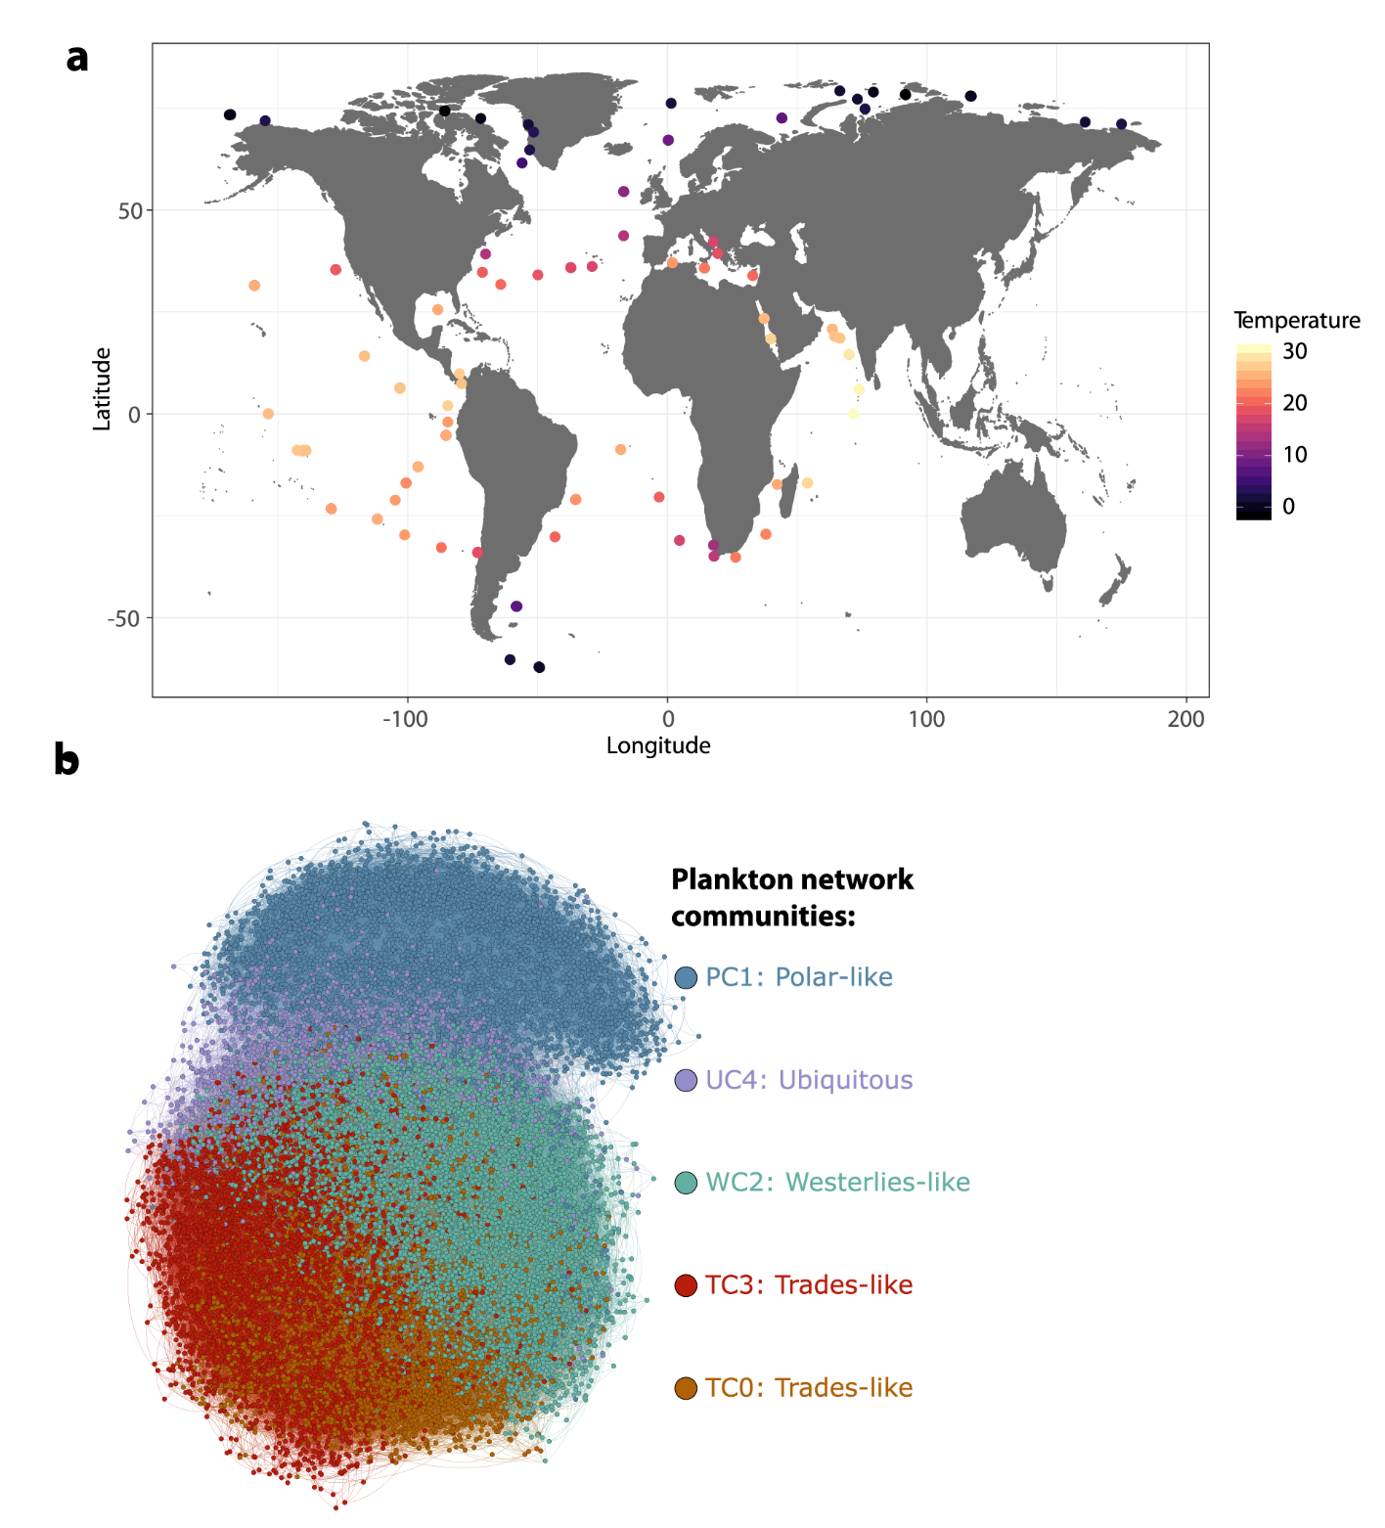
Supplementary Figure S1. Tara Ocean samplings allow reconstruction of a global-ocean euphotic zone plankton community network. (a) The Tara Oceans expeditions (2009-2013) collected plankton samples from 5 organismal size fractions (two prokaryotes-enriched size fractions (0.2-1.6 μm and 0.2-3 μm) and four eukaryotic size fractions (‘0.8-5 μm and 0.8-2000 μm’, ‘3-20 μm and 5-20 μm, ‘20-180 μm’ and ‘180-2000’ μm)) at 115 stations, from pole to pole. Here, we limited our analyses to the euphotic zone, including only samples from surface (SRF) and the Deep Chlorophyll Maximum (DCM). (b) We inferred a global marine plankton co-occurrence network across kingdoms of life by integrating these samples, and detected five communities that were enriched in specific marine biomes. Communities TC0 and TC3 are Trades-like, community WC2 is Westerlies-like, community PC1 is Polar-like and community UC4 is ubiquitous.

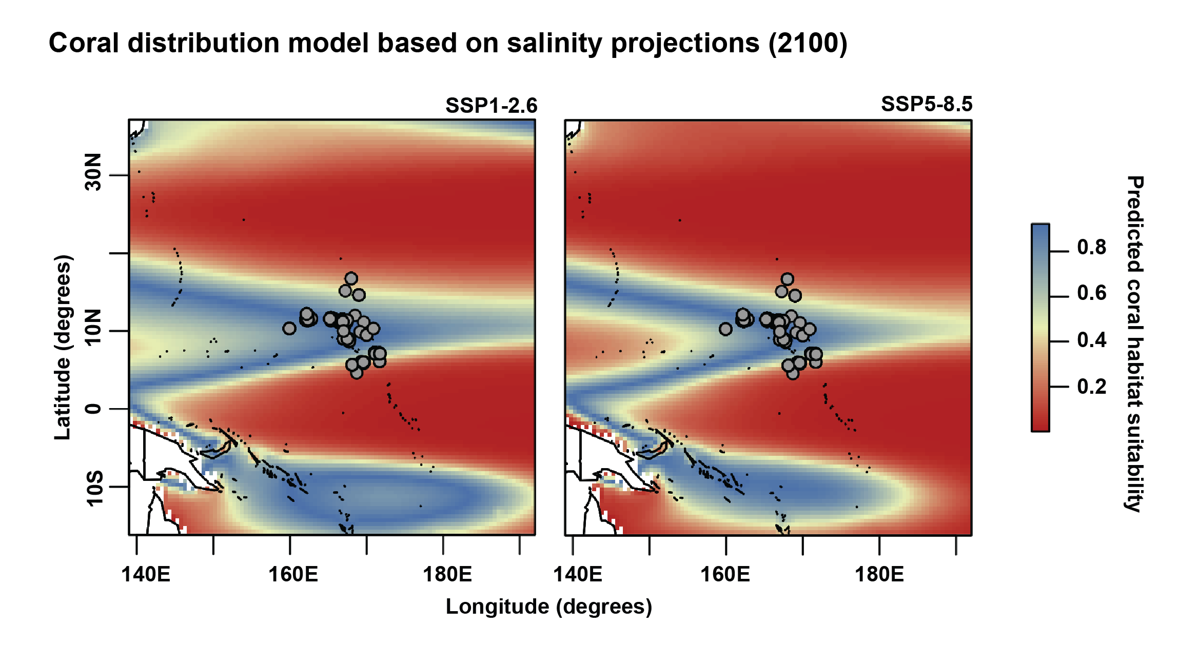
Supplementary Figure S2. Predicted distribution of Scleractinia (hard coral) genera (occurrences as grey dots) in the Marshall Islands region for mean near-surface salinity for the “2° Celsius scenario” (Shared Socioeconomic Pathway, SSP1-2.6) and the “high CO₂ emission scenario” (Shared Socioeconomic Pathway, SSP5-8.5) for the year 2100. These future projections stem from phase 6 of the Coupled Model Intercomparison Project (CMIP6) multi-model mean salinity data. The modeling region was defined by the coral occurrence in the Marshall Islands with a 20-degree buffer around the observations (139° E, 192° E, 16° S, 37° N). The training AUC scores for the SSP1-2.6 scenario was 0.845 and for the SSP5-8.5 scenario was 0.890. The legend for the model predictions ranges from blue (highest probability of occurrence > 0.8) to red (lowest probability of occurrence < 0.2).

Supplementary Table S2. CMIP6 model simulations used in construction of the SSP1-2.6 scenario for Figures 1 and 4 in the main text.
# | CMIP6 institution | CMIP6 model | SSP126 mrro experiment realizations | SSP126 sos experiment realizations | DOI
1 | CAS | CAS-ESM2-0 | r1, 3i1p1f1 | r1, 3i1p1f1 | CAS-ESM2.0
2 | CCCma | CanESM5-CanOE |  | r1-3i1p1f1 | 10.22033/ESGF/CMIP6.10269
3 | CCCma | CanESM5 |  | r1-25i1p1f1, r1-25i1p2f1 | 10.22033/ESGF/CMIP6.3683
4 | CAS | FGOALS-f3-L | r1i1p1f1 |  | 10.22033/ESGF/CMIP6.3464
5 | CAS | FGOALS-g3 | r1-4i1p1f1 |  | 10.22033/ESGF/CMIP6.3465
6 | CMCC | CMCC-ESM2 | r1i1p1f1 | r1i1p1f1 | 10.22033/ESGF/CMIP6.13250
7 | CNRM-CERFACS | CNRM-CM6-1 | r1-6i1p1f2 | r1-6i1p1f2 | 10.22033/ESGF/CMIP6.4184
8 | CNRM-CERFACS | CNRM-ESM2-1 | r1-5i1p1f2 | r1-5i1p1f2 | 10.22033/ESGF/CMIP6.4186
9 | CSIRO-ARCCSS | ACCESS-CM2 | r1-5i1p1f1 | r1-5i1p1f1 | 10.22033/ESGF/CMIP6.4319
10 | CSIRO | ACCESS-ESM1-5 | r1-40i1p1f1 | r1-40i1p1f1 | 10.22033/ESGF/CMIP6.4320
11 | DKRZ | MPI-ESM1-2-HR | r1i1p1f1 | r1i1p1f1 | 10.22033/ESGF/CMIP6.4397
 | DWD | MPI-ESM1-2-HR | r2i1p1f1 | r2i1p1f1 | 10.22033/ESGF/CMIP6.4473
12 | EC-Earth-Consortium | EC-Earth3-Veg-LR | r1-3i1p1f1 | r1-3i1p1f1 | 10.22033/ESGF/CMIP6.4877
13 | EC-Earth-Consortium | EC-Earth3-Veg | r1-4, 6, 12, 14i1p1f1 | r1-4, 6, 12, 14i1p1f1 | 10.22033/ESGF/CMIP6.4876
14 | EC-Earth-Consortium | EC-Earth3 | r1, 3-6, 9, 11, 13, 15, 101-150i1p1f1 | r1, 4-6, 9, 11, 13, 15, 101-150i1p1f1 | 10.22033/ESGF/CMIP6.4874
15 | FIO-QLNM | FIO-ESM-2-0 | r1-3i1p1f1 |  | 10.22033/ESGF/CMIP6.9208
16 | INM | INM-CM4-8 |  | r1i1p1f1 | 10.22033/ESGF/CMIP6.12325
17 | INM | INM-CM5-0 |  | r1i1p1f1 | 10.22033/ESGF/CMIP6.12326
18 | IPSL | IPSL-CM5A2-INCA |  | r1i1p1f1 | 10.22033/ESGF/CMIP6.15711
19 | IPSL | IPSL-CM6A-LR | r1-4, 6, 14i1p1f1 | r1-4, 6, 14i1p1f1 | 10.22033/ESGF/CMIP6.5262
20 | KIOST | KIOST-ESM | r1i1p1f1 | r1i1p1f1 | 10.22033/ESGF/CMIP6.11243
21 | MIROC | MIROC-ES2L | r1-10i1p1f2 | r1-10i1p1f2 | 10.22033/ESGF/CMIP6.5742
22 | MIROC | MIROC6 | r1-50i1p1f1 | r1-50i1p1f1 | 10.22033/ESGF/CMIP6.5743
23 | MOHC | HadGEM3-GC31-LL | r1i1p1f3 | r1i1p1f3 | 10.22033/ESGF/CMIP6.10849
24 | MOHC | UKESM1-0-LL | r1-12, 16-19i1p1f2 | r1-12, 16-19i1p1f2 | 10.22033/ESGF/CMIP6.6333
25 | MOHC | UKESM1-1-LL | r1i1p1f2 |  | 10.22033/ESGF/CMIP6.16841
26 | MPI-M | MPI-ESM1-2-LR | r1i1p1f1 | r1-30i1p1f1 | 10.22033/ESGF/CMIP6.6690
27 | MRI | MRI-ESM2-0 | r1-5i1p1f1 | r1-5i1p1f1 | 10.22033/ESGF/CMIP6.6909
28 | NASA-GISS | GISS-E2-1G |  | r1-5i1p1f2, r1i1p3f1, r1-5i1p5f1 | 10.22033/ESGF/CMIP6.7410
29 | NASA-GISS | GISS-E2-1-H |  | r1-5i1p1f2, r1-5i1p3f1 | 10.22033/ESGF/CMIP6.7411
30 | NASA-GISS | GISS-E2-2-G |  | r1-5i1p3f1 | 10.22033/ESGF/CMIP6.11866
31 | NCAR | CESM2-WACCM | r1i1p1f1 | r1i1p1f1 | 10.22033/ESGF/CMIP6.10100
32 | NCAR | CESM2 | r4, 10-11i1p1f1 | r4, 10-11i1p1f1 | 10.22033/ESGF/CMIP6.7746
33 | NCC | NorESM2-LM |  | r1i1p1f1 | 10.22033/ESGF/CMIP6.8248
34 | NCC | NorESM2-MM |  | r1i1p1f1 | 10.22033/ESGF/CMIP6.8250
35 | NIMS-KMA | KACE-1-0-G | r1-3i1p1f1 | r1-3i1p1f1 | 10.22033/ESGF/CMIP6.8432
36 | NOAA-GFDL | GFDL-ESM4 |  | r1i1p1f1 | 10.22033/ESGF/CMIP6.8684
37 | NUIST | NESM3 |  | r1-2i1p1f1 | 10.22033/ESGF/CMIP6.8780
38 | THU | CIESM | r1i1p1f1 | r1i1p1f1 | 10.22033/ESGF/CMIP6.8857
39 | UA | MCM-UA-1-0 | r1i1p1f2 | r1i1p1f2 | 10.22033/ESGF/CMIP6.13895
 | Total Models |  | 28 | 36
 | Total Simulations |  | 267 | 344

Supplementary Table S3. CMIP6 model simulations used in construction of the SSP3-7.0 scenario for Figure 1 in the main text.
# | CMIP6 institution | CMIP6 model | SSP370 mrro experiment realizations | SSP370 sos experiment realizations | DOI
1 | CAS | CAS-ESM2-0 | r1, 3i1p1f1 | r1, 3i1p1f1 | CAS-ESM2.0
2 | CAS | FGOALS-f3-L | r1i1p1f1 |  | 10.22033/ESGF/CMIP6.3479
3 | CAS | FGOALS-g3 | r1-5i1p1f1 |  | 10.22033/ESGF/CMIP6.3480
4 | CCCma | CanESM5-CanOE |  | r1-3i1p2f1 | 10.22033/ESGF/CMIP6.10271
5 | CCCma | CanESM5 |  | r1-25i1ip1f1, r1-25i1p2f1 | 10.22033/ESGF/CMIP6.3690
6 | CMCC | CMCC-ESM2 | r1i1p1f1 | r1i1p1f1 | 10.22033/ESGF/CMIP6.13253
7 | CNRM-CERFACS | CNRM-CM6-1 | r1-6i1p1f2 | r1-6i1p1f2 | 10.22033/ESGF/CMIP6.4197
8 | CNRM-CERFACS | CNRM-ESM2-1 | r1-5i1p1f2 | r1-5i1p1f2 | 10.22033/ESGF/CMIP6.4199
9 | CSIRO-ARCCSS | ACCESS-CM2 | r1-5i1p1f1 | r1-5i1p1f1 | 10.22033/ESGF/CMIP6.4323
10 | CSIRO | ACCESS-ESM1-5 | r1-40i1p1f1 | r1-40i1p1f1 | 10.22033/ESGF/CMIP6.4324
11 | DKRZ | MPI-ESM1-2-HR | r1-10i1p1f1 | r1-10i1p1f1 | 10.22033/ESGF/CMIP6.4399
12 | EC-Earth-Consortium | EC-Earth3-AerChem | r1, 3i1p1f1 | r1, 3i1p1f1 | 10.22033/ESGF/CMIP6.4885
13 | EC-Earth-Consortium | EC-Earth3-Veg-LR | r1-3i1p1f1 | r1-3i1p1f1 | 10.22033/ESGF/CMIP6.4887
14 | EC-Earth-Consortium | EC-Earth-Veg | r1-4, 12, 14i1p1f1 | r1-4, 12i1p1f1 | 10.22033/ESGF/CMIP6.4886
15 | EC-Earth-Consortium | EC-Earth3 | r1, 3, 4, 6, 9, 11, 13, 101-150i1p1f1 | r1, 4, 6, 9, 11, 13, 101-150i1p1f1 | 10.22033/ESGF/CMIP6.4884
16 | INM | INM-CM4-8 |  | r1i1p1f1 | 10.22033/ESGF/CMIP6.12329
17 | INM | INM-CM5-0 |  | r1-5i1p1f1 | 10.22033/ESGF/CMIP6.12330
18 | IPSL | IPSL-CM5A2-INCA |  | r1i1p1f1 | 10.22033/ESGF/CMIP6.15714
19 | IPSL | IPSL-CM6A-LR | r1-10, 14i1p1f1 | r1-10, 14i1p1f1 | 10.22033/ESGF/CMIP6.5265
20 | MIROC | MIROC-ES2L | r1-10i1p1f2 | r1-10i1p1f2 | 10.22033/ESGF/CMIP6.5751
21 | MIROC | MIROC6 | r1-50i1p1f1 | r1-50i1p1f1 | 10.22033/ESGF/CMIP6.5752
22 | MOHC | UKESM1-0-LL | r1-8, 16, 19i1p1f2 | r1-8, 16, 19i1p1f2 | 10.22033/ESGF/CMIP6.6347
23 | MOHC | UKESM1-1-LL | r1i1p1f2 | r1i1p1f2 | 10.22033/ESGF/CMIP6.16845
24 | MPI-M | MPI-ESM1-2-LR | r1-30i1p1f1 | r1-30i1p1f1 | 10.22033/ESGF/CMIP6.6695
25 | MRI | MRI-ESM2-0 | r1-5i1p1f1 | r1-5i1p1f1 | 10.22033/ESGF/CMIP6.6915
26 | NASA-GISS | GISS-E2-1-G |  | r1-10i1p1f2, r1-4i1p3f1, r1-3i1p3f2, r1-10i1p5f1 | 10.22033/ESGF/CMIP6.7426
27 | NASA-GISS | GISS-E2-1-H |  | r1-5i1p1f2, r1i1p3f1 | 10.22033/ESGF/CMIP6.7427
28 | NASA-GISS | GISS-E2-2-G |  | r1-5i1p3f1 | 10.22033/ESGF/CMIP6.11873
29 | NCAR | CESM2-FV2 | r1i2p2f1 | r1i2p2f1
30 | NCAR | CESM2-WACCM | r1i1p1f1 | r1i1p1f1 | 10.22033/ESGF/CMIP6.10102
31 | NCAR | CESM2 | r4, 10-11i1p1f1 | r3-4, 10-11i1p1f1 | 10.22033/ESGF/CMIP6.7753
32 | NCC | NorESM2-LM |  | r1i1p1f1 | 10.22033/ESGF/CMIP6.8268
33 | NCC | NorESM2-MM |  | r1i1p1f1 | 10.22033/ESGF/CMIP6.8270
34 | NIMS-KMA | KACE-1-0-G | r1-3i1p1f1 | r1-3i1p1f1 | 10.22033/ESGF/CMIP6.8437
35 | NOAA-GFDL | GFDL-ESM4 |  | r1i1p1f1 | 10.22033/ESGF/CMIP6.8691
36 | UA | MCM-UA-1-0 | r1i1p1f2 | r1i1p1f2 | 10.22033/ESGF/CMIP6.13897
 | Total Models |  | 25 | 34
 | Total Simulations |  | 270 | 364

Supplementary Table S4. CMIP6 model simulations used in construction of the SSP5-8.5 scenario for Figures 1 and 4 in the main text.
# | CMIP6 institution | CMIP6 model | SSP585 mrro experiment realizations | SSP585 sos experiment realizations | DOI
1 | CAS | CAS-ESM2-0 | r1, 3i1p1f1 | r1, 3i1p1f1 | CAS-ESM2.0
2 | CAS | FGOALS-f3-L | r1i1p1f1 |  | 10.22033/ESGF/CMIP6.3502
3 | CAS | FGOALS-g3 | r1-5i1p1f1 |  | 10.22033/ESGF/CMIP6.3503
4 | CCCma | CanESM5-1 |  | r1-2, 4-10i1p1f1, r1, 4, 6, 8, 10i1p2f1
5 | CCCma | CanESM5-CanOE |  | r1-3i1p2f1 | 10.22033/ESGF/CMIP6.10276
6 | CCCma | CanESM5 |  | r1-25i1p1f1, r1-25i1p2f1 | 10.22033/ESGF/CMIP6.3696
7 | CMCC | CMCC-ESM2 | r1i1p1f1 | r1i1p1f1 | 10.22033/ESGF/CMIP6.13259
8 | CNRM-CERFACS | CNRM-CM6-1 | r1-6i1p1f2 | r1-6i1p1f2 | 10.22033/ESGF/CMIP6.4224
9 | CNRM-CERFACS | CNRM-ESM2-1 | r1-5i1p1f2 | r1-5i1p1f2 | 10.22033/ESGF/CMIP6.4226
10 | CSIRO-ARCCSS | ACCESS-CM2 | r1-5i1p1f1 | r1-5i1p1f1 | 10.22033/ESGF/CMIP6.4332
11 | CSIRO | ACCESS-ESM1-5 | r1-40i1p1f1 | r1-40i1p1f1 | 10.22033/ESGF/CMIP6.4333
12 | DKRZ | MPI-ESM1-2-HR | r1i1p1f1 | r1i1p1f1 | 10.22033/ESGF/CMIP6.4403
 | DWD | MPI-ESM1-2-HR | r2i1p1f1 | r2i1p1f1 | 10.22033/ESGF/CMIP6.4479
13 | EC-Earth-Consortium | EC-Earth3-Veg-LR | r1-3i1p1f1 | r1-3i1p1f1 | 10.22033/ESGF/CMIP6.4915
14 | EC-Earth-Consortium | EC-Earth-Veg | r1-4, 6, 10, 12, 14i1p1f1 | r1-4, 6, 12i1p1f1 | 10.22033/ESGF/CMIP6.4914
15 | EC-Earth-Consortium | EC-Earth3 | r1, 3, 4, 6, 9, 11, 13, 101-150i1p1f1 | r1, 3, 4, 6, 11, 13, 101-150i1p1f1 | 10.22033/ESGF/CMIP6.4912
16 | FIO-QLNM | FIO-ESM-2-0 | r1-3i1p1f1 |  | 10.22033/ESGF/CMIP6.9214
17 | INM | INM-CM4-8 |  | r1i1p1f1 | 10.22033/ESGF/CMIP6.12337
18 | INM | INM-CM5-0 |  | r1i1p1f1 | 10.22033/ESGF/CMIP6.12338
19 | IPSL | IPSL-CM6A-LR | r1-4, 6, 14, 33i1p1f1 | r1-4, 6, 14, 33i1p1f1 | 10.22033/ESGF/CMIP6.5271
20 | KIOST | KIOST-ESM | r1i1p1f1 | r1i1p1f1 | 10.22033/ESGF/CMIP6.11249
21 | MIROC | MIROC-ES2L | r1-10i1p1f2 | r1-10i1p1f2 | 10.22033/ESGF/CMIP6.5770
22 | MIROC | MIROC6 | r1-50i1p1f1 | r1-50i1p1f1 | 10.22033/ESGF/CMIP6.5771
23 | MOHC | HadGEM3-GC31-LL | r1-3i1p1f3 | r1-3i1p1f3 | 10.22033/ESGF/CMIP6.10901
24 | MOHC | UKESM1-0-LL | r1-4, 8i1p1f2 | r1-4, 8i1p1f2 | 10.22033/ESGF/CMIP6.6405
25 | MPI-M | MPI-ESM1-2-LR | r1-30i1p1f1 | r1-30i1p1f1 | 10.22033/ESGF/CMIP6.6705
26 | MRI | MRI-ESM2-0 | r1-5i1p1f1, r1i2p1f1 | r1-5i1p1f1, r1i2p1f1 | 10.22033/ESGF/CMIP6.6929
27 | NASA-GISS | GISS-E2-1-G |  | r1-5i1p1f2, r1i1p3f1, r1-5i1p5f1 | 10.22033/ESGF/CMIP6.7460
28 | NASA-GISS | GISS-E2-1-H |  | r1-5i1p1f2, r1-5i1p3f1 | 10.22033/ESGF/CMIP6.7461
29 | NASA-GISS | GISS-E2-2-G |  | r1-5i1p3f1 | 10.22033/ESGF/CMIP6.11889
30 | NCAR | CESM2-FV2 | r1i2p2f1 | r1i2p2f1
31 | NCAR | CESM2-WACCM | r1-5i1p1f1 | r1-5i1p1f1 | 10.22033/ESGF/CMIP6.10115
32 | NCAR | CESM2 | r4, 10-11i1p1f1 | r4, 10-11i1p1f1 | 10.22033/ESGF/CMIP6.7768
33 | NCC | NorESM2-LM |  | r1i1p1f1 | 10.22033/ESGF/CMIP6.8319
34 | NCC | NorESM2-MM |  | r1i1p1f1 | 10.22033/ESGF/CMIP6.8321
35 | NIMS-KMA | KACE-1-0-G | r1-3i1p1f1 | r1-3i1p1f1 | 10.22033/ESGF/CMIP6.8456
36 | NOAA-GFDL | GFDL-CM4 |  | r1i1p1f1 | 10.22033/ESGF/CMIP6.9268
37 | NOAA-GFDL | GFDL-ESM4 |  | r1i1p1f1 | 10.22033/ESGF/CMIP6.8706
38 | NUIST | NESM3 |  | r1-2i1p1f1 | 10.22033/ESGF/CMIP6.8790
39 | THU | CIESM | r1i1p1f1 | r1i1p1f1 | 10.22033/ESGF/CMIP6.8863
40 | UA | MCM-UA-1-0 | r1i1p1f2 | r1i1p1f2 | 10.22033/ESGF/CMIP6.13901
 | Total Models |  | 28 | 38
 | Total Simulations |  | 264 | 357

