**Image analysis challenge**

***Context***:

We provide a set of 9 images to analyse. These are 3D medical images in NIFTI format (filename extension vol_*xx.nii.gz*) from chest CT scan. Data are encoded in Hounsfield units (HU). Those 3D segments are axial slices of the lungs.  
In those images, most of the bright voxels within the lung parenchyma represent vessels (see Figure 1). Most normal lung parenchyma is below –300 HU and above –1000 HU.

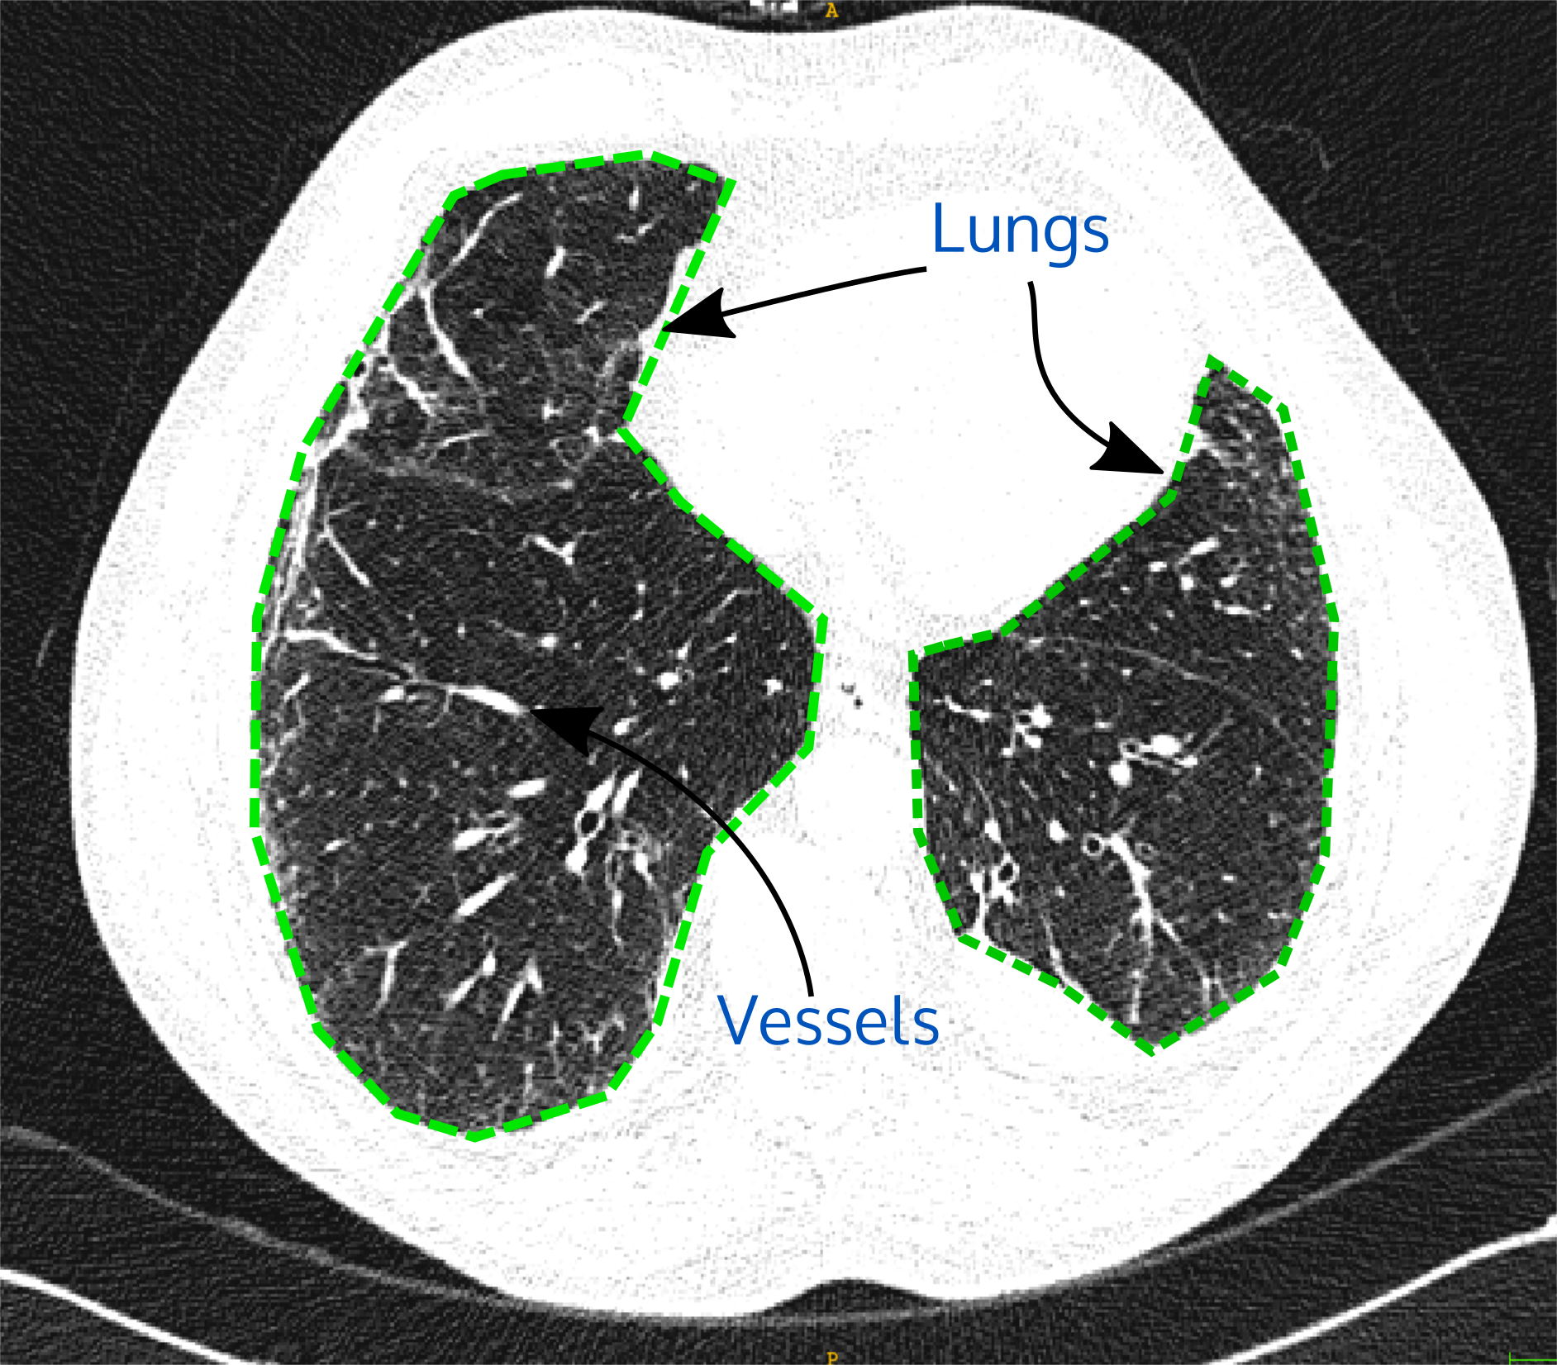  
Figure 1. *Example 2D axial view slice image of the chest CT scan with lung outlined in green. Current viewing window settings: level=-600HU and width=1000HU.*

***Task:***

Write a piece of code, ***provide commented code and instructions to run it***, to fulfil the following tasks:

1. For each image, segment (individualize) the lung in the image (excluding bowels, trachea and other dark regions outside the lung) and compute the lung volume in ml. Save and provide each mask with the following postfix: <*original name>_mask.nii.gz* as a result*.*
2. For each image, segment the main vessels voxels with values higher than -500 HU and compute the relative vessels over lung volume in % (vessel-lung volume ratio).
3. For the whole dataset, divide the images into classes by common characteristics. – Tip: the groups could be heavily imbalanced.
4. Create a report with explanations of your solution and at least the following figures:
   1. Summary of the distribution result of the vessels-lung ratio of the segmentations done in steps 1 and step 2.
   2. A global pair-plot images ID with a colour code for the classes found in step 3 for the complete set of 9 images. (1 image with 9 points)