Let’s Scratch and Have Fun
Beginner IT Camp
No experience needed!
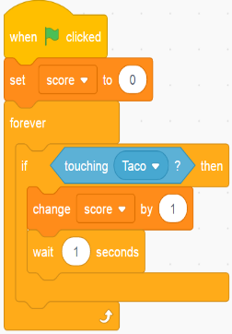
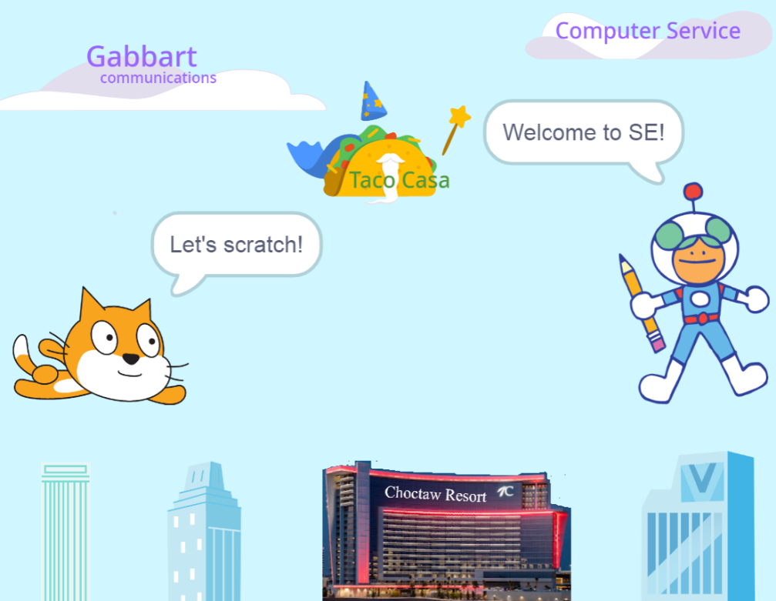

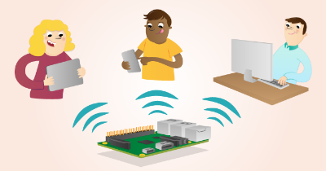
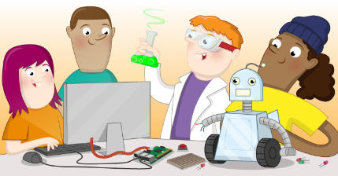
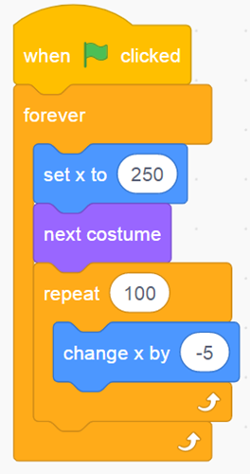
Each workshop⁵: No prior IT experience needed
Each workshop⁶: kids (20 seats) and parents/guardians (10 seats)
Grader⁷: for a student entering these grades in Fall 2022.
Parents/Guardians⁸: FREE OF CHARGE
Note⁹: $50 total per camp (updated on 5/18), not per workshop

Scratch¹: A block-based drag-and-drop programming language by MIT – https://scratch.mit.edu
Image credit²: https://projects.raspberrypi.org/en/projects/lamp-web-server-with-wordpress
Image credit³: https://projects.raspberrypi.org/en/projects/button-switch-scratch-pi
STEM⁴: Science Technology Engineering Mathematics

Hands-on IT – STEM⁴ Workshops^{5,6} - 2022:
- IoT (Internet of Things) using Raspberry Pi and Scratch for 5th-6th Graders⁷. Parents/Guardians are welcome!⁸
  - June 20-23, 8:30 AM – 10:00 AM (Mon.–Thur., 4-day), $50 total⁹, Classroom Building (CB104)
- IoT (Internet of Things) using Raspberry Pi and Scratch for 7th-8th Graders⁷. Parents/Guardians are welcome!⁸
  - June 20-23, 10:30 AM – 12:00 PM (Mon.–Thur., 4-day), $50 total⁹, Classroom Building (CB104)
- IoT (Internet of Things) using Raspberry Pi and Scratch for 9th-12th Graders⁷. Parents/Guardians are welcome!⁸
  - June 27-30, 8:30 AM – 10:00 AM (Mon.–Thur., 4-day), $50 total⁹, Classroom Building (CB104)
- Webpage Design for 5th-10th graders⁷. Parents/Guardians are welcome!⁸
  - June 27-30, 10:30 AM – 12:00 PM (Mon.–Thur., 4-day), $50 total⁹, Classroom Building (CB104)

How to apply? Please visit www.your.edu/ITcamp for more information.
Selection of participants will begin on May 20 and scholarships are available!

Image credit: raspberrypi.org²
Image: created using Scratch¹. raspberrypi.org²
Image credit: raspberrypi.org³
H
ow did they get started? “… I wanted to make something that was fun for myself and my sisters. I wrote this little program …”
How old were they when they started?
- Bill Gate (age 13), Microsoft
- Jack Dorsey (age 8), Twitter
- Mark Zuckerberg (6th grader), Facebook
- …
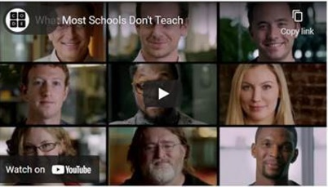
- Source: https://youtu.be/nKIu9yen5nc [5m:43s] by Code.org
It is never too late or early to get started!
– Mark Zuckerberg (Founder of Facebook)

With the technologies at our fingertips today, it has never been easier for almost anyone to create fun and interesting games and STEM projects, even with just a mobile device. Let’s explore the new technologies out there and discover your untapped talents, so that you can enrich your life and anyone around you.

Summer Hands-on IT-STEM Workshops:
What is IoT?

- Source: https://youtu.be/LlhmzVL5bm8 [3m:21s] by Edureka!
 | Workshops (WS)
Contents* (IoT) | WS-1 | WS-2 | WS-3
1. Introducing IoT (Internet of Things), Raspberry Pi, and Scratch 3
2. Game Programming - Scratch 3
3. Exploring Scratch Extensions
4. Getting to Know your Raspberry Pi
Take a brief guided tour of your new computer
5. Virtual IT Field Trip with Q & A
Choctaw Nation – IT Dept.
6. Special Speaker: The IT Professional
A day in the life of an IT Professional and Q&A
7. Starting your Raspberry Pi
8. Hands-on with the Sense HAT
Use the sensors and LED matrix display of this add-on board
9. Hands-on IoT Devices with Scratch
Use the things: LEDs, Sensors (soil moisture, temperature, humidity, distance, … *), *: depends on the class progress
10. Programming with Python (will be briefly covered).
11. Let’s Stargate the Present and the Future

¹Meet the IT Camp Team
- http://babbage.se.edu/itteam
What is Scratch?
- https://youtu.be/_q2RgQMc96k
Why Raspberry Pi?
- This powerful yet low-cost single-board computer opens the doors of new experimental and application creation possibilities.
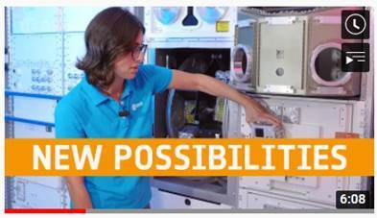
- The Pi 4 B (1GB) could have been as low as $35 prior to Covid-19
- Source: https://youtu.be/owcZeUnSixM [6m:08s] by European Space Agency, ESA
Contents* (Webpage) | Workshop-4
1. Using Basic HTML Tags
Explore the basic HTML tags, tables, navigation menu
2. Using the CSS (Cascading Style Sheet)
Explore the basic CSS style rules, … etc.
3. Designing for the Mobile Web
Use responsive layouts to create mobile friendly webpages
4. Animating your Web Contents
Animate the word, images, and scrolling the contents
5. Virtual IT Field Trip with Q&A
A virtual IT Field Trip – Gabbart Communications
6. Special Speaker: The IT Professional
A day in the life of an IT Professional and Q&A
7. Enhancing the Webpage with Multimedia
Add and configure the image, audio, and video data
8. Putting It All Together
Apply the design and technological knowledge and skill to create your own webpage.
Acknowledgement: this IT camp would not be possible without the help and support from the Dept. of Yours, Your-University, and the community.
Prepared by Dr. John Doe, 4/26/202x
*: The instructor reserves the right to make any adjustments to the contents and/or hardware as needed to meet the goals of the workshop, due to the global chip shortage.

