
2022 IT-Camp Sign Up Form (Workshop-1)
Chemistry, Computer and Physical Sciences (CCPS) Department
Southeastern Oklahoma State University – Durant, OK
Student Application

Return this application to Dr. Ming-Shan Su
Mail: 425 W University Blvd, Classroom Building CB-130, Durant, OK 74701
or Email: msu@se.edu

2022 IT-Camp for incoming Grades 5 - 6 students and any parent/guardian who wishes to join
The Chemistry, Computer and Physical Sciences (CCPS) Department at Southeastern Oklahoma State University (SE) is proud to present the first-ever IT-Camp for Summer 2022! We want to invite your child and any Parent/Guardian to attend this camp. A parent/guardian can just sign up for your child to attend the camp if the parent/guardian him/her-self will not be able to attend the camp. However, if a parent/guardian alone wants to sign up for him/her-self to attend the camp without your child attending the camp, we cannot accept your application.

The IT-Camp will be filled with fun educational activities and is designed to encourage anyone who is interested in the areas of Science, Technology, Engineering and Mathematics (STEM). Activities will include lectures, hands-on tutorial projects, a virtual IT field trip, a talk from an IT-Professional followed by a Q&A, as well as other exciting hands-on exercises.

Please complete this sign-up form no later than the closing date of Friday, May 20th at 5:00 PM (local time). Please make sure that we have an email address that can be used for communication before the camp.
Note: we reserve the right to give the seat(s) to different interested parties (e.g., pre-service or in-service teachers) if there are still seats available after the closing date.

*** Notification of acceptance will start AFTER May 25, 2022. ****

Workshop-1:
IoT (Internet of Things) using Raspberry Pi and Scratch for 5th-6th Graders. Parents/Guardians are welcome!
- Date/Time: June 20-23, 8:30am-10:00am, (Mon. – Thur., 4-day)
- Location: Classroom Building (CB104)
- Fee: $50 total for a child. Free for any parent/guardian who wishes to participate.
- Seat availability: Child (20 seats) and Parents/Guardians (10 seats)
**Note: There is no need to pre-pay for the camp during the sign-up process. After the date of notification, if we have a vacancy for your child, we will notify you through email about how to pay the camp fee. Again, this camp is free for Parent/Guardian participants.

Student Information
- Hereafter referred to as student regardless of whether the camp participant is a child or an adult
- *: required field, **: required if the student is under 18 years old
- Student’s Full Name*: ______________________________________________
- Parent/Guardian's Name**: ______________________________________________
- If you need to apply for a scholarship ($50) for the student to participate in this camp, please fill in the annual household income of the family. We will mainly consider those with an income under $60,000 in Oklahoma). Annual household income: ___________________________________
- Student's Phone Number* (area-code phone-#): ___________________________________
- Parent/Guardian's Phone Number**________________________
- Student Email* (if the student is under 18, please put Parent/Guardian's Email) _____________________
- Address*: _________________________________ City ___________________
State______________ Zip ______
- Name of School student will be attending in Fall 2022**: __________________________________
- Classification/Grade (e.g., 5th, 6th, …or 12th) student will be entering in Fall 2022**: _________________________
- Student's Age*: _________
- Gender*: ___________
- What motivates your child or you to attend this IT Camp*? (The answer can be as short as “just for fun or for educational learning” or as long as “… to fulfill a dream …”).
_____________________________________________________________________________________
_____________________________________________________________________________________
_____________________________________________________________________________________
_____________________________________________________________________________________

- Please contact Southeastern Oklahoma State University at (580) 745-3036 to request assistance due to a disability. Accommodations cannot be guaranteed without adequate advance notice.
- Student's Signature*: _____________________________________
- Parent's or Guardian's Signature (only if the student is under 18): _________________________________
- Date*(mm/dd/yy): __________________

- Sample Forms: There is no need to download or fill out the following three (3) forms during this sign-up process.
After the date of notification, if we have a vacancy for your child or you, we will notify and send you these three forms with information about how to proceed next.
Thank you for your participation!
Notification of acceptance will start AFTER May 25, 2022.

Form-1: Photo/ Video Release form  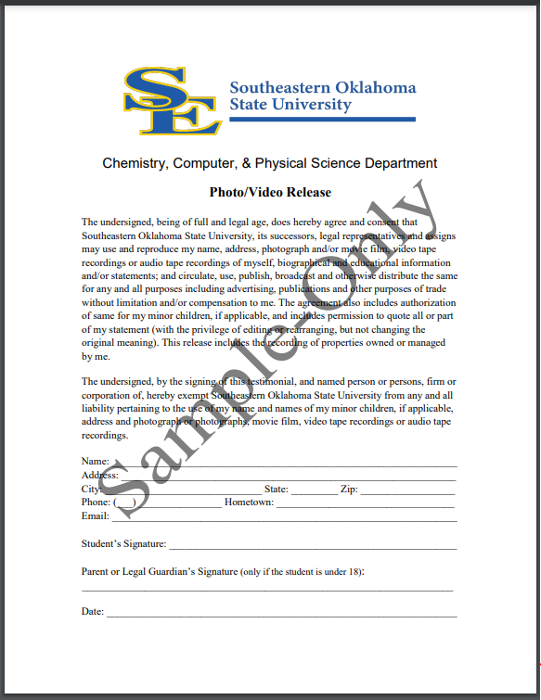 | Form-2: Information & Authorization for Medical Care for Minor/Adult form  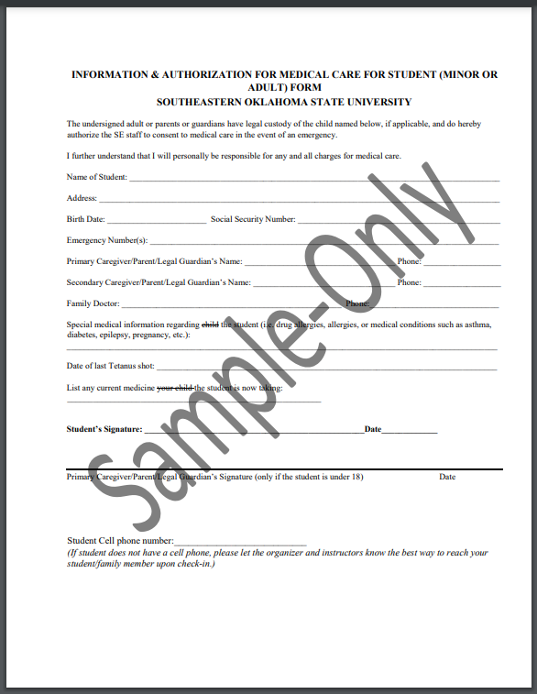 | Form-3: Waiver of Liability and Hold Harmless Agreement form  