Camp Recruitment

A two-page IT Camp flyer as presented in Illustration 1 on page 2 was developed to advertise the four workshops. Copies of the front and back pages of the flyer used to promote the two-week summer IT camp described in this study are provided. The flyer was designed to communicate key information to students and parents/guardians, including workshop topics, schedule, registration details, and learning objectives. The flyer served as a primary recruitment tool in a resource-constrained setting, where outreach channels were limited. It reflects practical considerations in designing clear, accessible, and engaging promotional materials for K–12 audiences and their families.
The front page included key information such as the target age group, date and time, admission fee, venue, registration link, scholarship availability, and free admission for accompanying parents/guardians. The back page provided overview information for each workshop. Due to the constraints of operating as a team of one, participants were recruited through a limited number of channels. Recruitment efforts included emailing the flyer to email distribution lists for students, staff, and faculty, creating an official IT Camp webpage under our university’s domain with additional information and a flyer download link, sending the flyer to principals and assistant principals at nearby high schools, junior high schools, and middle schools, and sharing the flyer in person with the superintendent of an independent school district in the Durant area.
These recruitment methods were selected because they were low-cost, practical, and manageable for a single instructor at a regional university. Among these methods, school-based communication channels appeared especially important for reaching the target student population, as some participants reported learning about the camp through relatives employed at our university who shared the information with them. Although these methods were feasible and economical, they may not have reached all eligible students equally, especially those outside existing school and university communication networks.
Before the registration deadline, 20 students registered for Workshop One, 15 for Workshop Two, eight for Workshop Three, and 15 signed up for Workshop Four. These registration counts provide a basic indication of participant interest across the four workshops. In the literature, additional recruitment approaches have included local news coverage, social media postings, visits to K–12 school counselors, and classroom presentations at K–12 schools. Such strategies may help broaden participation in future camps.

Illustration 1: Publication Flyer (next page)

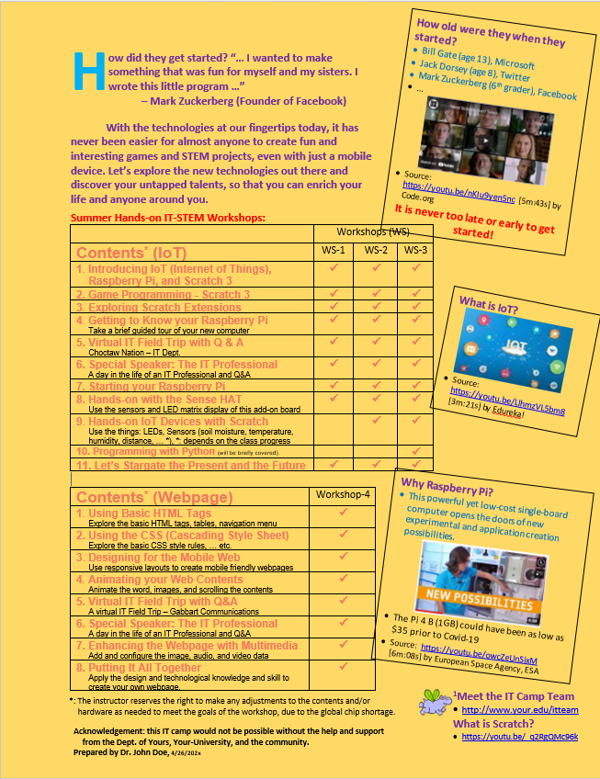
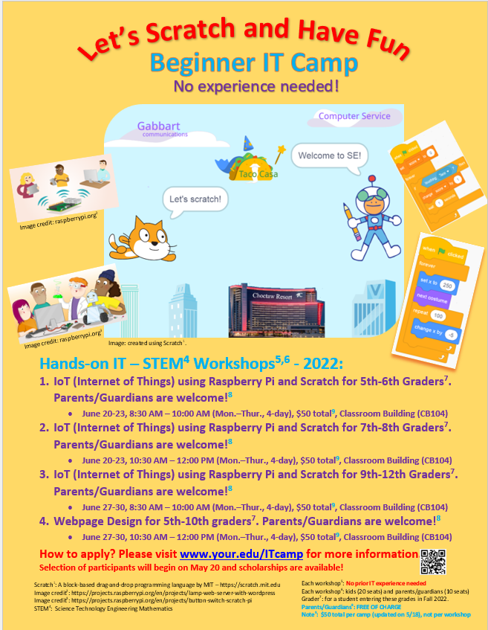
Front page of the IT camp flyer Back page of the IT camp flyer

